How to Program a GUI Application (with Python Tkinter)- <https://www.youtube.com/watch?v=D8-snVfekto>

Widgets- Widgets are eventful python objects that have a representation in the browser, often as a control like a slider, textbox, etc. <https://ipywidgets.readthedocs.io/en/latest/examples/Widget%20Basics.html#:~:text=Widgets%20are%20eventful%20python%20objects,a%20slider%2C%20textbox%2C%20etc>.

Tkinter- Tkinter is the Python interface to the Tk GUI toolkit shipped with Python.

Tkinter is the standard GUI library for Python. Python when combined with Tkinter provides a fast and easy way to create GUI applications. Tkinter provides a powerful object-oriented interface to the Tk GUI toolkit.

Creating a GUI application using Tkinter is an easy task. All you need to do is perform the following steps −

* Import the *Tkinter* module.
* Create the GUI application main window.
* Add one or more of the above-mentioned widgets to the GUI application.
* Enter the main event loop to take action against each event triggered by the user.

---------------------------------------------------

Example:

#!/usr/bin/python

import Tkinter

top = Tkinter.Tk()

# Code to add widgets will go here...

top.mainloop()

--------------------------------------------------

<https://www.tutorialspoint.com/python/python_gui_programming.htm>

Grid vs place vs pack: <https://redhuli.io/pack-place-and-grid-in-tkinter/>

For opening jpg images in tkinter <https://stackoverflow.com/questions/23901168/how-do-i-insert-a-jpeg-image-into-a-python-tkinter-window>

Autofocus on entry widget- <https://stackoverflow.com/questions/13626406/setting-focus-to-specific-tkinter-entry-widget>

Scrollbar in text widget- <https://www.python-course.eu/tkinter_text_widget.php>

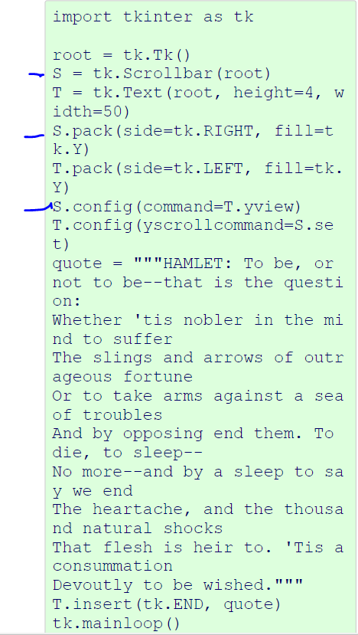

How to set text of tkinter text widget with a button: <https://www.delftstack.com/howto/python-tkinter/how-to-set-text-of-tkinter-text-widget-by-using-a-button/#:~:text=Tkinter%20Text%20widget%20doesn't,to%20change%20the%20content%20completely>.

Message widget- <https://www.geeksforgeeks.org/python-tkinter-message/?ref=lbp> (multiline label)

Resizable() - <https://www.geeksforgeeks.org/resizable-method-in-tkinter-python/?ref=lbp>

The more generalized formats are JPEG/JPG and PNG. To open and display with those formats, we need help of ImageTk and Image classes from PIL(photo imaging Library) package.

With the help of PIL(photo imaging Library), we can load images in over 30 formats and convert them to image objects, even base64-encoded GIF files from strings!! <https://www.c-sharpcorner.com/blogs/basics-for-displaying-image-in-tkinter-python>

Getting the size of an image using PIL <https://www.kite.com/python/answers/how-to-get-the-size-of-an-image-with-pil-in-python>

API GET and POST requests using Python- <https://www.geeksforgeeks.org/get-post-requests-using-python/>

Autocomplete using Listbox- <https://stackoverflow.com/questions/47839813/python-tkinter-autocomplete-combobox-with-like-search>

Before starting, I installed the following libraries – requests, Pillow

pip install requests

pip install Pillow