Using the program

New Game
Click the new game option in the main menu.
Select which colour and how many ply levels you would like to play with.
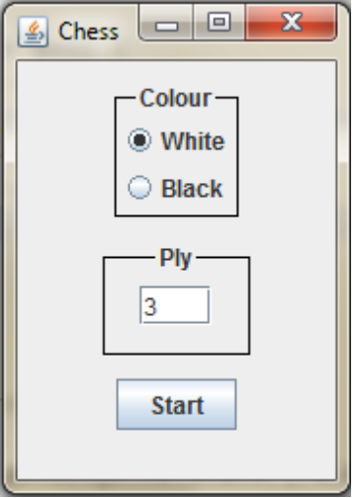
Once the game has started;
Select pieces to see what moves are available. Click one of the green or red squares to move your piece to that spot.
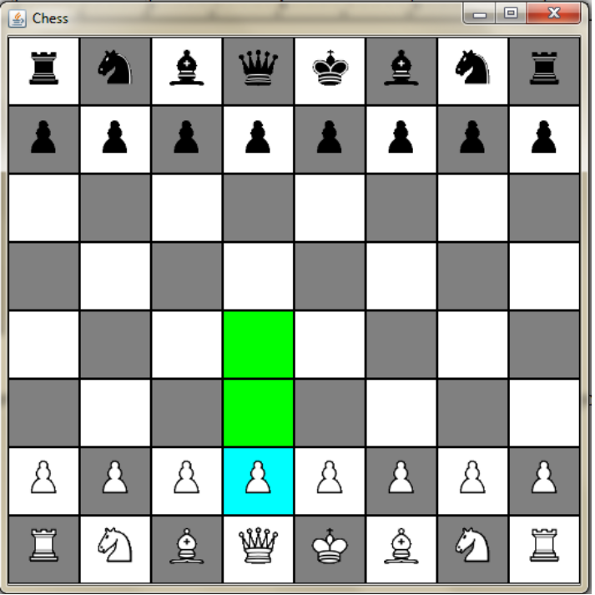

If one of your pawns reaches the other side of he board you will be prompted to select which type of piece to promote the pawn too.
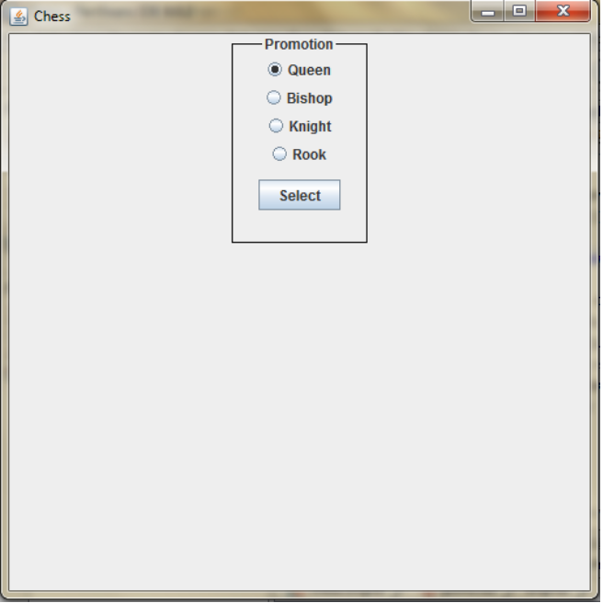
Custom Game
Select Custom Game from the main menu.
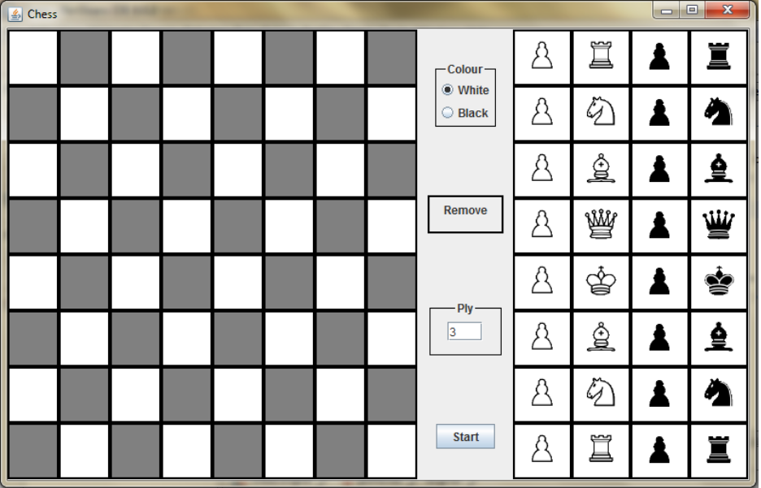

Select a piece from the right side.

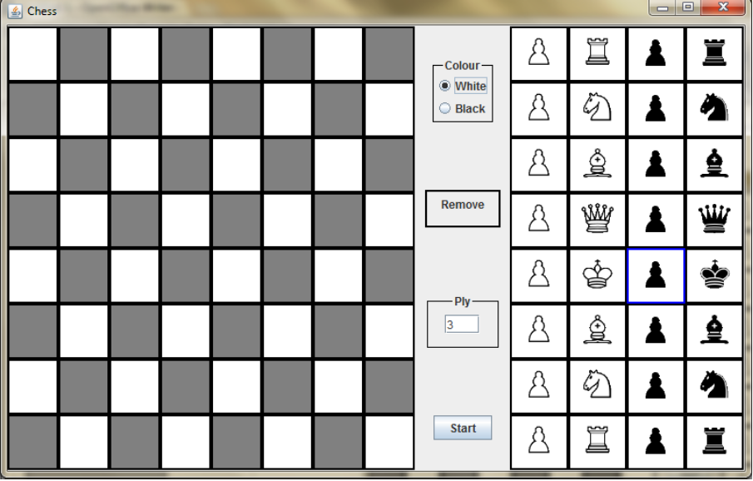
Click on the board for where you would like to place it.
To remove a piece from the board, click the 'remove' button, then click the piece you would like to remove.

Click start to start the game.

