**Probably the Best**

**Video Game Company**

**(Group 7)**

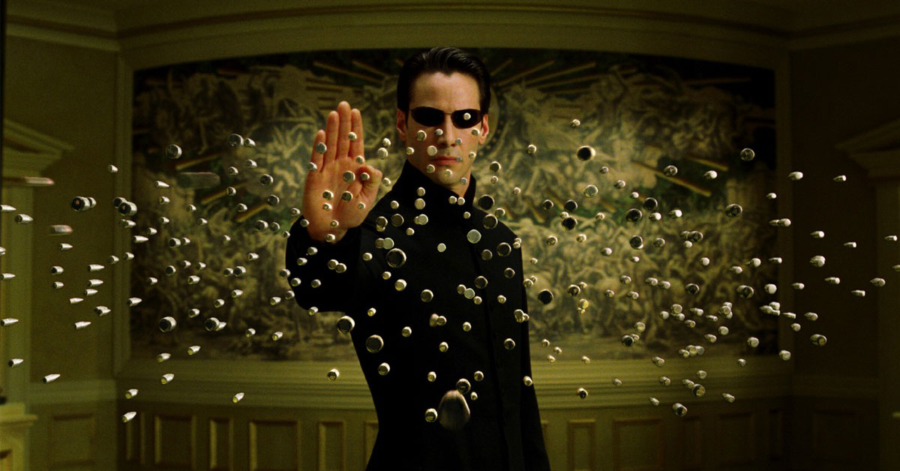

**BORIS MERLO 101027533**

**and**

**MICHAEL NOSEWORTHY 101027533**

**borismerlo@gmail.com**

**mikethenose@gmail.com**

Game Design Document

Draft 1.0.0

Presenting:

**GUARDAH with the ALIENS!**



• High level description of our game

A fast paced shooter that requires hand eye coordination with your fingers and good reflexes to win. Our goal for this game is to entertain the players with an action bullet hell game. An old school 2D classic. The audience will be for all ages as we want this to be a simple experience for all. It will be a top down level scroller that players will have to avoid swarms of alien ships and bullets as they try to reach the end.

• UI Flow diagram of how the screens connect to one another

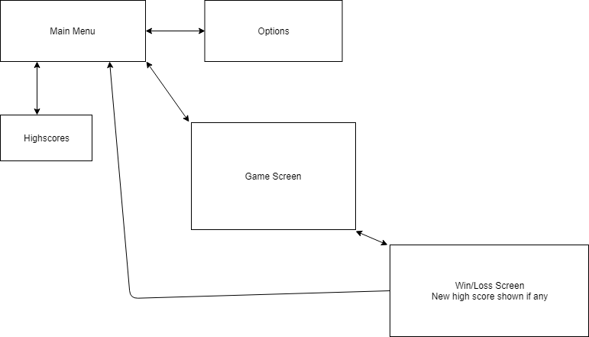

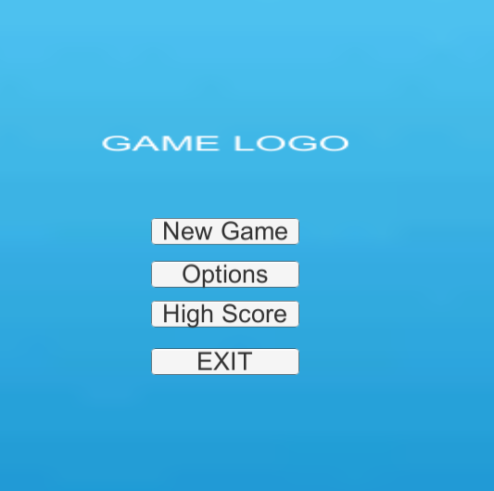

• Rough Layout of all our screens 

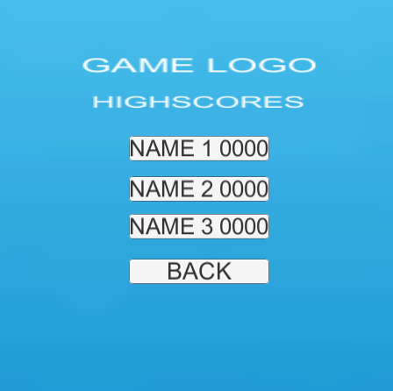 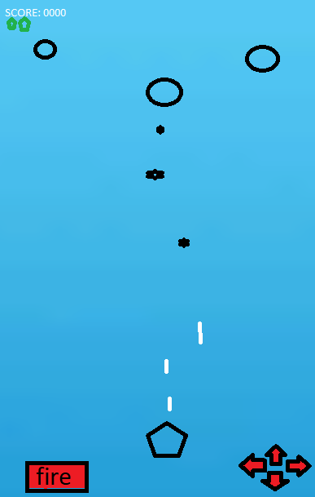

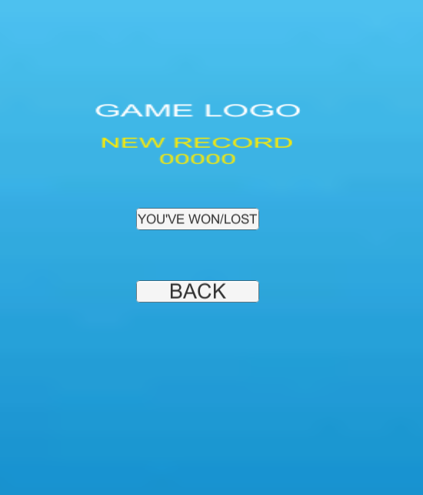

• Backstory of your game

After decades of diplomacy, the peace between the Ming Empire and Choso Consolidate cause an unprecedented conflict between their planets and moons. The decrease of Chosorium production, water substitute and eternal-life granter, end up giving birth to an old word now lost to the centuries, “War”. You, a mere miner are the only one that can stop this carnage by facing down pirates and mercenaries that will try to stop you from divulging the truth paid for by Bohr-iz, a self-proclaimed enemy of all life’s existence whom is the mastermind of this confrontation.

Are you up to the task?

• Game mechanics

- Tap the buttons on the bottom of the screen that will allow you to move and shoot

- Pop objects on the screen

- The player needs to double-tap to special-shoot enemies

- The player needs to hold down on the appropriate button to move

- Simple Boss AI at end of level

- Enemy will pop out on the screen in different patterns

Targeted platform: iOS

Influences: - Aero Fighters

- The Expanse

Example:

