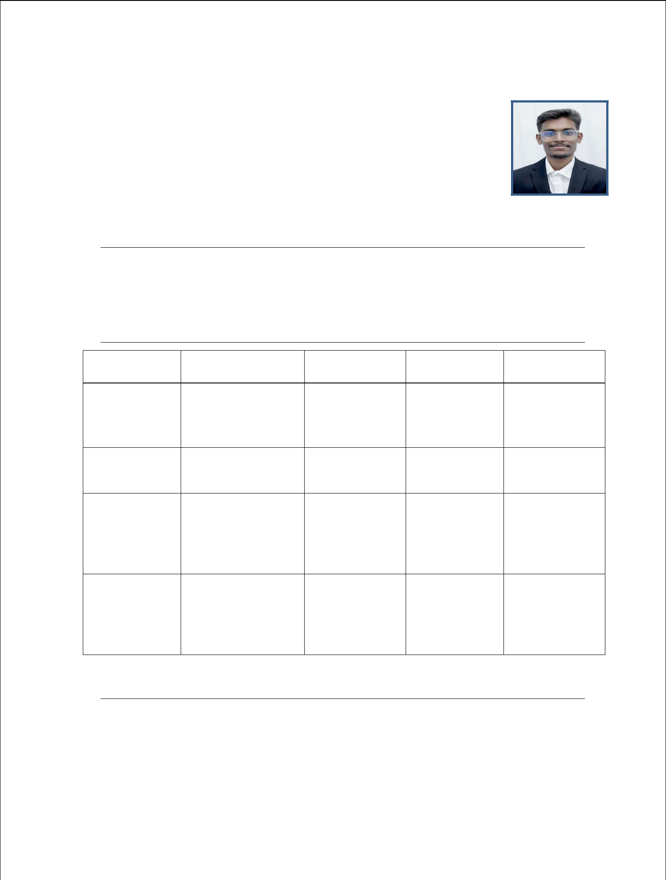
RESUME

Name : AVINASH PATIL

Moblie : 9742727766

Email :avinashpatil05662@gmail.com

Address : #209, 82nd cross Kumarswamy Layout police station,

Bangalore Karnataka

OBJECTIVE

To work for an organization that gives a scope to enhance my knowledge and gather experience, utilizing my technical skills and willingness to learn which would enable me as fresh graduate to grow while fulfilling organization goals.

EDUCATION

Course | College/school | University | Year of | Aggergate
 |  |  | Passout
 | Dayananda Sagar
MCA | college of | VTU
 | Engineering , |  | 2022 | 8.7 CGPA
 | Bengaluru
BCA | A S Patil College of | RCUB | 2019 | 8.0 CGPA
 | commerce
 | (autonomous)
 | Government boys Pre | Karnataka State
 | University College | Board
PCMB | Vijayapura |  | 2016 | 55.33%
 | Athani Vidyavardhak | Karnataka
 | School , Athani , | Seconadary
SSLC | Belagum | Education | 2014 | 81.2%
 |  | Examination

Board

COMPUTER PROFICIENCY

Skils:

    - Proficient in SQL, PYTHON, JAVA.

    - Knowledge of ETL processes and data integration techniques.

    - Familarity with cloud platforms(azure).

    - Using interface and inheritance concepts in java.

    - Solid knowledge in packages and access specifiers.

    - Good knowledge on exception handling.

    - Good in programming.

SQL

    - Solid Knowledge on DDL , DML ,TCL , DCL commands.

    - Good knowledge on Joins .

    - Good knowledge on Functions.

    - Good knowledge on Sub Queries.

PROJECT

TITLE : AUTO SPARE PARTS AUTOMATION (Duration: 4 months) Description :

The project uses the web application features to support access of authorized employee to inventory control information system , by providing options to explore details of inventory in stocks , browse the stocks , update the inventory based on the sale and purchasing details.

INTRENSHIP

- COMPANY NAME : Gyrit Solutions pvt ltd , Duration : 3 months(2022)
- Company Name : Bizmetric, Duration : 3 months(2023)

PERSONAL DETAILS

DOB : 22/08/1998

Nationality : Indian

Gender : Male

Father’s Name : Rajugouda Patil

Languages Known : English , Kannada , Hindi

DECLARATION

I hereby affirm that all the above information is true and correct to the best of my knowledge and belief.

Place : Bengaluru AVINASH PATIL

