Q_01

Write a program that displays a frame window 800 pixels wide and 600 pixels high. Set the title of the frame to Welcome to Java.

Answer:

package Q_01;  
import javax.swing.*;  
  
public class Q_01 {  
 public static void main(String[] args) {  
 JFrame myWindow;  
 myWindow = new JFrame();  
 myWindow.setSize(800, 600);  
 myWindow.setTitle("Welcome to Java");  
 myWindow.setVisible(true);  
 }  
}

Screenshot:

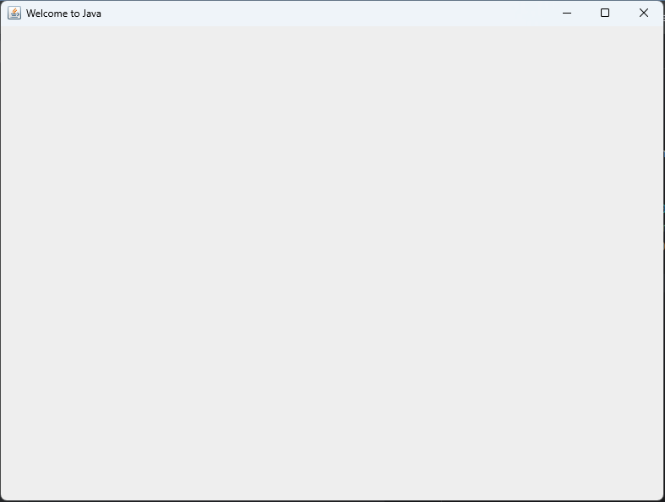

Q_02

Input the user’s first and last name as two separate strings. Then display a frame window with its title set to the input values (User’s full name). For example, if the input values are James and Bond, the title would be James Bond.

Answer:

package Q_02;  
  
import javax.swing.*;  
import java.util.Scanner;  
  
public class Q_02 {  
 public static void main(String[] args) {  
 Scanner scanner = new Scanner(System.*in*);  
 System.*out*.print("Enter your First name:");  
 String firstName = scanner.next();  
 System.*out*.print("Enter your Last name:");  
 String lastName = scanner.next();  
  
 JFrame myWindow;  
 myWindow = new JFrame();  
 myWindow.setSize(800, 600);  
 myWindow.setTitle(firstName + " " + lastName);  
 myWindow.setVisible(true);  
 }  
}

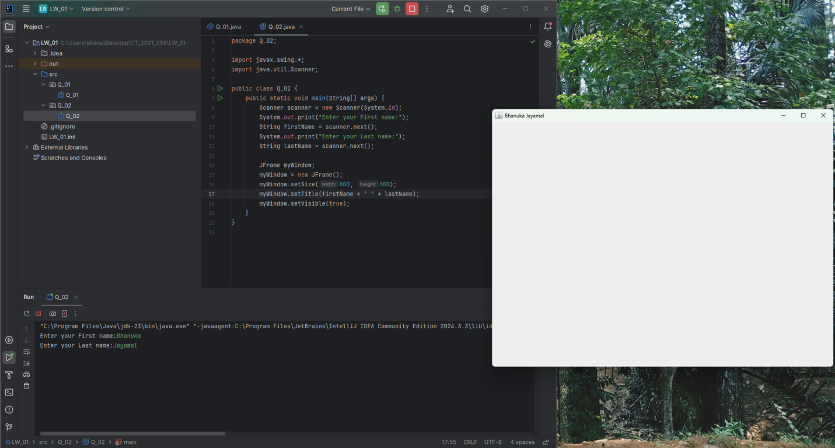Screenshot: