1. Code:

package Q_01;  
  
import java.util.Scanner;  
  
public class Q_01 {  
 public static void main(String[] args) {  
  
 //The square root of B^(2)+4AC  
 double A;  
 double B;  
 double C;  
  
 Scanner scanner = new Scanner(System.*in*);  
 System.*out*.print("Enter value for A:");  
 A = scanner.nextDouble();  
  
 System.*out*.print("Enter value for B:");  
 B = scanner.nextDouble();  
  
 System.*out*.print("Enter value for C:");  
 C = scanner.nextDouble();  
  
 double calc = Math.*sqrt*(Math.*pow*(B,2)+4*A*C);  
 System.*out*.println(calc);  
  
 //The square root of X+4Y^(3)  
 double X;  
 double Y;  
  
 System.*out*.print("Enter value for X:");  
 X = scanner.nextDouble();  
  
 System.*out*.print("Enter value for Y:");  
 Y = scanner.nextDouble();  
  
 double sqrt_xy = X + 4 * Math.*pow*(Y,3);  
 System.*out*.println(sqrt_xy);  
  
 //The cube root of the product of X and Y  
 X=0;  
 Y=0;  
 System.*out*.print("Enter value for X:");  
 X = scanner.nextDouble();  
  
 System.*out*.print("Enter value for Y:");  
 Y = scanner.nextDouble();  
  
 double cubert = Math.*cbrt*(X*Y);  
 System.*out*.println(cubert);  
  
 //The area of a circle  
 double R;  
 final double Pi = 3.14;  
  
 System.*out*.print("Enter the radius value:");  
 R = scanner.nextDouble();  
  
 double area = Pi*Math.*pow*(R,2);  
 System.*out*.println("Area of the circle = "+ area);  
  
 }  
}

Output (Q_01):

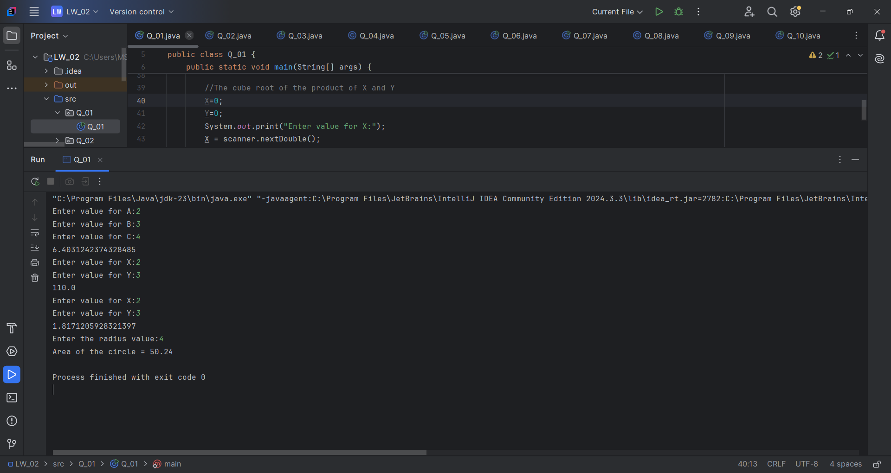

1. Code:

package Q_02;  
  
import java.util.Scanner;  
  
public class Q_02 {  
 public static void main(String[] args) {  
 double cm_input;  
 int feet;  
 Scanner scanner = new Scanner(System.*in*);  
  
 System.*out*.print("Enter the value in centimeters:");  
 cm_input = scanner.nextDouble();  
  
 double inches = (cm_input/2.54);  
 double new_Inches;  
 if (inches > 12){  
 feet = (int)(inches / 12);  
 new_Inches = (inches % 12);  
 System.*out*.println(cm_input + " in centimeter = "+ feet + " feet and " + new_Inches + " inches.");  
  
 } else {  
 System.*out*.println(cm_input + " in centimeter = "+ inches + " Inches.");  
 }  
  
  
  
 }  
}

Output(Q_02):

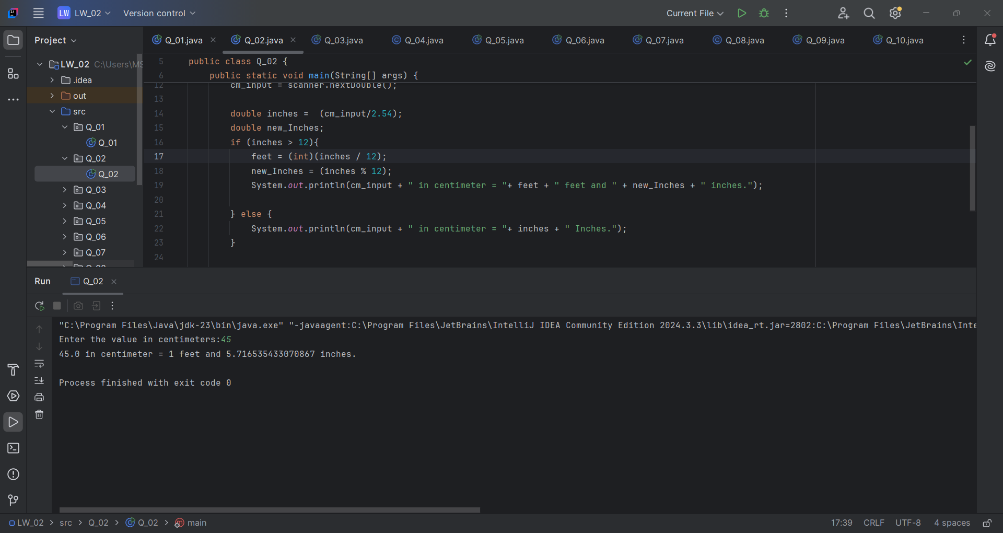

1. Code:

package Q_03;  
  
import java.util.Scanner;  
  
public class Q_03 {  
 public static void main(String[] args) {  
 double cel_input;  
 double fahrenheit;  
 Scanner scanner = new Scanner(System.*in*);  
  
 System.*out*.print("Enter the temperature in degrees Celsius:");  
 cel_input = scanner.nextDouble();  
  
 fahrenheit = (1.8*cel_input) + 32;  
  
 System.*out*.println(fahrenheit);  
  
 }  
}

Output (Q_03):

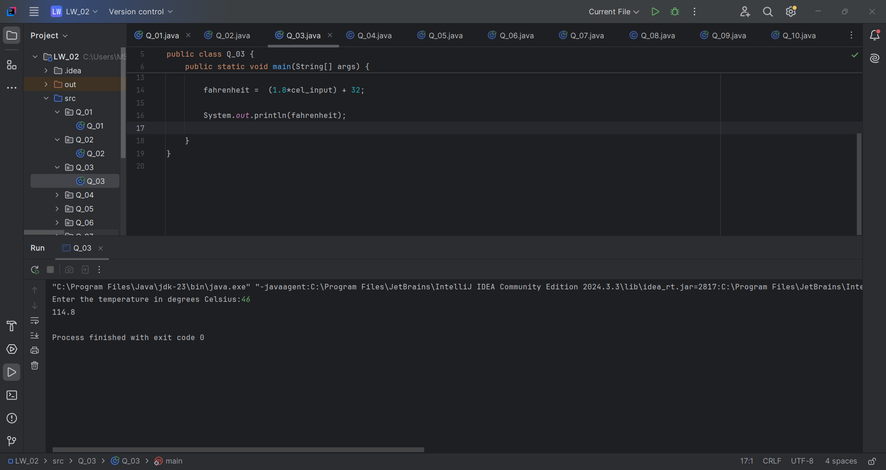

1. Code:

package Q_04;  
  
import java.util.Scanner;  
  
public class Q_04 {  
 public static void main(String[] args) {  
 double cal_input;  
 double calsNeeded;  
 Scanner scanner = new Scanner(System.*in*);  
  
 System.*out*.print("Enter the Weight:"

cal_input = scanner.nextDouble();  
  
 calsNeeded = cal_input * 32;  
  
 System.*out*.println("You need "+ calsNeeded + " Calories in one day");  
  
 }  
}

Output (Q_04):

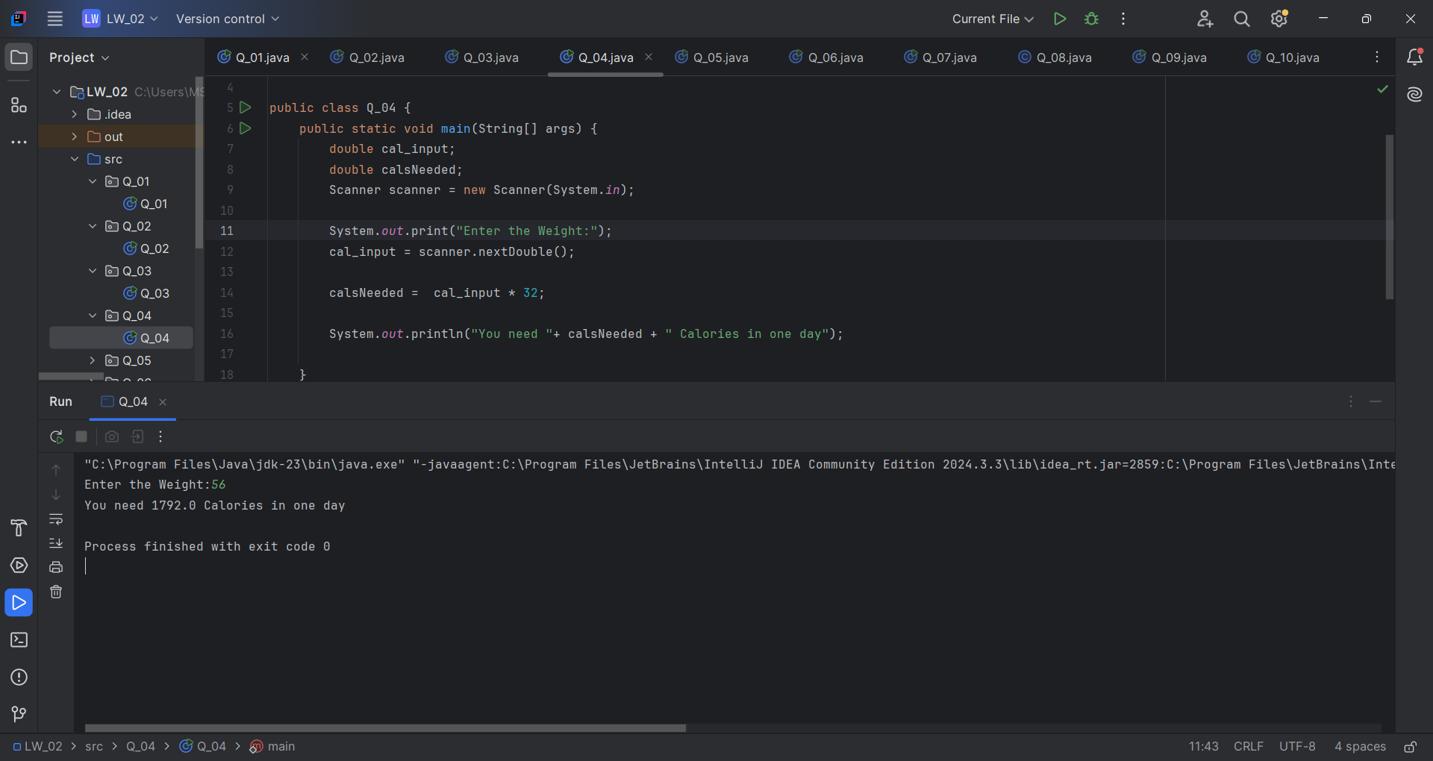

1. Code:

package Q_05;  
  
import java.util.Scanner;  
  
public class Q_05 {  
 public static void main(String[] args) {  
 double celsius;  
 double fahrenheit;  
 Scanner scanner = new Scanner(System.*in*);  
  
 System.*out*.print("Enter the temperature in degrees Fahrenheit:");  
 fahrenheit = scanner.nextDouble();  
  
 celsius = ((double) 5 /9)*(fahrenheit - 32);  
  
 System.*out*.println(celsius);  
  
 }  
}

Output (Q_05):

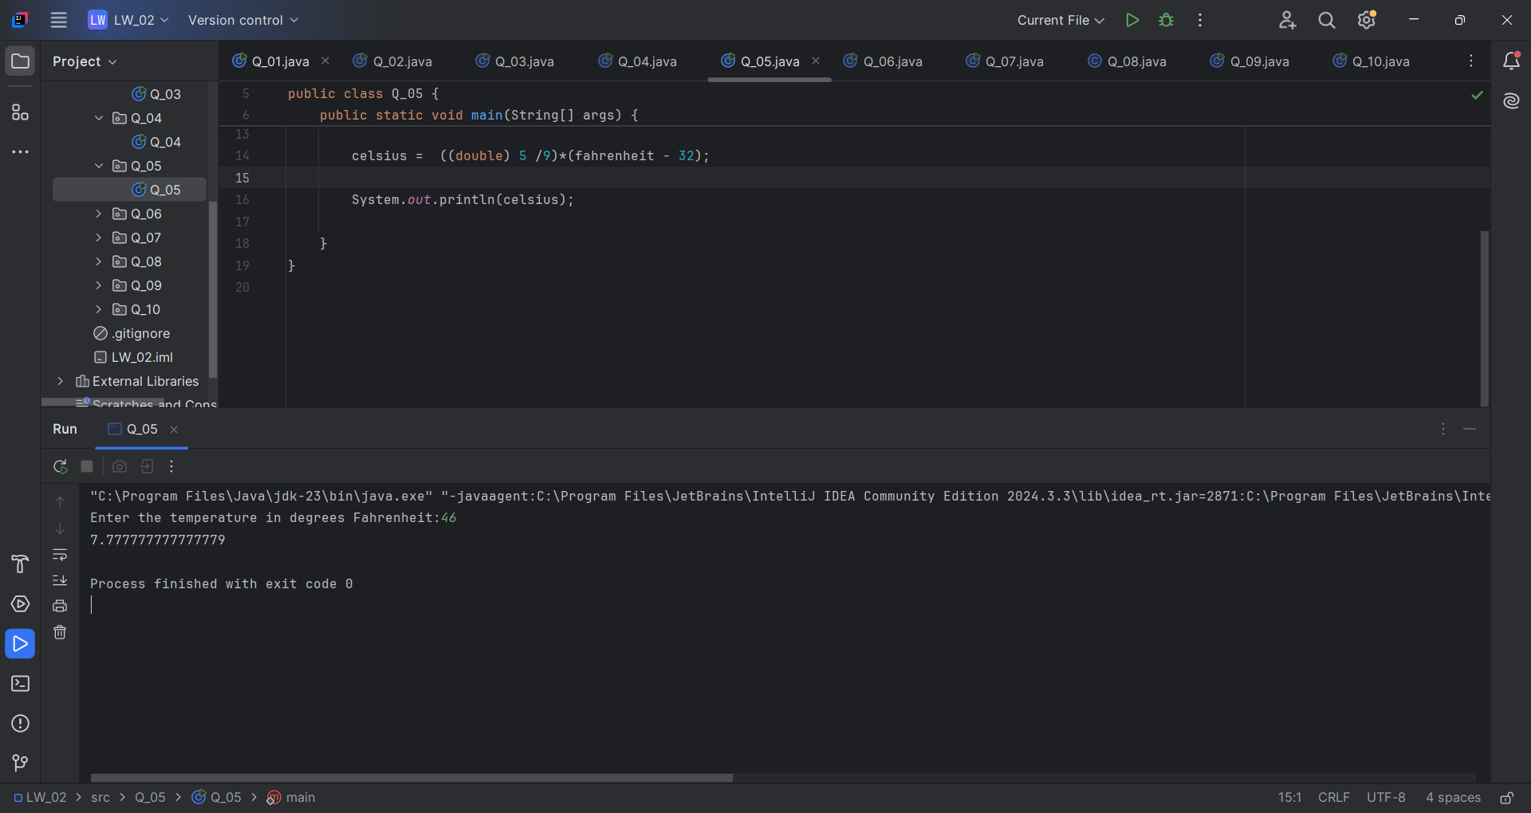

1. Code:

package Q_06;  
  
import java.util.Scanner;  
  
public class Q_06 {  
 public static void main(String[] args) {  
 int bornYear;  
 int age;  
 Scanner scanner = new Scanner(System.*in*);  
  
 System.*out*.print("Enter your birth year:");  
 bornYear = scanner.nextInt();  
  
 age = 2025 - bornYear;  
  
 System.*out*.println("You were born in "+bornYear+" and will be "+age+" this year.");  
  
 }  
}

Output (Q_06):

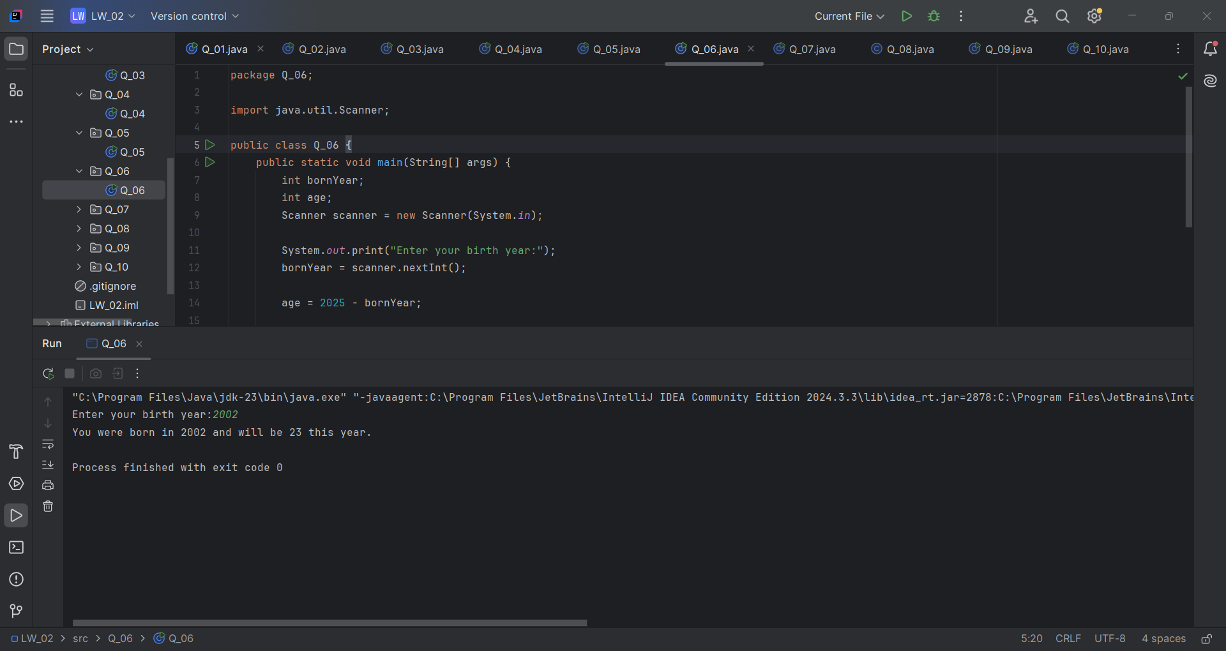

1. Code:

package Q_07;  
  
import java.util.Scanner;  
  
public class Q_07 {  
 public static void main(String[] args) {  
 Scanner scanner = new Scanner(System.*in*);  
 System.*out*.print("Enter your mass in kilograms: ");  
 float w = scanner.nextFloat();  
 System.*out*.print("Enter your height in centimeters: ");  
 float h = scanner.nextFloat();  
  
 double BMI = w/Math.*pow*(h/100.0,2);  
  
 if (BMI < 20){  
 System.*out*.println("Your BMI category: UnderWeight.");  
 System.*out*.print("BMI value: "+BMI);  
 }else if (BMI >= 20 && BMI <=25){  
 System.*out*.println("Your BMI category: Normal.");  
 System.*out*.print("BMI value: "+BMI);  
 }else{  
 System.*out*.println("your BMI category: OverWeight");  
 System.*out*.print("BMI value: "+BMI);  
 }  
 }  
}

Output (Q_07):

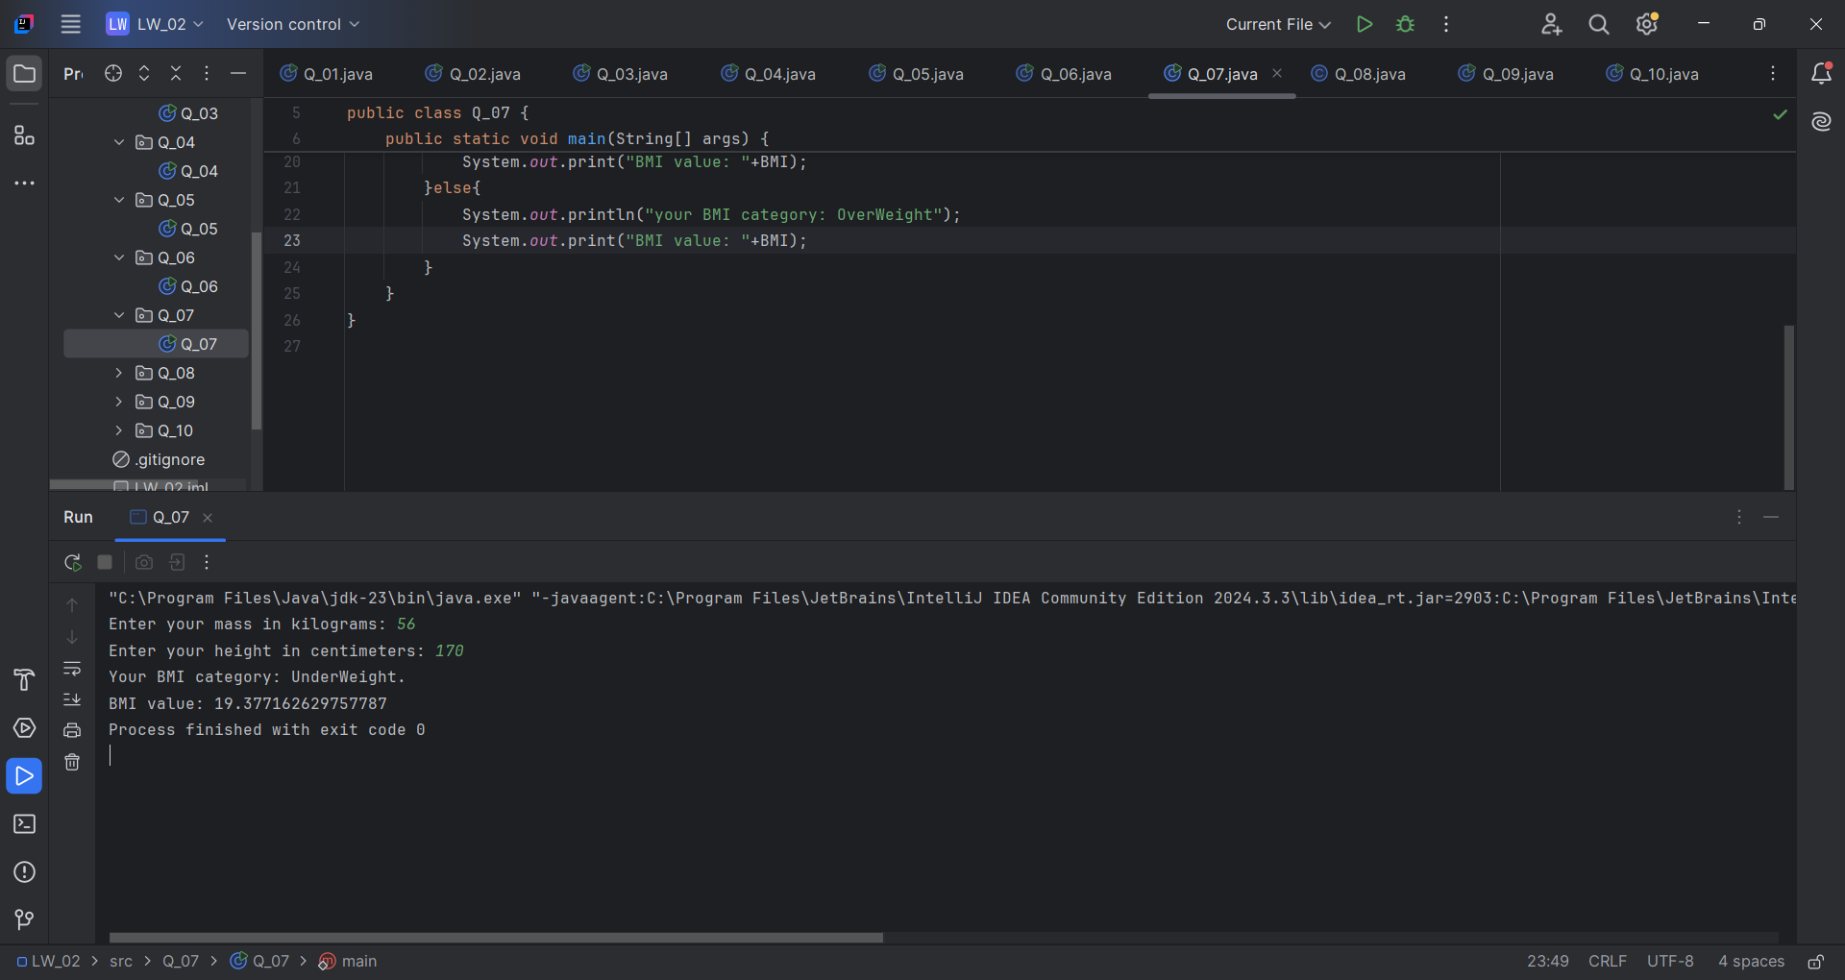

1. Code:

package Q_08;  
  
import java.util.Scanner;  
  
import static java.lang.Math.*PI*;  
  
public class Q_08 {  
 public static void main(String[] args) {  
 Scanner scanner = new Scanner(System.*in*);  
  
 System.*out*.print("Enter radius of your Sphere: ");  
 float r = scanner.nextFloat();  
  
 double V = (4.0/3)*(*PI*\*Math.*pow*(r,3));  
  
 System.*out*.println("Volume of your sphere: "+V);  
 }  
}

1. Code:

package Q_09;  
  
import java.util.Scanner;  
  
public class Q_09 {  
 public static void main(String[] args) {  
 Scanner scanner = new Scanner(System.*in*);  
  
 System.*out*.print("Enter your investment in Dollars: ");  
 float P = scanner.nextFloat();  
 System.*out*.print("Enter your investment percentage: ");  
 float R = scanner.nextFloat();  
 System.*out*.print("Enter your investment Period in Years: ");  
 int N = scanner.nextInt();  
  
 double grow = P*Math.*pow*((1+(R/100)),N);  
 System.*out*.println("You earned "+grow+ " dollars in "+N+" Years.");  
 }  
}

1. Code:

package Q_10;  
  
import java.util.Scanner;  
  
public class Q_10 {  
 public static void main(String[] args) {  
 Scanner scanner = new Scanner(System.*in*);  
  
 int MONTHS_IN_YEAR = 12;  
  
 System.*out*.print("Enter loan amount ($): ");  
 float loanAmount = scanner.nextFloat();  
 System.*out*.print("Enter Annual Interest Rate: ");  
 float annualInterestRate = scanner.nextFloat();  
 System.*out*.print("Enter loan period: ");  
 float loanPeriod = scanner.nextFloat();  
  
 double monthlyInterestRate = annualInterestRate/100.0/MONTHS_IN_YEAR;  
 double numberOfPayments = loanPeriod*MONTHS_IN_YEAR;  
 double monthlyPayment = (loanAmount*monthlyInterestRate)/(1-Math.*pow*(1/(1+monthlyInterestRate),numberOfPayments));  
 double totalPayment = monthlyPayment*numberOfPayments;  
  
 System.*out*.println("Your Monthly Payment: "+monthlyPayment+" $");  
 System.*out*.println("Your Total Payment: "+totalPayment+" $");  
 }  
}

