Q_01 & Q_02

Answer:

package Q_01_02;  
  
public class temperature {  
 private double celsius;  
 private double fahrenheit;  
  
 public temperature() {  
 celsius = 0;  
 fahrenheit = 0;  
 }  
  
 public temperature(double celsius) {  
 this.celsius = celsius;  
 }  
  
 public double getCelsius() {  
 return celsius;  
 }  
  
 public void setCelsius(double fahrenheit) {  
 celsius = (fahrenheit - 32) * 5/9 ;  
 }  
  
 public double getFahrenheit() {  
 return fahrenheit;  
 }  
  
 public void setFahrenheit(double celsius) {  
 fahrenheit = celsius * 9/5 + 32 ;  
 }  
  
}

package Q_01_02;  
  
import java.util.Scanner;  
  
public class Main {  
 public static void main(String[] args) {  
 double celsius;  
 temperature temp1 = new temperature();  
 Scanner scanner = new Scanner(System.*in*);  
  
 System.*out*.print("Enter the Temperature in Celsius: ");  
 celsius = scanner.nextDouble();  
  
 temp1.setFahrenheit(celsius);  
 System.*out*.println(celsius + " in celsius = " + temp1.getFahrenheit() + " in fahrenheit");  
  
 double fahrenheit;  
 temperature temp2 = new temperature();  
  
 System.*out*.print("Enter the Temperature in Fahrenheit: ");  
 fahrenheit = scanner.nextDouble();  
  
 temp2.setCelsius(fahrenheit);  
 System.*out*.println(fahrenheit + " in fahrenheit = " + temp2.getCelsius() + " in celsius");  
  
 }  
}

Screenshot:

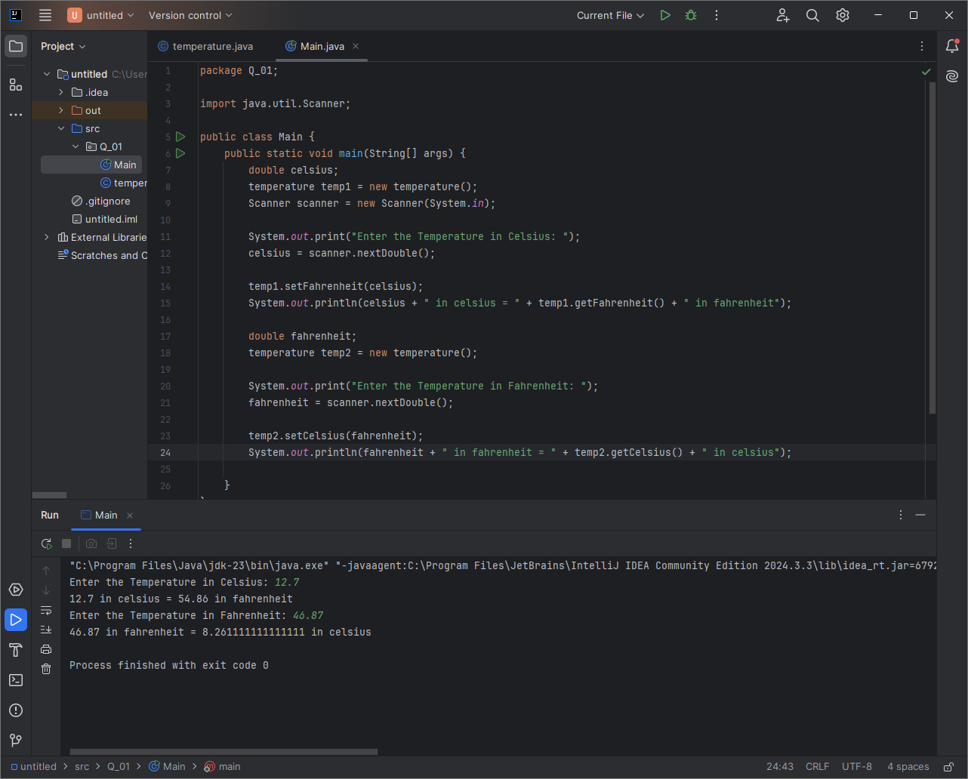

Q_03

Answer:

package Q_03;  
  
public class Circle {  
 private double r;  
 private double area;  
 private final double Pi = 3.14;  
 private double circumference;  
  
 public Circle() {  
 r = 0;  
 area = 0;  
 circumference = 0;  
 }  
  
 public void setRadius(double r) {  
 this.r = r;  
 }  
  
 public double getArea() {  
 return area;  
 }  
  
 public void computeArea(){  
 area = Pi * r * r ;  
 }  
  
 public void computeCircumference(){  
 circumference = 2 * Pi * r;  
 }  
  
}

package Q_03;  
import java.util.Scanner;  
public class Main {  
 public static void main(String[] args) {  
 double ri,ro;  
 Scanner scanner = new Scanner(System.*in*);  
 Circle innerCircle = new Circle();  
 Circle outerCircle = new Circle();  
  
 System.*out*.print("Enter inner circle radius:");  
 ri = scanner.nextDouble();  
 System.*out*.print("Enter outer circle radius:");  
 ro = scanner.nextDouble();  
  
 innerCircle.setRadius(ri);  
 innerCircle.computeArea();  
 outerCircle.setRadius(ro);  
 outerCircle.computeArea();  
 System.*out*.println("Area of the shaded area: "+(outerCircle.getArea() - innerCircle.getArea()));  
 }  
}

Screenshot:

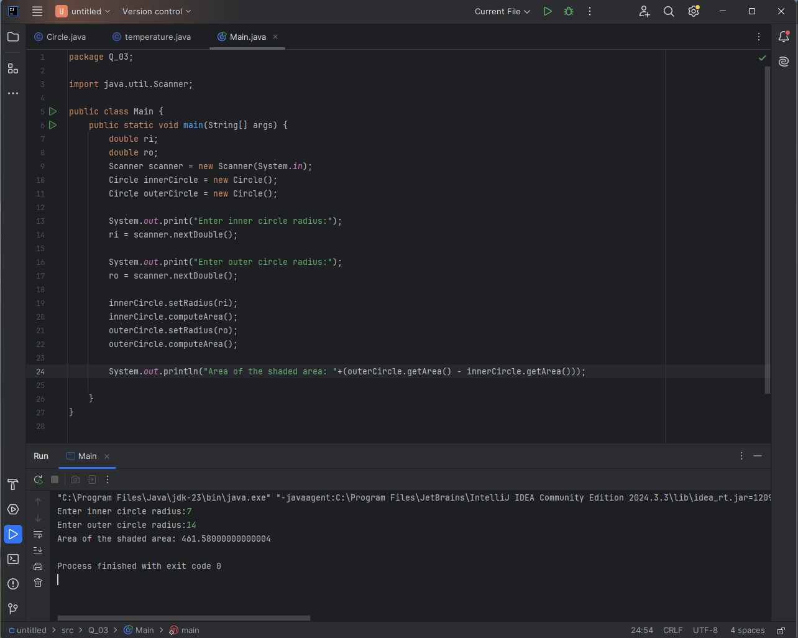

Q_04

Answer:

package Q_04;  
  
public class Owner {  
 private String ownerName;  
 private String phoneNo;  
  
 public Owner(String ownerName, String phoneNo) {  
 this.ownerName = ownerName;  
 this.phoneNo = phoneNo;  
 }  
  
 public String getOwnerName() {  
 return ownerName;  
 }  
  
 public void setOwnerName(String ownerName) {  
 this.ownerName = ownerName;  
 }  
  
 public String getPhoneNo() {  
 return phoneNo;  
 }  
  
 public void setPhoneNo(String phoneNo) {  
 this.phoneNo = phoneNo;  
 }  
}

package Q_04;  
  
public class Bicycle {  
 private Owner owner;  
  
 public Bicycle() {  
 // Ensure owner is initialized  
 this.owner = new Owner("Unknown", "Unknown");  
 }  
  
 public Bicycle(String ownerName, String phoneNo) {  
 // Initialize owner properly  
 this.owner = new Owner(ownerName, phoneNo);  
 }  
  
 public Owner getOwner() {  
 return owner;  
 }  
  
 public void setOwner(Owner owner) {  
 this.owner = owner;  
 }  
  
 // Method to set owner's details directly  
 public void setOwnerDetails(String name, String phone) {  
 if (this.owner == null) {  
 this.owner = new Owner(name, phone);  
 } else {  
 this.owner.setOwnerName(name);  
 this.owner.setPhoneNo(phone);  
 }  
 }  
}

Screenshot:

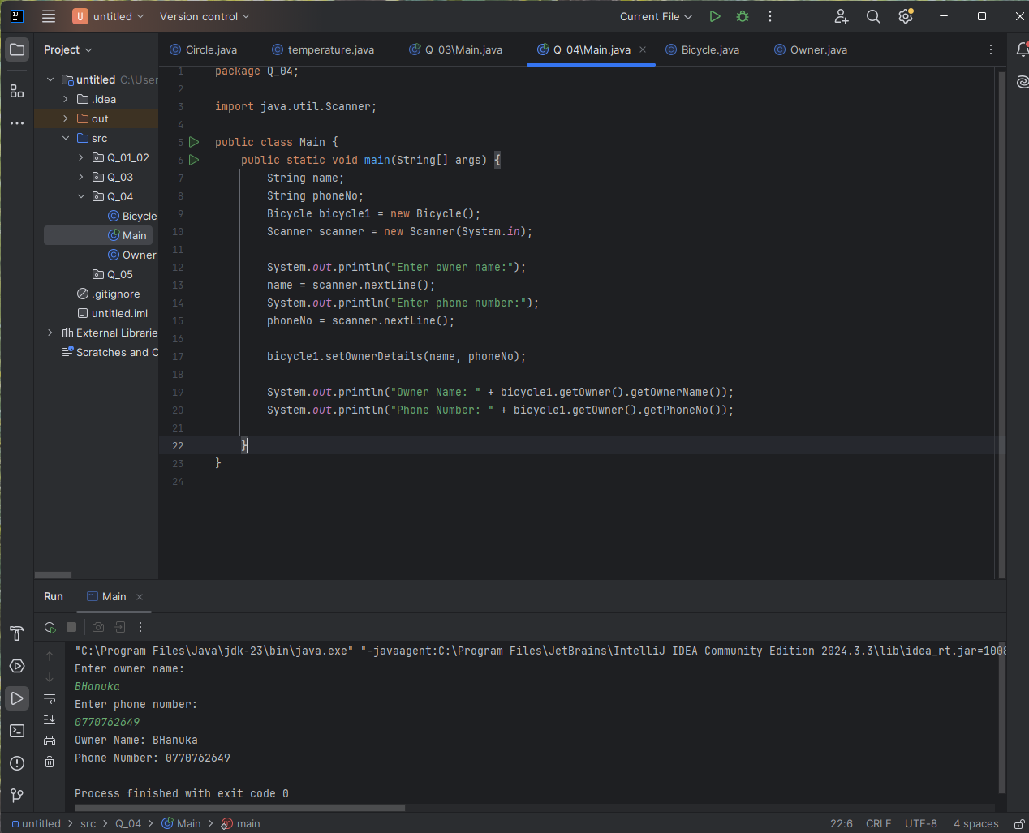

Q_05

Answer:

package Q_05;  
  
public class Course {  
 private String courseName;  
 private String courseCode;  
 private Lecturer lecturer;  
  
 public String getCourseName() {  
 return courseName;  
 }  
  
 public void setCourseName(String courseName) {  
 this.courseName = courseName;  
 }  
  
 public String getCourseCode() {  
 return courseCode;  
 }  
  
 public void setCourseCode(String courseCode) {  
 this.courseCode = courseCode;  
 }  
  
 public String getLecturerName() {  
 return lecturer.getLecturerName();  
 }  
  
 public void setLecturer(String name) {  
 lecturer.setLecturerName(name);  
 lecturer.setCourseTeaching(courseName);  
 }  
}

package Q_05;  
  
public class Lecturer {  
 private String lecturerName;  
 private String courseTeaching;  
  
 public String getLecturerName() {  
 return lecturerName;  
 }  
  
 public void setLecturerName(String lecturerName) {  
 this.lecturerName = lecturerName;  
 }  
  
 public String getCourseTeaching() {  
 return courseTeaching;  
 }  
  
 public void setCourseTeaching(String courseTeaching) {  
 this.courseTeaching = courseTeaching;  
 }  
}

package Q_05;  
  
public class Student {  
 private String studentName;  
 private String degreeName;  
 private String courseFollowing;  
  
 public String getStudentName() {  
 return studentName;  
 }  
  
 public void setStudentName(String studentName) {  
 this.studentName = studentName;  
 }  
  
 public String getDegreeName() {  
 return degreeName;  
 }  
  
 public void setDegreeName(String degreeName) {  
 this.degreeName = degreeName;  
 }  
  
 public String getCourseFollowing() {  
 return courseFollowing;  
 }  
  
 public void setCourseFollowing(String courseFollowing) {  
 this.courseFollowing = courseFollowing;  
 }  
}

package Q_05;  
import java.util.Scanner;  
public class Main {  
 public static void main(String[] args) {  
 String stName,dName,cFollowing,lName,cName,cCode;  
 Student student = new Student();  
 Lecturer lecturer = new Lecturer();  
 Course course = new Course();  
 Scanner scanner = new Scanner(System.*in*);  
  
 System.*out*.println("Enter Student Name: ");  
 stName = scanner.nextLine();  
 System.*out*.println("Enter degree Name: ");  
 dName = scanner.nextLine();  
 System.*out*.println("Enter Course Name: ");  
 cFollowing = scanner.nextLine();  
 cName = cFollowing;  
 System.*out*.println("Enter Lecturer Name: ");  
 lName = scanner.nextLine();  
 System.*out*.println("Enter Course code: ");  
 cCode = scanner.nextLine();  
  
 student.setStudentName(stName);  
 student.setDegreeName(dName);  
 student.setCourseFollowing(cFollowing);  
 course.setCourseCode(cCode);  
 course.setCourseName(cName);  
 lecturer.setLecturerName(lName);  
  
 System.*out*.println("Student name: " + student.getStudentName());  
 System.*out*.println("Lecturer name: " + lecturer.getLecturerName());  
 System.*out*.println("Course name: "+ course.getCourseName());  
  
 }  
}

Screenshot:

