**Following**

Junit Tutorial: //*[text()='JUnit Tutorial']

JXL Tutorial: //*[text()='JUnit Tutorial']//following::a

Apache poi: //*[text()='JUnit Tutorial']//following::a//following::a

**Preceding**

TestNG Tutorial: //*[text()='JUnit Tutorial']//preceding::a[1]

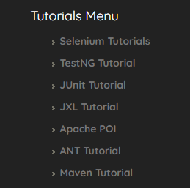

**Contains**

**Syntax: //tag[contains(@attribute, ‘value‘)]**

**Example:**//input[contains(@id, ‘er-messa’)]

ANT Tutorial : //*[contains(text(), 'ANT Tutorial')]

//*[contains(@id, 'name')]

//*[contains(@href,'swtestacademy.com')]

**Starts-with**

**Syntax: //tag[starts-with(@attribute, ‘value‘)]**

**Example:**JXL Tutorial : //a[starts-with(text(), 'JXL')]

//input[starts-with(@id, ‘user’)]

//*[starts-with(@id, 'name')]

**Chained Declarations**

**Example:***//div[@class=’form-group’]//input[@id=’user-message’]*

JXL Tutorial inside the footer = //footer[@class='footer']//a[text()='JXL Tutorial']

Input forms - //li[@class='tree-branch']//a[contains(text(),'Input')]

Progress bars and sliders = //li[@class='tree-branch']//a[contains(text(),'Bars ')]

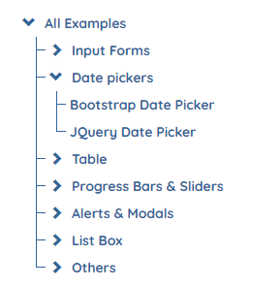

### ****Operator “or”****

**Syntax**: //tag[XPath Statement-1 or XPath Statement-2]

**Example**: //*[@id=’user-message’ or @class=’form-control’]

### ****Operator “and”****

**Syntax**: //tag[XPath Statement-1 and XPath Statement-2]

**Example**: *//*[@id=’user-message’ and @class=’form-control’]*

### ****Ancestor****

Finding ancestor using Date pickers link :

//*[contains(text(),'Date pickers')]//ancestor::div[@class="panel panel-default"]



### ****Child****

Selenium Tutorials: //div[@class="container"]/child::div[@class='col-md-6']/child::ul/child::li[1]

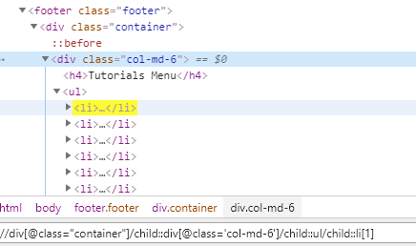

### ****Following-sibling****

//div[@class="container"]/child::div[@class='col-md-6']/child::ul//following::li

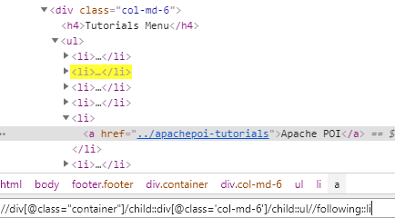

### ****Descendant****

Identifies and returns all the element descendants to current element which means traverse down under the current element’s node. Below, the XPath returns all “li” elements under the “treemenu”

//ul[@id='treemenu']/child::li/child::i/following-sibling::ul/descendant::li

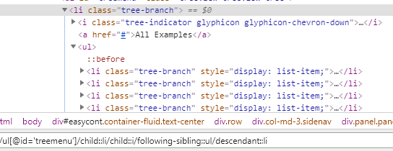

### ****Parent****

//a[text()='Date pickers']//parent::li

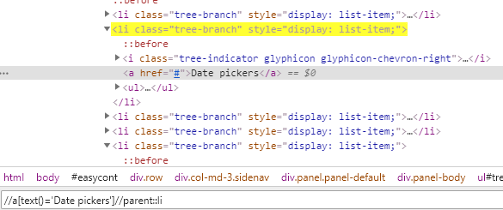

### ****Locate an Element inside Array of Elements****

(//a[starts-with(text(),'Date')])[1]

<https://www.swtestacademy.com/selenium-parallel-tests-grid-testng/>s

