🌀 Realm Theory - Simulation Report

Simulation Parameters
Parameter | Value
α (Alpha - Curvature Coupling) | 1.0000
β (Beta - Field Feedback) | 2.0700
Observer Position (X, Y) | (4.07, 0.65)
Target Position (X, Y) | (8.00, 8.00)
Report Generated | 2025-12-16 14:49:07

Field Statistics
Statistic | Value
Mean Curvature | -0.000000
Max Curvature | 0.999955
Min Curvature | -0.999955
Std Deviation | 0.483482

Simulation Visualizations

Tensor Field 3D Surface
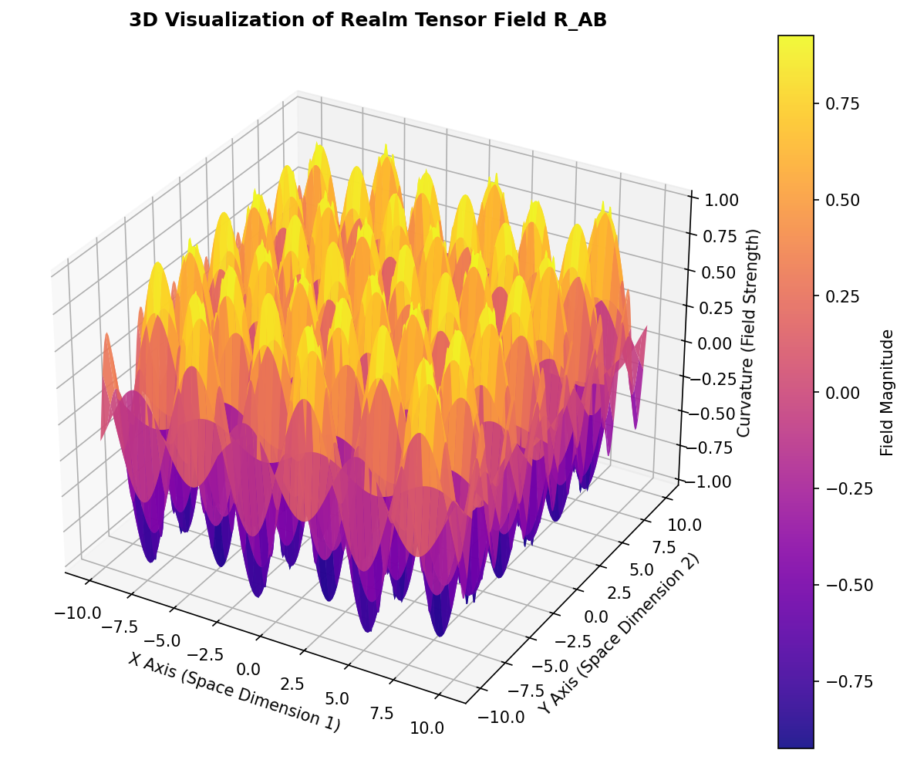

Enhanced Surface Visualization
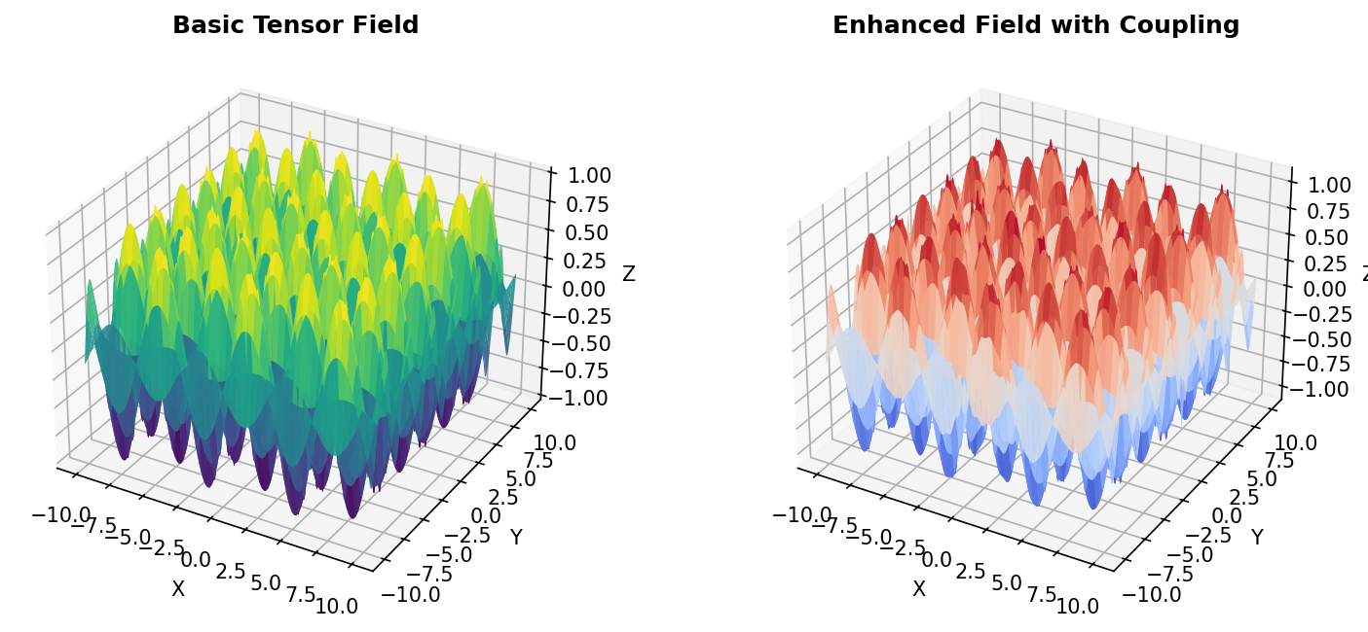

Entropy Flow Along Geodesic
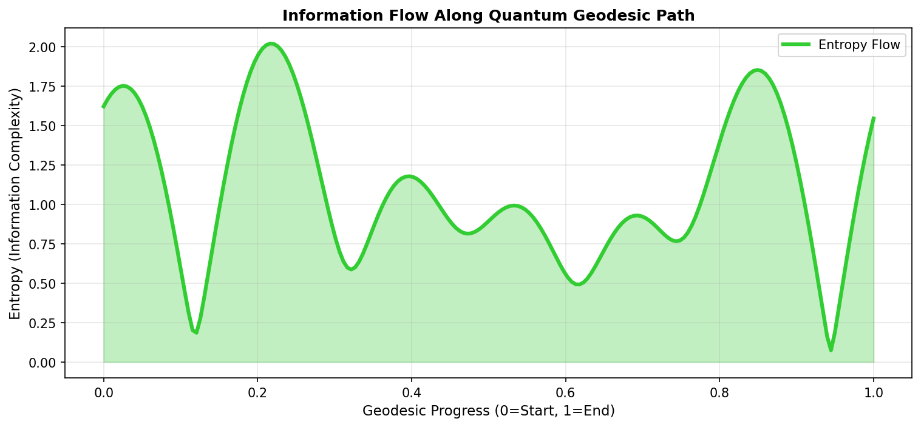

Entropy Distribution Heatmap


Entropy Time Evolution
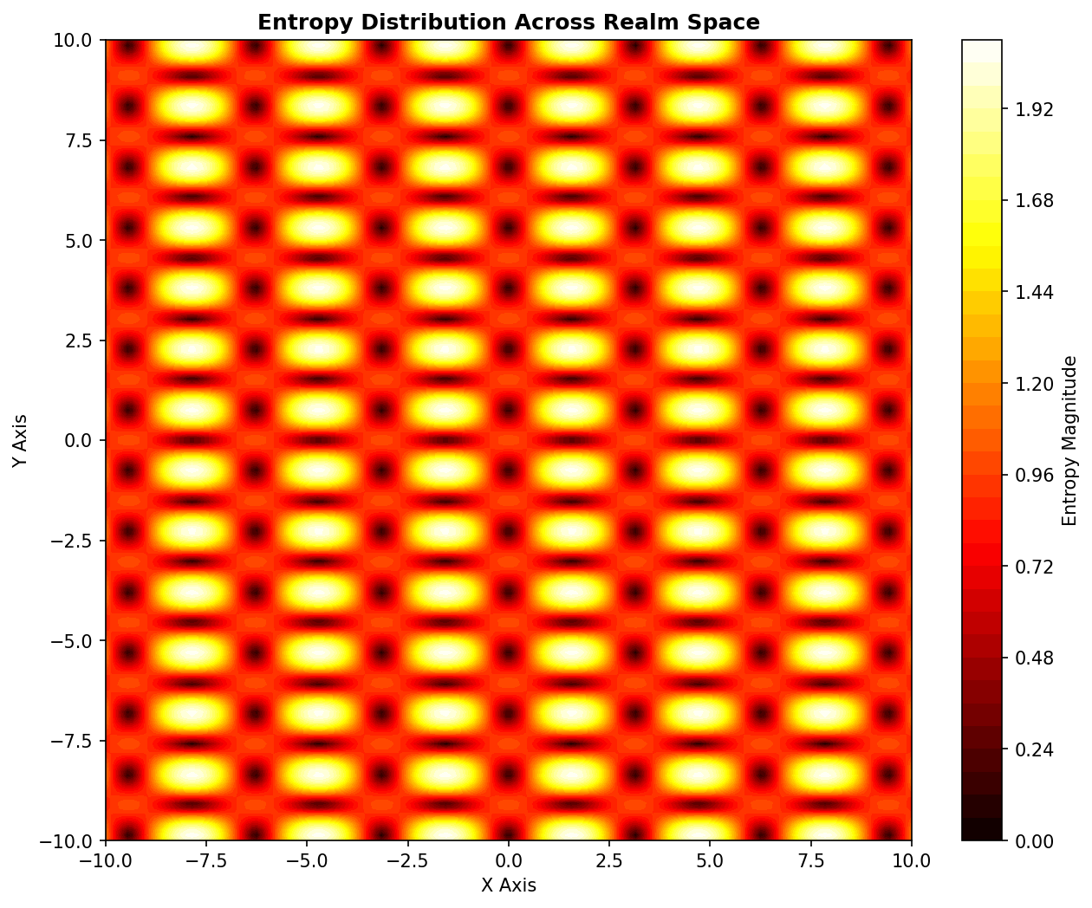

Geodesic Path in 3D
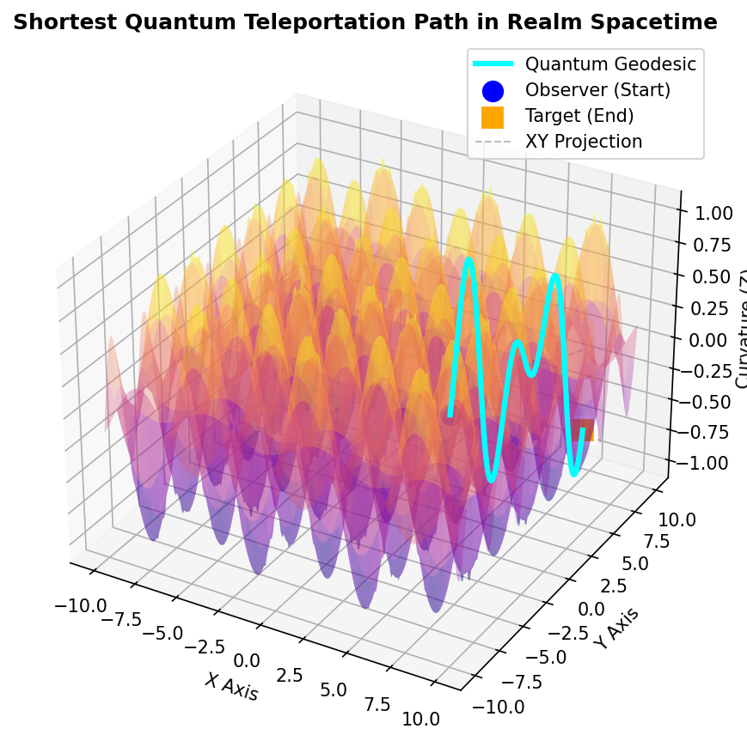

Geodesic 2D Projection
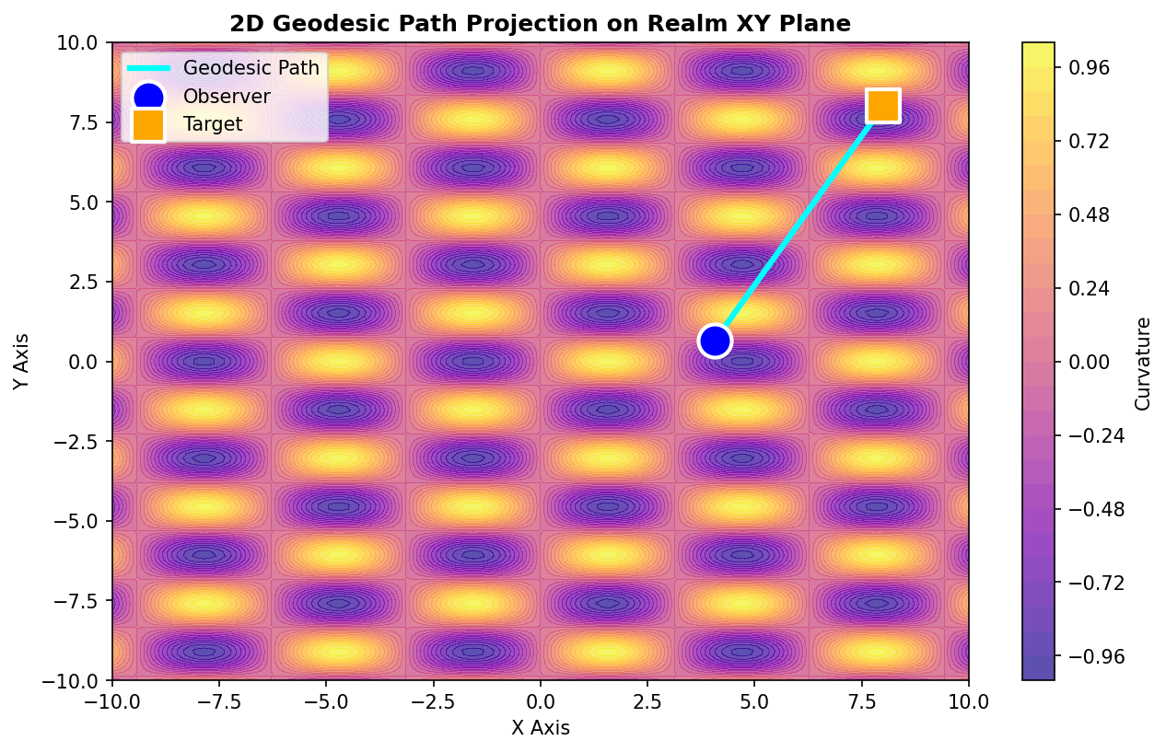

Realm Theory - Summary

Core Principles
- Tensor Field Evolution: Spacetime curvature evolves via R_AB(x,y,t) = e^(-(x²+y²))·cos(√(x²+y²) - β·t)
- Geodesic Minimization: The Realm geodesic minimizes ∫ √(1 + (∂z/∂x)² + (∂z/∂y)²) dt
- Entropy Flow: Information complexity changes via ∇z = √((∂z/∂x)² + (∂z/∂y)²)
- Quantum Entanglement: Entangled particles share identical quantum states across geodesic connections

Key Findings
- Geodesic paths provide the shortest routes through curved spacetime
- Parameter tuning (α and β) enables precise control over field behavior
- Entropy measures information loss along quantum teleportation paths
- The unified geometric framework bridges quantum mechanics and relativity

