**GRETNA and BrainNet Viewer: Toolkits for Graph-Theoretical Network Analysis and Visualization**

**Author**

Mingrui Xia1,2, Jinhui Wang1,3,4, Xindi Wang1,2, Zhengjia Dai1,2, Rui Hou1,2, Ni Shu1,2, Gaolang Gong1,2, Alan Evans5and Yong He1,2

**Institutions**

1State Key Laboratory of Cognitive Neuroscience and Learning & IDG/McGovern Institute for Brain Research, Beijing Normal University, Beijing, China, 100875

2Center for Collaboration and Innovation in Brain and Learning Sciences, Beijing Normal University, Beijing, China, 100875

3Center for Cognition and Brain Disorders, Hangzhou Normal University, Hangzhou, China, 310015

4Zhejiang Key Laboratory for Research in Assessment of Cognitive Impairments, Hangzhou, China, 310015

5McConnell Brain Imaging Center, Montreal Neurological Institute, McGill University, Montreal, QC H3A 2B4, Canada

**Introduction**

**简洁：因为没有人搞，所以我们搞了一个。**

The human brain organizes into a complex system whose topological descriptions have been represented as the human connectomes (Sporns et al., 2005).Recent studies have shown that the human connectomes can be mapped by non-invasive neuroimaging technologies and further characterized with sophisticated analytic strategies such as graph theory. Using these methods, researchers have been able to reveal many topological properties of the brain networks such as small-worldness, modularity and hubs (Bullmore and Sporns 2009). However, given huge complexity of this methodology, toolkits for graph-based brain network analysis and visualization are still lacking. Here, we developed a graph-theoretical network analysis toolkit, GRETNA, and a visualizing tool, BrainNet Viewer, for analysis and visualization of human connectomes.

**Methods**

**编程语言 总的介绍 阈值 功能**

Both GRETNA (V1.0, Fig. 1, 2) and BrainNet Viewer (V1.43, Fig. 3) were developed using Matlab as programming language, with graphical user interface (GUI), under Microsoft Windows environment.

GRETNA allows researchers to perform a comprehensive analysis on the topological properties of brain connectome. It can deal with both binary and weighted networks depending on whether to take connectivity strength into account. Given the lack of golden standard on definition of network nodes, edges and thresholding procedures, GRETNA provides flexible manipulations on these different methodological choices. Moreover, GRETNA contains several additional functions to perform simple statistical analyses. Finally, GRETNA extends capabilities to process raw resting-state fMRI (R-fMRI) data and construct functional connectivity matrices.

四个步骤 可供载入的文件类型 仪表板 详细信息见引用

BrainNet Viewer allows researchers to visualize brain network topology. The visualization procedure can be summarized as file loading, option setting, graph drawing and image saving. Four kinds of import files are defined: 1) Brain surface file including vertex and triangles of brain mesh; 2) Node file including coordinates, color, size and label of network nodes; 3) Edge file including association matrix; and 4) NIFTI volume file including statistical result or atlas. Various combinations of these files are permitted to load while visualizing different brain network types (Fig. 4). An options panel is also provided to help users to adjust the details of output figures. The BrainNet Viewer can be used to draw brain surface, nodes and edges in sequence and to display in multi-views as users demand. The figures can be printed directly or exported in frequently-used image formats for further usage. For the detailed visualization algorithms, see Xia et al (2013).

**Results**

源代码 和程序

Both GRETNA (Fig. 1, 2) and BrainNet Viewer (Fig. 3) toolkits can be downloaded freely on the NITRC web site ([www.nitrc.org/projects/gretna/](http://www.nitrc.org/projects/gretna/); [www.nitrc.org/projects/bnv/](http://www.nitrc.org/projects/bnv/)).

两个的功能

GRETNA fulfills network analysis as follow: 1) Adjustable preprocessing procedure for R-fMRI data; 2) Graph-based network metrics including small-worldness (Watts and Strogatz 1998), efficiency (Latora and Marchiori 2001), modularity (Clauset et al., 2004; Newman 2006), assortativity (Newman 2002) and hierarchy (Ravasz and Barabasi 2003); 3) Nodal properties calculation including degree, efficiency and betweenness; and 4) Data analysis in a parallel way using PSOM.

BrainNet Viewer mainly achieves the following functions: 1) Display combinations of brain surface, nodes, edges and volumes in multi-views (Fig. 4); 2) Adjust color and size of both nodes and edges in different ways; 3) Map Nifti images onto brain surface; 4) Support various kinds of image format exporting; 5) Provide interactive operations such as zoom and rotate; 6) Support command line calling; and 7) Display network matrix.

**Conclusions**

**总结：有用的**

GRETNA and BrainNet Viewer can help researchers to analyze and visualize topological structure of brain networks in an easy, flexible and quick way.

**References**

Bullmore, E. (2009), 'Complex brain networks: graph theoretical analysis of structural and functional systems', Nat Rev Neurosci, vol. 10, no. 3, pp. 186-198.

Clauset, A. (2004), 'Finding community structure in very large networks', Phys Rev E Stat Nonlin Soft Matter Phys, vol. 70, no. 6 Pt 2, pp. 066111.

Latora, V. (2001), 'Efficient behavior of small-world networks', Phys Rev Lett, vol. 87, no. 19, pp. 198701.

Newman, M.E. (2002), 'Assortative mixing in networks', Phys Rev Lett, vol. 89, no. 20, pp. 208701.

Newman, M.E. (2006), 'Modularity and community structure in networks', Proc Natl Acad Sci U S A, vol. 103, no. 23, pp. 8577-8582.

Ravasz, E. (2003), 'Hierarchical organization in complex networks', Phys Rev E Stat Nonlin Soft Matter Phys, vol. 67, no. 2 Pt 2, pp. 026112.

Sporns, O. (2005), 'The human connectome: A structural description of the human brain', PLoS Comput Biol, vol. 1, no. 4, pp. e42.

Watts, D.J. (1998), 'Collective dynamics of 'small-world' networks', Nature, vol. 393, no. 6684, pp. 440-442.

Xia, M. (2013), 'BrainNet Viewer: a network visualization tool for human brain connectomics', PLoS One, vol. 8, no. 7, pp. e68910.

**Fig 1. Interface of functional network construction of GRETNA**

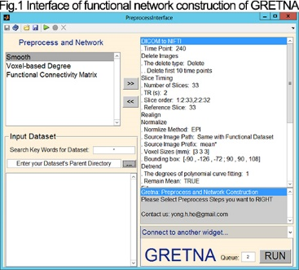

**Fig 2. Interface of network analysis of GRETNA**

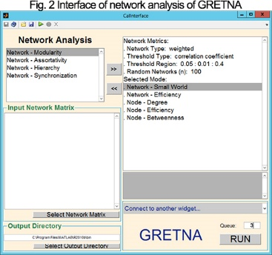

**Fig 3. Main window of BrainNet Viewer**

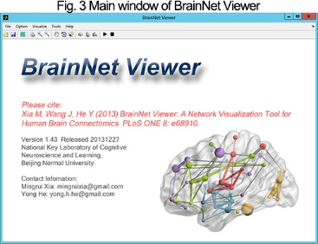

**Fig 4. Pictures generated by BrainNet Viewer**

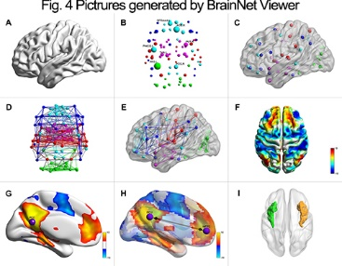

**Title**

Parallel Toolkits for Fast Mapping of High-Resolution Human Brain Connectome

**Author**

Kang Zhao, Haixiao Du, Mingrui Xia, Huazhong Yang, Yu Wang, Yong He,

**Institutions**

Nowadays, graph theoretical approaches combined with non-invasive neuroimaging technologies are widely used for mapping and topological description of complex human brain networks, represented as the human connectomes (Bullmore and Sporns, 2012). The construction and analysis of high-resolution brain connectomes at a voxel scale are important because they provide finer spatial information without prior parcellations (Hayasaka 2010). However, the increasing amount of datasets and the growing network size bring forward high requirements for the computational capabilities in the high-resolution human connectome study. Here, we developed a parallel graph-theoretical analysis of ??? (Pagani-) using a hybrid CPU-GPU accelerated framework.

**Introduction**

**Methods**

This hybrid CPU-GPU platform for brain network analysis(BNA) consists of a series of graph-theoretical algorithms and corresponding graphical user interface(GUI).

The workflow of BNA platform can be summarized as network construction and network analysis(Fig 1). For first step，GPU-based acceleration algorithm is applied for preprocessed BOLD signal in order to achieve the voxel-level brain network construction. For network analysis, with the continuous updating the platform can deal with both binary and weighted networks now according to whether to take connectivity strength into account. The parameters of networks that have been constructed fall into two classes: global metrics and nodal metrics. With regard to global metrics we calculate the parameters aimed at whole network, including characteristic path length, clustering coefficient, modularity and small-worldness. The nodal metrics provided by the platform are as follow: 1) nodal efficiency, clustering coefficient(for each node) and participation coefficient; 2) centrality, such as degree centrality, betweenness centrality, eigenvector centrality; and 3) output NII format algorithm with which user can convert these nodal metrics conveniently to NII format for further treatment, like visualization.

Among these global and nodal metrics, getting some parameters of them is extremely time-consuming for voxel-level brain network especially for characteristic path length, modularity and centrality, etc. Therefore, much work has been done for for purpose of acceleration via [parallelization](javascript:void(0);) and algorithmic improvement. If you want to probe deeper, see Haixiao et al (2013). Besides, for those parameters that may is unaccommodated with GPU implementation, we still take full advantage of CPU for optimization to obtain a better performance. The CPU-GPU hybrid framework makes it possible for rapid analysis of high-resolution or even voxel-based brain network.

A GUI was meticulously designed for practicability and better promotion of BNA platform.

**Results**

Both the source code and already packed software within GUI and .exe files of all algorithm can be downloaded freely on the NITRC web site (网址) or Github web site (网址). Thereinto, the GUI is shown in Fig 2.

For same brain network, we calculated the running time for computing each network metric on the CPU, GPU and CPU-GPU hybrid platform(Table 1). As can be seen from the table, the introduction of CPU-GPU hybrid framework has brought greatly comprehensive superiority.

**Conclusions**

As a complete tool the BNA platform can assist researchers to execute voxel-based analysis of brain networks in an easy and quick way

是不是还得给参数等，加参考文献。每个加速算法参考哪篇文献？参与度：别人的。

**平台包括贵和算法。算法分为有权和无权。平台工作流程。平台算法（哪些gpu哪些cpu）。如何使用平台（归）。详细信息见引用**

**ping**

**workflow那张图 能做哪些 哪些用gpu，哪些用cpu**

**（有权无权，加速（lp，modularity），smallworld，nodalmetrics，图形界面）**

**Results 界面，workflow重画(weighted画出来)，加速比（表格 weighted都要） (源代码和程序，还有执行结果对照表格)**

**表格的叙述应该说列举了部分算法的执行结果。文字叙述对稀疏度进行说明（还有lp可以根据不同稀疏度自动选择）。先不管基于bfs的lp的对比，这个记得和大师兄讨论。有权网第二行空了，不合适，和大师兄商量。**

**Conclusions**

**References**

Fig