**GRETNA and BrainNet Viewer: Toolkits for Graph-Theoretical Network Analysis and Visualization**

**Author**

Mingrui Xia1,2, Jinhui Wang1,3,4, Xindi Wang1,2, Zhengjia Dai1,2, Rui Hou1,2, Ni Shu1,2, Gaolang Gong1,2, Alan Evans5and Yong He1,2

**Institutions**

1State Key Laboratory of Cognitive Neuroscience and Learning & IDG/McGovern Institute for Brain Research, Beijing Normal University, Beijing, China, 100875

2Center for Collaboration and Innovation in Brain and Learning Sciences, Beijing Normal University, Beijing, China, 100875

3Center for Cognition and Brain Disorders, Hangzhou Normal University, Hangzhou, China, 310015

4Zhejiang Key Laboratory for Research in Assessment of Cognitive Impairments, Hangzhou, China, 310015

5McConnell Brain Imaging Center, Montreal Neurological Institute, McGill University, Montreal, QC H3A 2B4, Canada

**Introduction**

The human brain organizes into a complex system whose topological descriptions have been represented as the human connectomes (Sporns et al., 2005).Recent studies have shown that the human connectomes can be mapped by non-invasive neuroimaging technologies and further characterized with sophisticated analytic strategies such as graph theory. Using these methods, researchers have been able to reveal many topological properties of the brain networks such as small-worldness, modularity and hubs (Bullmore and Sporns 2009). However, given huge complexity of this methodology, toolkits for graph-based brain network analysis and visualization are still lacking. Here, we developed a graph-theoretical network analysis toolkit, GRETNA, and a visualizing tool, BrainNet Viewer, for analysis and visualization of human connectomes.

**Methods**

Both GRETNA (V1.0, Fig. 1, 2) and BrainNet Viewer (V1.43, Fig. 3) were developed using Matlab as programming language, with graphical user interface (GUI), under Microsoft Windows environment.

GRETNA allows researchers to perform a comprehensive analysis on the topological properties of brain connectome. It can deal with both binary and weighted networks depending on whether to take connectivity strength into account. Given the lack of golden standard on definition of network nodes, edges and thresholding procedures, GRETNA provides flexible manipulations on these different methodological choices. Moreover, GRETNA contains several additional functions to perform simple statistical analyses. Finally, GRETNA extends capabilities to process raw resting-state fMRI (R-fMRI) data and construct functional connectivity matrices.

BrainNet Viewer allows researchers to visualize brain network topology. The visualization procedure can be summarized as file loading, option setting, graph drawing and image saving. Four kinds of import files are defined: 1) Brain surface file including vertex and triangles of brain mesh; 2) Node file including coordinates, color, size and label of network nodes; 3) Edge file including association matrix; and 4) NIFTI volume file including statistical result or atlas. Various combinations of these files are permitted to load while visualizing different brain network types (Fig. 4). An options panel is also provided to help users to adjust the details of output figures. The BrainNet Viewer can be used to draw brain surface, nodes and edges in sequence and to display in multi-views as users demand. The figures can be printed directly or exported in frequently-used image formats for further usage. For the detailed visualization algorithms, see Xia et al (2013).

**Results**

Both GRETNA (Fig. 1, 2) and BrainNet Viewer (Fig. 3) toolkits can be downloaded freely on the NITRC web site ([www.nitrc.org/projects/gretna/](http://www.nitrc.org/projects/gretna/); [www.nitrc.org/projects/bnv/](http://www.nitrc.org/projects/bnv/)).

GRETNA fulfills network analysis as follow: 1) Adjustable preprocessing procedure for R-fMRI data; 2) Graph-based network metrics including small-worldness (Watts and Strogatz 1998), efficiency (Latora and Marchiori 2001), modularity (Clauset et al., 2004; Newman 2006), assortativity (Newman 2002) and hierarchy (Ravasz and Barabasi 2003); 3) Nodal properties calculation including degree, efficiency and betweenness; and 4) Data analysis in a parallel way using PSOM.

BrainNet Viewer mainly achieves the following functions: 1) Display combinations of brain surface, nodes, edges and volumes in multi-views (Fig. 4); 2) Adjust color and size of both nodes and edges in different ways; 3) Map Nifti images onto brain surface; 4) Support various kinds of image format exporting; 5) Provide interactive operations such as zoom and rotate; 6) Support command line calling; and 7) Display network matrix.

**Conclusions**

GRETNA and BrainNet Viewer can help researchers to analyze and visualize topological structure of brain networks in an easy, flexible and quick way.

**References**

Bullmore, E. (2009), 'Complex brain networks: graph theoretical analysis of structural and functional systems', Nat Rev Neurosci, vol. 10, no. 3, pp. 186-198.

Clauset, A. (2004), 'Finding community structure in very large networks', Phys Rev E Stat Nonlin Soft Matter Phys, vol. 70, no. 6 Pt 2, pp. 066111.

Latora, V. (2001), 'Efficient behavior of small-world networks', Phys Rev Lett, vol. 87, no. 19, pp. 198701.

Newman, M.E. (2002), 'Assortative mixing in networks', Phys Rev Lett, vol. 89, no. 20, pp. 208701.

Newman, M.E. (2006), 'Modularity and community structure in networks', Proc Natl Acad Sci U S A, vol. 103, no. 23, pp. 8577-8582.

Ravasz, E. (2003), 'Hierarchical organization in complex networks', Phys Rev E Stat Nonlin Soft Matter Phys, vol. 67, no. 2 Pt 2, pp. 026112.

Sporns, O. (2005), 'The human connectome: A structural description of the human brain', PLoS Comput Biol, vol. 1, no. 4, pp. e42.

Watts, D.J. (1998), 'Collective dynamics of 'small-world' networks', Nature, vol. 393, no. 6684, pp. 440-442.

Xia, M. (2013), 'BrainNet Viewer: a network visualization tool for human brain connectomics', PLoS One, vol. 8, no. 7, pp. e68910.

**Fig 1. Interface of functional network construction of GRETNA**

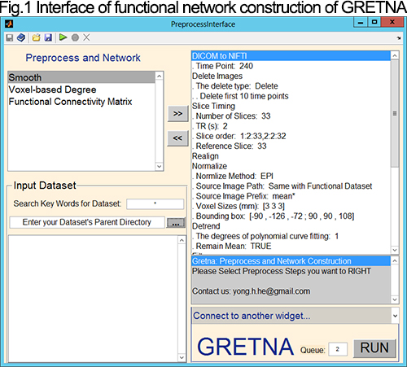

**Fig 2. Interface of network analysis of GRETNA**

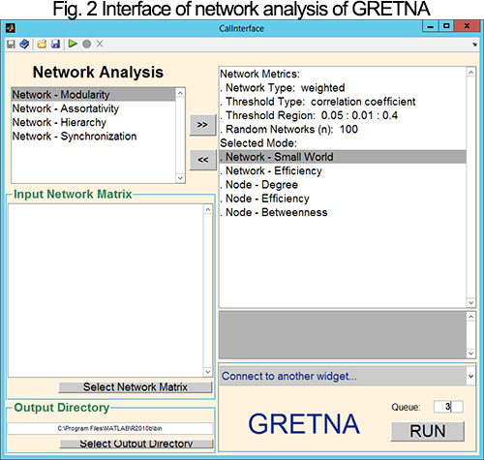

**Fig 3. Main window of BrainNet Viewer**

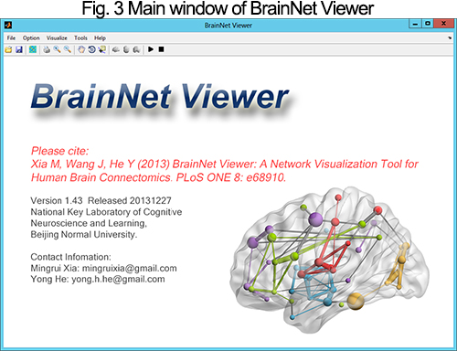

**Fig 4. Pictures generated by BrainNet Viewer**

