## WikiTube

## Asynchronous operations

Your challenge is to create the WikiTube app

UX Concept:

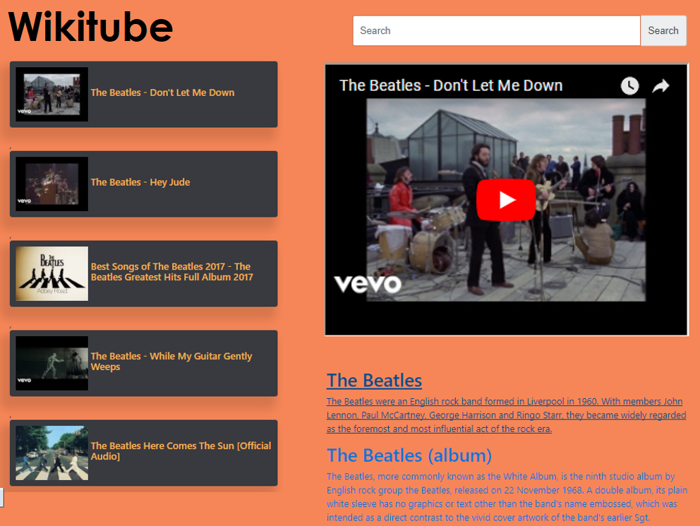

## Requirements

1. UI shall have the following fields:

* Search input
* List of videos
* Video player for the selected video
* Wikipedia results for the searched term

1. UI shall look nice and responsive
2. There shall be a default search with which the website loads
3. Videos shall be retrieved from youtube API (see instructions below)
4. When user performs a search, also show information from Wikipedia (see instructions below)

## Youtube API guidelines

1. To get API KEY, Goto: <https://console.developers.google.com/cloud-resource-manager?pli=1> follow the instructions given at the following video: <https://www.youtube.com/watch?v=SzlG5Qnjd4Y>
2. To get Youtube 5 top search results, use: `[https://www.googleapis.com/youtube/v3/search?part=snippet&videoEmbeddable=true&type=video&key=${YT_KEY}&q=${value](https://www.googleapis.com/youtube/v3/search?part=snippet&videoEmbeddable=true&type=video&key=$%7BYT_KEY%7D&q=$%7Bvalue)}`
3. Use Youtube embeded. An example can be taken from: <https://www.w3schools.com/html/html_youtube.asp>

## Wikipedia API guidelines

## Wikipedia API Url:: `[https://en.wikipedia.org/w/api.php?&origin=*&action=query&list=search&srsearch=](https://en.wikipedia.org/w/api.php?&origin=*&action=query&list=search&srsearch=)beatles&format=json`

Here is an example of the Wikipedia's output:

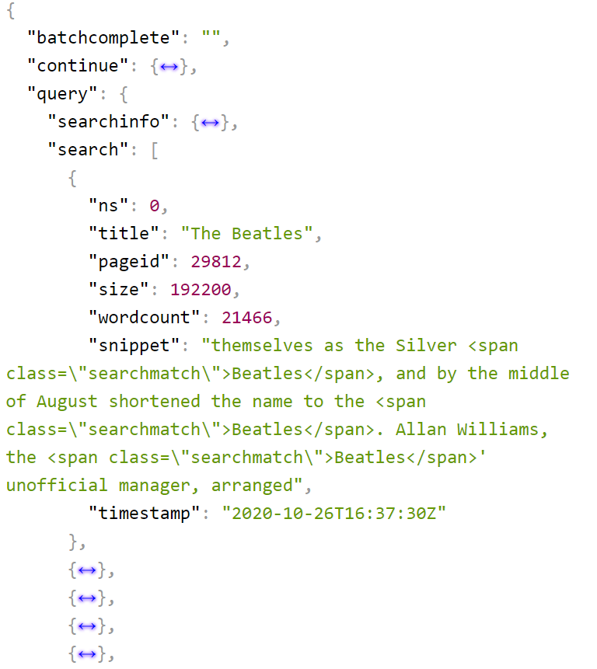

# Bonus – Modals with Promises

* Save all the terms that were searched in local storage and show them at the footer of the page, show a *Clear History* button that shows a modal to confirm deletion.
* Show a button "Change Theme" that opens a modal with <input type="color" /> and OK/Cancel buttons, and allow the user to change the background color of the page