Assessing the impact of household smoking on childhood respiratory illness
This project investigates whether children living in households with adult smokers have an increased risk of acute respiratory illness, using linked health and demographic data for approximately 200,000 children aged 0–17 years in BNSSG, connected to household-level adult data via unique property reference numbers. The use of UPRN enabled analysis of environmental and social context alongside clinical history.
Severe respiratory disease is a substantial burden on health services worldwide and is a leading cause of hospital admission in young children (Nair et al., 2013). Asthma admissions are increasing (figure 1), with Bristol rates higher than the England average (OHID, 2026).

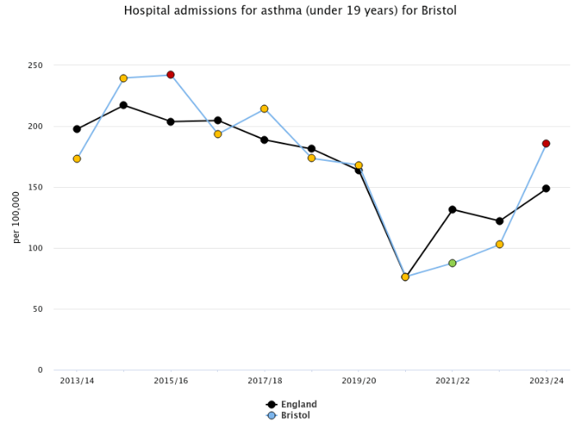
Figure 2: Bristol asthma admissions upward trend (OHID, 2026)
Second-hand smoke exposure is associated with increased risk of asthma and acute respiratory symptoms (ASH, 2020). Previous studies have found that acute childhood respiratory exacerbations vary by age, sex, and ethnicity (Nair et al., 2013), with a deprivation impact linked to cold homes with poor ventilation and fuel poverty (Barrett et al., 2022). Social vulnerabilities, such as being an asylum seeker or living in unstable housing, also contribute to physical health deterioration (Healthier Together, 2025).

A reproducible end-to-end analytical pipeline was implemented within a secure SQL Server environment. Data from multiple sources were extracted, linked via pseudonymised identifiers, and transformed into a denormalised analytical dataset. Event-level hospital data were aggregated to person-level, with engineered features capturing demographic, clinical, housing and social vulnerability characteristics.

ETL pipeline:

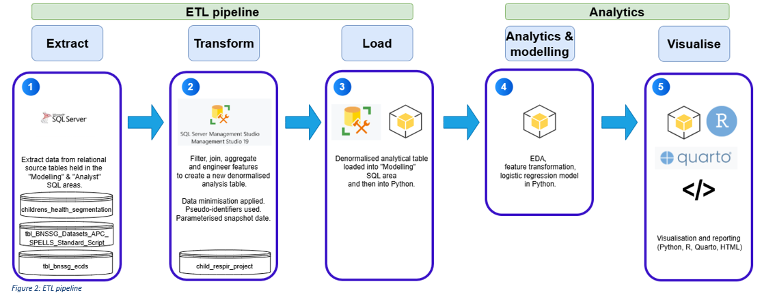

Feature engineering included creation of composite indicators (e.g. social vulnerability), binary encoding of categorical variables, and validation of data quality, completeness and multicollinearity. The resulting dataset supported robust modelling while maintaining interpretability and reproducibility.
A logistic regression model was developed to predict risk of unplanned respiratory activity. Model performance demonstrated good discrimination (AUC ≈ 0.80), with strong sensitivity to threshold selection. Techniques to address class imbalance significantly improved detection of respiratory events but increased false positives, highlighting trade-offs between recall and precision in operational use.
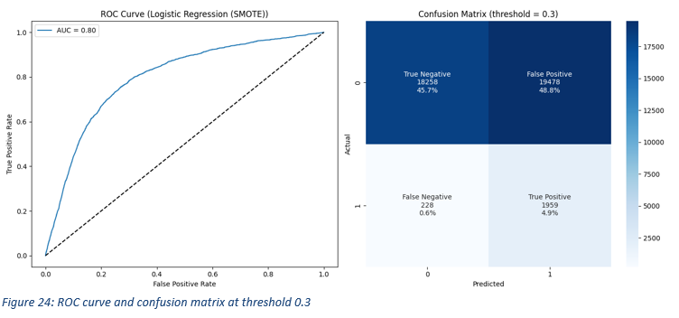

Predictor analysis showed that prior asthma diagnosis was the strongest driver of risk, alongside younger age, deprivation, social vulnerability, and demographic factors. After adjustment for these variables, household smoking was not independently associated with increased risk, indicating that broader socioeconomic and clinical factors play a dominant role within this dataset.
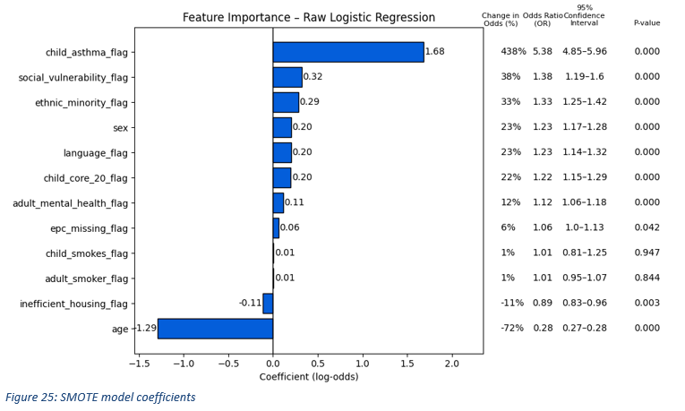

Scenario modelling demonstrated that the value of predictive analytics depends on how models are deployed. Lower classification thresholds maximise case detection but generate high volumes of false positives, leading to inefficient targeting. Higher thresholds provide a more balanced approach, enabling clinically meaningful impact without incurring additional system cost.
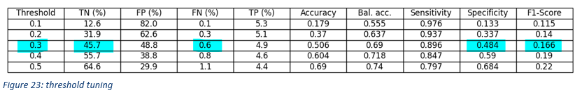
The analysis estimates that targeted interventions for children at highest risk could reduce respiratory admissions and attendances, with potential system savings of approximately £83k per annum, subject to intervention effectiveness.

Discussion & reflection
Model outputs may reflect underlying data biases and risk reinforcing existing health inequalities if used without appropriate contextual interpretation. Adult smoking correlates with deprivation, potentially confounding observed effects. Both smoking status and ethnicity data may be inconsistently recorded, introducing misclassification bias. Mitigation includes cautious interpretation.

Model associations do not imply causation. While predictors highlight risk factors, interventions should not assume causal relationships. High sensitivity increases false positives; and clinical judgment is needed to avoid unnecessary interventions.

Alternative approaches, such as random forests or gradient boosting, were considered; however, logistic regression was selected due to its interpretability, which is critical in a healthcare decision-making context.

Successful operational deployment would require clinical governance oversight, integration into existing risk stratification software, and agreement on intervention thresholds aligned with service capacity and costs.

Overall, this project demonstrates how linked data and predictive modelling can support population health management by identifying high-risk cohorts, informing targeted interventions, and enabling evidence-based commissioning decisions. It also highlights the importance of aligning analytical outputs with service.

References – impact project

ASH (2020) Secondhand Smoke, ASH. Available at: https://ash.org.uk/resources/view/secondhand-smoke (Accessed: 9 February 2026).
Barrett, C. et al. (2022) ‘Eat or heat: fuel poverty and childhood respiratory health’, The Lancet Respiratory Medicine, 10(3), p. 229. Available at: https://doi.org/10.1016/S2213-2600(21)00584-1.
Champagne, S., Phimister, E. and Macdiarmid, J. (2023) Assessing the impact of energy and fuel poverty on health: a European scoping review. - EBSCO. Available at: https://research.ebsco.com/c/daqibk/viewer/html/wtmjede565?auth-callid=d66a782b-1684-4623-81fc-80630800ac34 (Accessed: 14 January 2026).
Chatterton, T.J. et al. (2016) ‘Mapping household direct energy consumption in the United Kingdom to provide a new perspective on energy justice’, Energy Research & Social Science, 18, pp. 71–87. Available at: https://doi.org/10.1016/j.erss.2016.04.013.
Feng, Y., Miao, Y. and Turner, E. (2025) ‘Examining spatial variations in the relationship between domestic energy consumption and its driving factors using multiscale geographically weighted regression: a case study in Nottingham, England’, Energy, Sustainability and Society, 15(1), p. 24. Available at: https://doi.org/10.1186/s13705-025-00523-1.
Friends of the Earth & the and Marmot Review Team (2011) The health impacts of cold homes and fuel poverty. London: Friends of the Earth & the Marmot Review Team.
General Data Protection Regulation (2016) Regulation (EU) 2016/679 of the European Parliament and of the Council of 27 April 2016 on the protection of natural persons with regard to the processing of personal data and on the free movement of such data (United Kingdom General Data Protection Regulation) (Text with EEA relevance), https://webarchive.nationalarchives.gov.uk/eu-exit/https://eur-lex.europa.eu/legal-content/EN/TXT/?uri=CELEX:02016R0679-20160504. King’s Printer of Acts of Parliament. Available at: https://www.legislation.gov.uk/eur/2016/679/contents (Accessed: 18 March 2026).
Government Data Quality Hub (2020) The Government Data Quality Framework, GOV.UK. Available at: https://www.gov.uk/government/publications/the-government-data-quality-framework/the-government-data-quality-framework (Accessed: 2 July 2025).
Haixiang, G. et al. (2017) ‘Learning from class-imbalanced data: Review of methods and applications’, Expert Systems with Applications, 73, pp. 220–239. Available at: https://doi.org/10.1016/j.eswa.2016.12.035.
Healthier Together (2025) Needs Assessment Refugees and Asylum Seekers in BNSSG. Available at: https://www.bristol.gov.uk/files/documents/8675-jsna-needs-assessment-refugees-and-asylum-seekers-in-bnssg/file (Accessed: 4 February 2026).
Henninger, F. (2023) ‘Born-fair Data Projects Using Cookiecutter Templates’, Proceedings of the Conference on Research Data Infrastructure, 1. Available at: https://doi.org/10.52825/cordi.v1i.331.
Information Commissioner’s Office (2024) A guide to the data protection principles. ICO. Available at: https://ico.org.uk/for-organisations/uk-gdpr-guidance-and-resources/data-protection-principles/a-guide-to-the-data-protection-principles/ (Accessed: 21 July 2025).
Khemka, A. and Jain, P. (Dr ) A. (2025) ‘Optimizing Data Pipelines With AI In Cloud Environments: Best Practices For Snowflake, Azure, And Databricks’, Journal of Quantum Science and Technology, 2(2), p. Apr(569-581). Available at: https://doi.org/10.63345/jqst.v2i2.286.
Martin, J. (2021) Lean Six Sigma for the Office, 2nd Edition. Available at: https://learning.oreilly.com/library/view/lean-six-sigma/9781000356847/ (Accessed: 11 August 2025).
McKinney, W. (2022) Python for Data Analysis, 3rd Edition. Available at: https://learning.oreilly.com/library/view/python-for-data/9781098104023/ (Accessed: 12 March 2026).
Mohamad, I.B. and Usman, D. (2013) ‘Standardization and Its Effects on K-Means Clustering Algorithm’, Research Journal of Applied Sciences, Engineering and Technology, 6(17), pp. 3299–3303. Available at: https://doi.org/10.19026/rjaset.6.3638.
Nair, H. et al. (2013) ‘Global and regional burden of hospital admissions for severe acute lower respiratory infections in young children in 2010: a systematic analysis’, The Lancet, 381(9875), pp. 1380–1390. Available at: https://doi.org/10.1016/S0140-6736(12)61901-1.
OHID (2026) Fingertips | Department of Health and Social Care. Available at: https://fingertips.phe.org.uk/search/asthma%20admission#page/4/gid/1/pat/15/ati/502/are/E06000023/iid/90810/age/220/sex/4/cat/-1/ctp/-1/yrr/1/cid/4/tbm/1 (Accessed: 20 March 2026).
Rogers, P. and Limongi, R. (2025) Open Science in Three Acts: Foundations, Practice, and Implementation - Third Act. - EBSCO. BAR: Brazilian Administration Review. Available at: https://research.ebsco.com/c/daqibk/viewer/html/vw42ycp7cn (Accessed: 5 March 2026).
Santos, G. (2023) Data Wrangling with R. Available at: https://learning.oreilly.com/library/view/data-wrangling-with/9781803235400/ (Accessed: 12 February 2026).
Sethi, S. and Panda, S. (2024) ‘SQL or NoSQL—Practical Aspect and Rational behind Choosing Data Stores’, Journal of Computer and Communications, 12(8), pp. 1–20. Available at: https://doi.org/10.4236/jcc.2024.128001.
Srivastava, A. (2024) ‘Use of Python in Data Science, Data Integration and Data Engineer – IJSREM’. Available at: https://ijsrem.com/download/use-of-python-in-data-science-data-integration-and-data-engineer/ (Accessed: 16 March 2026).
Stróżyna, M. et al. (2018) ‘A framework for the quality-based selection and retrieval of open data - a use case from the maritime domain’, Electronic Markets, 28(2), pp. 219–233. Available at: https://doi.org/10.1007/s12525-017-0277-y.
Walker, D.A. and Smith, T.J. (2019) ‘Logistic Regression Under Sparse Data Conditions’, Journal of Modern Applied Statistical Methods, 18. Available at: https://doi.org/10.22237/jmasm/1604190660.

Appendix 2: impact project

Data model
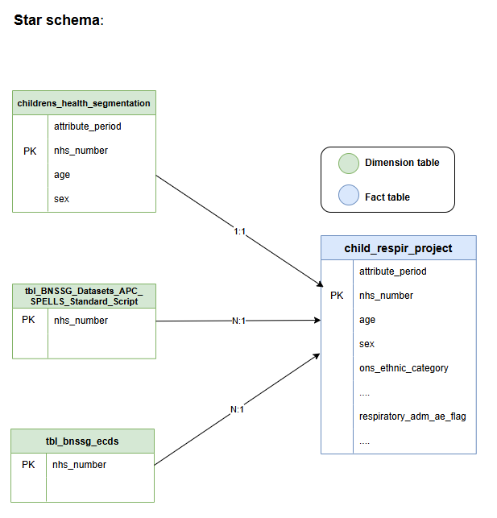

Data lineage

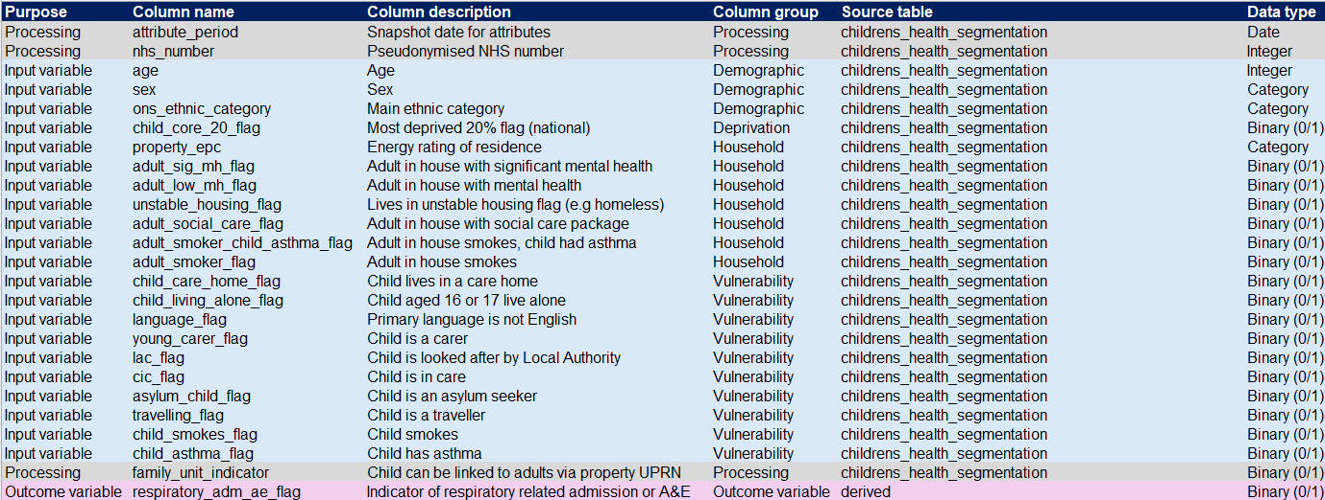

Feature transformations log
