Using Software Engineering principals to design a model that predicts 12 month diabetes diagnosis.

Project background
Type II Diabetes is largely preventable through lifestyle changes but accounts for around 10% of the annual budget (NHS England, 2025). Whilst validated tools already exist to assess the risk at individual-level, (Healthier You | NHS Diabetes Prevention Programme, 2022) given these tools require manual input and data fields not available in the local datasets this report investigates whether a population level prediction tool is viable.
The project aims to identify individuals likely to be formally diagnosed with Type II diabetes within the next 12 months, enabling targeted communication to the most at risk populations. The features used within the model were derived from Diabetes UK (Diabetes risk factors, 2025).
PyCaret, an auto machine learning package fitted the dataset to multiple algorithms. Unsurprisingly the dataset is highly imbalanced, see Figure 1, with around ~2% of undiagnosed individuals receiving a diagnosis annually, given this level imbalance the metric chosen to score the models is ROC-AUC.
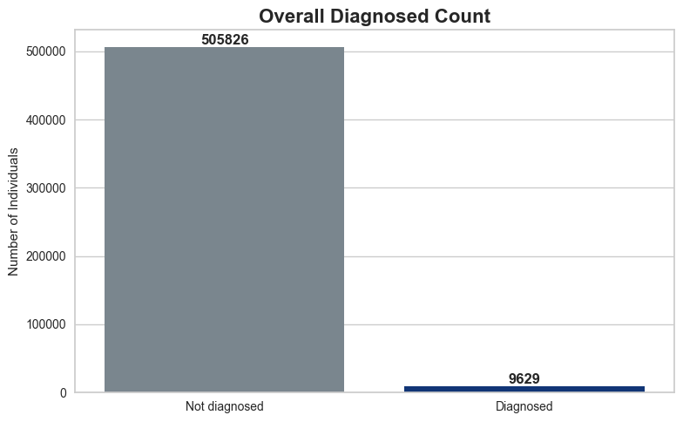
Figure 1, dataset class imbalance

Scripting structure and project methodology overview
CRISP-DM project management style was used, see Figure 2, and an iterative software engineering lifecycle adopted. This method allows for iterative movement between stages, particularly data preparation and modelling. Whilst recognising a limitation of this approach is maintaining movement towards deployment.
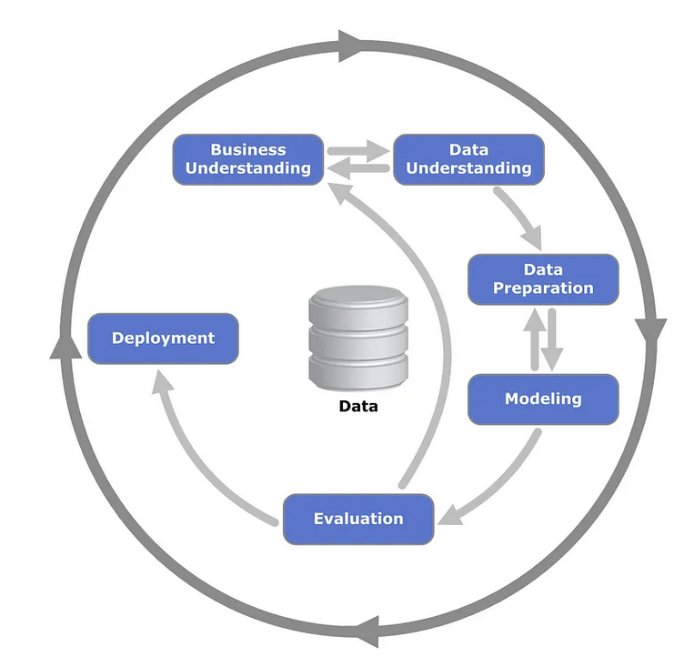
Figure 2 stages of software lifecycle (Chumbar, 2023)

Following initial modelling, the one-hot encoded ethnicity categories appeared uniformly negative. This pattern can arise where coefficients are interpreted relative to a reference category, rather than indicating all categories reduce risk in absolute terms, Figure 3. To simplify and reduce sparsity, a new derived binary feature ([is_asian_ethnicity]) was created and the performance re-evaluated using AUC.
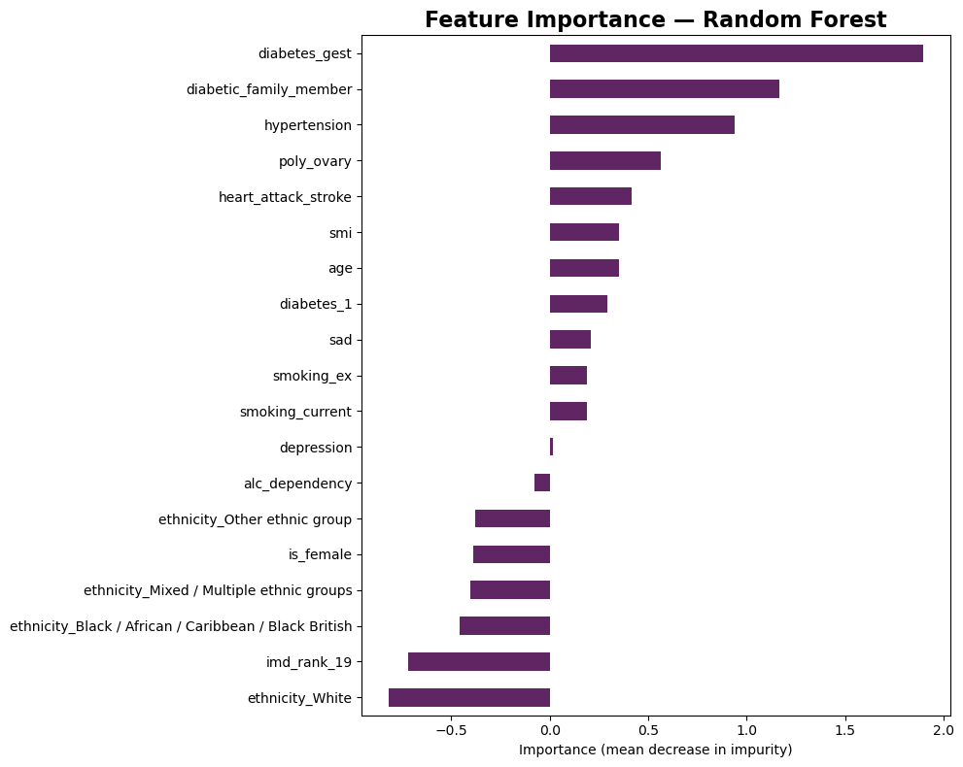
Figure 3, original output before changing approach to the use of ethnicity data

The data is stored within a secure SQL Server data warehouse, with access strictly controlled through user-level permissions, ensuring compliance with GDPR and the safeguarding of personal and sensitive data (General Data Protection Regulation (GDPR) - information and the Directory of data uses, 2026). Connection details are stored within an .env Figure 4 while data extraction is handled via a .sql script.
The relationship between these files is standardised across multiple projects, with only the contents of data_load.sql requiring modification between projects. This introduces some redundancy, sharing to a common repository such as GitHub could address the problem. However, local policy dictates neither the .venv nor .sql files can be stored there. Alternatives such as Azure Key Vault could be considered, but access is currently not available. The rest of this project is stored in a Github repository, to allow version control and to allow collaboration, however the file extensions .sql and .env are noted in the .gitignore file.
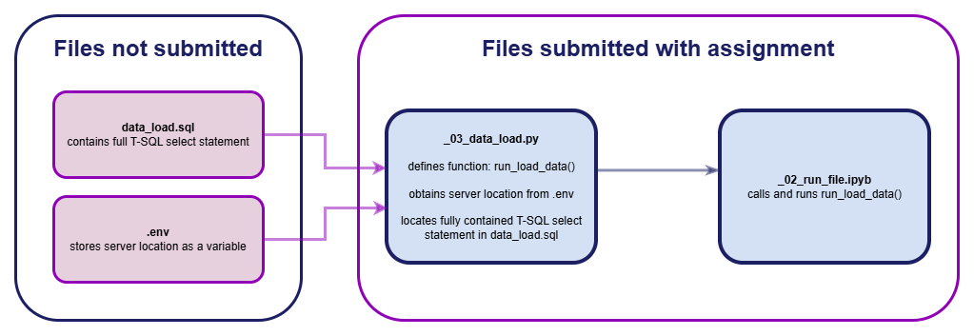
Figure 4, visualisation of the interaction between files during data loading process.

Figure 5 below is coding output from file _02_run_file.ipynb confirms 515,472 rows across 19 columns were successfully loaded.
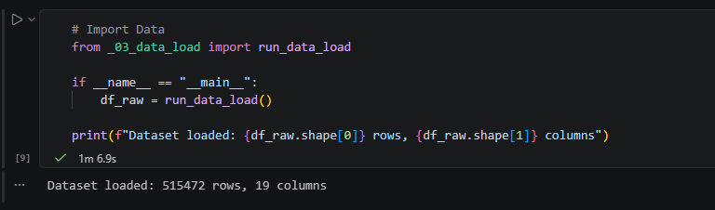
Figure 5, code chunk output showing a 515,472 rows of data across 19 columns was loaded in 1minute 7 seconds

Data Preparation
Data Understanding and Data Preparation steps were undertaken. Amongst initial investigations is the code ‘df.isna().sum()’ to understand the extent of any missing data.
Initial visualisations support feature selection. For example, Figure 6 shows the relationship between diagnosis rate per 1000 population and age with particular increase in rates around 40yrs.
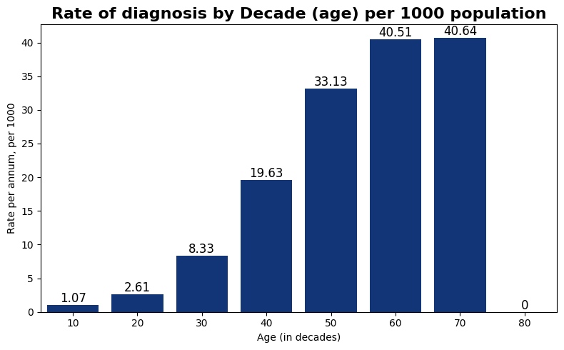
Figure 6, the relationship between age and rate showing it is not consistent between the decades with sharp increase around 40yrs

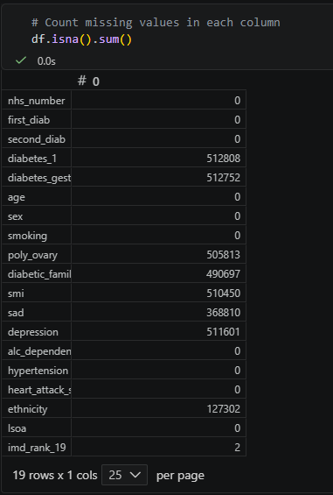
Figure 7, coding output to assess where NA values appear in data

Validation checks were implemented to confirm that transformations produced logically consistent outputs, such as ensuring missing values were appropriately handled and population counts remained stable, Figure 7. Field specific rules were applied to handle missing values, Figure 8, notably diagnosis fields recoded from null to 0, and custom functions were used instead of the existing .fillna() with defined parameters to improve code readability and maintainability. This supports future modifications, even if the underlying data source changes.
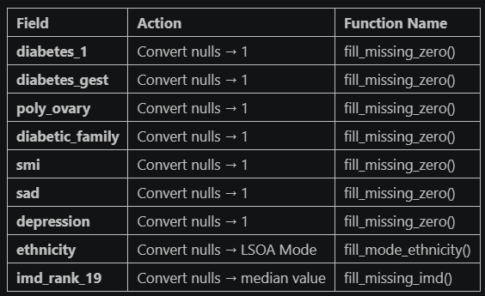
Figure 8, image from script which includes expected action and function name by field

To help keep track of the data preparation phases print statements are included in the script to give assurance that the code does not fail basic validation steps, Figure 9, this was the final ethnicity transformation and represents both the benefit of using CRISP-DM as data preparation and modelling improve data understanding but also the limitation of manual processing which relies on manual and often random investigation. An alternative could be to use auto EDA modules such as ydata_profiling which produces an interactive, methodical, report about the dataset.
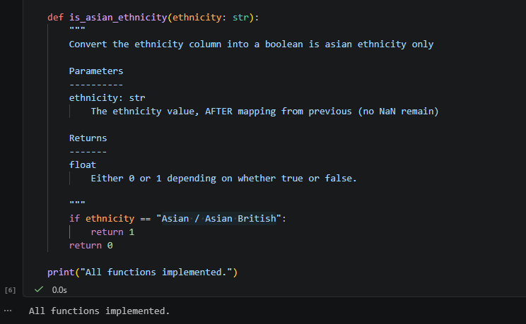
Figure 9, validation that script functions have correctly been created.

Unit tests were implemented to ensure functions behaved correctly across valid and edge-case inputs, (Khorikov, 2020).
For example, in Figure 10 within the data field ‘sex’ whilst the value is expected to be “Female” in case of future changes to procedures “female”, “F” and “f” are all included.
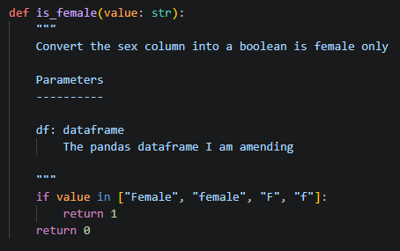
Figure 10, the inclusion of potential values should support sustainability of the code

Unit tests are applied from within a Class Function. The output will point any future users to what has failed along with confirming total tests run, failed or contain errors, Figure 11.
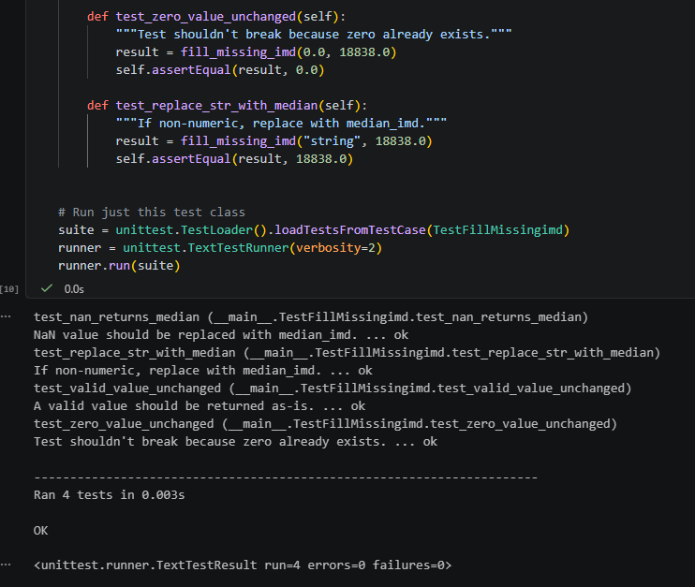
Figure 11, example from fill_missing_imd() which shows 4 tests run, with 0 errors and 0 failures.

Integration testing ensured that individual components of the data pipeline (e.g., data extraction, transformation functions, and modelling steps) worked cohesively without introducing errors. Inline checks were also applied after each transformation step, Figure 12. Relating back to the is_female function and sustainability, had the function not included “F” but a future amendment to the raw data did see “F” appear it could be spotted at this point.
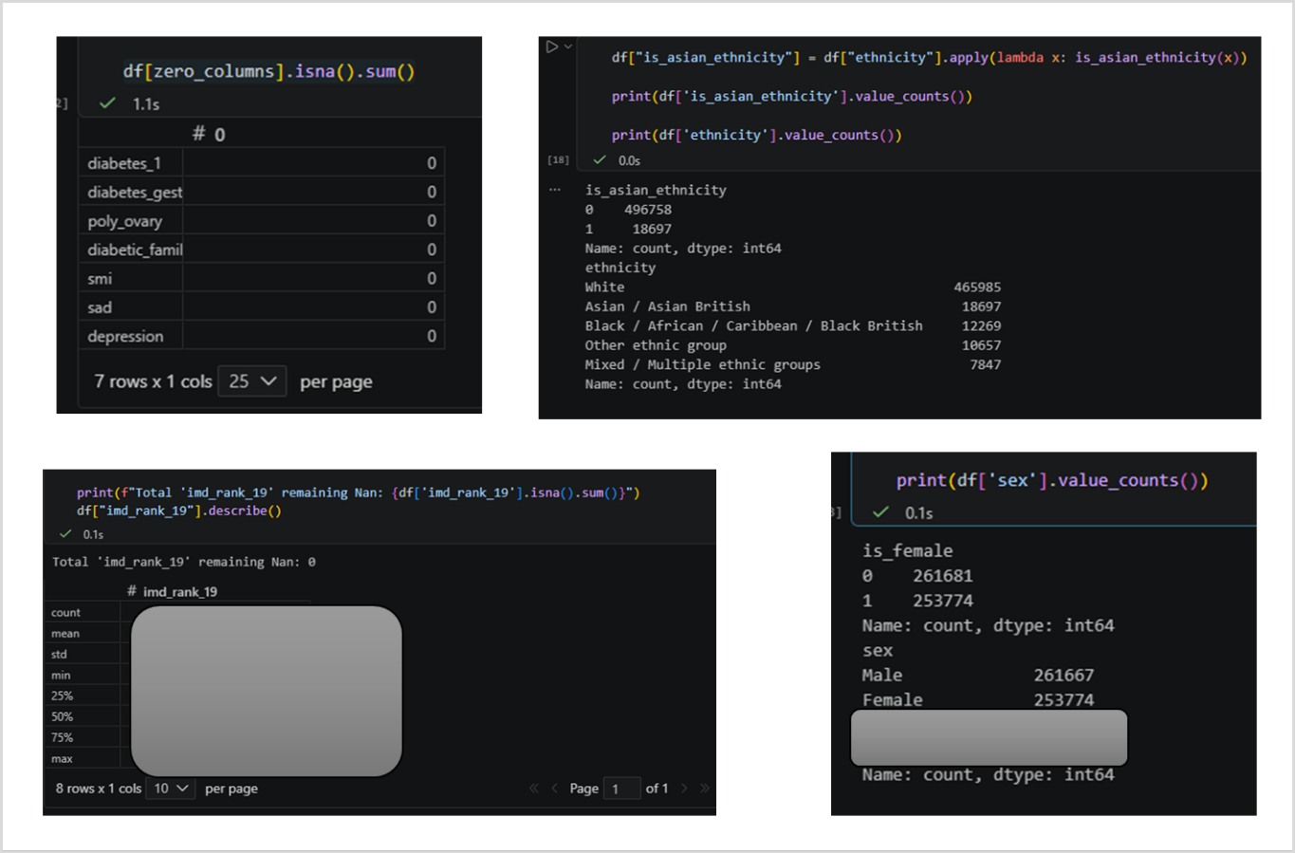
Figure 12, at the point each function is applied an inline test gives assurance that the function has been appropriately applied.

Auto Machine Learning
Auto machine learning is performed using PyCaret, enabling comparison of multiple models with minimal code, although this comes at the expense of flexibility as the models cannot be manually tuned at this stage.
The sklearn package is deployed to undertake the train – test split, importantly due to the imbalanced nature of the dataset stratify=y is selected which ensures that positive outcome variables exist in equal proportions in both sets, Figure 13
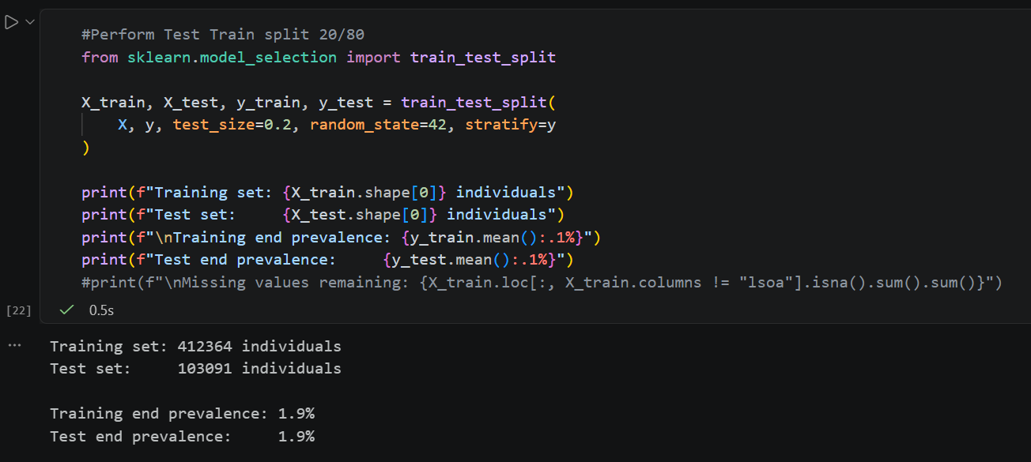
Figure 13, train test split, followed by check on prevalence

Final transformations include MinMaxScaler which is fitted on the training dataset only, with the same transformation applied to the test dataset avoiding data leakage. However, any values in the test dataset which are out-of-range will require the model to extrapolate, the risk is minimal due to the stable nature of both age and imd_rank_19 features.
Within PyCaret model metrics are sorted by the ‘AUC’ value, which provides a common evaluation framework by ranking ability of predicted scores rather than relying on fixed class assignments(Hancock, Khoshgoftaar and Johnson, 2023). The selection of this metric is known to potentially penalise models like K Neighbours Classifier which is accepted as a limitation of the metric. To help with interpretation the output is both printed on screen and saved to an excel file and below in Figure 14.
Figure 14, output from PyCaret model, table sorted by AUC

As identified in Figure 14, logistic regression is the best performing algorithm. Whilst a lot of the scores are fairly similar locally the business stakeholders are very familiar with logistic regression models and outputs. Using a supervised learning model is well suited to the target audience.
However, as with all machine learning models there are many leavers to tweak so a distinct Logistic Regression model was created using a pipeline-based method. Whilst precision is particularly low, Figure 15, this potentially reflects the nature of undiagnosed disease and is an acceptable trade-off to the business. The AUC value of 0.789 is particularly strong indication that the model is working appropriately and supports the use of Diabetes UK to identify features. However, this dataset was not created for this purpose. In particular diabetic_family_member is of unknown source and the coverage of the feature is unknown, data inaccuracies within this field could introduce noise to any model.
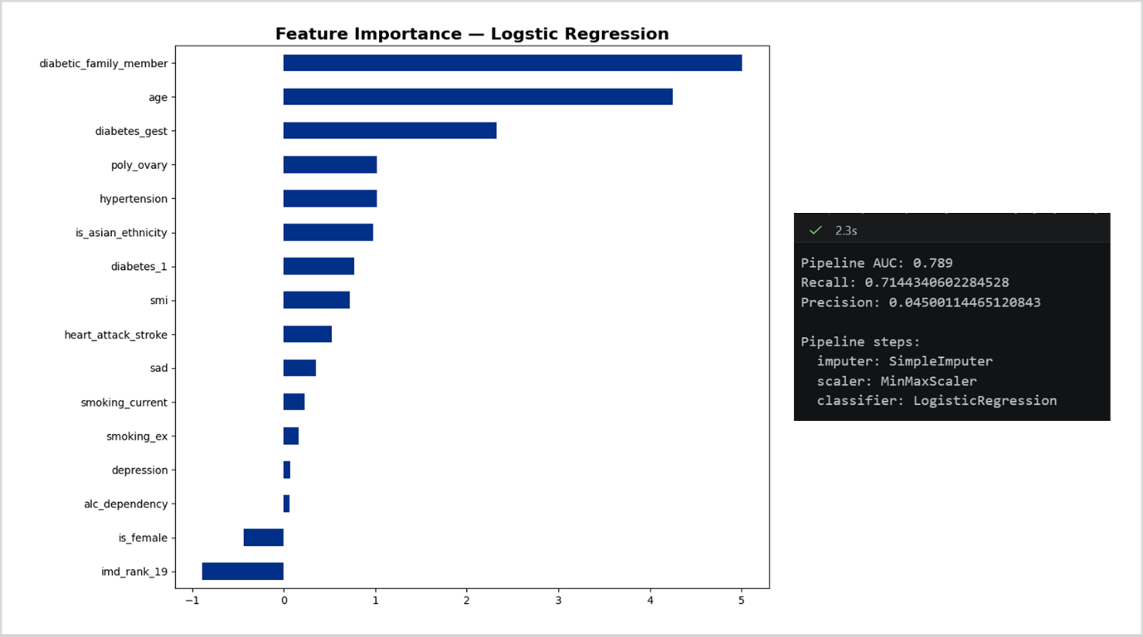
Figure 16, Feature importance and script outputs from pipeline.

The model fitted would enable targeted communication, compared to contacting the whole undiagnosed population this model could save 72,514 communications. Although false positives remain (~29k), this is acceptable given low intervention cost and the likelihood of undiagnosed cases.
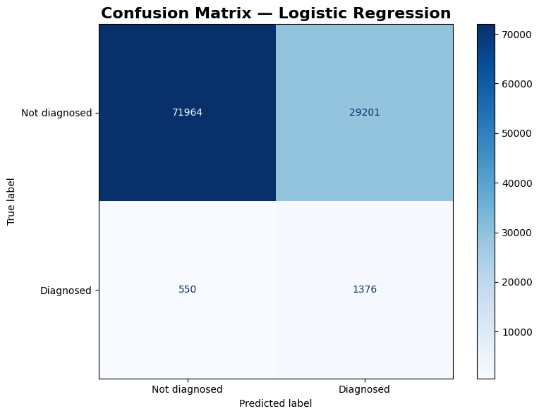
Figure 16, Confusion Matrix for final logistic regression model

Reflection
Whilst package control is a known weakness of Python compared to R, the absence of locally established Python practices within the wider analytical teams presents a potential barrier to wider adoption and knowledge sharing. Highlighting the importance of aligning software choices not only by technical capability, but also with local policy and preference.
The circular nature of the coding method meant that whilst scope and objectives did not need to be rigidly defined at project initiation, it did make sticking to software coding principals challenging. In particular the creation of testing, initially it was felt all testing could take place within a defined unit testing section and carried out through application of class and functions. In reality different tests, such as integration tests after application of transformation functions and of course validation checks carried out when data is first loaded into the environment.
Overall the model performed well, with AUC of 0.789, successfully identifying a small population for targeted intervention despite high false positive rates. Next steps could include investigating how many false positives receive a diagnosis at a later date and the exploration of whether a ranked probability score could further isolate the most at risk population for enhanced support.

Referencing
Chumbar, S. (2023) ‘The CRISP-DM Process: A Comprehensive Guide’, Medium, 24 September. Available at: https://medium.com/@shawn.chumbar/the-crisp-dm-process-a-comprehensive-guide-4d893aecb151 (Accessed: 19 March 2026).
Diabetes risk factors (2025) Diabetes UK. Available at: https://www.diabetes.org.uk/about-diabetes/type-2-diabetes/diabetes-risk-factors (Accessed: 19 March 2026).
General Data Protection Regulation (GDPR) - information and the Directory of data uses (2026) NHS England Digital. Available at: https://digital.nhs.uk/data-and-information/keeping-data-safe-and-benefitting-the-public/gdpr (Accessed: 7 May 2026).
Hancock, J.T., Khoshgoftaar, T.M. and Johnson, J.M. (2023) ‘Evaluating classifier performance with highly imbalanced Big Data’, Journal of Big Data, 10(1), p. 42. Available at: https://doi.org/10.1186/s40537-023-00724-5.
Healthier You | NHS Diabetes Prevention Programme (2022). Available at: https://preventing-diabetes.co.uk/ (Accessed: 6 May 2026).
Khorikov, V. (2020) Unit Testing Principles, Practices, and Patterns. Simon and Schuster.
NHS England (2025) ‘NHS England » NHS Diabetes Prevention Programme (NHS DPP)’, 11 November. Available at: https://www.england.nhs.uk/diabetes/diabetes-prevention/ (Accessed: 6 May 2026).

