Unet Predicted Masks 1 Epoch
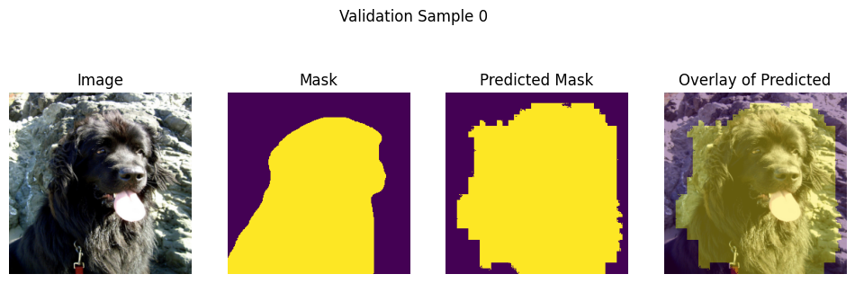
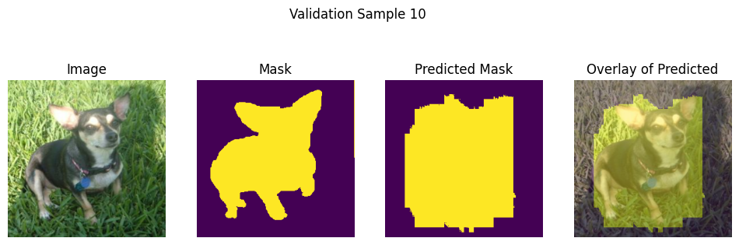
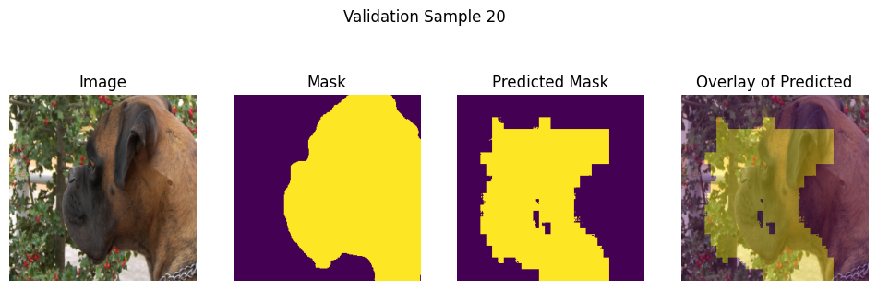
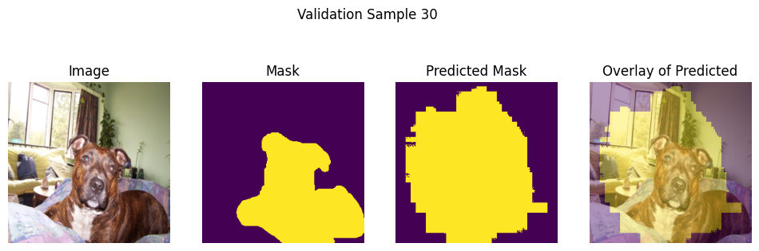
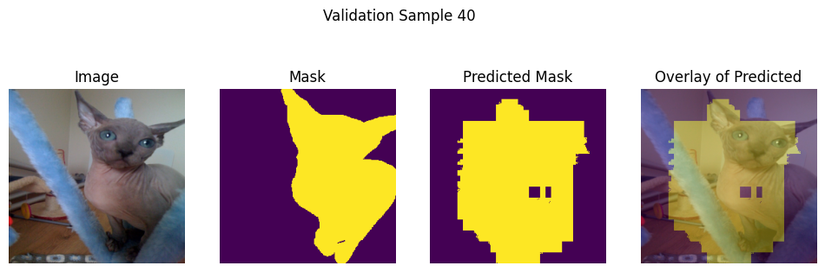
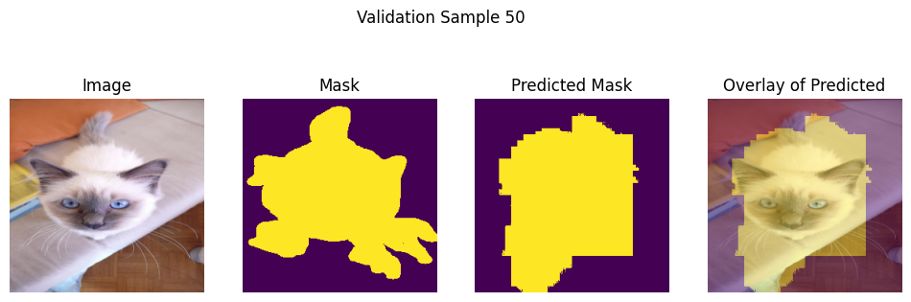
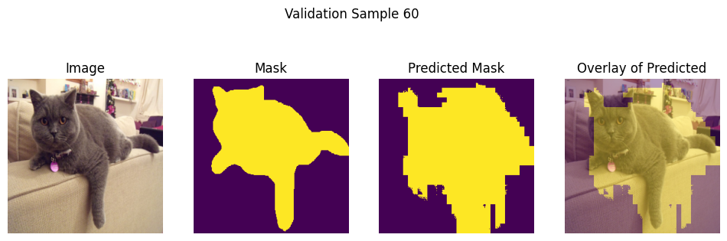
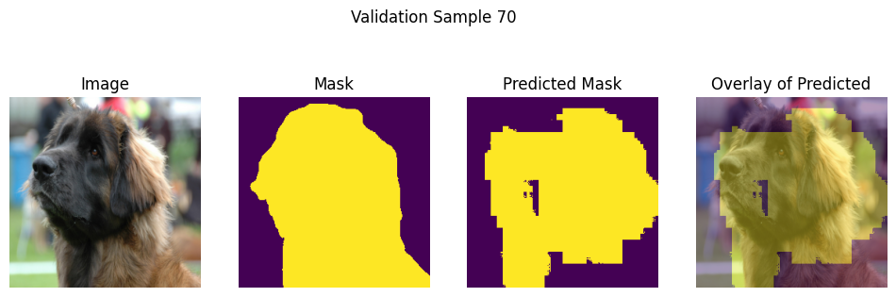
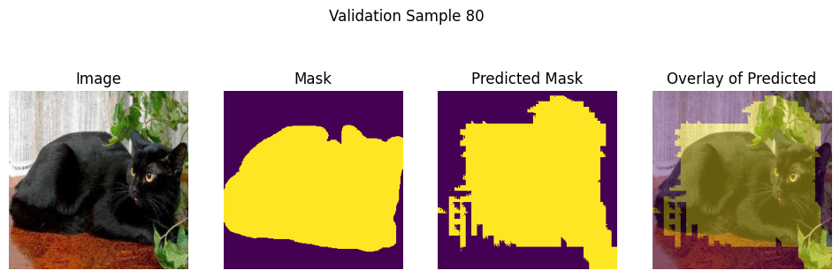
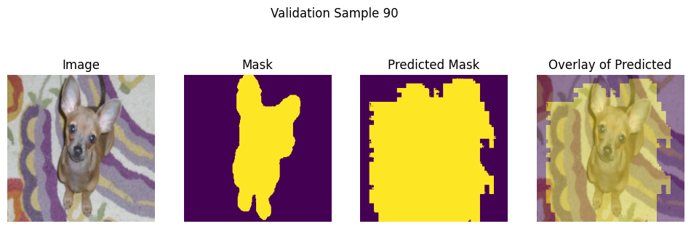
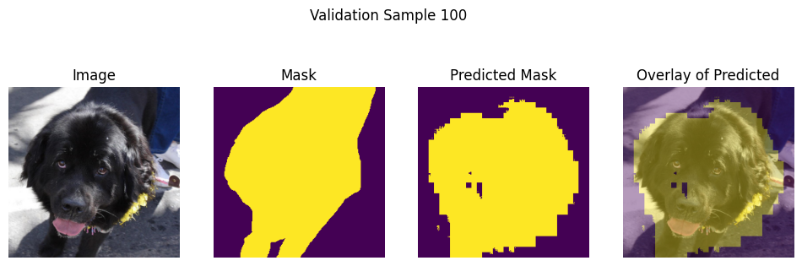

Unet Loss Graph 1 Epoch
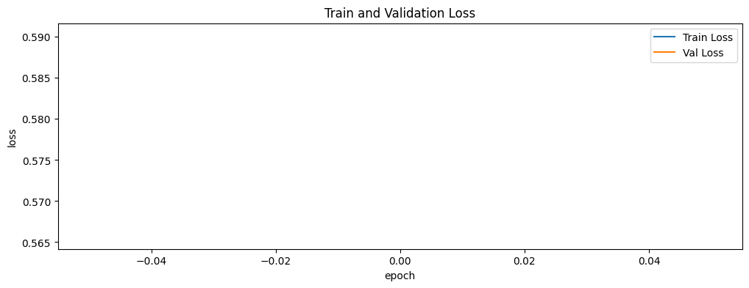

Unet Predicted Masks 10 Epoch
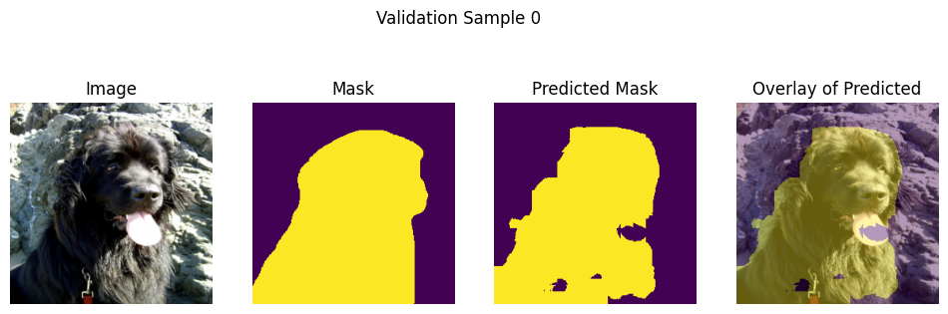
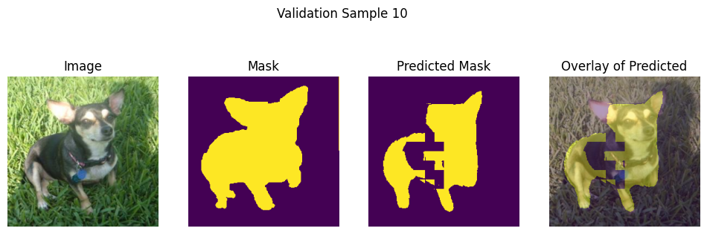
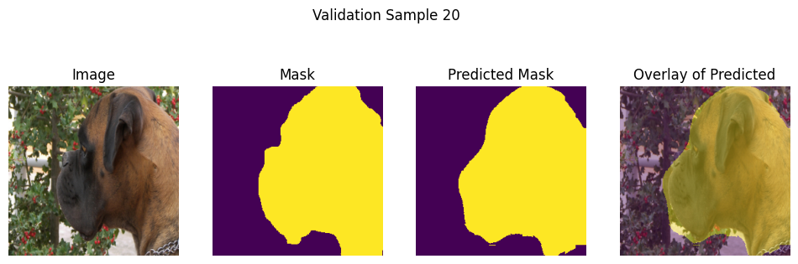
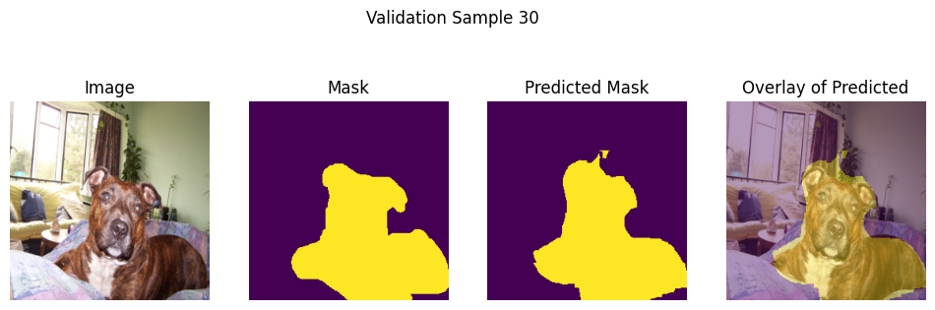
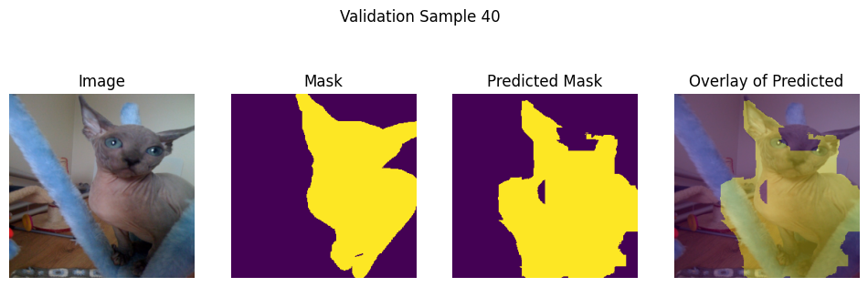
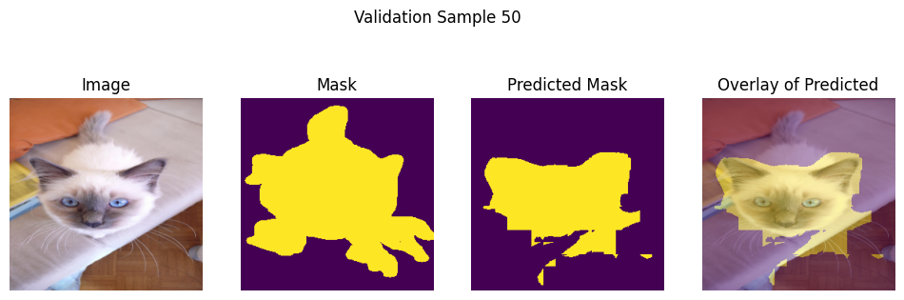
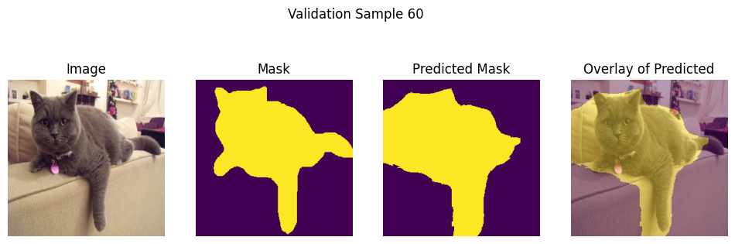
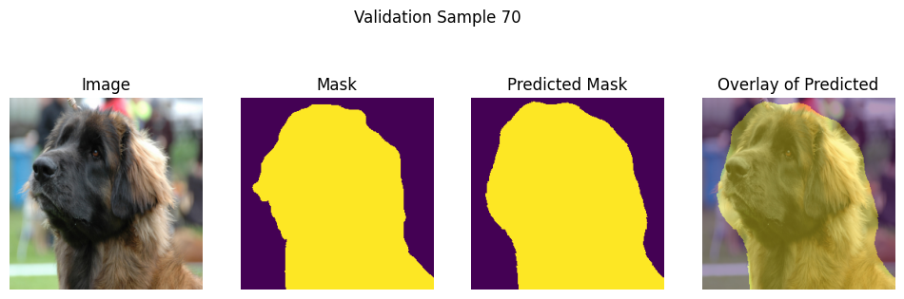
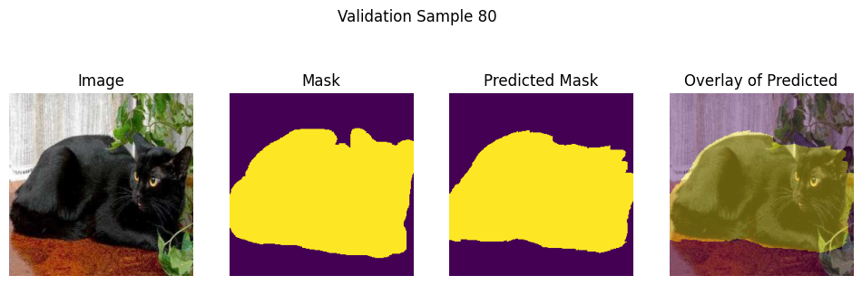
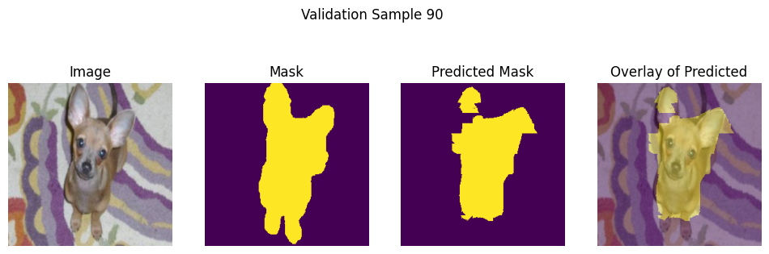
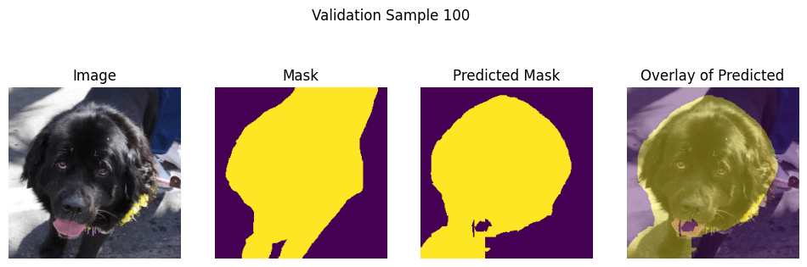

Unet Loss Graph 10 Epoch
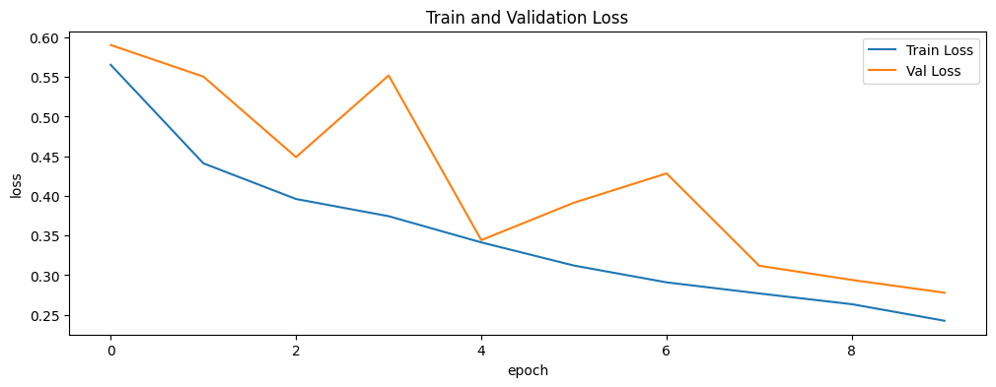

Unet Predicted Masks 25 Epoch
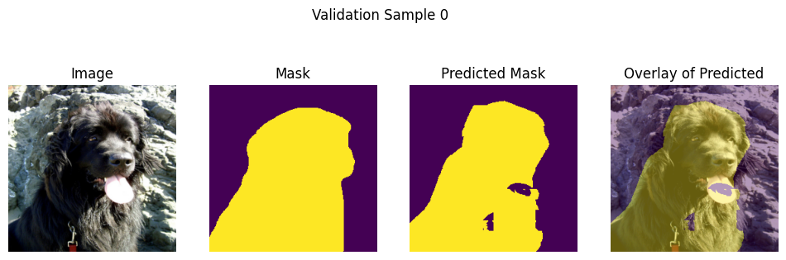
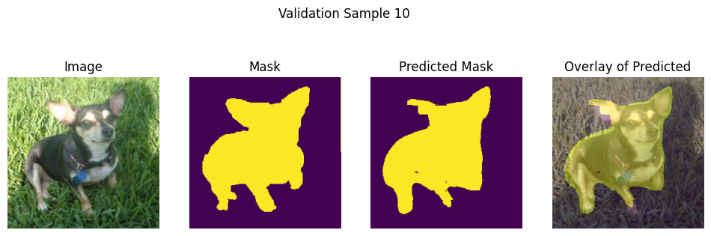
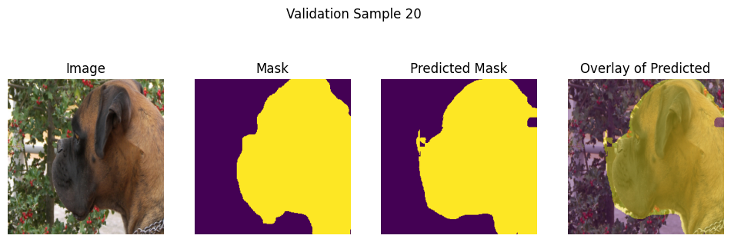
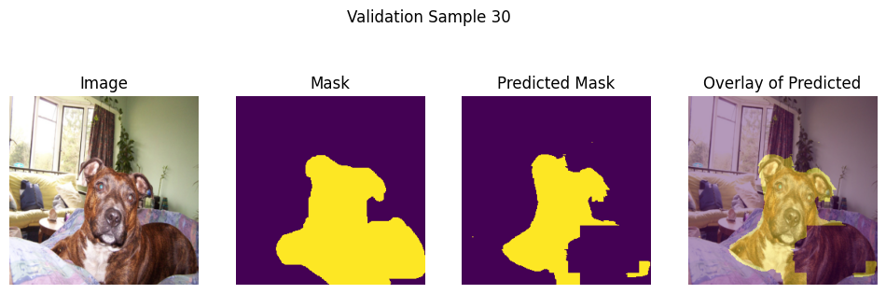
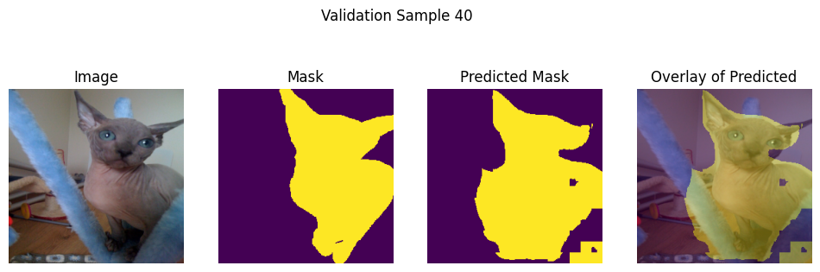
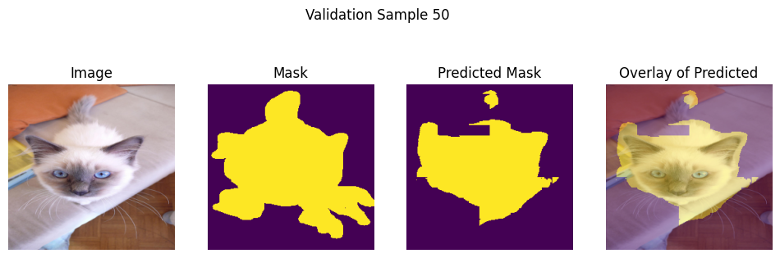
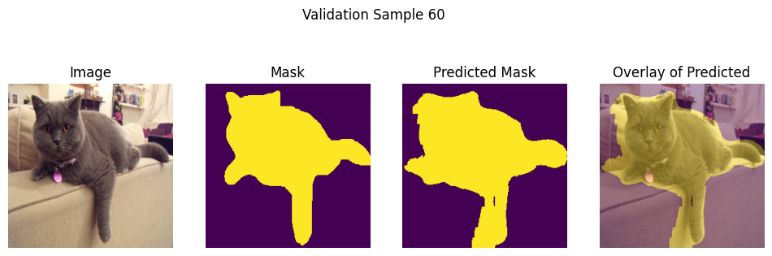
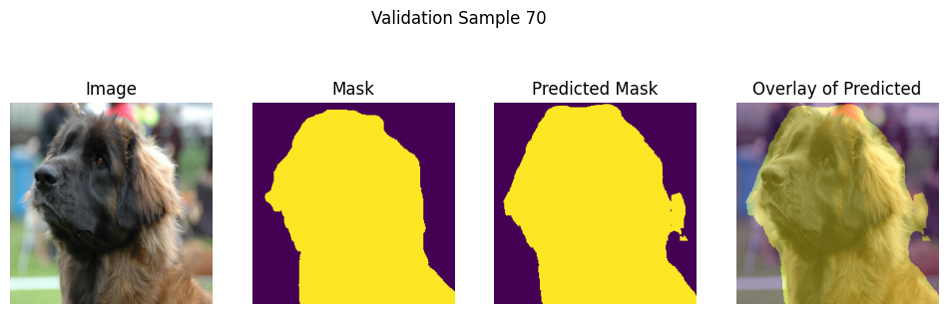
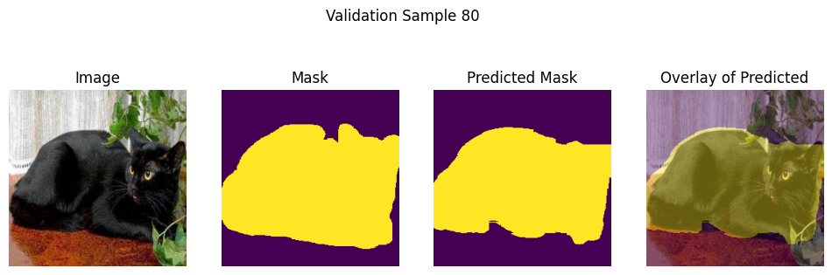
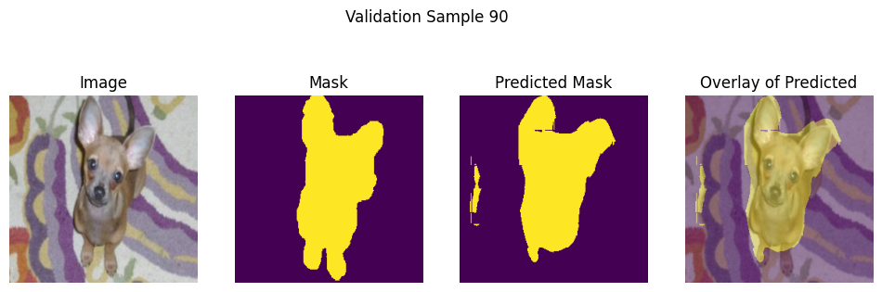
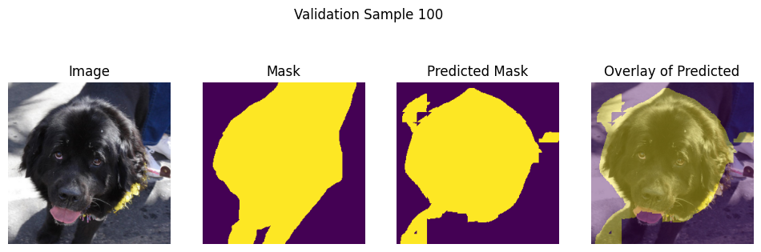

Unet Loss Graph 25 Epoch


