Higher LR and lower Weight decay

IMG_SIZE = 256
BATCH_SIZE = 128
VAL_SPLIT = 0.20
EPOCHS = 10
LR = 0.1
MOMENTUM = 0.9
WEIGHT_DECAY = 1e-2
PATIENCE = 4
ES_MIN_DELTA = 0.001

NUM_CLASSES = 2

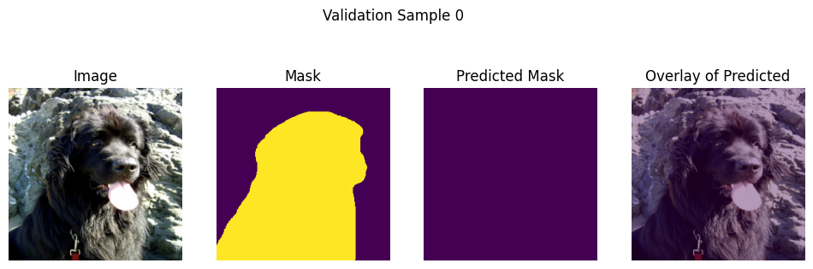
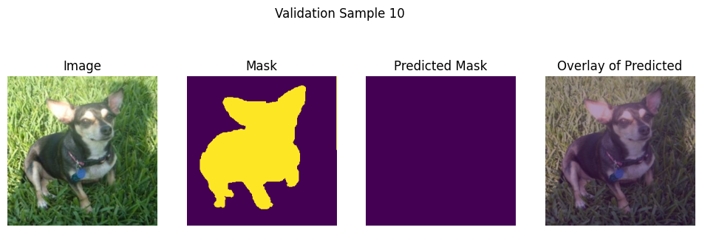
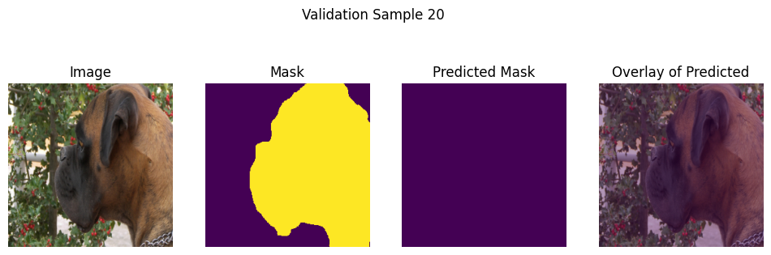
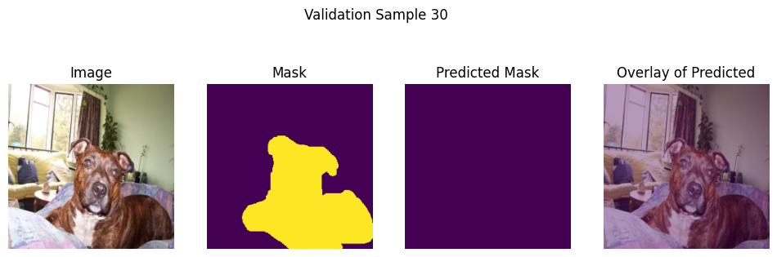
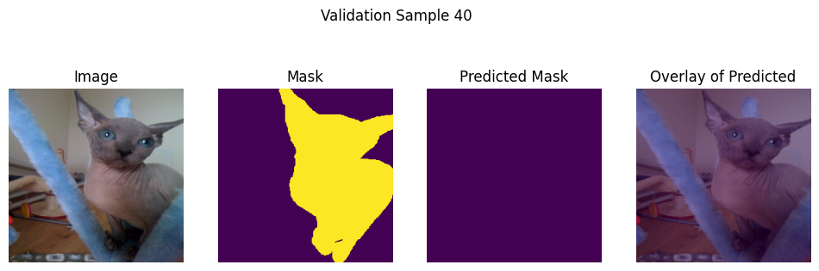
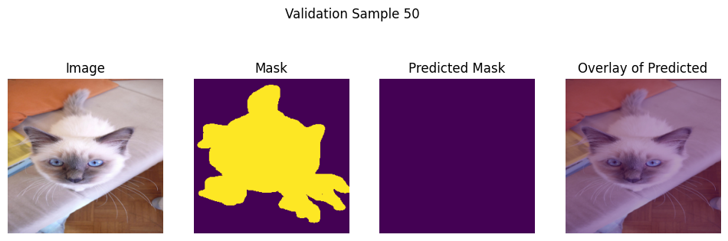
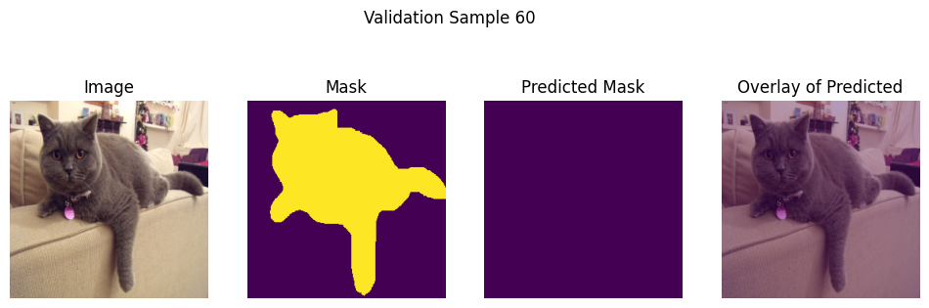
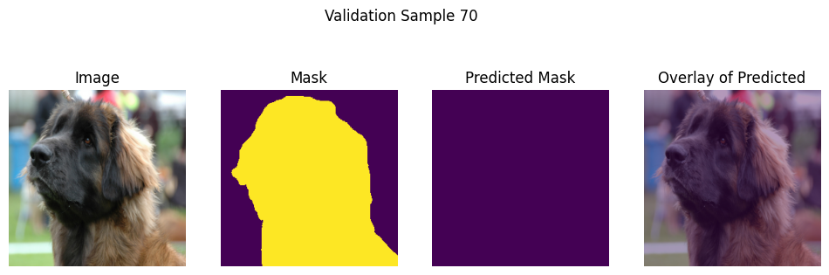
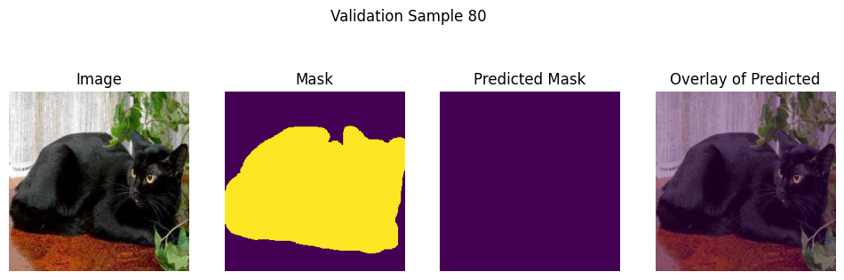
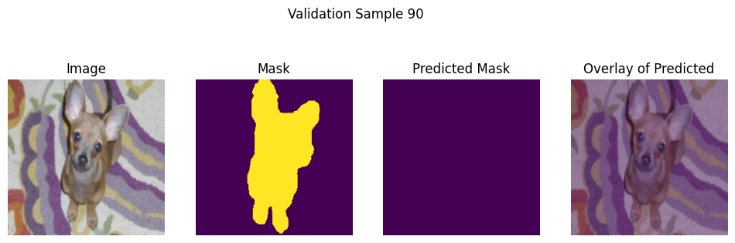
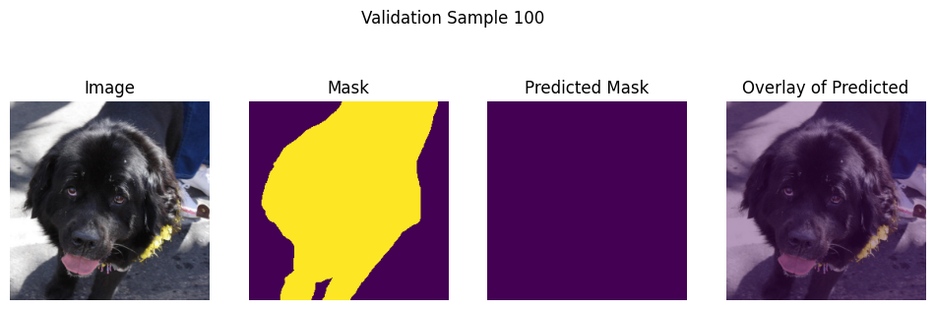

Lower LR

IMG_SIZE = 256
BATCH_SIZE = 128
VAL_SPLIT = 0.20
EPOCHS = 10
LR = 0.0001
MOMENTUM = 0.9999
WEIGHT_DECAY = 1e-6
PATIENCE = 4
ES_MIN_DELTA = 0.001

NUM_CLASSES = 2

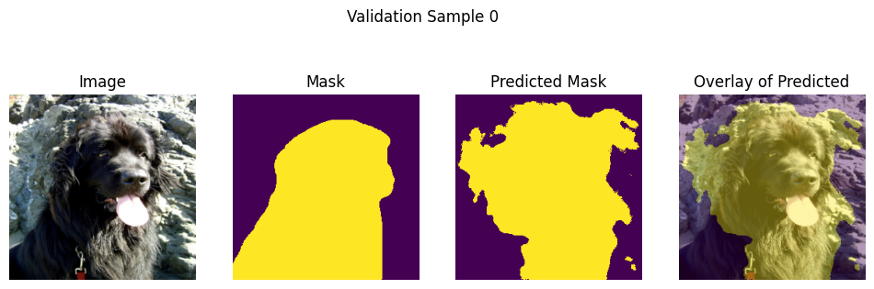
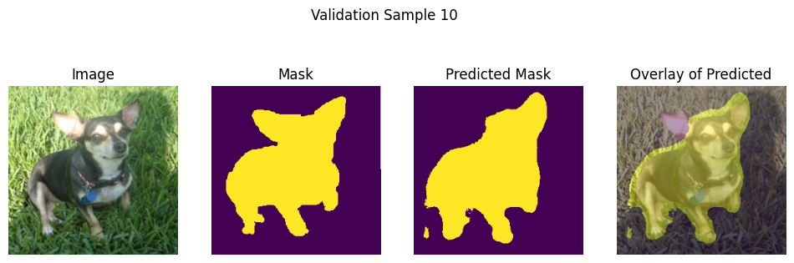
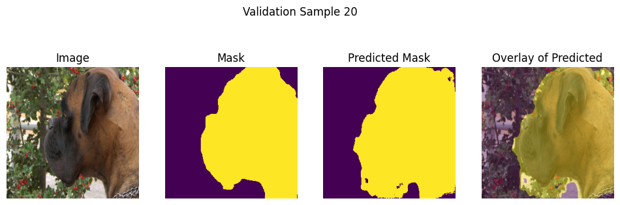
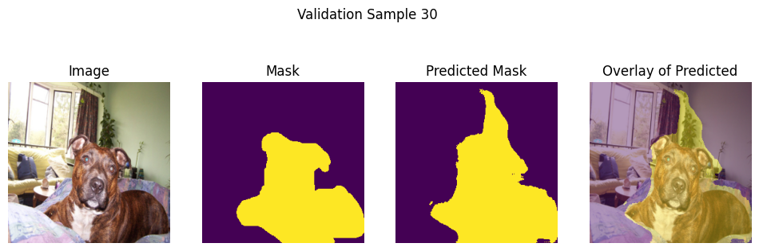
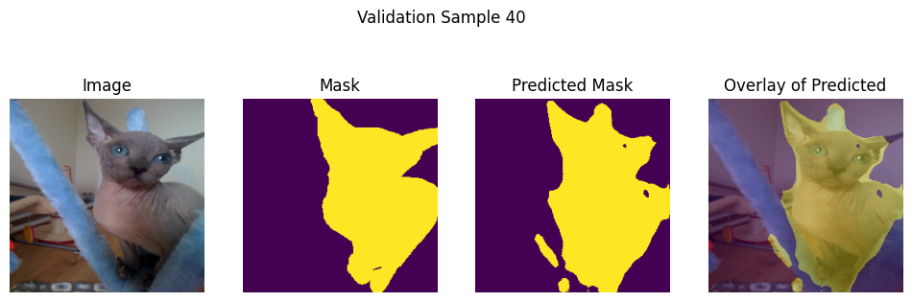
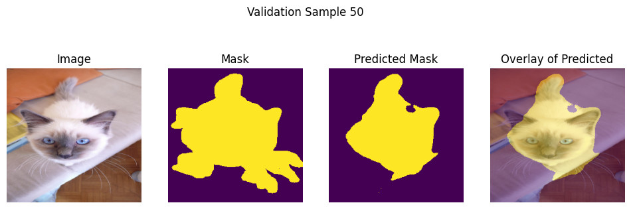
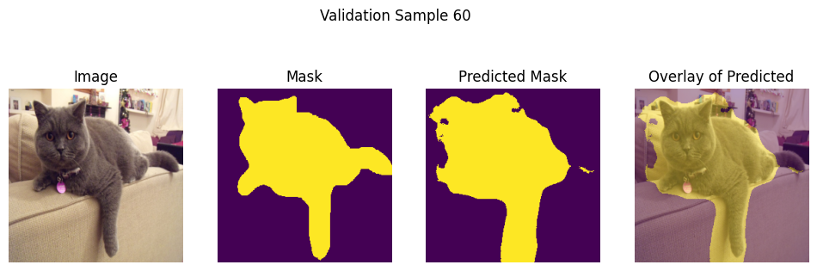
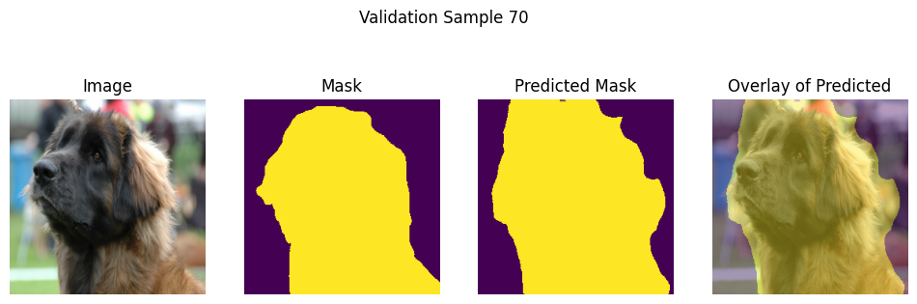
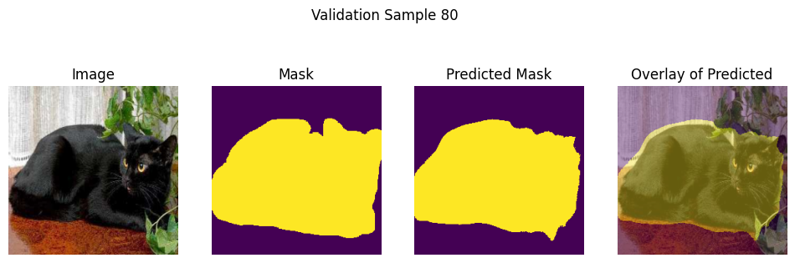
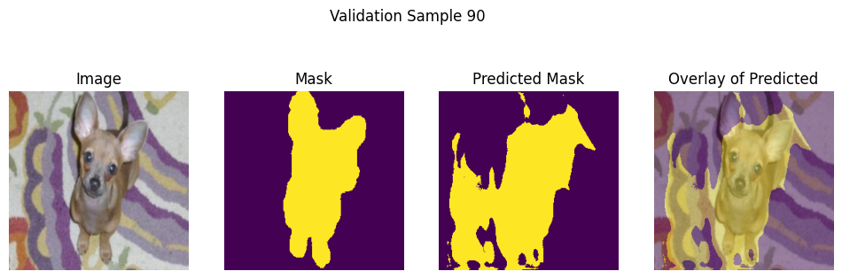
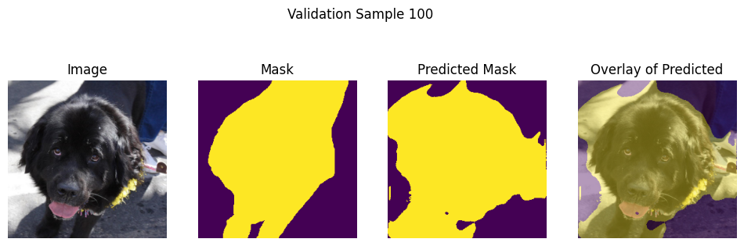

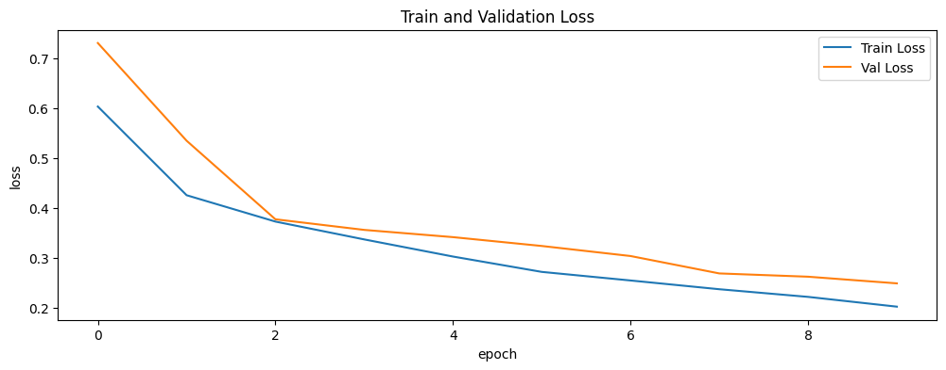

Adagrad optimizer

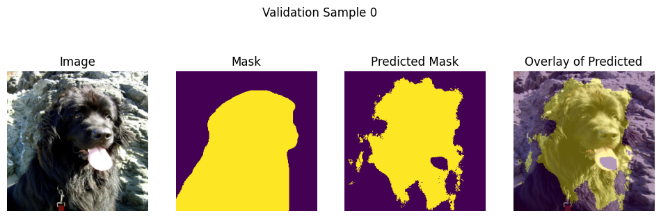
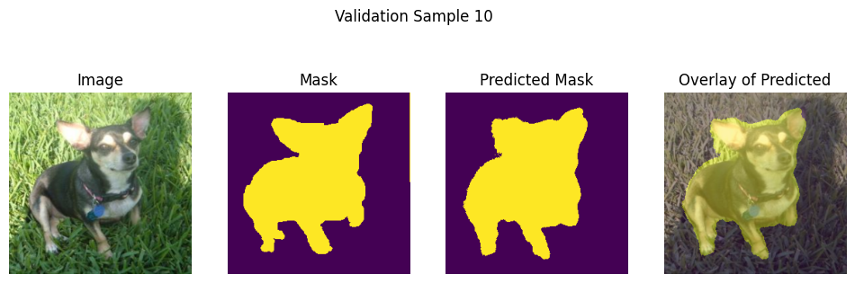
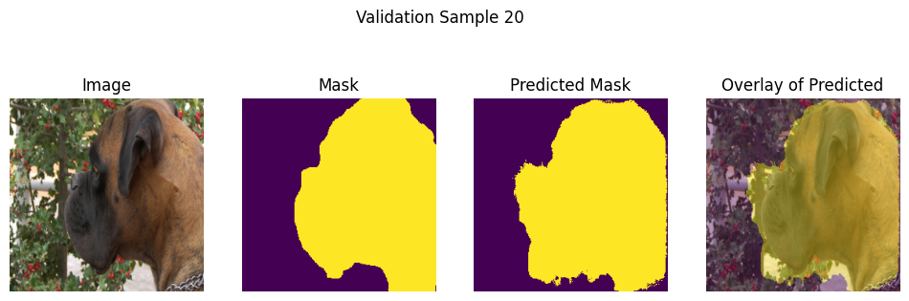
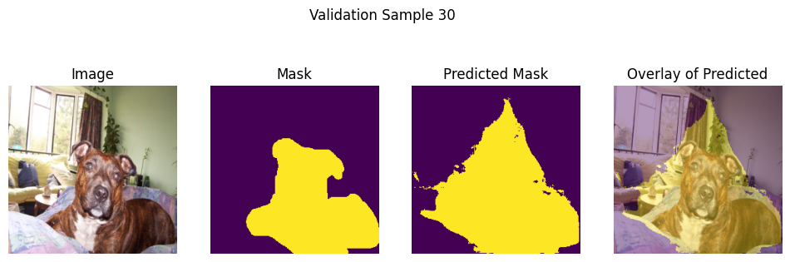
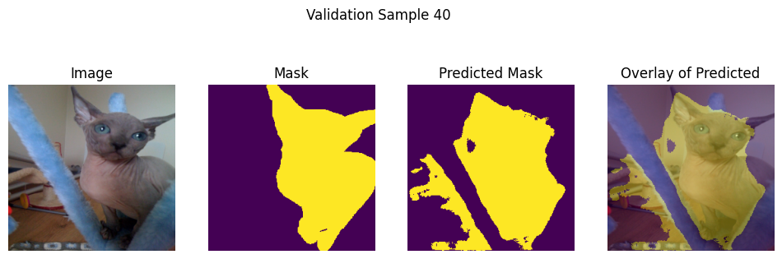
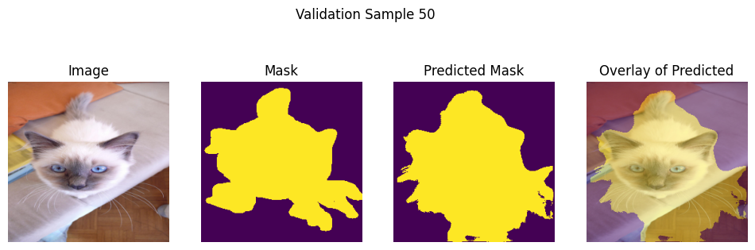
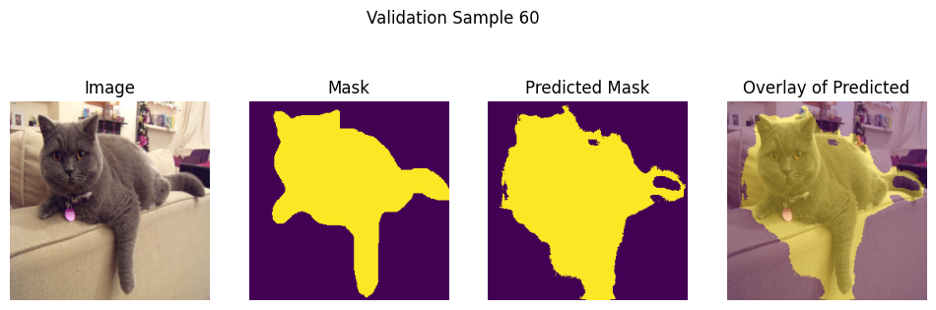
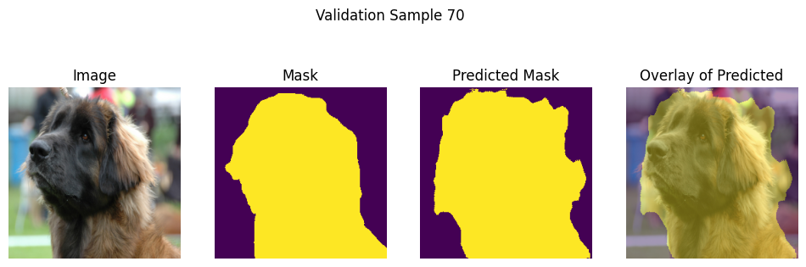
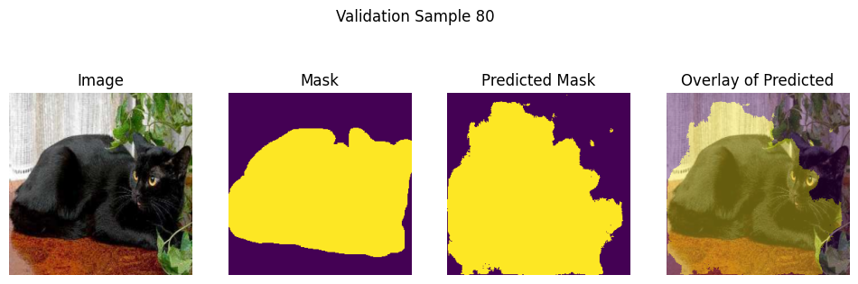
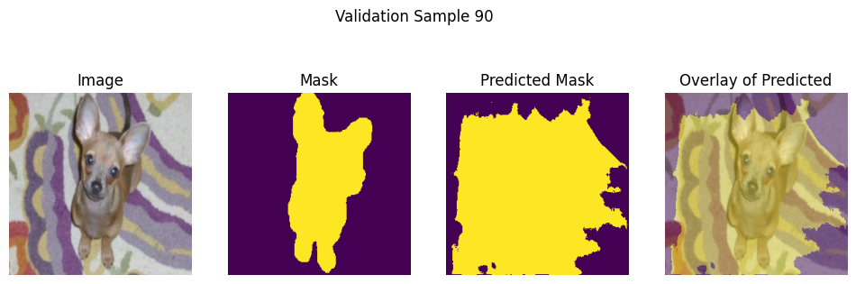
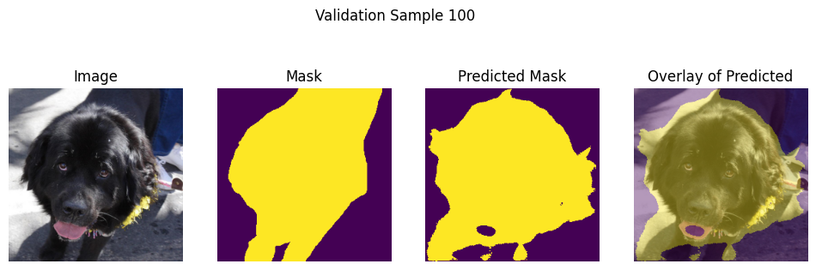

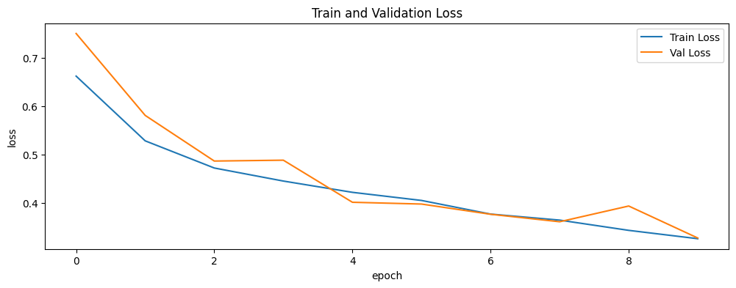

Gradient Scaler
scaler = torch.amp.GradScaler(growth_factor= 5.0,backoff_factor= 0.15,enabled=(device.type=="cuda"))

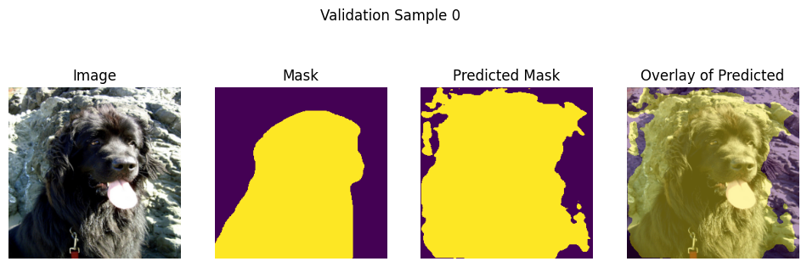
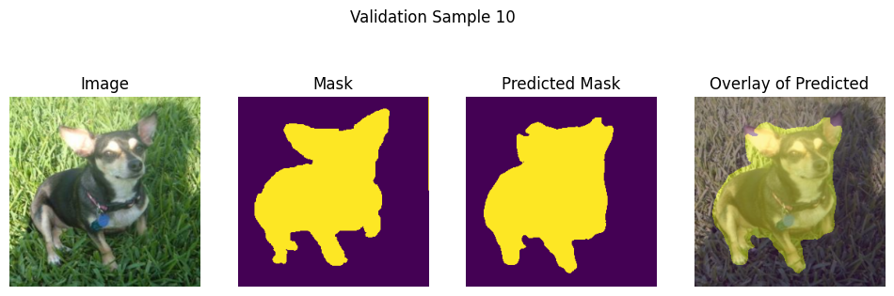
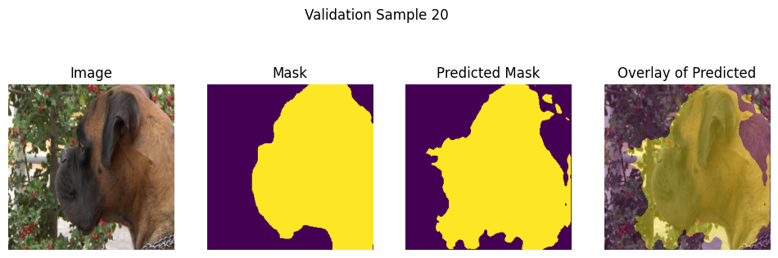
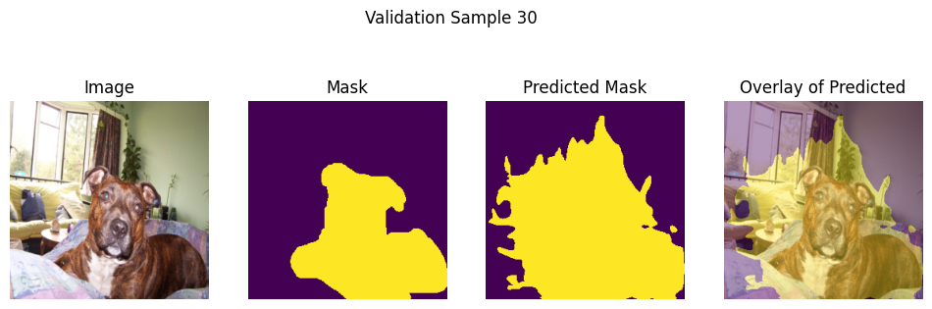
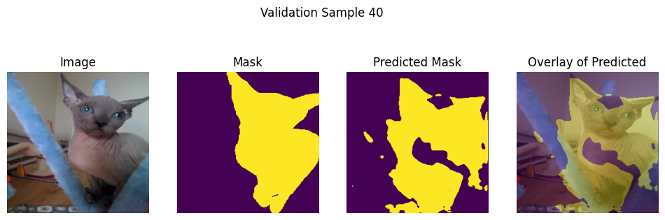
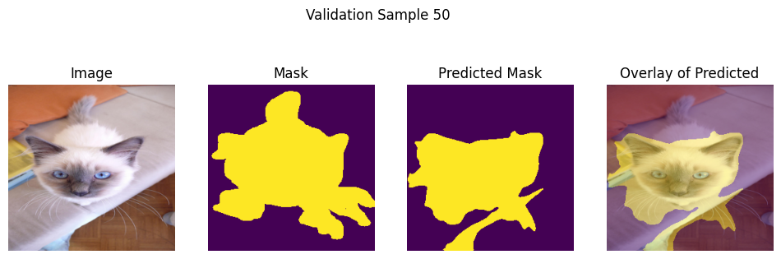
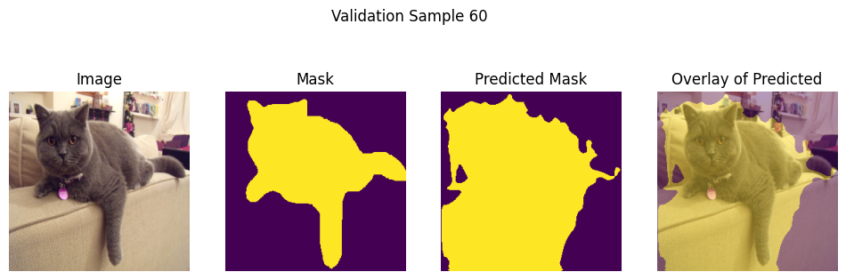
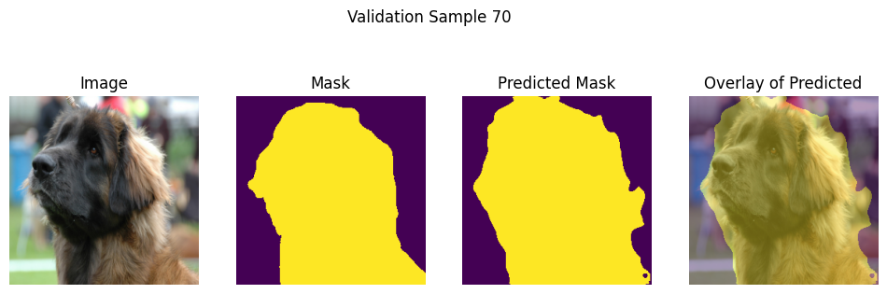
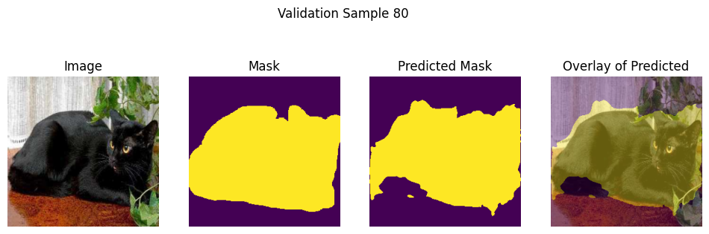
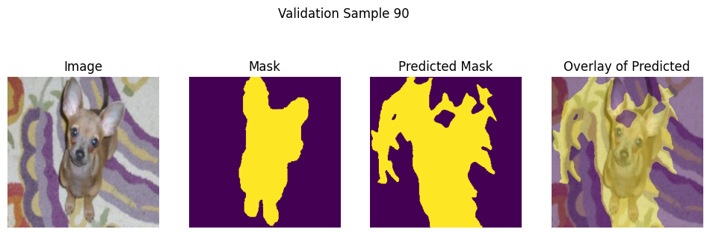
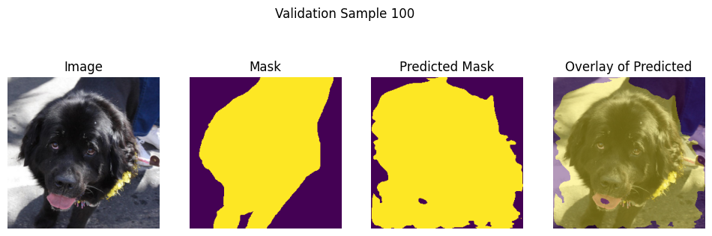

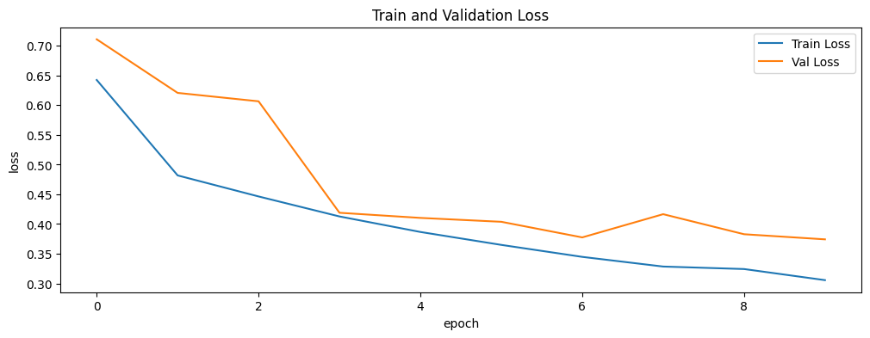

Jaccard Loss as criterion



