Higher LR and Weight Decay

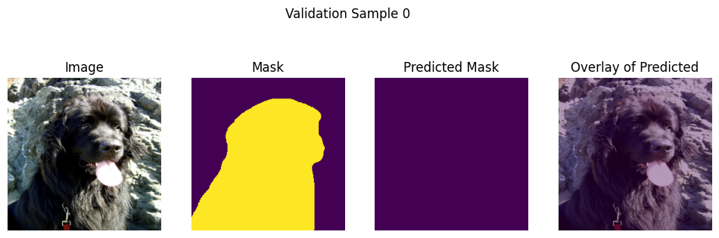
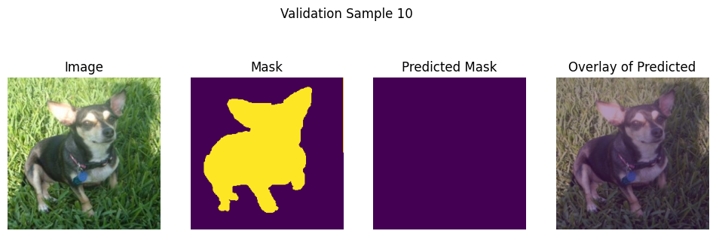
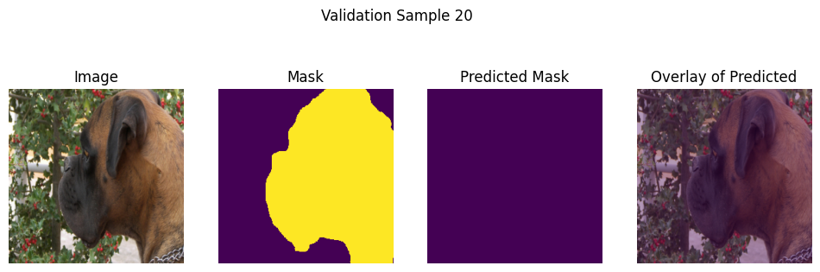
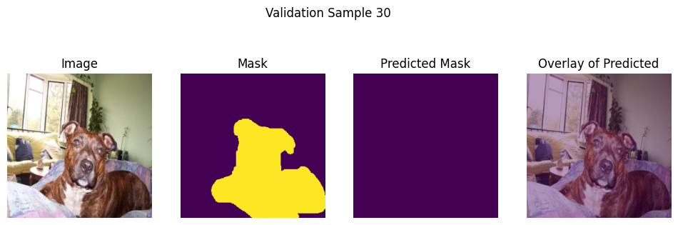
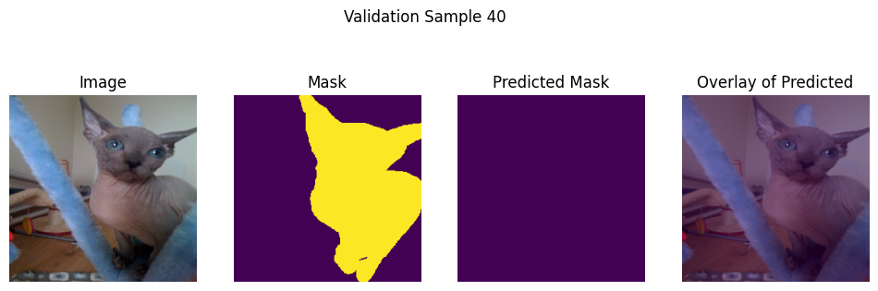
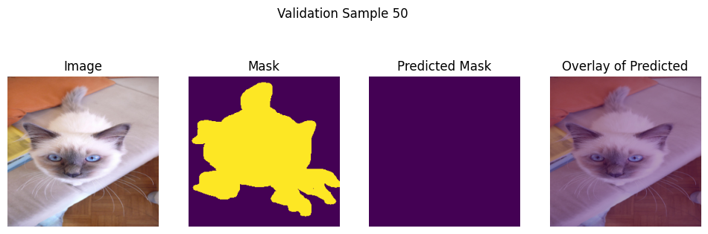
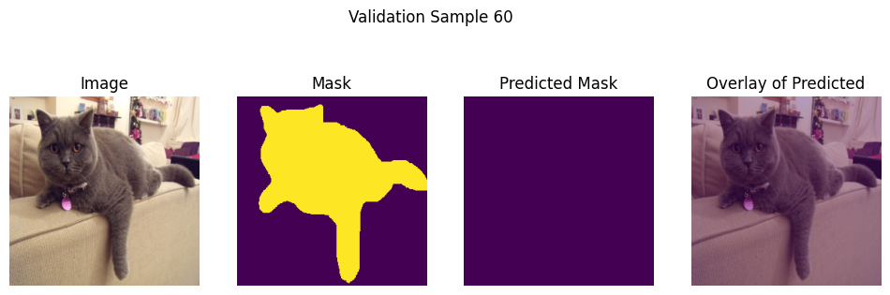
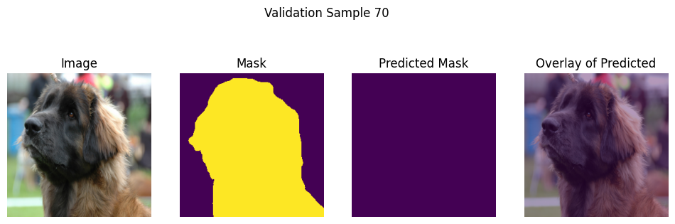
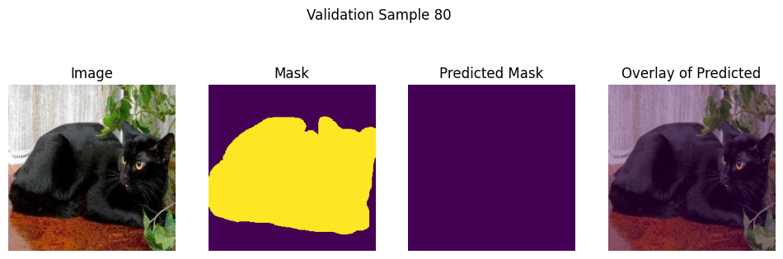
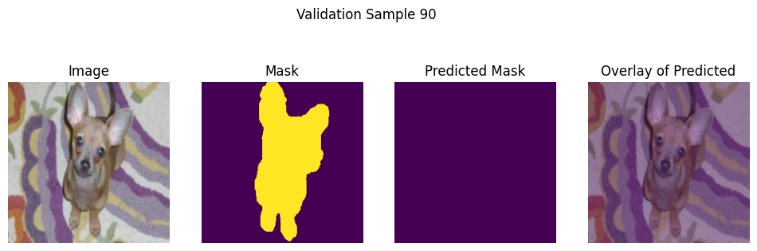
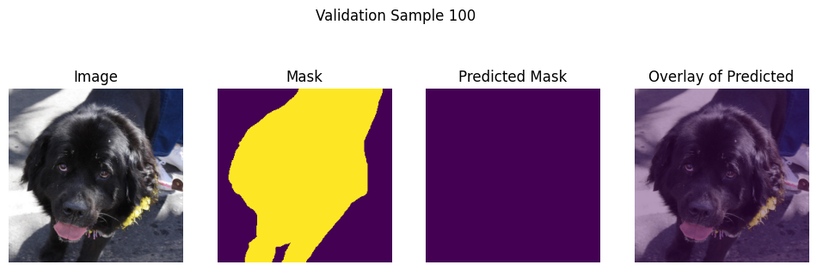

Lower Learning Rate

IMG_SIZE = 256
BATCH_SIZE = 128
VAL_SPLIT = 0.20
EPOCHS = 10
LR = 0.0001
MOMENTUM = 0.9999
WEIGHT_DECAY = 1e-6
PATIENCE = 4
ES_MIN_DELTA = 0.001

NUM_CLASSES = 2

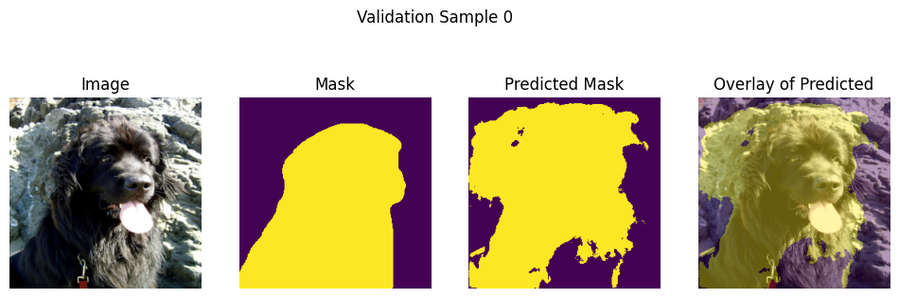
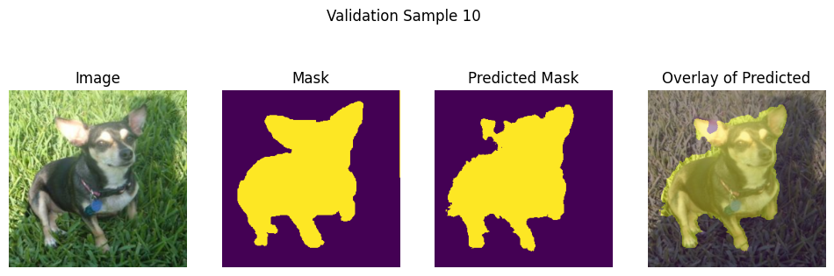
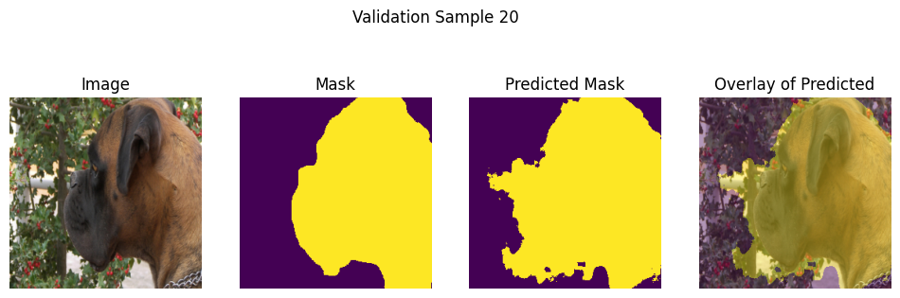
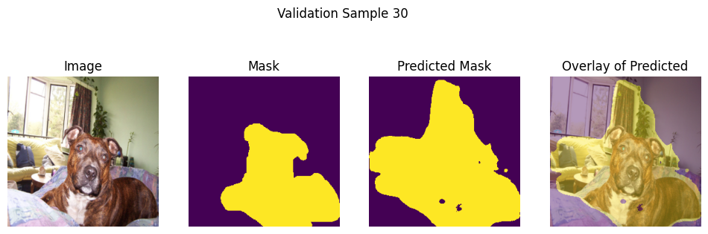
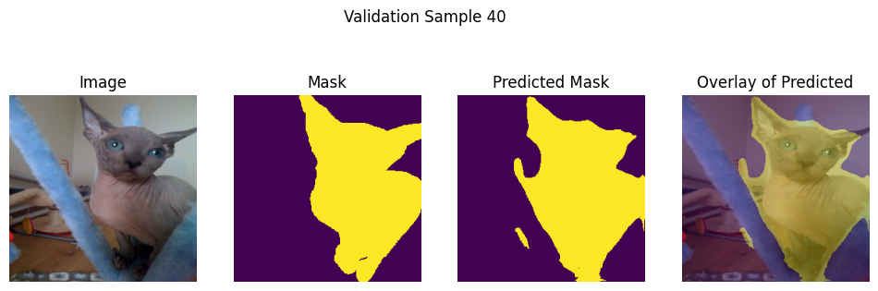
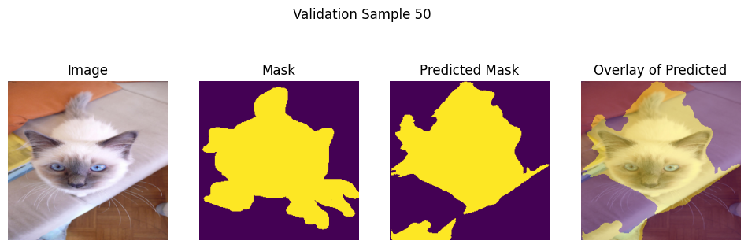
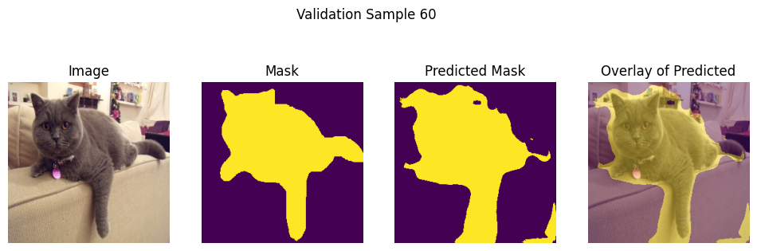
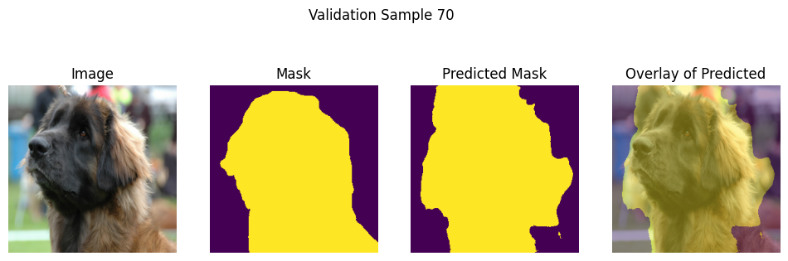
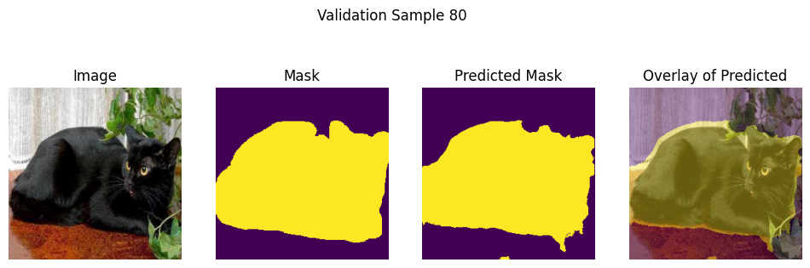
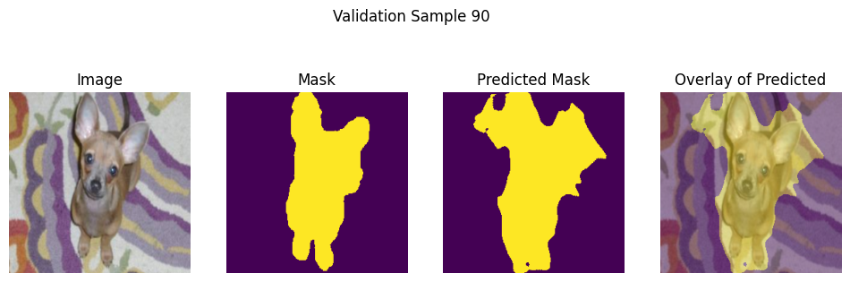
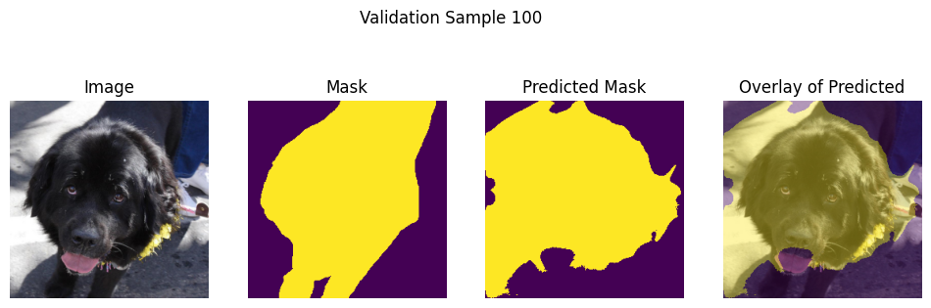
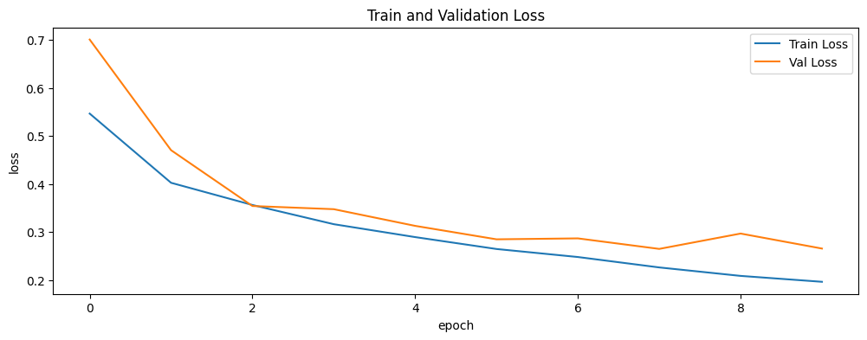

Adagrad optimizer

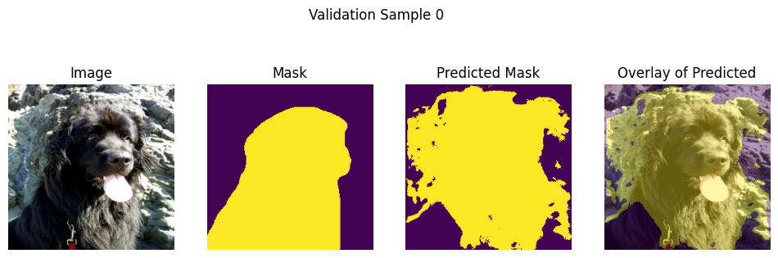
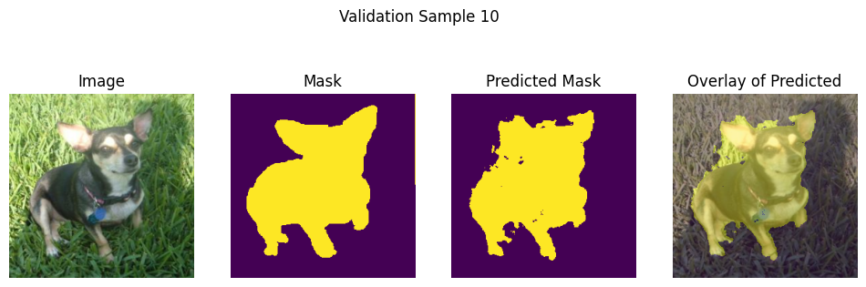
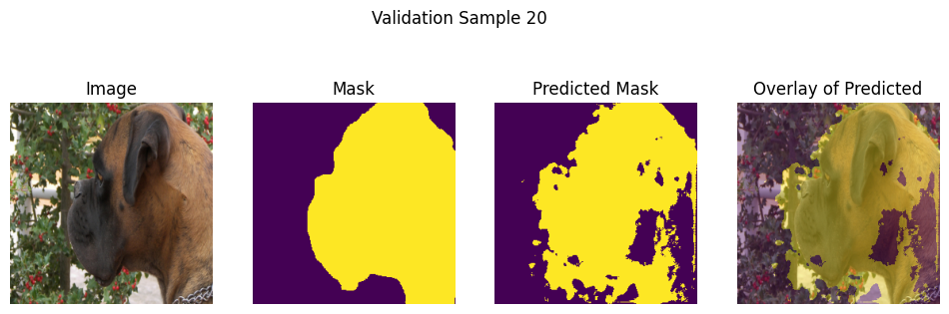
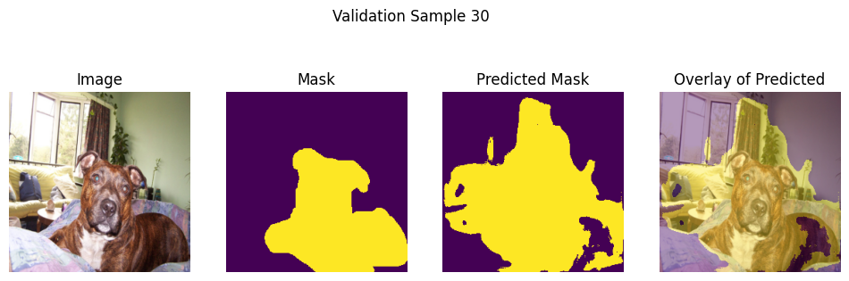
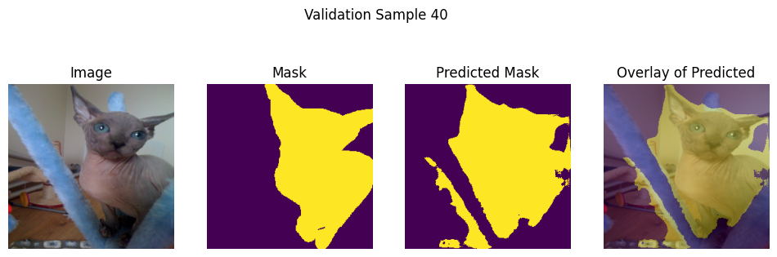
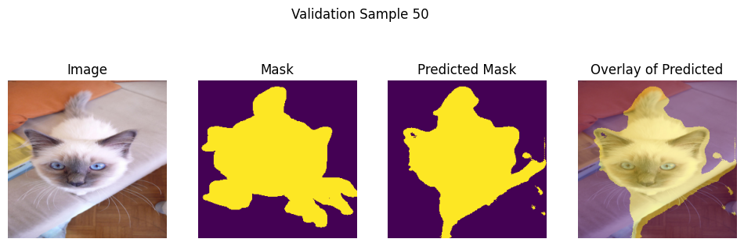
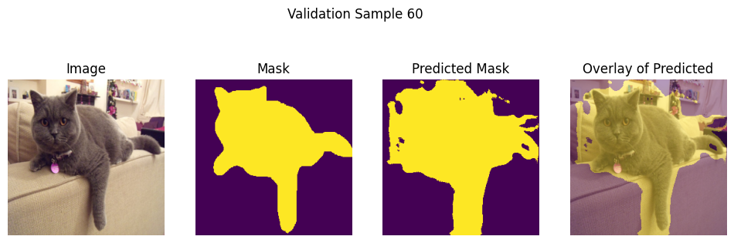
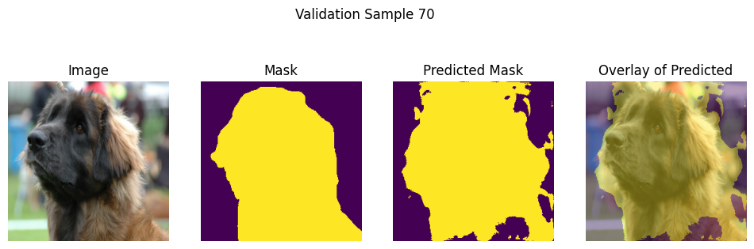
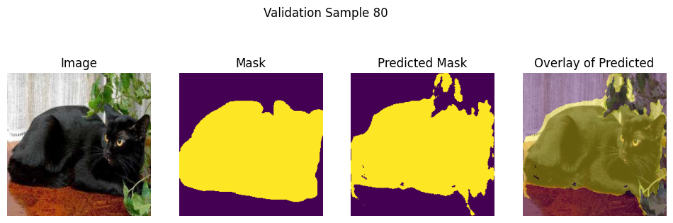
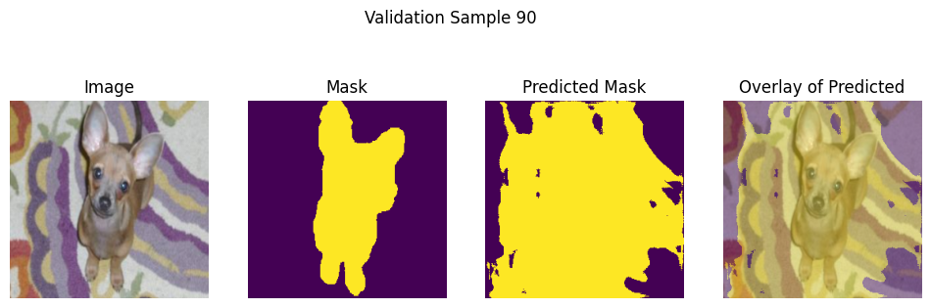
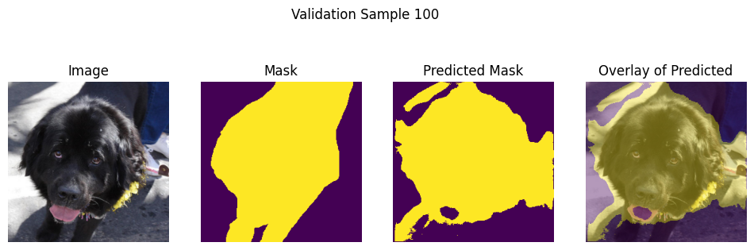

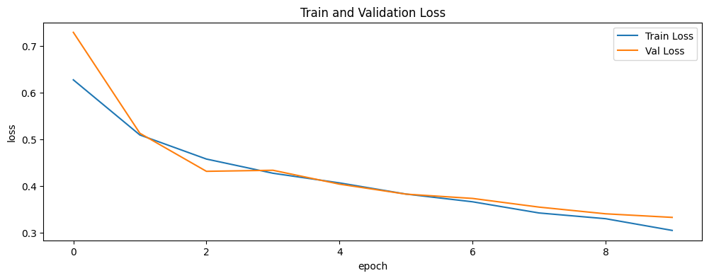

Gradient Scaler
scaler = torch.amp.GradScaler(growth_factor= 5.0,backoff_factor= 0.15,enabled=(device.type=="cuda"))

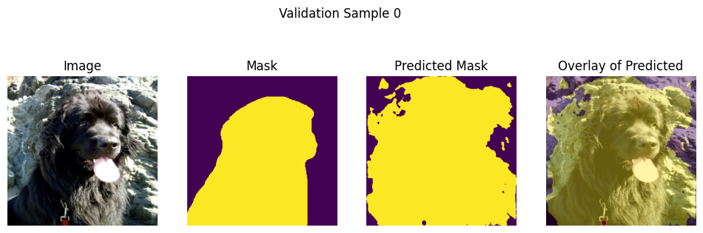
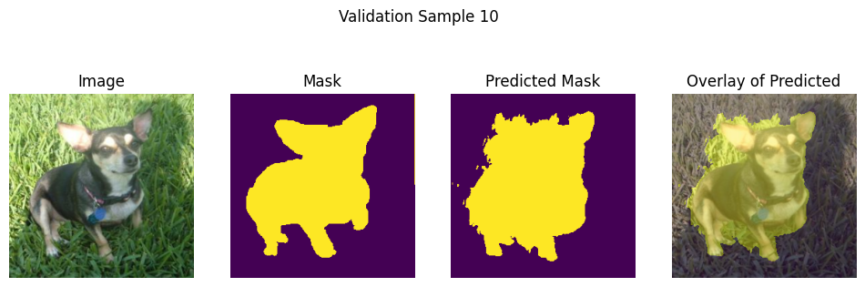
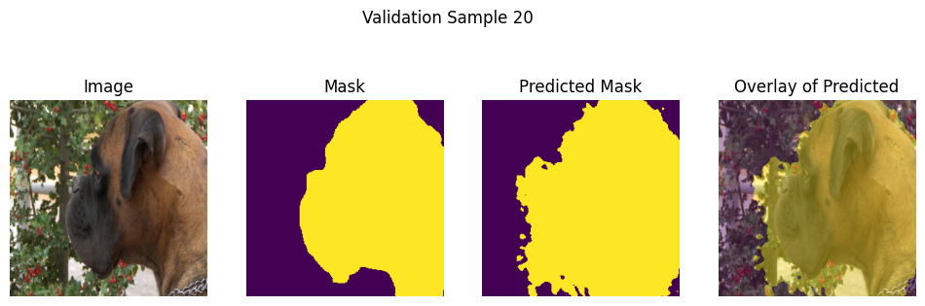
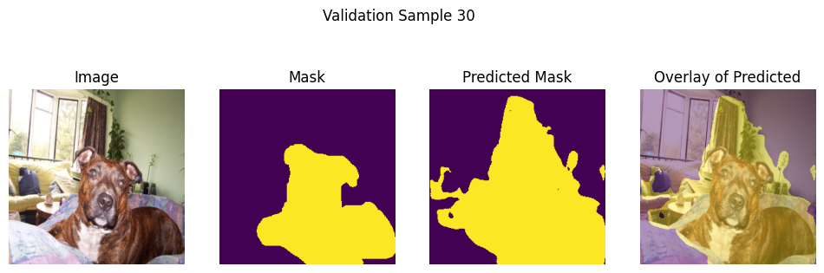
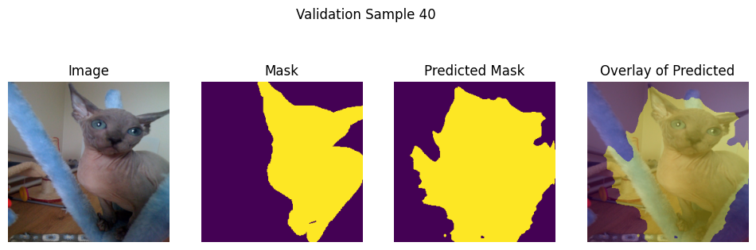
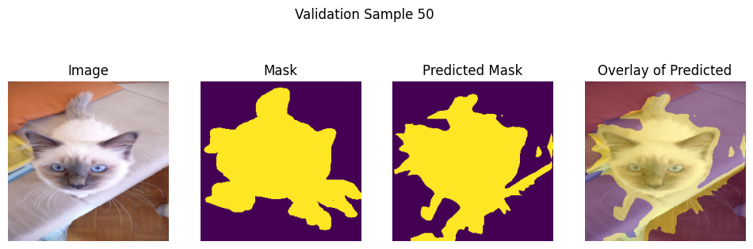
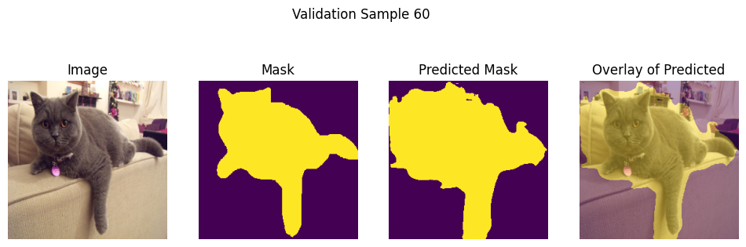
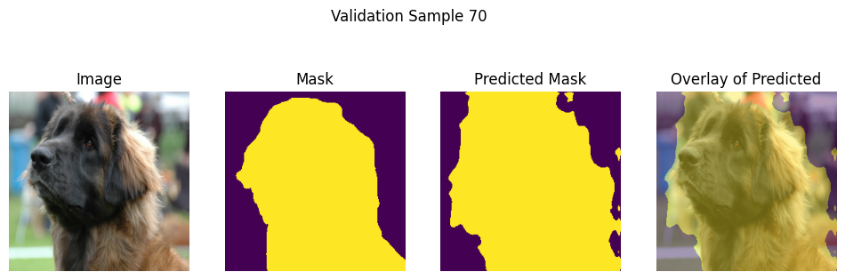
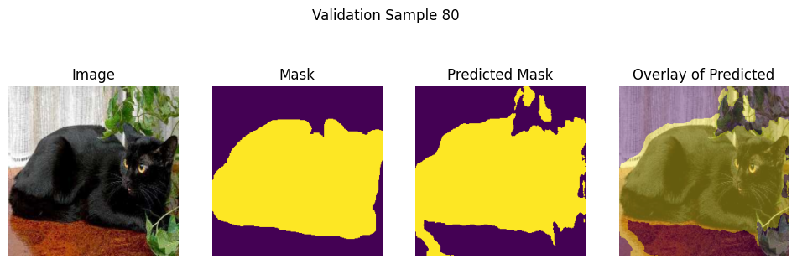
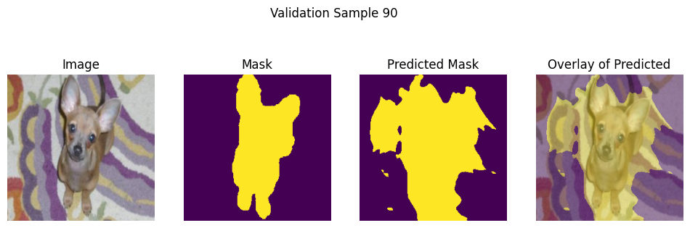
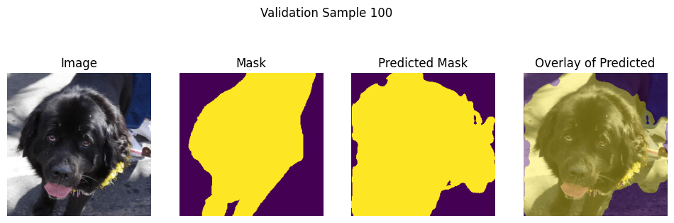
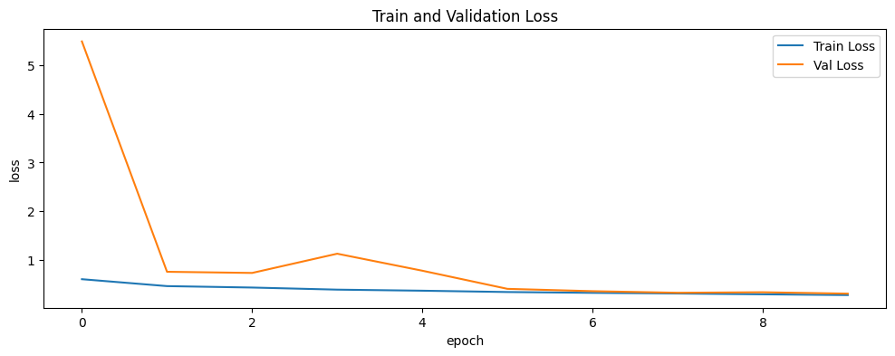

Jaccard loss



