From Micro-level Sycophancy to Macro-level Convergence: Social Influence and Opinion Dynamics in Networks of LLM Agents
Chenxi Peng, Lun Zhang*
School of Journalism and Communication, Beijing Normal University, Beijing, China
As large language models enter public information environments, generative agents are becoming interactive actors capable of continuously encountering, responding to, and recirculating others’ opinions. Previous studies on opinion dynamics shows how micro-level social influence, through repeated interaction, gives rise to collective patterns such as convergence, consensus, fragmentation, and polarization (Starnini et al., 2026). Recent studies of LLM agents likewise document substantial opinion convergence. Convergence may arise from selective agreement, persuasion, or conformity (Cau et al., 2025). The current study aims to investigate the process of opinion dynamics among LLM agents in sustained networked discussion.
This study draws on theories of social influence and group norm formation in computer-mediated communication (Postmes et al., 2000). For each agent, an updated expression becomes part of the informational environment for subsequent agents, allowing micro-level responses to recursively accumulate into collective opinion patterns over time. At the micro level, we distinguish selective agreement from sycophantic alignment. Opinion shifts supported by new and credible arguments are interpreted as selective agreement, whereas movement toward a locally dominant position without sufficient evidential support—or despite conflicting facts or prior reasons—more closely resembles sycophantic alignment. Through repeated interaction, such micro-level social influence may accumulate into macro-level opinion convergence. We further examine how social identity salience and communication network structure shape this process.
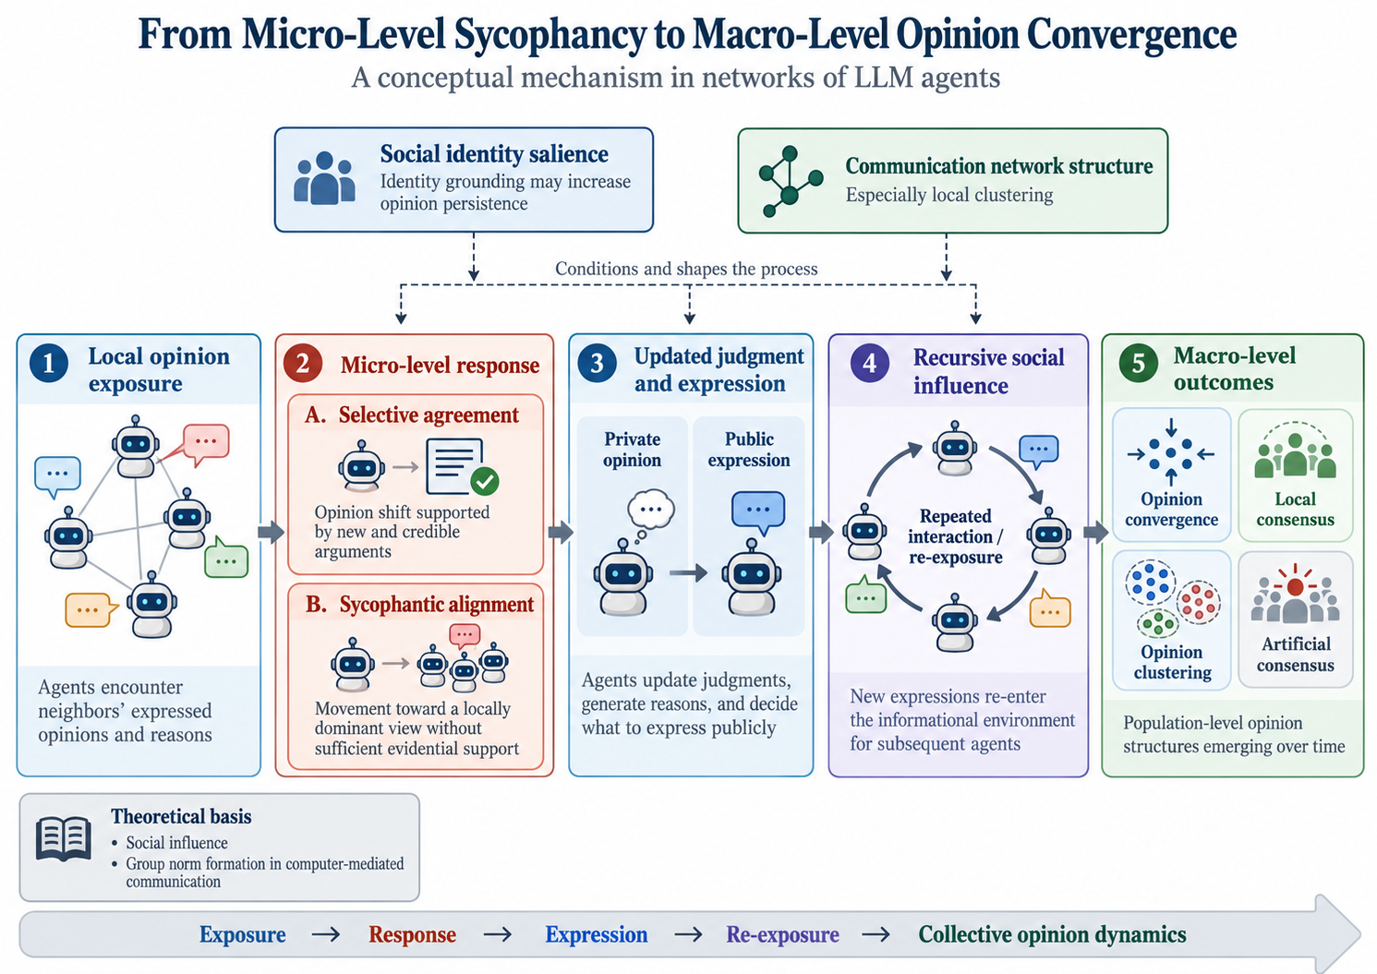
Figure 1. Micro-to-macro mechanism linking social influence and collective opinion dynamics in networks of LLM agents.
Note. In repeated discussion, agents encounter locally available messages, generate conditional responses, decide what to express publicly, and thereby reshape the informational environment for subsequent rounds. Depending on social identity salience and communication network structure, these micro-level adjustments may accumulate into macro-level outcomes such as convergence, consensus, clustering, fragmentation, or polarization.
Methodologically, the study uses agent-based modeling (ABM) to construct a multi-round networked discussion environment populated by LLM agents. In each interaction, agents are exposed to available messages, form judgments in response to the information they encounter, decide whether to express them publicly, and thereby contribute new information to subsequent rounds. To examine how this recursive micro-to-macro process varies across social conditions, the main experiment adopts a 2 × 3 design manipulating social identity salience and communication network structure (Steiglechner et al., 2023). Network conditions include a no-social-interaction baseline, a degree-preserving randomized network, and a small-world network with relatively high local clustering. The system records agents’ private opinions, actual information exposures, expressed opinions, reasoning texts, and confidence judgments, enabling us to trace both event-level influence and population-level opinion trajectories.
Preliminary simulations involving 200 agents over 30 simulated rounds already reveal a strong tendency toward homogenization and directional convergence. Under weak-persona conditions, agents rapidly move toward an endpoint, whereas stronger, lifelong persona grounding preserves more intermediate positions and substantially slows convergence (Figure 2). These preliminary patterns suggest that identity-related conditioning can shape opinion persistence and motivate a more explicit test of social identity salience in the formal design.
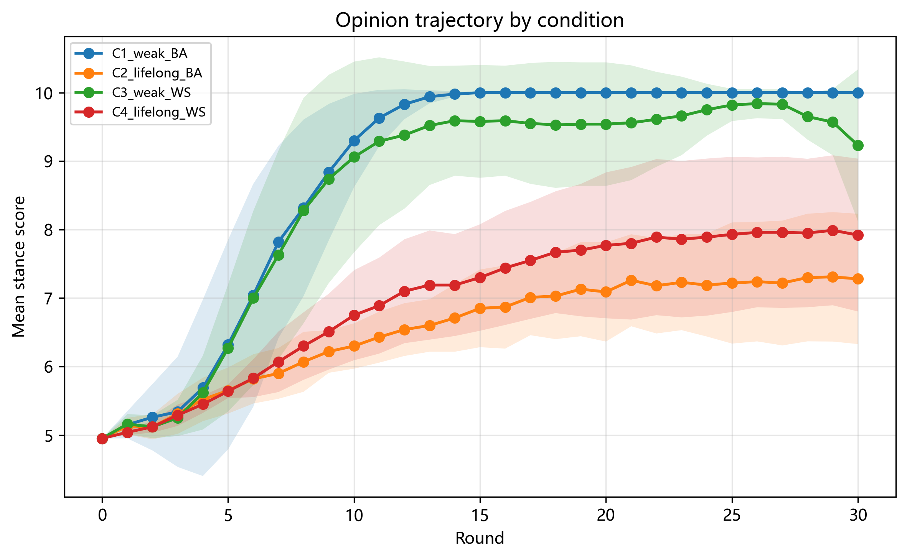
Figure 2. Preliminary opinion trajectories across persona-grounding and network-topology conditions.
Note. Earlier pilot with 200 agents over 30 simulated rounds. Weak-persona conditions (C1/C3) show rapid directional convergence toward the upper end of the opinion scale; lifelong/strong-persona conditions (C2/C4) retain more intermediate positions and converge more slowly. BA = Barabási–Albert; WS = Watts–Strogatz.
This study therefore moves the study of LLM sycophancy beyond a dyadic response bias to a potential mechanism of networked social influence and collective opinion formation. When agents repeatedly align with locally dominant positions, their updated expressions re-enter the network as new social information, allowing majority-consistent responses to accumulate and amplify over time. Macro-level opinion convergence may therefore emerge not from independently formed agreement, but from recursively interdependent judgments. Such dynamics can generate artificial consensus: a visible majority that overstates the extent of independent agreement within the population. As generative agents increasingly participate in public communication, this process may reduce the informational value of consensus cues and compress opinion diversity, making apparent agreement a less reliable signal of independently formed public judgment.
References
Cau, E., Pansanella, V., Pedreschi, D., & Rossetti, G. (2025). Selective agreement, not sycophancy: Investigating opinion dynamics in LLM interactions. EPJ Data Science, 14, 59. https://doi.org/10.1140/epjds/s13688-025-00579-1
Postmes, T., Spears, R., & Lea, M. (2000). The formation of group norms in computer-mediated communication. Human Communication Research, 26(3), 341-371. https://doi.org/10.1111/j.1468-2958.2000.tb00761.x
Starnini, M., Baumann, F., Galla, T., Garcia, D., Iñiguez, G., Karsai, M., Lorenz, J., & Sznajd-Weron, K. (2026). Opinion dynamics: Statistical physics and beyond. Reviews of Modern Physics, 98(3), 035004. https://doi.org/10.1103/j1zg-ddqv
Steiglechner, P., Smaldino, P. E., Moser, D., & Merico, A. (2023). Social identity bias and communication network clustering interact to shape patterns of opinion dynamics. Journal of the Royal Society Interface, 20(209), 20230372. https://doi.org/10.1098/rsif.2023.0372
Author Biographies
Chenxi Peng is a master's student in the School of Journalism and Communication, Beijing Normal University. His research focuses on generative AI, computational communication, and AI-mediated public communication. His recent work examines generative gatekeeping and how generative AI reshapes information production and public information environments. His related work on generative gatekeeping has been published in Journalism and Mass Communication Monthly (Xinwen Jie).
Lun Zhang is a professor in the School of Journalism and Communication at Beijing Normal University. Her research focuses on computational communication, social and complex networks, opinion dynamics, social media, and the social consequences of intelligent media. Her work uses computational and network approaches to examine information diffusion, knowledge formation, news consumption, and public opinion.

