AI-Powered Digital Branding Agency Project

Prepared by: Brian Nzomo

Date: 10th August 2025

Course / Module: Exploring AI with Creativity

# Table of Contents

* Phase 1: Branding & Business Setup
* Phase 2: AI-Generated Design & Marketing Content
* Phase 3: Client Outreach & Monetization
* Appendix: AI Prompts

# Phase 1: Branding & Business Setup

## Business Name

NeoBrand AI

## Tagline

"Branding the Future, One Pixel at a Time"

## Mission

To empower startups and small businesses with innovative, AI-driven branding solutions that are visually stunning, strategically sound, and future-proof.

## Brand Story

In a world where attention spans are short and competition is fierce, NeoBrand AI was born to help brands rise above the noise. Founded by a team of creative technologists, our mission is simple: merge the artistry of human imagination with the precision of artificial intelligence.  
  
At NeoBrand AI, we believe that every business has a unique story to tell — and it deserves to be told in a way that captivates, connects, and converts. Our AI-powered tools analyze market trends, audience behavior, and design aesthetics to craft branding that feels personal, powerful, and perfectly aligned with your vision.  
  
From sleek logos to persuasive marketing copy, NeoBrand AI gives you the edge you need in the digital age. We’re not just creating brands — we’re shaping the future of storytelling.

## Logo

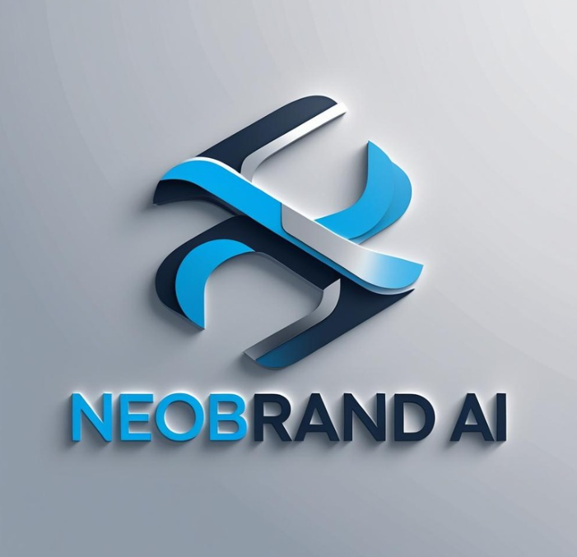

# Phase 2: AI-Generated Design & Marketing Content

## Social Media Post Ideas

* Before & after brand logo transformation.
* Futuristic workspace with holographic branding designs.
* Collage of startup founders with AI-generated branding.
* AI robot painting a colorful logo.
* Timeline graphic showing brand growth after rebranding.

## Website Mockup

## 

## Marketing Blog Post

Why AI Branding is the Future of Business Success  
  
In today’s hyper-connected world, branding is more than just a logo — it’s the emotional bridge between your business and your audience. The challenge? Standing out in a sea of competitors. This is where AI-powered branding comes in.  
  
AI branding tools combine the best of human creativity with machine precision. They analyze design trends, consumer psychology, and market data to produce branding that resonates on a deeper level. Unlike traditional methods that can take weeks or even months, AI solutions deliver results faster without sacrificing quality.  
  
From generating unique logos to crafting targeted marketing copy, AI-powered branding adapts to your business needs instantly. This agility means your brand stays relevant, no matter how quickly the market evolves.  
  
Startups, small businesses, and even established brands are turning to AI to cut costs, increase efficiency, and gain a creative edge. In short, AI branding isn’t just a trend — it’s the future.  
  
Ready to future-proof your brand? Let’s create something extraordinary together.

# Phase 3: Client Outreach & Monetization

## Monetization Strategy

Pricing Models:

* Basic Branding Package – $150 (Logo + Tagline)
* Startup Growth Package – $400 (Logo + Tagline + 3 Social Media Templates + Brand Story)
* Full Branding Suite – $1,000 (Logo, Tagline, Brand Story, 10 Social Media Templates, Website Mockup, Marketing Copy)

Revenue Streams:

* One-time branding packages
* Monthly subscription for ongoing content creation ($200/month)
* Upselling marketing campaigns and seasonal promotions

Client Retention Ideas:

* Offer quarterly brand check-ins to suggest updates
* Provide discounts for referral clients
* Send monthly trend reports to position your agency as a thought leader

## Outreach Email

Subject: Transform Your Brand with AI-Powered Creativity 🚀  
  
Hello [Client Name],  
  
I hope this message finds you well. My name is Brian Nzomo, and I’m reaching out from NeoBrand AI, a digital branding agency that merges human creativity with artificial intelligence to deliver unforgettable brand identities.  
  
In today’s fast-paced market, first impressions matter more than ever. Our AI-powered tools analyze design trends, audience behavior, and industry insights to craft branding that is not only visually stunning but strategically impactful.  
  
Whether you’re looking to refresh your logo, create compelling marketing copy, or design engaging social media content, we can help you stand out and attract the right customers.  
  
Let’s schedule a quick 15-minute call to explore how we can elevate your brand together.  
  
Looking forward to hearing from you,  
Brian Nzomo  
[briannzomo24@gmail.com](mailto:briannzomo24@gmail.com) | 0724533636

## Pitch Deck

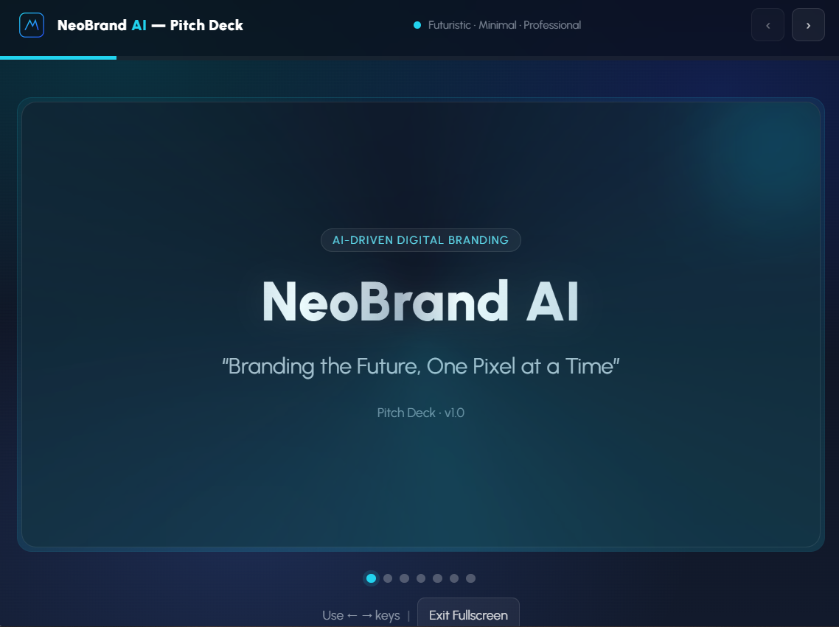

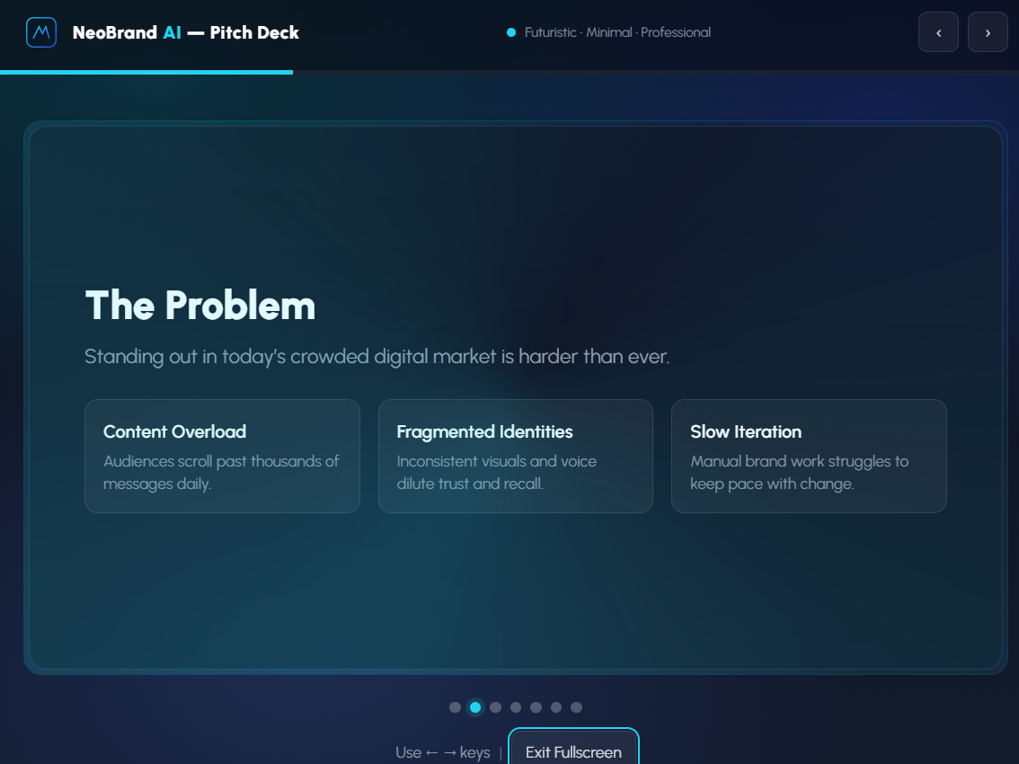

# Appendix: AI Prompts Used

* Imagine you're creating a futuristic digital branding agency powered by AI. Generate a business name, tagline, and a compelling brand story that appeals to startups.
* Create an AI-generated logo for a modern digital branding agency. The theme should be sleek, futuristic, and tech-driven.
* Generate five engaging social media post ideas that promote AI-powered branding services. Each post should have a call to action.
* Generate an AI image of a vibrant social media post showcasing the power of AI branding for businesses.
* Write an AI-generated blog post explaining why businesses should use AI-powered branding services to stay competitive.
* Write a persuasive email to a potential client explaining how AI-generated branding can help elevate their business presence.
* Design a clean and compelling presentation slide that highlights the advantages of AI-generated branding for startups and small businesses.