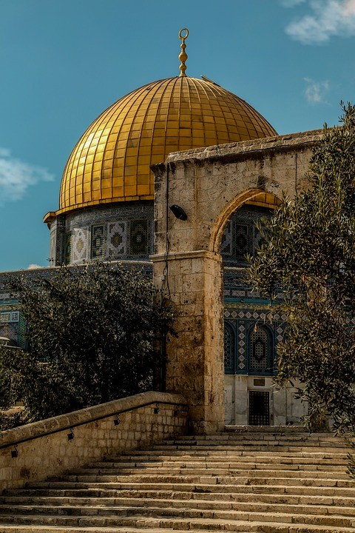

**We picked the boycott theme because we believe it is one of the best ways to express our moral outrage these days and also to give credit to our local Algerian and Arab brands in the world. To combine these two great ideas, we decided to create a website that not only indicate brands we must boycott but also suggests Local brands depending on the country you live in !**

**The use of this website is verry practicale you just need to enter the name of the brand and then select the country youre in.**

**If the brand is involved with the boycott, a list of substitutions appears on your screen so you can support your local economy while inflicting some loss in theirs.**