PFL DATA REPORT

# CONFIDENTAL CONTENT FOR BOA EMPLOYEES ONLY. PLEASE CONTACT PFL DIRECTLY WITH ANY QUESTIONS.

| Test Name | AS_AdvStructure_Materials_Dec23 |
| --- | --- |
| **Benefit:** | Agility & Speed |
| **Date:** | 12/2023 |
| **Test Type:** | Materials |
| **Configurations** | Baseline: LL (Low Upper, Low Midsole Structure)  Test configurations:   * LH (Low Upper, High Midsole Structure) * HL (HighUpper, Low Midsole Structure) * HH( High Upper, High Midsole Structure) |

## Purpose & Background

* Previous agility and speed tests have shown that we need a structured upper in order to see differences in material properties and there is an optimal range of upper structure to improve performance
* The purpose of this test was to understand how much material we can remove from the midsole/outsole and compensate with improved fit

## Hypothesis

H1: Improved fit with reduction in bulk of midsole/outsole will result in better agility, ie. reduced contact time.

H1.a: Reduced contact time will be achieved through increased propulsive force (i.e. in the direction of movement)

## Methods

| Subjects | Movements | Equipment | Measurements |
| --- | --- | --- | --- |
| 12 Male Athletes | Lateral Skater Jump | Force plates & Motion Capture | Agility:   * Time to change direction * Peak Power * Peak Ankle Force |
|  | Vertical CMJ | In-ground force plates  Motion capture | Agility |
|  | Anterior-Posterior Drill | Pressure Insoles | Fit:   * Heel contact area * Forefoot contact area * Forefoot pressure |

## Configurations

**Qualitative**

| Config | avg | medAvg |
| --- | --- | --- |
| Forefoot | | |
| HL | 5.000000 | 5.0 |
| LH | 3.944444 | 4.0 |
| LL | 3.833333 | 4.0 |
| HH | 4.833333 | 5.0 |
| Heel | | |
| HL | 4.666667 | 4.5 |
| LH | 4.000000 | 4.0 |
| LL | 4.222222 | 4.0 |
| HH | 4.444444 | 4.5 |
| Midfoot | | |
| HL | 5.444444 | 5.0 |
| LH | 5.611111 | 5.0 |
| LL | 5.333333 | 5.0 |
| HH | 5.388889 | 5.0 |
| OverallFit | | |
| HL | 7.055556 | 7.0 |
| LH | 6.666667 | 7.0 |
| LL | 3.944444 | 3.5 |
| HH | 7.944444 | 8.0 |

Warning: Returning more (or less) than 1 row per `summarise()` group was deprecated in  
dplyr 1.1.0.  
ℹ Please use `reframe()` instead.  
ℹ When switching from `summarise()` to `reframe()`, remember that `reframe()`  
 always returns an ungrouped data frame and adjust accordingly.

`summarise()` has grouped output by 'Subject'. You can override using the  
`.groups` argument.

Warning: Removed 36 rows containing non-finite values (`stat_bin()`).

|  |  |
| --- | --- |
|  |  |

**Dial Torque**

| Config | R_Torque_Prox | L_Torque_Prox |
| --- | --- | --- |
| HL | 39.44444 | 42.88889 |
| LH | 31.66667 | 39.33333 |
| LL | 42.00000 | 41.66667 |
| HH | 36.22222 | 46.66667 |

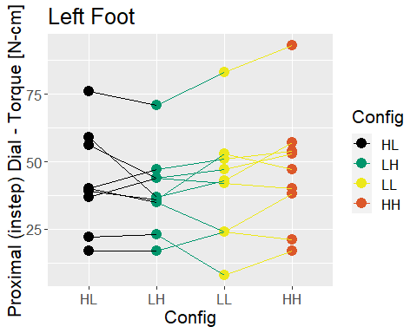

**Contact Time**

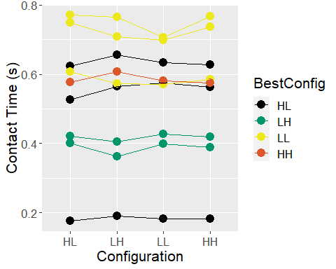

There were inconsistent differences between LH and HL ( 32 %)   
 Estimated difference: -1.6 to 3.2 %  
There were inconsistent differences between LL and HL ( 54 %)   
 Estimated difference: -1.9 to 1.7 %  
There were inconsistent differences between HH and HL ( 34 %)   
 Estimated difference: -0.9 to 1.8 %

NULL

**Peak Force**

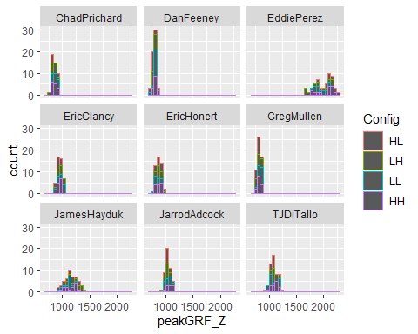

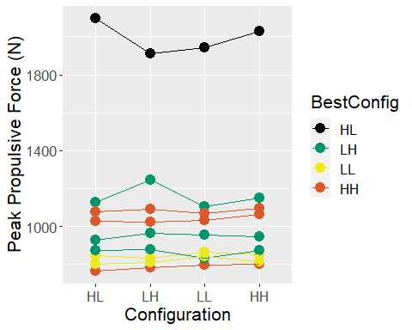

We have minimal confidence that LH outperformed HL ( 76 %)   
 Estimated difference: -0.6 to 2 %  
There were inconsistent differences between LL and HL ( 62 %)   
 Estimated difference: -1.1 to 1.7 %  
We have meaningful confidence that HH outperformed HL (97%)  
 - Estimated difference: 0.5 to 2.4%

NULL

**Peak Plantarflexion Moment**

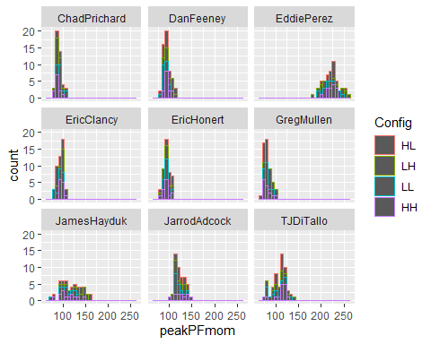

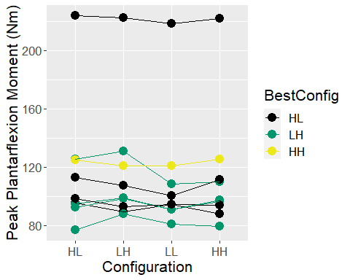

We have minimal confidence that LH outperformed HL ( 72 %)   
 Estimated difference: -1.3 to 3.4 %  
We have meaningful confidence that LL performed worse than HL ( 97 %)   
 Estimated difference: -4.4 to -1 %  
There were inconsistent differences between HH and HL ( 30 %)   
 Estimated difference: -2.6 to 1.1 %

NULL

**Skater Contact Time**

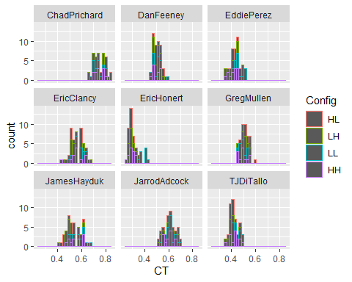

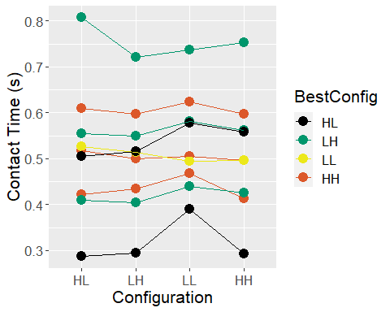

We have meaningful confidence that LH outperformed HL (94%)  
 - Estimated difference: -3.3 to -0.4%  
We have meaningful confidence that LL performed worse than HL ( 91 %)   
 Estimated difference: 0.2 to 5.4 %  
We have minimal confidence that HH outperformed HL ( 78 %)   
 Estimated difference: -2.5 to 0.6 %

NULL

**Skater Propulsive Force**

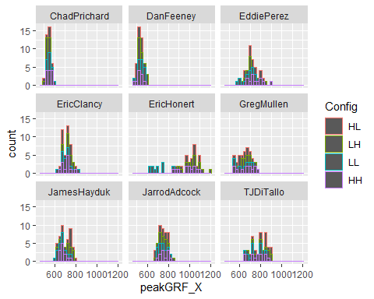

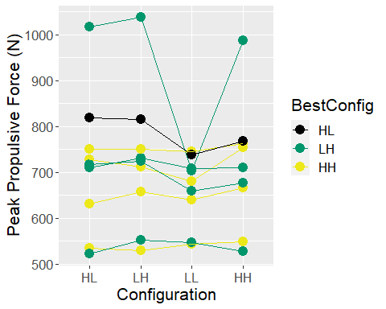

We have moderate confidence that LH outperformed HL ( 86 %)   
 - Estimated difference: -0.3 to 2.9 %  
We have meaningful confidence that LL performed worse than HL ( 94 %)   
 Estimated difference: -5.9 to -0.6 %  
There were inconsistent differences between HH and HL ( 53 %)   
 Estimated difference: -1.5 to 1.7 %

NULL

**Skater Power**

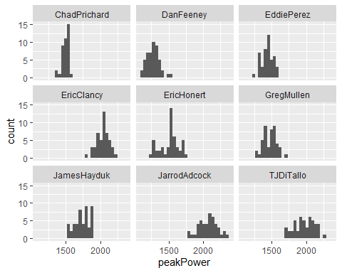

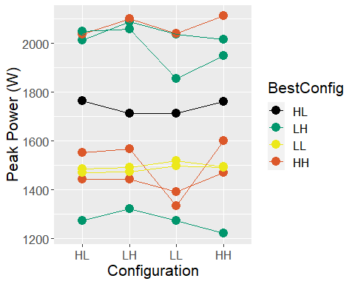

We have moderate confidence that LH outperformed HL ( 81 %)   
 - Estimated difference: -0.3 to 1.5 %  
We have meaningful confidence that LL performed worse than HL ( 91 %)   
 Estimated difference: -3.9 to -0.1 %  
There were inconsistent differences between HH and HL ( 61 %)   
 Estimated difference: -0.8 to 1.2 %

NULL

**Heel contact area (heel hold): Higher is better**

###### Heel Contact  
  
HeelCondat1 <- Pressdat %>%   
 group_by(Subject) %>%  
 mutate(z_score = scale(heelAreaP)) %>%   
 group_by(Config)  
  
HeelCondat1Mod <- brm(data = HeelCondat1, # Bayes model  
 family = gaussian,  
 z_score ~ Config + (1 + Config| Subject), #fixed effect of configuration and time period with a different intercept and slope for each subject  
 prior = c(prior(normal(0, 1), class = Intercept), #The intercept prior is set as a mean of 25 with an SD of 5 This may be interpreted as the average loading rate (but average is again modified by the subject-specific betas)  
 prior(normal(0, 1), class = b), #beta for the intercept for the change in loading rate for each configuration  
 prior(cauchy(0, 1), class = sd), #This is a regularizing prior, meaning we will allow the SD of the betas to vary across subjects  
 prior(cauchy(0, 1), class = sigma)), #overall variability that is left unexplained   
 iter = 2000, warmup = 1000, chains = 4, cores = 4,  
 control = list(adapt_delta = .975, max_treedepth = 20),  
 seed = 190831)

Compiling Stan program...

Start sampling

extractVals(HeelCondat1, HeelCondat1Mod, otherConfigs, baseline, 'heelAreaP', 'higher')

Warning: Method 'posterior_samples' is deprecated. Please see ?as_draws for  
recommended alternatives.  
  
Warning: Method 'posterior_samples' is deprecated. Please see ?as_draws for  
recommended alternatives.  
  
Warning: Method 'posterior_samples' is deprecated. Please see ?as_draws for  
recommended alternatives.

We have moderate confidence that LH outperformed HL ( 87 %)   
 - Estimated difference: -0.3 to 5.3 %  
We have meaningful confidence that LL outperformed HL (100%)  
 - Estimated difference: 3.4 to 8.1%  
We have meaningful confidence that HH outperformed HL (100%)  
 - Estimated difference: 6.5 to 12%

NULL

p <- withinSubPlot(HeelCondat1, colName = 'heelAreaP', dir = 'higher')

`summarise()` has grouped output by 'Subject'. You can override using the  
`.groups` argument.

p + ylab('Heel Contact (%)')

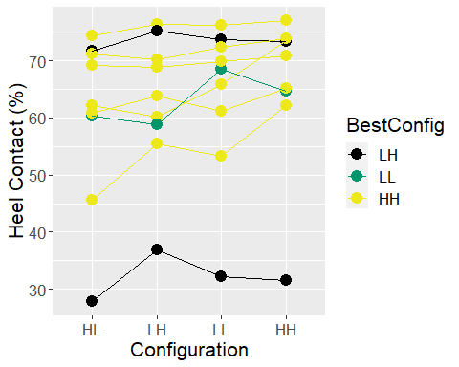

DorsalPress1 <- Pressdat %>%   
 group_by(Subject) %>%  
 mutate(z_score = scale(maxDorsalP)) %>%   
 group_by(Config)  
  
DorsalPressDat1Mod <- brm(data = DorsalPress1, # Bayes model  
 family = gaussian,  
 z_score ~ Config + (1 + Config| Subject), #fixed effect of configuration and time period with a different intercept and slope for each subject  
 prior = c(prior(normal(0, 1), class = Intercept), #The intercept prior is set as a mean of 25 with an SD of 5 This may be interpreted as the average loading rate (but average is again modified by the subject-specific betas)  
 prior(normal(0, 1), class = b), #beta for the intercept for the change in loading rate for each configuration  
 prior(cauchy(0, 1), class = sd), #This is a regularizing prior, meaning we will allow the SD of the betas to vary across subjects  
 prior(cauchy(0, 1), class = sigma)), #overall variability that is left unexplained   
 iter = 2000, warmup = 1000, chains = 4, cores = 4,  
 control = list(adapt_delta = .975, max_treedepth = 20),  
 seed = 190831)

Compiling Stan program...  
Start sampling

extractVals(DorsalPress1, DorsalPressDat1Mod, otherConfigs, baseline, 'maxDorsalP', 'lower')

Warning: Method 'posterior_samples' is deprecated. Please see ?as_draws for  
recommended alternatives.  
  
Warning: Method 'posterior_samples' is deprecated. Please see ?as_draws for  
recommended alternatives.  
  
Warning: Method 'posterior_samples' is deprecated. Please see ?as_draws for  
recommended alternatives.

There were inconsistent differences between LH and HL ( 56 %)   
 Estimated difference: -11.3 to 8.7 %  
We have meaningful confidence that LL outperformed HL (98%)  
 - Estimated difference: -20.5 to -5.9%  
There were inconsistent differences between HH and HL ( 47 %)   
 Estimated difference: -6.1 to 6.8 %

NULL

p <- withinSubPlot(DorsalPress1, colName = 'maxDorsalP', dir = 'lower')

`summarise()` has grouped output by 'Subject'. You can override using the  
`.groups` argument.

p + ylab('Max Dorsal Pressure (kpa)')

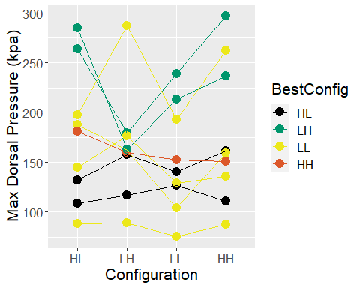

Radar Plots