pyBoard AS Gardener

and if you don't have a garden ,don't worry ,you can find another way to use this weekly timer
or just have a good excuse to play with PyBoard and MicroPython !

Some years are gone from the first time that I've visited Kickstarter and I tripped in the
MicroPython project.

After have participated to the campaign and received the first board ,for about one year the board is remained into a drawer , till one day of last year when I've decided to do something with it ,just to learn something new in the area of microcontrollers on which my limited knowledge was just around the PIC.

At that point the most difficult things for me was decide what to do with the board , find a project that was enough interesting to be realized and at the same time enough complex to push me to
explore something more than switch on/off a led or turn a servo motor.

Fortunately a friends asked me to refresh an old circuit that I build for him many years ago to drive the pumps used to water the garden, so I decided to work on it , with the intention to use the pyBOARD connected via BT to an Android smart phone to program the weekly timing of this
“gardener”.

I must admit that that intentions were serious and good ,but the project was too ambitious for my real capabilities ,in terms of skill on Android and Python.

In fact during the study for this project I immediately met with a difficult obstacle to overcome ,that was learn how program with Android .

To don't stop completly the project I decided as first step to use instead than BT, a connection via Xbee modules and Processing 2 as software to develop the host application because really powerful and much more easy to set up /learn, and last but not least , with a console very very useful to better track/debug and learn what happen in the communication between host and pyBoard.
Move then from Xbee to BT it will be no so complex as I've already done with some projects with PIC.

Before go more in details of this project , consider that I've done this project primarly with the intention to learn as many things as possible that were not already in my knowledeg,starting from python or Processing 2 and the use of capabilities provided by the MCU used in the pyBoard as the RTC and EEPROM, instead than add external components.

About this point let me say that without the contribute received in the MicroPython forum
http://forum.micropython.org/viewtopic.php?f=6&t=953 and the answers to my posts , I could not complete this project, so let me express my regards specially, but not only, to pythoncoder ( his uPower module is a key component of my project ) and Dave Hylands for their contribution to explain me how use some of those features.

The main components of this solution :
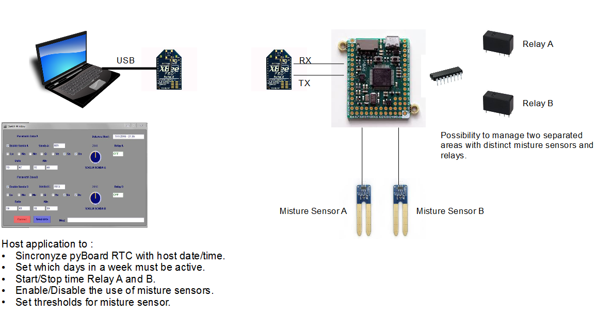
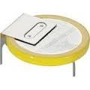

NOTE: For my prototype having not moisture sensors available I've used two simple trimmers
so may be that in case are used real sensors could be required change the way the reading is compared with the threshold. The same for the relays that I've substituted by two LEDs.

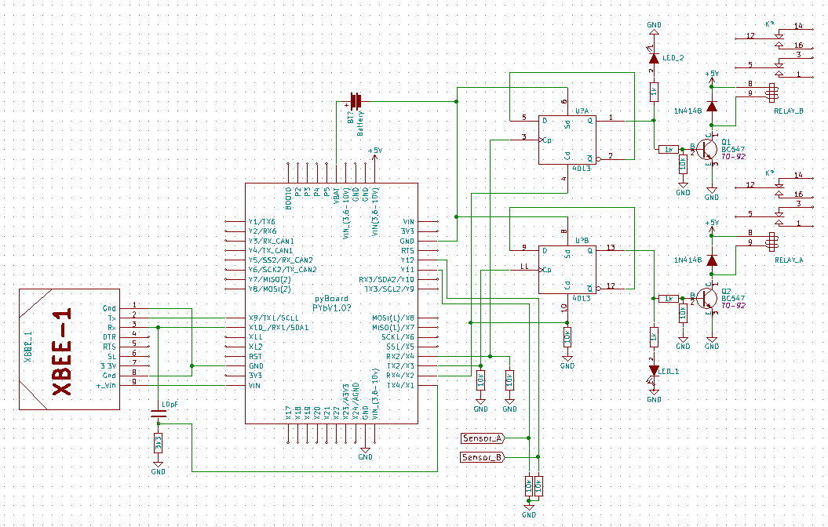
If needed ,moisture sensors can be replaced by other king of sensors ( light , temperature
weight etc. ) and use this timer to perform other operations . In this case may be required
change some piece of code and input of sensors on the Hw.

Host Application:

The host application is written in Processing2 a very powerful language , relative easy to learn .
that can be download and installed with few clicks here: https://processing.org/

To develop the GUI interface I've used the G4P tool: http://www.lagers.org.uk/g4p/download.html

This tool help to design the GUI using many available components ( checkbox, knobs,label
etc.) placing them on a form and generating the relative code in automatic way.
The module generated than is loaded with the main sketch .
At the end under the same directory you must have the Irrigatore_uPython_pde.pde that is the main module and the gui.pde that is the piece of code used to produce the GUI.

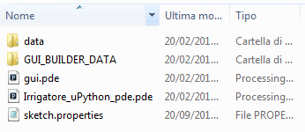
The usage of host application is quite simple and can be summarized in few steps:

Refer to the picture at the next page.

- User ask the connection with pyBoard pressing the red button “Connect”.
- Host send a first command just to wake up the MCU ( (*) we'll talk later of this … ).
- pyBoard reply with “ready”
- Host send request to connect with pyBoard.
- pyBoard respond with “sono connesso!” , recover the setting from the EEPROM
and send them to Host.
- Host decode the incoming setting and fill according the controls on the form.
- The red button “Connect” change to green “Ready”
- At this point the user can change the settings or left as it is ,and send back to pyBoard
pressing Send Data button. .
Warning ! IF USER DON'T PRESS SEND DATA ,pyBOARD CAN'T
RETURN IN SLEEP MODE.
- pyBoard receive the data and store into the EEPROM as a bytearray.
- The received data are decoded ,the RTC is synchronized with the host date-time ,
the alarms are set to the start time and MCU put in sleep mode.

Please note that the COMM # ports used are plugged into the code (host and uPython)
so change them based on your needs.
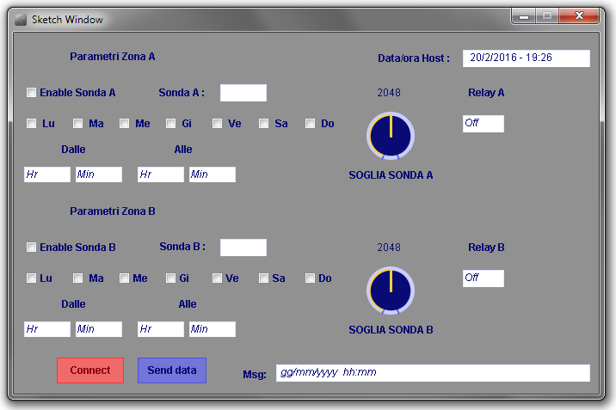
Form of Host application before start the communication with pyBoard.

To exchange data between host and pyBoard I decided to use python dictionary instead than a simple data string separated by commas.

I know that isn't the best solution , because are transmitted much more bytes that needed, but I choose this way just because when I've posted in the forum the question about how store in the EEPROM the data received by serial , one of the solution proposed was save a bytestring using Json or Pickle to serialize/deserialize data .
At the end I found the solution very smart and easy to be implemented ,and the use of dictionary object a good alternative instead than used index to identify elements into a list or substrings to separate the single informations. Anyway if you prefer other solutions ,consider this choice just
as an experiment and not as the most appropriated solution to send few bytes of information .

Below the structure of dictionary used to transfer data from/to host & pyBoard :

reset_dict={'header':'$$$','setting_ab':'0',
'hrs_a':'0','mins_a':'0','hre_a':'0','mine_a':'0','in_sonda_a':'0',
'relay_a':'0','tr_sonda_a':'0','setting_b':'0','hrs_b':'0','mins_b':'0',
'hre_b':'0','mine_b':'0','in_sonda_b':'0','relay_b':'0','tr_sonda_b':'0','yyyy_h':'0',
'mm_h':'0','gg_h':'0','wd_h':'0','hr_h':'0','min_h':'0','yy_rtc':'0','mm_rtc':'0',
'dd_rtc':'0','wkd_rtc':'0','hr_rtc':'0','min_rtc':'0','footer':'###'}

This reset_dict is used as is the first time that is powered up the pyBoard or if for any reason the EEPROM is empty

Note:
“header” and “footer” are remained in the dictionary from such previous experiment done with lists and string ,to understand if all data string was received. Now with the dictionary that don't maintain the order of elements have less sense but I still use the the host application.

This table show the element inside the dictionary ,the function and value range:
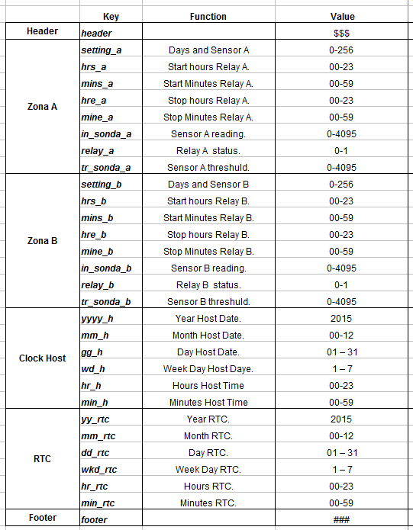

Few words about setting_a and setting_b .

These value are combined base on setting of some checkbox on the main form of host
application. As you can see from the below picture , in the highlighter area, there are 8
checkbox for each area ,1 to enable the use sensor input ( Enable Sonda )
and 7 to select the single days in a week.
These checkbox are used as bit inside a byte and based on setting will generate a value
that will be the decoded and used by pyBoard code to define in which days activate
the relay and if consider or not the sensor reading , comparing the value with
a threshold set using the SOGLIA SONDA knob.

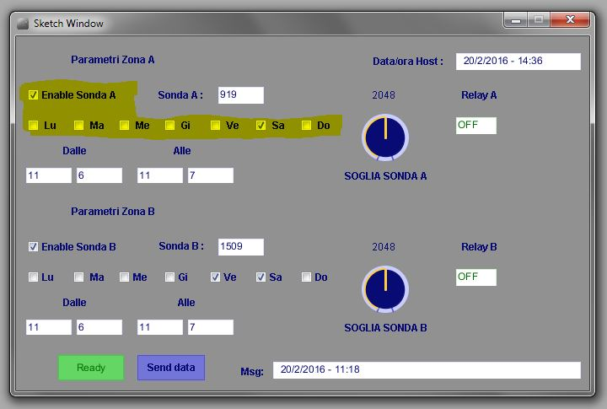

Lu=Monday … Do= Sunday
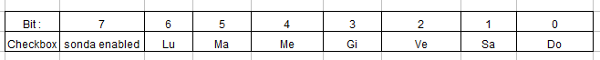

The uPython Code :

As said at the beginning, one of the key element in this project is the upower module.
This module is part of a project developed by Peter Hinch that can be found here:

https://github.com/peterhinch/micropython-micropower

The module permit the use of pyBoard at the lowest possible power consumption
putting the microcontroller , in low power mode or sleep mode as you prefer call.

To do that is used the RTC integrated into MCU.
Using the alarms generated by the RTC is possible wakeup the pyBoard ,and based on
the reason that has generated the alarm , define what to do.

For my projects there is no a real need to put the processor in low power mode , because in case
or real application should be powered with power supply plugged in a power outlet , but having
to activate/deactivate the relay at certain time ,and just in some days of a week, the RTC
functions are perfect for the scope.

The upower module help to manage the wakeup in case of power on and RTC alarms
in a very easy way , while uPython implement only the possibility to set the RTC and read
date-time elements from it.

As you can read from upower documentation, the upower module is able to return a reason of
MCU wakeup based on upower.why() function.

The possible reasons of wakeup managed are listed below and the bold ones are used
into this project:

- 'POWERUP' Power re-applied to board with backup battery.
- 'TAMPER' Woken by the tamper object (event on pin X18).
- 'WAKEUP' Timer wakeup.
- 'X1' Woken by a high going edge on pin X1.
- 'ALARM_A' Woken by RTC alarm A.
- 'ALARM_B' Woken by RTC alarm B.
- returns None if none of the above apply.
(*)
Just few words about how and why I've used the “X1” wakeup detection.....

The upower.why() return “X1” if while the MCU is in sleep mode a rising edge is applied
to pix X1.

As we can imagine this circuit must be ready to receive a new setting ,any time the user need
verify or adjust the setting stored in the MCU EEPROM, but at the same time after have set the
parameters the MCU is put into sleep mode and it wakeup just in case occur an alarm
because is the right time .

For this reason I needed find a way to wake up the MCU when the host need enter in
communication with the pyBoard while MCU is in sleep mode.

For this reason I've connected the X1 pin with the RX1 pin ,so a change of state on
this line is enough to wakeup the MCU and put it ready to receive the commands
to start the connection between pyBoard and Host.
On the other side the host application when has to start a communication with pyBoard ,first send
a message that is just used to wakeup the MCU and then immediately send real commands.

The uPython code, if the upower.why() function return “X1” ,manage all the stuff to exchange
the setting , otherwise if return “ALARM_A or B” knows that is time or to activate or deactivate
the relays.
The piece of code used to manage the wakeup due to an alarm is quite simple :

When the reason of wakeup is ALARM_A or ALARM_B the “restore_data() “function
restore the setting saved into the EEPROM , then decode the setting_a/b values to understand
if must be considered or not the input from the moisture sensors , and if the week day returned
from the RTC is one of the days in which the relay has to be activated.
These elements plus the last status of relay are used to determine if must be generated a 10ms
pulse on pin “X3” for Relay A or “X4” for Relay B ,that will drive a flip-flop used set the
output up or down until the next pulse will be generated by an alarm.

Before generate the pulse ,if the relay as to be activated ,the correspondent alarm is set to fire
at the stop hours/minutes and the relay_a/b is set to 1 to indicate that the relay is ON,
otherwise if the relay_a/b is = 1 , so the relay was already ON , means that the pulse generated
will deactivate the relay , so the alarm is set to fire at start hours/minutes and relay_a/b is set 0 .

NOTE about Alarms setting:
Due that the circuit is able to manage two relays , the two alarms can't fire at the same precise
time ,because the routine to manage the alarms takes some time to be completed.
This is the reason why I set alarm_a with the second=0 and alarm_b with second=2
so to give 2 seconds of time to complete the routine that mange the alarm_a.

Only for debug in purpose, during the above operations , pyBoard send to the host some
messages that describe what is happening.

These message ( sorry are in Italian … ) are visible in console/error area of processing
windows that can remain in background to the application form .
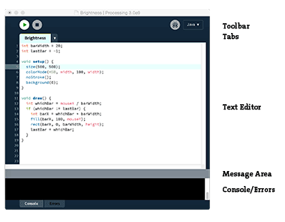

In the consol area every time one of the controls is changed you see a message that refer to
the name of control, plus system time in millesconds. This is generated automatically by G4P
tool and can be boring , but you can remove from the host code .

To finish ,
as I said this is my first project , useful to learn as much as possibile new things around uPython pyBoard and Processing2.
I think to have achieved the goal , thanks also support from Micropython and Proceesing 2
forums.

I hope It can be useful for other newbie as me that want play with this fantastic board .

I'm sure that probably is possible write a code more valid and clean , or pythonic - as someone call - but having started from scratch ,at the moment I'm enough satisfied with the result,and any comments to improve the project are welcome .

ANYWAY …
KEEP IN MIND THAT I RELASE THE HW PROJECT AND SW AS IS , WITHOUT ANY WARRANTY AND WITHOUT TAKE ANY RESPONSABILITY OF DAMAGES FOR YOU
AND YOUR GARDENS !!!!!!

Roberto Portesani .
(BOB63)

P.S. Few hours ago ,while I was finishing to write this file , the new Kickstarter
campaign “Micropython on ESP8266” ended, with strong success.

I start to be worried …...
I feel that I must find another idea on which work to learn something with
ESP8266 .

