Name:王虹博

Student ID：18098532-I011-0018

**Report**

**#PAGE 1**

**Html + Linked CSS + Linked JS**

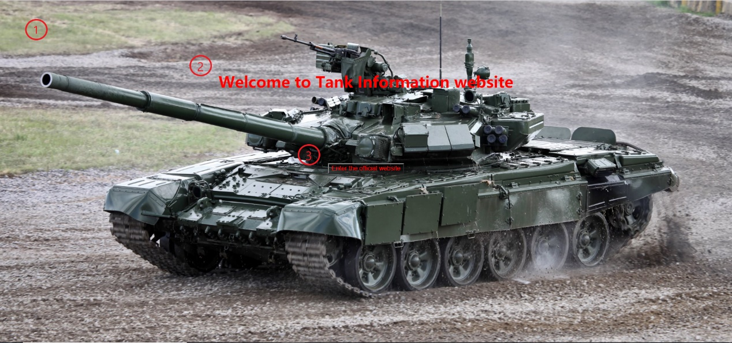

Implement function：Background insertion

Adopt technology：background+url

Implement function：Introduce the title

Adopt technology：color+text-alian+margin-top

Implement function：Button and hyperlink

Adopt technology：<button>+color+background+cuisor

**#PAGE 2**

**Html + Linked CSS + Linked JS**

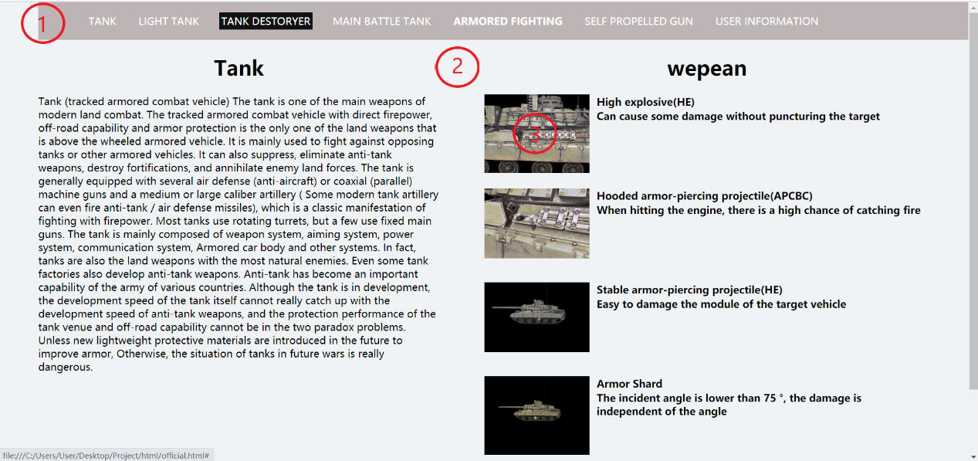

Implement function：Navigation Bar

Adopt technology：<center>+onclick()+height+width+background+position+margin-botton

Implement function：Background and page segmentation

Adopt technology：import class+float+color+text-align+width+height+margin+padding

Implement function：Dynamic pictures and tables

Adopt technology：<div>+import class+<img src=”url”>+<table>

**#PAGE 3**

**Html + Linked CSS + Linked JS**

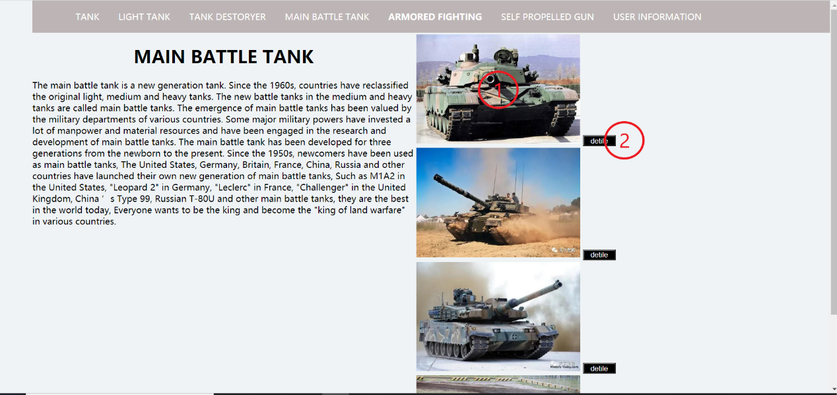

Implement function：Insert picture + hyperlink URL

Adopt technology：<img src=”url”>+ cuisor

Implement function：Button + hyperlink page address

Adopt technology：<table>+<button>+onclick()

**#PAGE 4**

**Html + Linked CSS + Linked JS+链接式JS**

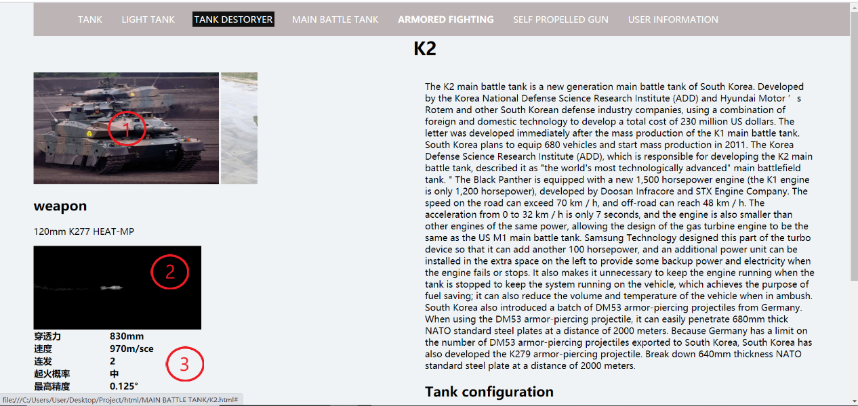

Implement function：Picture automatically moves to the right

Adopt technology：js setInterval() + align+border+<table>+<tr>+<td>+<img src=”url”>

Implement function：Insert MP4 video or .jpg file

Adopt technology：<mp4>+<img src=”url”>

Implement function：Table insertion and writing

Adopt technology：<table>+<tr>+<td>

**#PAGE 5**

**Html + Linked CSS + Linked JS**

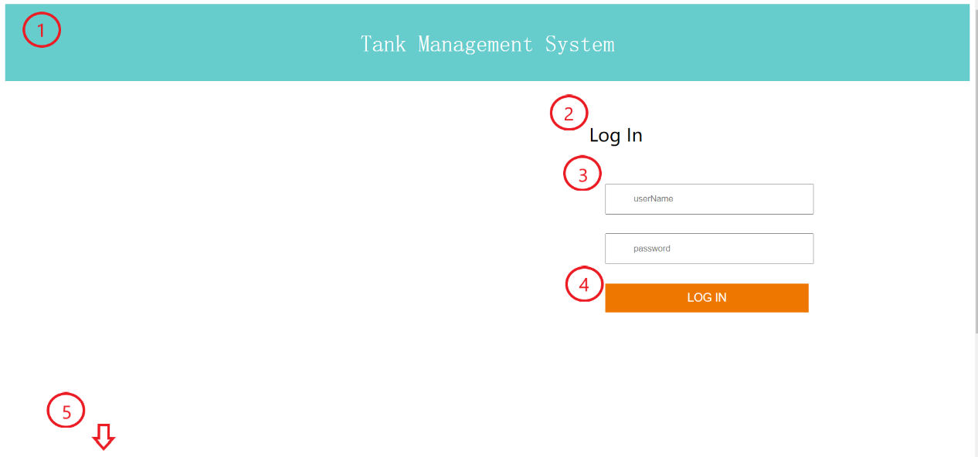

Implement function：Head color and text selection and insertion

Adopt technology：height+width+background-repeat+background-position+text-align+background-color

Implement function：Write text at the specified location

Adopt technology：display+font-size+margin-top+width

Implement function：Get user input

Adopt technology：<input>+ width+ margin-top + margin-right + margin-bottom + margin-left

Implement function：Insert background and button + hyperlink

Adopt technology：<button>+ background-color +<a href+”url”>+ font-family+ top+ left+ transform+ height+ width

Implement function：Color design and text insertion at the bottom

Adopt technology：font-family+ color+ position+ top+ left+ transform+ height+ width+ text-align

**#PAGE 6**

**Html + Linked CSS + Linked JS**

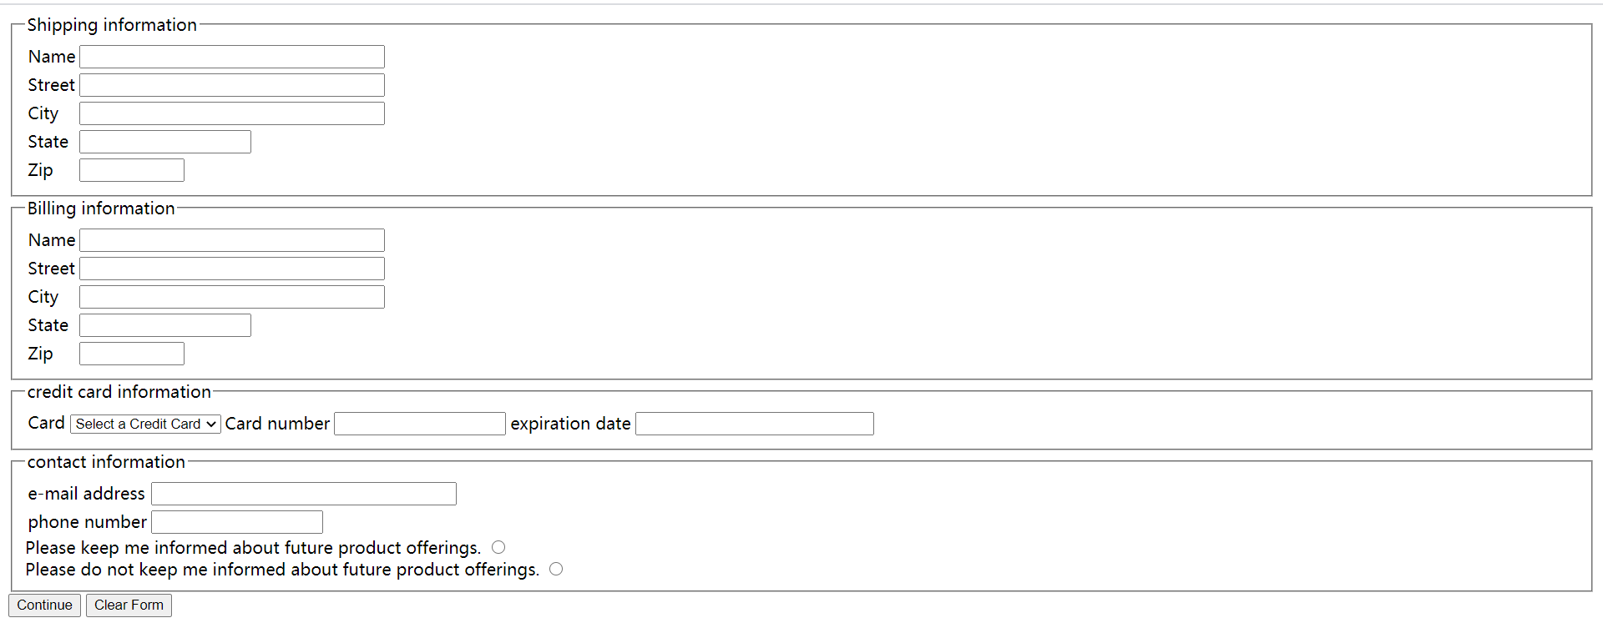

User order interface