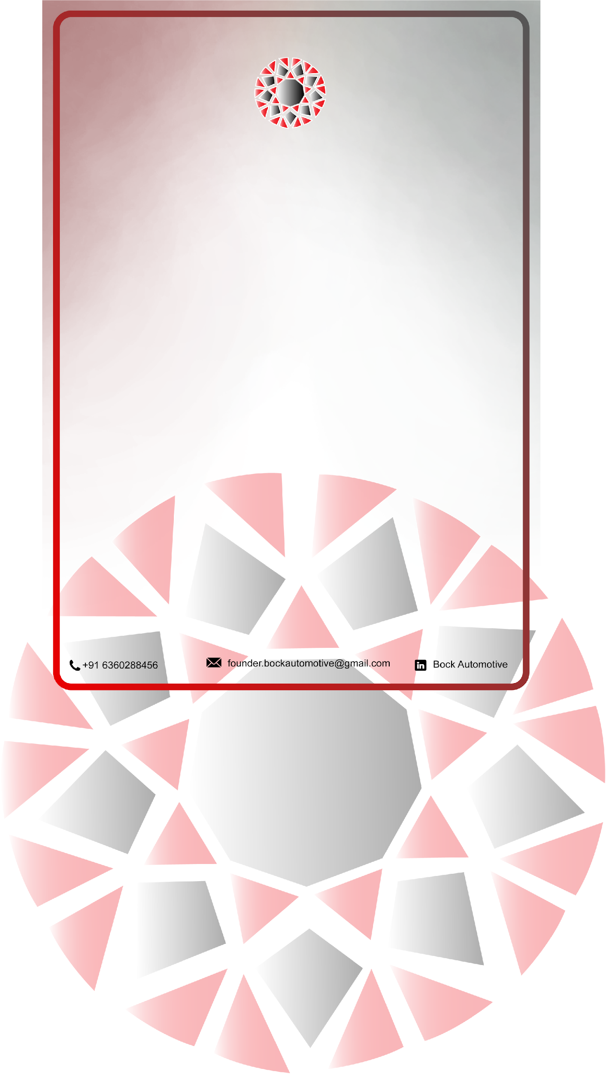

BOCK Automotive

INTERNSHIP OFFER LETTER

XDATEX
Greetings ${XLAMAX},

We are overjoyed to extend this offer to you for the XVARIXBLEX Training/Internship Program at BOCK Automotive, a business that focuses on modern automotives. This training/internship is an excellent educational opportunity created to give you knowledge about the fascinating field of Modern XVARIXBLEX and its technologies.

You have XOX months of internship period of Hybrid internship program starting on XNOXNOXXXXOXX, and ending on YNOXNOXXXXOXY. Please be aware that this is an unpaid program with the main goal of improving your skills and expertise in the field of XVARIXBLEX. We are sure that working with us will provide you with incalculable experiences and opportunities to learn, laying the groundwork for your potential careers in the field of XVARIXBLEX sector.

We eagerly anticipate a fruitful and beneficial working relationship throughout this internship, and we look forward to seeing how you develop and contribute to our XVARIXBLEX-related projects. I hope you have the most enjoyable and rewarding internship program ever.


Sincerely Bock Automotive,
Director/Founder

