Theme - Design Requirement

MyCompany - Fands Infonet Pvt. Ltd.

Training Report for CDK

1. Modules Covered

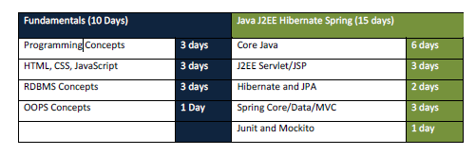

1. Programming Concepts
   1. Contents(html)
   2. Execution
      1. Attendance
      2. Daily Feedback
      3. Final Feedback
      4. Test Result