## Business Analysis of "*Youth With You In Second Season*"

With the rapid development of China's Internet industry, the ratings and benefits of China's film and television entertainment industry have increased substantially. In recent years, variety shows have occupied a large portion of the ratings of the Chinese film and television industry. Especially the talent show that has emerged in the past two years. This year's "*Youth With You In Second Season*" has undoubtedly become a national hot spot. Especially during the epidemic when everyone depends on the Internet.

在这里，可以加一大段数据分析的商业意义。（可搬运课件，百度百科类，论文 然后谷歌翻译）

So I will analyze this variety show.

"*Youth With You In Second Season* " will premiere on March 12, 2020 and end on June 6, 2020.

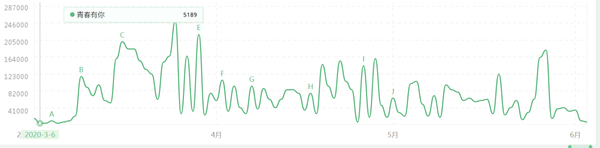

360 Trend Attention Index—from 360 Trend Index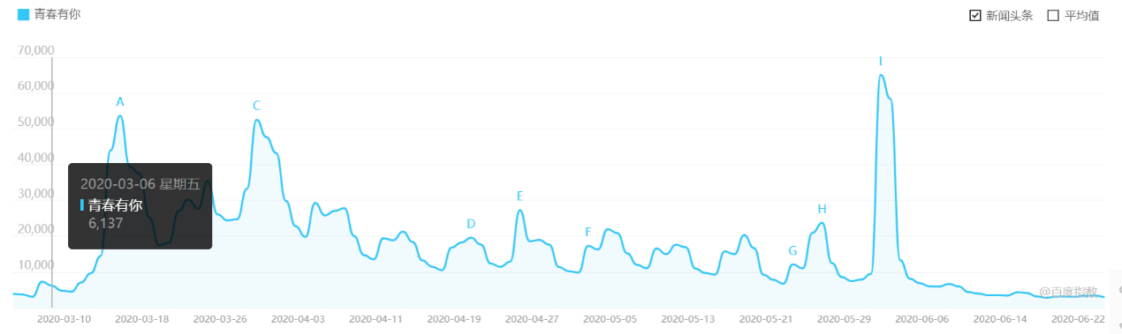

Baidu Attention Index—from Baidu Index

Because the producer of "*Youth With You In Second Season* " is iQiyi, we will analyze the playback index of the two companies here.(在这里可以说一下几家公司的商业合作，买热搜之类的，所以用两家公司对比着看)

Each peak in the figure represents the broadcast time of each period. Here we can find that the previous episodes and the May 31st broadcast volume are very high.

※ issue 1: Cai Xukun is the producer's representative

※ issue 2: Xu Jiaqi Anqi Kong Xueer Shangguan loves battle, the first A student is born

※ Issue 3: Yu Shuxin talks about Cai Xukun, LISA wins tears from fans

※ The 23rd issue: Liu Yuxin won the center position! THE9 group starts a new journey

Through analysis, it is found that the reasons for the previous issues of publicity and premiere have high ratings, and the 23 issues have high ratings because of the group battle.

（在这里可以仔细分析一下这几期为啥收视率会那么高。有的因为是刚开播，有的是因为一些热词eg哇呜 23期决战之夜类，然后总结一下 如果想再多写点，可以再找中间比较火的几期，分析一下这几期出现的元素，引述到为什么观众喜欢，再引述到商业应用）

For the quality Y of a variety show, people usually use S ratings (another, more overall term, total commercial revenue) and M audience ratings to balance.

Y=k1*S+k2*M

The overall commercial income S in the " *Youth With You In Second Season* " program is specifically expressed by the ratings of the cooperation platform, the commercial income from the artist company, the commercial income of the fan list, the commercial income of the advertisers' cooperation and the value of the debut artist, etc. Because the commercial income of the cooperation platform, the commercial income of the artist company, and the debut artist value are all parts that cannot be quantitatively analyzed. Here we uniformly specify S3. The commercial revenue of fan rankings and the commercial revenue of advertisers are S1 and S2, respectively.

S=f1*S1+f2*S2+f3*S3

We can get the data from the dumplings list for the commercial revenue of the fan list. (The dumplings list is organized spontaneously by the rice circle. In order to prevent the embezzlement of public funds from support clubs, many fund-raising fans do not count the total amount of aid clubs. This dumpling list is for them. This list is The rankings generated by the statistics of each fund raising situation through technology.--From Baidu Encyclopedia)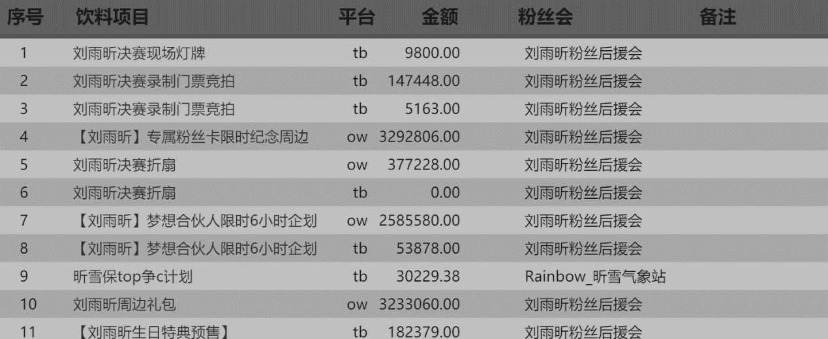

Part of C Yu Liuxin’s Fans Gaining the Ranking List-From the Dumplings List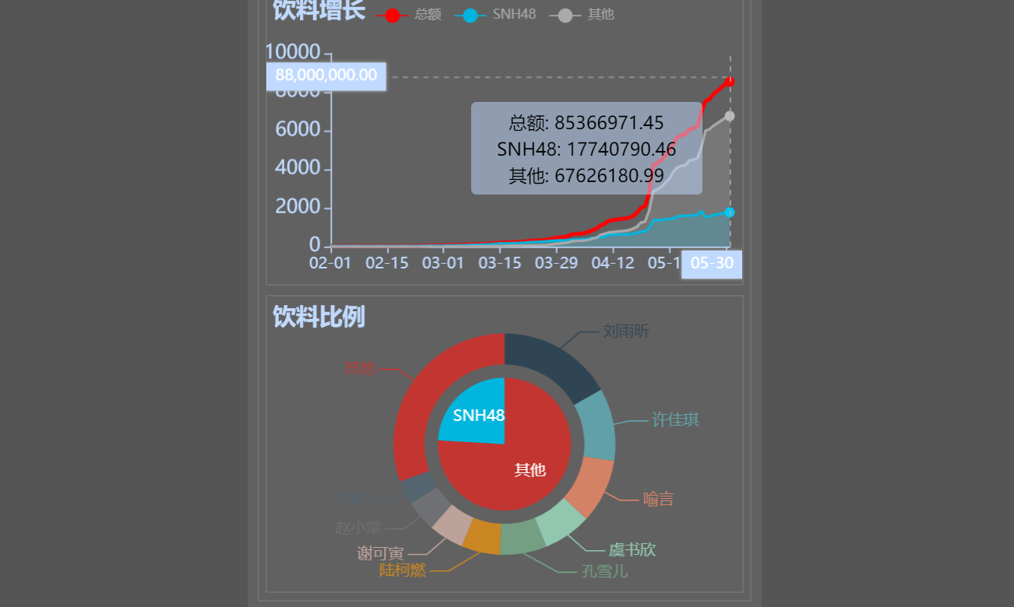

" *Youth With You In Second Season* " fans hit the list of business income-from the dumplings list

From the data, we can see that from the beginning to the end of the show, the fan's commercial revenue totaled 85,366,971.45 yuan. Of course, the commercial revenue of fans' rankings is also related to the possibility of players' debut. 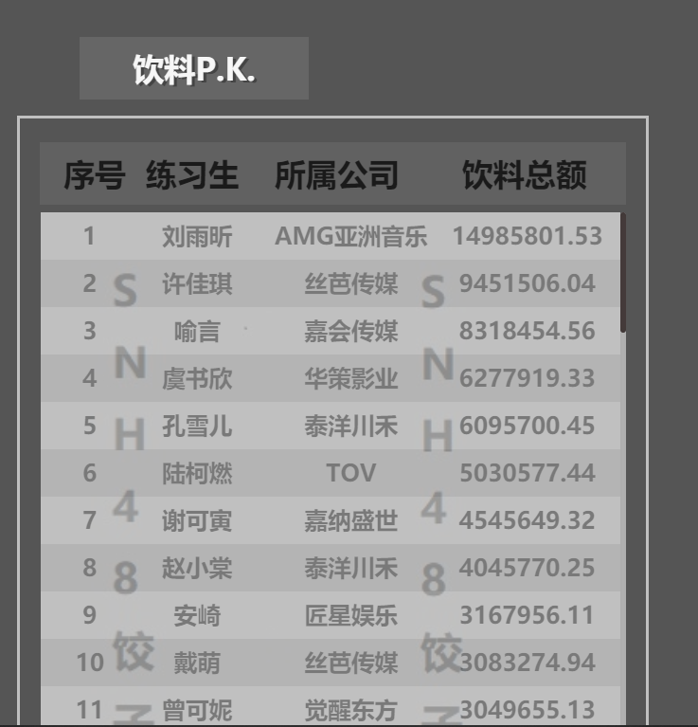

（上面这个图我是刚加的，在这里仔细分析粉丝的打投是和艺人的出道息息相关的。注意 成团夜那天这个饺子榜的前九名正好真是他们出道了！通过分析前几期，可以发现节目组也有在根据粉丝的打投去调整艺人的镜头出场时间，这里可以举例子eg虞书欣。当然，镜头时间不仅仅和粉丝打投相关的，还有观众关注热度eg冰清玉洁 然后这种根据数据调整实施形成良性循环，也是属于商业应用的 这部分我觉得可以写好多字，加油）

Advertiser cooperation business income S2 belongs to the commercial confidential content of the iQiyi "Youth Have You Second Season" program group, I did not get this data. But this commercial income must be directly related to the commercial income of the program group.

The ratings of the cooperation platform are directly related to the capital investment of advertisers, the value of debut artists, fan followers and directly related commercial revenue of fan rankings. For ratings, the following aspects will be relevant. The first is the publicity of the program, which generally includes micro-blog hot search and push, related content push of major websites, and advertising of the broadcast platform. According to this program group, it is possible to adjust the investment of publicity funds in the future. In order to get the maximum benefit of funds!

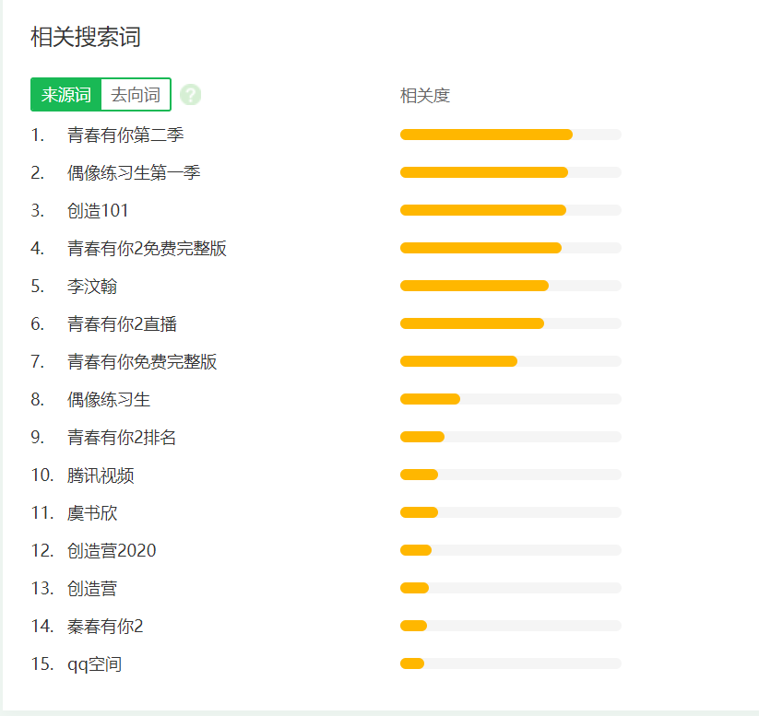

The source word of "*Youth With You In Second Season*"-from 360 Trend Index

The second is related to the entertainers and the audience. From the picture above, we can see that Yu Shuxin and Liu Yuxin have occupied a lot of the heat of " *Youth With You In Second Season* " and also attracted many fans. Another example is that the main audience of "Y *Youth With You In Second Season* " is a group of young people 18-30 years old. The youthful vitality of the content of the program will inevitably meet the needs of this group of people. If the content of the program is heavy and serious, it may cause the favor of the audience after the age of 30, but it will also lose part of the younger group. This requires the program group to choose. Through the data analysis of the figure below, the female audience of " *Youth With You In Second Season* " is as high as 83%. This is the program group must make content that caters to the female group and then retains this part of the group. In addition, through regional analysis, we found that Beijing and Shanghai, which have a particularly fast pace of life, occupy a large share. This is because the workers in Beijing and Shanghai are younger and need this variety to relieve work pressure.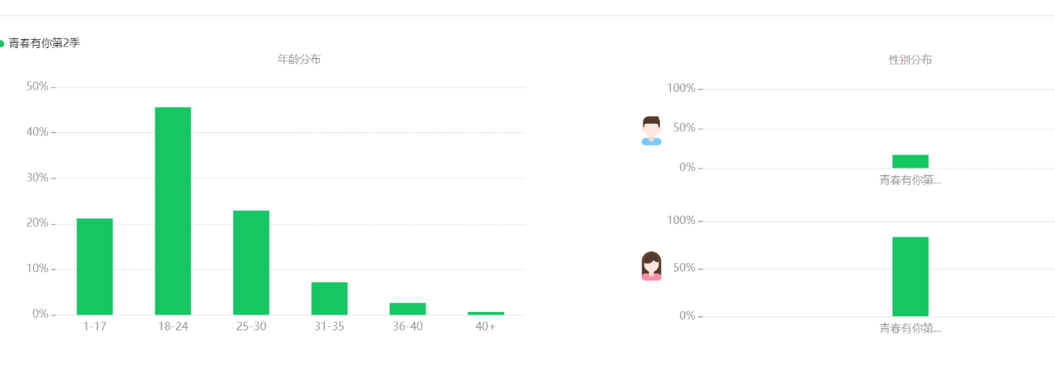

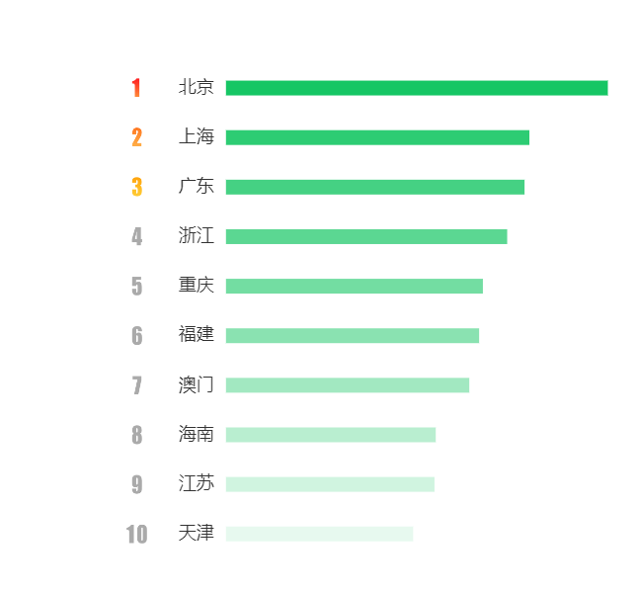

Regarding the debut value of the artist and the commercial income of the artist company, this involves the confidential and professional estimation of the program group. Here we can view them and the ratings as a whole S3.

Finally, the evaluation of the audience is also a very abstract parameter. Professional analysis of variety show personnel is required. The specific data can be seen in the figure.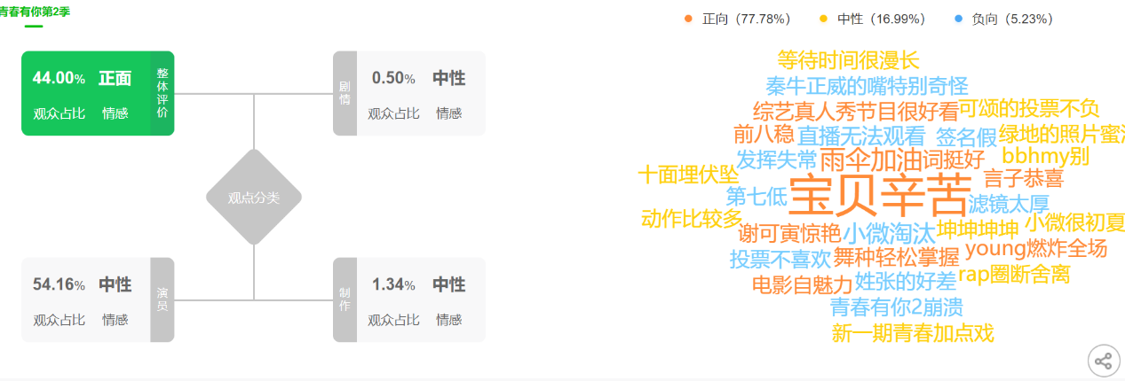

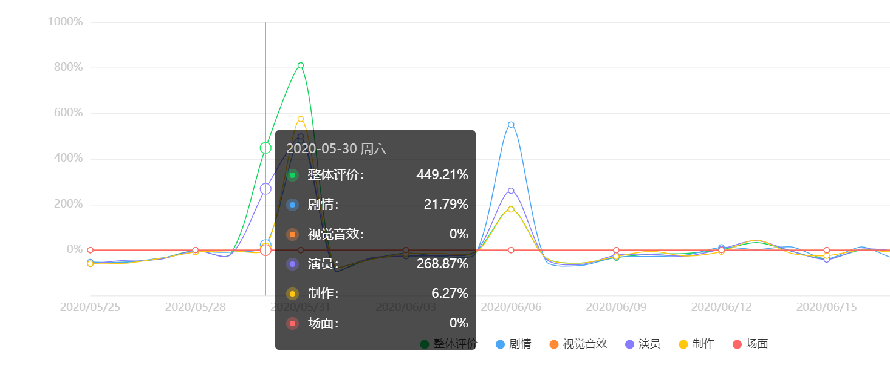

-- From iQIYI Index

Get a very simple model

Y=k1*S+k2*M

=k1*(f1*S1+f2*S2+f3*S3)+k2*M

(S: All business income

S1: commercial revenue from fan rankings

S2: commercial revenue from advertisers’ cooperation

S3: Cooperating platform ratings, commercial revenue from artist companies and debut artist value

M: Audience evaluation)

（这里可以总结下这些数据对这款综艺的用处（可以看上面写的，总结写就好），然后升华到全体综艺节目和影视反馈直播带货粉丝反馈之类的，这种线上互动带来的大数据对这些线上行业的用处）