**CURRICULUM VITAE**

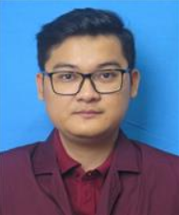

**PERSONAL INFORMATION**

**Binusian ID** 2201867941

**Full Name** Errick Prayuda

**E-Mail** errick.prayuda@binus.ac.id

**Address Current**

Jl. Sariwates Timur No. 16, RT/RW 005/014

Kel. Antapani Kidul, Kec. Antapani

Kota Bandung, Jawa Barat

**Permanent**

Jl. Sariwates Timur No. 16, RT/RW 005/014

Kel. Antapani Kidul, Kec. Antapani

Kota Bandung, Jawa Barat

**Phone Numbers Home : -**

**Mobile :** 082115510401

**Gender** Male

**Birth Place / Date** Bandung, 22nd July 1991

**Nationality** Indonesian

**Marital Status** Married

**Religion** Christian

**FORMAL EDUCATION**

July 1997 – June 2003 SDK Gracia Bandung

July 2003 – June 2006 SMPK Gracia Bandung

July 2006 – June 2009 SMAN 3 Bandung (IPA)

June 2019 – Present Bina Nusantara University (Computer Science)

**INFORMAL EDUCATION**

**PERSONAL CERTIFICATION**

**ORGANIZATION PREFERENCE**

**WORKING EXPERIENCE**

July 2009 – November 2013 Private Music Teacher

December 2013 – April 2018 Marketing Vice Coordinator PT. Sanbe Farma

April 2018 – October 2018 Assistant District Sales Manager PT. Gracia Pharmindo

October 2018 – September 2020 Marketing Supervisor PT. Kalbe Farma

September 2020 – Present Product Marketing Officer Regional PT. Sinar Roda Utama

**Job Description :**

Responsible for sales of hemodialysis products at Bandung, Cimahi, Kabupaten Bandung Barat, Purwakarta, Subang, Cianjur and Sukabumi.

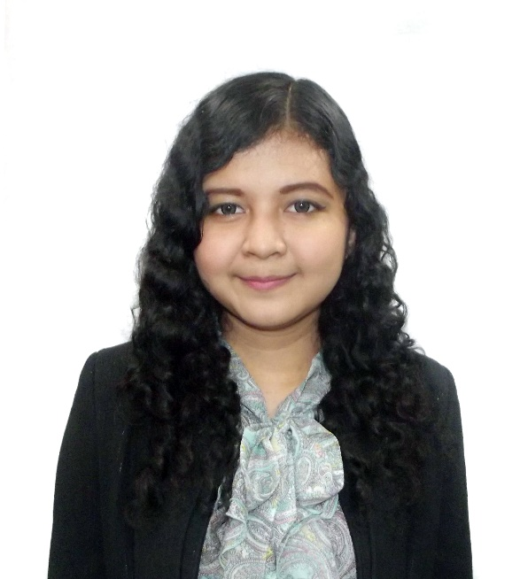

**PERSONAL INFORMATION**

**Binusian ID** 2201867664

**Full Name** Helena Trisa Monica

**E-Mail** helena.trisamonica@binus.ac.id

**Address Current**

Pondok Surya Mandala Blok R1 No. 24 RT 11/013

Kel. Jaka Mulya, Kec. Bekasi Selatan

Kota Bekasi, Jawa Barat

**Permanent**

Pondok Surya Mandala Blok R1 No. 24 RT 11/013

Kel. Jaka Mulya, Kec. Bekasi Selatan

Kota Bekasi, Jawa Barat

**Phone Numbers Home : -**

**Mobile :** 08121993363

**Gender** Female

**Birth Place / Date** Jakarta, 10th September 1993

**Nationality** Indonesian

**Marital Status** Single

**Religion** Moslem

**FORMAL EDUCATION**

July 1999 – June 2005 SDN Jatiasih VIII

July 2005 – June 2008 SMPN 12 Bekasi

July 2008 – June 2011 SMAN 44 Jakarta (IPA)

July 2011 – June 2014 Tarakanita Secretarial Academy

June 2019 – Present Bina Nusantara University (Computer Science)

**INFORMAL EDUCATION**

**PERSONAL CERTIFICATION**

**ORGANIZATION PREFERENCE**

**WORKING EXPERIENCE**

January – August 2014 Prakerin (Appprenticeship Program) at Human Capital and Corporate Association,

Learning & Development Section PT Petrosea Tbk.

September – October 2014 Secretary to the Trading Operation Division (Temporary) at Indonesia Stock Exchange

October 2014 - Present Secretary to the IT Development Division at Indonesia Stock Exchange

2019 - Present Officer to the IT Development Division at Indonesia Stock Exchange

**Job Description :**

Responsible for the secretarial, administrative and financial reporting for the entire IT Development Division at Indonesia Stock Exchange

**ADDITIONAL EXPERIENCES**

1. Internal Internship Program in Release Management Unit - IT Development Division at Indonesia Stock Exchange (January-March 2020)
2. Internal Internship Program in Infrastructure Development Unit - IT Development Division (March 2020)
3. Internal Internship Program in Application Development Unit - IT Development Division (September – December 2021)

**PERSONAL INFORMATION**

**Binusian ID** 2201867336

**Full Name** Samuel

**E-Mail** samuel014@binus.ac.id

**Address Current**

Jl. Lembah Sukaresmi 2 No. 1, Kel. Cipedes Kec. Sukajadi, Kota Bandung, Jawa Baran, 40162

**Permanent**

Jl. Lembah Sukaresmi 2 No. 1, Kel. Cipedes Kec. Sukajadi, Kota Bandung, Jawa Baran, 40162

**Phone Numbers Home : -**

**Mobile :** 0895374617306

**Gender** Male

**Birth Place / Date** Tangerang, 10th January 2000

**Nationality** Indonesian

**Marital Status** Single

**Religion** Christian

**FORMAL EDUCATION**

June 2004 – July 2007 SD Strada Bhakti Nusa

June 2007 – July 2008 SDN Pondok Jagung 2

June 2009 – July 2010 SDN Baros Mandiri 6 Cimahi

June 2010 – July 2011 SDN Pondok Jagung 2

June 2011 – July 2014 SMPN 15 Tangsel

July 2014 – June 2017 SMK ICB Cinta Teknika (Rekayasa Perangkat Lunak)

June 2019 – Present Bina Nusantara University (Computer Science)

**INFORMAL EDUCATION**

**PERSONAL CERTIFICATION**

**ORGANIZATION PREFERENCE**

**WORKING EXPERIENCE**

May 2017 – Present PT. Grand Textile Industry Bandung

**Job Description :**

Responsible for payroll, and part of software and application development department.