EMBEDDED SYSTEMS-II

(Programs for Record) ~ VBS_402

1).Write an embedded C program to blink the 1 LED . [ complete the simulation? ] / execute this using proteus 8 Professional Software ?

A).

#include <1 LED Blink.h>

#bit LED = 0X06.1

#bit TLED = 0X86.1

void main()

{

TLED = 0;

LED = 0;

while(TRUE)

{

LED = 1;

delay_ms(1000);

LED=0;

delay_ms(1000);

}

}

**SIMULATION OUTPUT:**

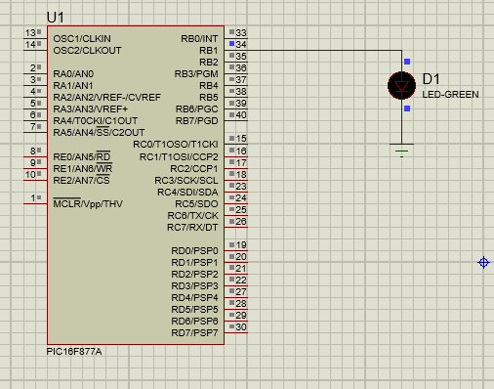

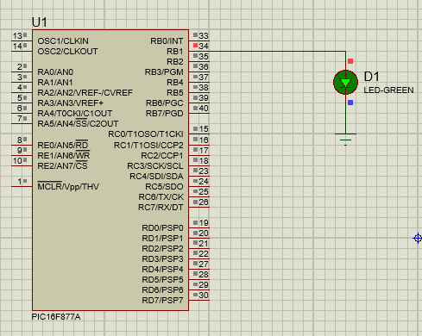



2). Write an embedded C program to blink the 1 LED . [ complete the simulation? ] / execute this using proteus 8 Professional Software ?

A).

#include <2 LED Blink.h>

#bit LED1=0X06.1

#bit TLED1=0X86.1

#bit LED2=0X07.1

#bit TLED2=0X87.1

void main()

{

TLED1=0;

LED1=0;

TLED2=0;

LED2=0;

while(TRUE)

{

LED1=1;

LED2=1;

delay_ms(1000);

LED1=0;

LED2=0;

delay_ms(1000);

}

}

**SIMULATION OUTPUT:**

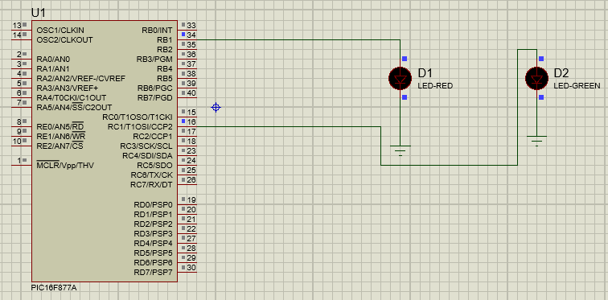

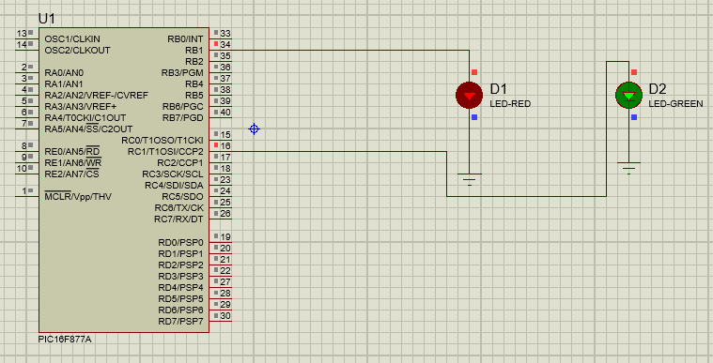



3). Write an embedded C program to blink the even LEDs one time & then some delay & then ODD LED blink & then some delay . [ complete the simulation? ] / execute this using proteus 8 Professional Software ?

A).

#include <8 LED even odd.h>

#bit LED1=0X06.0

#bit TLED1=0x86.0

#bit LED2=0X06.1

#bit TLED2=0X86.1

void main()

{

LED1=0;

TLED1=0;

LED2=0;

TLED2=0;

while(TRUE)

{

LED1=1;

delay_ms(1000);

LED1=0;

delay_ms(1000);

LED2=1;

delay_ms(1000);

LED2=0;

delay_ms(1000);

}

}

**SIMULATION OUTPUT:**

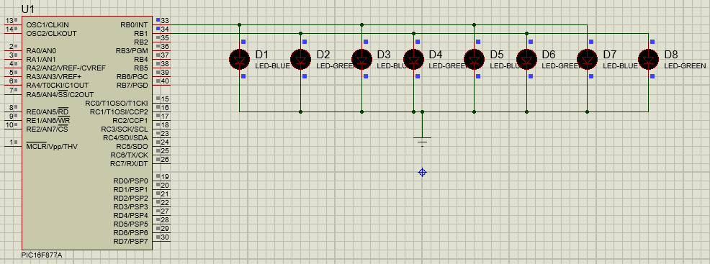

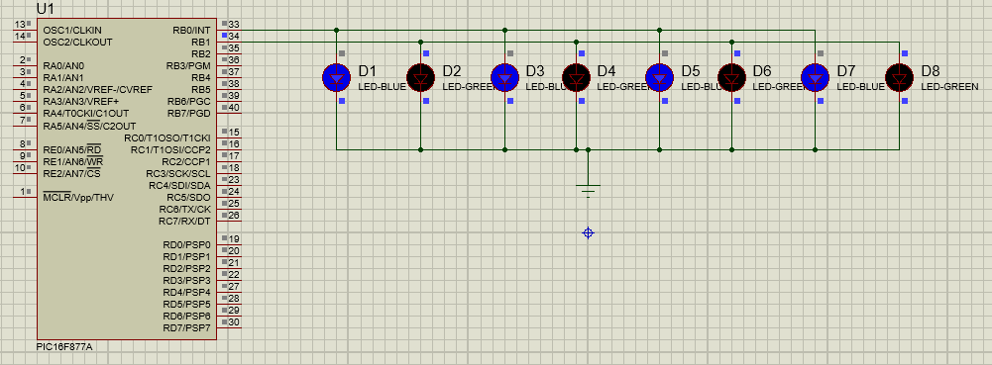



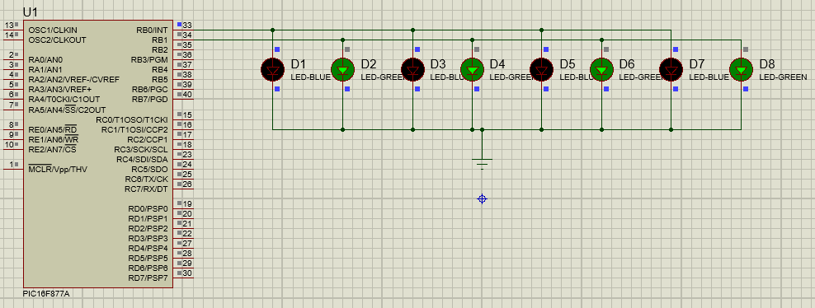



4). Write an embedded C program to blink 1 LED using 1 SWITCH . [ complete the simulation? ] / execute this using proteus 8 Professional Software ?

A).

#include <1 SWITCH 1 LED.h>

#bit sw=0X06.1

#bit tsw=0x86.1

#bit led=0x07.0

#bit tled=0x87.0

void main()

{

sw=0;

tsw=1;

led=0;

tled=0;

while(TRUE)

{

if(sw==1)

{

led=1;

}

else

{

led=0;

}

}

}

**SIMULATION OUTPUT:**

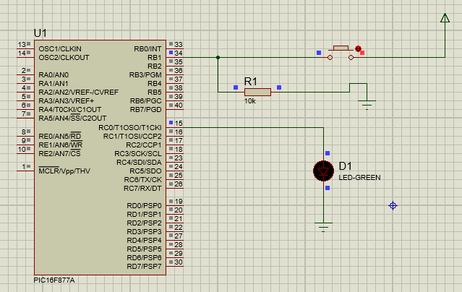

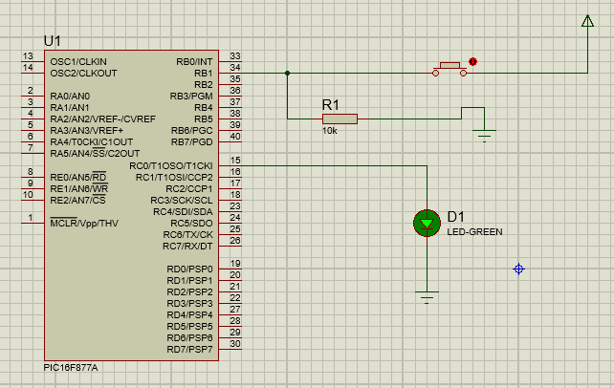

5). Write an embedded C program to blink 1 LED using 2 SWITCH,when one switch is pressed LED must turn ON & another switch is pressed Led must turn OFF. [ complete the simulation? ] / execute this using proteus 8 Professional Software ?

A).

#include <2 SWITCH 1 LED.h>

#bit sw1=0X06.0

#bit tsw1=0X86.0

#bit sw2=0x06.1

#bit tsw2=0X86.1

#bit LED=0X07.0

#bit TLED=0X87.0

void main()

{

sw1=0;

tsw1=1;

sw2=0;

tsw2=1;

LED=0;

TLED=0;

while(TRUE)

{

if(sw1==1)

{

LED=1;

}

if(sw2==1)

{

LED=0;

}

}

}

**SIMULATION OUTPUT:**

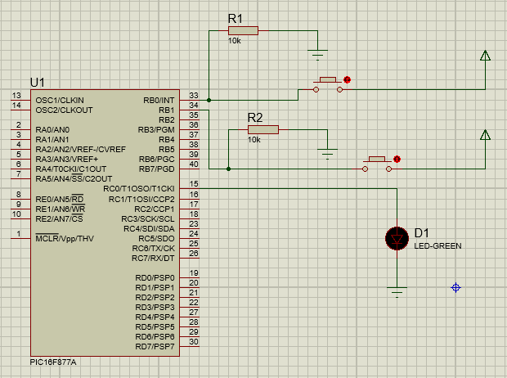

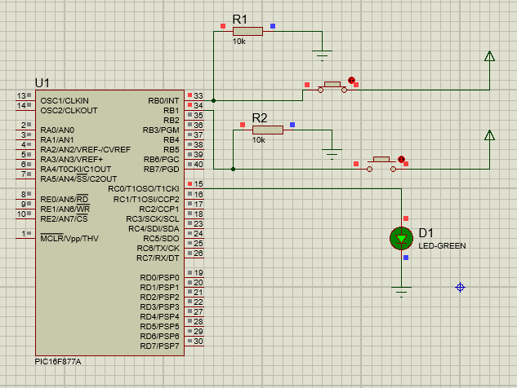

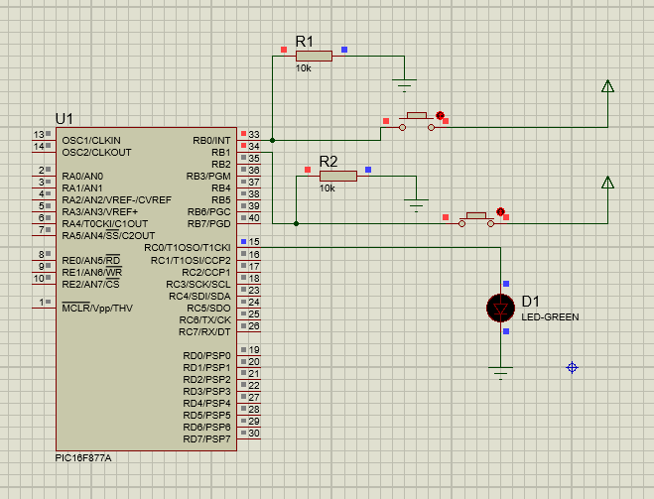

6). Write an embedded C program to turn the LED ON when only both switches are ON condition. [ complete the simulation? ] / execute this using proteus 8 Professional Software ?

A).

#include <2 ON SWITCH 1 LED.h>

#bit sw1=0x06.0

#bit tsw1=0x86.0

#bit sw2=0x06.1

#bit tsw2=0x86.1

#bit LED=0x07.0

#bit TLED=0x87.0

void main()

{

sw1=0;

tsw1=1;

sw2=0;

tsw2=1;

LED=0;

TLED=0;

while(TRUE)

{

if(sw1==1 && sw2==1)

{

LED=1;

}

else

{

LED=0;

}

}

}

**SIMULATION OUTPUT:**

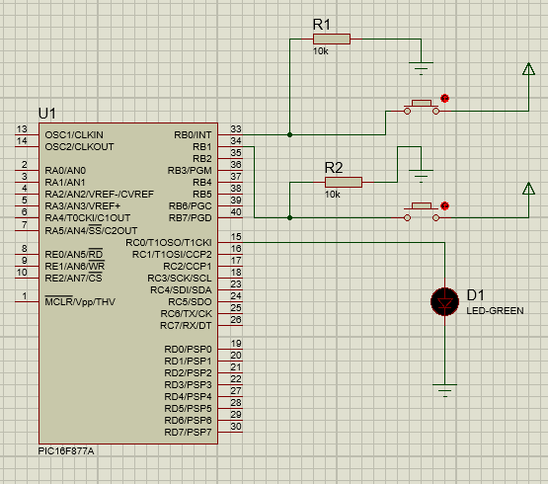

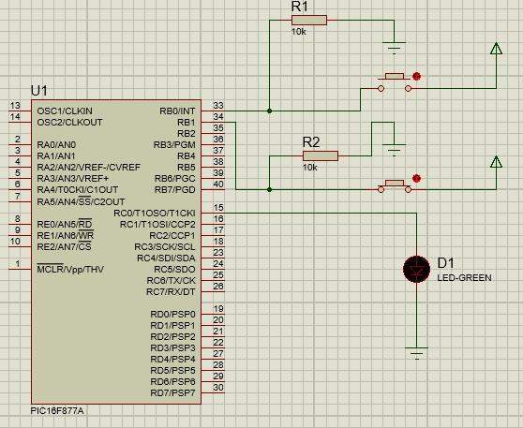

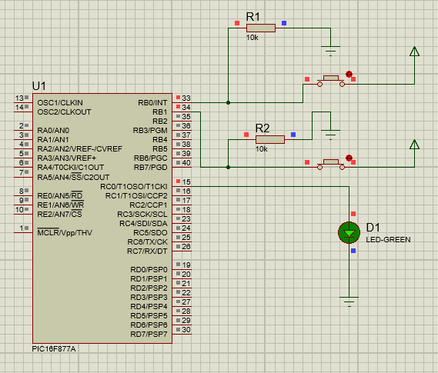

7). Write an embedded C program to display a Character on LCD. [ complete the simulation? ] / execute this using proteus 8 Professional Software ?

A).

#include <1 LCD DISPLAY A.h>

#byte LCD=0X08

#byte TLCD=0X88

#bit RS=0X07.0

#bit TRS=0X87.0

#bit EN=0X07.1

#bit TEN=0X87.1

void display(unsigned int A,unsigned int B)

{

LCD=A;

RS=B;

EN=1;

delay_ms(200);

EN=0;

}

void main()

{

LCD=0;

TLCD=0;

RS=0;

TRS=0;

EN=0;

TEN=0;

display(0X0C,0);

display(0X38,0);

while(TRUE)

{

display(0X80,0);

display('A',1);

}

}

**SIMULATION OUTPUT:**

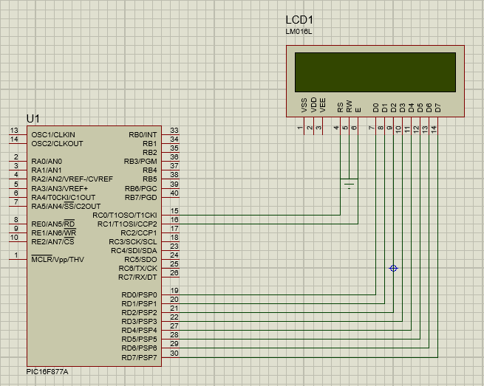

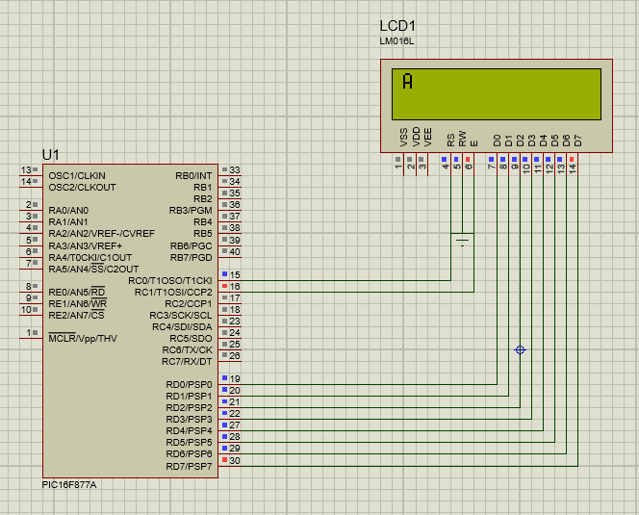

8). Write an embedded C program to display a Word/name/QISCET on LCD. [ complete the simulation? ] / execute this using proteus 8 Professional Software ?

A).

#include <1 LCD DISPLAY QISCET & ECE.h>

#byte LCD=0X08

#byte TLCD=0X88

#bit RS=0X07.0

#bit TRS=0X87.0

#bit EN=0X07.1

#bit TEN=0X87.1

void display(unsigned int A,unsigned int B)

{

LCD=A;

RS=B;

EN=1;

delay_ms(200);

EN=0;

}

void main()

{

LCD=0;

TLCD=0;

RS=0;

TRS=0;

EN=0;

TEN=0;

display(0X0C,0);

display(0X38,0);

while(TRUE)

{

display(0X80,0);

display('Q',1);

display(0X81,0);

display('I',1);

display(0X82,0);

display('S',1);

display(0X83,0);

display('C',1);

display(0X84,0);

display('E',1);

display(0X85,0);

display('T',1);

display(0XC0,0);

display('E',1);

display(0XC1,0);

display('C',1);

display(0XC2,0);

display('E',1);

}

}

**SIMULATION OUTPUT:**



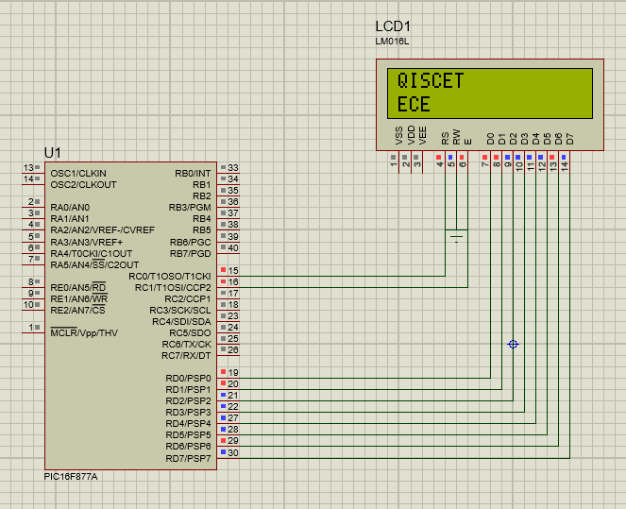

9). Write an embedded C program to display a Word/name/QISCET on LCD using Strings. [ complete the simulation? ] / execute this using proteus 8 Professional Software ?

A).

#include <1 LCD DISPLAY A.h>

#byte LCD=0X08

#byte TLCD=0X88

#bit RS=0X07.0

#bit TRS=0X87.0

#bit EN=0X07.1

#bit TEN=0X87.1

char STR[8]="QISCET";

void display(unsigned int A,unsigned int B)

{

LCD=A;

RS=B;

EN=1;

delay_ms(200);

EN=0;

}

void display_string(char *str)

{

for(int i=0;str[i]!=0;i++)

{

display(str[i],1);

delay_ms(200);

}

}

void main()

{

LCD=0;

TLCD=0;

RS=0;

TRS=0;

EN=0;

TEN=0;

display(0X0C,0);

display(0X38,0);

while(TRUE)

{

display(0X85,0);

display_string(STR);

}

}

**SIMULATION OUTPUT:**

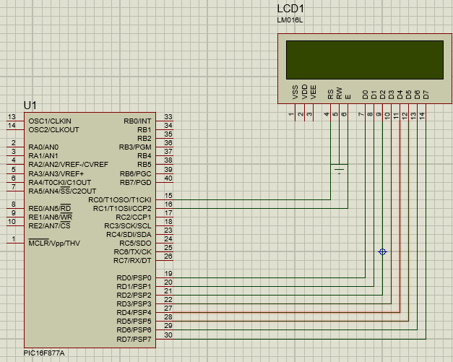

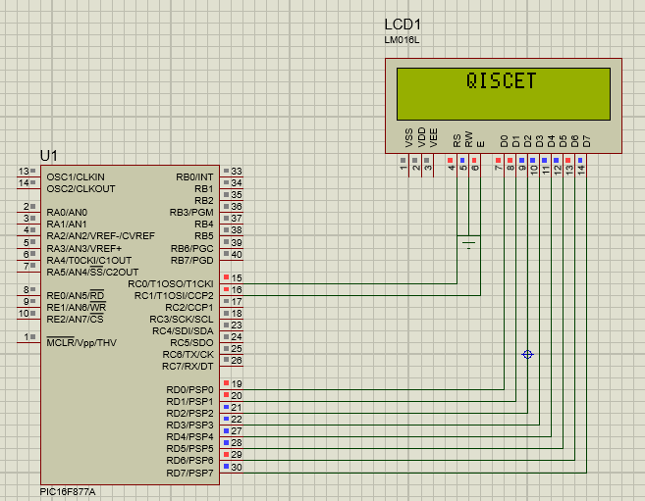

10). Write an embedded C program to turn the LEDS ,LED-1 will be turned ON when COUNT>=0, LED-2 will be turned ON when COUNT>=5, LED-3 will be turned ON when COUNT>=8, LED-4 will be turned ON when COUNT>=10, using Two Switches for increamenting and decreamenting the COUNT. [ complete the simulation? ] / execute this using proteus 8 Professional Software ?

A).

#include <SENSOR TYPE 3.h>

#byte LCD=0x08

#byte TLCD=0x88

#bit RS=0x07.6

#bit TRS=0x87.6

#bit EN=0x07.7

#bit TEN=0x87.7

#bit SW1=0x07.0

#bit TSW1=0x87.0

#bit SW2=0x07.1

#bit TSW2=0x87.1

#bit LED1=0x06.0

#bit TLED1=0x86.0

#bit LED2=0x06.1

#bit TLED2=0x86.1

#bit LED3=0x06.2

#bit TLED3=0x86.2

#bit LED4=0x06.3

#bit TLED4=0x86.3

char str[10]="COUNT : ";

int count=0;

VOID display(unsigned int A,unsigned int B)

{

LCD=A;

RS=B;

EN=1;

delay_ms(200);

EN=0;

}

void display_string(char *str)

{

for(int j=0;str[j]!=0;j++)

{

display(str[j],1);

delay_ms(200);

}

}

void main()

{

SW1=0;

TSW1=1;

SW2=0;

TSW2=1;

LCD=0;

TLCD=0;

RS=0;

TRS=0;

EN=0;

TEN=0;

LED1=0;

TLED1=0;

LED2=0;

TLED2=0;

LED3=0;

TLED3=0;

LED4=0;

TLED4=0;

display(0x0c,0);

display(0x38,0);

while(TRUE)

{

display(0X80,0);

display_string(str);

if(SW1==1)

{

while(SW1==1);

count+=1;

}

if(SW2==1)

{

while(SW2==1);

count-=1;

}

display(0x89,0);

display((count/10)+0x30,1);

display(0x8A,0);

display((count%10)+0x30,1);

if(count>=1)

{

LED1=1;

}

else

{

LED1=0;

}

if(count>=5)

{

LED2=1;

}

else

{

LED2=0;

}

if(count>=8)

{

LED3=1;

}

else

{

LED3=0;

}

if(count>9)

{

LED4=1;

}

else

{

LED4=0;

}

}

}

**SIMULATED OUTPUT:**

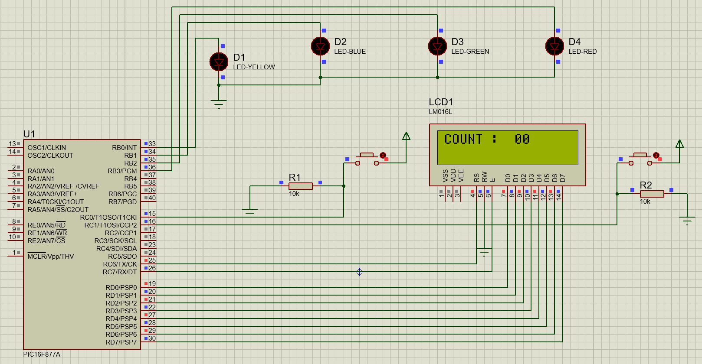

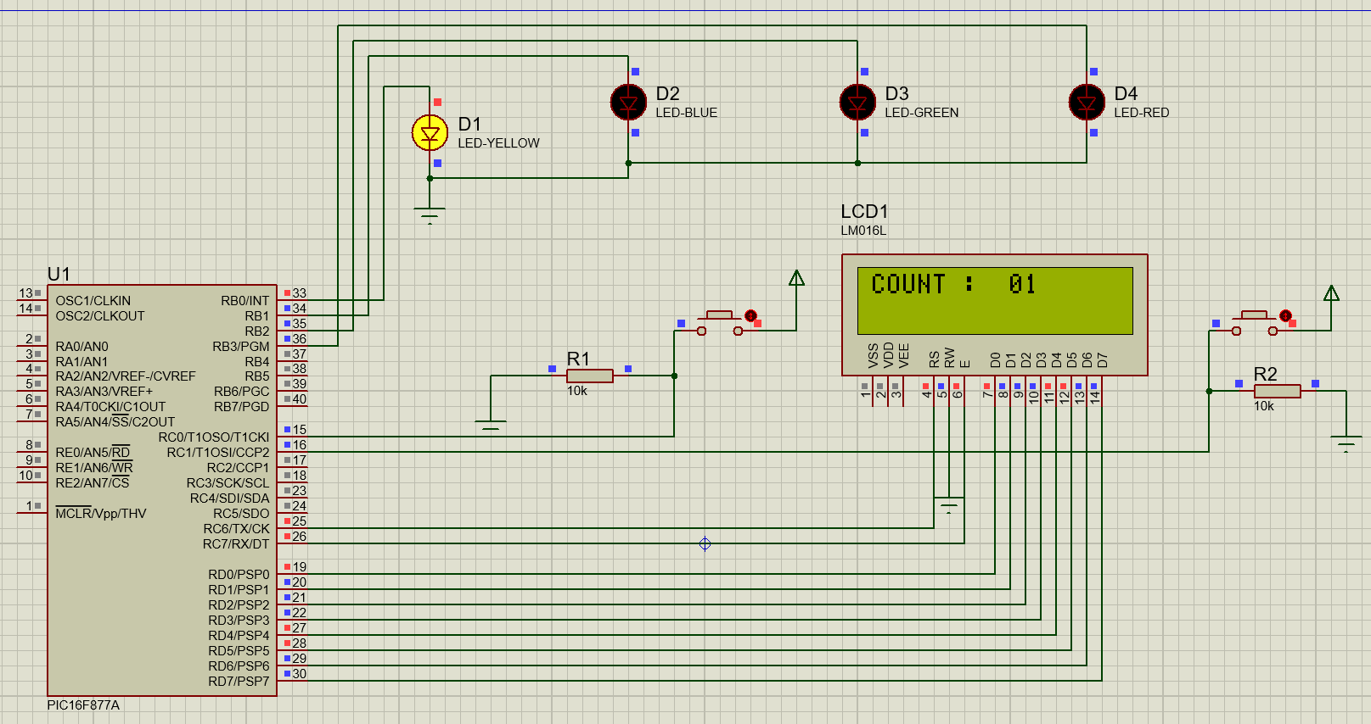 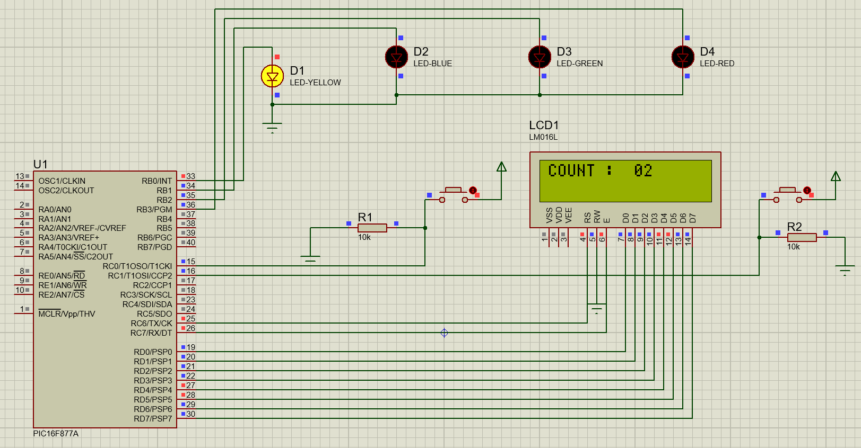 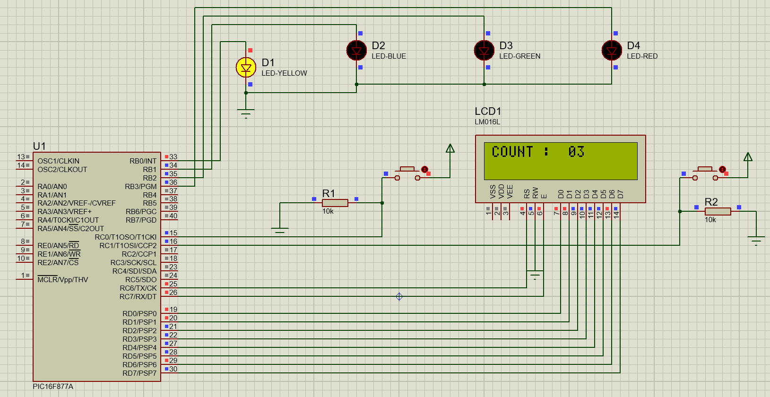 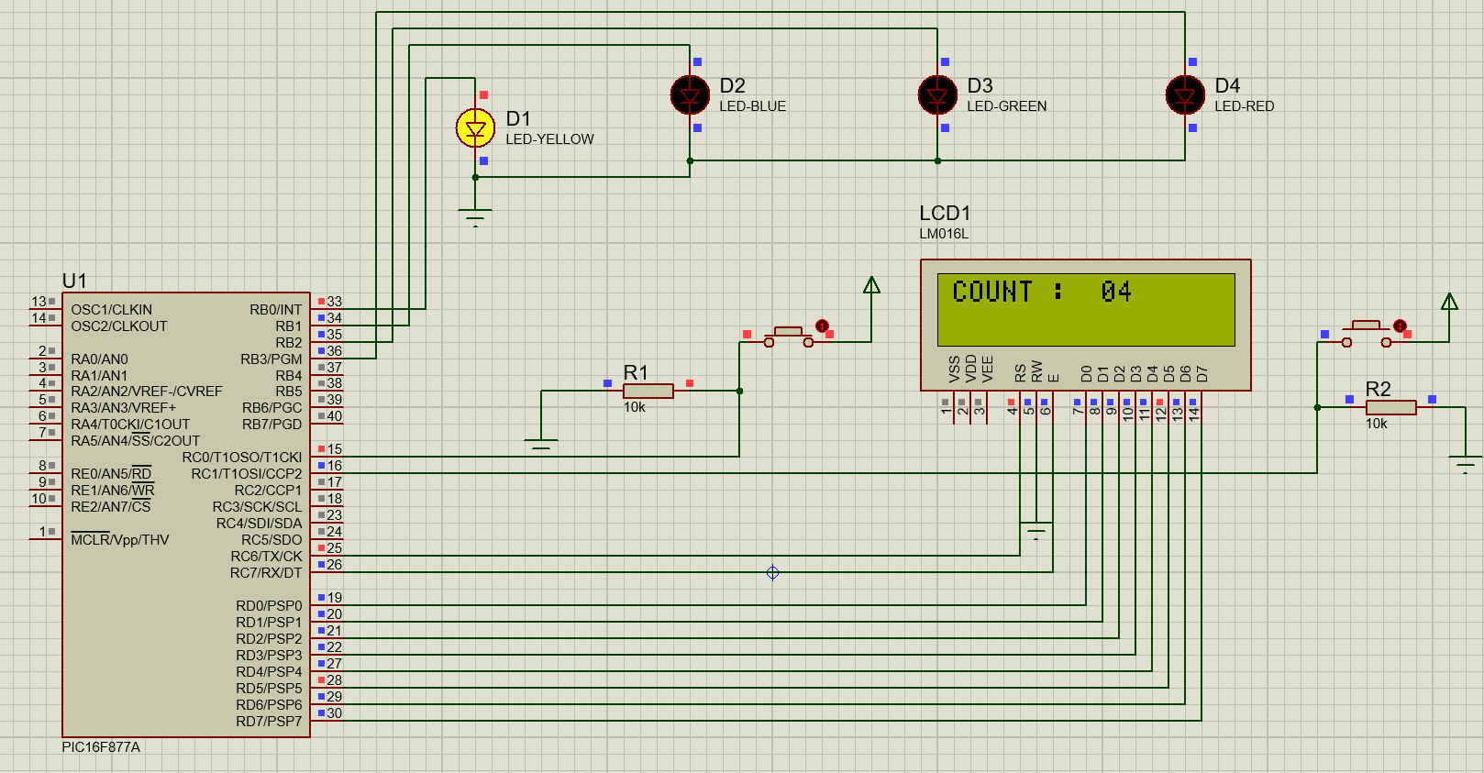 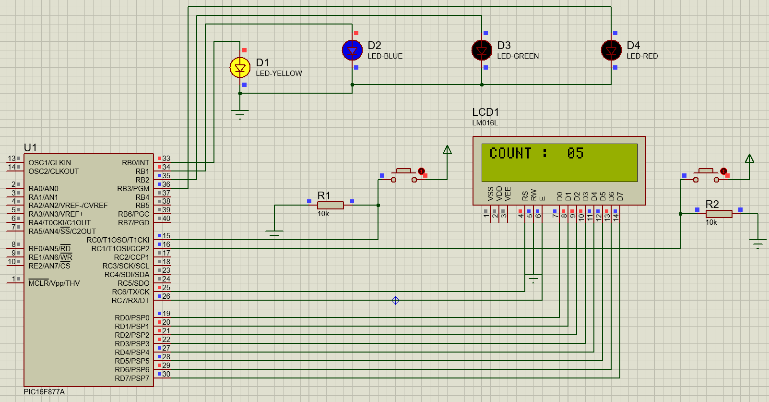 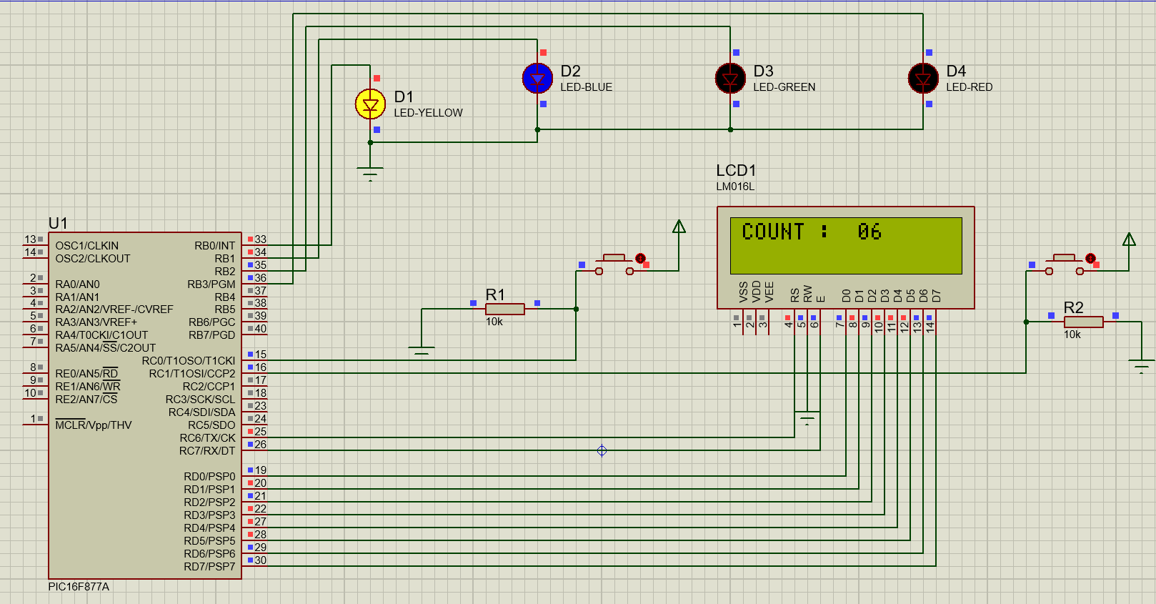 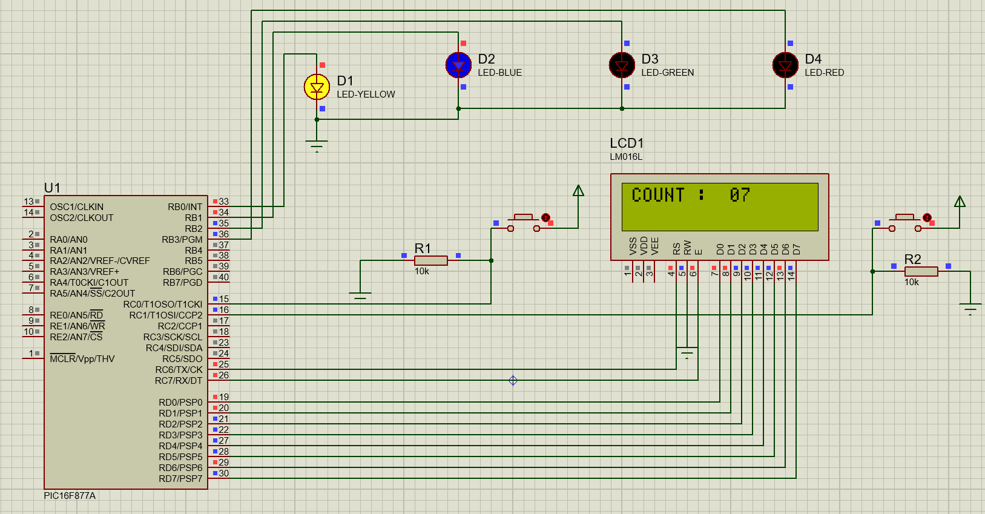 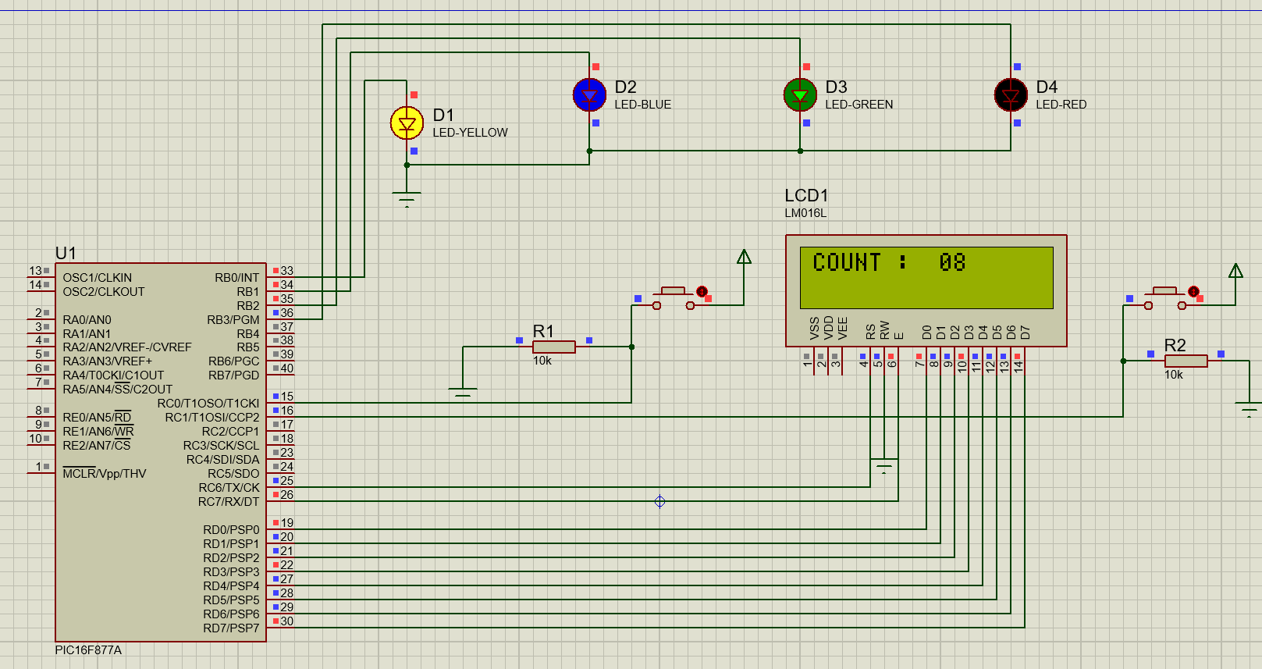 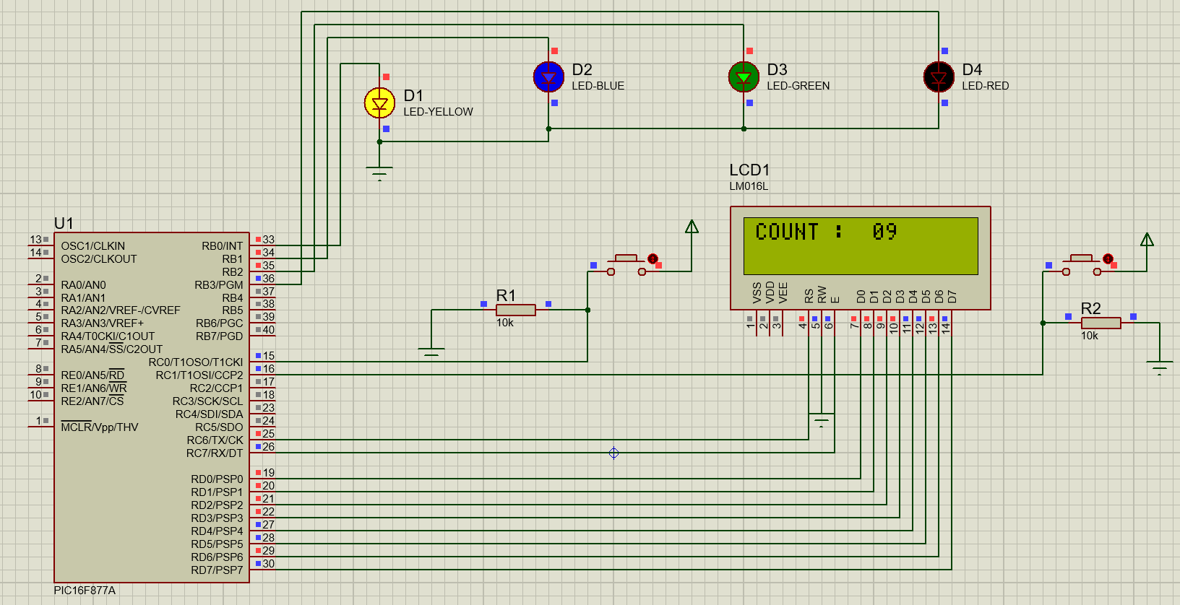 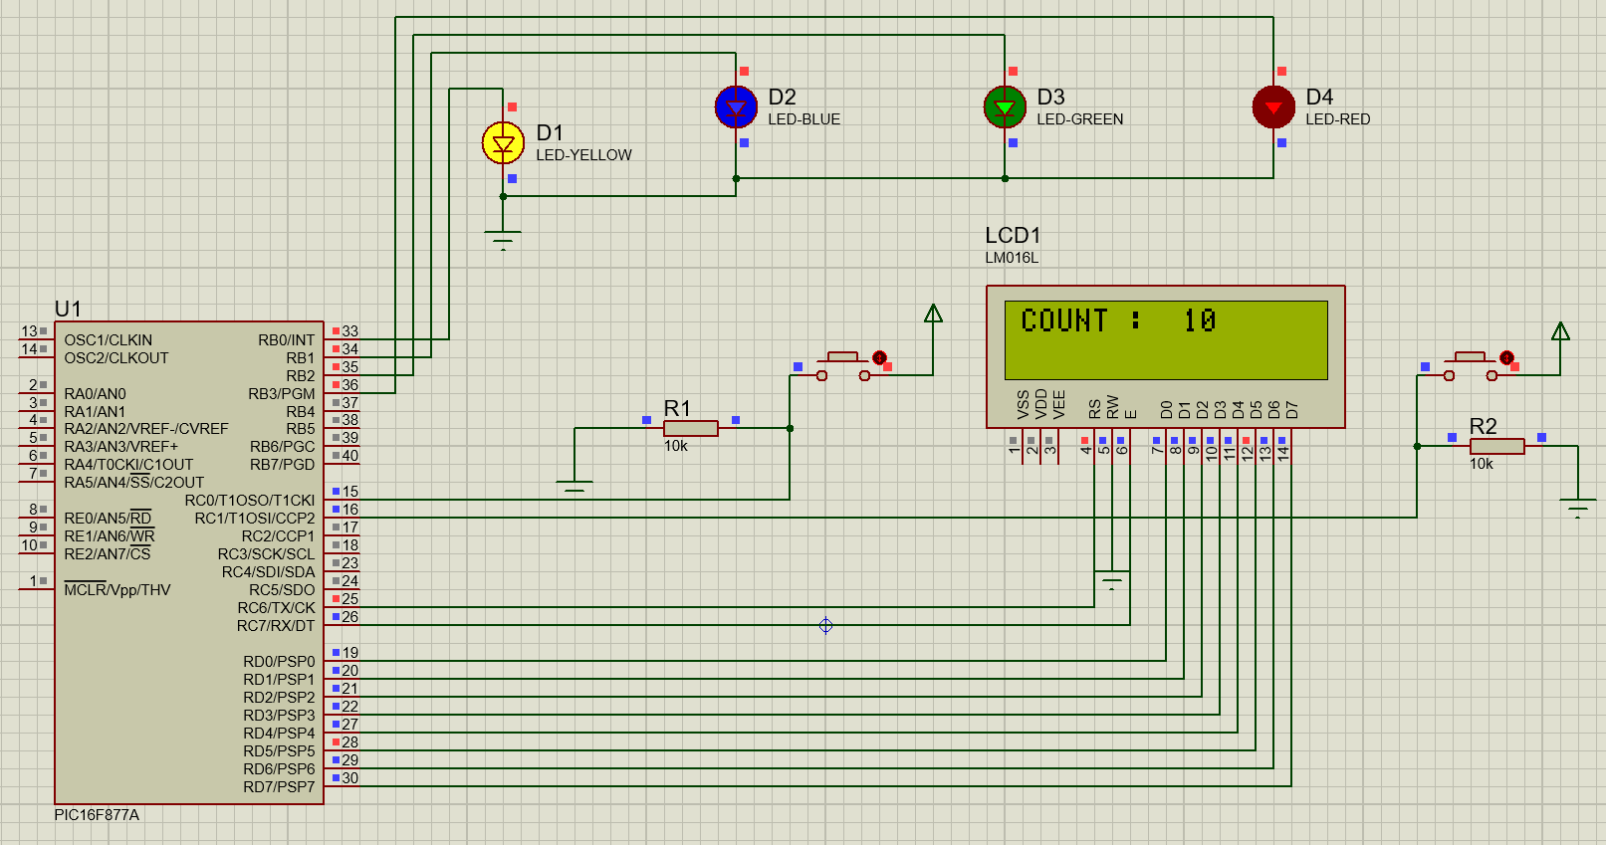

11). Write an embedded C Program when switch-1 is pressed LEDs will be turned On ,when switch-2 is pressed LEDs will be turned OFF,Use 8 LEDs . [ complete the simulation? ] / execute this using proteus 8 Professional Software ?

A).

#include <2 SWITCH 8 LED INC DEC 3.h>

#bit LED1=0x06.0

#bit TLED1=0x86.0

#bit LED2=0x06.1

#bit TLED2=0x86.1

#bit LED3=0x06.2

#bit TLED3=0x86.2

#bit LED4=0x06.3

#bit TLED4=0x86.3

#bit LED5=0x06.4

#bit TLED5=0x86.4

#bit LED6=0x06.5

#bit TLED6=0x86.5

#bit LED7=0x06.6

#bit TLED7=0x86.6

#bit LED8=0x06.7

#bit TLED8=0x86.7

#bit SW1=0x07.6

#bit TSW1=0x87.6

#bit SW2=0x07.7

#bit TSW2=0x87.7

int count=0;

void main()

{

LED1=0;

TLED1=0;

LED2=0;

TLED2=0;

LED3=0;

TLED3=0;

LED4=0;

TLED4=0;

LED5=0;

TLED5=0;

LED6=0;

TLED6=0;

LED7=0;

TLED7=0;

LED8=0;

TLED8=0;

SW1=0;

TSW1=1;

SW2=0;

TSW2=1;

while(TRUE)

{

if(SW1==1)

{

while(SW1==1);

count+=1;

}

if(SW2==1)

{

while(SW2==1);

count-=1;

}

if(count>=1 && count<=8)

{

LED1=1;

delay_ms(200);

}

else

{

LED1=0;

delay_ms(200);

}

if(count>=2 && count<=8)

{

LED2=1;

delay_ms(200);

}

else

{

LED2=0;

delay_ms(200);

}

if(count>=3 && count<=8)

{

LED3=1;

delay_ms(200);

}

else

{

LED3=0;

delay_ms(200);

}

if(count>=4 && count<=8)

{

LED4=1;

delay_ms(200);

}

else

{

LED4=0;

delay_ms(200);

}

if(count>=5 && count<=8)

{

LED5=1;

delay_ms(200);

}

else

{

LED5=0;

delay_ms(200);

}

if(count>=6 && count<=8)

{

LED6=1;

delay_ms(200);

}

else

{

LED6=0;

delay_ms(200);

}

if(count>=7 && count<=8)

{

LED7=1;

delay_ms(200);

}

else

{

LED7=0;

delay_ms(200);

}

if(count==8)

{

LED8=1;

delay_ms(200);

}

else

{

LED8=0;

delay_ms(200);

}

}

}

**SIMULATED OUTPUT:**

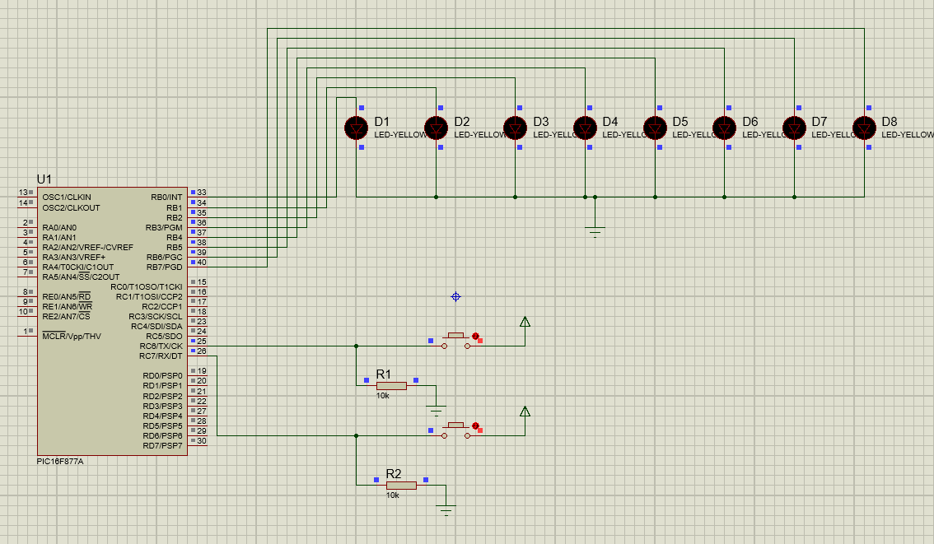

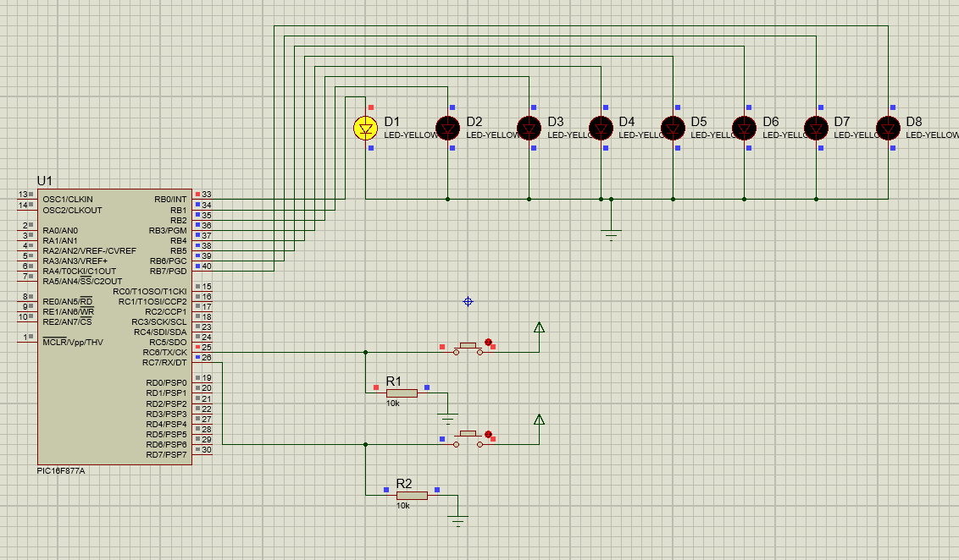 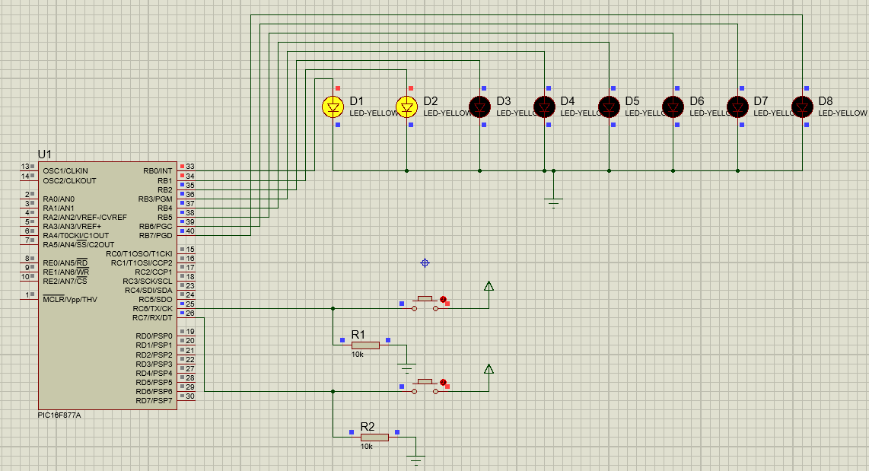 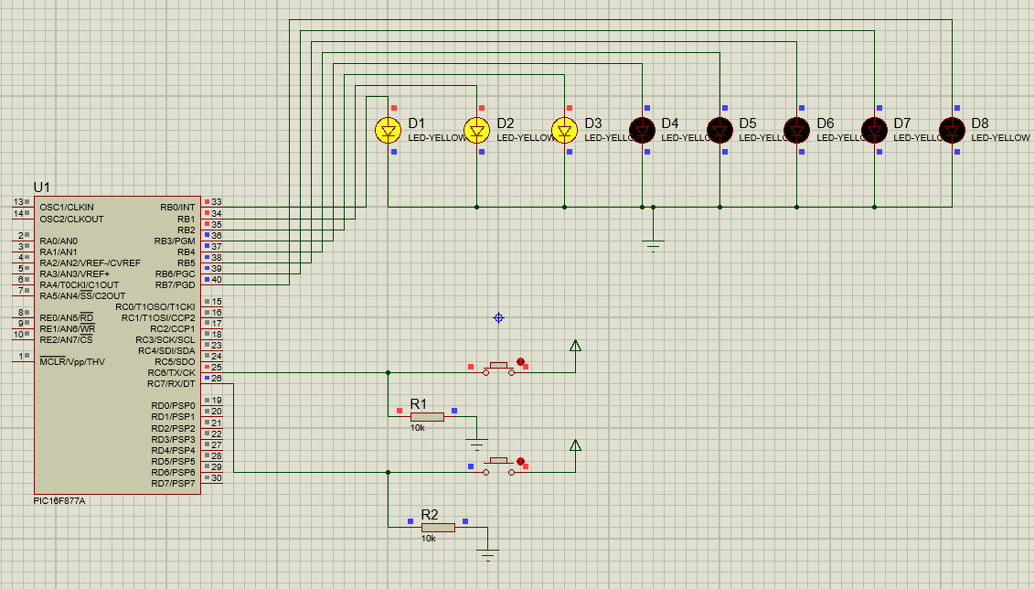 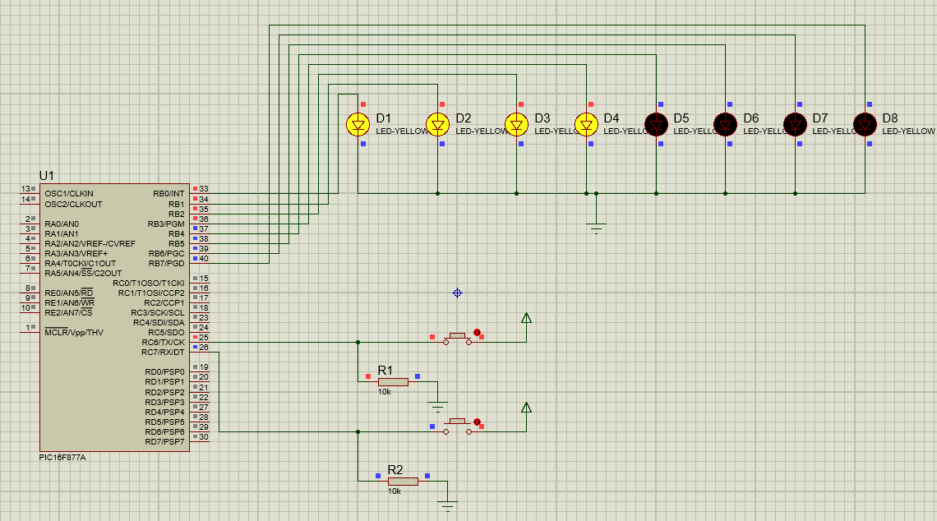 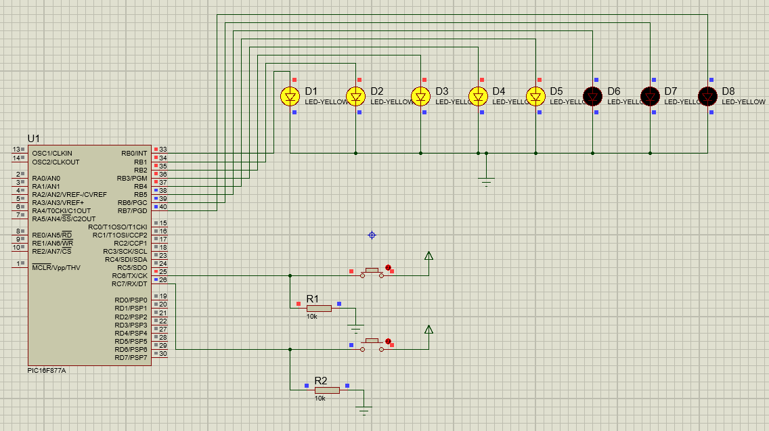 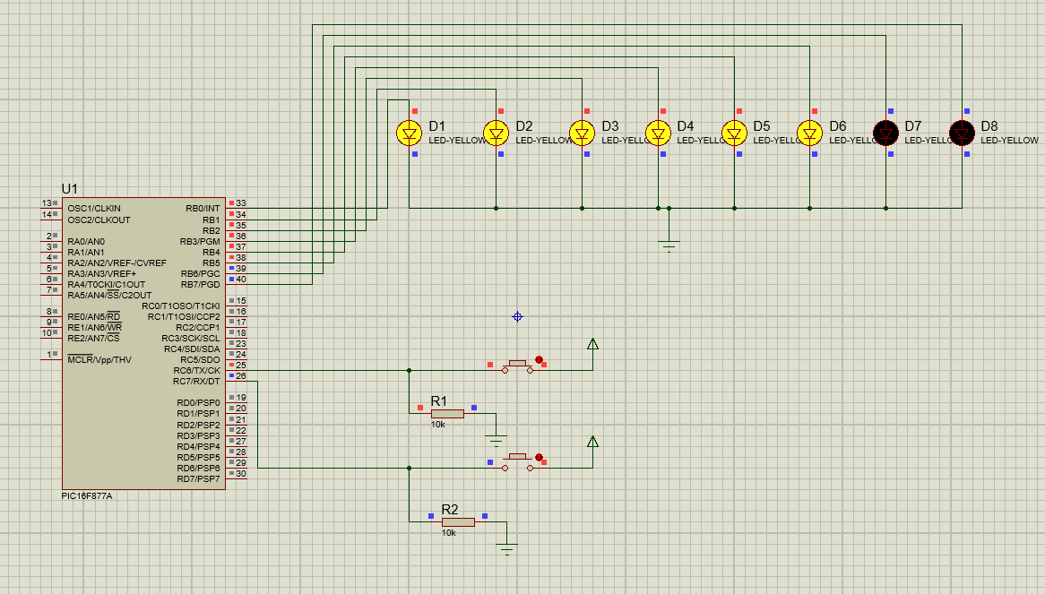 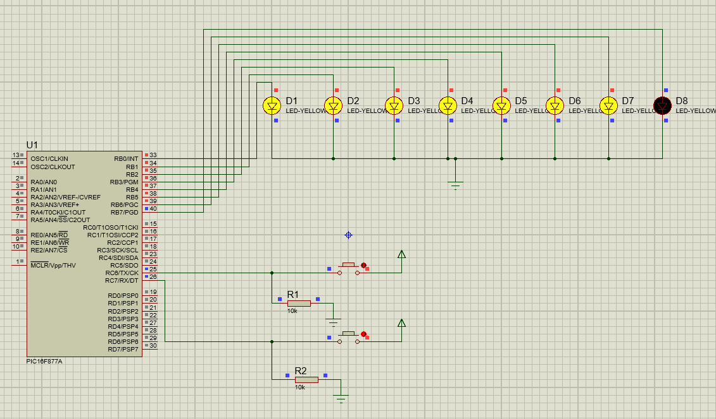 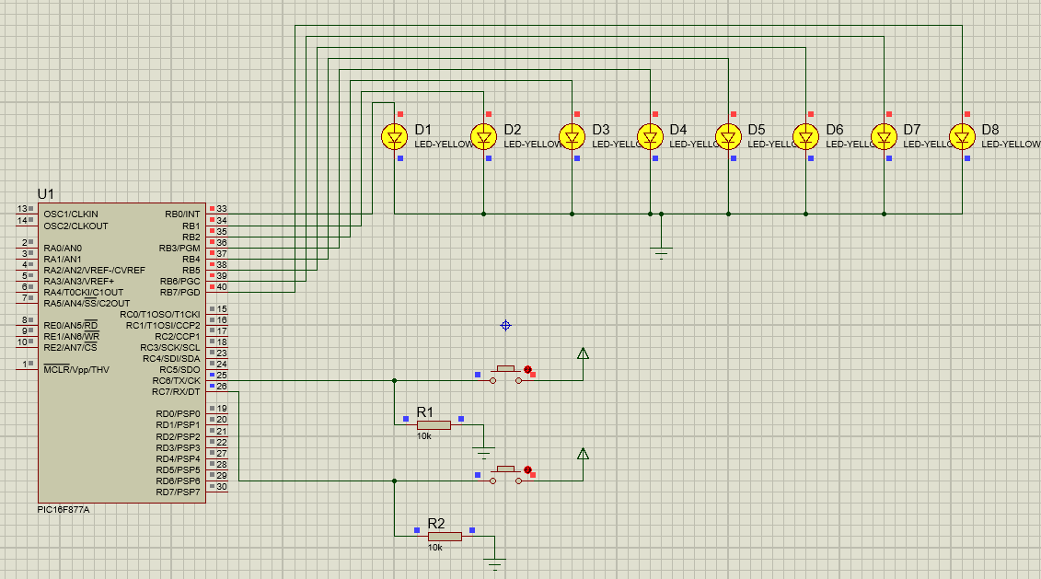 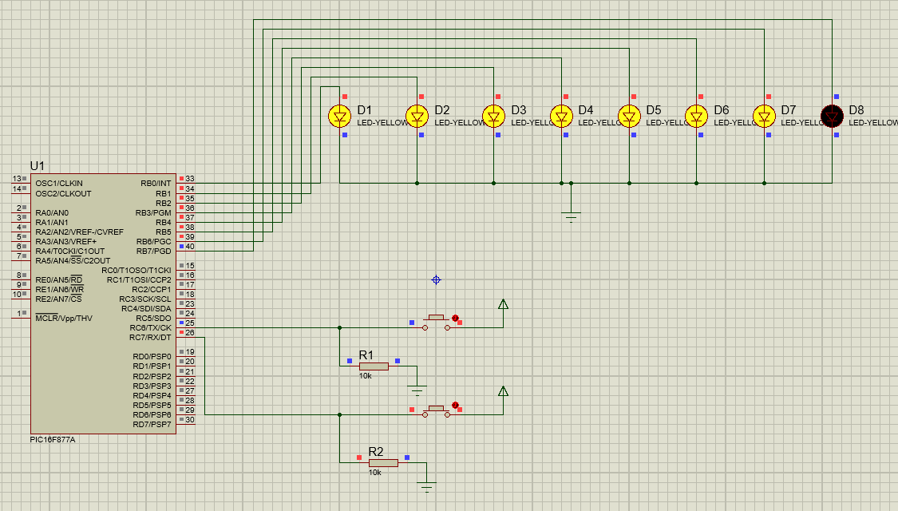 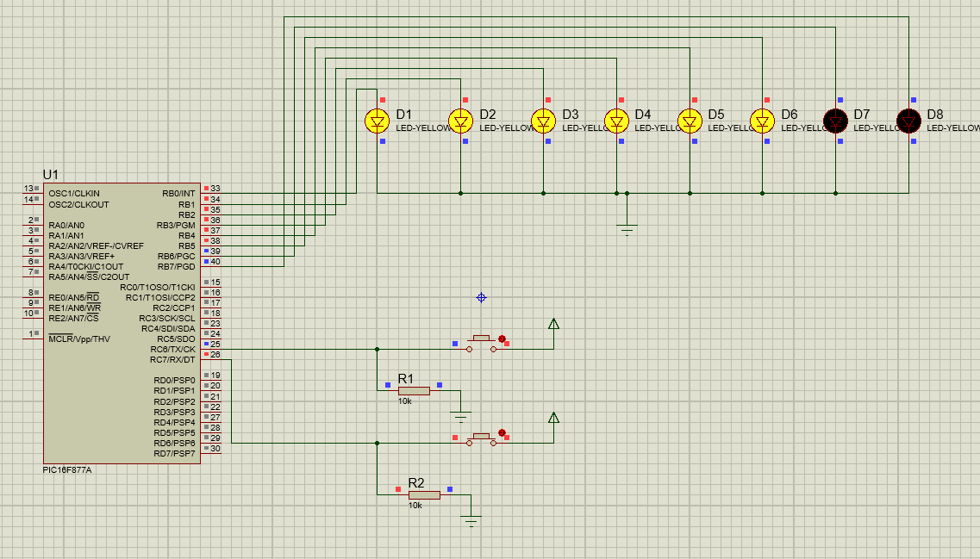 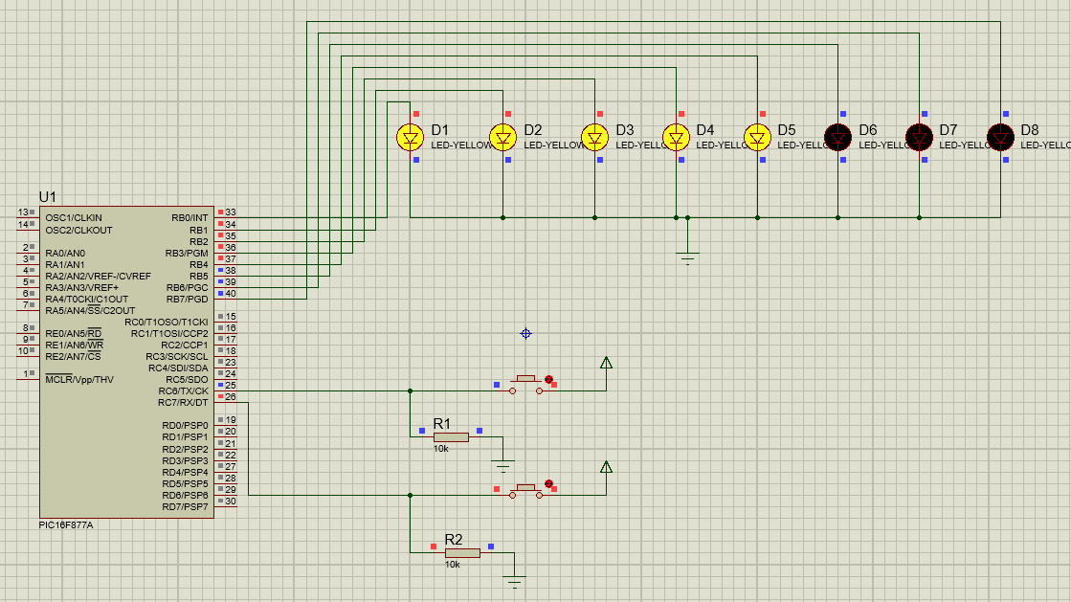 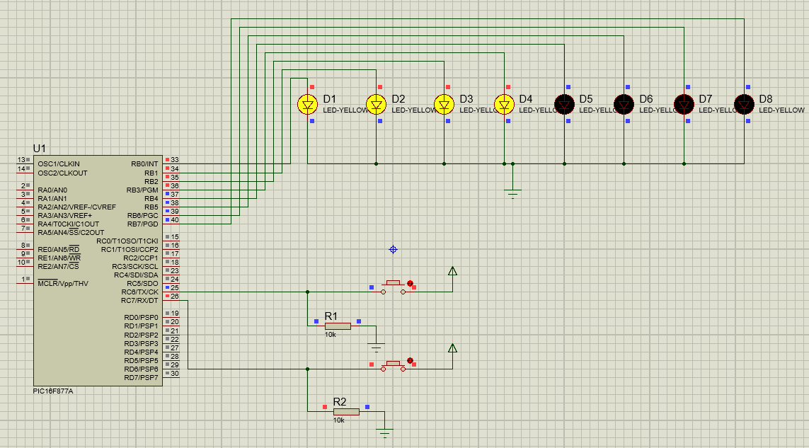 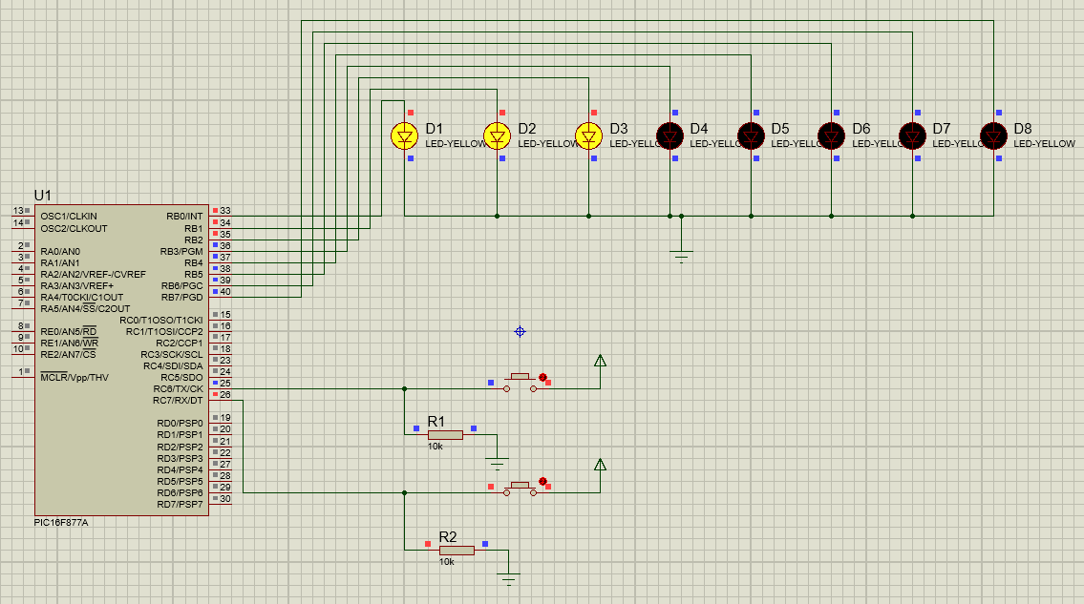 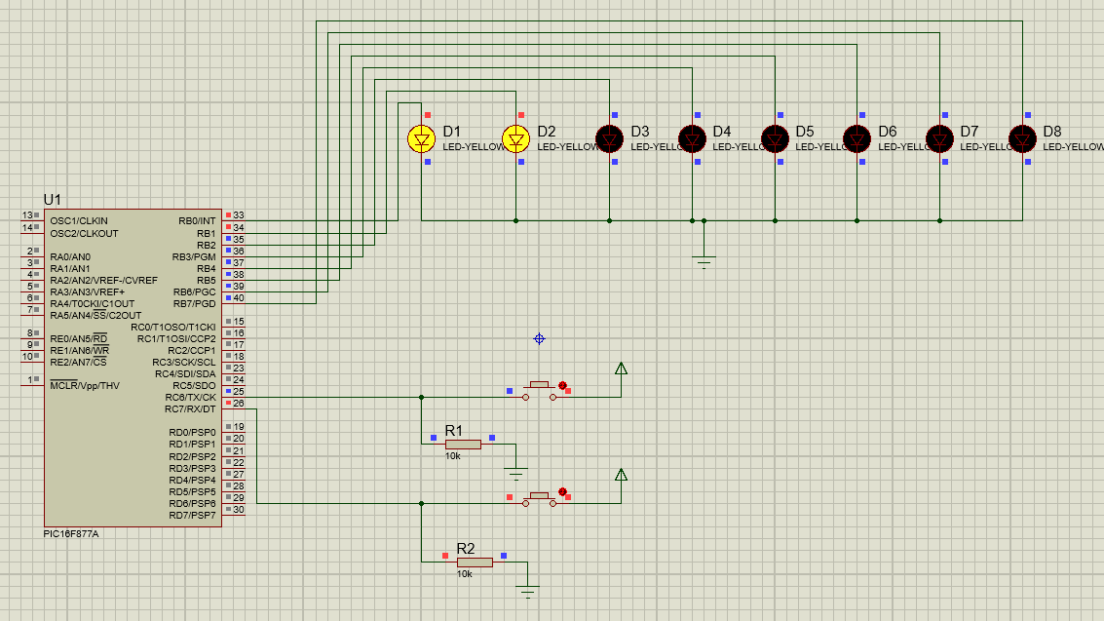 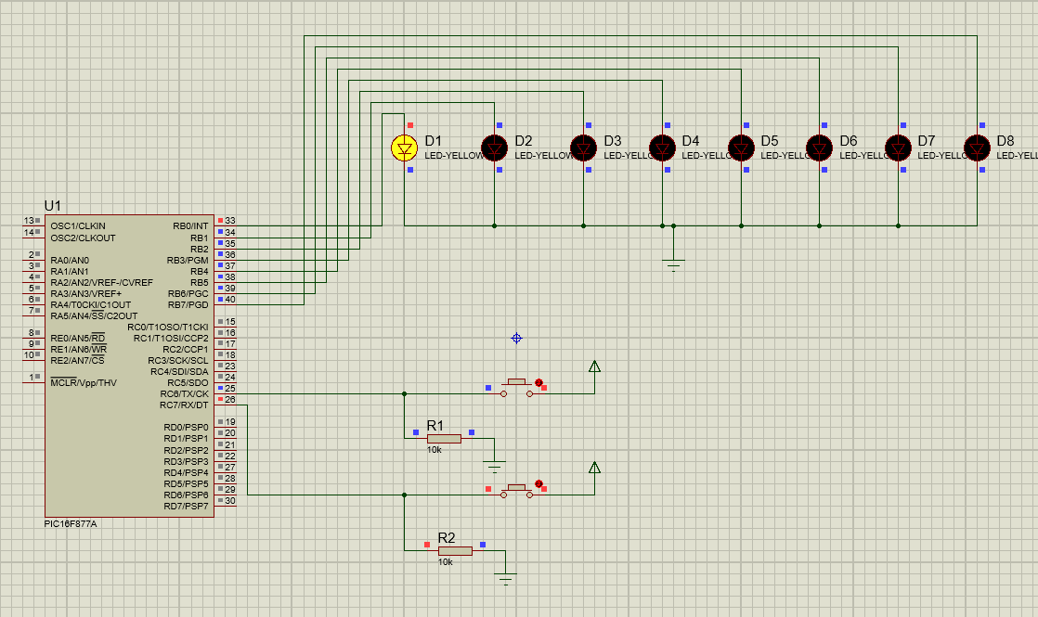 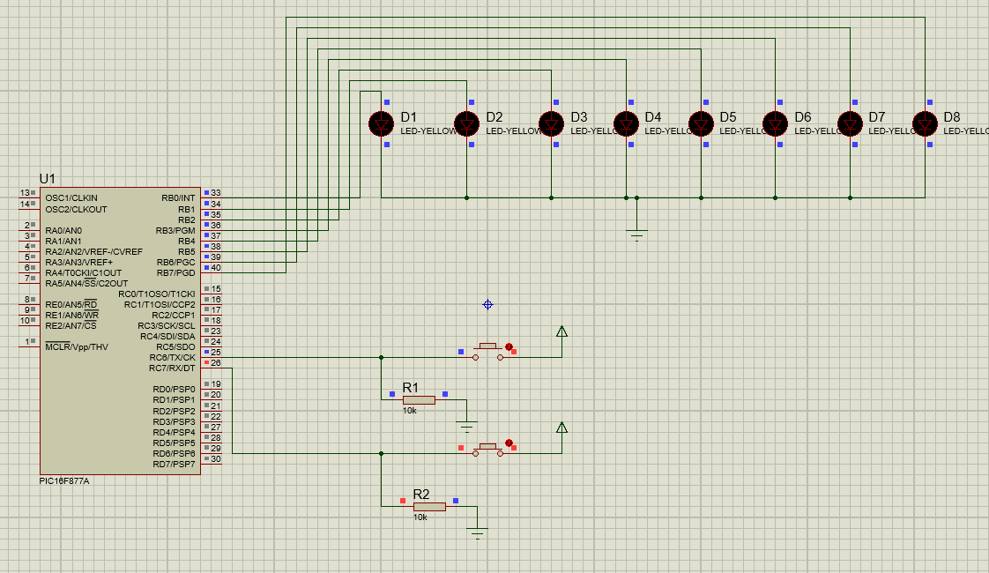

12). Write an embedded C Program for ADC . [ complete the simulation? ] / execute this using proteus 8 Professional Software ?

A).

#include <ADC1.h>

#byte LCD=0x08

#byte TLCD=0x88

#bit RS=0x07.6

#bit TRS=0x87.6

#bit EN=0x07.7

#bit TEN=0x87.7

#byte ADCON0=0x1F

#byte ADRESH=0x1E

#byte ADCON1=0x9F

#byte ADRESL=0x9E

#bit GO_DOWN=0X1F.2

void display(char,int);

void main()

{

ADCON0=0x01;

LCD=0x00;

RS=0;

EN=0;

TEN=0;

TLCD=0;

TRS=0;

ADCON1=0x80;

long int RESULT,adres;

int a,b,c,d,e,f;

while(TRUE)

{

GO_DOWN=1;

display(0x38,0);

display(0x0e,0);

display(0xc0,0);

adres=ADRESH;

delay_ms(200);

RESULT=ADRESL|adres<<8;

delay_ms(200);

a=RESULT/1000;

b=RESULT%1000;

c=b/100;

d=b%100;

e=d/10;

f=d%10;

display(a+0x30,1);

delay_ms(200);

display(c+0x30,1);

delay_ms(200);

display(e+0x30,1);

delay_ms(200);

display(f+0x30,1);

delay_ms(200);

}

}

void display(char x,int y)

{

LCD=x;

RS=y;

EN=1;

delay_ms(3);

EN=0;

delay_ms(3);

}

**SIMULATED OUTPUT:**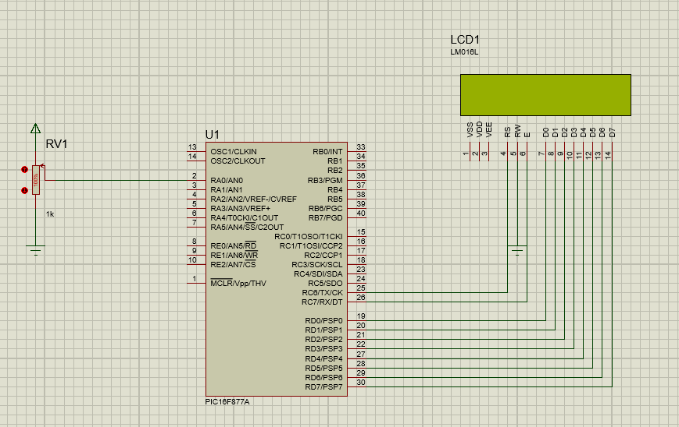 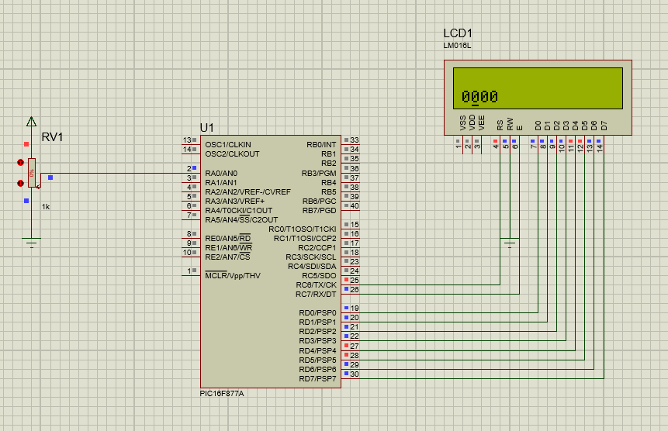 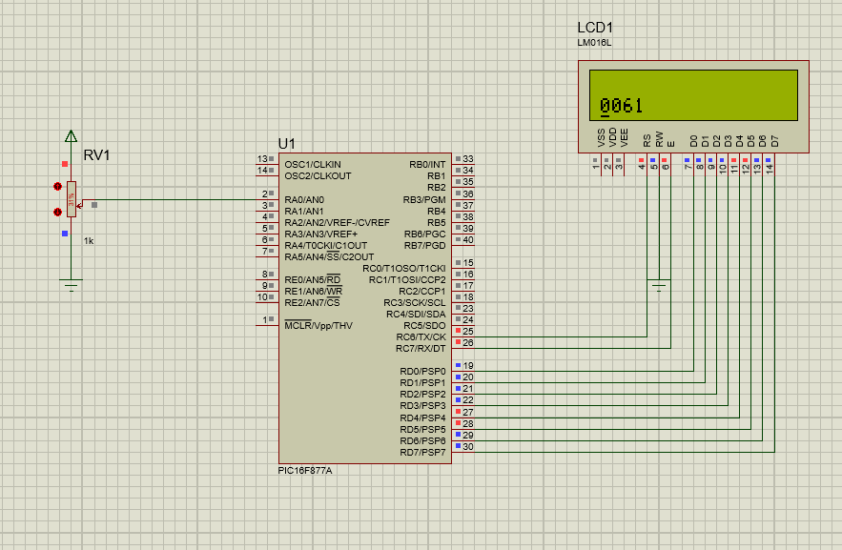 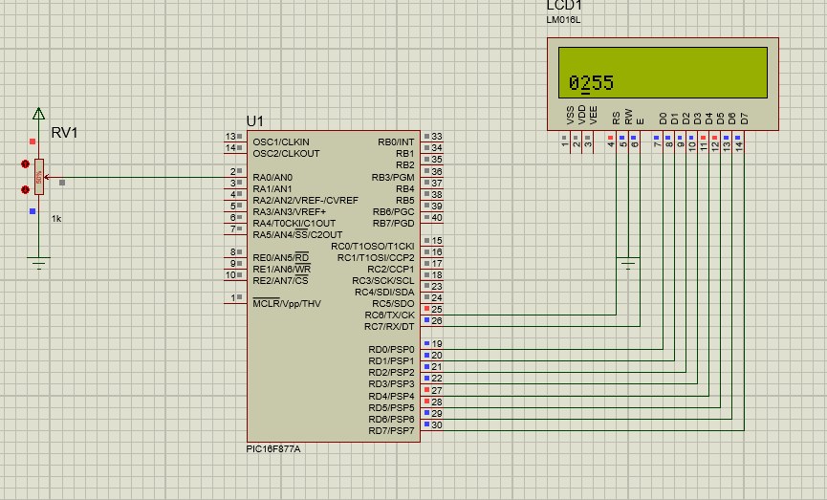

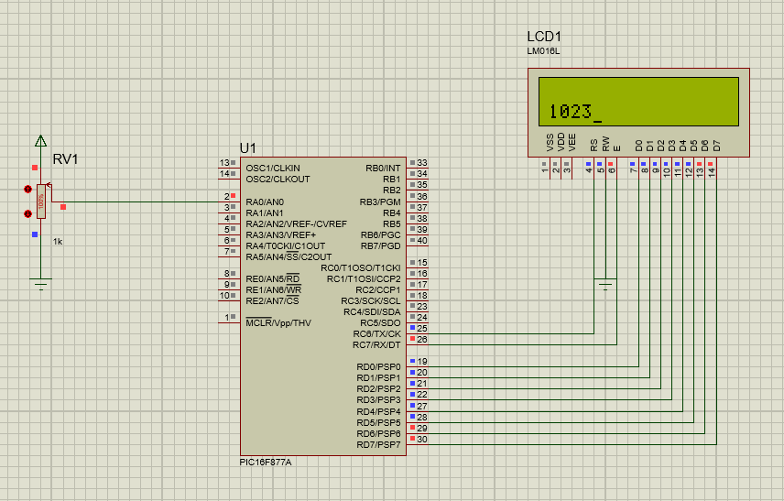

13). Write an embedded C Program for turning ON the LEDS, when ADC value greater than zero LED-1 will be turned On, when ADC value greater than 250 LED-2 will be turned On, when ADC value greater than 500 LED-3 will be turned On, when ADC value greater than 1000 LED-4 will be turned On. [ complete the simulation?] / execute this using proteus 8 Professional Software?

A).

#include <4 LED ADC count.h>

#byte LCD=0x08

#byte TLCD=0x88

#bit RS=0x07.6

#bit TRS=0x87.6

#bit EN=0x07.7

#bit TEN=0x87.7

#bit LED1=0x06.0

#bit TLED1=0x86.0

#bit LED2=0x06.1

#bit TLED2=0x86.1

#bit LED3=0x06.2

#bit TLED3=0x86.2

#bit LED4=0x06.3

#bit TLED4=0x86.3

#byte ADCON0=0x1F

#byte ADRESH=0x1E

#byte ADCON1=0x9F

#byte ADRESL=0x9E

#bit GO_DOWN=0X1F.2

void display(char ,int);

void main()

{

ADCON0=0x01;

LCD=0x00;

RS=0;

EN=0;

TEN=0;

TLCD=0;

TRS=0;

LED1=0;

TLED1=0;

LED2=0;

TLED2=0;

LED3=0;

TLED3=0;

LED4=0;

TLED4=0;

ADCON1=0x80;

long int RESULT,adres;

int a,b,c,d,e,f;

while(TRUE)

{

GO_DOWN=1;

display(0x38,0);

display(0x0e,0);

display(0xc0,0);

adres=ADRESH;

delay_ms(200);

RESULT=ADRESL|adres<<8;

delay_ms(200);

a=RESULT/1000;

b=RESULT%1000;

c=b/100;

d=b%100;

e=d/10;

f=d%10;

display(a+0x30,1);

delay_ms(200);

display(c+0x30,1);

delay_ms(200);

display(e+0x30,1);

delay_ms(200);

display(f+0x30,1);

delay_ms(200);

if(RESULT>=250)

{

LED1=1;

}

else

{

LED1=0;

}

if(RESULT>=500)

{

LED2=1;

}

else

{

LED2=0;

}

if(RESULT>=750)

{

LED3=1;

}

else

{

LED3=0;

}

if(RESULT>=1000)

{

LED4=1;

}

else

{

LED4=0;

}

}

}

void display(char x,int y)

{

LCD=x;

RS=y;

EN=1;

delay_ms(3);

EN=0;

delay_ms(3);

}

**SIMULATED OUTPUT:**

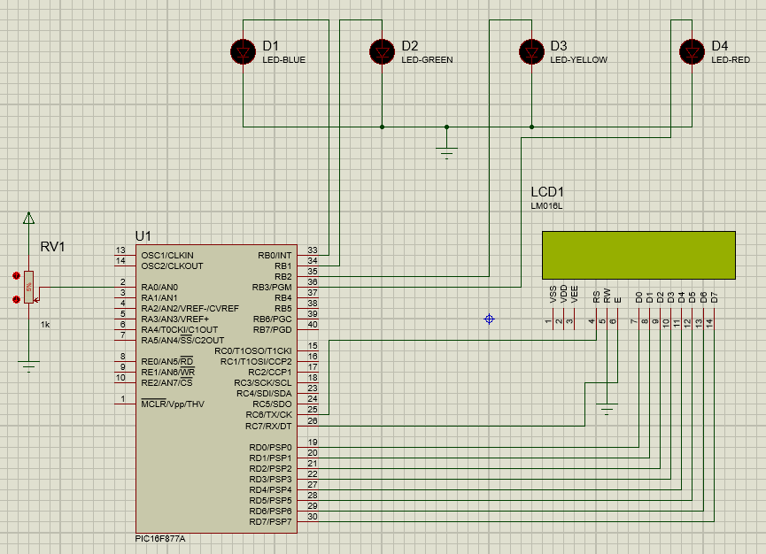 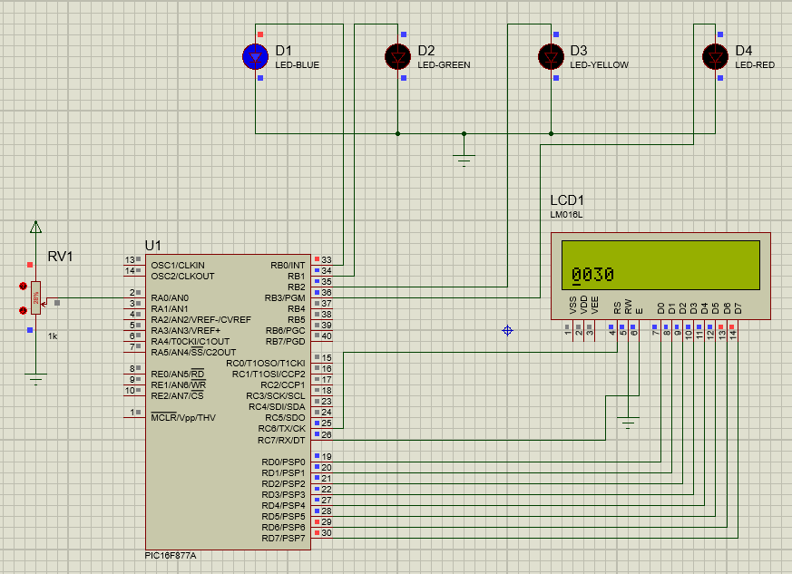 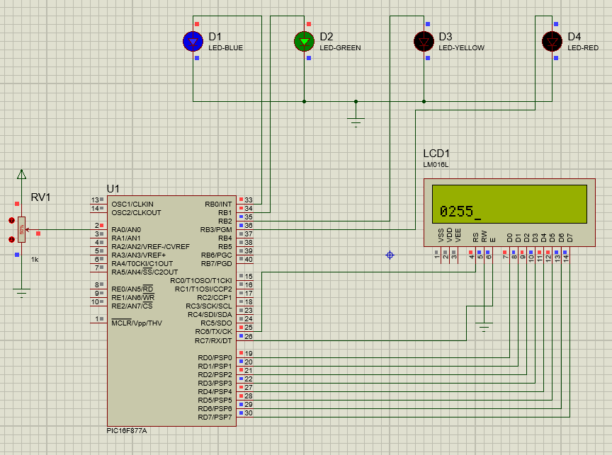

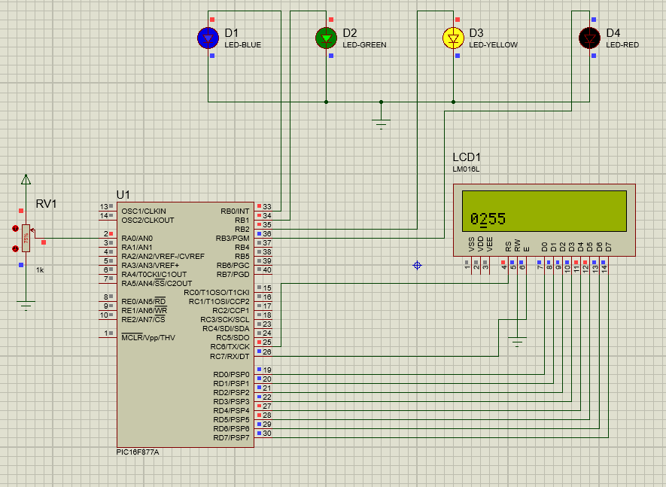 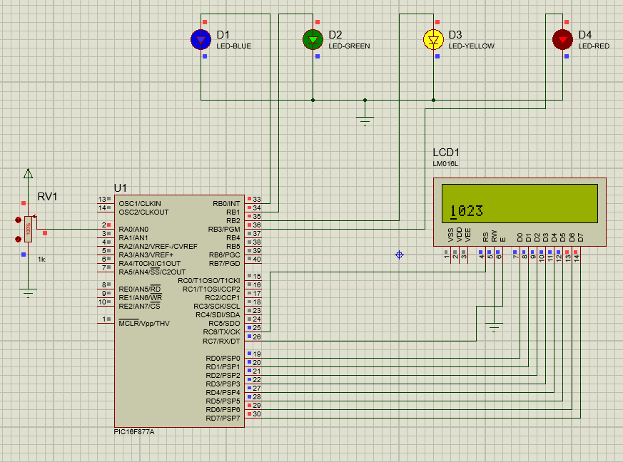

14). Write an embedded C Program for UART-TX(transmitter) . [ complete the simulation? ] / execute this using proteus 8 Professional Software ?

A).

#include <UART1.h>

#byte SPBRG=0x99

#byte TXREG=0x19

#byte RCREG=0x1A

#bit TXIF=0x0c.4

#bit RCIF=0x0c.5

#byte TXSTA=0x98

#byte RCSTA=0x18

void transmit(char a)

{

TXREG=a;

while(TXIF==0);

TXIF=0;

}

void main()

{

int i;

char data[]="QISCET_ECE";

TXSTA=0x26;

RCSTA=0x90;

SPBRG=129;

while(1)

{

for(i=0;data[i]!=0;i++)

{

transmit(data[i]);

}

transmit('\r');

delay_ms(500);

}

}

**SIMULATED OUTPUT:**

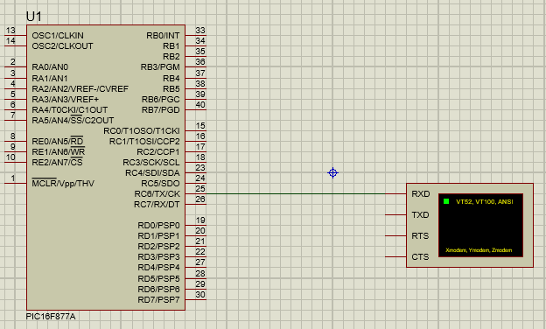

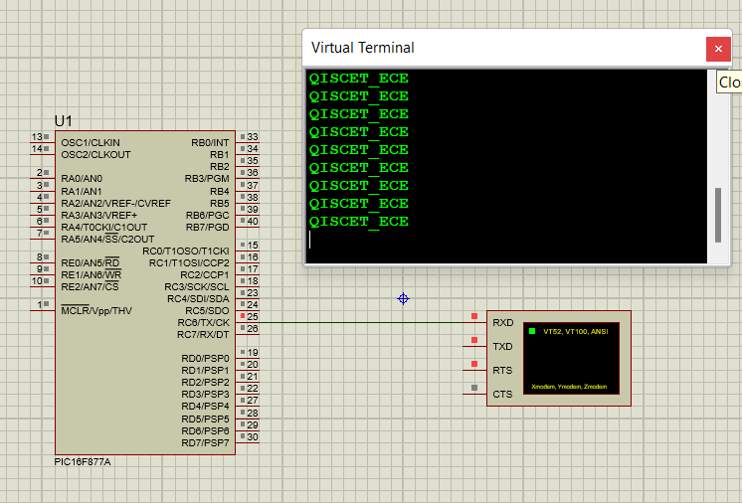

15). Write an embedded C Program forUART-RX(Receiver). [ complete the simulation? ] / execute this using proteus 8 Professional Software ?

A).

#include <UART2.h>

#byte LCD=0X08

#byte TLCD=0X88

#bit RS=0X06.0

#bit TRS=0X86.0

#bit EN=0X06.1

#bit TEN=0X86.1

#bit tx=0x07.6

#bit Ttx=0x87.6

#bit rx=0x07.7

#bit Trx=0x87.7

#byte SPBRG=0x99

#byte TXREG=0x19

#byte RCREG=0x1A

#bit TXIF=0x0C.4

#bit RCIF=0x0C.5

#byte TXSTA=0x98

#byte RCSTA=0x18

//char v;

char data[11]="ECE_QISCET";

void display(unsigned int A,unsigned int B)

{

LCD=A;

RS=B;

EN=1;

delay_ms(200);

EN=0;

delay_ms(200);

}

void transmit(char a)

{

TXREG=a;

while(TXIF==0);

TXIF=0;

}

void receive()

{

while(RCIF==0);

RCIF=0;

char v=RCREG;

display(0x80,0);

display(v,1);

delay_ms(200);

}

void main()

{

LCD=0;

TLCD=0;

RS=0;

TRS=0;

EN=0;

TEN=0;

Ttx=0;

Trx=1;

display(0x0c,0);

display(0x38,0);

display(0x80,0);

TXSTA=0x24;

RCSTA=0x90;

SPBRG=129;

while(true)

{

receive();

display(0xC0,0);

for(int i=0;data[i]!=0;i++)

{

transmit(data[i]);

display(data[i],1);

}

transmit('\r');

delay_ms(200);

}

}

**SIMULATED OUTPUT :**

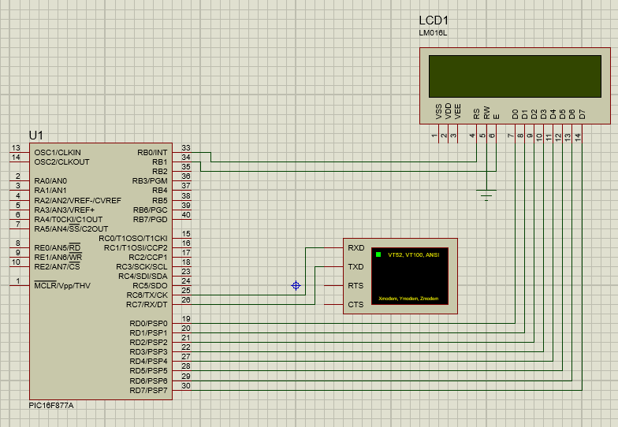

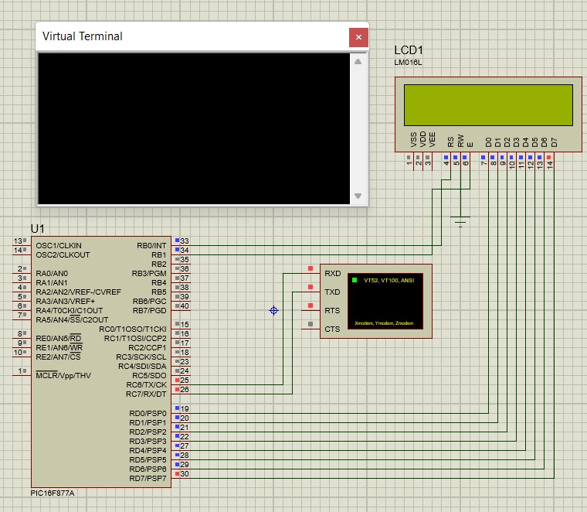

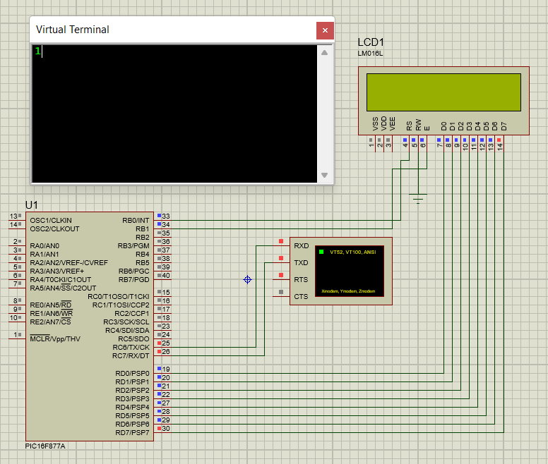

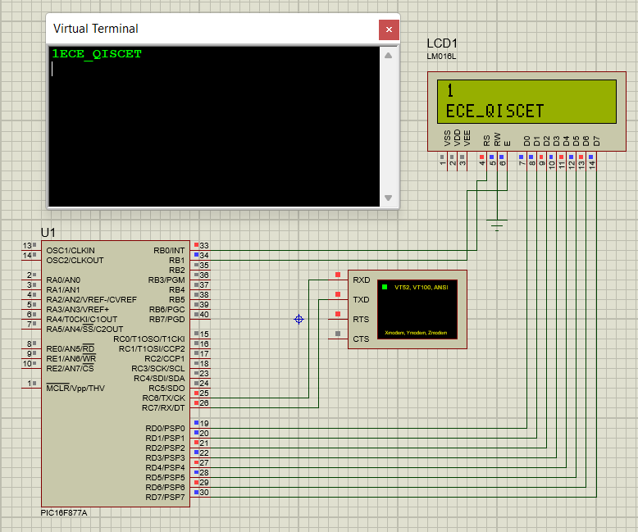

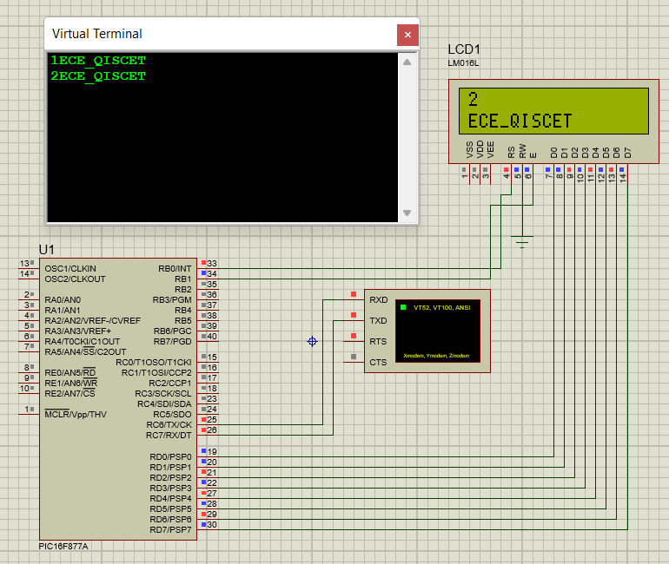

*Done By :*

***Velidi Bola ShankaR_***

*ROLL NO :: 20491A0402*