***HTML***

* Hyper Text Markup Language
* HTML is the standard markup language for creating Web pages.

<!DOCTYPE html>  
<html>  
<head>  
<title>Page Title</title>  
</head>  
<body>  
  
<h1>My First Heading</h1>  
<p>My first paragraph.</p>  
  
</body>  
</html>

* The <!DOCTYPE html> declaration defines that this document is an HTML5 document
* The <html> element is the root element of an HTML page
* The <head> element contains meta information about the HTML page
* The <title> element specifies a title for the HTML page (which is shown in the browser's title bar or in the page's tab)
* The <body> element defines the document's body, and is a container for all the visible contents, such as headings, paragraphs, images, hyperlinks, tables, lists, etc.
* The <h1> element defines a large heading
* The <p> element defines a paragraph

**HTML History**

Since the early days of the World Wide Web, there have been many versions of HTML:

Year Version

1989 Tim Berners-Lee invented www

1991 Tim Berners-Lee invented HTML

1993 Dave Raggett drafted HTML+

1995 HTML Working Group defined HTML 2.0

1997 W3C Recommendation: HTML 3.2

1999 W3C Recommendation: HTML 4.01

2000 W3C Recommendation: XHTML 1.0

2008 WHATWG HTML5 First Public Draft

2012 WHATWG HTML5 Living Standard

2014 W3C Recommendation: HTML5

2016 W3C Candidate Recommendation: HTML 5.1

2017 W3C Recommendation: HTML5.1 2nd Edition

2017 W3C Recommendation: HTML5.2

**HTML Headings**

HTML headings are defined with the <h1> to <h6> tags.

<h1> defines the most important heading. <h6> defines the least important heading:

**Example**

<h1>This is heading 1</h1>

<h2>This is heading 2</h2>

<h3>This is heading 3</h3>

**HTML Paragraphs**

HTML paragraphs are defined with the <p> tag:

Example

<p>This is a paragraph.</p>

<p>This is another paragraph.</p>

**HTML Links**

HTML links are defined with the <a> tag:

**Example**

<a href="https://www.w3schools.com">This is a link</a>

**HTML Images**

HTML images are defined with the <img> tag.

The source file (src), alternative text (alt), width, and height are provided as attributes:

**Example**

<img src="w3schools.jpg" alt="W3Schools.com" width="104" height="142">

**HTML Elements**

|  |  |  |  |
| --- | --- | --- | --- |
| **Start tag** | **Operation** | **Element content** | **End tag** |
| <h1> | Heading pupose | My First Heading | </h1> |
| <p> | Paragraph writing | My first paragraph. | </p> |
| <br> | Break the line | none | none |

**HTML Attributes**

* All HTML elements can have attributes
* Attributes provide additional information about elements
* Attributes are always specified in the start tag
* Attributes usually come in name/value pairs like: name="value"

***The href Attribute***

The <a> tag defines a hyperlink. The href attribute specifies the URL of the page the link goes to:

**Example**

<a href="https://www.w3schools.com">Visit W3Schools</a>

***The src Attribute***

The <img> tag is used to embed an image in an HTML page. The src attribute specifies the path to the image to be displayed:

**Example**

<img src="img_girl.jpg">

There are two ways to specify the URL in the src attribute:

1. Absolute URL - Links to an external image that is hosted on another website. Example:

src="https://www.w3schools.com/images/img_girl.jpg"

Notes: External images might be under copyright. If you do not get permission to use it, you may be in violation of copyright laws. In addition, you cannot control external images; it can suddenly be removed or changed.

2. Relative URL - Links to an image that is hosted within the website. Here, the URL does not include the domain name. If the URL begins without a slash, it will be relative to the current page.

Example: src="img_girl.jpg".

If the URL begins with a slash, it will be relative to the domain.

Example: src="/images/img_girl.jpg".

**The width and height Attributes**

The <img> tag should also contain the width and height attributes, which specify the width and height of the image (in pixels):

**Example**

<img src="img_girl.jpg" width="500" height="600">

**The alt Attribute**

The required alt attribute for the <img> tag specifies an alternate text for an image, if the image for some reason cannot be displayed. This can be due to a slow connection, or an error in the src attribute, or if the user uses a screen reader.

**Example**

<img src="img_girl.jpg" alt="Girl with a jacket">

**Example**

See what happens if we try to display an image that does not exist:

<img src="img_typo.jpg" alt="Girl with a jacket">

**The style Attribute**

The style attribute is used to add styles to an element, such as color, font, size, and more.

**Example**

<p style="color:red;">This is a red paragraph.</p>

**The lang Attribute**

You should always include the lang attribute inside the <html> tag, to declare the language of the Web page. This is meant to assist search engines and browsers.

The following example specifies English as the language:

<!DOCTYPE html>

<html lang="en">

<body>

...

</body>

</html>

The following example specifies English as the language and United States as the country:

<!DOCTYPE html>

<html lang="en-US">

<body>

...

</body>

</html>

**The title Attribute**

The title attribute defines some extra information about an element.

The value of the title attribute will be displayed as a tooltip when you mouse over the element:

**Example**

<p title="I'm a tooltip">This is a paragraph.</p>

***Chapter Summary :***

* All HTML elements can have attributes
* The href attribute of <a> specifies the URL of the page the link goes to
* The src attribute of <img> specifies the path to the image to be displayed
* The width and height attributes of <img> provide size information for images
* The alt attribute of <img> provides an alternate text for an image
* The style attribute is used to add styles to an element, such as color, font, size, and more
* The lang attribute of the <html> tag declares the language of the Web page
* The title attribute defines some extra information about an element

**HTML Headings :**

<h1>Heading 1</h1>

<h2>Heading 2</h2>

<h3>Heading 3</h3>

<h4>Heading 4</h4>

<h5>Heading 5</h5>

<h6>Heading 6</h6>

**OUTPUT:**

**Heading 1**

**Heading 2**

**Heading 3**

**Heading 4**

**Heading 5**

**Heading 6**

**Bigger Headings**

Each HTML heading has a default size. However, you can specify the size for any heading with the style attribute, using the CSS font-size property:

**Example**

<h1 style="font-size:60px;">Heading 1</h1>

**HTML Paragraphs**

<!DOCTYPE html>

<html>

<body>

<p>

This paragraph

contains a lot of lines

in the source code,

but the browser

ignores it.

</p>

<p>

This paragraph

contains a lot of spaces

in the source code,

but the browser

ignores it.

</p>

<p>

The number of lines in a paragraph depends on the size of the browser window. If you resize the browser window, the number of lines in this paragraph will change.

</p>

</body>

</html>

***OUTPUT:***

This paragraph contains a lot of lines in the source code, but the browser ignores it.

This paragraph contains a lot of spaces in the source code, but the browser ignores it.

The number of lines in a paragraph depends on the size of the browser window. If you resize the browser window, the number of lines in this paragraph will change.

**The Poem Problem**

This poem will display on a single line:

Example

<!DOCTYPE html>

<html>

<body>

<p>In HTML, spaces and new lines are ignored:</p>

<p>

My Bonnie lies over the ocean.

My Bonnie lies over the sea.

My Bonnie lies over the ocean.

Oh, bring back my Bonnie to me.

</p>

</body>

</html>

**OUTPUT:**

In HTML, spaces and new lines are ignored:

My Bonnie lies over the ocean. My Bonnie lies over the sea. My Bonnie lies over the ocean. Oh, bring back my Bonnie to me.

Solution - **The HTML <pre> Element**

* The HTML <pre> element defines preformatted text.
* The text inside a <pre> element is displayed in a fixed-width font (usually Courier), and it preserves both spaces and line breaks:

**Example**

<!DOCTYPE html>

<html>

<body>

<p>The pre tag preserves both spaces and line breaks:</p>

<pre>

My Bonnie lies over the ocean.

My Bonnie lies over the sea.

My Bonnie lies over the ocean.

Oh, bring back my Bonnie to me.

</pre>

</body>

</html>

**OUTPUT:**

The pre tag preserves both spaces and line breaks:

My Bonnie lies over the ocean.

My Bonnie lies over the sea.

My Bonnie lies over the ocean.

Oh, bring back my Bonnie to me.

**HTML Styles**

* The HTML Style Attribute
* Setting the style of an HTML element, can be done with the style attribute.
* The HTML style attribute has the following syntax:

<*tagname* style="*property*:*value;*">

* The ***property*** is a CSS property. The ***value*** is a CSS value.

<!DOCTYPE html>

<html>

<body>

<p>I am normal</p>

<p style="color:red;">I am red</p>

<p style="color:blue;">I am blue</p>

<p style="font-size:50px;">I am big</p>

</body>

</html>

**OUTPUT:**

I am normal

I am red

I am blue

I am big

**Background Color**

The CSS background-color property defines the background color for an HTML element.

<!DOCTYPE html>

<html>

<body style="background-color:powderblue;">

<h1>This is a heading</h1>

<p>This is a paragraph.</p>

</body>

</html>

**OUTPUT:**

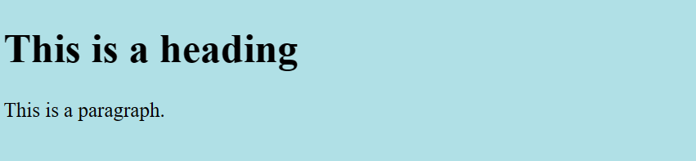

<!DOCTYPE html>

<html>

<body>

<h1 style="background-color:powderblue;">This is a heading</h1>

<p style="background-color:tomato;">This is a paragraph.</p>

</body>

</html>

**OUTPUT:**

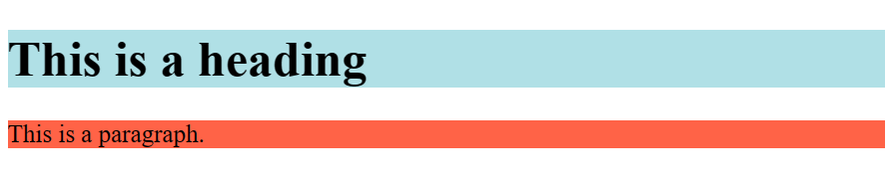

**Text Color :**

The CSS color property defines the text color for an HTML element:

<!DOCTYPE html>

<html>

<body>

<h1 style="color:blue;">This is a heading</h1>

<p style="color:red;">This is a paragraph.</p>

</body>

</html>

**OUTPUT:**

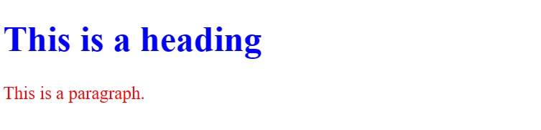

**Fonts**

The CSS font-family property defines the font to be used for an HTML element:

<!DOCTYPE html>

<html>

<body>

<h1 style="font-family:verdana;">This is a heading</h1>

<p style="font-family:courier;">This is a paragraph.</p>

</body>

</html>

**OUTPUT:** 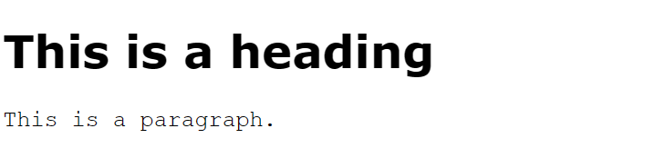

**Text Size**

The CSS font-size property defines the text size for an HTML element:

<!DOCTYPE html>

<html>

<body>

<h1 style="font-size:300%;">This is a heading</h1>

<p style="font-size:160%;">This is a paragraph.</p>

</body>

</html>

**OUTPUT:**

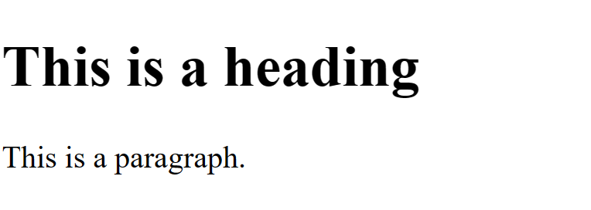

**Text Alignment**

The CSS text-align property defines the horizontal text alignment for an HTML element:

<!DOCTYPE html>

<html>

<body>

<h1 style="text-align:center;">Centered Heading</h1>

<p style="text-align:center;">Centered paragraph.</p>

</body>

</html>

**OUTPUT:**



**Chapter Summary**

* Use the style attribute for styling HTML elements
* Use background-color for background color
* Use color for text colors
* Use font-family for text fonts
* Use font-size for text sizes
* Use text-align for text alignment