MSDS 692 Data Science Practicum I:

Final Report: Predicting the Price of Used Cars

Babawale Olatunji

Regis University

Authors Note

This Final Report was prepared for MSDS 692 taught by Prof. Hart Douglas

**Predicting the Price of Used Cars**

1. **Introduction**

Predicting the price of used cars is a challenging task. This is due to several features that should be examined for accurate prediction. Potential used car buyers do not know if they are paying too much for the selling price of used cars. It is a difficult task for potential used car buyers to keep track of all the interesting used cars available on the automobile market at any given time. Furthermore, they are not even cognizant of the comparable used cars with similar car features that are available on the automobile market at any given period.

The goal of this data science practicum project is to develop a machine learning model that can be leveraged in predicting price of used cars. This model can further be used in predicting the price value for a single car model, top selling car models, features importance on car price value, and averaged time elapsed before selling a car.

1. **Data**

**2.1 Presentation of the data**

This project utilized Kaggle dataset located at https://www.kaggle.com/orgesleka/used-cars-database to achieve its objectives. The data contains offerings of used cars in Germany. The content of the original dataset is in German. Google Translator was used to make the necessary translations to English. The data was scraped or collected with Python Scrapy from Ebay-Kleinanzeigen and have been crawled between 03-05-2016 and 04-07-2016. The data contains over 370,000 used cars information, each characterized by the following 20 variables:

* dateCrawled: The date when this advertisement was first crawled, all field-values were obtained on this date;
* name: "name" of the car;
* seller: seller type – private or dealer;
* offerType: Offer Type - offer or request;
* price: the price in Euro on the advertisement to sell the car;
* abtest: abtest category - test or control;
* vehicleType: vehicle body type - limousine, small car, station wagon, bus, cabrio, coupe, suv, other;
* yearOfRegistration: At what year the car was first registered - the age of the car;
* Transmission: Transmission Type - manual or automatic;
* powerPS: Car Engine Power in PS;
* model: car model;
* kilometer: car mileage in kilometer;
* monthOfRegistration: the month of the year the car was first registered;
* fuelType: Fuel Type - gas, diesel, autogas, compressed natural gas, hybrid, other, or electric;
* brand: car brand;
* notRepairedDamage: Unrepaired Damage - yes or no;
* dateCreated: The date the ad was created on Ebay-Kleinanzeigen;
* nrOfPictures: number of pictures in the ad;
* postalCode: car seller postal code;
* lastSeen: when the crawler saw this ad last online.

The data is consisting of 14 string variables and 6 numerical variables.

* 1. **Data Preparation**

There are missing values identified as NaNs/Null and zeros (0.0) in the dataset used for this project. Missing values if not dealt with would result in bias resulting from the differences between missing and complete data. I dealt with missing values in the dataset by dropping the rows and columns that contain them. Figure 1 and Figure 2 depict the summary count of missing values by column before and after data cleaning.

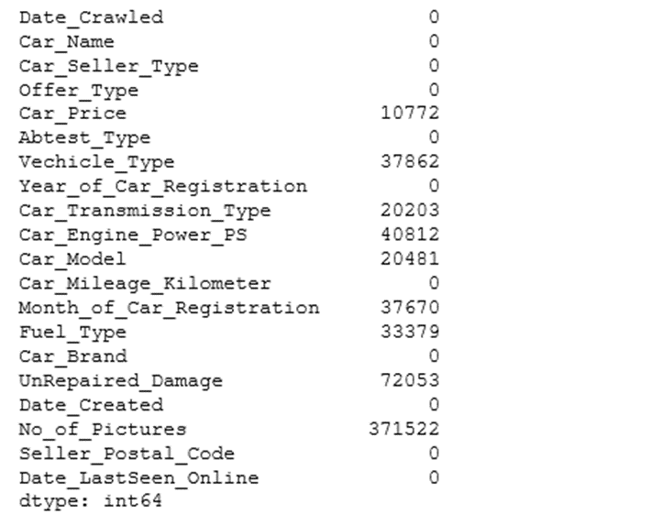

Figure 1: Summary count of missing values by column before data cleaning

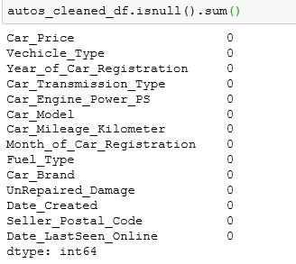

Figure 2: Summary count of missing values by column after data cleaning

Further examination of the dataset revealed the dataset contains Outliers. These are values that are distant from other observations in the column. Interquartile range (IQR) from the summary statistics first quartile and third quartile was used to detect the Outliers from the relevant columns. Outlier values were removed from the data. Outliers would have a positive or negative effect on the correlation of the data if not handled correctly. Figure 3 highlights the summary of the dataframe including the data type of each column after the data cleaning.

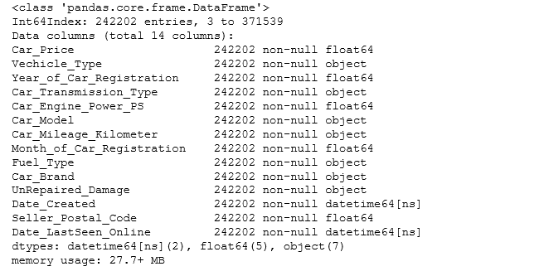

Figure 3: Summary of the dataframe after data cleaning

* 1. **Exploratory Data Analysis (EDA)**

Summary Statistics of both Numerical and Non-Numerical Attributes were used to highlight the overall view of the cleaned dataset. Table 1 depicts the Summary Statistics of Non-Numerical Attributes.

Table 1: Summary Statistics of Non-Numerical Attributes

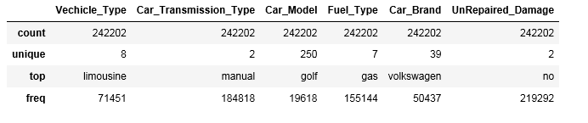

The above Table 1 shows limousine, manual, golf, gas and Volkswagen are the top Vehicle Type, Car Transmission Type, Car Model, Fuel Type and Car Brand respectively. Furthermore, Table 2 below depicts the Summary Statistics of Numerical Attributes highlighting the mean, standard deviation, first, second and third quartiles, minimum and maximum descriptive statistics for each of the numerical variables.

Table 2: Summary Statistics of Numerical Attributes

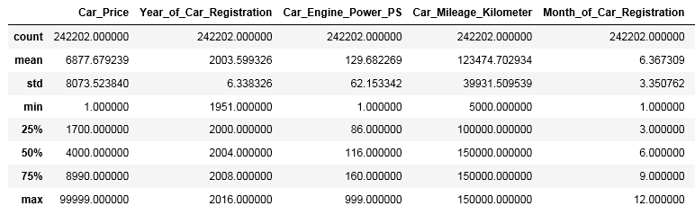

Histograms of numerical variables were created to visualize the distribution of the data for the numerical features. Figure 4 showcases the histogram for each of the numerical variable. Each histogram below highlights if the distribution of data for each of the numerical variable is symmetric, left-skewed or right-skewed. It is worth noting that Age of Car in months variable was calculated from the dataset Year of Registration and Month of Registration variables.

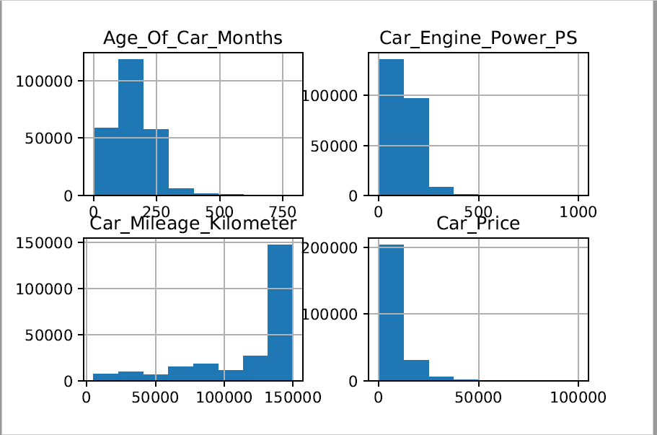

Figure 4: Histograms of Numerical Attributes

Pairs Plots is another effective tool to leverage in Exploratory Data Analysis. Pairs Plots were created for this project to visualize both the distribution of single variables including Car Price, numerical and non-numerical variables and the relationships between Car Price and each of the numerical and non-numerical variables. Figure 5 depicts the Pairs Plots of Car Price and Numerical Attributes and Figure 6 showcases the Pairs Plots of Car Price and Non-Numerical Attributes.

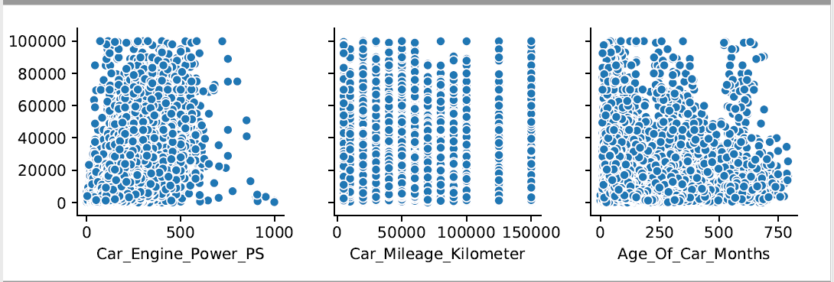

Figure 5: Pairs Plots of Car Price and Numerical Attributes

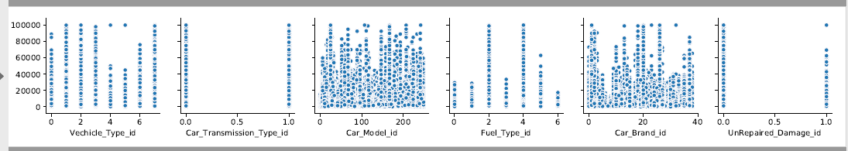

Figure 6: Pairs Plots of Car Price and Non-Numerical Attributes

To find out the correlation coefficient, the correlation matrix was developed to visualize how each attribute of the project dataset is compared to the other factors. Specifically, the correlation between the Car Price and each of the other attributes. Figure 7 depicts the correlation matrix of the dataset attributes. The correlation results show a positive correlation of (0.59) between Car Price and Car Engine Power. That means an increase in Car Engine Power would have an increase in the Car Price. Conversely, there is negative correlation between Car Mileage and Car Price. Also, there is a negative correlation between Age of Car and Car Price.

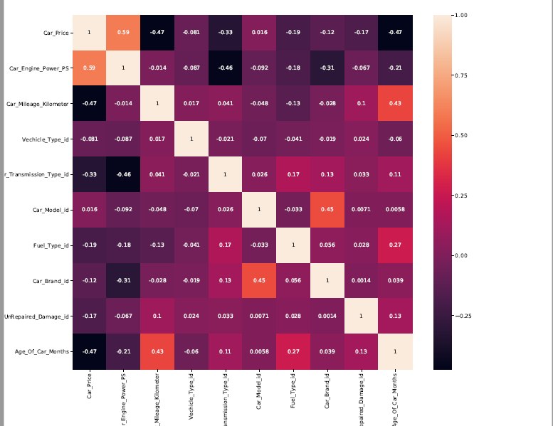

Figure 7: Correlation Matrix of the Attributes

1. **Feature Selection**

The performance of a machine learning model is greatly affected by feature selection. It is worth noting that model performance can be negatively affected by irrelevant or partially pertinent features. The process of manually or automatically selecting those features or input that contribute the most to the target or prediction variable is called Feature Selection. It minimizes overfitting, fosters prediction accuracy and minimizes training time.

To determine the important features for the output (Car Price) variable, univariate selection process was leveraged in this project to identify relevant features (independent variables) that contribute the most to the target or output(dependent) variable.

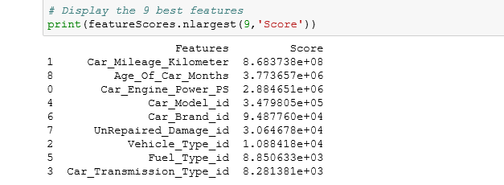

Figure 8: Univariate Feature Selection Result

The above result identifies Car_Mileage_Kilometer, Age_Of_Car_Months, and Car_Engine_Power_PS as the three most important features in predicting the price of used cars. This is also consistent with the correlation result above. This result can be utilized to determine if certain features should be included in the models to be constructed using this dataset.

1. **Methods**

**4.1 Models**

There are two types of supervised machine learning algorithms including Regression and Classification. Predicting the price of used cars is a regression problem. To predict a continuous value like the price of used cars, regression models are used. Using Python Scikit learn library, various kinds of regression models can be developed and implemented.

For this practicum project, I chose to utilize four different Python Scikit learn regression methods/algorithms for training and building four different regression models:

* Linear Regression: In this project, multiple linear regression is leveraged to model the relationship between multiple car features including Vehicle Type, Transmission Type, Car Mileage and car price as the response or outcome.
* Decision Tree Regression: This is the second model constructed in this project. It trains a model in a flowchart-like tree structure to predict data in the future.
* Random Forest Regression. This is the third model developed in this regression problem project. It is an ensemble method and it combines multiple decision trees in determining the final output.
* Ensemble Voting Regressor: This is the fourth model constructed in this project. It fits Linear Regressor, Decision Tree Regressor and Random Forest Regressor each on the training dataset. This ensemble voting regressor averages these three individual regressors' predictions to produce a final prediction.
  1. **Methods**

To predict the price of used cars, I developed four machine learning models using Python Scikit learn library and based on the results obtained from each of the four models, the best model was selected.

To accomplish this, the dataset was separated into features (independent variables) or inputs (X) and target(y). In this project, the target (dependent variable) data is from the Car Price variable and features or input data are from the remaining attributes including Car Engine Power, Car Mileage, Vehicle Type and other dataset variables. Both Feature and Target data were then split into training and test datasets with a 70/30 ratio. The training data is the data leveraged for learning by the four models and the test data is the data utilized to measure the performance of the four models on unseen data.

* + 1. **Training Models**

In this project, four training models were constructed using multiple linear regression, decision tree regression, random forest regression and ensemble voting regressor machine learning techniques. This was done by importing linear model, decision tree regressor, random forest regressor and voting regressor from Scikit learn library. This was followed with the creation of an instance of the class regression for each model (LinearRegression, DecisionTreeRegressor, RandomForestRegressor, VotingRegressors) which represent the regression model. Each regression model was leveraged to train the model on both features train (X_train) dataset and target(y_train) dataset. That means, fitting the training data to the regression model. This was followed with the generation of prediction score. It is worth noting that the score is the R squared metric indicating the goodness of fit of the predicted used car prices to the true used car prices. Each model was then provided with test data (X_test) and the predictions for the used car prices based on each model were generated. This was followed with the calculation of Mean Absolute Error (MAE), Mean Square Error (MSE) and Root Mean Square Error (RMSE) by passing the true or observed car prices (y_test) and model predicted car prices to the respective scikit learn metrics mean error method. MAE is the mean of the absolute difference between values predicted by a model or an estimator (such as car price) and true or observed values and is a linear score. MSE is the averaged squared difference between values predicted by a model or an estimator and observed values. RMSE is the square root of the mean of the squared errors (MSE) and is the commonly used measure.

All the four models developed in this project have more than one input variable, hence it is not feasible to represent several variables in a plot. Instead, scatterplot was leveraged to plot each model predicted used car prices versus the observed used car prices.

* + 1. **Cross Validation**

The train-test split based on one split is referred to as classical approach. However, more than one split is done in cross validation. In this project, I utilized 10 splits in cross validation. These splits are called Folds. Cross-Validation provides a better understanding of what is going on by training 10 different models. Cross-validation requires fitting the same machine learning regression model multiple times leveraging different subsets of the data or different splits each time. Cross-Validation would reveal consistency in performance of the algorithm and data or reveal inconsistency for further investigation. Furthermore, cross-validation would ensure similar performance in production deployment of the model. Testing accuracy can vary greatly depending on which observation happen to be in the testing dataset. Therefore, it is important to use k-fold cross-validation to fix this problem.

All the four models were constructed again with cross validation using multiple linear regression, decision tree regression, random forest regression and ensemble voting regression machine learning techniques. The four models were run with the input data(X) and target data(y) ten times (Kfold times) and estimated the score or R squared metric each time. The mean function was used to find the average of these ten prediction scores and standard deviation function was utilized to calculate the standard deviation of the 10 prediction scores. This was followed with the calculation of Mean Absolute Error (MAE), Mean Square Error (MSE) and Root Mean Square Error (RMSE) leveraging cross validation score method. Furthermore, scatterplot was utilized to visually highlights how R-squared values denote the scatter around the regression line and plot each model predicted used car prices versus the observed used car prices.

1. **Results**

**5.1 Presentation of the results**

The followings are the R-Squared, MAE, MSE, and RMSE model evaluation metrics generated by the four models based on a single 70:30 train to test split ratio:

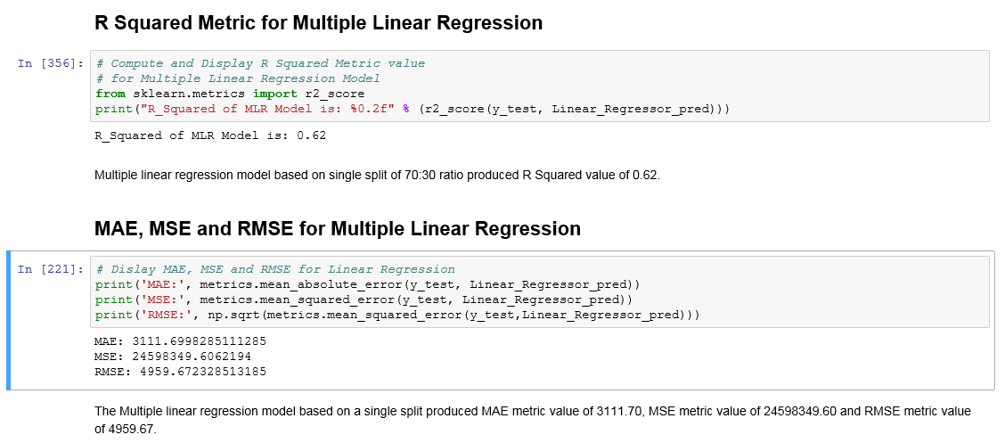

Figure 9: Multiple Linear Regression Model Results

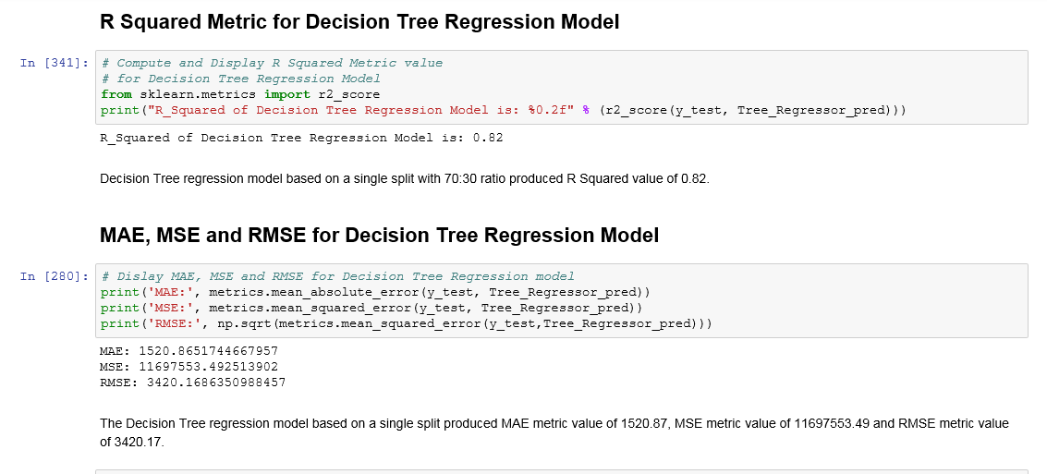

Figure 10: Decision Tree Regression Model Results

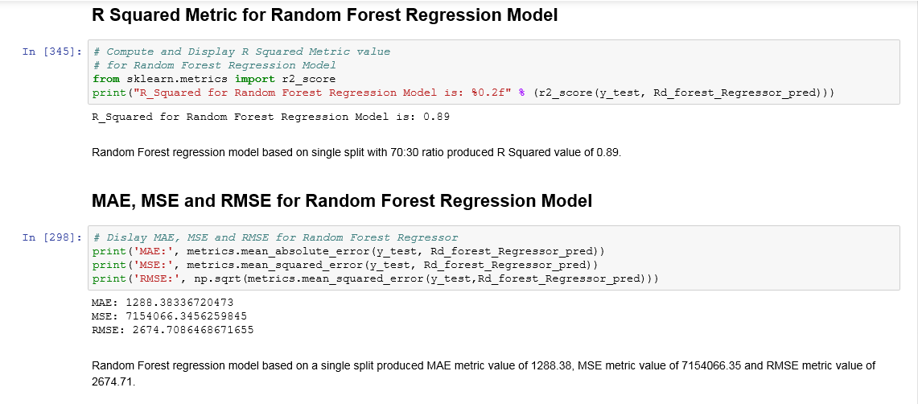

Figure 11: Random Forest Regression Model Results

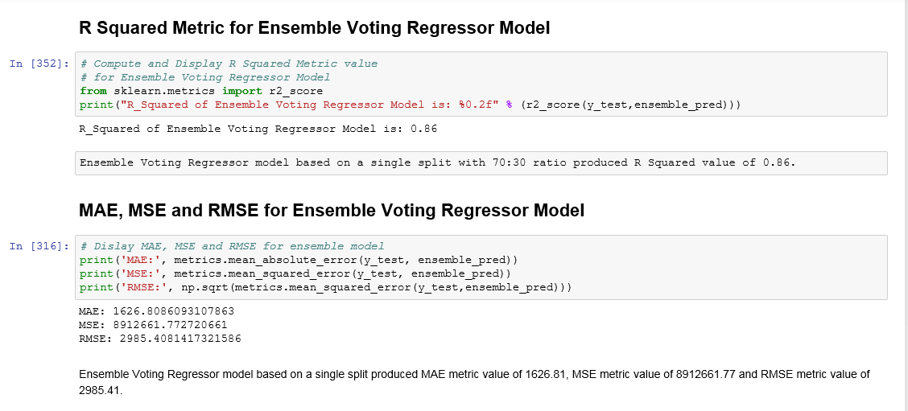

Figure 12: Ensemble Voting Regressor Model Results

Table 3: Regression Models Results Comparison

|  |  |  |  |  |
| --- | --- | --- | --- | --- |
| Evaluation Metrics | Multiple Linear Regression Model | Decision Tree Regression Model | Random Forest Regression Model | Ensemble Voting Regressor Model |
| R-Squared | 0.62 | 0.82 | 0.89 | 0.86 |
| Mean Absolute Error (MAE) | 3111.70 | 1520.87 | 1288.38 | 1626.81 |
| Mean Square Error (MSE) | 24598349.60 | 11697553.49 | 7154066.35 | 8912661.77 |
| Root Mean Square Error (RMSE) | 4959.67 | 3420.17 | 2674.71 | 2985.41 |

From the results in Table 3 above, Random Forest Regression model based on a single 70/30 train to test ratio split generated R-Squared metric of 0.89, Mean Absolute Error (MAE) of 1288.38, Mean Square Error (MSE) of 7154066.55 and Root Mean Square Error metric of 2674.71. Random Forest model produced the best metrics among the four models developed, hence it is best model selected based on these four-evaluation metrics for predicting the price of used cars.

The followings are the Scatterplots depicting the four models predicted car prices versus the true car prices:

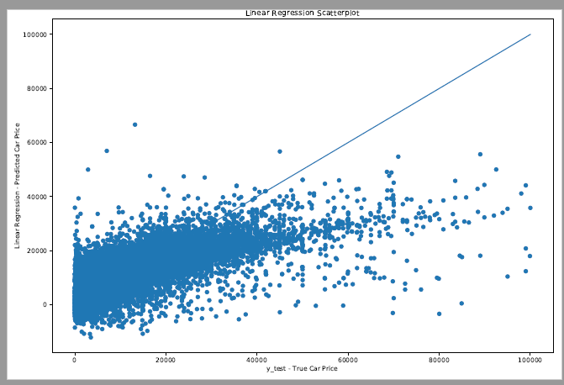

Figure 13: Scatterplot of Multiple Linear Regression model predicted car prices versus true car prices

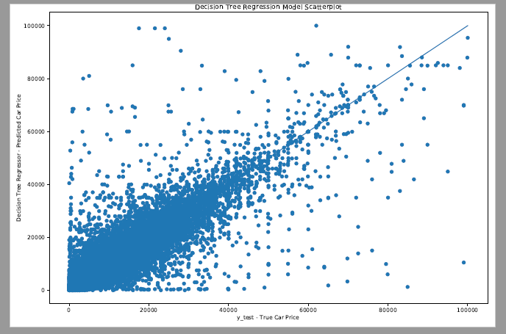

Figure 14: Scatterplot of Decision Tree Regression model predicted car prices versus true car prices

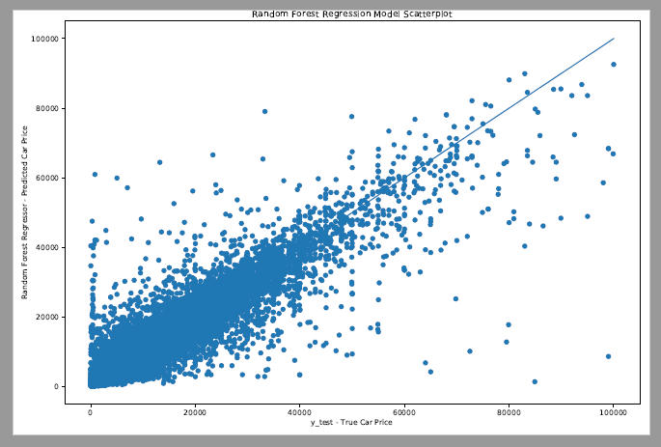

Figure 15: Scatterplot of Random Forest Regression model predicted car prices versus true car prices

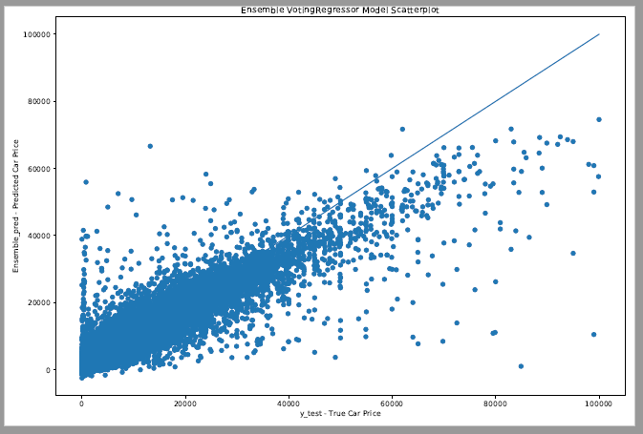

Figure 16: Scatterplot of Ensemble Voting Regressor model predicted car prices versus true car prices

It is worth noting that each scatterplot visually highlights how R-Squared values denote the scatter around the regression line.

**Cross-Validation**

The train-test split based on one split is known as classical approach. The results above are based on this approach. In this project, the technique of cross-validation is further applied to the splitting of data. This project utilized 10 splits in cross validation. Cross-Validation would reveal consistency in performance of the machine learning regression model and data or reveal inconsistency for further investigation. The followings are the R-Squared, MAE, MSE, and RMSE model evaluation metrics generated by the four models when than one split is done in cross validation:

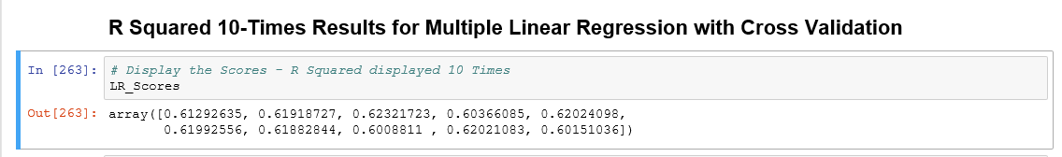

Figure 17: Multiple Linear Regression Model 10 Times R-Squared Results

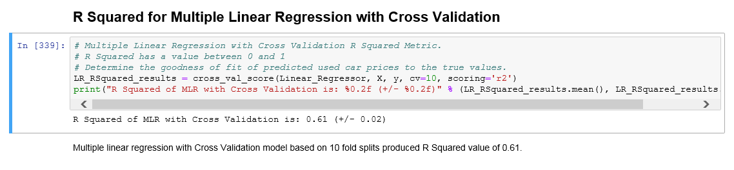

Figure 18: Multiple Linear Regression with Cross-Validation Average R-Squared Result

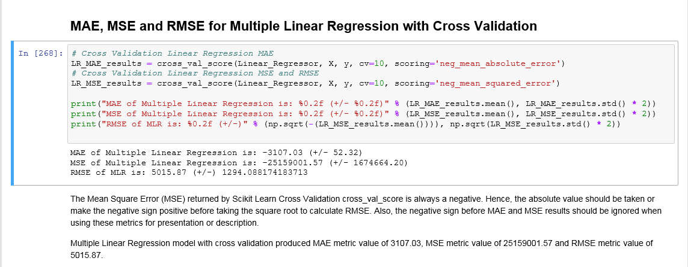

Figure 19: Multiple Linear Regression with Cross Validation Average MAE, MSE and RMSE Results

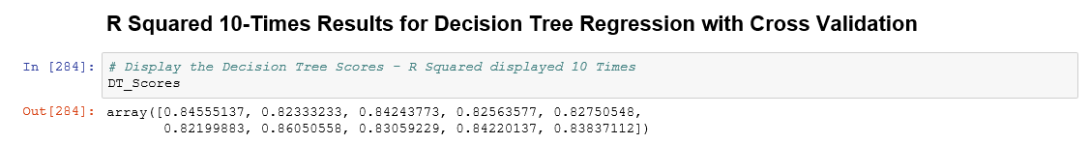

Figure 20: Decision Tree Regression Model 10 Times R-Squared Results

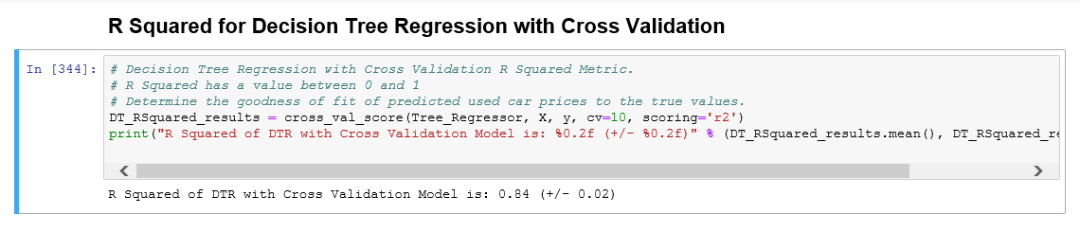

Figure 21: Decision Tree Regression with Cross Validation Average R-Squared Result

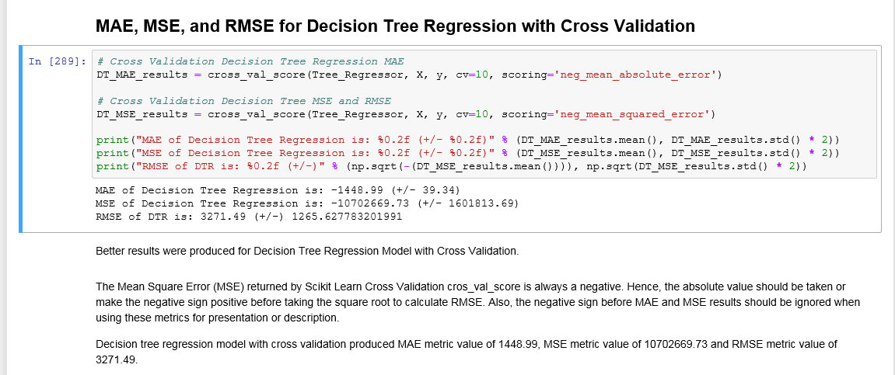

Figure 22: Decision Tree Regression with Cross Validation Average MAE, MSE and RMSE Results

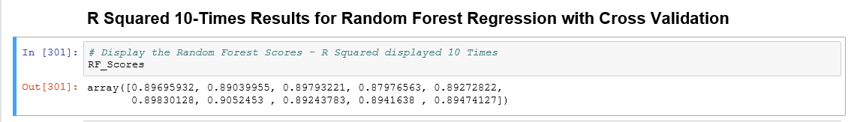

Figure 23: Random Forest Regression Model 10 Times R-Squared Results

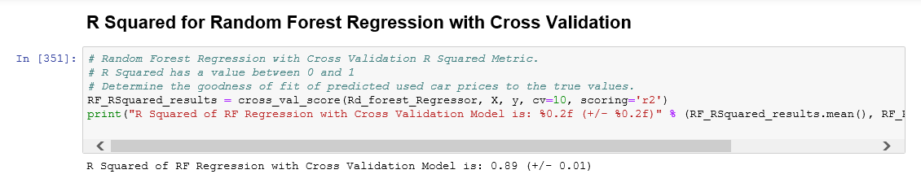

Figure 24: Random Forest Regression with Cross Validation Average R-Squared Result

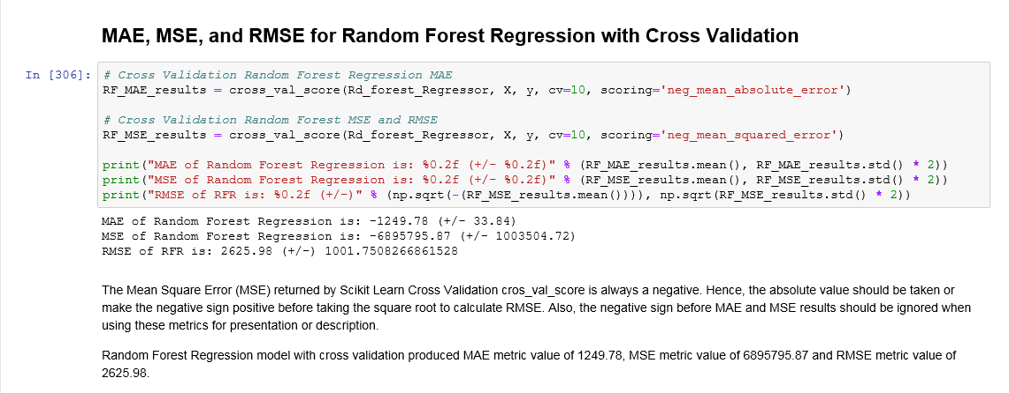

Figure 25: Random Forest Regression with Cross Validation Average MAE, MSE and RMSE Results

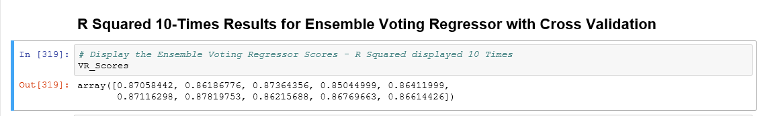

Figure 26: Ensemble Voting Regressor Model 10 Times R-Squared Results

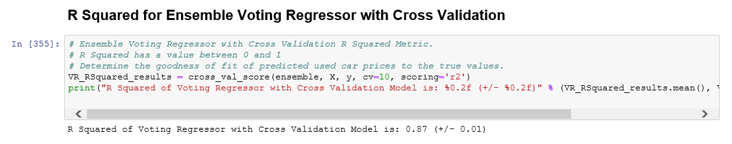

Figure 27: Ensemble Voting Regressor with Cross Validation Average R-Squared Result

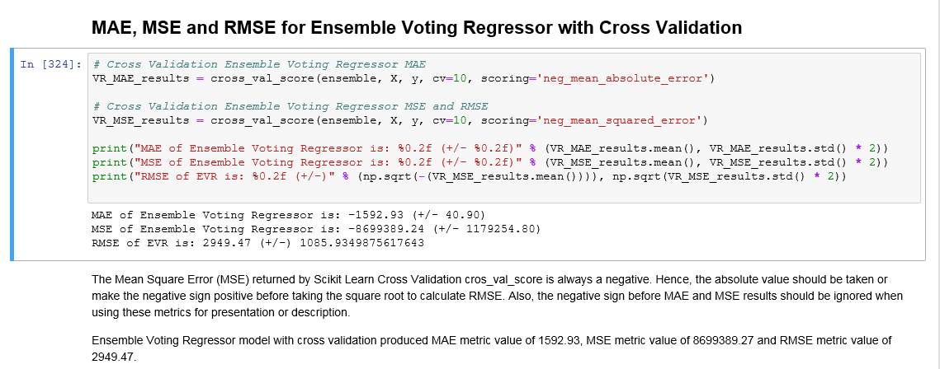

Figure 28: Ensemble Voting Regressor with Cross Validation Average MAE, MSE and RMSE Results

Table 4: Regression Models with Cross Validation Results Comparison

|  |  |  |  |  |
| --- | --- | --- | --- | --- |
| Evaluation Metrics | Multiple Linear Regression Model | Decision Tree Regression Model | Random Forest Regression Model | Ensemble Voting Regressor Model |
| R-Squared | 0.61 | 0.84 | 0.89 | 0.86 |
| Mean Absolute Error (MAE) | 3107.03 | 1448.99 | 1249.78 | 1592.93 |
| Mean Square Error (MSE) | 25159001.57 | 10702669.73 | 6895795.87 | 8699389.24 |
| Root Mean Square Error (RMSE) | 5015.87 | 3271.49 | 2625.98 | 2949.47 |

From the results in Table 4 above, Random Forest Regression with the incorporation of cross validation produced the best metric results. It yielded an average R Squared result of 0.89, Mean Absolute Error (MAE) of 1249.78, Mean Square Error (MSE) of 6895795.87 and Root Mean Square Error of 2625.98. Hence, it is the regression model selected for predicting the price of used cars.

With the incorporation of cross validation into construction the four models, the followings are the Scatterplots depicting the four models predicted car prices versus the true car prices:

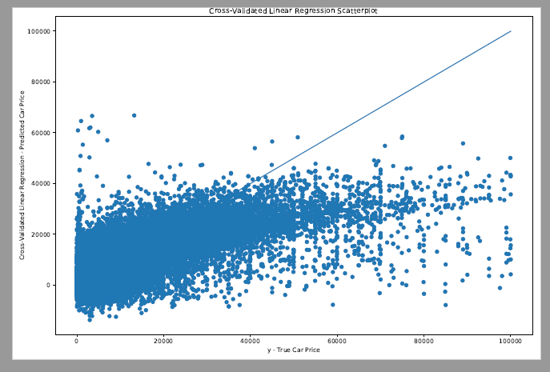

Figure 29: Scatterplot of Multiple Linear Regression with cross validation model predicted car prices versus true car prices

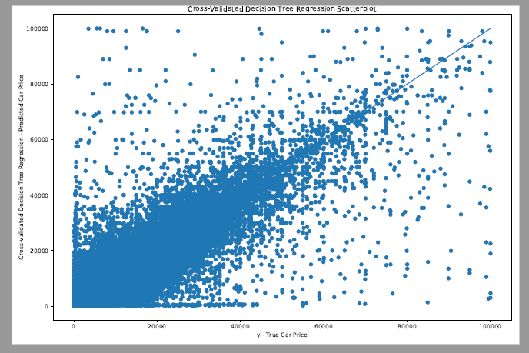

Figure 30: Scatterplot of Decision Tree Regression with cross validation model predicted car prices versus true car prices

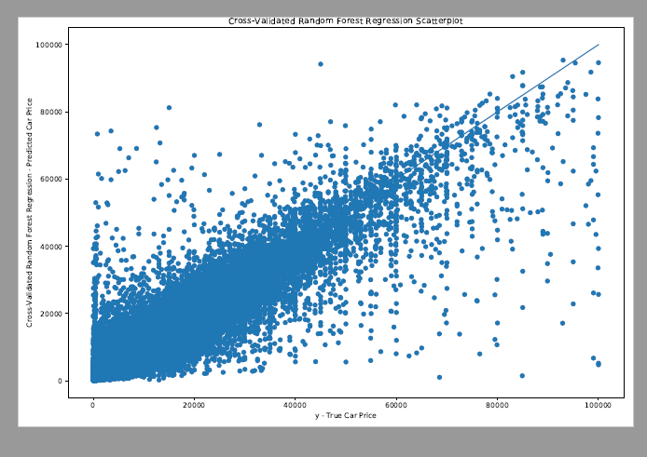

Figure 31: Scatterplot of Random Forest Regression with cross validation model predicted car prices versus true car prices

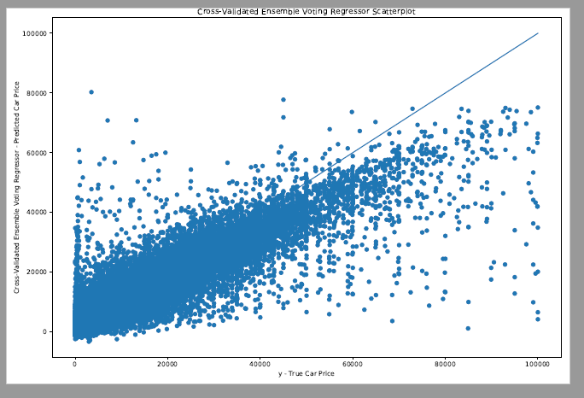

Figure 32: Scatterplot of Ensemble Voting Regressor with cross validation model predicted car prices versus true car prices

1. **Conclusion**

Multiple Linear Regression (MLR), Decision Tree Regression (DTR), Random Forest Regression (RFR) and Ensemble Voting Regressor are four popular strategies for machine learning and regression. In this project, these four machine learning techniques were leveraged to develop four models for predicting the price of used cars based on Kaggle dataset located at https://www.kaggle.com/orgesleka/used-cars-database. Four evaluation metrics including R Squared, Mean Absolute Error (MAE), Mean Square Error (MSE) and Root Mean Square Error (RMSE) were used to select the best model for predicting the price of used cars.

After performing the data cleaning technique on the data, both missing values and outliers were removed from the dataset. Then the data was split into 70/30 train to test ratio. This was utilized in constructing the four models using the machine learning regression techniques. From the results obtained from these four models, Random Forest Regression model produced the best results based on the four-evaluation metrics. Random Forest Regression model generated R-Squared metric of 0.89, Mean Absolute Error (MAE) of 1288.38, Mean Square Error (MSE) of 7154066.55 and Root Mean Square Error metric of 2674.71.

To further showcase the consistency about the performance of the four machine learning regression algorithms used in this project, cross validation technique was incorporated to the data splitting process. Ten splits in cross validation was utilized in this project. The four machine learning regression techniques were run with the features data and target data ten times and the results produced were measured each time. Four models leveraging cross validation were created using these four regression techinques. Again, Random Forest Regression with the incorporation of cross validation produced the best metric results. It yielded an average R Squared result of 0.89, Mean Absolute Error (MAE) of 1249.78, Mean Square Error (MSE) of 6895795.87 and Root Mean Square Error of 2625.98. Hence, it is the regression model selected for predicting the price of used cars.

This project further showcases Car Power Engine, Car Mileage, and the Age of the car as the three most important features in predicting the price of used cars based on the results obtained from feature selection.

**7 Future Work**

Future work on this project would include predicting the price of each brand and model of used car collections in this dataset. It would be interesting to learn how the inclusion of pictures into the dataset would influence predicting the price of used cars.

References

Brownlee J. May 2016. Metrics To Evaluate Machine Learning Algorithms in Python. Retrieved from https://machinelearningmastery.com/metrics-evaluate-machine-learning-algorithms-python/

Cross Validation and Model Selection. Retrieved from https://www.pythonforengineers.com/cross-validation-and-model-selection/.

Cross-validation: evaluating estimator performance. Retrieved from <https://scikit-learn.org/stable/modules/cross_validation.html>.

Frost J. 2019. How To Interpret R-squared in Regression Analysis. Retrieved from https://statisticsbyjim.com/regression/interpret-r-squared-regression/.

Ng R. 2019. Cross-Validation. Retrieved from <https://www.ritchieng.com/machine-learning-cross-validation/>.

Shaikh R. October 2018. Feature Selection Techniques in Machine Learning with Python. Retrieved from https://towardsdatascience.com/feature-selection-techniques-in-machine-learning-with-python-f24e7da3f36e.

https://stackoverflow.com/questions.

https://www.kaggle.com/orgesleka/used-cars-database/discussion

https://www.kaggle.com/orgesleka/used-cars-database/kernels

https://www.researchgate.net/publication/319306871_Predicting_the_Price_of_Used_Cars_using_Machine_Learning_Techniques

http://www.temjournal.com/content/81/TEMJournalFebruary2019_113_118.pdf