# HWSW – Final Exam

OpenCL Acceleration of Image Convolution

# Charles Bollig

The code for the runs below is included in the .zip file. The convolveCL.c was modified to include timing functionality.

In addition, the driver file (runFinalExam.py) modifies the Makefile each time to alter the image dimension size and filter size.

In each of the below images, the CPU time is considered the base. The other times are a percentage speed up or slowdown of this value.

The runs were all run from the eecalc server. Data was stored to a file (data.txt). The data was used by jupyter notebook (HWSW_Final_Plots.ipynb) to create plots.

Evaluations:

Image size: 512x512, 1024x1024, 2048x2048

Filter size: 3x3,5x5,7x7,9x9,11x11,13x13

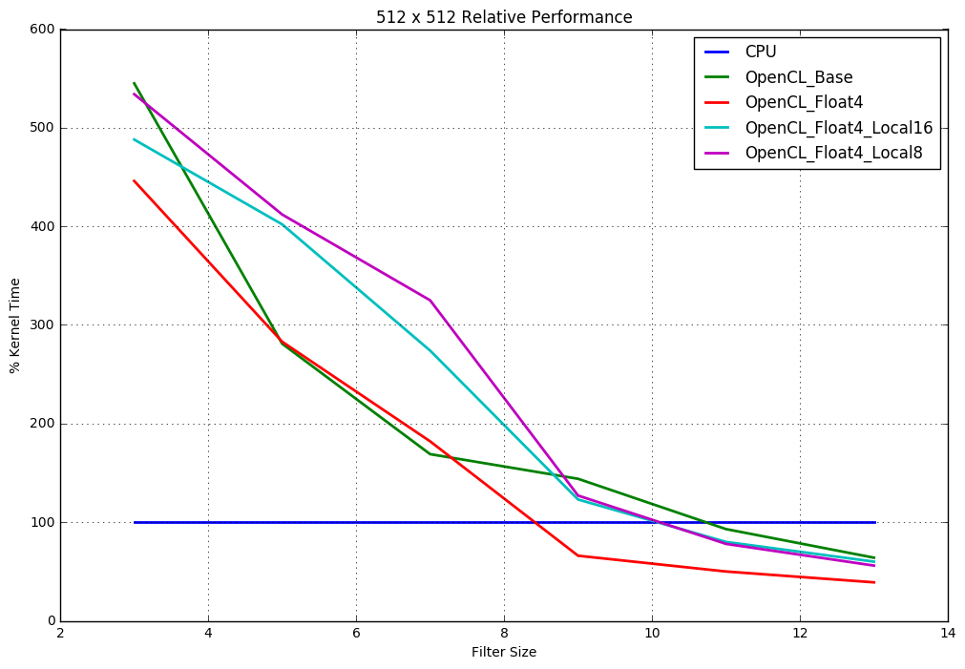

The image size 512x512 runs are above. As can be seen, using specialized OpenCL kernels, in general, does not even become truly efficient until the filter size is greater than ten (>10).

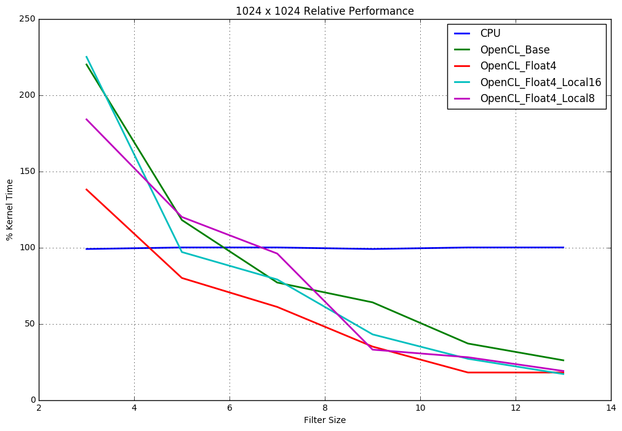

The image size 1024x1024 runs are above. Specialized OpenCL kernels, in general, become efficient after the filter size is greater than 5 (>5).

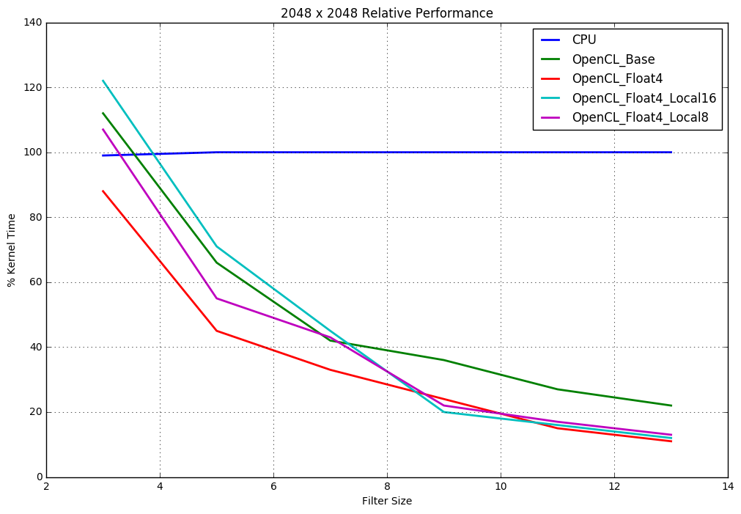

The image size 2048x2048 runs are above. Specialized OpenCL kernels, in general, become efficient almost immediately.