SILKWORM INCUBATOR

1stIlluru Sai Jahnavi   
*Department of Computer Science and Engineering   
 Kalasalingam Academy of Research and Education*Virudhunagar, India

jahnavi1096@gmail.com

2nd Sesham Surya Vamsi  
*Department of Computer Science and Engineering   
 Kalasalingam Academy of Research and Education*Virudhunagar, India

suryavamsisis005@gmail.com

3rd Bommanchu Akhil   
*Department of Computer Science and Engineering*   
 *Kalasalingam Academy of Research and Education*Virudhunagar, India

akiyadav2002@gmail.com

4th Kyatham Rajesh Reddy   
*Department of Computer Science and Engineering   
 Kalasalingam Academy of Research and Education*Virudhunagar, India

rajeshreddykyatham900@gmail.com

5thR.Rama Lakshmi  
*Department of Computer Science and Engineering   
 Kalasalingam Academy of Research and Education*Virudhunagar, India

rama@klu.ac.in

***Abstract—*** ***Sericulture is the production of raw silk from Silkworms. China is largest silk producer which is about approximately 70%, Whereas India is the second largest producer about 18%. So, there is a need of automation to increase the production of silk. Now-a-days everything will be automatically controlled and operated. Maintaining the right temperature and humidity inside a silkworm farm is crucial for the silkworms to grow properly. This can be a challenging task because the environment needs to be carefully controlled to ensure that the silkworms are healthy and productive. If the temperature or humidity is too high or too low, it can cause problems for the silkworms and reduce their growth rate. Therefore, maintaining the right environmental conditions is one of the main challenges in silkworm rearing process. This study aims to investigate how parameters like temperature, humidity, air circulation, luminosity and gases like carbon-di-oxide, smoke affect the embryonic development of silkworm. In this article we are explaining our prototype Silkworm Incubator. It involves the following: Whenever the temperature is high LED will be turned off, cooling fan will be turned on and vice versa (Temperature and Humidity sensor, Relay, cooling fan, LED connected with NodeMCU and executed).***

***Keywords—* Sericulture, silkworm, environmental conditions, sensors, automation, incubator.**

1. **Introduction**

The main purpose of Sericulture is production of silk by rearing of silkworms. Silkworms survive on the environmental conditions like Relative Humidity, Temperature, air circulation, light duration and gases. The lifespan of silkworm is around 6-8 weeks (from hatching to cocoons and pupae). Sericulture involves in rearing of silkworms to produce raw silk from cocoons. Silk is produced by spinning and reeling the cocoons which helps in processing and weaving The major activities of sericulture comprise of food-plant cultivation to feed the silkworms which spin silk cocoons and reeling the cocoons for unwinding the silk filament for value-added benefits such as processing and weaving. Environmental conditions play a major role for silkworm growth.

**Effects on Environmental parameters include**

**Temperature**

Silkworms are sensitive to temperature changes and their growth and development which can be affected by both high (>30) and low temperatures (<20).

|  |  |
| --- | --- |
| Stages of silkworm | Temperature |
| Incubation | 25 |
| Instar.no.1 | 28 |
| Instar.no.2 | 27 |
| Instar.no.3 | 26 |
| Instar.no.4 | 25 |
| Stage 5 | 25 |

**Relative Humidity**

Relative humidity can also affect the growth and development of silkworms. Due to low relative humidity silkworms become hydrated, which results in slow growth and development issues which also results into ultimately death. High relative humidity can also have negative effects on silkworms. High humidity can also cause silkworms to become less active and eat less which slow down their growth and development. The ideal relative humidity range for silkworm in rearing process is 70-80%.

|  |  |
| --- | --- |
| Stages of silkworm | Temperature |
| Incubation | 75-80% |
| Instar.no.1 | 85-90% |
| Instar.no.2 | 85% |
| Instar.no.3 | 80% |
| Instar.no.4 | 70-75% |
| Stage 5 | 65-70% |
| Spinning | 70% |
| Cocoon preservation | 80% |

**Air and light**

**Air**

Silkworms require fresh air to breath, poor air quality can leads to build carbon dioxide and other harmful gases which affects silkworm’s health and growth.

**Light**

Silkworms do not require light, but exposure to light affects in their development. Too much light cause silkworms to more active than required and eat more leads to premature pupation and smaller cocoons. Too little light is vice versa to Too much light.

In this study we will describe about automation of our silkworm incubator using software and hardware.

1. **Literature Review**

Management of Climatic Factors for Successful Silkworm (Bombyx mori L.) Crop and Higher Silk Production [1] The requirement for managing temperature and relative humidity for sustained cocoon production is highlighted by fluctuations in the environment from day to day and season to season. The role of temperature and humidity on silkworm growth and development, as well as new studies on heat shock protein, are all covered in detail in the current review study. The study explored potential approaches for managing climatic conditions for a productive cocoon crop.

Carbohydrate metabolism and restricted oxygen supply in the eggs of the silkworm, Bombyx mori [2] O2-incubation, which increases the oxygen flow to diapause silkworm eggs, successfully delays the onset of diapause and causes the same pattern of glycogen, polyol, and lactate levels as seen in healthy, non-diapause eggs. In order to determine if changes in the egg membranes' permeability to oxygen have a role in limiting the flow of this gas to the eggs during the start of diapause, experiments were conducted.

Cultivation of the virus of grasserie in silkworm tissue cultures [3] There is a medium that allows specific female silkworm gonad cells to multiply and live for two to three weeks. Silkworm grasserie virus strains were kept alive in these tissue cultures after 10 further passes. The virus replicated rapidly, and infected cultures' cells, typical polyhedral bodies developed.

Internet of Things Based Innovative and Cost-effective Smart Sericulture Farm Incubator [4] the most significant farming in the silk business is sericulture. It uses silkworms to generate raw silk. In order to maintain the ambient conditions inside the incubator, appropriate devices including heaters, air conditioners, humidifiers, and exhaust fans function whenever the inputs are higher or lower than the threshold values. The user receives the detected sensor data via an application. Any climatic changes inside the incubator will cause the established system to respond.

The scientific basis of the implementation of differential incubation periods of mulberry silkworm (Bombyx mori L.) seeds in the harsh continental climate of Central Asia [5] New efficient scientifically based novel technologies are being created in many foreign nations where cocooning is practised for the development of high-quality cocoon raw materials, their preparatory processing, and an increase in cocoon productivity. Getting developed cocoons to produce high-quality, thin, and strong silk fibre is essential.

Biotechnological Importance of Cocoon Magnetization with Particular Reference to the Larval Performance of Multivoltine Mulberry Silkworm (Bombyx mori Linn.) [6] It has been demonstrated that the use of a magnetic field on a Bombyx mori cocoon has biotechnological importance in the sericulture sector. Variation in the static magnetic field had a substantial (P10.05) impact on Bombyx mori's larval performance in terms of time, weight, and survival. When the cocoon was exposed to magnetic fields of 1000, 2000, and 3000 gauss for exposure times ranging from 24 to 96 hours, the larval weight and survival rate both increased. Bombyx mori's larval life span shrank when cocoon exposure time increased from 24 to 96 hours in the presence of 1000, 2000, and 3000 gauss magnetic fields.

1. **Proposed Architecture**

The framework proposed is implemented with the help of both software and hardware tools, that will control the variations of environmental factors in silkworm incubator for healthy growth of silkworm. The proposed system does the following things: temperature range of silkworm incubator is 23-28*C, ideal humidity range is 70-80% with the help of hardware and software requirements. Nodemcu works as microcontroller. Temperature and Humidity sensor (DHT22) takes temperature and humidity, and gives to Nodemcu to measure temperature and humidity. Relay, cooling fan, 3.7v battery, LED, dht22 connects with nodemcu directly or indirectly with the help jumper wires. The hardware components connect with Nodemcu and Arduino IDE is a software requirement where we used to code with Nodemcu and other hardware components. The Nodemcu and PC connect each other with the help of connector (usb cable). If the temperature is high then light will be turned off, cooling will be turned on and if the temperature is low then light will be turned on, cooling fan will be turned off. The process will be done automatically. The proposed system is shown in the following figure1.

**BLOCK DIAGRAM**

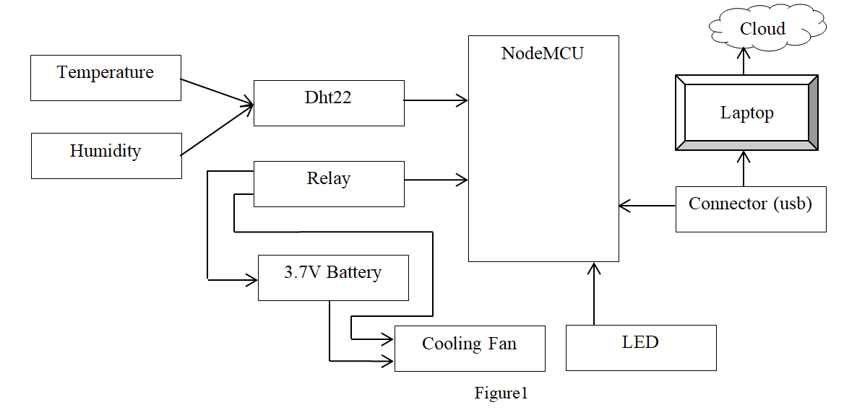

Fig.1 Block Diagram

1. **METHODOLOGY**

As shown in figure1, the SilkWorm Incubator system consists of Temperature and Humidity Sensor(DHT22), Relay, 3.7V Battery, NodeMCU, LED, Cooling Fan, USB Connector, Cloud. NodeMCU is programmed and has the ability to monitor and control the model. The framework consists of both the software and hardware. The NodeMCU will be connected with PC via connecter (USB Cable). The whole setup will be directly or indirectly linked with NodeMCU. The main purpose of our design is to automate the action of the controller. Printed circuit board is loaded with the code via selected ports to perform the required task. Here we have used COM4 port. It is simplest way to control the entire procedure based on the certain circumstances given in the code. The program is implemented in Arduino integrated development environment (IDE) in similar way to maintain the suitable environmental conditions. This code will helps in automation of Silkworm Incubator. If temperature is high the cooling fan will be turned on and LED will be turned off vice versa.

**HARDWARE COMPONENTS**

**1. TEMPERATURE AND HUMIDITY SENSOR:**

The DHT22 sensor is a digital-output relative humidity and temperature sensor with an accuracy of ±1°C and ±1%. It can measure temperature from -40°C to 80°C and humidity from 0% to 100%. It uses a capacitive humidity sensor and a thermistor to measure the surrounding air and outputs a digital signal on the data pin. Through the common single-wire interface, the DHT22 can be used to measure the surrounding environment's temperature and humidity. Compared to DHT11, it has higher accuracy and larger measuring range. The DHT22 is factory calibrated and delivers serial data, making it easy to set up.

**2. RELAY**

A relay is an electrically operated switch that can be used to turn on or off a device without human involvement. It consists of following pins: GND, IN, VCC and NO, COM, NC. The GND pin and VCC pin are connected to the circuit's ground and power supply, respectively. The IN pin is connected to a digital output pin of a microcontroller. The NO (Normally Open), COM (Common) and NC (Normally Closed) pins are connected to the load which needs to be controlled. When the relay is off, the COM pin is connected to the NC pin. When the relay is activated, the COM pin is connected to the NO pin.

**3. MICROCONTROLLER NODEMCU**

NodeMCU is an open-source framework and development kit that helps to prototype or builds IoT products. The name “NodeMCU” combines “node” and “MCU” (micro-controller unit). NodeMCU stands for Node MicroController Unit. The framework uses the Lua scripting language that is designed for IoT (Internet of Things) applications. The module that runs this framework is ESP-12E and it is based on 32-bit ESP8266 MCU.

**4. LED**

In this project LED is being used to provide the sufficient light for silkworms to grow in a healthy way.

**5. Cooling Fan**

In this project we are using cooling fan when the temperature became high. It is used to cool the temperature in silkworms rearing unit.

**6. Jumper wires**

Jumper wires are used to connect the components.

**7. Resistor (330 ohm)**

330 ohm resistors are used for LED current limiters.

**8. 3.7V Battery**

The 3.7v lithium battery is a lithium battery having a nominal voltage of 3.7v and a full-charge voltage of 4.2v. It has capacity ranges from hundred to several thousand mAh. It is used for power supply in this project.

**SOFAWRE SPECIFICATIONS**

**Ardunio IDE**

Arduino IDE (Integrated Development Environment) is an open-source programming tool which is used to upload or write code. With this program, you can work in real-time. Moreover, the code can be relocated to the Cloud, so you can frequently and simply access your works without redundancy. To upload programs and communicate with the Arduino boards, a connection is made using the Arduino Integrated Development Environment, or Arduino Software (IDE). Programs created using Arduino Software (IDE) are called sketches. These sketches are written in the text editor which is then saved with the file extension.ino.

**CIRCUIT DIAGRAM**

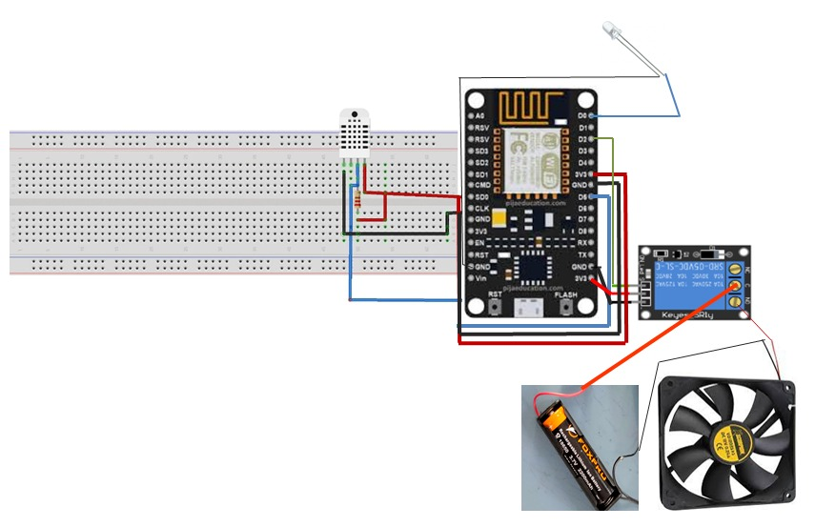

Fig.2 Circuit Diagram

1. **EXPERIMENTAL RESULTS**

It reads temperature and humidity data from dht22 and then checks the temperature and humidity readings. if they are valid then prints the readings to serial monitor as shown in Fig.3

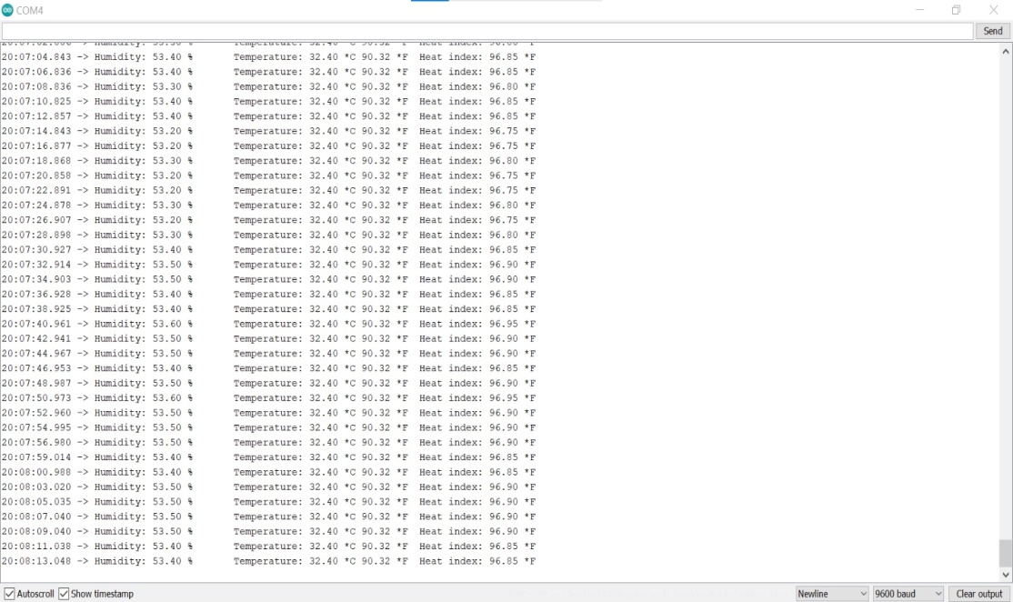

Fig.3 Readings

If the temperature is higher than 28*C, it turns on the fan and turns off an LED as shown in Fig.4

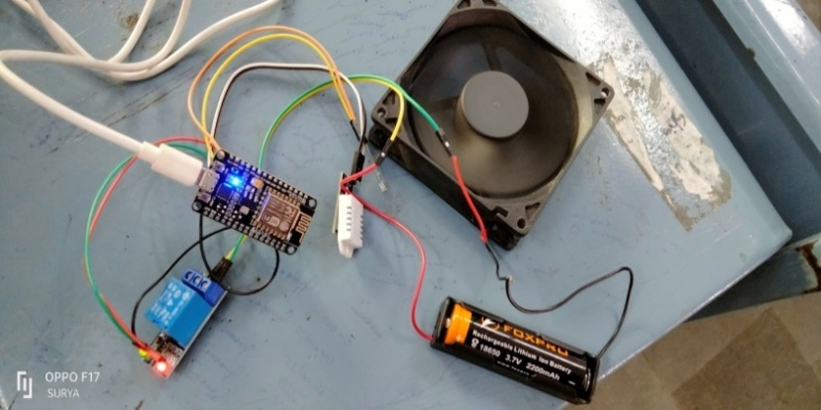

Fig.4 Temp Above 28*C

If the temperature is less than or equal to 28*C, it turns off the fan and turns on an LED as shown in Fig.5

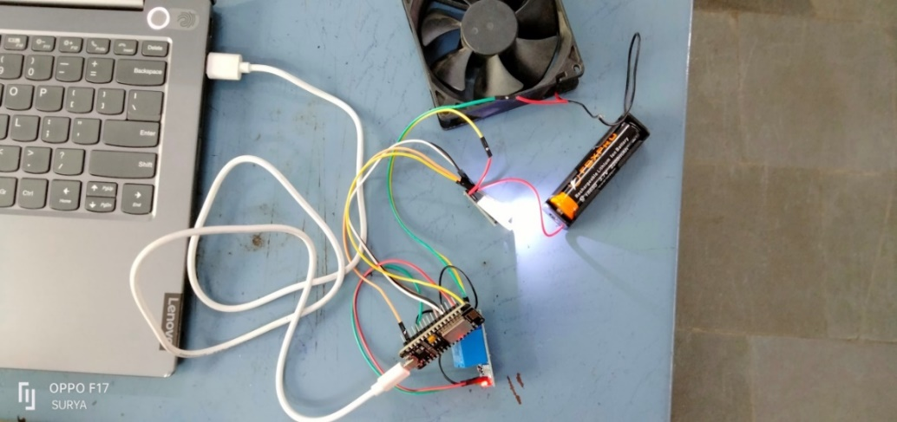

Fig.5 Temp Below 28*C

The code then waits for 2 seconds before checking the temperature and humidity again, and repeating the process.

1. **CONCLUSION**

The silkworm incubator prototype is designed to provide the sufficient environmental conditions for silkworms to grow. From this project we can conclude variations occurred in automation of the silkworm incubator prototype. It uses dht22 sensor to monitor the environmental conditions and controls the temperature and humidity based on the readings. When temperature is high cooling fan turns on and LED turns off, when temperature is low cooling fan turns off and LED turns on. Overall, the prototype shows how nodemcu and other components are used to create a system that can provide the optimal environment conditions for silkworm growth. In future work we grow the silkworms with our equipment and the data will be stored in cloud these data will be used for analysis.

1. **REFERENCES**
2. Rahmathulla, V. K. "Management of climatic factors for successful silkworm (Bombyx mori L.) crop and higher silk production: a review." Psyche: A Journal of Entomology 2012 (2012).
3. Sonobe, H., et al. "Carbohydrate metabolism and restricted oxygen supply in the eggs of the silkworm, Bombyx mori." Journal of Insect Physiology 25.5 (1979): 381-388.
4. Trager, William. "Cultivation of the virus of grasserie in silkworm tissue cultures." The Journal of Experimental Medicine 61.4 (1935): 501.
5. Mekala, V., et al. "Internet of Things Based Innovative and Cost-effective Smart Sericulture Farm Incubator." 2021 5th International Conference on Electronics, Communication and Aerospace Technology (ICECA). IEEE, 2021.
6. Jumaghulov, Kh A., and Kh E. Rakhmanova. "The scientific basis of the implementation of differential incubation periods of mulberry silkworm (Bombyx mori L.) seeds in the harsh continental climate of Central Asia." IOP Conference Series: Earth and Environmental Science. Vol. 1142. No. 1. IOP Publishing, 2023.
7. Prasad, S., and V. B. Upadhyay. "Biotechnological importance of cocoon magnetization with particular reference to the larval performance of multivoltine mulberry silkworm (Bombyx mori Linn.)." Middle-East J. Sci. Res 10.5 (2011): 565-572.
8. Yamashita, Okitsugu, and Toshinobu Yaginuma. "Silkworm eggs at low temperatures: implications for sericulture." Insects at low temperature (1991): 424-445.
9. Saha, A. K., et al. "Low cost incubation pot for better hatching of silkworm eggs in dry summer." UTTAR PRADESH JOURNAL OF ZOOLOGY (2002): 263-267.
10. He, Weiyi, et al. "Effect of heat, enzymatic hydrolysis and acid-alkali treatment on the allergenicity of silkworm pupa protein extract." Food chemistry 343 (2021): 128461.
11. Altomare, Alessandra Anna, et al. "Silkworm pupae as source of high‐value edible proteins and of bioactive peptides." Food Science & Nutrition 8.6 (2020): 2652-2661.
12. Yashaswini, B., Nagmani Madhusudhan, and D. Suresh. "Automated smart sericulture based on IoT and image processing technique 10 (6)." ISSN 2321.3361 (2020): 2020.
13. Nikitha, Mrs. "Efficient water management system for mulberry garden using IOT."
14. Rasooli, Mohammad Wasi, Brij Bhushan, and Nagesh Kumar. "Applicability of wireless sensor networks & IoT in saffron & wheat crops: A smart agriculture perspective." Int. J. Sci. Technol. Res 9.2 (2020): 2456-2461.
15. Jegadeesan, S., et al. "ISISF: IoT Based Smart Incubator for Sericulture Farm." International Journal of Modern Agriculture 10.2 (2021): 3202-3208.
16. Sreedhar, Guru, Lakhan B. Makam, and Mr Mylara Reddy. "Intelligent Control System for Sericulture using IoT." Journal of Xi'an University of Architecture & Technology 12.4 (2020): 3967.