任务1：用函数实现求两点之间的距离
源代码
distance_function.py
import math
def distance(**dot):
point1_keys=sorted([k for k in dot.keys() if k.endswith('1')])
point2_keys=sorted([k for k in dot.keys() if k.endswith('2')])
sum_of_squares=0
x_distance=0
for k1,k2 in zip(point1_keys,point2_keys):
diff=dot[k1]-dot[k2]
sum_of_squares+=diff**2
if k1=='x1' and k2=='x2':
x_distance=abs(diff)
total_distance=math.sqrt(sum_of_squares)
return x_distance,total_distance
distance_test.py
import distance_function as df
diamension1=df.distance(x1=1,x2=2)
diamension2=df.distance(x1=1,y1=1,x2=2,y2=2)
diamension3=df.distance(x1=1,y1=1,z1=1,x2=2,y2=2,z2=2)
import distance_function as df
# 直接获取距离值
x_dist1, total_dist1 = df.distance(x1=1, x2=2)
print(f"x之间的距离为{x_dist1:.2f},空间之间的距离为{total_dist1:.2f}")

x_dist2, total_dist2 = df.distance(x1=1, y1=1, x2=2, y2=2)
print(f"x之间的距离为{x_dist2:.2f},空间之间的距离为{total_dist2:.2f}")

x_dist3, total_dist3 = df.distance(x1=1, y1=1, z1=1, x2=2, y2=2, z2=2)
print(f"x之间的距离为{x_dist3:.2f},空间之间的距离为{total_dist3:.2f}")
测试运行截图
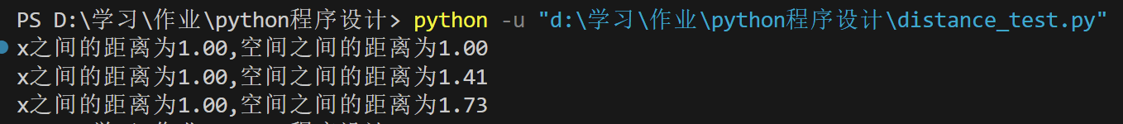
任务2：利用高阶函数map求解所有3位4位5位水仙花数
源代码
'''利用高阶函数map求解所有3位、4位、5位水仙花数'''
def is_narcissistic(num):
str_num=str(num)
digits=len(str_num)
sum_of_powers=sum(map(lambda x:x**digits,map(int,str_num)))
return sum_of_powers==num
#查找三位数水仙花数
three_digits_range=range(100,1000)
three_digits_narcissistic=list(filter(is_narcissistic,three_digits_range))
#查找四位数水仙花数
four_digits_range=range(1000,10000)
four_digits_narcissistic=list(filter(is_narcissistic,four_digits_range))
#查找五位数水仙花数
five_digits_range=range(10000,100000)
five_digits_narcissistic=list(filter(is_narcissistic,five_digits_range))
#输出结果
print("三位数水仙花数：")
for num in three_digits_narcissistic:
print(num)
print("\n四位数水仙花数：")
for num in four_digits_narcissistic:
print(num)
print("\n五位数水仙花数：")
for num in five_digits_narcissistic:
print(num)
运行测试截图
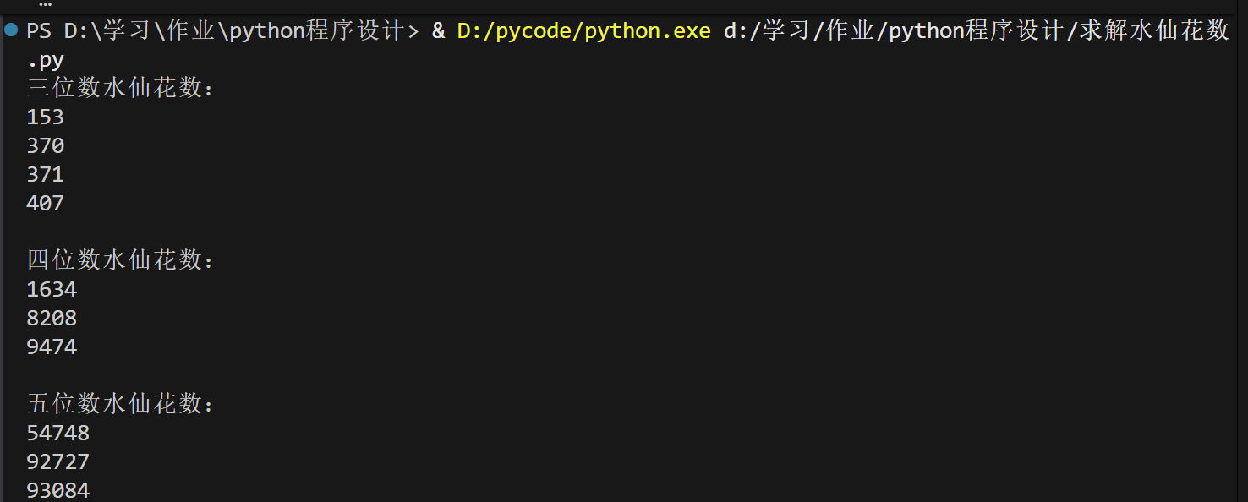
基础练习1：设计一个圆类Circle和一个桌子类Table
源代码
import math
#创建圆类
class Circle:
def __init__(self,R):
self.Radius=R
def getArea(self):
return math.pi*(self.Radius**2)
#创建桌子类
class Table:
def __init__(self,H):
self.Heigt=H
def getHeight(self):
return self.Heigt
c1=Circle(2)
t1=Table(4)
c2=Circle(4)
t2=Table(8)
print(f"圆的面积: {c1.getArea():.2f}")
print(f"桌子的高度: {t1.getHeight()}")
print(f"圆的面积: {c2.getArea():.2f}")
print(f"桌子的高度: {t2.getHeight()}")
运行测试截图
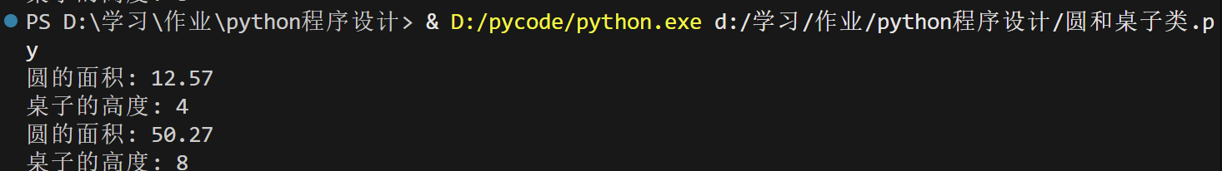
基础练习2：设计一个圆类Circle和一个桌子类Table，包含私有成员
源代码
import math
class Circle:
def __init__(self,R):
self.Radius=R
def getArea(self):
return math.pi*(self.Radius**2)
#私有成员
def setRadius(self,r):
self.__Radius=r
#创建桌子类
class Table:
def __init__(self,H):
self.Heigt=H
def getHeight(self):
return self.Heigt
#私有成员
def setHeight(self,H):
self.__Height=H
c1=Circle(2)
t1=Table(4)
c2=Circle(4)
t2=Table(8)
print(f"圆的面积: {c1.getArea():.2f}")
print(f"桌子的高度: {t1.getHeight()}")
print(f"圆的面积: {c2.getArea():.2f}")
print(f"桌子的高度: {t2.getHeight()}")
运行测试截图
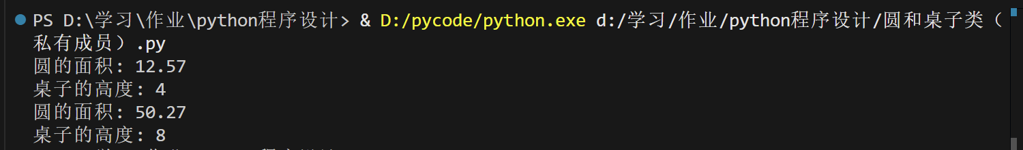
基础练习3：设计一个圆桌类Roundtable，它由基础练习1中的圆类和桌子类派生而来
源代码
import math
#创建圆类
class Circle:
def __init__(self,R):
self.Radius=R
def getArea(self):
return math.pi*(self.Radius**2)
#创建桌子类
class Table:
def __init__(self,H):
self.Heigt=H
def getHeight(self):
return self.Heigt
#派生出圆桌类
class RoundTable(Circle,Table):
def __init__(self,r,h,c):
Circle.__init__(self,r)
Table.__init__(self,h)
self.color=c
def info(self):
print('圆桌的面积为：{:.2f},高度为：{},颜色为：{}'.format(self.getArea(),self.getHeight(),self.color))
RT1=RoundTable(2,4,'红色')
RT1.info()
运行程序截图
任务3：创建Person类及其派生类，并实现多态性
源代码
#创建Person类
class Person:
def __init__(self,n,a,s):
self.name=n
self.age=a
self.sex=s
def personInfo(self):
print("姓名为：{}，年龄为：{}，性别为：{}".format(self.name,self.age,self.sex))
#创建student类
class Student(Person):
def __init__(self, n, a, s,college,class_name):
super().__init__(n, a, s)
self.college=college
self.class_name=class_name
def personInfo(self):
#调用父类的方法
super().personInfo()
print("学院：{}，班级：{}".format(self.college,self.class_name))
#创建Teacher类，继承自Person
class Teacher(Person):
def __init__(self, n, a, s,college,pro):
super().__init__(n, a, s)
self.college=college
self.pro=pro
def personInfo(self):
super().personInfo()
print("学院：{}，专业：{}".format(self.college,self.pro))
#定义一个函数Info，实现多态
def Info(obj):
obj.personInfo()
#分别创建对象
p=Person('张三',30,'男')
s=Student('李四',20,'女','计算机学院','计科1班')
t=Teacher('王五',40,'男','外国语学院','英语专业')
#调用函数Info，实现多态
Info(p)
print('-'*30)
Info(s)
print('-'*30)
Info(t)
运行程序截图
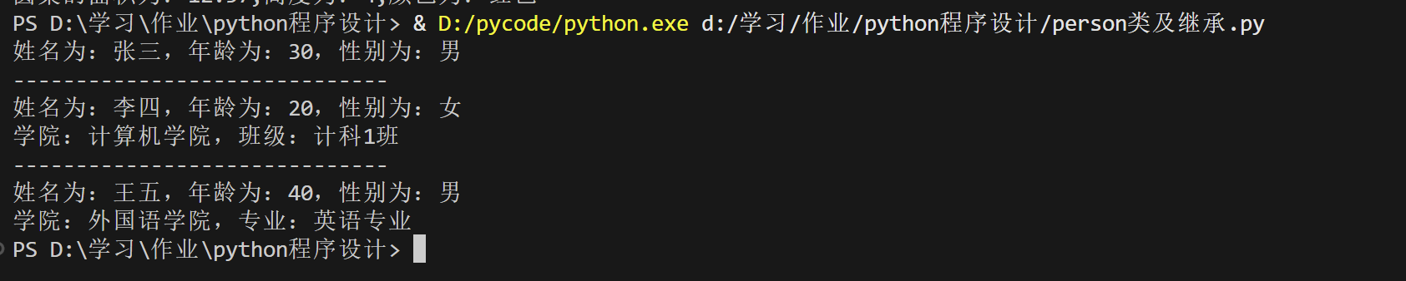
任务4：修改给定的文件myarray.py，重载运算符“*”，完成对向量（数组）的乘积。
源代码
Myarray.py
class MyArray:
"""All the elements in this array must be numbers"""
def __IsNumber(self,n):
return isinstance(n, (int, float, complex))
def __init__(self,*args):
if not args:
self.__value =[]
else:
for arg in args:
if not self.__IsNumber(arg):
print('All elements must be numbers')
return
self.__value = list(args)
#重载运算符+
#数组中每个元素都与数字n相加，或两个数组相加，返回新数组
def __add__(self,n):
if self.__IsNumber(n):
#数组中所有元素都与数字n 相加
b = MyArray()
b.__value = [item + n for item in self.__value]
return b
elif isinstance(n, MyArray):
#两个等长的数组对应元素相加
if len(n.__value)==len(self.__value):
c = MyArray()
c.__value = [i+j for i, j in zip(self.__value, n.__value)]
return c
else:
print('Length not equal')
else:
print('Not supported')
# 重载运算符-
# 数组中每个元素都与数字n相减，返回新数组
def __sub__(self,n):
if not self.__IsNumber(n):
print('- operation with ',type(n),'and number type is not supported')
return
b = MyArray()
b.__value = [item-n for item in self.__value]
return b
# 重载运算符*
# 数组中每个元素都与数字n相乘，返回新数组
# def __mul__(self,n):
# if not self.__IsNumber(n):
# print('* operation with ',type(n),'and number type is not supported')
# return
# b = MyArray()
# b.__value = [item*n for item in self.__value]
# return b
def __mul__(self,n):
if self.__IsNumber(n):
b = MyArray()
b.__value = [item*n for item in self.__value]
return b
elif isinstance(n,MyArray):
if len(n.__value) == len(self.__value):
return sum([i*j for i,j in zip(self.__value,n.__value)])
else:
print("Length not equal")
else:
print('* operation with ',type(n),'and number type is not supported')
return

# 重载运算符/
# 数组中每个元素都与数字n相除，返回新数组
def __truediv__(self,n):
if not self.__IsNumber(n):
print(r'/ operation with ',type(n),'and number type is not supported')
return
b = MyArray()
b.__value = [item/n for item in self.__value]
return b
#重载运算符//
# 数组中每个元素都与数字n整除，返回新数组
def __floordiv__(self,n):
if not self.__IsNumber(n):
print(n,' is not a integer')
return
b = MyArray()
b.__value = [item//n for item in self.__value]
return b
#重载运算符%
#数组中每个元素都与数字n求余数，返回新数组
def __mod__(self,n):
if not self.__IsNumber(n):
print(r'% operation with ',type(n),'and number type is not supported')
return
b = MyArray()
b.__value = [item%n for item in self.__value]
return b
#重载运算符**
#数组中每个元素都与数字n进行幂运算，返回新数组
def __pow__(self,n):
if not self.__IsNumber(n):
print('** operation with ',type(n),'and number type is not supported')
return
b = MyArray()
b.__value = [item**n for item in self.__value]
return b
def __len__(self):
return len(self.__value)
#直接使用该类对象作为表达式来查看对象的值
def __repr__(self):
#等价于return self.__value
return repr(self.__value)
#支持使用print()函数来查看对象的值
def __str__(self):
return str(self.__value)
#追加元素
def append(self,v):
assert self.__IsNumber(v),'Only number can be appended.'
self.__value.append(v)
#获取指定下表的元素值，支持使用列表或元组指定多个下标
def __getitem__(self,index):
length = len(self.__value)
#如果指定单个整数作为下标，则直接返回元素值
if isinstance(index, int) and 0<=index<length:
return self.__value[index]
#使用列表或元组指定多个整数下标
elif isinstance(index,(list,tuple)):
for i in index:
if not (isinstance(i, int) and 0<=i<length):
return 'index error'
result = []
for item in index:
result.append(self.__value[item])
return result
else:
return 'index error'
#修改元素值，支持使用列表或元组指定多个下标，同时修改多个元素值
def __setitem__(self, index, value):
length = len(self.__value)
#如果下标合法，则直接修改元素值
if isinstance(index, int) and 0<=index<length:
self.__value[index] = value
#支持使用列表或元组指定多个整数下标
elif isinstance(index,(list,tuple)):
for i in index:
if not (isinstance(i, int) and 0<=i<length):
raise Exception('index error')
#如果下标和给的值都是列表或元组，并且个数一样，则分别为多个下标的元素修改值
if isinstance(value,(list,tuple)):
if len(index) == len(value):
for i,v in enumerate(index):
self.__value[v] = value[i]
else:
raise Exception('values and index must be of the same length')
#如果指定多个下标和一个普通值，则把多个元素修改为相同的值
elif isinstance(value, (int,float,complex)):
for i in index:
self.__value[i] = value
else:
raise Exception('value error')
else:
raise Exception('index error')
#支持成员测试运算符in，测试数组中是否包含某个元素
def __contains__(self, v):
return v in self.__value
#重载运算符==,测试两个数组是否相等
def __eq__(self, v):
assert isinstance(v, MyArray), 'wrong type'
return self.__value == v.__value
#重载运算符<，比较两个数组大小
def __lt__(self, v):
assert isinstance(v, MyArray), 'wrong type'
return self.__value < v.__value

if __name__ == '__main__':
print('Please use me as a module')
ma = MyArray(1,2,3,4,5,6)
ma = ma.__add__(2)
mb = MyArray(1,1,1,1,1,1)
ma = ma.__add__(mb)
ma = ma.__add__(ma)
ma = ma + mb
ma = ma + 2
ma.append(3)
# print(ma._MyArray__value)
ma = MyArray(1,2,3,4,5,6)
ma = ma*2
print(ma)
mc = MyArray(1,2,3,4,5,6)
result = ma*mc
print("这两个向量相乘的结果为："+str(result))
myarray_test.py
import myarray as mya
ma = mya.MyArray(1,2,3,4,5,6)
ma = ma * 2
print("ma 乘以 2 后：", ma)
mc = mya.MyArray(1,2,3,4,5,6)
result = ma * mc
print("ma 与 mc 的内积结果为：", result)
运行程序截图
