任务1：根据数据集WN18.txt文件数据，显示四个深度模型mrr和hit的可视化。
源代码：
import matplotlib.pyplot as plt
import numpy as np
#读取数据
filename='d:\\学习\\作业\\python程序设计\\实验5：可视化\\wn18.txt'
data=[]
with open(filename,'r') as f:
lines=f.readlines()
current_model=None
models={'TransE':[],'TransD':[],'ComplEx':[]}
for line in lines:
line=line.strip()
if not line:
continue
if line.startswith('TransE') or line.startswith('TransD') or line.startswith('ComplEx'):
current_model=line.strip()
continue
else:
parts=line.split()
mrr=float(parts[0])
hits=float(parts[1])
epoch=int(parts[2])
models[current_model].append((epoch,mrr,hits))
#提取数据
def extract_data(model_name):
epochs=[]
mrrs=[]
hits=[]
for epoch,mrr,hit in models[model_name]:
epochs.append(epoch)
mrrs.append(mrr)
hits.append(hit)
return epochs,mrrs,hits
#获取各模型数据
epochs_T,mrr_T,hits_T=extract_data('TransE')
epochs_D,mrr_D,hits_D=extract_data('TransD')
epochs_C,mrr_C,hits_C=extract_data('ComplEx')
#创建图形
fig,(ax1,ax2)=plt.subplots(1,2,figsize=(14,6))
#MRR
ax1.plot(epochs_T,mrr_T,'g-',marker='x',label='TransE',linewidth=2)
ax1.plot(epochs_D,mrr_D,'r-',marker='*',label='TransD',linewidth=2)
ax1.plot(epochs_C,mrr_C,'b-',marker='o',label='ComplEx',linewidth=2)
ax1.set_title('WN18 Validation MRR')
ax1.set_xlabel=('Epochs')
ax1.set_ylabel=('MRR')
ax1.legend()
ax1.grid(True)
#Hits@10
ax2.plot(epochs_T,hits_T,'g-',marker='x',label='TransE',linewidth=2)
ax2.plot(epochs_D,hits_D,'r-',marker='*',label='TransD',linewidth=2)
ax2.plot(epochs_C,hits_C,'b-',marker='o',label='ComplEx',linewidth=2)
ax2.set_title('WN18 Validation Hits@10')
ax2.set_xlabel=('Epochs')
ax2.set_ylabel=('Hits@10')
ax2.legend()
ax2.grid(True)
#调整布局
plt.tight_layout()
plt.show()
运行结果：
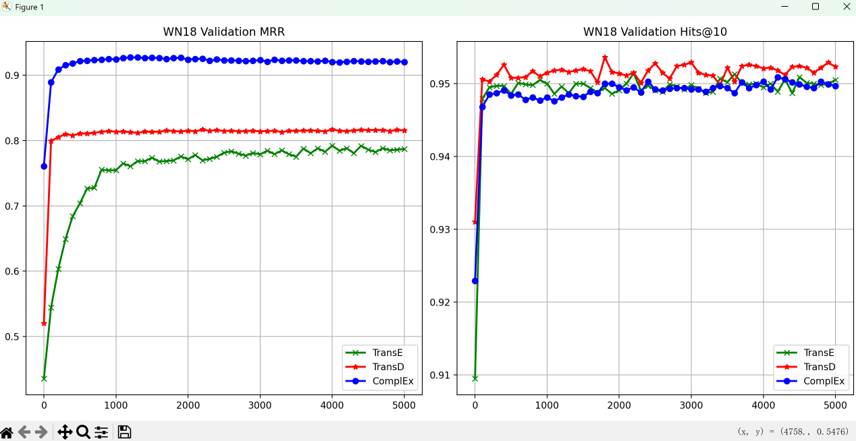
任务2：根据BDRAN模型和BDRAN+CA模型，对头实体和尾实体的预测排名分布进行可视化。
源代码：
import matplotlib.pyplot as plt
import numpy as np

# 文件路径
head_file = 'd:\\学习\\作业\\python程序设计\\实验5：可视化\\WN18RR\\GAT+2sides_head_tail.txt'
tail_file = 'd:\\学习\\作业\\python程序设计\\实验5：可视化\\WN18RR\\GAT+convauto_head_tail.txt'

# 读取数据
def read_data(filename):
with open(filename, 'r') as f:
lines = f.readlines()
# 去除空格和换行符，转换为整数列表
data = []
for line in lines:
values = [int(x.strip()) for x in line.split() if x.strip()]
data.append(values)
return data

# 读取头实体和尾实体数据
head_data = read_data(head_file) # [[BDRAN_head], [BDRAN+CA_head]]
tail_data = read_data(tail_file) # [[BDRAN_tail], [BDRAN+CA_tail]]

# 提取数据
bdran_head = head_data[0] # [1050, 246, 92, 264, 425, 847]
bdran_ca_head = head_data[1] # [1253, 98, 56, 156, 278, 1083]

bdran_tail = tail_data[0] # [1103, 272, 100, 277, 423, 749]
bdran_ca_tail = tail_data[1] # [1299, 89, 62, 159, 316, 999]

# 定义横坐标标签
x_labels = ['1', '2', '3', '4-10', '11-100', '101-']

# 设置图形大小
fig, (ax1, ax2) = plt.subplots(2, 1, figsize=(12, 10))

# 第一个子图：头实体预测
x = np.arange(len(x_labels))
width = 0.35

ax1.bar(x - width/2, bdran_head, width, label='BDRAN', color='red')
ax1.bar(x + width/2, bdran_ca_head, width, label='BDR+CA', color='blue')

ax1.set_title('Performance of head entity prediction on WN18RR')
ax1.set_xlabel('Range of rank')
ax1.set_ylabel('Number of entities')
ax1.set_xticks(x)
ax1.set_xticklabels(x_labels)
ax1.legend()
ax1.grid(axis='y', linestyle='--', alpha=0.7)

# 在柱子上方添加数值标签
for i, (h, ca) in enumerate(zip(bdran_head, bdran_ca_head)):
ax1.text(i - width/2, h + 10, str(h), ha='center', va='bottom', fontsize=9)
ax1.text(i + width/2, ca + 10, str(ca), ha='center', va='bottom', fontsize=9)

# 第二个子图：尾实体预测
ax2.bar(x - width/2, bdran_tail, width, label='BDRAN', color='red')
ax2.bar(x + width/2, bdran_ca_tail, width, label='BDR+CA', color='blue')

ax2.set_title('Performance of tail entity prediction on WN18RR')
ax2.set_xlabel('Range of rank')
ax2.set_ylabel('Number of entities')
ax2.set_xticks(x)
ax2.set_xticklabels(x_labels)
ax2.legend()
ax2.grid(axis='y', linestyle='--', alpha=0.7)

# 添加数值标签
for i, (h, ca) in enumerate(zip(bdran_tail, bdran_ca_tail)):
ax2.text(i - width/2, h + 10, str(h), ha='center', va='bottom', fontsize=9)
ax2.text(i + width/2, ca + 10, str(ca), ha='center', va='bottom', fontsize=9)

plt.tight_layout()
plt.show()
运行结果：
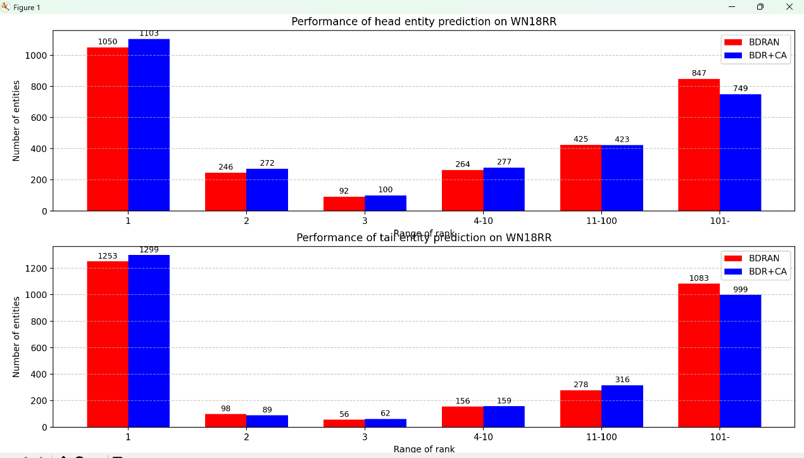
任务3：对红楼梦知识图谱数据进行可视化。
源代码：
import pandas as pd
import networkx as nx
import matplotlib.pyplot as plt

# 读取CSV文件
file_path = 'd:\\学习\\作业\\python程序设计\\实验5：可视化\\triples.csv'
df = pd.read_csv(file_path, encoding='utf-8')

# 创建有向图
G = nx.DiGraph()

# 添加边（head -> tail）
for _, row in df.iterrows():
head = row['head']
tail = row['tail']
G.add_edge(head, tail)

# 设置图形大小
plt.figure(figsize=(14, 12)) # 增大画布以容纳文字

# 使用Kamada-Kawai布局（适合复杂图，避免交叉）
pos = nx.kamada_kawai_layout(G)

# 绘制节点（红色圆形）
nx.draw_networkx_nodes(G, pos, node_size=15, node_color='red', alpha=0.9, edgecolors='black')

# 绘制边（黑色箭头）
nx.draw_networkx_edges(G, pos, arrows=True, arrowstyle='->', arrowsize=15, edge_color='black', alpha=0.8)

# 显示节点标签（人物名）
nx.draw_networkx_labels(
G,
pos,
font_size=6, # 字体大小，较小以避免重叠
font_family='SimHei', # 中文支持（黑体）
font_weight='normal',
verticalalignment='center',
horizontalalignment='center'
)

# 关闭坐标轴
plt.axis('off')
plt.tight_layout()
plt.show()
运行结果：
