任务2&任务3
源代码：
A=0
B=0
C=0
D=0
E=0
#评估等级
def EvaluateScore(s):
global A,B,C,D,E
if(s>=90 and s<=100):
grade="优秀"
A=A+1
elif(s>=80 and s<90):
grade="良好"
B=B+1
elif(s>=70 and s<80):
grade="中等"
C=C+1
elif(s>=60 and s<70):
grade="及格"
D=D+1
elif(s<60 and s>=0):
grade="不及格"
E=E+1
return grade
#排序成绩
def sortScores(s):
s_sorted=sorted(s,reverse=True)
print("这是从高到低排序的成绩：")
for score in s_sorted:
print(score)
return s_sorted
#查询成绩区间的学生
def search(s,n):
upScope=eval(input("请输入你想要查询的成绩区间上限："))
downScope=eval(input("请输入你想要查询的成绩区间下限："))
found=False
for i in range(len(s)):
if downScope<=s[i]<=upScope:
print(f"{n[i]}: {s[i]}")
found=True
if not found:
print("没有查询到该区间的成绩")
return " "
print("===== 学生成绩评定系统 =====")
print("请输入学生成绩(0-100)，输入-1结束录入")
i=1
sum=0
scores=[]
names=[]
while(True):
try:
score=eval(input("请输入第{}位学生的成绩：".format(i)))
if(score==-1):
break
else:
name=input("请输入学生的姓名：")
scores.append(score)
names.append(name)
grade=EvaluateScore(score)
print("学生{}：成绩{:.1f}-> 等级：{}".format(i,score,grade))
i=i+1
sum=sum+score
except:
print("请输入有效的数字")
print("===== 成绩统计报告 =====")
print("学生总数：",i-1)
print("平均成绩：{:.2f}".format(sum/(i-1)))
print("优秀人数：{}({:.2f}%)".format(A,(A/(i-1))*100))
print("良好人数：{}({:.2f}%)".format(B,(B/(i-1))*100))
print("中等人数：{}({:.2f}%)".format(C, (C/(i-1))*100))
print("及格人数：{}({:.2f}%)".format(D,(D/(i-1))*100))
print("不及格人数：{}({:.2f}%)".format(E,(E/(i-1))*100))
print("总体评价: 班级整体表现良好！")
print("这是学生的姓名和对应的成绩：")
for name,score in zip(names,scores):
print(f"{name}:{score}")
sortScores(scores)
search(scores,names)
运行测试截图：
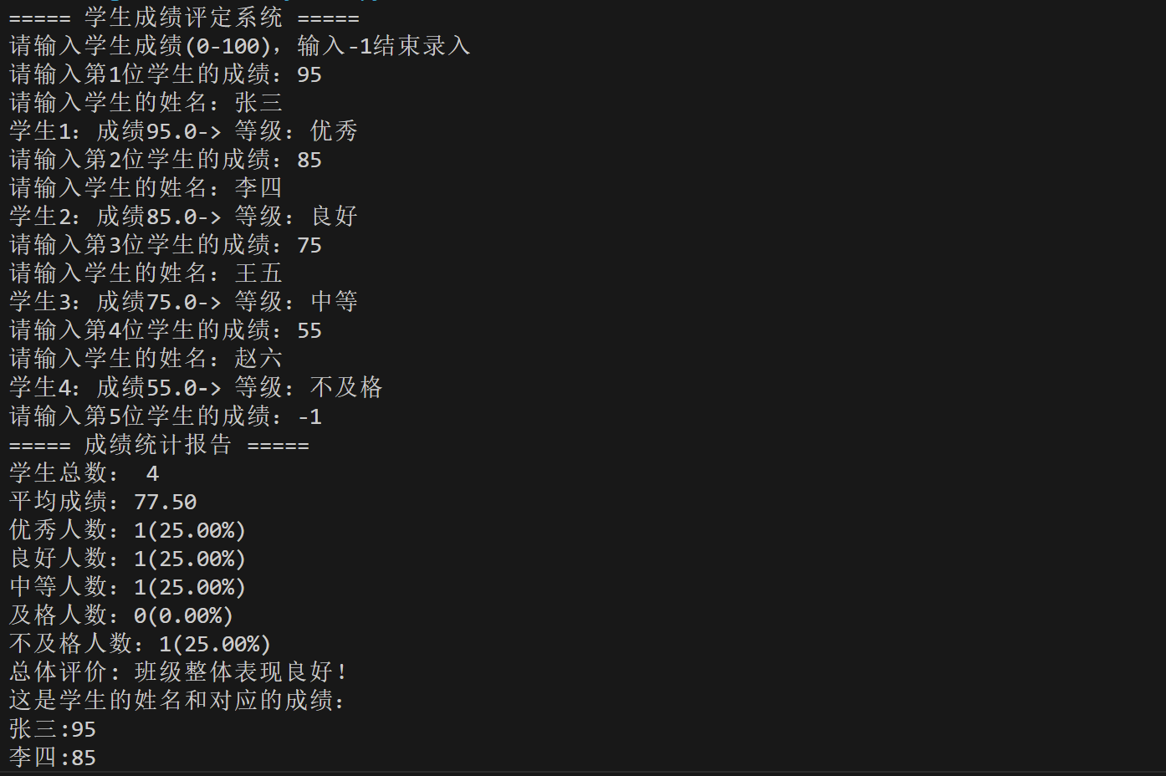
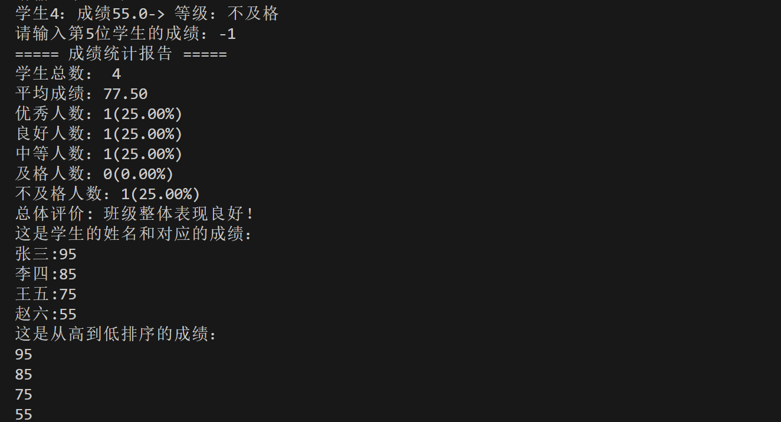
场景二
源代码：
import random
# 模拟多传感器数据输入
current_speed = random.randint(30, 120) # 当前车速(km/h)
front_distance = random.randint(0, 200) # 前方障碍物距离(m)
road_condition = random.choice(["干燥", "湿滑", "积雪"]) # 道路条件
weather = random.choice(["晴朗", "小雨", "大雨", "雾天"]) # 天气条件
traffic_light = random.choice(["绿色", "黄色", "红色"]) # 交通信号灯

# 打印当前环境状态
print("=== 自动驾驶系统决策日志 ===")
print(f"当前车速: {current_speed} km/h")
print(f"前方障碍物距离: {front_distance} m")
print(f"道路条件: {road_condition}")
print(f"天气条件: {weather}")
print(f"交通信号灯: {traffic_light}")

# 决策逻辑
decision = ""
emergency = False

# 紧急情况：前方障碍物太近（< 50米）
if front_distance < 50:
decision = "紧急刹车！"
emergency = True
elif traffic_light == "红色":
decision = "停车等待"
elif traffic_light == "黄色":
decision = "减速准备停车"
elif traffic_light == "绿色":
# 根据天气和路况调整速度
if weather in ["大雨", "雾天"] or road_condition in ["湿滑", "积雪"]:
if current_speed > 60:
decision = "减速行驶"
else:
decision = "保持当前速度"
else:
decision = "保持当前速度"

# 输出决策结果
print(f"\n决策结果: {decision}")

# 记录驾驶日志（写入文件）
with open("driving_log.txt", "a", encoding="utf-8") as f:
f.write(f"时间: {random.randint(1, 24):02d}:{random.randint(0, 59):02d}\n")
f.write(f"车速: {current_speed} km/h\n")
f.write(f"障碍物距离: {front_distance} m\n")
f.write(f"道路: {road_condition}, 天气: {weather}, 信号灯: {traffic_light}\n")
f.write(f"决策: {decision}\n")
f.write("-" * 40 + "\n")

print("\n驾驶日志已记录到 driving_log.txt")
运行测试截图：
