RUAHA CATHOLIC UNIVERSITY(RUCU)

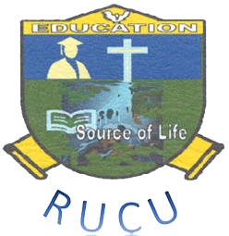

**FACULITY OF LAW**

**DEPARTMENT OF PUBLIC LAW**

**BACHELOR OF LAW**

**COURSE CODE:** RLW 124

**COURSE NAME:** LEGAL METHOD II

**LECTURER NAME:** IGNATUS BARONGO

**ACADEMIC YEAR:** 2022/2023

**NATURE OF THE ASSIGNMENT:** INDIVIDUAL ASSIGMENT

|  |  |  |
| --- | --- | --- |
| NAME | REG.NO | SIGNATURE |
| JOSEPH.M.MAYENGA | RU/LLB/2022/140 |  |