[MU123] - TMA01 2025J

Question 1
With reference to good mathematical communication (GMC), give 5 reasons why the second solution is better than the first.
- Clear Structure and Layout:
The student rewrites the question within their solution and uses linking words such as “so” to show logical progression. Each step is presented on a new line, which makes the method clear and easy to follow.

- Correct Use of Units:
Units are included throughout the working and in the final answer. This ensures clarity and demonstrates an understanding of how the values change throughout the calculation.

- Accurate and Appropriate Notation:
The student uses correct mathematical notation, including the degree symbol where appropriate. They show sufficient decimal places during the calculation before rounding to one decimal place, demonstrating accuracy and transparency in their working.

- Proper Use of the Equals Sign:
- The equals sign is used correctly—only once per line and only when it is mathematically appropriate. This avoids misleading statements and maintains mathematical accuracy.

- Clear and Concise Conclusion:
The final answer is written clearly and concisely, with the correct units and notation. The conclusion follows the conventions of good mathematical communication and confirms the reasoning and result.

Question 2a
Alex is following a recipe to make a pavlova that uses 280 grams of sugar and 6 eggs. However, they drop one egg and so only have the 5 remaining eggs to use. Calculate the quantity of sugar that Alex should now use to make their pavlova. Give your answer in grams, correct to 2 significant figures.
The recipe states that there is 280 grams of sugar for 6 eggs.
Therefore,

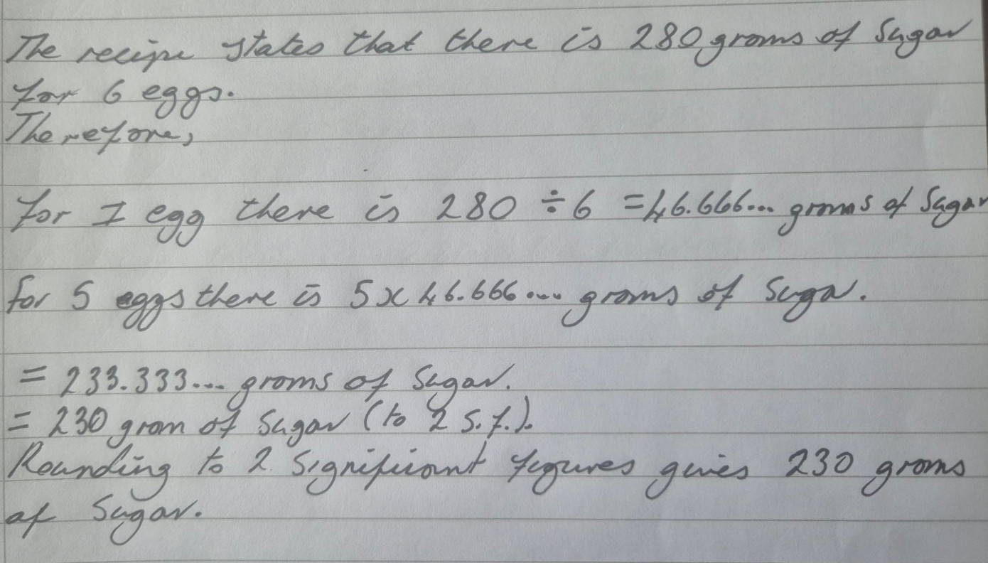

Question 2b
The book Is maths real? by Eugenia Cheng has 336 pages. An online preview of the book includes 39 pages. Calculate the percentage of pages that are included in the online preview. Give your answer correct to the nearest whole number.
The book has 336 pages and the online preview has 39 pages. Therefore, the percentage of pages in the online preview is:
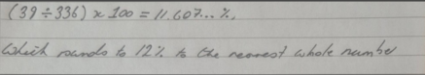

Question 2c
A farm has 140 sheep.
- 45% of these sheep are Texel sheep. Calculate the number of Texel sheep on the farm.
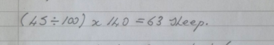

- Of these Texel sheep, 36 are lambs (are under 1 year old). Write the number of Texel lambs as a fraction of the total number of Texel sheep on the farm. Give your answer both as an un-simplified fraction, and as a fraction in its simplest form.

There are 63 Texel sheep on the farm, 36 of which are lambs. Therefore, the number of Texel lambs as a fraction of the total number of Texel sheep is:

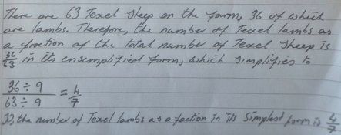

Question 2d – (ii) NOT ANSWERED
Bo, Cal and Drew are each crocheting a scarf.
- At one point, Bo’s scarf is 87 cm long and Cal’s scarf is 19% longer than Bo’s. Calculate the length of Cal’s scarf. Give your answer in centimetres correct to the nearest centimetre.
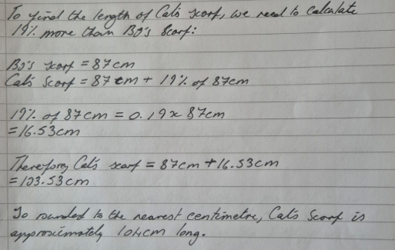
- At this point, Drew’s scarf is $\frac{8}{11}$ of the length of Cal’s scarf. Calculate the length of Drew’s scarf. Give your answer in centimetres, correct to the nearest centimetre.

Question 2e
The price of a first class Royal Mail stamp increased in October 2024 from £1.35 to £1.65.
- Calculate the percentage increase in the price of a first class stamp. Give your answer correct to one decimal place.
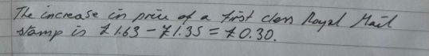
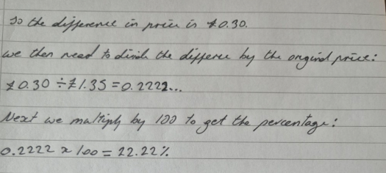

- Explain briefly why you used the method you used to answer Question 2 part (e)(i), and why you laid your solution out as you did.
I laid out my solution step-by-step to make it clear and easy to follow, showing each calculation and the reasoning behind it, using the GMC guidelines to help me.

Question 3a
Erin is an endurance (horse) rider.
Erin completes a training ride of 28.5 kilometres in 2 hours and 45 minutes. Calculate their average speed for this ride, giving your answer in kilometres per hour (km/h) correct to one decimal place.
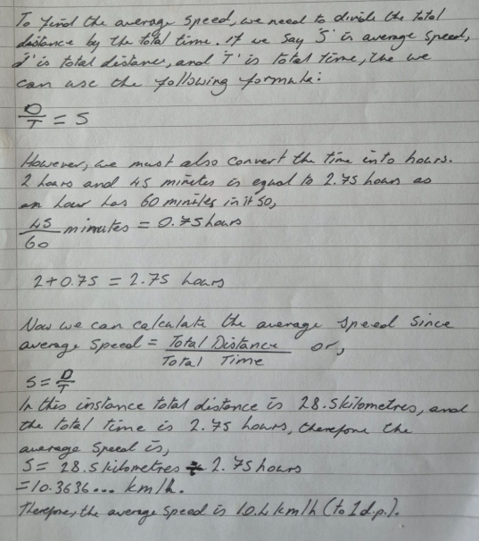

Question 3b
The first bridlepath (horse riding trail) on Erin’s training ride measures 34.6 cm on a map which has a scale of 1 : 16 000. Calculate the corresponding distance covered on the ground. Give your answer in kilometres, correct to two significant figures.
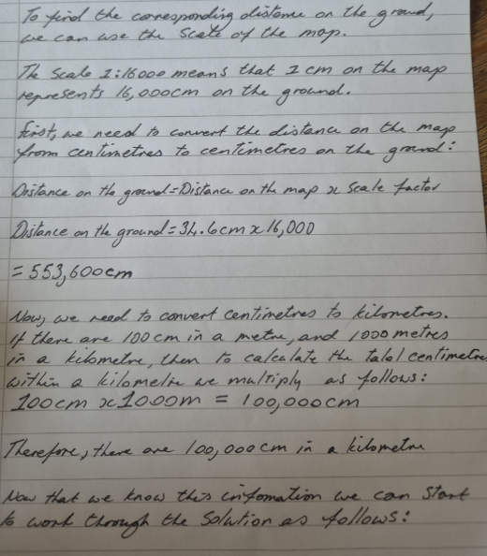
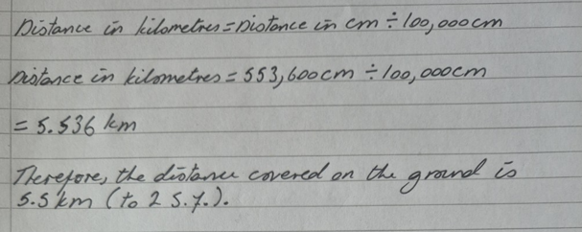

Question 3c
Erin competes in the young rider category; young riders are aged 14 years old to 25 years old, inclusively. Let y represent the age of a competitor, in years.
- Explain what the inequality y ≥14 means in this practical context.
The inequality 14 ≤ x ≤ 25 means that a competitor must be 14 years or older to 25 years old, to take part in the young rider category.

- Draw a number line to illustrate the range of ages for a young rider.
Here is a number line showing the age range for young riders — from 14 to 25 years old. You can see the range clearly highlighted.
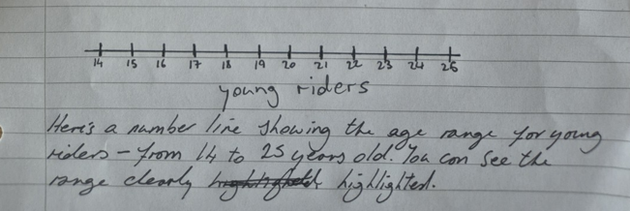
- Write down a double inequality, using y, to describe this range of ages.
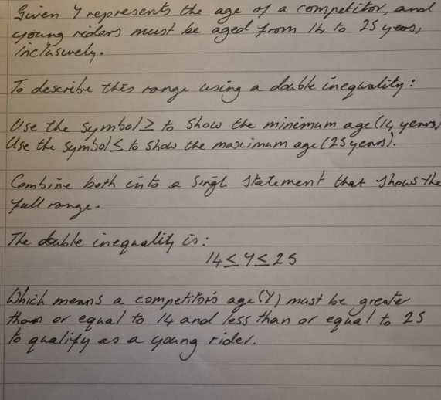

Question 3d
Erin enters a competition, a novice Graded Endurance Ride of 35 kilometres. The ride must be completed at an average speed of between 8 and 15 km/h. Calculate the maximum time that Erin can take to complete the ride without being eliminated. Give your answer in hours and minutes, correct to the nearest 5 minutes. 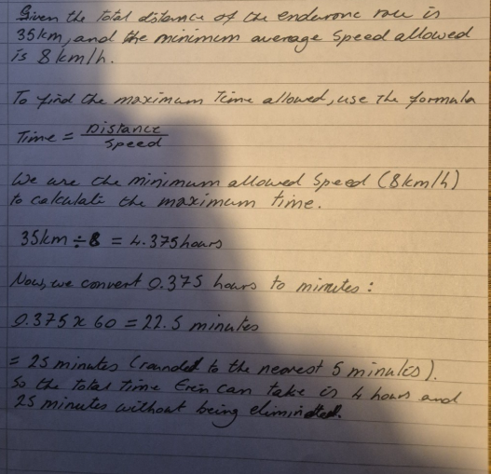

Question 4a
After a storm, the water level in the river Derwent near Fu’s home is rising steadily. At 9:00 pm the water is 25 cm above the normal level. The water then rises at a rate of 15 cm each hour, for the next 12 hours.
Using this information, complete a copy of the table below.
Time, T, in hours after 9pm | 0 | 1 | 3 | 4 | 6 | 9 | 12
Height of water, H, in  centimetres above the  normal level | 25 | 40 | 70 | 85 | 115 | 160 | 205

Question 4b
Mark the points from part (a) on a graph, with the vertical axis showing H, the height of water above the normal level in centimetres, and the horizontal axis showing T, the time in hours after 9 pm. Draw a line through these points
