[MU123] - TMA02 – 2025J

Question 1a
What have you enjoyed most about your MU123 experience so far? [1 mark]

Question 1b
What has been your most challenging experience on MU123 so far? [1 mark]

Question 1c
What is the most important thing you have learnt from your tutor’s feedback from TMA01? [1 mark]

Question 1d
How has this changed the way you approached this assignment? [2 marks]

Question 2a (i)
Use a factor tree or similar method to write 8316 as a product of prime factors. Display your factor tree in your answer. If you choose to use an alternative method, then clearly show your working: just writing down the answer is not sufficient.
- Book: Mu123:unit 3 – 1.4: Prime Factors (p145 – 151)
8316
- 8316/2
- 4158/2
- 2079/3
- 693/3
- 231/11
- 21/3
- 7
x2^2 = 4
x3 ^3 = 27
x 11
x 7

= 4 x 27 x 11 x 7 = 8316

- OR: 8316
  - answer: 92 x 90
  - 4 x 23 x 9 x 10
  - 2 x 2 x 23 x 3 x 3 x 2 x 5
  - prime factorization: 2 x 2 x 2 x 3 x 3 x 5 x 23
  - or in exponential form: 2^3 x 3^2 x 5^1 x 23^1

Question 2a (ii)
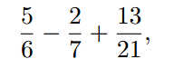
Calculate
leaving your answer as a fraction in its simplest form, showing your working.
- Find the lowest common multiplier of 6, 7 and 21
- Denom, 6: Factors are 2,3
- Denom, 7: Factors are 7
- So highes is 3x7 = 21
- 21: Factors are 3,7
- Denom 21: Factors are 3,7
- So highest is 7x7
- Which is 42
- Then bidmas that shit
- 35/42 – 12/42 + 26/42
- So 35/42 – 12/42 = 23/42
- And 23/42 + 26/42 = 49/42
- So simplified to 1 7/42 = 1 1/6

Question 2a (iii)
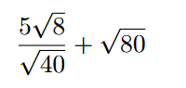
Simplify the surd

by writing it as a surd in its simplest form, showing your working.
- Book: MU123:Unit3 - 3.3 Surds (p179-187)

Question 2b (i)
540 students are required to take a test. Of these, 495 actually take the test, and 45 are absent that day
Write down the ratio of the number of students who take the test to the number of students who are absent. Simplify this ratio as far as possible.

- Book: MU123:Unit3 - 4 Ratios (p187-197)

Question 2b (ii)
Of the 495 students who take the test, the numbers of students obtaining grades A, B, C and D are in the ratio 8 : 12 : 9 : 4, respectively. Calculate the number of students obtaining each grade. Show how you could check that your answers are plausible
- Book: MU123:Unit3 - 4 Ratios (p187-197)

Question 2c (i)
Jannik Sinner played in tennis matches for a total of 17 hours and 46 minutes to win the Australian Open men’s singles title in 2025. The winner’s prize money was $3 500 000 (Australian dollars).
Calculate how long Jannik played (in minutes) for each Australian dollar that he won in this tournament. Give your answer to three significant figures in both ordinary notation and scientific notation.
- Book: MU123:Unit3 - 4 Ratios (p187-197)

Question 2c (ii)
Calculate how much Jannik won (in Australian dollars) for each hour that he played in this tournament. Give your answer to three significant figures in both ordinary notation and scientific notation.
- Book: MU123:Unit3 - 4 Ratios (p187-197)

Question 3a (i)
Which of the three types of investigation discussed on pages 210–214 of Unit 4 is this? Explain your answer briefly.

Question 3a (ii)
Are these primary or secondary data, from the researcher’s point of view? Explain your answer briefly.
- Book: MU123:Unit4 - 2.1 – Primary and Secondary Data (p218 – 220)

Question 3b
List any three features that you should be looking for when initially scanning datasets by eye.
Book: MU123:Unit4 - 5.1 – Summarising a set of scientific measurements (p251– 253)

Question 3c
Copy and complete the following table, using the datasets given above, to work out the missing values.
 | Number of Minutes to complete the test
 | Industry Standard | In-House
Minimum (Min)
Lower quartile (Q1) | 439 | 418
Median | 451.5 | 431
Upper quartile (Q3) | 473.5 | 443.5
Maximum (Max)
Mean | 462.5 | 429
Standard deviation (SD) | 49.76 | 16.51
Interquartile Range (IQR)
Range
Size of dataset (n) | 20 | 30

Question 3d (i)
Identify the two measures of location from the table in part (c). By referring to both of these measures, explain which of the two datasets has the higher location
- Book: MU123:Unit4

Question 3d (ii)
Identify the three measures of spread from the table in part (c). By referring to each of these three measures, explain which of the two datasets has the wider spread.
- Book: MU123:Unit4 - 2.5 – Single and Paired Data (p227 – 229)

Question 3e (i)
The researcher concludes that the in-house software package runs quicker than the industry standard software package. Is this a reasonable conclusion? Explain your answer briefly.

Question 3e (ii)
Which stage of the statistical investigation is used in part (e)(i)? Briefly justify your answer. 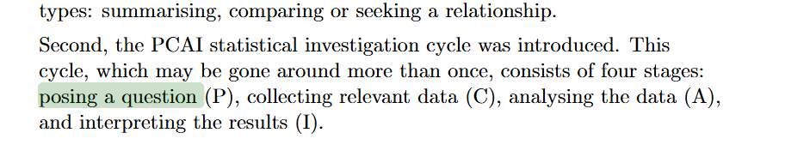

Question 3f
The researcher notices that the industry standard software package entry for the ninth test was a typing error. The correct value should have been 454. The revised mean and median for the industry standard software package data with the correct value for the ninth test are given in the following table.
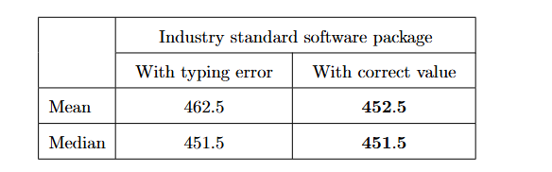
What is the effect on the mean and on the median of including the typing error instead of the correct value? Explain why this happens.

Book: MU123:Unit4 – 3.2 Measuring location (p232 – 237)

Question 4
The student has made a mistake in both parts of their attempt. Identify each mistake and explain, as if directly to the student, why, for each mistake, their reasoning is incorrect.

Unit 5

Question 4b
Write out your own solution to each part of the question, showing your working.

Question 4c (i)
Explain why the approach to checking that they have chosen is incorrect.

Question 4 (ii)
Show how the student should have performed the check and explain your approach to checking.

Question 5a
Simplify each of the following expressions as far as possible; multiply out any brackets, expand any algebraic fractions, and collect like terms together. Show your working.
- 7(9−3t)
- 31 + m(15 −9m) −15m
- 36t −9(11s −7t)
- 7p(5 + 12p2) −4(6p −8 + 3p3)
- 7x2 + 42x −63/7x

Question 5b
Solve the following equations. Show your working and show that you have checked that your solutions are correct.
(i) 21a −18 = 36 + 12a
(ii) y/5 −4 = 3(y −6)

Question 6
A score out of 5 marks for good mathematical communication over the entire
TMA will be recorded under Question 6.

