A7 - Sensors

Dawson Brown
NSCC
MOBI3002: Mobile Application Development - Android

[40%] Come up with your own idea of using android sensors:
Figure 1 Sensor Logic
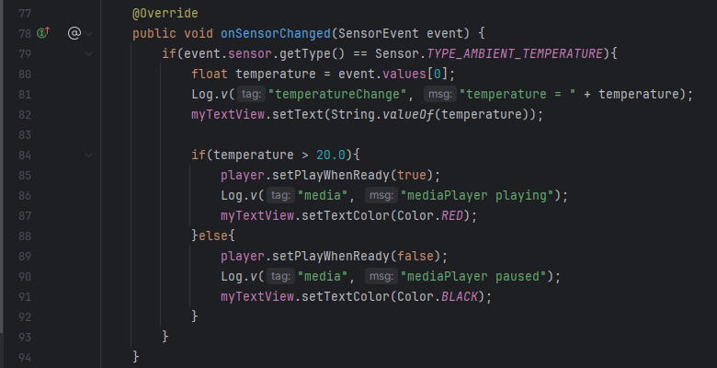
Figure 2 Media Player Setup
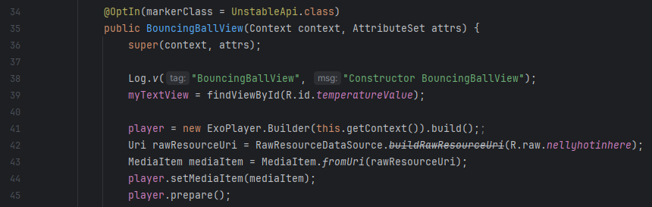
Figure 3 Class Level ExoPlayer and TextView Setup
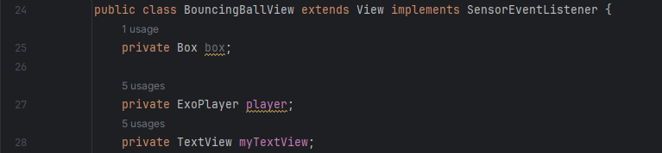
Figure 4 Getting a reference for the temperature value, and feeding it into the bouncingBallView so it can be updated
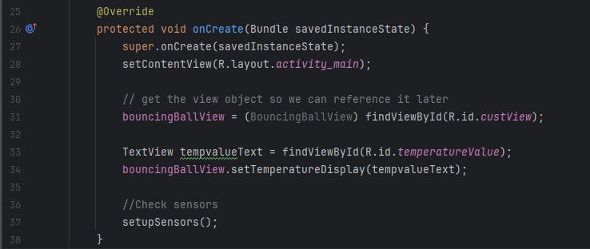
Figure 5 Within the bouncingBallView, this stores a valid textView value in bbview
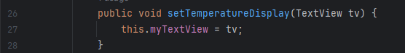

[20%] Make your own launcher.png.
