# **Loan Risk Prediction Automated ML System**

## **System Architecture**

The MoneyLion Loan Risk Prediction system is an automated machine learning pipeline designed to continuously assess and improve loan risk predictions. It integrates data from various sources including loan applications, payment histories, and fraud check variables. The system performs advanced data preprocessing, feature engineering, and model training using LightGBM. It includes modules for model evaluation, deployment, and ongoing performance monitoring with drift detection. Governed by configurable workflows and robust logging, the pipeline ensures reproducibility, versioning, and compliance. This scalable and modular architecture supports continuous learning, enabling MoneyLion to maintain accurate and reliable risk scoring for loan applicants.

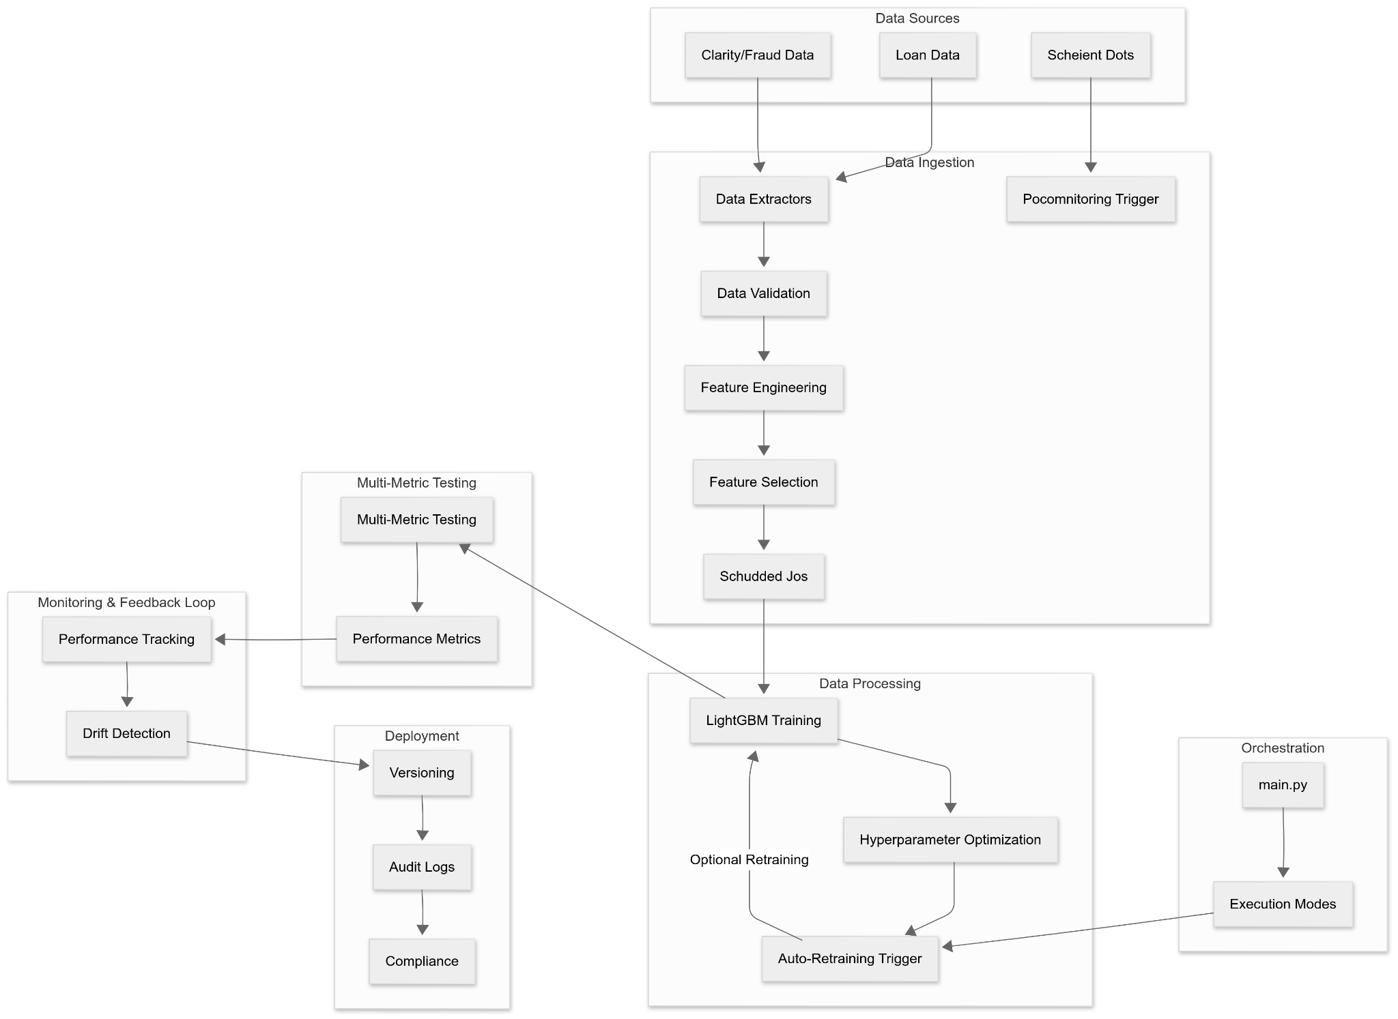

| Component | Description |
| --- | --- |
| Data Sources | Includes multiple datasets:  - Loan Data: Historical loan information  - Clarity/Fraud Data: Underwriting and fraud detection data  - Scheint Dots: External/auxiliary data source |
| Poco Monitoring Trigger | Triggers data ingestion processes from external sources or monitors input readiness |
| Data Extractors | Extracts raw data from the source systems and prepares it for validation and transformation |
| Data Validation | Ensures the quality, consistency, and completeness of the ingested data |
| Feature Engineering | Creates new features from the validated data, including transformations and combinations |
| Feature Selection | Selects the most relevant features for modeling |
| Scheduled Jobs | Automates pipeline steps like data extraction and training at defined intervals |
| LightGBM Training | Trains the core risk model using LightGBM (a fast, efficient gradient boosting framework) |
| Hyperparameter Optimization | Tunes model parameters for optimal performance |
| Optional Retraining | Allows retraining of the model based on performance metrics or new data |
| Auto-Retraining Trigger | Automatically initiates retraining when certain thresholds are met |
| Multi-Metric Testing | Evaluates model using various metrics (classification, regression, etc.) |
| Performance Metrics | Outputs model evaluation scores used for deployment decisions |
| Performance Tracking | Monitors deployed model's performance over time |
| Drift Detection | Identifies changes in input data distribution or model prediction behavior |
| Versioning | Tracks different versions of the model and pipeline artifacts |
| Audit Logs | Records every operation for compliance and debugging |
| Compliance | Ensures the system meets regulatory and internal standards |
| main.py (Orchestration) | Entry point for executing pipeline steps using different modes (training, evaluation, etc.) |
| Execution Modes | Allows the system to run in different configurations: training, evaluation, or deployment |