**VACCINE MANAGEMENT SYSTEM**

This is a back-end project is about vaccine management system using java and Mysql .Project Scope: It is a thought process on current covid scenario where user can know their dosages and hospital and admin sections can update the status of people to get a clear note on type of vaccine ,dosage level and the date within which a person should complete his vaccination.

**MySQL:**

MySQL is a relational database management system based on SQL – Structured Query Language. The application is used for a wide range of purposes, including data warehousing, e-commerce, and logging applications.MySQL Workbench 8.0 CE is used for this project.

**IDE:**

**Eclipse** is an [integrated development environment](https://en.wikipedia.org/wiki/Integrated_development_environment" \o "Integrated development environment) (IDE) used in [computer programming](https://en.wikipedia.org/wiki/Computer_programming" \o "Computer programming).Eclipse [software development kit](https://en.wikipedia.org/wiki/Software_development_kit" \o "Software development kit) (SDK) is [free and open-source software](https://en.wikipedia.org/wiki/Free_and_open-source_software" \o "Free and open-source software),Eclipse is written mostly in Java and its primary use is for **developing Java applications.**

**DATABASE:**

|  |
| --- |
| create database vaccinemanagement;; |

**TABLES USED:**

**LOGIN**

|  |  |
| --- | --- |
| **USERNAME (VARCHAR(20))** | **PASSWORD(VARCHAR(20))** |
| HOSPITAL | VACCINE |
| ADMIN | ADMIN |

|  |
| --- |
| use vaccinemanagement;  create table login(username varchar(20),password varchar(20)); |

**VACCINATION**

|  |  |  |  |  |  |  |
| --- | --- | --- | --- | --- | --- | --- |
| **AADHAR** | **NAME** | **AGE** | **MOBILE NUMBER** | **DOSAGE** | **VACCINE_DATE** | **TYPE OF VACCINE** |
| 15156156(USE REG EX) | abcd | 50 | 154545 | 1ST | 1ST DOSAGE DATE | COVISHIELD OR COVACCINE |
|  |  |  |  |  |  |  |

|  |
| --- |
| use vaccinemanagement;  Create table VACCINATION(aadhar bigint(12)primary key, name varchar(25),age int(3),mobile bigint(10),dosage varchar(3),vaccine_date date,type_of_vaccine varchar(15)); |

**VACCINATED**

|  |  |  |  |  |  |  |
| --- | --- | --- | --- | --- | --- | --- |
| **AADHAR** | **NAME** | **AGE** | **Mobile number** | **Dose1 date** | **Dose 2 date** | type_of_vaccine |
|  |  |  |  |  |  |  |

|  |
| --- |
| use vaccinemanagement;  Create table VACCINATED(aadhar bigint(12)primary key, name varchar(25),age int(3),dose1_date date,dose2_date date,type_of_vaccine varchar(15)); |

1. user -no login credentials
2. Hospital side -login user name-hospital password -vaccine
3. admin - login user name -admin password -admin

**USER (select)**

1. Prompt the user to enter the aadhar number
2. (select ) Check from vaccinated table
3. **( if dose 2date is not null )** display the

Aadhar number age name dose1 date dose2 date

“congrats vaccinated succesffully you can collect your certificate from any hospital”

1. (**ELSE** ) select from vaccination table

Display aadhar number, name, age, dose1 date and “kindly take your 2nd dose of “+type of vaccine+” before” dose1date+84;

**HOSPITAL (select,update,delete) and( update to vaccinated)**

1. CERTIFICATION(VIEW FROM VACCINATED)
2. VIEW VACCINATION TABLE
3. A. IF 1ST TIME (**UPDATE DOSE AS 1ST AND SYSDATE IN DATE**) IN VACCINATION
4. ELSE IF 2ND DOSE(SELECT FROM VACCINATION) Display aadhar number, name,Dose1 date, (dose1date+80)-sysdate;{if result is LESS THAN display ”Expired”}

else

(UPDATE DOSE AS 2ND AND SYSDATE IN DATE)

1. Once dose=2nd delete the record from vaccination insert to vaccinated
2. Dosage date cant be modified,only today(sysdate) can be inserted.(should be inserted )

**admin(select,update,delete,insert)**

1. **INSERT IN BOTH THE TABLE(AADHAR ,NAME ,AGE,)**
2. **DELETE A RECORD FROM VACCINATED**
3. **UPDATE (IF 2ND DOSAGE)**
4. **VIEW BOTH THE TABLE**
5. **CHANGE THE LOGIN TABLE**

OUTPUT

**USER SECTION**

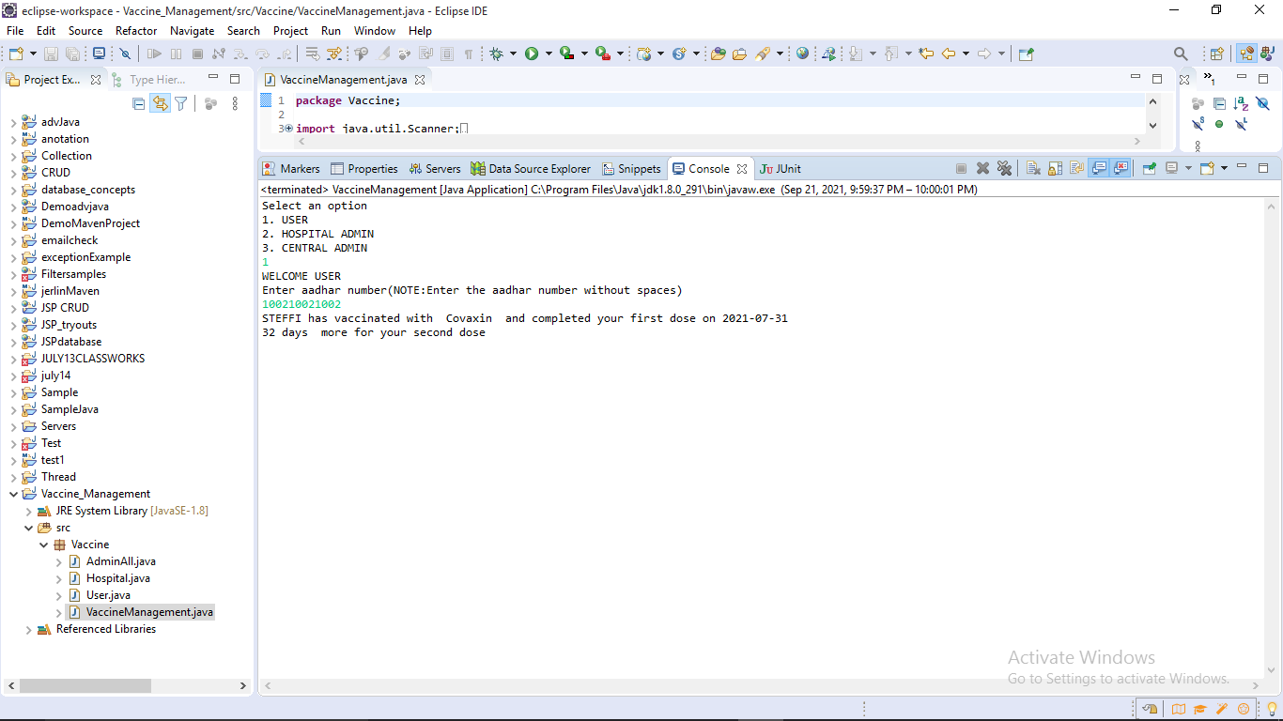

**HOSPITAL SECTION**

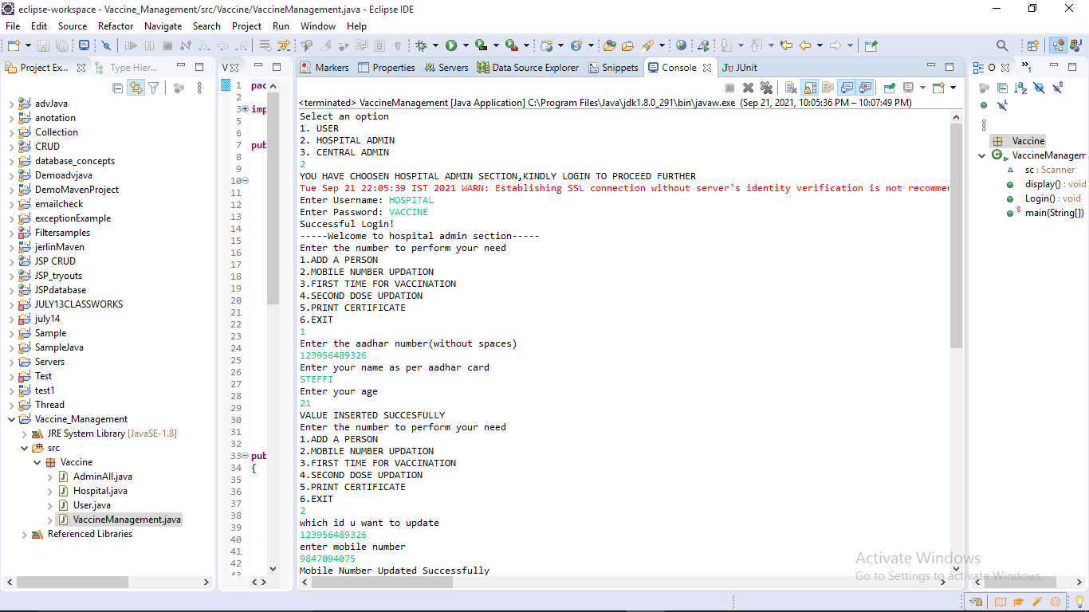

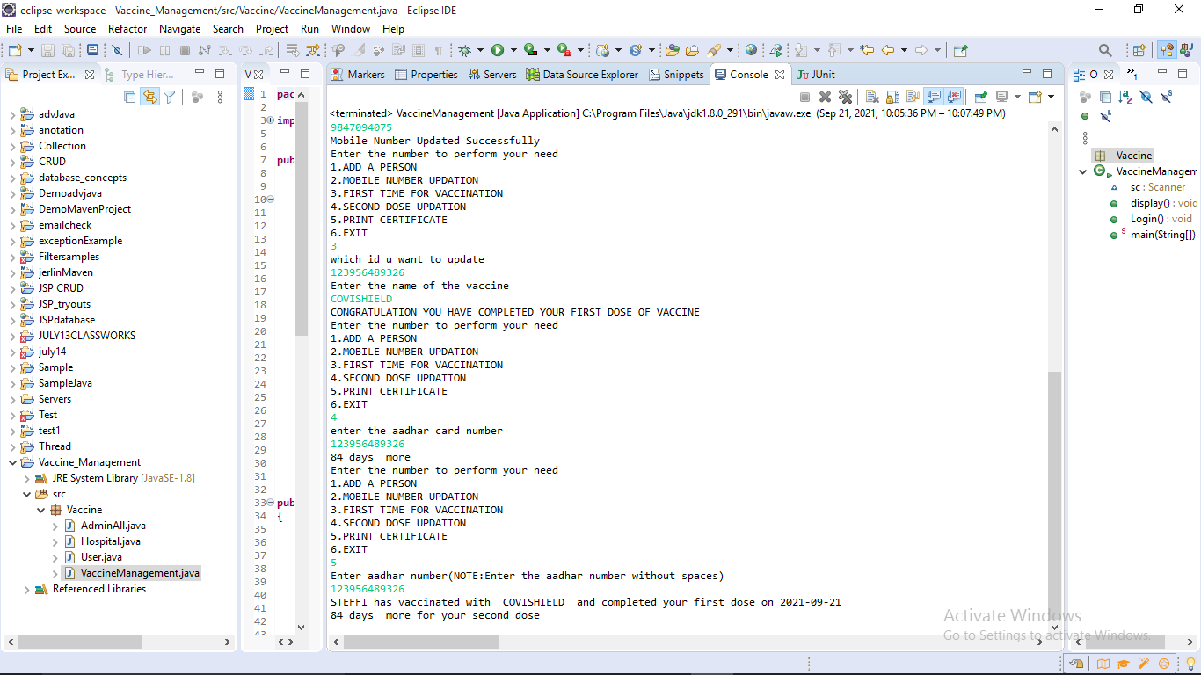

**ADMIN SECTION**

