Name :B. Meghana Reddy
Hall ticket no:2303A53022
Task 1: AI-Generated Logic Without Modularization
Fibonacci Sequence Without Functions
Scenario
A quick Fibonacci sequence generator is required for a learning platform prototype.
Prompt Given to Copilot
# Write a Python program to print Fibonacci series up to n terms
# Take user input
# Do not use functions
Copilot-Generated Code
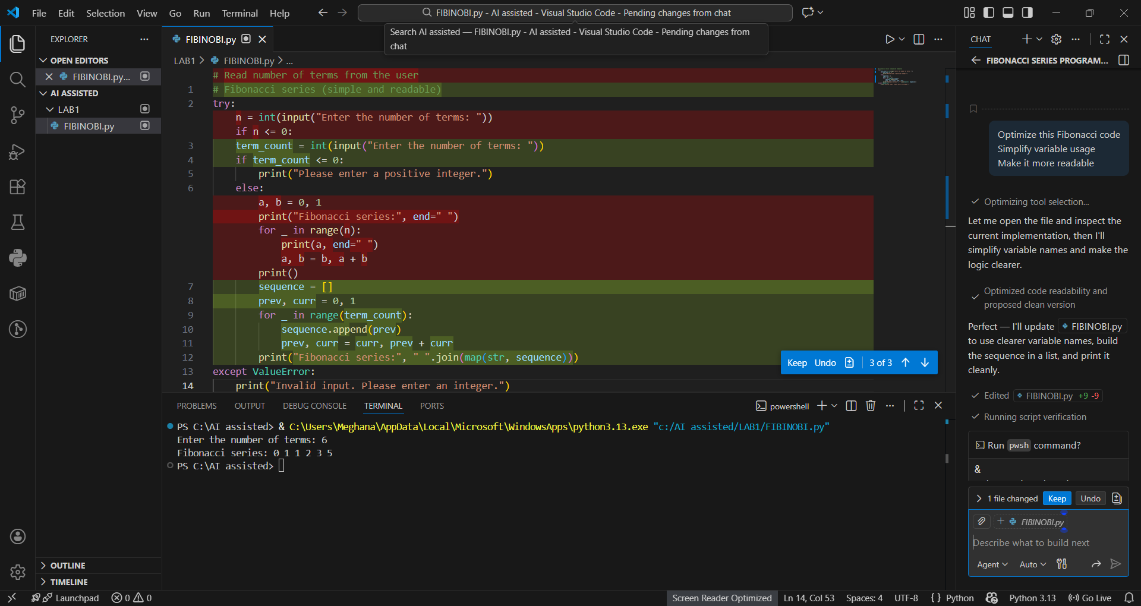Sample Input
Enter number of terms: 7
Sample Output
0 1 1 2 3 5 8

Task 2: AI Code Optimization & Cleanup
Original Code Issues
- Extra temporary variable (c)
- Repeated reassignment logic
- Less readable variable naming
- Initial values printed separately
Prompt Given to Copilot
Optimize this Fibonacci code
Simplify variable usage
Make it more readable
Optimized Code
Improvements Explained
Aspect | Original Code | Optimized Code
Variables | Multiple temporary variables | Minimal variables
Readability | Moderate | High
Loop Logic | Complex | Simplified
Performance | Same complexity | Cleaner execution
Conclusion:
The optimized version improves readability, reduces redundancy, and follows Pythonic coding practices while maintaining the same time complexity.

Task 3: Modular Design Using AI Assistance
Fibonacci Using Functions
Scenario
The Fibonacci logic must be reused across multiple modules.
Prompt Given to Copilot
# Write a Python function to generate Fibonacci series up to n terms
# Include comments
Function-Based Code
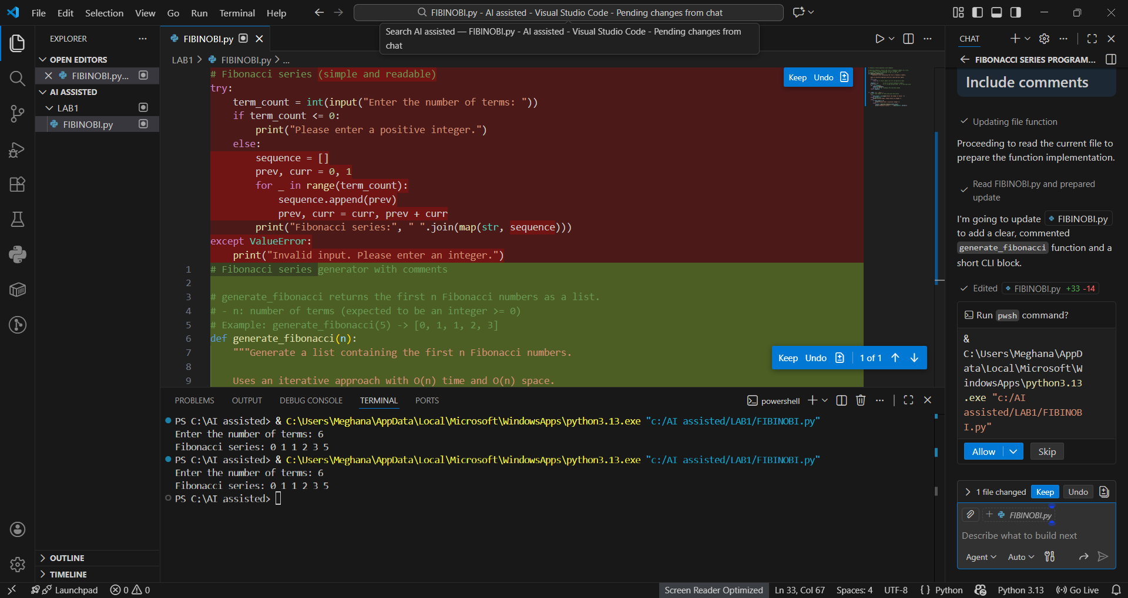Sample Input
Enter number of terms: 6
Sample Output
0 1 1 2 3 5

Task 4: Comparative Analysis – Procedural vs Modular Code
Criteria | Without Functions | With Functions
Code Clarity | Lower | Higher
Reusability | Poor | Excellent
Debugging | Difficult | Easier
Scalability | Not suitable | Suitable
Maintainability | Low | High
Conclusion:
Function-based (modular) code is better suited for large systems due to improved readability, reusability, and maintainability.

Task 5: Iterative vs Recursive Fibonacci Approaches
Iterative Fibonacci (Copilot Generated)
def fibonacci_iterative(n):
a, b = 0, 1
for i in range(n):
print(a, end=" ")
a, b = b, a + b
Execution Flow
- Uses loop
- Updates values step-by-step
- Efficient memory usage

Recursive Fibonacci (Copilot Generated)
def fibonacci_recursive(n):
if n <= 1:
return n
return fibonacci_recursive(n-1) + fibonacci_recursive(n-2)

n = int(input("Enter number: "))
for i in range(n):
print(fibonacci_recursive(i), end=" ")
Execution Flow
- Function calls itself
- Uses call stack
- Recomputes values repeatedly

Comparison
Aspect | Iterative | Recursive
Time Complexity | O(n) | O(2ⁿ)
Space Complexity | O(1) | O(n)
Performance (large n) | Fast | Very slow
Stack Overflow Risk | No | Yes
Recommended Usage | Large inputs | Educational only
Conclusion:
Recursion should be avoided for large n due to high time complexity and memory overhead. Iterative solutions are more efficient and practical.

Overall Conclusion
This lab successfully demonstrated:
- Installation and usage of GitHub Copilot
- AI-assisted code generation
- Optimization through prompt engineering
- Modular vs procedural design
- Iterative vs recursive algorithmic approaches
GitHub Copilot significantly improves development speed, but human evaluation is essential to ensure correctness, efficiency, and maintainability.

