1

Software Support for Face-to-Face
Parliamentary Procedure
Dana B. Dahlstrom and Bayle Shanks

Abstract
This Parliamentary procedure of the sort codified in Robert’s Rules of Order is a widely used system of rules for group decision making. Unfortunately, in many settings where parliamentary procedure is used, unfamiliarity with the rules inhibits participation, working against the aim of giving due consideration to each member’s opinion.
This paper describes software that supports face-to-face parliamentary procedure by publicly displaying information about items under consideration and about actions available under the rules. These features facilitate shared context among the participants, encourage adherence to the rules, and help novices engage and learn the process.

- Introduction
Parliamentary procedure is a centuries-old, evolving tradition of rules and customs for group decision making. It aims for full and free discussion, safeguarding the rights of the minority and of individual members, even in the face of intense disagreement. The houses of UK Parliament and of the US Congress, for example, each have their own parliamentary rules; but the best-known codification is called Robert’s Rules of Order, after Henry Robert, who wrote the first popular manual on parliamentary law in the late-19th-century United States.
Parliamentary procedure is used in many different organizations ranging from small boards and committees to governmental legislative bodies. A group meeting using Robert’s Rules of Order is called a deliberative assembly and requires that all members communicate synchronously by voice, normally face-to-face. A deliberative assembly may have from a few to a few hundred members.
Central to Robert’s Rules of Order are motions, by which a member may propose that the assembly take certain actions. The “Table of Rules Relating to Motions” in the 1915 version of Robert’s Rules of Order Revised, now in the public domain, includes 45 different motions that fall mostly into 4 classes: main motions, subsidiary motions, incidental motions, and privileged motions. Precedence among and within the classes specifies which motions are in order—that is, permitted by the rules—depending on which motions are currently pending.
Each class of motions has general characteristics, and many individual motions have peculiarities of their own. Some motions are debatable; others are not; some are amendable; some allow subsidiary motions applied to them; some can be reconsidered. Most require first obtaining the floor, being seconded, and a majority vote in the affirmative to be adopted; others may interrupt a speaker, need not be seconded, and require no vote; yet others require a two-thirds vote. In short the rules are many and difficult to remember, especially in a lively meeting.

1.1 Procedural Difficulties
The complexity of parliamentary procedure can be challenging for anyone, and particularly stifling to a novice participant who knows little or nothing of the rules. He or she may have opinions to voice or objectives to accomplish, but not know how. Robert’s Rules of Order allow a parliamentary inquiry by which a member may ask for advice on such matters, but the member must know this option is available and the chair must be prepared to give an appropriate response.
In many organizations that nominally use parliamentary procedure, even the chair of an assembly is only vaguely familiar with the rules, often having learned mainly from experience in meetings and never having studied a manual. One problem that can arise in such circumstances is that the assembly may take action without due process, and in doing so violate fundamental rights of the minority, of individual members, or of the assembly itself.
For example, one common misbelief about parliamentary procedure is that any member may halt debate and initiate a vote at any time by shouting, “I call the question!” In fact, to “call the question” or, more properly, to move the previous question, one must obtain the floor in order to make the motion, and it must be seconded and finally itself receive a two-thirds vote in the affirmative. Robert’s Rules of Order consistently emphasize that suppressing debate requires the support of two thirds; this requirement protects the fundamental right to have questions thoroughly discussed before taking action. Absent knowledge of the rules, this fundamental right is easily violated.
Even when members have a working knowledge of the rules and their fundamental rights are intact, participants can lose track of the proceedings for a variety of reasons. Parliamentary procedure is formally linear and verbal and relies on shared context. When one loses context in a deliberative assembly, one may rise to a point of information in order to ask questions, but this may be socially awkward. If participants miss something, it is easy to become confused about what has happened or what is happening.

1.2 Our Software
This paper describes software that can run on a portable computer connected to a digital projector. A single user enters events as they transpire, such as motions and votes. Based on this input, the software keeps track of the meeting state and updates the large display so that at any time, assembly members can see information such as currently pending motions, motions currently in order, and transacted business.
The prototype application shown in Figure 1 is operated in a face-to-face meeting conducted according to Robert’s Rules of Order. It is written using the Parliament module (Shanks and Dahlstrom 2006), and is freely available.
- Design Considerations
A main concern is which information to display in the interface, especially as there are too many motions to display at once.
A second design goal is to serve the secretary’s needs. Under Robert’s Rules of Order, the duties of the secretary include several activities: preparing of an order of business for the chair; tending business that is postponed, laid on the table, or left unfinished; and producing the minutes. The system is intended in part to aid the secretary in executing these duties.
Assisting the secretary is not merely ancillary. As Grudin has pointed out, the disparity between who does the work and who gets the benefit is often a barrier to acceptance of groupware systems (Grudin 1994). While it aims to benefit many individuals and the group as a whole, this system requires someone to do work: continually and promptly entering meeting proceedings into a computer. Helping get the secretary’s job done is a key incentive for this work.
A third requirement for the interface is that it be quick and flexible enough to keep up with live action. The user must not get backlogged entering events; a public display of obsolete information is worse than useless.
Finally, the interface must gracefully handle at least two kinds of irregularities: mistakes by the user, which must be promptly correctable; and deviations from the ordinary rules, either by a motion to suspend the rules or by mistake.

2.1 Use Considerations
When software support for parliamentary procedure is introduced, it should be made clear that the chair, not the software, presides over the assembly. However, to prevent confusion, it is crucial for the chair to monitor the output of the software to ensure the information being recorded and displayed to the assembly is correct.
The software should not be considered a parliamentary authority or a substitute for knowledge of the rules. One of the chair’s responsibilities is to advise members on how to achieve their aims; in most cases, simply ruling a motion out of order will not do. Because Robert’s Rules of Order are intricate and rely on subjective determinations, the software’s capacity to settle parliamentary questions is necessarily limited. The chair should be familiar with the rules and have a copy of the assembly’s parliamentary authority at the meeting.
Computers are oblivious to social conventions, which makes them less fit for many tasks of chairmanship, but perhaps more fit for others. For example, enforcing time limits can be socially awkward, but is often generally appreciated so long as it is done fairly.
- The User Interface
Figure 1 depicts the user interface, designed for a single user such as an organization’s secretary. The window which is displayed on the projector is different.
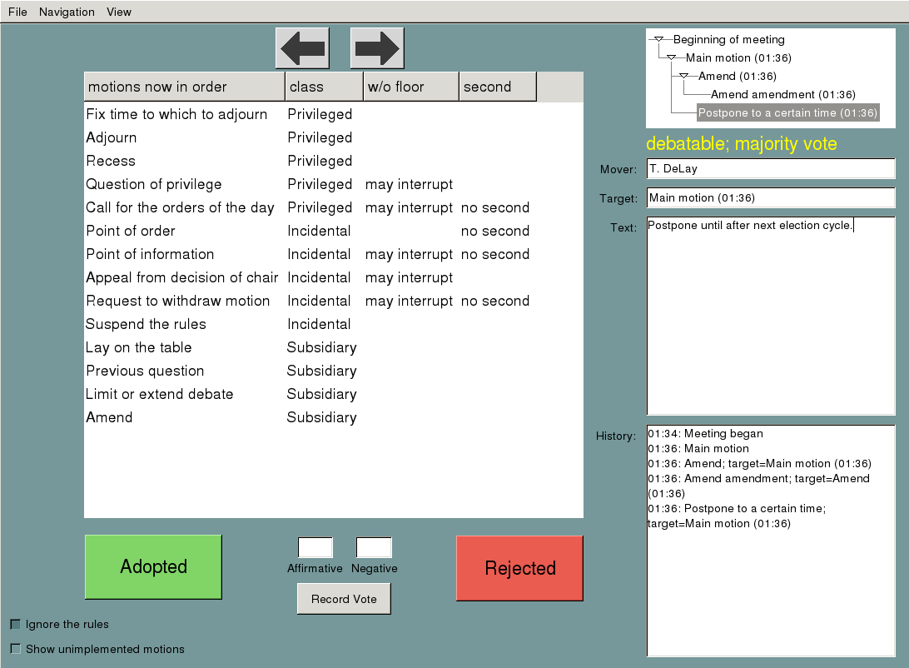
The motions currently in order contains a list of only those motions that are in order at the present time. The user may activate any of these motions to indicate that that motion has been moved in the meeting. There are text fields for the number of affirmative and negative votes and a button to compare the tallies to the proportion of votes required by the rules. Adopted and rejected buttons allow the user to indicate the fate of the immediately pending motion directly when votes are not counted. Back and forward buttons navigate through meeting history, providing a multiple undo/redo mechanism.
The currently pending motions in the tree diagram can be selected, populating several other fields with information about the selected motion. In addition to the text of the motion, these also include its mover and its target. All of these fields are editable by the user.
The interface also provides an event log with a record of each motion, and whether that motion was adopted or rejected.
Real-world assemblies sometimes deviate from the rules. To be useful, the software must continue to track the state of the meeting. Hence the interface provides an ignore rules checkbox that allows the user to record actions and motions despite these being out of order according to the module’s interpretation of the rules.

- Results of Preliminary Trials
The prototype has been pilot-tested in meetings of the Graduate Student Association Council at UCSD.
One problem was the physical arrangement of the room. Since members spend much of the meeting looking toward the chair, who faces them, it seemed fitting to place the projected display behind the chair. However, this meant the chair could not see the display. That made it difficult for the chair to realize when the software was displaying inaccurate information.
A projector screen displaying inaccurate information about the state of the meeting is potentially disastrous and should be avoided. Meeting participants may rely on the projected information which, if inaccurate, will hinder rather than help. Therefore, the chair should keep aware of what the software is displaying and see that it is corrected when necessary.
One solution is for the system’s operator (perhaps the secretary) to sit next to the chair. This way, though the projected display may not be visible to the chair, the computer screen will be.
Preliminary experience confirms that when a computer and projector are introduced into a meeting, people want to put the equipment to various uses. Members of GSAUCSD asked us to launch other software on the computer in order to display their governing documents and long resolutions under consideration.
- Relation to Other Work
There is a considerable body of work on electronic meeting systems and systems to support group decision making, whether face-to-face or otherwise, but little work has focused on parliamentary procedure.
A group decision support system (GDSS) employs technology to facilitate group decision making. A GDSS is groupware, in that it is designed for multiple people working collaboratively. As a field, GDSSs are related to decision support systems (DSS), although the latter typically focus on information gathering and analysis for a single individual.
A GDSS to apply parliamentary procedure was envisioned at least as early as 1987 by DeSanctis and Gallupe. In their nomenclature, such a system is called a Level 3 GDSS. While Level 1 GDSSs aim only to facilitate communication and Level 2 GDSSs passively offer tools and models, Level 3 GDSSs actively apply rules regulating the decision process.
In their survey of systems for cooperative work and group decision support, Kraemer and King (1998) argue that “most of the efforts to apply these technologies have affected decision processes too much or too little to provide a good assessment of their effects.” On one hand, audiovisual presentation and teleconferencing technologies merely speed up process without improving the quality of decision making; on the other hand, technology that imposes structured collaboration techniques also imposes the designers’ views of the decision process on the participants.
Our software aims to improve group decision making without externally imposing structure; many organizations have already adopted a parliamentary authority such as Robert’s Rules of Order.
A number of GDSSs have been built. For example, Davies et al. have built an online deliberation environment, Deme (Davies et al. 2004), primarily to supplement the activities of groups that already meet face-to-face.

5.1 Work Related to Robert’s Rules of Order
Some aspects of parliamentary procedure are oriented toward a face-to-face setting, but the underlying principles and many of the rules can be applied to decision-making groups using various other modes of communication.
One group designed a document-based collaboration system based on an “agenda item life cycle” inspired by Robert’s Rules of Order (Zhang et al. 2003).
Horan and Benington describe a protocol for conducting deliberations by e-mail in academic committees using Robert’s Rules of Order (Horan and Benington 2000).
Robert’s Rules in Motion is a commercially available single-user application that simulates meetings in order to train the user in the use of parliamentary procedure.
- Conclusions
The technology described herein shows promise for improving the practice of parliamentary procedure in face-to-face meetings. Assemblies with members not well practiced in the rules can especially benefit from such a system.
Software support for parliamentary procedure fills a unique niche among similar research. By supporting group work while having a single user operating the interface, it avoids many pitfalls of groupware applications. By aiming to improve group decision making without externally imposing structure, parliamentary-procedure software offers opportunities to study effects on groups that were obscured by the more dramatic interventions of other group decision support systems.
Parliamentary-procedure software should run on common portable computers, and be easy for any organization’s secretary to learn and use, streamlined enough to keep pace with live meetings, and flexible enough to handle the adaptive circumvention of rules that inevitably occurs in real assemblies. The software should generate a record from which official minutes can be produced, and which may in the future be a medium for interoperation with online deliberation systems.
Preliminary experience with a prototype system in real meetings has met with enthusiastic response. Further development and experimentation is underway.

References
Davies, T., B. O’Connor, A. A. Cochran, and J. J. Effrat. 2004. An online environment for democratic deliberation: Motivations, principles, and design. Working paper.
DeSanctis, G. and R. B. Gallupe. 1987. A foundation for the study of group decision support systems. Management Science 33(5):589–609.
Grudin, J. 1994. Groupware and social dynamics: eight challenges for developers. Communications of the ACM 37(1):92–105.
Horan, S. M. and J. H. Benington. 2000. A protocol for using electronic messaging to facilitate academic committee deliberations. Journal of Higher Education Policy and Management 22(2):187–197.
Kraemer, K. L. and J. L. King. 1988. Computer-based systems for cooperative work and group decision making. ACM Computing Surveys 20(2):115–146.
Shanks, B. and Dahlstrom, D. B. 2006. Parliament: a module for parliamentary procedure software. (In this volume.)
Zhang, J., C. K. Chang, K. H. Chang, and F. K. H. Quek. 2003. Rule-mitigated collaboration framework. Proceedings of the Eighth IEEE International Symposium on Computers and Communication 1:614–619.

http://parliament.sourceforge.net/
http://imovethat.com/

