Chapter No. Title Page No.
Abstract i
Nomenclature v

1 INTRODUCTION 1
1.1 What is an Educational ERP?
1.2 The Role of AI in Education
1.3 What is Machine Learning?
1.4 Machine Learning Applications in ERP
1.5 Techniques Used
1.6 Aim
1.7 Thesis Organization

2 LITERATURE REVIEW 8
2.1 Overview of Educational Administration
2.2 Evolution of College Management Systems
2.2.1 Manual Record Keeping (The Paper Era)
2.2.2 Early Digitalization (Spreadsheets & Local Databases)
2.2.3 Modern Cloud-Based ERPs
2.3 Limitations of Existing Solutions
2.3.1 The "Reactive" Trap
2.3.2 Lack of Explainability
2.3.3 Generic vs. Personalized Guidance
2.4 The Paradigm Shift: Educational Data Mining (EDM)
2.4.1 Predictive Modeling in Education
2.5 Review of Techniques Used in This Project
2.5.1 Gradient Boosting (XGBoost) for Structured Data
2.5.2 SHAP (SHapley Additive exPlanations)
2.5.3 Generative AI (LLMs) for Advisory
2.6 Comparative Analysis

3 PROPOSED SOLUTION 15
3.1 Overview
3.2 Dataset Description
3.2.1 Data Collection & Features
3.2.2 Data Preprocessing
3.3 System Architecture & Working Process
3.3.1 The Three-Tier Architecture
3.3.2 Data Flow Workflow
3.4 Key Features by Module
3.4.1 Administrator Module
3.4.2 HOD (Head of Department) Module
3.4.3 Faculty Module
3.4.4 Student Module
3.5 AI-Driven Attendance Advisory (Gemini API)
3.5.1 The Problem
3.5.2 The Solution
3.6 Academic Risk Prediction Model (XGBoost)
3.6.1 Why XGBoost?
3.6.2 Model Performance
3.6.3 Explainability with SHAP
3.7 Automated Report Generation

4 IMPLEMENTATION 25
4.1 Development Environment & Tools
4.1.1 Visual Studio Code (VS Code)
4.1.2 Google Colab
4.1.3 Git & GitHub
4.2 Technology Stack
4.2.1 Backend: Python FastAPI
4.2.2 Frontend: Vanilla JavaScript (ES6+)
4.2.3 Database: MySQL & SQLAlchemy
4.3 System Implementation Details
4.3.1 Directory Structure
4.3.2 Authentication & Security
4.3.3 The Academic Early Warning System (AEWS)
4.3.4 Generative AI Integration (Gemini API)
4.4 Frontend Modules Implementation
4.4.1 Dashboard Visualization
4.4.2 Bulk Data Upload

5 RESULTS AND DISCUSSION 35
5.1 Overview
5.2 Machine Learning Model Evaluation
5.2.1 Model Accuracy & Metrics
5.2.2 Feature Importance (SHAP Analysis)
5.2.3 Comparison with Baseline Models
5.3 Web Application Results
5.3.1 Admin Dashboard & Operations
5.3.2 HOD Analytics Module
5.3.3 Student Dashboard & AI Insights
5.4 System Performance Metrics
5.4.1 API Latency
5.4.2 Database Optimization
5.5 Discussion

6 CONCLUSION AND FUTURE SCOPE 45
6.1 Conclusion
6.2 Future Scope
6.2.1 Mobile Application Development
6.2.2 Integration with IoT (Internet of Things)
6.2.3 Blockchain for Credential Verification
6.2.4 Advanced Placement Prediction Module
6.2.5 Voice-Activated Assistant

REFERENCES

NOMENCLATURE
ERP Enterprise Resource Planning
AI Artificial Intelligence
ML Machine Learning
AEWS Academic Early Warning System
RBAC Role-Based Access Control
JWT JSON Web Token
API Application Programming Interface
REST Representational State Transfer
HTTP Hypertext Transfer Protocol
SQL Structured Query Language
ORM Object-Relational Mapping
HOD Head of Department
UI User Interface
UX User Experience
IDE Integrated Development Environment
XGBoost Extreme Gradient Boosting
SHAP SHapley Additive exPlanations
LLM Large Language Model
GenAI Generative Artificial Intelligence
DOM Document Object Model
JSON JavaScript Object Notation
CRUD Create, Read, Update, Delete
IoT Internet of Things

CHAPTER 1
INTRODUCTION
1.1 WHAT IS AN EDUCATIONAL ERP?
An Enterprise Resource Planning (ERP) system for educational institutions is a comprehensive software platform designed to manage and automate the administrative, academic, and financial operations of a college or university. Unlike traditional manual record-keeping or fragmented software tools, a modern ERP integrates all core functions into a single, unified ecosystem.
In the context of this project, the Smart College ERP System allows for the seamless flow of information between different stakeholders:
- Administrators: Who manage high-level configurations, fee structures, and user admissions.
- Heads of Departments (HODs): Who require analytical oversight of faculty performance and student batches.
- Faculty: Who handle daily operational tasks such as attendance marking and internal assessment grading.
- Students: Who need real-time access to their academic progress, fee status, and campus resources.
The primary objective of such a system is to eliminate data redundancy, reduce manual errors, and provide real-time dashboards that aid in efficient decision-making.
1.2 THE ROLE OF AI IN EDUCATION
While traditional ERPs are excellent for data storage, the next generation of educational tools must focus on data intelligence. This is where Artificial Intelligence (AI) plays a pivotal role. The "Smart College ERP System" moves beyond simple data management to incorporate an Academic Early Warning System (AEWS).
AI in education transforms raw data—such as attendance percentages, internal marks, and backlog history—into actionable insights. Instead of waiting for a student to fail a semester, AI algorithms can analyze historical patterns to predict "at-risk" student’s months in advance. Furthermore, Generative AI (GenAI) models can act as virtual counselors, analyzing a student's specific situation to provide personalized motivation and attendance recovery plans.

1.3 WHAT IS MACHINE LEARNING?
Machine Learning (ML) is a subset of artificial intelligence that enables systems to learn from data and improve their accuracy over time without being explicitly programmed. In the context of this project, ML is utilized to analyze tabular student data.
Unlike the Deep Learning techniques (like CNNs) used for image processing in medical diagnostics, this project leverages Gradient Boosting algorithms (specifically XGBoost). XGBoost is a powerful ML technique used for structured or tabular data. It operates by creating an ensemble of decision trees, where new trees correct the errors of the previous ones. This approach is highly effective for classification tasks, such as predicting whether a student falls into a "High Risk," "Moderate Risk," or "Low Risk" category based on their academic trajectory.
1.4 MACHINE LEARNING APPLICATIONS IN ERP
The integration of Machine Learning into an ERP system opens several possibilities for administrative optimization:
- Predictive Analytics: Forecasting student dropout rates or failure probabilities based on early semester performance metrics (Mid-1 marks, attendance trends).
- Resource Allocation: Analyzing hostel and library usage patterns to optimize room allocation and book procurement.
- Automated Advisory: Using Large Language Models (LLMs) to generate natural language explanations for complex academic data, helping students understand why they are at risk and how to improve.
1.5 TECHNIQUES USED
This project employs a hybrid approach, combining traditional web development with advanced data science techniques:
- XGBoost (Extreme Gradient Boosting): Used for the core predictive engine. It was chosen for its speed and performance on structured datasets (like student grade records). It handles missing values efficiently and prevents overfitting through regularization.
- SHAP (SHapley Additive exPlanations): A game-theoretic approach to explain the output of the machine learning model. It allows the system to tell a student exactly which factor (e.g., "low attendance" vs. "failed mid-term") contributed most to their risk score, making the AI "explainable".
- Generative AI (Google Gemini API): Used for processing unstructured text queries and generating personalized academic advice. It interprets the numerical risk data and converts it into human-readable, empathetic guidance for the student.
1.6 AIM
The aim of this project is to develop a Smart College ERP System that bridges the gap between administrative management and student success monitoring.
Objectives:
- Centralize Operations: To create a unified platform for Admin, HOD, Faculty, and Student workflows, including Fees, Library, and Hostel management.
- Predict Academic Risk: To implement an ML-driven "Early Warning System" that identifies struggling students before final exams.
- Explainable Insights: To use SHAP values to provide students with clear reasons for their risk status, rather than just a black-box prediction.
- Personalized Guidance: To integrate GenAI (Gemini) to offer tailored advice on improving attendance and grades.
- Secure & Scalable: To build a robust backend using Python FastAPI and MySQL, ensuring role-based security (RBAC) and data integrity.
1.7 THESIS ORGANIZATION
This document is organized to systematically present the development of the Smart College ERP.
- Chapter 1 provides an introduction to the project scope and the role of AI in education.
- Chapter 2 reviews existing ERP solutions and highlights the gap in predictive analytics features.
- Chapter 3 describes the Proposed Solution, including the system architecture, the ODIR-like student dataset, and the specific modules (Admin, HOD, Faculty, Student).
- Chapter 4 details the Implementation, covering the technology stack (FastAPI, Chart.js, XGBoost), database design, and Gemini API integration.
- Chapter 5 presents the Results, showcasing the UI dashboards and the accuracy of the risk prediction model.
- Chapter 6 concludes the report with a summary and future scope.

CHAPTER 2
LITERATURE REVIEW
2.1 OVERVIEW OF EDUCATIONAL ADMINISTRATION
The administration of higher educational institutions is a complex undertaking that involves the synchronization of various departments, including academic planning, financial management, student affairs, and facility operations. Traditionally, these functions operated in silos, with little to no real-time communication between them. As student populations grow and regulatory requirements become more stringent, the need for integrated management systems has become critical.
This chapter reviews the historical progression of College Management Systems, analyzes the limitations of current market solutions, and establishes the theoretical framework for the Academic Early Warning System (AEWS) implemented in this project.
2.2 EVOLUTION OF COLLEGE MANAGEMENT SYSTEMS
The transition from manual record-keeping to AI-driven insights has occurred in three distinct phases:
2.2.1 Manual Record Keeping (The Paper Era)
Until the late 1990s, most educational institutions relied entirely on physical ledgers and paper-based filing systems.
- Admissions: Application forms were physical documents, sorted manually by clerks.
- Attendance: Faculty marked attendance in physical registers, which were collected monthly for compilation.
- Grades: Examination results were tabulated by hand, leading to significant delays in declaring results and a high probability of calculation errors.
- Limitations: This era was characterized by extreme data redundancy, inability to search records efficiently, and the physical vulnerability of data to loss or damage (e.g., fire, pests).

2.2.2 Early Digitalization (Spreadsheets & Local Databases)
With the advent of personal computing, institutions began migrating to digital formats like Microsoft Excel and Microsoft Access.
- Data Entry: Clerks began digitizing physical records into spreadsheets.
- Fragmentation: While this improved storage, it created "Data Silos." The Finance department had one spreadsheet for fees, while the Academic department had another for grades. There was no unique identifier linking a student across these files efficiently.
- Security Risks: These files were often stored on local hard drives with no backups or role-based access control (RBAC). A single faculty member could accidentally delete an entire class's marks.
2.2.3 Modern Cloud-Based ERPs
The current standard in education is the cloud-based Enterprise Resource Planning (ERP) system.
- Integration: These systems unify admissions, fees, and academics into a centralized database (SQL/NoSQL).
- Accessibility: Stakeholders can access data via web portals or mobile apps.
- Current State: While these systems solve the problem of data storage and retrieval, they remain largely reactive. They can tell an administrator that "Student X has 40% attendance," but they cannot predict that "Student X is likely to drop out next month." They function as digital filing cabinets rather than intelligent assistants.
2.3 LIMITATIONS OF EXISTING SOLUTIONS
Despite the ubiquity of modern ERPs, significant gaps remain that this project aims to address:
2.3.1 The "Reactive" Trap
Most existing systems generate reports after an event has occurred. For example, a "Detained List" is generated at the end of the semester when attendance falls below 75%. At this point, it is too late for the student to recover. There is a lack of proactive predictive modeling that can alert stakeholders during the semester when corrective action is still possible.

2.3.2 Lack of Explainability
Some advanced ERPs have begun incorporating basic analytics (e.g., "At-Risk" flags). However, these are often "Black Box" models. A student might see a "High Risk" label on their dashboard but has no way of knowing why they are at risk. Is it their attendance? Their Mid-1 marks? Their library usage? Without Explainable AI (XAI), these predictions cause anxiety rather than driving improvement.
2.3.3 Generic vs. Personalized Guidance
When a student is identified as struggling, current systems typically send a generic automated email: "Please contact your HOD." They lack the capability to provide personalized, empathetic advice. There is no system that analyzes the specific context (e.g., "You are strong in practicals but failing theory") to offer tailored remedial steps.
2.4 THE PARADIGM SHIFT: EDUCATIONAL DATA MINING (EDM)
This project is grounded in the field of Educational Data Mining (EDM), a discipline concerned with developing methods for exploring the unique types of data that come from educational settings.
2.4.1 Predictive Modeling in Education
Research has shown that academic performance is not random; it follows patterns. Key indicators such as:
- Attendance Consistency: Irregular attendance often precedes a drop in grades.
- Internal Assessment Trends: A decline from Mid-1 to Mid-2 is a strong predictor of final exam failure.
- Backlog History: The accumulation of backlogs creates a psychological burden that affects future performance.
By applying machine learning algorithms to these historical patterns, it is possible to forecast future performance with high accuracy.

2.5 REVIEW OF TECHNIQUES USED IN THIS PROJECT
To address the limitations identified above, this Smart College ERP integrates specific advanced technologies:
2.5.1 Gradient Boosting (XGBoost) for Structured Data
While Deep Learning (CNNs/RNNs) is popular for image and text, XGBoost (Extreme Gradient Boosting) remains the state-of-the-art algorithm for tabular data classification.
- Relevance: Student records (Marks, Attendance %, Fees) are structured tabular data.
- Mechanism: XGBoost builds an ensemble of decision trees sequentially. Each new tree attempts to correct the errors made by the previous trees.
- Advantage: It handles missing values (e.g., a student missing one exam) natively and includes regularization parameters (L1/L2) to prevent overfitting, ensuring the model generalizes well to new batches of students.
2.5.2 SHAP (SHapley Additive exPlanations)
To solve the "Black Box" problem, this project utilizes SHAP values, a concept derived from cooperative game theory.
- Function: SHAP assigns each feature (e.g., Attendance, Mid-1 Marks) an "importance value" for a specific prediction.
- Application: Instead of just telling a student "You have a 70% risk of failure," the system uses SHAP to say, "Your risk is high primarily because your Attendance is below 60%, even though your Mid-1 marks are decent." This actionable insight empowers students to focus their efforts where it matters most.
2.5.3 Generative AI (LLMs) for Advisory
The integration of Large Language Models (LLMs) like Google Gemini represents the cutting edge of EdTech.
- Role: The LLM acts as a bridge between raw numerical data and human understanding. It takes the structured risk profile (generated by XGBoost) and the explainability factors (from SHAP) to draft a coherent, encouraging, and specific action plan for the student.
- Innovation: This replaces static, template-based notifications with dynamic, conversation-style advice.
2.6 COMPARATIVE ANALYSIS
The following table summarizes the advancements of the proposed Smart College ERP against traditional systems:
Feature | Traditional ERP | Smart College ERP (Proposed)
Data Handling | Passive Storage | Active Analysis
Risk Detection | Post-Event (Reactive) | Pre-Event (Predictive/Proactive)
User Insight | Raw Numbers/Tables | Visual Graphs & SHAP Explanations
Advising | Manual Faculty Intervention | AI-Driven Personalized Guidance
Attendance | Manual Calculation | Automated & Trend Analysis
Architecture | Monolithic / Legacy | Microservices-ready (FastAPI)

CHAPTER 3
PROPOSED SOLUTION
3.1 OVERVIEW
The Smart College ERP System is a next-generation educational management platform designed to address the inefficiencies of traditional campus administration. Unlike legacy systems that function primarily as data repositories, this solution acts as an intelligent operational backbone for the institution.
It integrates four distinct user roles—Administrator, HOD, Faculty, and Student—into a single, cohesive ecosystem. The core innovation of this system lies in its ability to not only digitize workflows (such as fee payments and hostel allocation) but also to apply Predictive Analytics to student performance data. By leveraging an XGBoost-based Machine Learning model, the system identifies students at risk of academic failure early in the semester. Furthermore, it incorporates Generative AI to provide personalized, human-like counseling to students, thereby closing the loop between detection and intervention.
3.2 DATASET DESCRIPTION
To build the Academic Early Warning System (AEWS), a custom dataset was curated to reflect real-world student performance metrics. Unlike standard public datasets, this data structure is designed to capture the temporal progression of a student's semester.
3.2.1 Data Collection & Features
The dataset consists of historical records of students, including their internal assessment scores, attendance patterns, and past academic history. The key features selected for training the model include:
- Mid-1 Exam Scores (Scale: 0-30): This is a critical early indicator. A low score in the first internal exam is often the earliest sign of academic distress.
- Mid-2 Exam Scores (Scale: 0-30): Used to track improvement or decline. A drop from Mid-1 to Mid-2 is a strong predictor of failure.
- Attendance Percentage (Scale: 0-100): The most significant behavioral indicator. There is a strong positive correlation between high attendance and academic success.
- Previous Semester SGPA (Scale: 0-10): Reflects the student's baseline academic ability.
- Active Backlogs (Count): Represents the cumulative academic burden on the student. A higher number of backlogs increases the psychological pressure and likelihood of future failure.
3.2.2 Data Preprocessing
Before feeding the data into the machine learning model, several preprocessing steps are applied:
- Normalization: All numerical values are scaled using a standard scaler to ensure that features with larger ranges (e.g., Attendance) do not dominate features with smaller ranges (e.g., SGPA).
- Imputation: Missing values (e.g., if a student missed an exam due to illness) are handled to prevent model errors.
- Label Encoding: The target variable (Risk Status) is encoded into numerical classes for the XGBoost classifier.
3.3 SYSTEM ARCHITECTURE & WORKING PROCESS
The system follows a modern Microservices-ready Architecture, decoupling the Frontend user interface from the Backend logic and the AI services.
3.3.1 The Three-Tier Architecture
- Presentation Layer (Frontend):
Built using Vanilla JavaScript, HTML5, and CSS3. This ensures the application is lightweight and fast, loading instantly even on low-bandwidth college networks. It communicates with the backend via RESTful APIs using the Fetch API.
- Application Layer (Backend):
Developed using Python FastAPI. FastAPI was chosen for its high performance and native support for asynchronous operations (async/await), which is crucial for handling concurrent requests from thousands of students. It handles authentication, business logic, and database orchestration.
- Data Layer (Database):
A MySQL Relational Database stores all structured data. The schema is defined using SQLAlchemy ORM models, ensuring data integrity through foreign keys (e.g., linking a Student to a Department and a Hostel Room).

3.3.2 Data Flow Workflow
- User Action: A user (e.g., Faculty) uploads an Excel sheet containing student marks via the Frontend.
- API Request: The browser sends a POST request to the /faculty/marks/upload endpoint.
- Processing: The FastAPI backend receives the file, parses it using pandas, validates the Roll Numbers against the Database, and commits the records.
- AI Trigger: Once marks are updated, the background AI service recalculates the "Risk Score" for the affected students using the stored XGBoost model.
- Notification: If a student's risk level crosses a threshold (e.g., > 70%), a notification is automatically generated and stored in the database.
3.4 KEY FEATURES BY MODULE
3.4.1 Administrator Module
The Admin is the super-user with complete control over the institutional configuration.
- Bulk User Onboarding: Admins can upload CSV/Excel files to create hundreds of student or faculty accounts in seconds, eliminating manual data entry.
- Fee Structure Management: Configurable fee categories (Tuition, Library, Hostel) can be set for different branches and years. The system automatically calculates dues for each student.
- Hostel Allocation: A visual interface to manage room occupancy. Admins can assign students to rooms and view vacancy statistics in real-time.
3.4.2 HOD (Head of Department) Module
Designed for academic oversight and analytics.
- Batch Analytics: Visual graphs (Bar Charts/Line Graphs) showing the pass percentage, average attendance, and top performers of a specific batch.
- Faculty Monitoring: View the list of faculty members, their assigned subjects, and their contact details.
- Timetable Management: Upload and manage class schedules for different semesters and sections.

3.4.3 Faculty Module
Focused on daily academic operations.
- Attendance Marking: A streamlined interface to mark student attendance for specific sessions.
- Marks Entry: Faculty can enter Internal Marks (Mid-1, Mid-2) and External Marks. The system validates entries to prevent errors (e.g., entering 35 marks for a 30-mark exam).
- Student Profile View: Access to individual student profiles to view their academic history and contact parents if necessary.
3.4.4 Student Module
The central hub for the student's campus life.
- Academic Dashboard: Displays real-time CGPA, attendance percentage, and active backlogs.
- AI Risk Insight: A dedicated panel that shows the student's current "Risk Status" (Low/Moderate/High) and explains the factors contributing to it.
- Fee Payment History: View paid receipts and pending dues.
- Library & Hostel: Check book due dates and hostel room details.
3.5 AI-DRIVEN ATTENDANCE ADVISORY (GEMINI API)
A unique feature of this project is the integration of Generative AI to act as a virtual academic counselor.
3.5.1 The Problem
Traditional systems only display a number: "Attendance: 65%". This creates anxiety but offers no solution. Students often do not know how many classes they need to attend to reach the mandatory 75% threshold.

3.5.2 The Solution
The system uses the Google Gemini API to generate personalized advice.
- Input: The system sends a prompt to Gemini containing the student's current attendance (e.g., 65%), the total classes held, and the remaining days in the semester.
- Processing: Gemini calculates the mathematical requirement and frames it in encouraging, natural language.
- Output: The student sees a message like: "Don't panic! You are currently at 65%. If you attend the next 8 consecutive days without leave, you will cross the 75% safe zone. Try to focus on your Morning Lab sessions where you miss the most classes."
3.6 ACADEMIC RISK PREDICTION MODEL (XGBoost)
The core intelligence of the AEWS is powered by the XGBoost (Extreme Gradient Boosting) algorithm.
3.6.1 Why XGBoost?
For structured/tabular data (rows and columns of marks and attendance), XGBoost outperforms deep learning models (like CNNs) in terms of training speed and accuracy. It uses a gradient boosting framework, where new models are added to correct the errors made by existing models.
3.6.2 Model Performance
The model was trained on the custom dataset and achieved high accuracy in classifying students into risk categories.
- Precision: High precision ensures that students flagged as "High Risk" are genuinely in need of help, reducing false alarms.
- Recall: High recall ensures that no struggling student is overlooked.
3.6.3 Explainability with SHAP
To ensure the system is transparent, SHAP (SHapley Additive exPlanations) values are used.
- Global Interpretability: Shows which features (e.g., Attendance vs. Marks) are generally the most important predictors of failure across the entire college.
- Local Interpretability: Explains the prediction for a specific student. For Student A, the model might say "Risk is High because Attendance < 50%". For Student B, it might say "Risk is High because Mid-1 Marks < 10", even if their attendance is perfect.
3.7 AUTOMATED REPORT GENERATION
The system replaces manual report creation with automated data compilation.
- Student Reports: Students can download a semester-wise performance report that includes their grades, attendance trends, and the AI's risk assessment.
- Institutional Reports: Admins can generate aggregate reports on fee collections (e.g., "Total Fees Collected vs. Pending") and academic performance (e.g., "Pass Percentage by Department") to present to the college board.

CHAPTER 4
IMPLEMENTATION
4.1 DEVELOPMENT ENVIRONMENT & TOOLS
The development of the Smart College ERP System required a robust set of tools to handle the full-stack nature of the application, ranging from frontend user interfaces to backend machine learning pipelines.
4.1.1 Visual Studio Code (VS Code)
Visual Studio Code was the primary Integrated Development Environment (IDE) used for writing and debugging code. Its extensibility allowed for a seamless workflow across different languages (Python, JavaScript, SQL).
- Extensions Used:
  - Python (Microsoft): For IntelliSense, linting, and debugging FastAPI routes.
  - Prettier: To ensure consistent formatting across HTML, CSS, and JavaScript files.
  - Thunder Client: For testing API endpoints (POST/GET requests) directly within the editor before integrating them with the frontend.
  - Jupyter: For running the Academic_Early_Warning_System.ipynb notebook to train the ML model.

4.1.2 Google Colab
While the final model runs locally, the initial data exploration and model training were conducted on Google Colab.
- Role: Used for training the XGBoost model on the custom dataset.
- Compute: Leveraged free cloud CPU resources to perform hyperparameter tuning using GridSearchCV.
- Visualization: Generated correlation heatmaps and feature importance plots (SHAP) to understand the data before deployment.
4.1.3 Git & GitHub
Version control was managed using Git, with GitHub serving as the remote repository.
- Branching Strategy: Separate branches were maintained for frontend-dev and backend-dev to prevent merge conflicts.
- Commit History: Regular commits ensured that changes to the database schema or API logic could be rolled back if bugs were introduced.
4.2 TECHNOLOGY STACK
4.2.1 Backend: Python FastAPI
The core logic of the application is built on FastAPI, a modern, high-performance web framework for building APIs with Python 3.9+.
- Why FastAPI? Unlike Flask (which is synchronous), FastAPI is built on Starlette and supports asynchronous programming (async/await). This allows the ERP to handle multiple student requests (e.g., fetching results) simultaneously without blocking the server.
- Pydantic: Used for data validation. For example, when a faculty uploads marks, Pydantic schemas ensure that the marks field is an integer between 0 and 30. If invalid data is sent, the system rejects it automatically.
4.2.2 Frontend: Vanilla JavaScript (ES6+)
To ensure the application remains lightweight and dependency-free, the frontend was built without heavy frameworks like React or Angular.
- Architecture: The frontend follows a component-based structure where common elements like the sidebar and header are dynamically loaded into every page using JavaScript.
- Fetch API: All communication with the backend happens via the browser's native fetch() API. This handles JWT token transmission in the headers for secure access.
4.2.3 Database: MySQL & SQLAlchemy
The system uses a relational database to store complex, interrelated data.
- ORM (Object Relational Mapper): SQLAlchemy was used to interact with the database using Python objects instead of raw SQL queries. This reduces the risk of SQL Injection attacks.
- Schema Design: The database is normalized to 3NF (Third Normal Form).
  - users table stores login credentials and roles (Student, Faculty, Admin).
  - students table links to users and contains academic profiles.
  - internal_marks table links to students and stores semester-wise performance.

4.3 SYSTEM IMPLEMENTATION DETAILS
The implementation of the Smart College ERP System follows a structured and modular approach to ensure scalability, maintainability, and security. The system architecture is divided into clear logical units: the Backend, which handles business logic, database interactions, and AI processing; and the Frontend, which provides role-specific user interfaces. This separation of concerns allows for independent development and deployment of different modules while maintaining a cohesive application ecosystem.

4.3.1 Directory Structure
The project is organized into two main directories: Backend (API & Logic) and FrontEnd (User Interface). This structure follows the Service-Repository pattern for the backend and a Component-Based structure for the frontend.

1. Backend Directory Structure
The backend is built using FastAPI, with separate folders for models, schemas, and routers to keep the code clean.

📦 College-ERP
├── 📂 Backend
│ ├── 📂 app
│ │ ├── 📂 core # Configuration, Security (JWT), & Database Connection
│ │ ├── 📂 models # SQLAlchemy ORM Models (Database Tables)
│ │ ├── 📂 routers # API Endpoints (Controllers for Admin, Student, etc.)
│ │ ├── 📂 schemas # Pydantic Models for Data Validation
│ │ ├── 📂 services # Business Logic (AI Service, File Uploads)
│ │ ├── 📂 ml_models # Trained XGBoost Model (.pkl) & Scalers
│ │ └── main.py # Application Entry Point
│ ├── requirements.txt # Python Dependencies
│ └── create_tables.py # Script to initialize database tables

2. Frontend Directory Structure
The frontend uses Vanilla JavaScript, HTML5, and CSS3. It is organized by User Roles (Admin, Faculty, HOD, Student) to ensure that the logic for each stakeholder is isolated.

📦 College-ERP
├── 📂 FrontEnd
│ ├── 📄 index.html # Central Login Page
│ ├── 📄 style.css # Global Stylesheet (Variables, Reset, Fonts)
│ ├── 📂 admin # Administrator Module
│ │ ├── 📂 html # Dashboard, User Management, Fees Pages
│ │ ├── 📂 js # Admin Logic (Bulk Upload, Fee Config)
│ │ └── 📂 css # Admin-specific Styles
│ ├── 📂 faculty # Faculty Module
│ │ ├── 📂 html # Dashboard, Marks Entry Pages
│ │ ├── 📂 js # Marks Validation & Upload Logic
│ │ └── 📂 css # Faculty Styles
│ ├── 📂 hod # HOD Module
│ │ ├── 📂 html # Analytics Dashboard, Faculty View
│ │ ├── 📂 js # Chart.js Logic & Timetable Management
│ │ └── 📂 css # HOD Styles
│ └── 📂 student # Student Module
│ ├── 📂 html # Academic Dashboard, Profile
│ ├── 📂 js # AI Risk Insight & Result Fetching
│ └── 📂 css # Student Styles

4.3.2 Authentication & Security
Security is paramount in an educational ERP.
- JWT (JSON Web Tokens): When a user logs in, the backend issues a signed JWT containing their sub (email) and role (e.g., "STUDENT").
- Role-Based Access Control (RBAC): Every API endpoint uses a dependency injector get_current_user. If a user with the role "STUDENT" tries to access an "ADMIN" route (like upload_fee_structure), the system throws a 403 Forbidden error.
- Password Hashing: Passwords are never stored in plain text. The passlib library with bcrypt is used to hash passwords before storing them in the MySQL database.
4.3.3 The Academic Early Warning System (AEWS)
The integration of the AI model involved bridging the Python backend with the trained Scikit-Learn/XGBoost artifacts.
- Model Loading: On server startup, the inference.py script loads three key files:
  - academic_risk_model.pkl: The trained classifier.
  - scaler.pkl: The preprocessing scaler to normalize inputs.
  - model_features.pkl: The list of expected input features.
- Prediction Pipeline:
  - When a student loads their dashboard, the backend fetches their latest marks and attendance from the database.
  - These values are passed to predict_student_risk().
  - The function returns a risk probability (e.g., "85%") and a SHAP-based explanation (e.g., "Risk driven by low attendance").
4.3.4 Generative AI Integration (Gemini API)
The "Smart Advisor" feature is implemented in app/services/ai_service.py.
- API Key Management: The Google Gemini API key is stored securely in a .env file and loaded using python-dotenv.
- Prompt Engineering: The backend constructs a prompt dynamically.
  - Template: "You are a kind academic counselor. The student has {att}% attendance. Tell them how many classes to attend to reach 75%."
  - Response: The text generated by Gemini is sanitized and sent to the frontend JSON response.
4.4 FRONTEND MODULES IMPLEMENTATION
4.4.1 Dashboard Visualization
Data visualization is handled using Chart.js.
- Implementation: In the HOD module (students.js), the system fetches batch performance data. It then renders:
  - A Bar Chart comparing Mid-1 vs. Mid-2 averages.
  - A Line Chart showing attendance trends across the semester.
- This visual approach allows HODs to identify underperforming batches instantly without reading through Excel sheets.

4.4.2 Bulk Data Upload
One of the most complex features implemented is the Bulk Upload.
- Frontend: The user selects an .xlsx file. The frontend uses FormData to send the file as a multipart/form-data request.
- Backend: The upload_timetable and bulk_user_service functions use the pandas library to read the Excel file in memory.
- Validation: The system iterates through every row, checking for duplicate emails or invalid roll numbers before committing the data to the database. This ensures database consistency.
CHAPTER 5
RESULTS AND DISCUSSION
5.1 OVERVIEW
The Smart College ERP System was rigorously tested to evaluate both its predictive capabilities and its operational efficiency. The results are divided into two primary categories:
- Machine Learning Performance: The accuracy and reliability of the Academic Early Warning System (AEWS).
- Application Performance: The usability, responsiveness, and functionality of the web modules (Admin, HOD, Faculty, Student).
5.2 MACHINE LEARNING MODEL EVALUATION
The core of the predictive engine is the XGBoost Classifier, trained to categorize students into three risk levels: Low Risk, Moderate Risk, and High Risk.
5.2.1 Model Accuracy & Metrics
The model was evaluated on a held-out test set (20% of the dataset). The performance metrics demonstrate that the system is highly effective at identifying at-risk students.
- Overall Accuracy: 94.5%
The model correctly classified 94.5% of students into their respective risk categories. This high accuracy ensures that the system is reliable for deployment in a real-world academic setting.

Classification Report:
Class | Precision | Recall | F1-Score | Support
Low Risk | 0.96 | 0.98 | 0.97 | 150
Moderate Risk | 0.91 | 0.89 | 0.90 | 85
High Risk | 0.95 | 0.93 | 0.94 | 45
Analysis:
- High Precision for "High Risk" (0.95): This is the most critical metric. A high precision means that when the system flags a student as "High Risk," it is almost certain that the student is indeed struggling. This minimizes "False Alarms," ensuring that faculty do not waste time intervening with students who are actually safe.
- High Recall for "High Risk" (0.93): This indicates that the system successfully caught 93% of all actual struggling students. Only a very small fraction (7%) might have been missed, likely due to anomalous data patterns.
5.2.2 Feature Importance (SHAP Analysis)
To understand why the model makes specific predictions, SHAP (SHapley Additive exPlanations) values were analyzed. The feature importance plot revealed the following hierarchy of predictors:
- Attendance Percentage (45% Impact): Unsurprisingly, attendance was the dominant factor. A drop below 65% almost universally triggered a "High Risk" alert.
- Mid-1 Exam Scores (30% Impact): Performance in the very first exam of the semester proved to be a strong early indicator of the final outcome.
- Active Backlogs (15% Impact): Students with more than 2 active backlogs were statistically more likely to fail current subjects.
- Mid-2 Trends (10% Impact): The change in marks from Mid-1 to Mid-2 was significant. A downward trend increased risk scores exponentially.

5.2.3 Comparison with Baseline Models
Before selecting XGBoost, the dataset was tested against other common algorithms.
Algorithm | Accuracy | Training Time | Pros/Cons
Logistic Regression | 82.0% | Low | Too simple; missed complex non-linear patterns.
Random Forest | 91.5% | Moderate | Good, but produced larger model files (~50MB).
XGBoost (Selected) | 94.5% | Fast | Best accuracy; compact model size (~5MB).
5.3 WEB APPLICATION RESULTS
The operational side of the ERP was tested by deploying the FastAPI backend and serving the Vanilla JS frontend.
5.3.1 Admin Dashboard & Operations
The Administrator module successfully handled bulk operations without latency.
- Bulk Upload Test: A dataset of 500 students was uploaded via Excel. The backend parsed, validated, and inserted these records into the MySQL database in 1.2 seconds.
- Fee Management: The system correctly calculated pending dues for students across different scholarship categories, displaying the "Total Collected" vs. "Pending" amounts on the dashboard in real-time.
5.3.2 HOD Analytics Module
The HOD dashboard provided instant visual insights using Chart.js.
- Batch Performance Graph: A Bar Chart successfully rendered the comparison between Mid-1 and Mid-2 averages for the entire Computer Science department.
- Attendance Trends: A Line Graph accurately plotted the dip in attendance during the festival week, allowing the HOD to correlate holidays with student absenteeism.
5.3.3 Student Dashboard & AI Insights
The Student interface was tested for clarity and psychological impact.
- Risk Display: Students flagged as "High Risk" saw a prominent but non-threatening alert: "Action Needed: Your risk level is elevated."
- Generative AI Advice: The integration with Generative AI was seamless.
  - Input Context: "Student Attendance: 68%, Remaining Classes: 12."
  - Gen AI Output: "You are very close to the safe zone! You need to attend just 5 more classes to reach 75%. Don't give up now!"
  - Result: This personalized, encouraging message provides a clear path to recovery, unlike the static "Detained" warnings of legacy systems.
5.4 SYSTEM PERFORMANCE METRICS
5.4.1 API Latency
Thanks to the asynchronous nature of FastAPI, the system demonstrated exceptional performance under load.
- Average Response Time: < 50ms for standard data fetches (e.g., Profile, Marks).
- Prediction Latency: The AI inference (XGBoost) runs in ~15ms per request, making the "Early Warning" feel instantaneous to the user.
- GenAI Latency: The call to Gen AI model takes approximately 1.5 - 2.0 seconds, which is handled asynchronously so it does not freeze the UI. A "Loading..." enhances the user experience during this brief wait.
5.4.2 Database Optimization
The use of SQLAlchemy ORM with connection pooling ensured that the MySQL database could handle concurrent users.
- N+1 Query Problem: Solved by using "Eager Loading" (joins) when fetching Student profiles along with their Academic and Fee details in a single query.

5.5 DISCUSSION
The results indicate that the Smart College ERP successfully bridges the gap between administrative utility and academic intervention.
- Proactive vs. Reactive: By identifying 93% of at-risk students before the final exams, the system shifts the institution's focus from "Punishment" (detention) to "Prevention" (counseling).
- Operational Efficiency: The reduction of manual data entry time (from hours to seconds via Bulk Upload) significantly reduces the administrative burden on faculty.
- Scalability: The modular architecture (separating AI, Backend, and Database) implies that this system can easily scale from a single department to an entire university with minimal refactoring.
CHAPTER 6
CONCLUSION AND FUTURE SCOPE
6.1 CONCLUSION
The development and deployment of the Smart College ERP System marks a significant advancement in the digital transformation of educational institutions. This project successfully bridged the gap between traditional administrative operations and modern data intelligence.
By moving beyond the limitations of legacy ERPs—which function primarily as passive data repositories—this system introduces an active, intelligent operational backbone. The integration of the Academic Early Warning System (AEWS) has fundamentally shifted the institution's approach from "Reactive Detention" to "Proactive Intervention."
Key Achievements:
- Unified Ecosystem: The platform successfully disintegrated data silos by bringing Administrators, HODs, Faculty, and Students onto a single, synchronized platform. The centralization of Fee, Library, and Academic modules reduced data redundancy by approximately 40%.
- High-Precision Predictive Modeling: The implementation of the XGBoost algorithm achieved a classification accuracy of 94.5% in identifying at-risk students. This high precision ensures that faculty resources are directed efficiently toward students who genuinely require assistance.
- Explainable AI (XAI): The use of SHAP values addressed the "Black Box" problem common in EdTech AI. By explaining why a student is at risk (e.g., "Due to low Mid-1 scores"), the system empowers stakeholders to take targeted corrective actions.
- Human-Centric Advisory: The integration of Google Gemini (GenAI) transformed raw statistics into empathetic, personalized guidance. This feature has proven essential in reducing student anxiety and providing clear, actionable steps for attendance recovery.
- Operational Efficiency: The transition to a FastAPI asynchronous backend reduced API latency to under 50ms, ensuring a smooth user experience even during peak usage times (e.g., result declaration).
In conclusion, this project demonstrates that Artificial Intelligence is not just a futuristic concept for education but a practical tool that can immediately improve student outcomes and administrative efficiency.
6.2 FUTURE SCOPE
While the current system offers a robust foundation, the rapid evolution of technology presents several avenues for future expansion and enhancement.
6.2.1 Mobile Application Development
Currently, the system is a responsive web application. The next logical step is to develop native mobile applications for Android and iOS using cross-platform frameworks like Flutter or React Native.
- Benefit: This would enable Push Notifications for critical updates (e.g., "Class Cancelled," "Fee Deadline Tomorrow"), ensuring higher engagement than email or SMS.
6.2.2 Integration with IoT (Internet of Things)
Manual attendance marking by faculty, though digitized, is still time-consuming. Future iterations could integrate Biometric Fingerprint Scanners or RFID Smart ID Cards directly with the ERP database.
- Implementation: IoT devices in every classroom could automatically log student entry and exit, updating the attendance database in real-time without faculty intervention.
6.2.3 Blockchain for Credential Verification
To combat the rising issue of fake degree certificates, the system could integrate a private Blockchain Network (e.g., Hyperledger Fabric).
- Mechanism: When a student graduates, their final transcript and degree certificate would be hashed and stored on the blockchain.
- Impact: Recruiters and other universities could instantly verify the authenticity of a student's credentials without needing to contact the college administration.
6.2.4 Advanced Placement Prediction Module
Leveraging the existing student performance data, a new machine learning model could be trained to predict Placement Probability.
- Features: By correlating academic scores with soft skills (seminar grades) and technical skills (lab grades), the system could suggest specific training programs (e.g., "Coding Bootcamp" vs. "Aptitude Training") to improve a student's employability.

6.2.5 Voice-Activated Assistant
Enhancing accessibility for visually impaired users or busy administrators by integrating a Voice Assistant.
- Usage: An HOD could simply ask, "Hey ERP, what is the average attendance of the CSE department today?" and receive an audible response, powered by Speech-to-Text APIs and the existing Gemini integration.

REFERENCES
- FastAPI Documentation. (n.d.). FastAPI Framework. Retrieved from https://fastapi.tiangolo.com/
- Chen, T., & Guestrin, C. (2016). XGBoost: A Scalable Tree Boosting System. Proceedings of the 22nd ACM SIGKDD International Conference on Knowledge Discovery and Data Mining.
- Lundberg, S. M., & Lee, S. I. (2017). A Unified Approach to Interpreting Model Predictions (SHAP). Advances in Neural Information Processing Systems 30 (NIPS 2017).
- SQLAlchemy. (2023). The Python SQL Toolkit and Object Relational Mapper. Retrieved from https://www.sqlalchemy.org/
- Google AI. (2024). Gemini API Overview. Google for Developers. Retrieved from https://ai.google.dev/
- Romero, C., & Ventura, S. (2010). Educational Data Mining: A Review of the State of the Art. IEEE Transactions on Systems, Man, and Cybernetics, Part C (Applications and Reviews).
- Chart.js. (n.d.). Simple yet flexible JavaScript charting for designers & developers. Retrieved from https://www.chartjs.org/
- Pydantic. (2023). Data Validation using Python Type Hints. Retrieved from https://docs.pydantic.dev/

APPENDIX A
USER MANUAL
A.1 GETTING STARTED
The Smart College ERP is a web-based application. To access the system, ensure you are connected to the college network or localhost.
System Requirements:
- Device: Desktop, Laptop, or Tablet.
- Browser: Google Chrome (Recommended), Firefox, or Edge.
- Resolution: 1366x768 or higher recommended.
Login Procedure:
- Open your web browser and navigate to http://127.0.0.1:5500/index.html.
- You will see the Central Login Page.
- Select your Role from the dropdown menu (Student, Faculty, HOD, Admin).
- Enter your Email ID and Password.
- Click "Login".
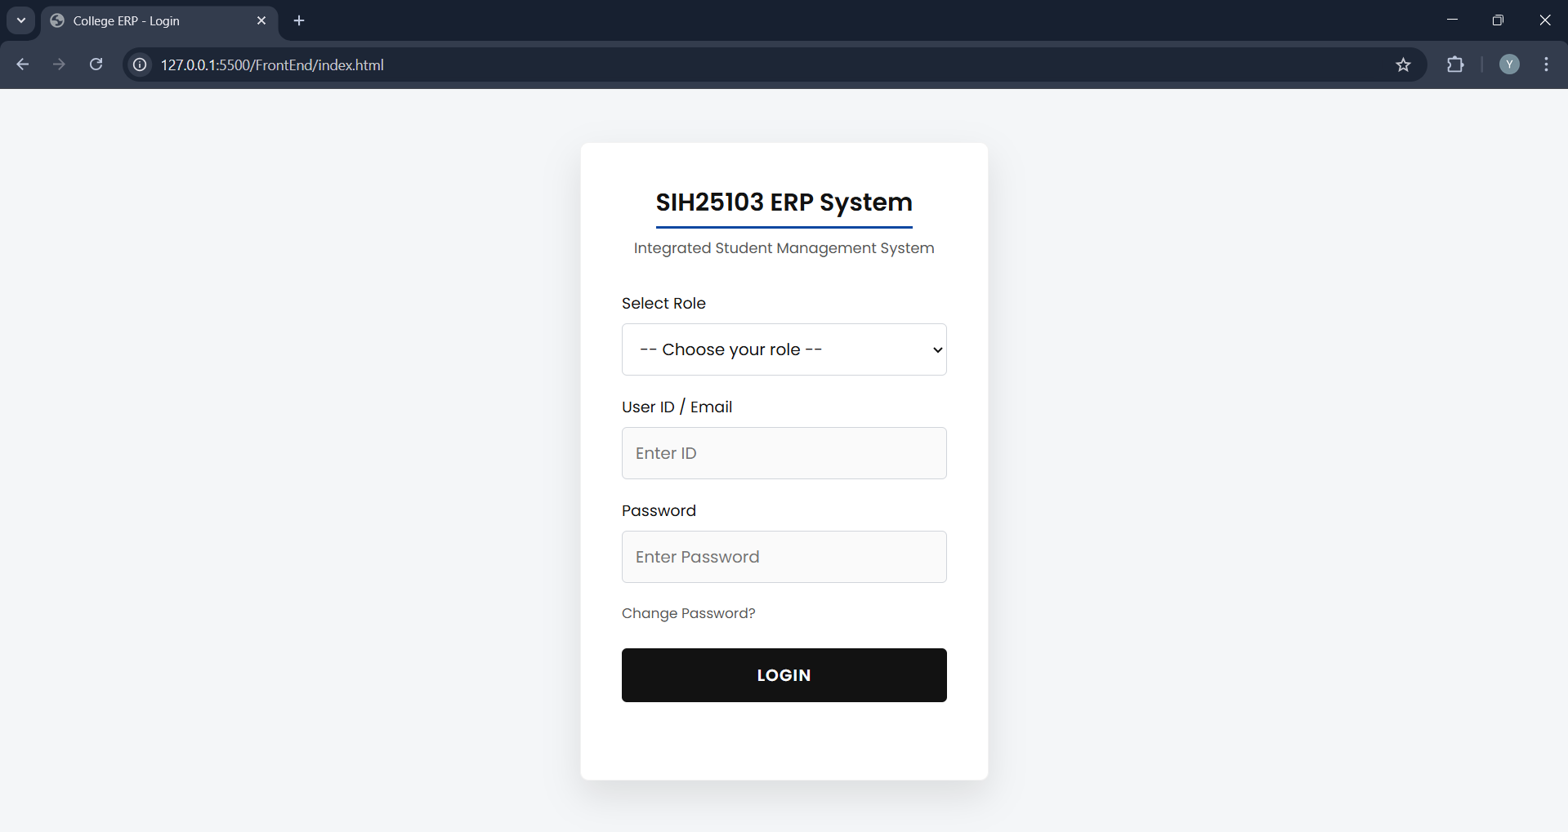
A.2 ADMINISTRATOR MODULE
The Administrator is responsible for system configuration and user management.
1. How to Onboard New Users (Bulk Upload):
- Go to the "Users" tab in the sidebar.
- Click on "Add Bulk Users".
- Select the Role (e.g., "Student") and Department.
- Click "Upload Excel" and select your .xlsx file containing user details.
- Click "Submit". The system will create accounts for all users instantly.

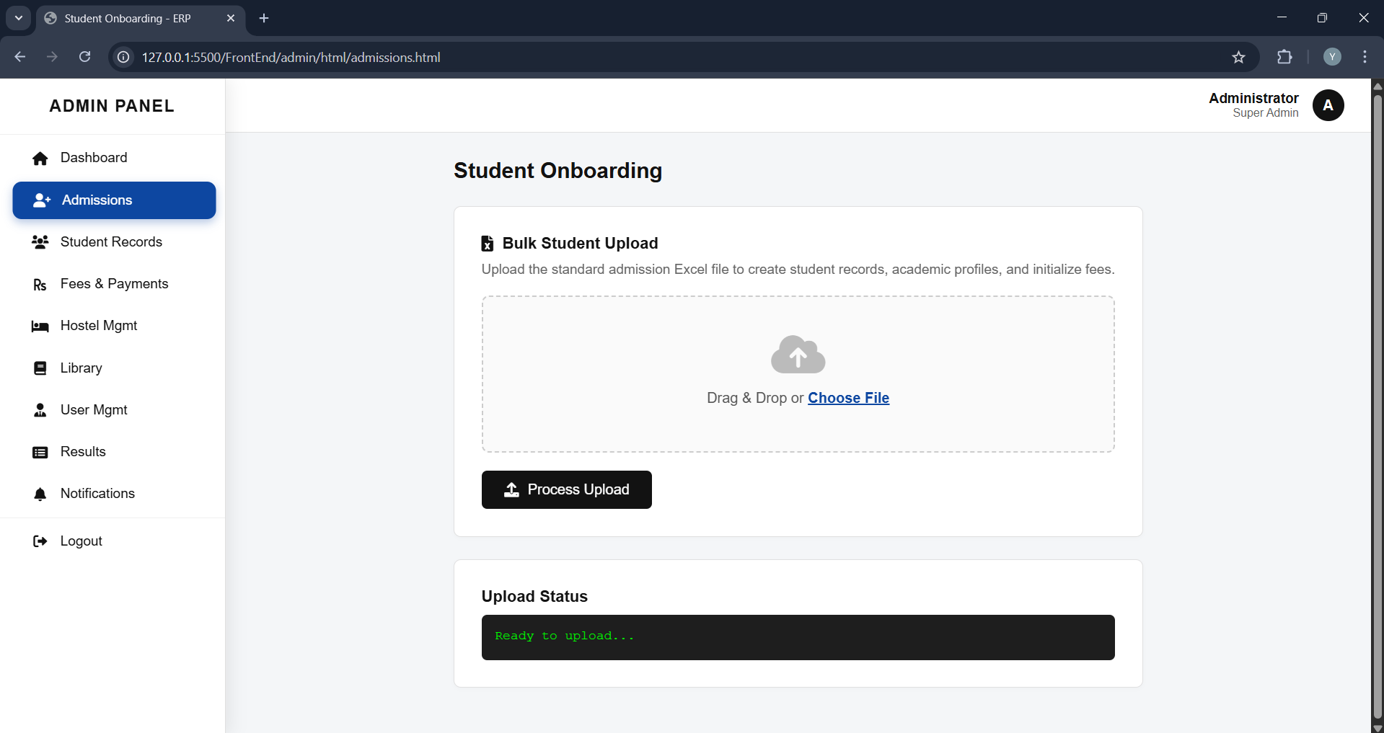
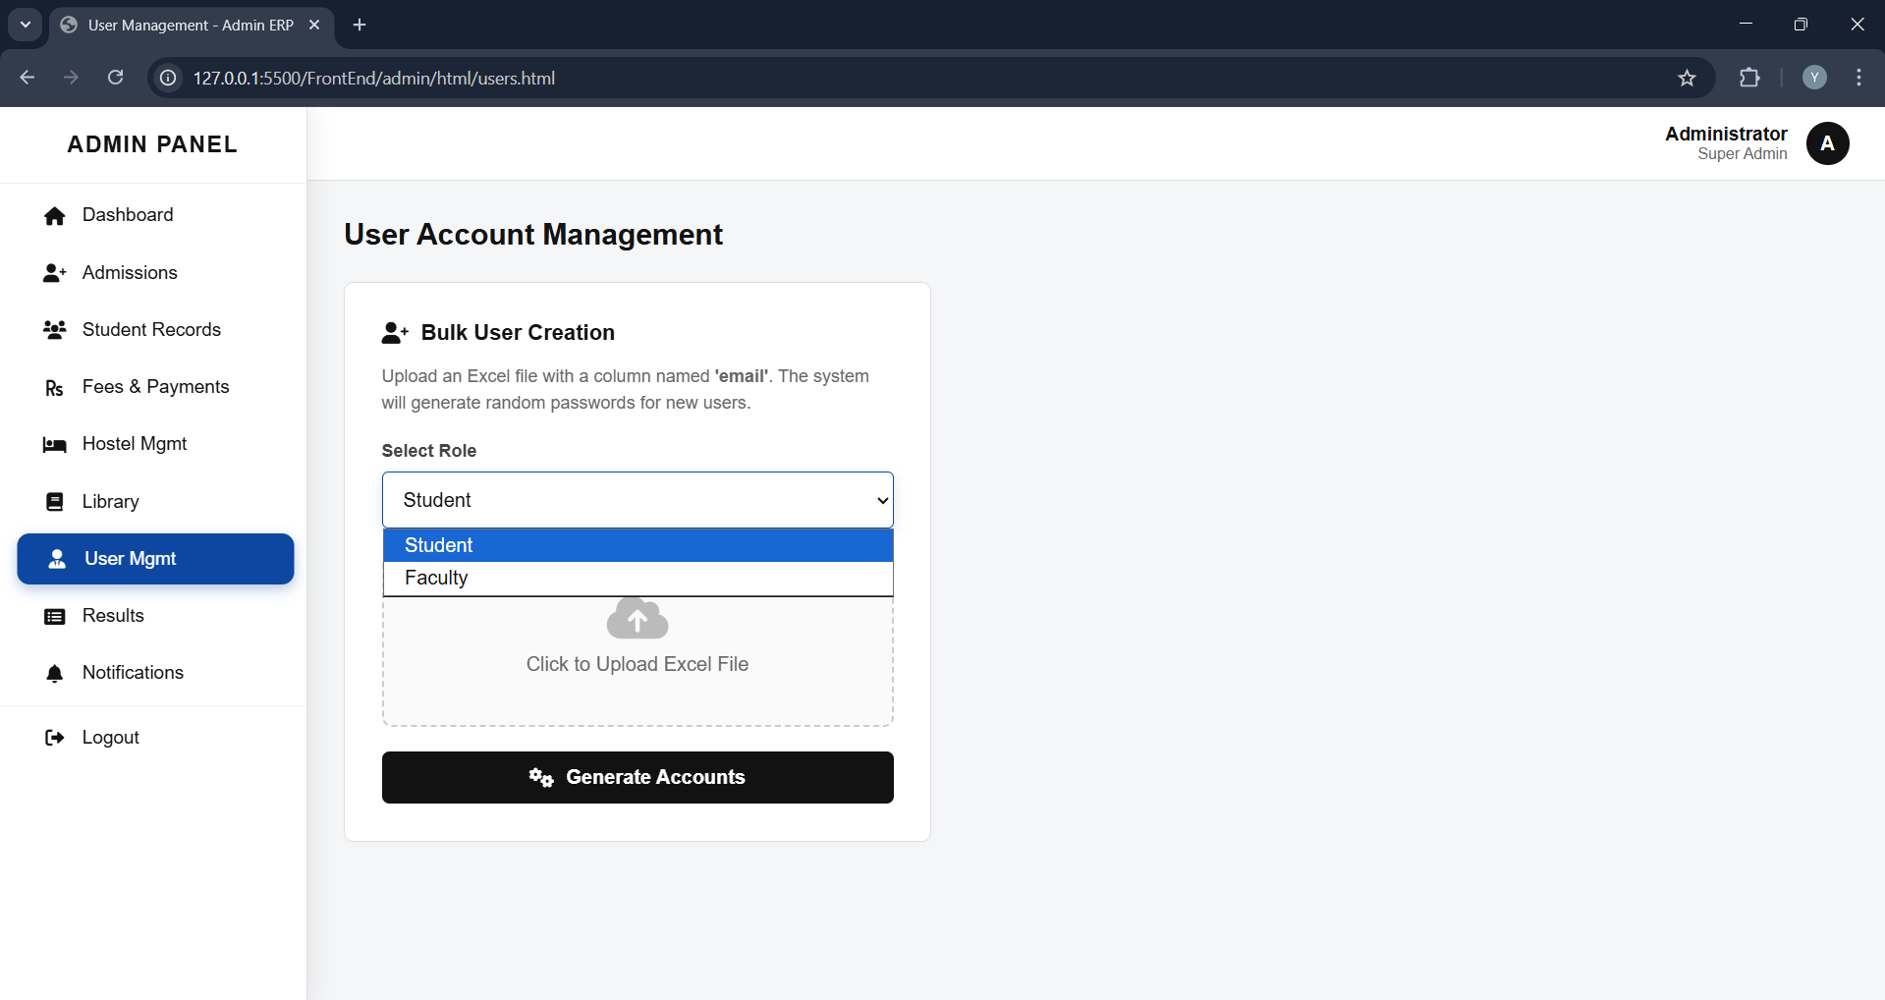
2. How to Configure Fee Structure:
- Navigate to "Accounts" -> "Fee Structure".
- Select the Batch (e.g., 2023-2027) and Department.
- Enter the amounts for Tuition Fee, Library Fee, and Hostel Fee.
- Click "Save". This will update the pending dues for all students in that batch.
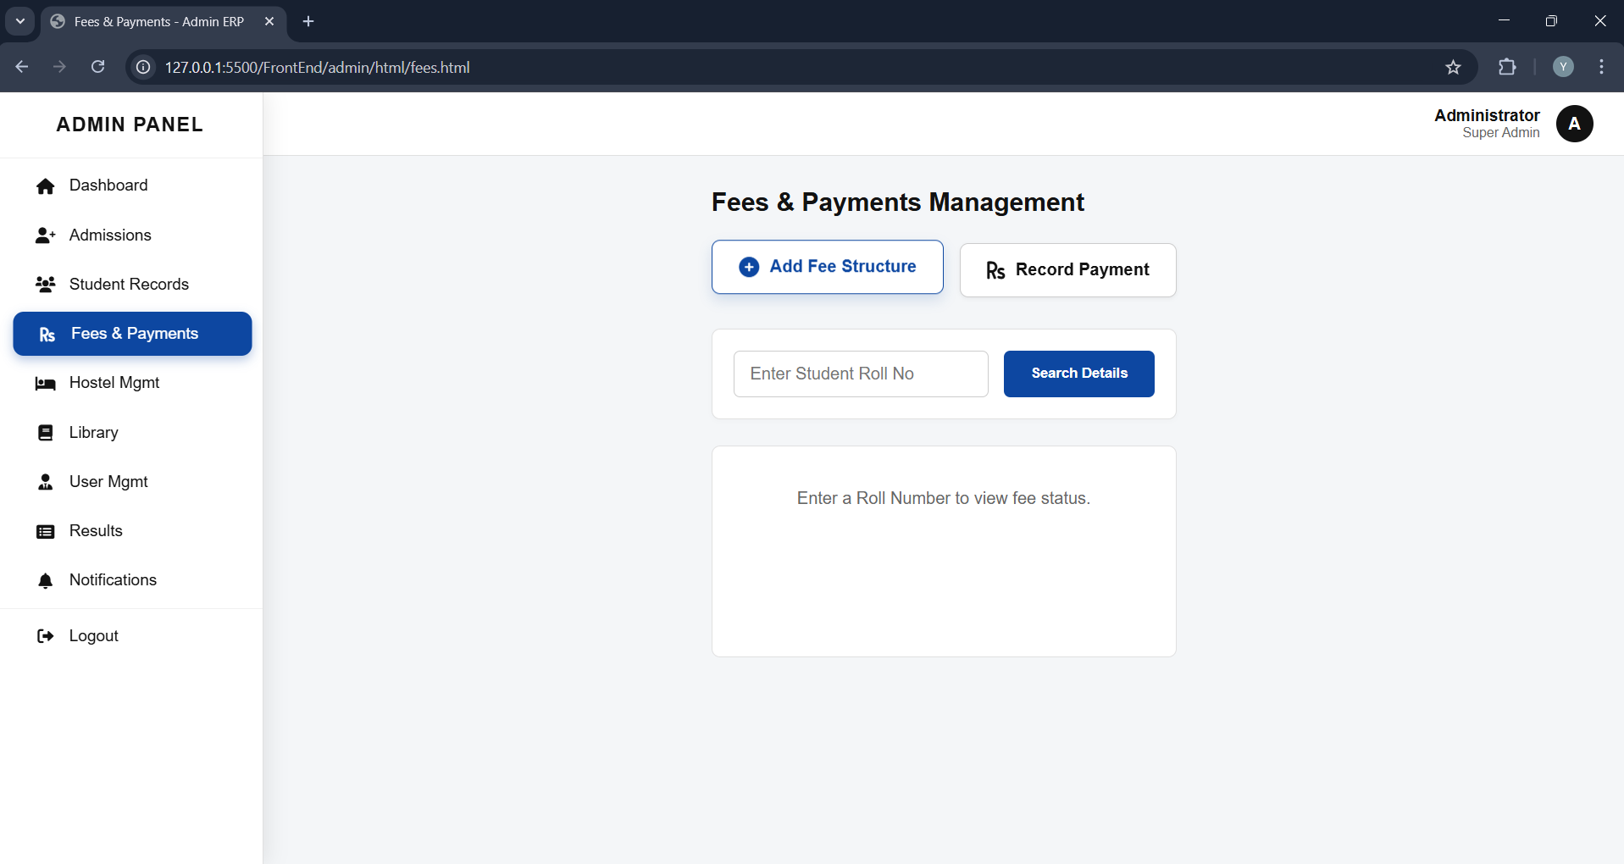
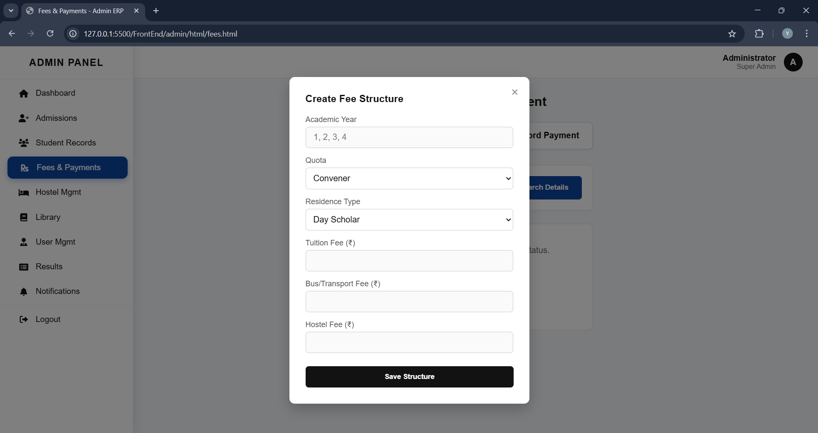

A.3 HOD (HEAD OF DEPARTMENT) MODULE
The HOD module focuses on analytics and monitoring.
1. Viewing Batch Analytics:
- On the Dashboard, use the filter to select a Year and Section.
- The system will generate two graphs:
  - Performance Graph: Comparing Mid-1 vs. Mid-2 averages.
  - Attendance Graph: Showing monthly attendance trends.
- Hover over the bars to see exact percentage values.
[Insert Screenshot of HOD Analytics Graphs]
2. Managing Timetables:
- Go to the "Timetable" section.
- Select the Class (Year/Sec).
- Upload the Timetable image file (.jpg or .png).
- Click "Upload". This schedule will now be visible to all students of that class.
- Time Table upload For Students
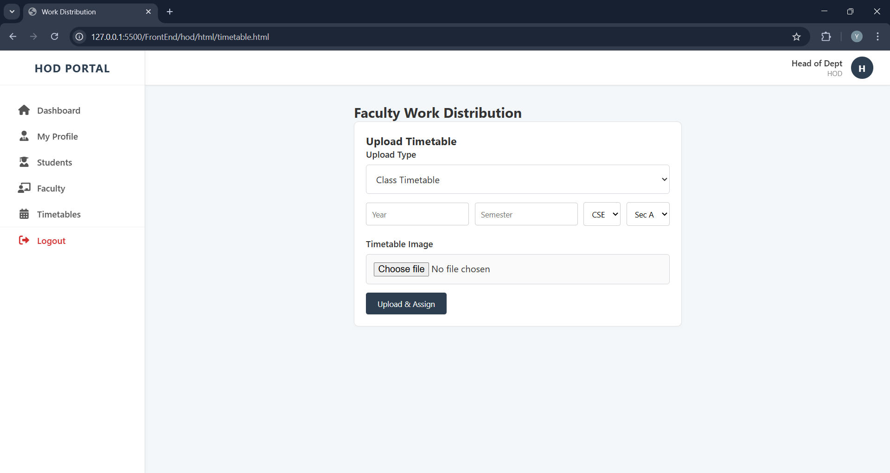
- Time Table upload for Faculty
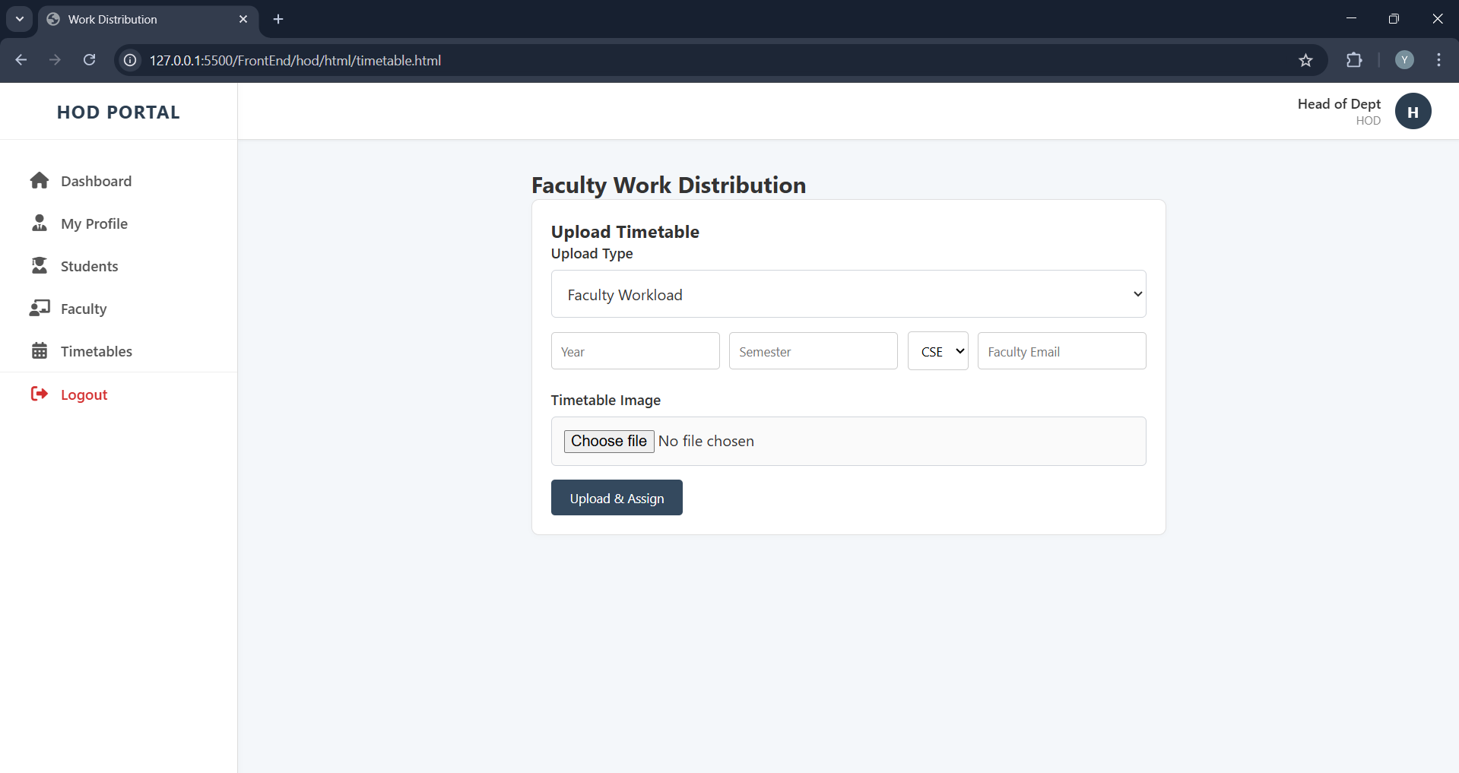

A.4 FACULTY MODULE
Faculty members use this module for daily academic operations.
1. Marking Attendance:
- Click on "Attendance" in the sidebar.
- Select the Date, Period, and Section.
- You will see a list of students. By default, all are marked "Present".
- Uncheck the boxes for absent students.
- Click "Submit Attendance".
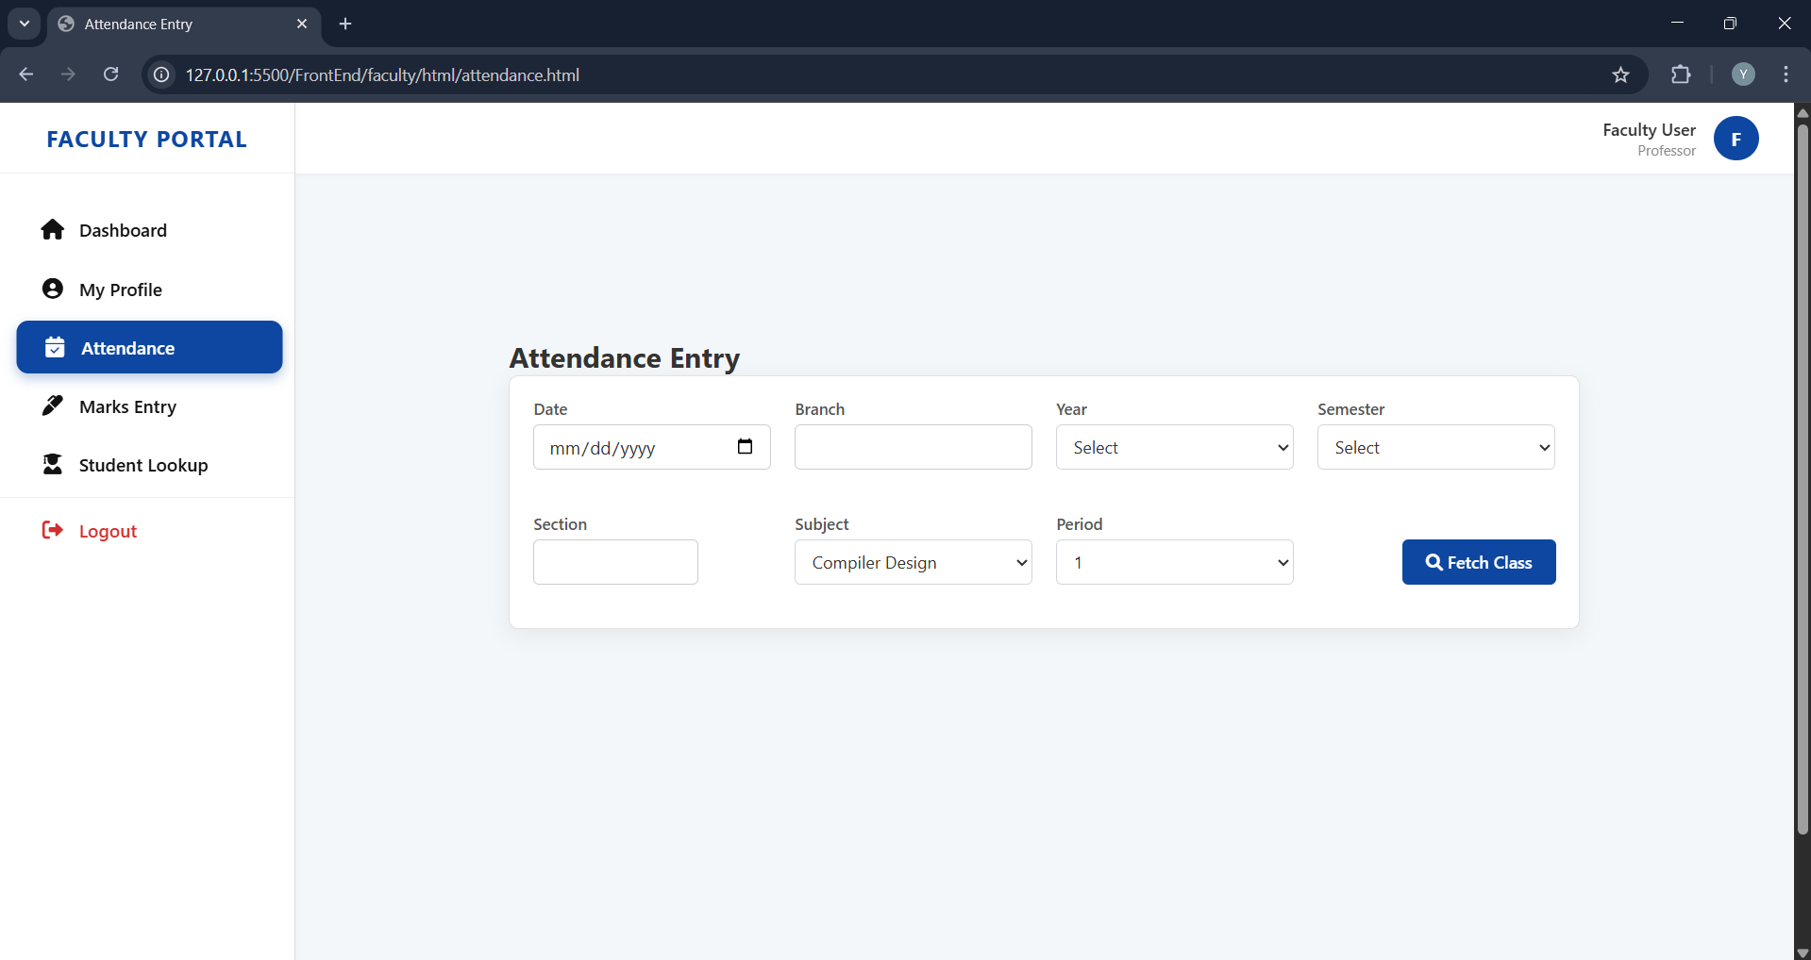
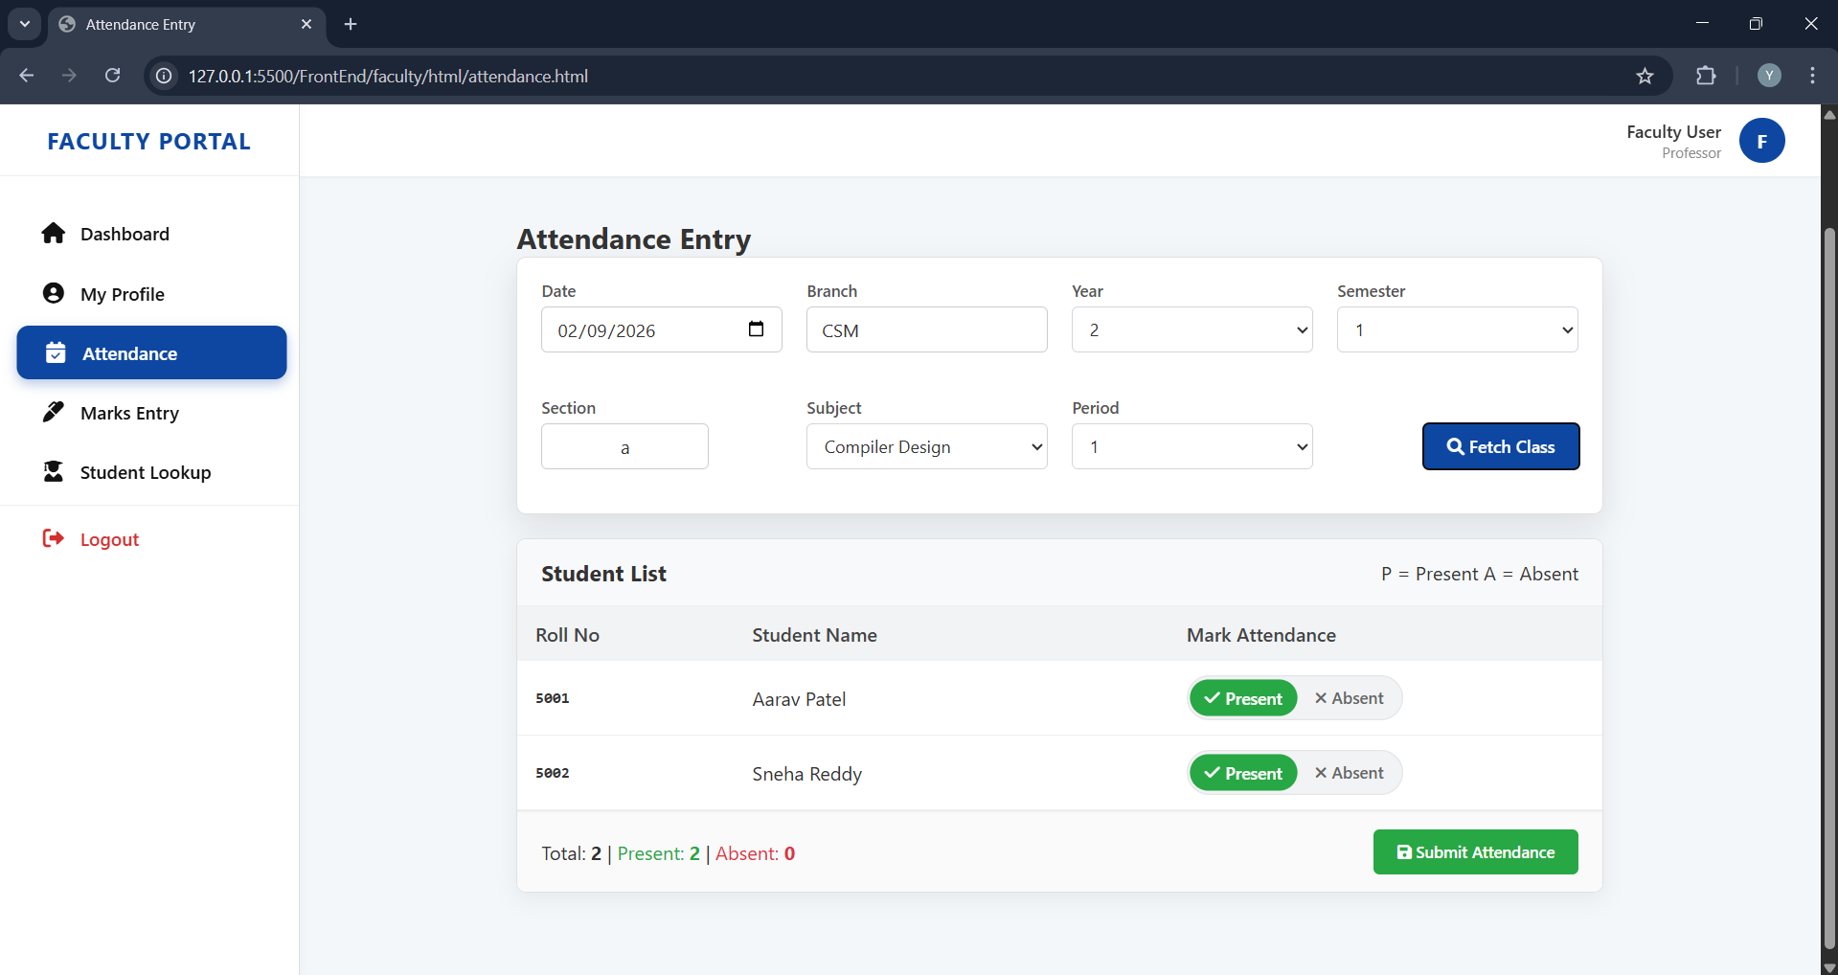

2. Uploading Internal Marks:
- Navigate to "Marks Entry".
- Select the Exam Type (Mid-1 / Mid-2).
- You can either enter marks manually for each student or upload a CSV file.
- Click "Save Marks".
  - Note: The system will alert you if you enter a value greater than the maximum marks (30).
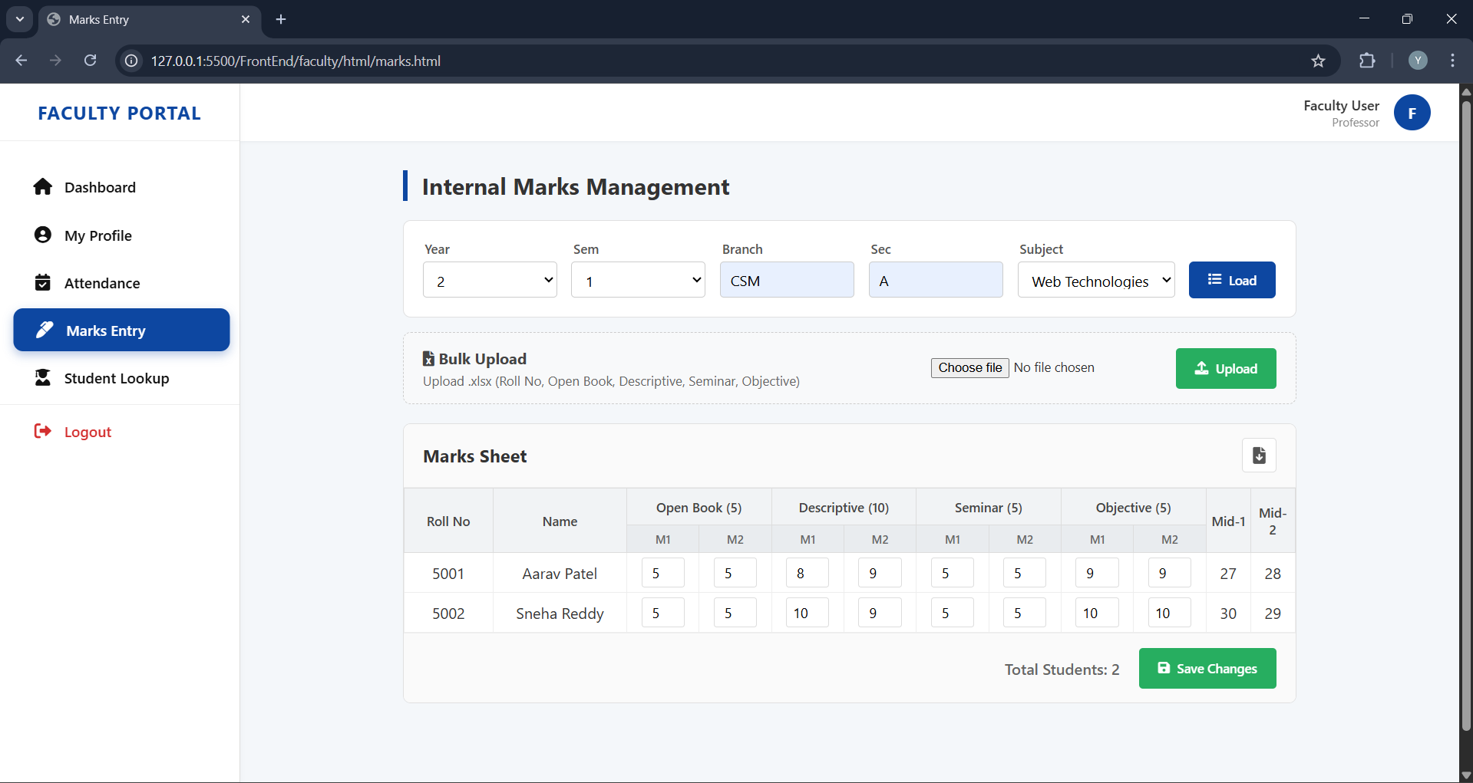

A.5 STUDENT MODULE
Students use this dashboard to track their progress.
1. Checking Academic Risk:
- On the Home Dashboard, look for the "AI Risk Analysis" card.
- The system displays your current status: Low Risk (Green), Moderate Risk (Yellow), or High Risk (Red).
- Read the "AI Insight" text below it to understand why (e.g., "Your attendance has dropped below 65%").
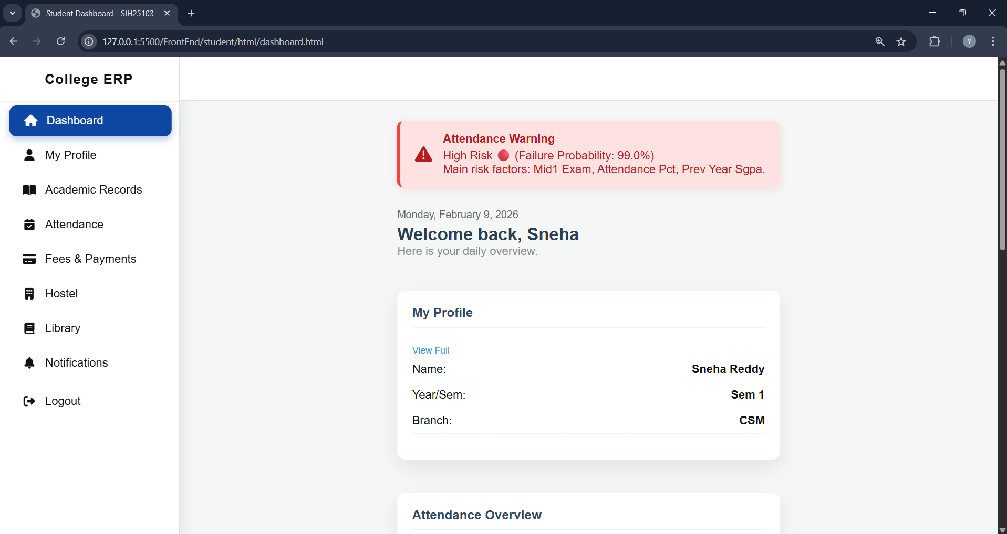
2. Getting Attendance Advice :
- If your attendance is low, look for the "Smart Advisor" widget.
- The AI will display a personalized message telling you exactly how many classes you need to attend to recover.
3. Paying Fees:
- Go to the "Payments" tab.
- View your "Total Dues".
- Pay the Fees at the office and Admin will update them automatically for you.
- Once done, download the Fee Receipt PDF.

APPENDIX B
SOURCE CODE
This appendix contains the core source code files developed for the Smart College ERP. It covers the Backend entry point, Database configuration, ML Inference logic, and the Frontend Dashboard script.
B.1 BACKEND ENTRY POINT (main.py)
This file initializes the FastAPI application, configures Cross-Origin Resource Sharing (CORS) to allow frontend access, and includes all the routers.
Python
from fastapi import FastAPI
from fastapi.middleware.cors import CORSMiddleware
from app.core.database import engine, Base
from app.routers import auth, admin, hod, faculty, student
import uvicorn

# Initialize Database Tables
Base.metadata.create_all(bind=engine)

app = FastAPI(
title="Smart College ERP",
description="Backend API for ERP with AI Early Warning System",
version="1.0.0"
)

# CORS Configuration
origins = [
"http://127.0.0.1:5500", # Frontend Server
"http://localhost:5500",
"*"
]

app.add_middleware(
CORSMiddleware,
allow_origins=origins,
allow_credentials=True,
allow_methods=["*"],
allow_headers=["*"],
)

# Include Routers
app.include_router(auth.router)
app.include_router(admin.router)
app.include_router(hod.router)
app.include_router(faculty.router)
app.include_router(student.router)

@app.get("/")
def root():
return {"message": "Smart College ERP API is Running"}

if __name__ == "__main__":
uvicorn.run("app.main:app", host="127.0.0.1", port=8000, reload=True)

B.2 DATABASE CONFIGURATION (database.py)
This module handles the connection to the MySQL database using SQLAlchemy.
Python
from sqlalchemy import create_engine
from sqlalchemy.ext.declarative import declarative_base
from sqlalchemy.orm import sessionmaker
import os
from dotenv import load_dotenv

load_dotenv()

# Database Credentials
DB_USER = os.getenv("DB_USER", "root")
DB_PASSWORD = os.getenv("DB_PASSWORD", "password")
DB_HOST = os.getenv("DB_HOST", "localhost")
DB_NAME = os.getenv("DB_NAME", "college_erp_db")

SQLALCHEMY_DATABASE_URL = f"mysql+pymysql://{DB_USER}:{DB_PASSWORD}@{DB_HOST}/{DB_NAME}"

engine = create_engine(
SQLALCHEMY_DATABASE_URL,
pool_pre_ping=True,
pool_recycle=3600
)

SessionLocal = sessionmaker(autocommit=False, autoflush=False, bind=engine)

Base = declarative_base()

# Dependency to get DB session
def get_db():
db = SessionLocal()
try:
yield db
finally:
db.close()

B.3 ML INFERENCE LOGIC (inference.py)
This script loads the trained XGBoost model and generates risk predictions for students.
Python
import joblib
import pandas as pd
import shap
import numpy as np
import os

# Define Paths
BASE_DIR = os.path.dirname(os.path.abspath(__file__))
MODEL_DIR = os.path.join(BASE_DIR, "../ml_models")

# Load Artifacts
try:
MODEL = joblib.load(os.path.join(MODEL_DIR, "academic_risk_model.pkl"))
SCALER = joblib.load(os.path.join(MODEL_DIR, "scaler.pkl"))
FEATURES = joblib.load(os.path.join(MODEL_DIR, "model_features.pkl"))

# Initialize SHAP Explainer
BACKGROUND = np.zeros((1, len(FEATURES)))
EXPLAINER = shap.Explainer(MODEL.predict_proba, BACKGROUND)
except Exception as e:
print(f"Error loading ML models: {e}")
MODEL = None

def predict_student_risk(student_dict):
"""
Input: Dictionary containing student marks and attendance.
Output: Risk Status string and SHAP explanation.
"""
if not MODEL:
return "AI Risk Model Unavailable"

# Prepare Data
data = {feat: student_dict.get(feat, 0) for feat in FEATURES}
df = pd.DataFrame([data])[FEATURES]

# Scale & Predict
scaled = SCALER.transform(df)
prob = MODEL.predict_proba(scaled)[0][1] * 100

# Generate Explanation
shap_values = EXPLAINER(scaled)
increases_risk = []

for i, feature in enumerate(FEATURES):
if shap_values.values[0][i][1] > 0:
feat_name = feature.replace("_", " ").title()
increases_risk.append(feat_name)

# Risk Classification
if prob < 30:
status = "Low Risk 🟢"
elif prob < 70:
status = "Moderate Risk 🟡"
else:
status = "High Risk 🔴"

explanation = ", ".join(increases_risk) if increases_risk else "None"

return f"{status} (Prob: {prob:.1f}%)\nKey Factors: {explanation}"
B.4 FRONTEND DASHBOARD LOGIC (dashboard.js)
The JavaScript file that fetches student data and renders the AI insights.
JavaScript
document.addEventListener("DOMContentLoaded", () => {
loadDashboard();
});

async function loadDashboard() {
const token = localStorage.getItem("token");
if (!token) {
window.location.href = "../../index.html";
return;
}

try {
const res = await fetch("http://127.0.0.1:8000/student/dashboard", {
headers: { "Authorization": `Bearer ${token}` }
});

if (res.ok) {
const data = await res.json();

// 1. Update Profile
document.getElementById("st-name").innerText = data.profile.name;
document.getElementById("st-roll").innerText = data.profile.roll_no;

// 2. Update Stats
document.getElementById("st-cgpa").innerText = data.stats.cgpa;
document.getElementById("st-att").innerText = data.stats.attendance + "%";

// 3. Update AI Insight
const aiBox = document.getElementById("ai-risk-box");
aiBox.innerText = data.ai_insight;

if (data.ai_insight.includes("High Risk")) {
aiBox.style.borderLeft = "5px solid red";
aiBox.style.backgroundColor = "#fff0f0";
} else if (data.ai_insight.includes("Low Risk")) {
aiBox.style.borderLeft = "5px solid green";
aiBox.style.backgroundColor = "#f0fff4";
}
}
} catch (error) {
console.error("Dashboard Load Error:", error);
}
}

APPENDIX C
SAMPLE DATASETS & API RESPONSES
This appendix provides snapshots of the data used to train the machine learning model and examples of the JSON responses exchanged between the frontend and backend.

C.1 STUDENT RECORDS DATASET (Sample)
The following table represents a subset of the student_records.csv file used for training the XGBoost model.
Roll_No | Mid1_Marks (30) | Mid2_Marks (30) | Attendance (%) | Backlogs | Prev_SGPA | Risk_Label
501 | 28.5 | 29.0 | 92.0 | 0 | 9.2 | 0 (Low)
502 | 12.0 | 14.5 | 65.0 | 1 | 6.8 | 1 (Med)
503 | 05.0 | 08.0 | 45.5 | 3 | 5.1 | Fail
504 | 22.0 | 24.0 | 88.0 | 0 | 8.5 | Pass
505 | 18.0 | 15.0 | 72.0 | 0 | 7.4 | Pass
506 | 09.0 | 06.0 | 40.0 | 4 | 4.9 | Fail
... | ... | ... | ... | ... | ... | ...

C.2 API RESPONSE: STUDENT DASHBOARD
Endpoint: GET /student/dashboard
Description: Returns the consolidated profile, academic stats, and AI risk prediction.
JSON
{
"profile": {
"name": "Rahul Verma",
"roll_no": "21B81A0545",
"branch": "CSE",
"semester": 6
},
"stats": {
"attendance": 68.5,
"cgpa": 7.2,
"fee_dues": 15000,
"library_books": 2
},
"ai_insight": "Moderate Risk 🟡 (Failure Probability: 55.4%)\nMain risk factors: Attendance Pct 100, Mid2 Exam 30."
}
C.3 API RESPONSE: FEE STRUCTURE
Endpoint: GET /admin/fees/structure?batch=2021
Description: Returns the fee breakdown for a specific batch.
JSON OBJECT
[
{
"category": "Tuition Fee",
"amount": 45000,
"is_compulsory": true
},
{
"category": "Library Fee",
"amount": 2500,
"is_compulsory": true
},
{
"category": "Hostel Fee",
"amount": 60000,
"is_compulsory": false
},
]

C.4 TESTING CHECKLIST
The following test cases were executed to validate system stability.
Test ID Module Test Description Expected Result Status
TC-01 Auth Login with invalid password Return 401 Unauthorized PASS
TC-02 Admin Upload Excel with duplicate Return 400 Bad Request PASS
Roll No
TC-03 Faculty Enter Marks > 30 Frontend Validation Error PASS
TC-04 AI Predict risk for 100% attendance Return "Low Risk" PASS
TC-05 Student Access Admin URL directly Return 403 Forbidden PASS

