
By Zach Spanier

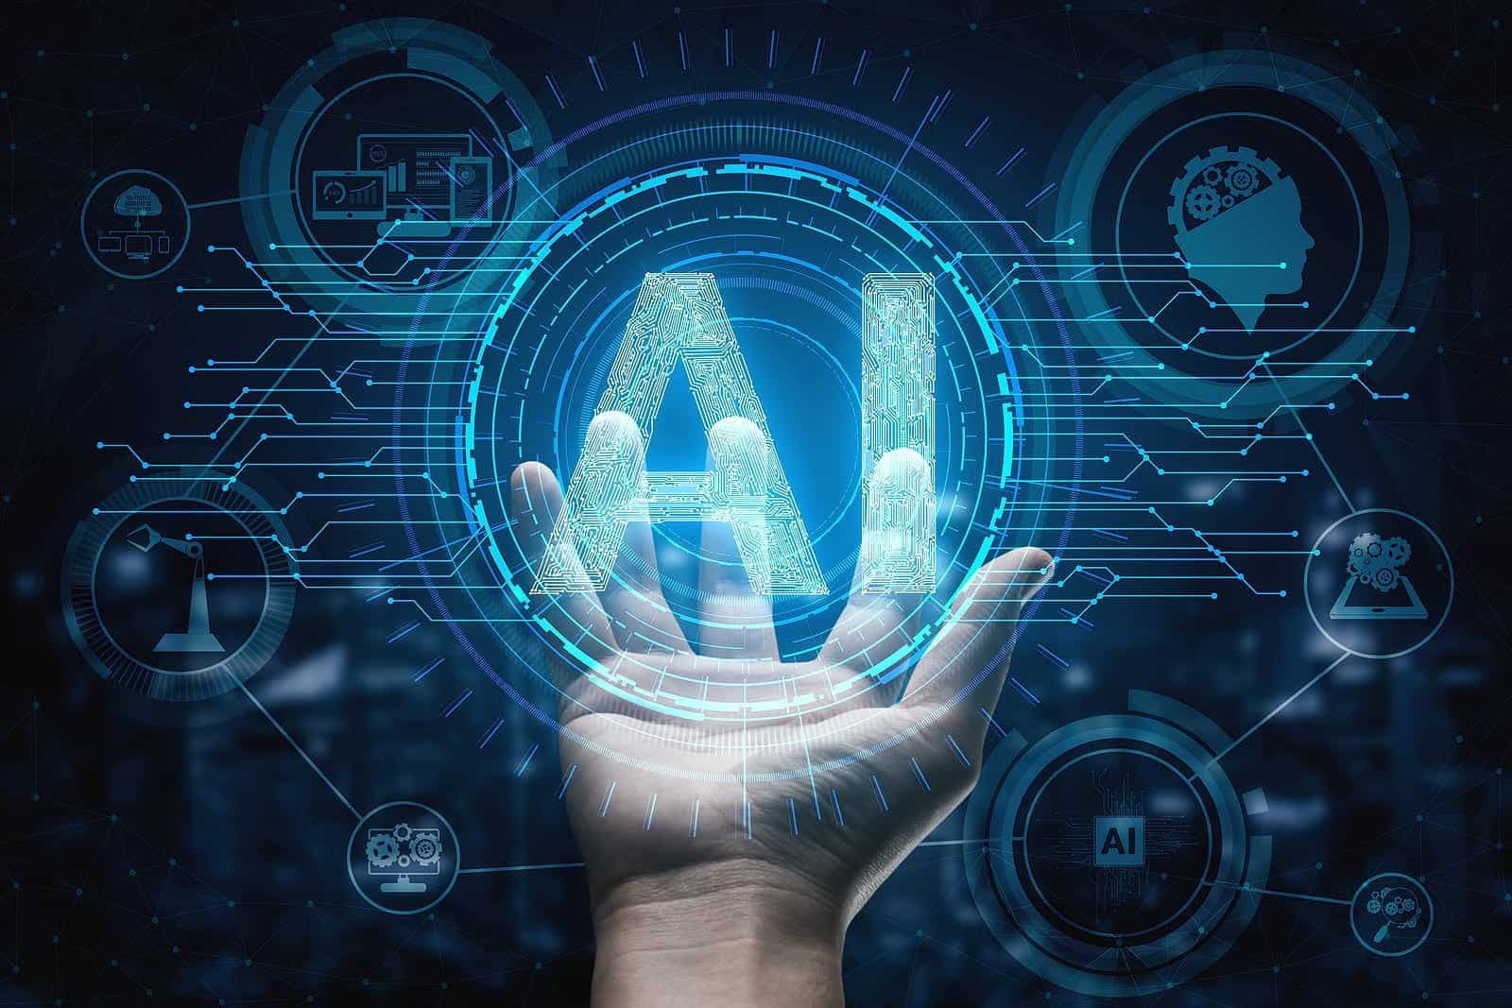
Cisco Networking Academy
Locally Hosting AI

Purpose:
Hosting AI models using docker for a locally routable IP such that everyone on a local network can connect to it from a local host.

Background:
AI has quite a large scope, from early machine learning to the LLMs that are used by millions of people every day. The issue with using public AI is that the companies store your data and the information you request from the AI, but people are often a lot more open with AI and go more in depth on their problems and in extreme cases try to marry or use the AI to be their therapist. AI is also known to have caused conformation bias when people use it as their only source of information.
There are many different subsets of AI, and each one has different use cases, LLMs fall under Generative pre -trained transformers but their other types of AI like machine learning (supervised or unsupervised) and general intelligence that have unique use cases and different advantages.
AI will often have artificial neural network where it takes an input, passes the input through a set of nodes (amount of nodes may vary on how varied or complex the input can be as well as how specific the output is), These large neural networks are used for learning and can be of different types (such as feed forward, and recurrent) each one of these neural networks. Many of these networks have some issues that come with the repetitive nature of them, and this allows for the end output to be severely changed and incorrect due to the recursive nature of the network. Despite this, recurrent neural networks maintain a short memory of how the previous set of inputs ended up becoming outputs.

Deep learning is a subset of Machine learning which allows the neural networks to process images better by using each layer to prosses different parts of the image like #s or just shapes. This technology was theorized in the 1950s but wasn’t fully utilized until the 2010s till now due to the lack of processing power and available RAM.
Nowadays when someone says AI they are generally referring to an LLM but this may verry based on the group you are interacting with and many people find it annoying how much companies are forcing AI into product where they are not needed and not helpful like Copilot and AI overview which provide sometimes false information and are unhelpful in providing context or sources especially because they have a large chance of being partially or completely wrong about issues as the companies that own them simply read any and all things that exist on the internet for data that the AI uses. Unfortunately, AI has led to a large increase in unemployment and has decreased the number of available low specialization/experience. Other issues with LLMs are that you shouldn’t put in any personal information of you or your coworkers/clients because this will cause a security breach of your information which a local AI would be able to solve. The local
For the local running of the AI, we used Docker. Docker places things within a virtual container and can be done on any operating system. This allows for things to be run in the public network as well as in private locations. Docker can encapsulate and even scale across multiple docker instances. We then linked docker to OpenWebUI through specific commands that allow us to chose a specific port # for input and output.
Lab Commands:

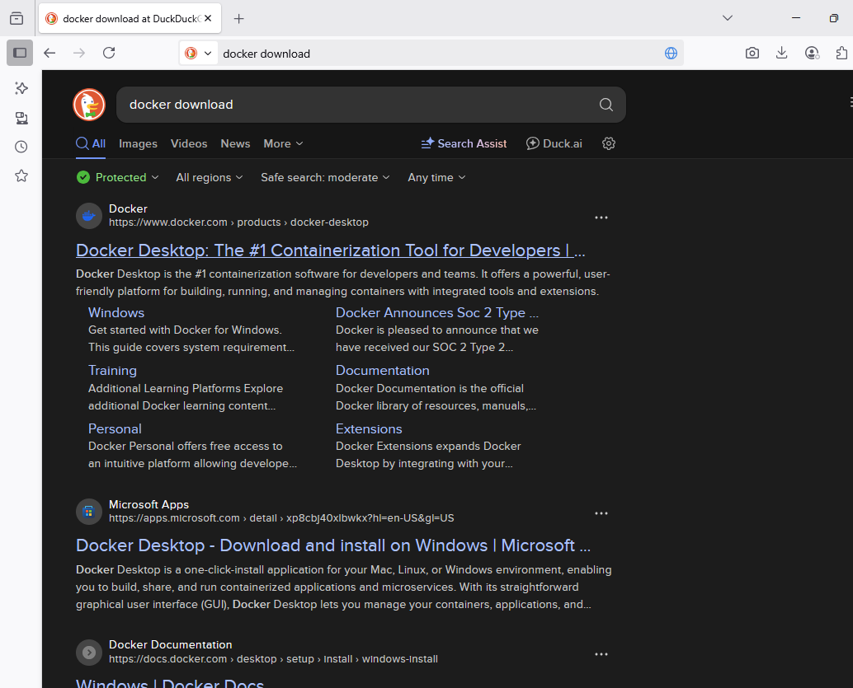
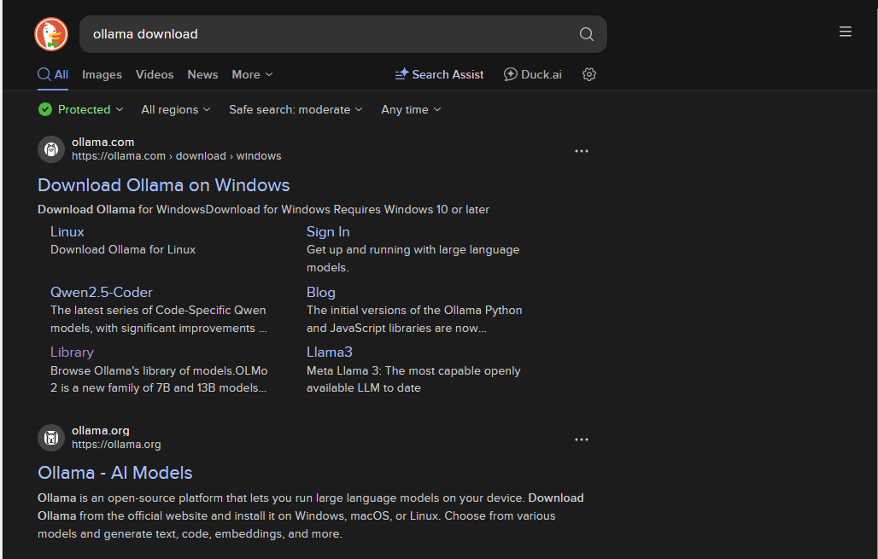

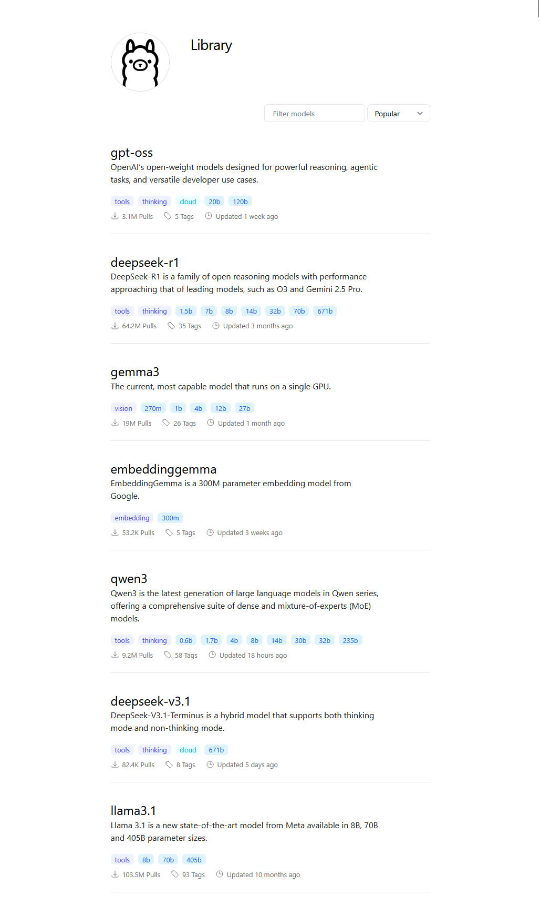
Pick any model
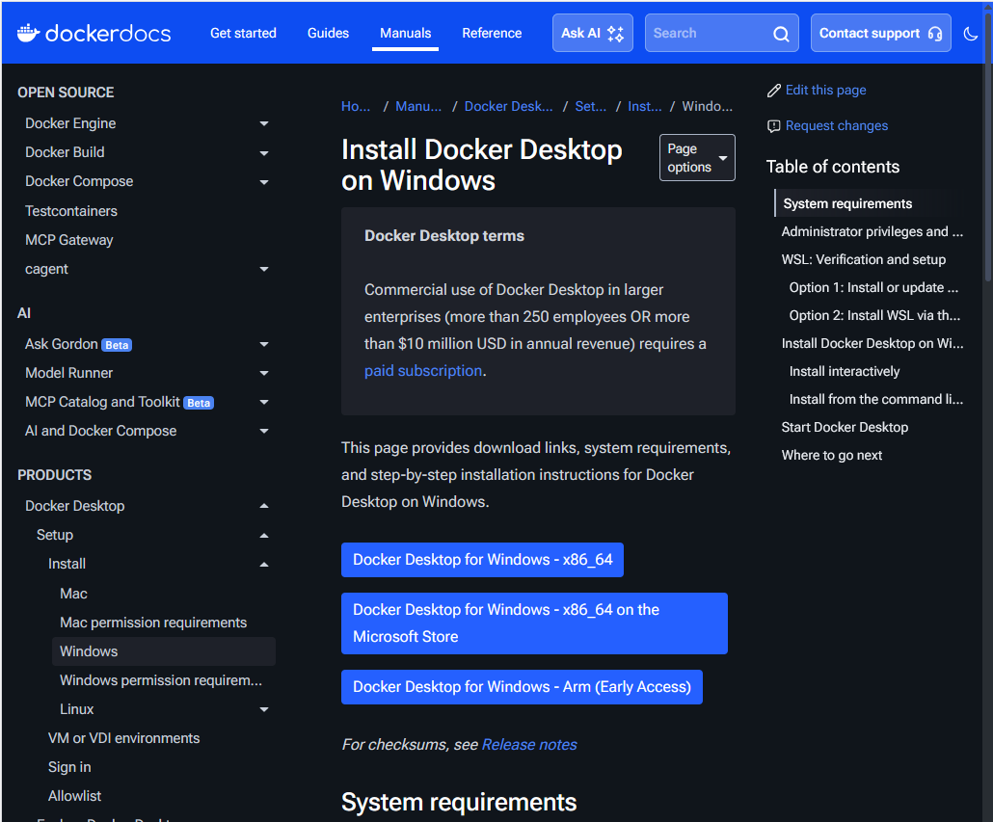

docker run -d -p 3000:8080 --add-host=host.docker.internal:host-gateway -v open-webui:/app/backend/data --name open-webui --restart always ghcr.io/open-webui/open-webui:main

Problems:
The creation of a user for open web UI was unable to allow me to use the model already downloaded on my computer. Open Web UI would allow for me to be able to get the AI up and make as many accounts as I wanted to allow whether they had a real email or not. This is problematic and it took some time to find a work around and look through the lists of the possible groupings and other things that I could change. Furthermore due to the lack of other documentation on these processes it was significantly harder to attempt to determine how the Open Web UI functions in tandem with the different AI tools that I attempted to use. While I was able to make other Admin Users that were able to interact with the AI and see the other chats this wasn’t the intended way of doing other users. Eventually I found documentation on how to adjust user privileges so they could access the AI. It also allowed me to interact with both accounts. Other issues I encountered were needing to change port number to non-matching port number so that your packets don’t collide and die you can change this within Docker and or avoid this by using a different one in the commands as mentioned above. It can also be problematic to forget to trigger both in docker at the same time, make sure that your firewalls are down on the same private network, and confirm the port numbers in your address for your connection from another device. Remember to choose a model in the top left corner of the web UI as the initial connection to it will not automatically choose the ai you have selected.
Conclusion
The usage of local AI is important to the safety and security of` important personal data and documentation that should not be freely given to a company that would use that data to train its model as opposed to that you can simply locally host an AI that you prevent from accessing the internet but is accessible on a local network so that your company can continue to receive the benefits of AI and not have to worry about security. While it may be less sophisticated and more likely to provide less accurate information if you have a verry specific AI model that you want to use/download or enough space/money then you could run your own mini AI center.

