Snow Bros Project Report
Muhammad Saad 25I-3039, Daniyal Ahmed Zaki 25I-3014 BSE-2D

1. INTRODUCTION
Snow Bros is a 2D game project developed using object-oriented design principles. Our project demonstrates key OOP concepts including inheritance, composition, aggregation, and abstraction through a well-structured class hierarchy. Our report documents the decisions, design patterns, and individual contributions of our team members.

2. OOP DESIGN DECISIONS

2.1 Inheritance Hierarchy
Our project extensively uses inheritance for code reuse and polymorphism. The Enemy class serves as an abstract base class from which all enemy types derive, reducing code redundancy and enabling consistent behaviour patterns.
Similarly, the Projectiles class acts as an abstract base allowing multiple projectile types (Snowballs, Knives) to inherit common functionality while implementing specialized behaviour. This hierarchical approach ensures maintainability and allows for easy addition of new enemy or projectile types.

2.2 Composition Relationships
Composition creates strong ownership relationships where components cannot exist independently. Key compositions include:
- Player with AnimationComponent and Projectiles
- Game Unit with LoginManager and LevelManager
- Level Manager with Players and PlayerDatabaseManager
These relationships ensure that dependent components are created and destroyed with their owners, preventing memory leaks and maintaining data consistency.

2.3 Aggregation Relationships
Aggregation represents weak relationships where components can exist independently. The project uses aggregation for:
- PhysicsEngine with Player, Enemy, Blocks, and Collectibles
- Shop with Player
- Collectibles with Player, PowerUpMenu, and Projectiles
This design allows flexible interaction between game entities without creating hard dependencies, promoting loose coupling and code reusability.

2.4 Association Relationships
Association represents one-way relationships between classes. The Player class has an association with InputManager for handling user inputs, allowing the Player to use InputManager services without owning it. This separation of concerns keeps input handling logic independent from player behavior.

3. CLASS HIERARCHY DIAGRAMS (UML)

3.1 Enemy Class Hierarchy
The Enemy hierarchy demonstrates strategic inheritance design to minimize redundancy:
Enemy (Abstract)
Bottom | Ground-based enemy
FlyingFoogaFong | Inherits Bottom properties
Tornado | Advanced flying enemy
Mogera Boss | Ground-based boss
Gamakichi Boss | Uses health from Bottom
Minions | Ground-based unit
Bombers | Specialized minion
Classes inherit from Bottom rather than Enemy directly to reuse common variables (x, y, Vx, Vy, health) and reduce implementation redundancy. Mogera and Gamakichi use specific Bottom properties while implementing unique behaviours independently.

3.2 Game Management Hierarchy
Core game systems follow a manager pattern:
Game Unit (Main Interface) | Game entry point
LoginManager | Player authentication
LevelManager | Level loading
PlayerDatabaseManager | Manages saves
LeaderboardManager | Score tracking
Player | Game character
PhysicsEngine | Collision detection
Enemy
Blocks
Collectibles
This structure centralizes game initialization through Game Unit while dividing responsibilities to specialized managers, ensuring clean separation of concerns.

4. DESIGN PATTERNS USED

4.1 Manager/Controller Pattern
Multiple manager classes (LoginManager, LevelManager, PhysicsEngine, LeaderboardManager) encapsulate specific game subsystems. These managers provide controlled access to game resources and handle complex interactions transparently.

4.2 Component Pattern
AnimationComponent, PlayerInfo, and PlayerSaveData are used as a reusable component within Player, Shop and levelManager classes, demonstrating composition over inheritance. This allows multiple classes to share animation functionality without complex inheritance chains.

4.3 Template Method Pattern
The Enemy abstract class defines template methods (CreateEnemy, update, draw, getScore) that derived classes implement. This ensures all enemies follow consistent interfaces while allowing specialized behaviour in subclasses.

4.4 Data Access Pattern
PlayerDatabaseManager, LeaderboardManager, and LoginManager separate data logic from game logic, enabling easy switching between storage implementations without affecting game code.

5. CHALLENGES FACED

5.1 Muhammad Saad
Mogera and Gamakichi Bosses: Implementing complex boss behaviors required careful design of the Enemy hierarchy. Mogera, derived from Bottom, required implementing sophisticated movement and attack patterns while maintaining inherited health and position variables. Gamakichi Boss presented a different challenge, as it primarily needed the health mechanism from Bottom but required completely independent functionality, leading to careful decisions about inheritance depth and code organization.

5.2 Daniyal Ahmed Zaki
Implementing persistent player data through PlayerDatabaseManager required coordinating multiple components (PlayerInfo, LeaderBoard) with aggregation relationships. Ensuring data consistency across save/load cycles while maintaining independence between components was complex.
Level Manager Integration: Integrating multiple systems (player loading, enemy allocation, block placement, shop access) into LevelManager required careful composition and aggregation design. The challenge was managing dependencies between dynamic level loading, runtime player configuration (single/multiplayer), and persistent game state while keeping code modular.

6. INDIVIDUAL CONTRIBUTIONS
Member | Contributions
Daniyal Ahmed Zaki | - Player class with composition relationships  - InputManager for input handling  - Projectiles abstract class  - PlayerDatabaseManager  - PhysicsEngine for collisions  - LoginManager  - LevelManager for system integration  - Game Unit abstraction layer  - Block and Hitbox classes
Muhammad Saad | - Complete Enemy hierarchy  - Enemy abstract base class  - Bottom class  - FlyingFoogaFong and Tornado  - Mogera and Gamakichi bosses  - Minions and Bombers  - LeaderboardManager  - Shop class  - Collectibles class

7. UML DIAGRAM

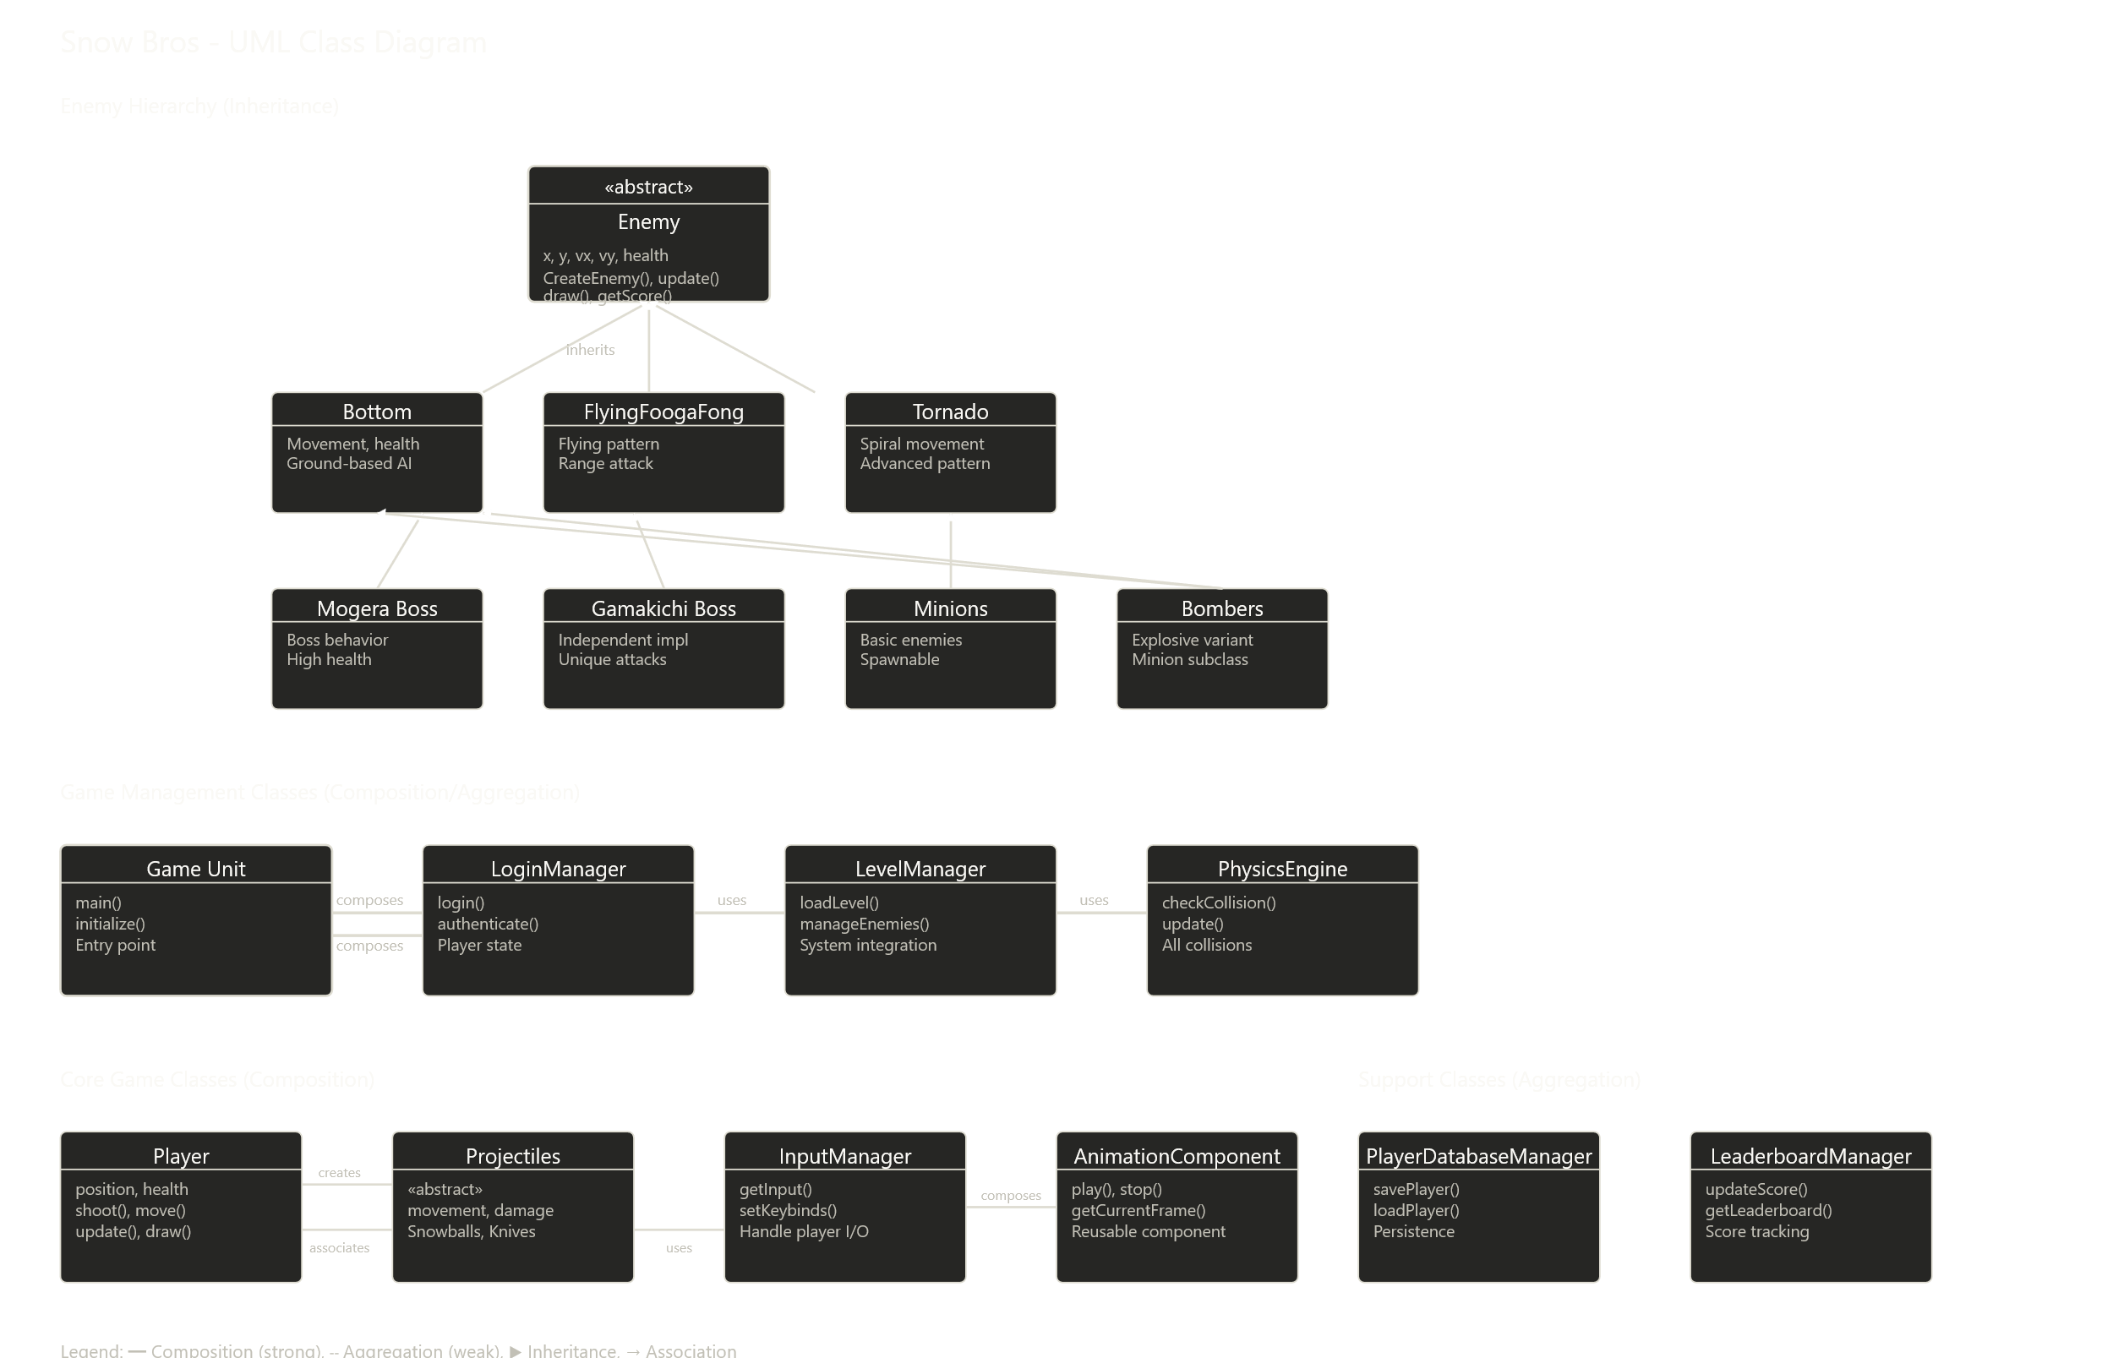

8. CONCLUSION
The Snow Bros project helped us learn solid object-oriented design principles using inheritance, composition, association, and aggregation. Our class hierarchies are well-structured to minimize redundancy while maintaining flexibility. Manager and component patterns abstraction and encapsulation, enabling maintainable and extensible code. Challenges in boss implementation and level system integration were managed by co-ordination between us and careful design decisions to balance code reusability with specialized functionality.

