Online Payments Fraud Detection Using Machine Learning
Project Description:
In today’s digital world, online payments have become a part of our daily lives. From shopping and bill payments to money transfers, most financial transactions are now done online. While this has made life easier and faster, it has also increased the risk of fraudulent activities. Fraudsters constantly try to exploit online systems, leading to financial losses for individuals and organisations.
This project focuses on building a smart system that can detect fraudulent online payment transactions using Machine Learning. Instead of manually checking every transaction, which is time-consuming and inefficient, this system automatically analyses transaction details and predicts whether a transaction is legitimate or fraudulent.
The model is trained using a real-world dataset containing thousands of transaction records. By studying patterns such as transaction amount, balance changes, and transaction type, the system learns to identify suspicious behaviour. Since fraud cases are much fewer compared to genuine transactions, special techniques are used to handle this imbalance and improve prediction accuracy.
Multiple machine learning algorithms were tested, including Decision Tree, Random Forest, Extra Trees, and XGBoost. After comparing their performance, XGBoost was selected as the final model because it provided the highest accuracy and better fraud detection capability.
To make the system practical and user-friendly, the trained model was integrated into a Flask-based web application. Users can enter transaction details through a simple interface, and the system instantly predicts whether the transaction is fraudulent or not.
Overall, this project demonstrates how Machine Learning can be applied in the financial sector to enhance security, reduce risk, and automate fraud detection in real-time.

Technical Architecture

User Input (Web UI)
↓
Flask Backend (app.py)
↓
Load Saved Model (payments.pkl)
↓
Prediction (Fraud / Legitimate)
↓
Display Result on UI
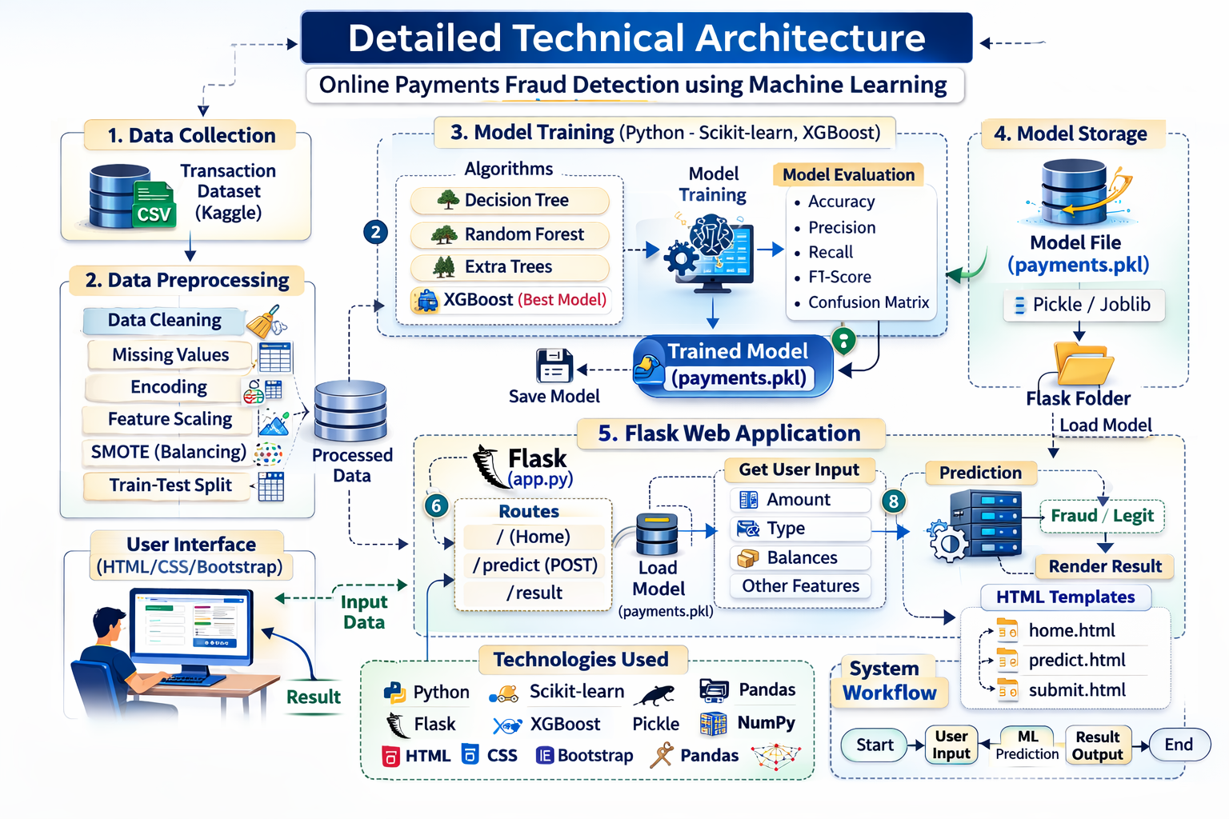

Pre-Requisites :

To complete this project, you must required following software’s, concepts and packages
- Anaconda navigator and pycharm:
  - Refer the link below to download anaconda navigator
  - Link : https://youtu.be/1ra4zH2G4o0

Software Requirements:
- Python3x
- Anaconda/VS Code / PYCharm
- Required Python Libraries:
- Type “pip install numpy” and click enter.
- Type “pip install pandas” and click enter.
- Type “pip install scikit-learn” and click enter.
- Type ”pip install matplotlib” and click enter.
- Type ”pip install scipy” and click enter.
- Type ”pip install pickle-mixin” and click enter.
- Type ”pip install seaborn” and click enter.
- Type “pip install Flask” and click enter.

Prior Knowledge:
You must have prior knowledge of following topics to complete this project.
- ML Concepts
  - Supervised learning: https://www.javatpoint.com/supervised-machine-learning
  - Unsupervised learning: https://www.javatpoint.com/unsupervised-machine-learning
  - Regression and classification
- Decision tree: https://www.javatpoint.com/machine-learning-decision-tree-classification-algorithm
- Random forest: https://www.javatpoint.com/machine-learning-random-forest-algorithm
- KNN: https://www.javatpoint.com/k-nearest-neighbor-algorithm-for-machine-learning
- Xgboost: https://www.analyticsvidhya.com/blog/2018/09/an-end-to-end-guide-to-understand-the-math-behind-xgboost/
- Evaluation metrics: https://www.analyticsvidhya.com/blog/2019/08/11-important-model-evaluation-error-metrics/
- Flask Basics : https://www.youtube.com/watch?v=lj4I_CvBnt0

Project Objectives
- Understand fraud detection using Machine Learning
- Perform Exploratory Data Analysis (EDA)
- Handle imbalanced datasets using SMOTE
- Train and evaluate multiple ML models
- Deploy the best model using Flask
- Perform real-time fraud prediction

Project Flow

Data Collection:
Load CSV dataset (Kaggle transaction data).
Data Preprocessing:
- Handle missing values
- Encode categorical features
- Feature selection
- Handle imbalance using SMOTE
- Train-Test split (80:20)
Model Training:
Train multiple models
- Decision Tree
- Random Forest
- Extra Trees
- XGBoost (Selected Best Model)
Model Evaluation :
- Accuracy
- Precision
- Recall (important for fraud)
- F1-Score
- Confusion Matrix
Save Model :
joblib.dump(model, "payments.pkl")
Flask Deployment :
Backend (app.py):
- Load model
- Receive user input
- Preprocess input
- Predict fraud/legit
- Return result
Frontend (HTML):
- User enters transaction details
- Click Predict
- Show result

Project Structure:
Create the Project folders that contain files as shown below
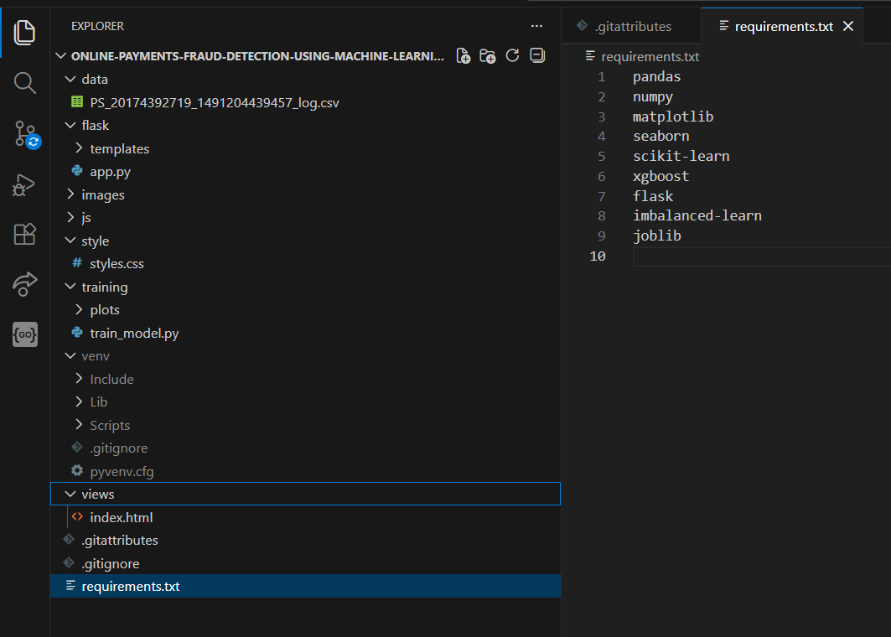

Dataset Description
Dataset Name: PS_20174392719_1491204439457_log.csv
Important Features:
- step
- type
- amount
- oldbalanceOrg
- newbalanceOrig
- oldbalanceDest
- newbalanceDest
- isFraud

Milestone 1: Data Collection
ML depends heavily on data, It is most crucial aspect that makes algorithm training possible. So this section allows you to download the required dataset.
Activity 1: Download the dataset
There are many popular open sources for collecting the data. Eg: kaggle.com, UCI repository, etc.
In this project we have used drug200.csv data. This data is downloaded from kaggle.com. Please refer to the link given below to download the dataset.
Link: https://docs.google.com/spreadsheets/d/1T4tlqMwRXEpYdWlneX2sY5UqrcsVIMMirgkTOKLdkI/edit#gid=1373903219
Milestone 2: Visualizing and analysing the data
As the dataset is downloaded. Let us read and understand the data properly with the help of some visualization techniques and some analysing techniques.
Note: There is n number of techniques for understanding the data. But here we have used some of it. In an additional way, you can use multiple techniques.
Activity 1: Importing the libraries
Import the necessary libraries as shown in the image. (optional) Here we have used visualization style as fivethirtyeight.
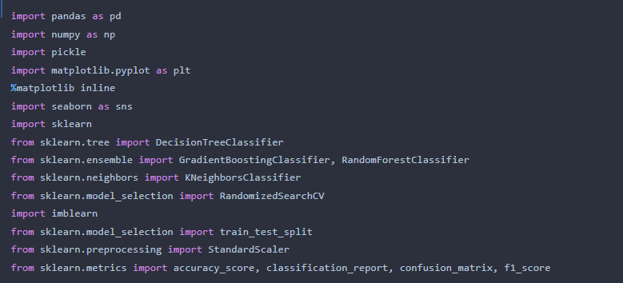

Machine Learning Models Used
- Decision Tree Classifier
- Random Forest Classifier
- Extra Trees Classifier
- XGBoost Classifier (Best Performing Model)

Model Evaluation Metrics
- Accuracy Score
- Confusion Matrix
- Precision
- Recall
- F1-Score
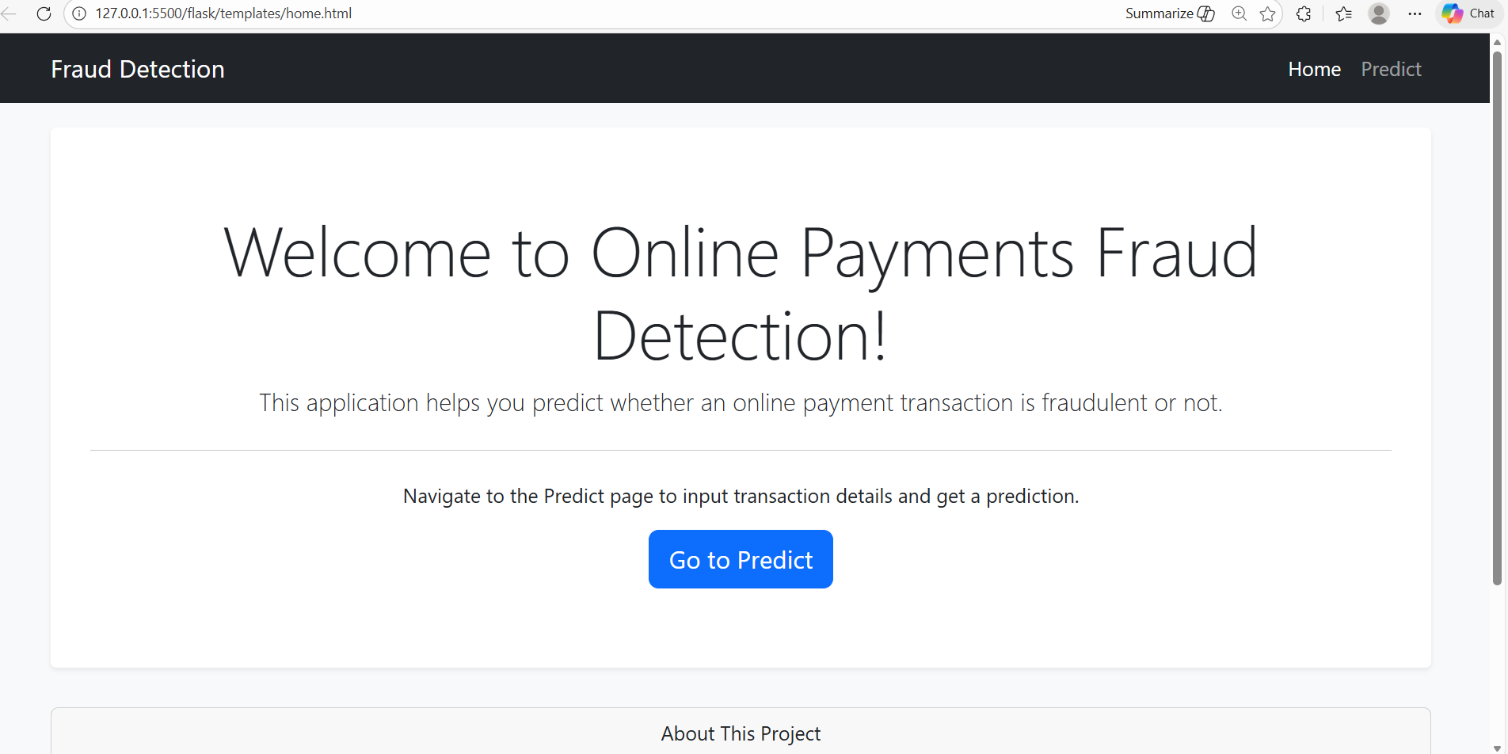
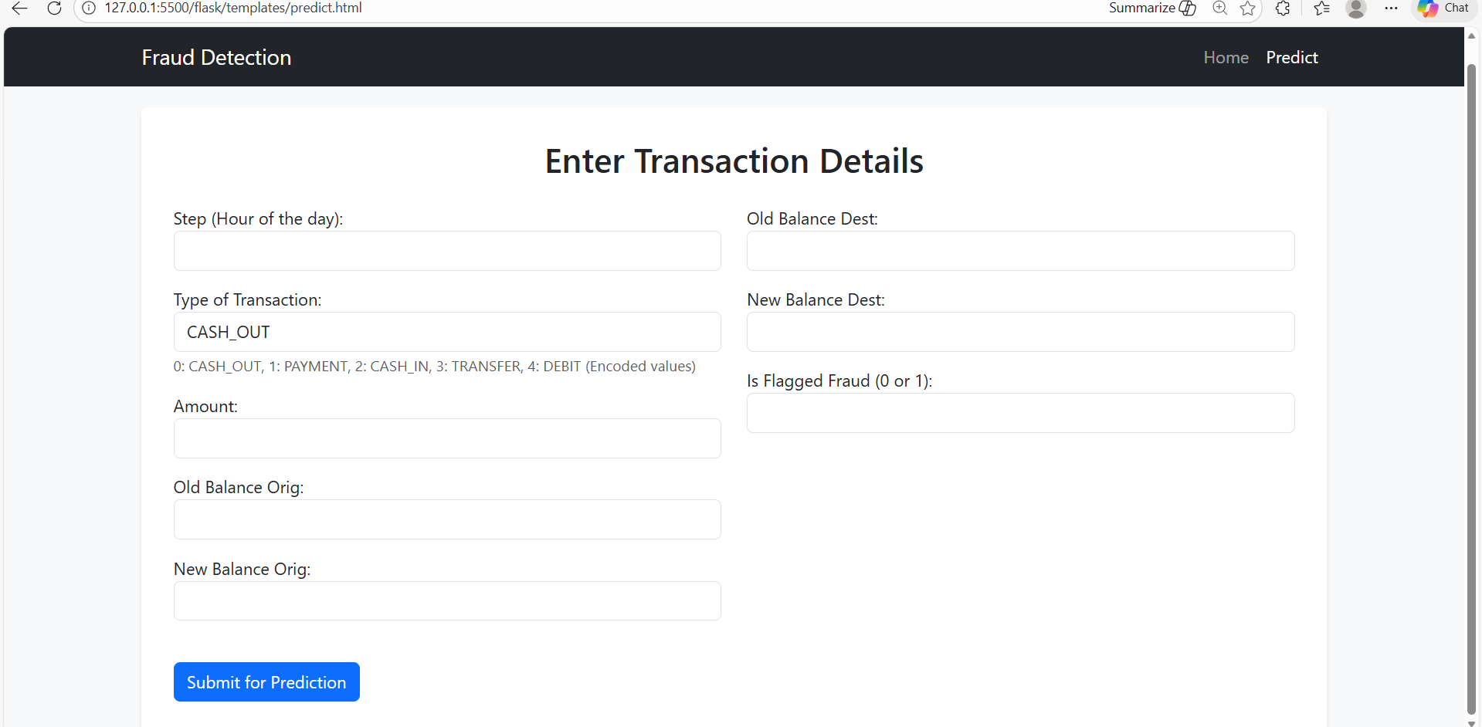

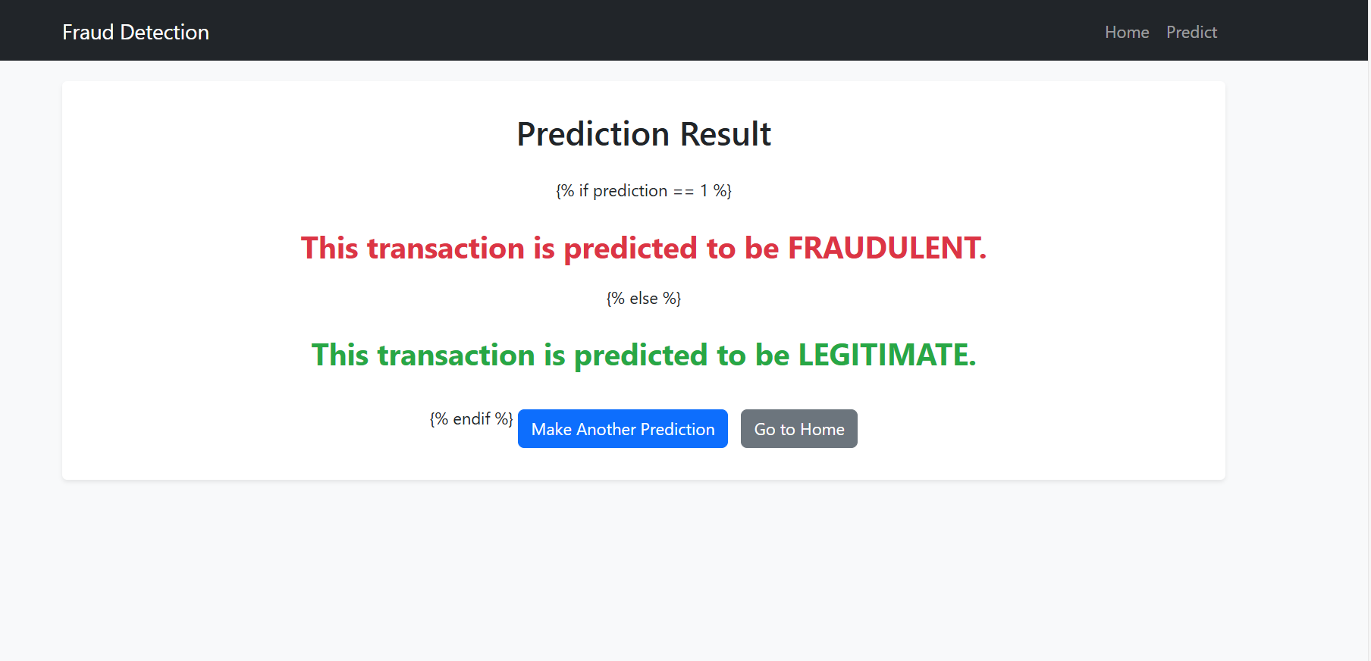

Conclusion
This project demonstrates the application of Machine Learning techniques in detecting fraudulent online transactions.
The XGBoost classifier provided the highest performance and was deployed using Flask for real-time fraud prediction.
This system can be further enhanced for large-scale financial applications.

