WEEK 4: SYSTEM DEVELOPMENT II
I. INTENDED LEARNING OUTCOME (ILO)
At the end of this laboratory activity, students should be able to:
Develop and integrate advanced system modules by implementing authentication and security features, integrating front-end and back-end components, and demonstrating functional interaction among major system modules in accordance with approved project requirements.
II. PERFORMANCE TASK
Following the completion of initial module development during Week 3, your team must continue system development by implementing advanced functionalities, securing user access through authentication and authorization mechanisms, and integrating front-end interfaces with back-end services and databases.
The outputs for this week should demonstrate that the project is transitioning from isolated module development into an integrated working system.
III. WEEK 4 ACTIVITIES
Activity 1 – Development Progress Review
Activity 2 – Advanced Module Development
Activity 3 – Authentication and Security Implementation
Activity 4 – Front-End and Back-End Integration
Activity 5 – Integration Testing
Activity 6 – Repository Update and Documentation
Activity 7 – Progress Report No. 2 and Adviser Consultation

ACTIVITY 1 DEVELOPMENT PROGRESS REVIEW
Purpose
To evaluate the completion status of Week 3 outputs and identify remaining development tasks.
Procedure
1. Review Progress Report No. 1.
2. Review completed modules.
3. Identify unfinished functionalities.
4. Assign development tasks for Week 4.
5. Complete Form 1.
FORM 1 DEVELOPMENT TASK ASSIGNMENT
Directions
List the remaining functionalities and assign responsible team members.
Functionality/Module | Assigned Member | Priority | Target Completion
Authentication & security hardening (audit logging, pagination, token TTL verification) | Jilmar Caesar D. Ferrer | High | Aug 14, 2026
Mobile module stabilization (service mapping, request cancel path, integration testing) | Eduard Joseph B. De Belen | High | Aug 14, 2026
Weekly documentation & progress report compilation | Jamby Villarta | Medium | Aug 14, 2026
Adviser and Agency consultation | Jamby Villarta | Medium | Aug 14, 2026
Expected Outputs
☑ Advanced Functional Modules
☑ Authentication Module
☑ Integrated Components

ACTIVITY 2 ADVANCED MODULE DEVELOPMENT
Purpose
To continue the implementation of core and supporting system functionalities.
Procedure
1. Develop remaining modules identified in the project plan.
2. Apply coding standards established in Week 2.
3. Conduct developer-level testing.
4. Upload source code to repository.
5. Complete Form 2.
FORM 2 ADVANCED MODULE DEVELOPMENT REPORT
Directions
Document all modules developed during Week 4.
Module Description | Status
Audit logging trait applied to Equipment and Barangay models (stock/record edits now logged) | Completed
Admin panel table redesign: Vehicles and Equipment Inventory converted to scannable list views | Completed
Service Management row numbering; pagination added to system-log and SMS-history endpoints | Completed
Mobile: landmark rename (Photo of the Site → Landmark); admin dispatch panel unit-identifier bug fix | Completed
Reason-required workflow for request approval/refusal | Completed
Head-of-household terminology applied across seven UI strings | Completed
Dependency security advisories cleared (17 resolved) | Completed
Functionality Verification
Test Conducted | Result
Input Processing | Pass
Data Validation | Pass
Business Logic Execution | Pass
Output Generation | Pass
Required Evidence
☑ Screenshots of Module
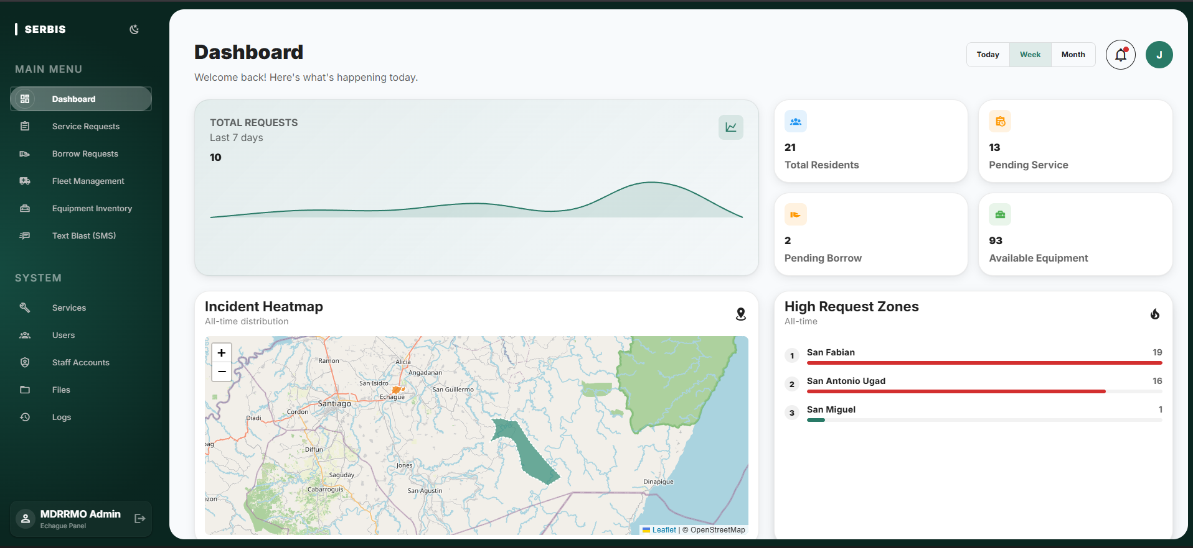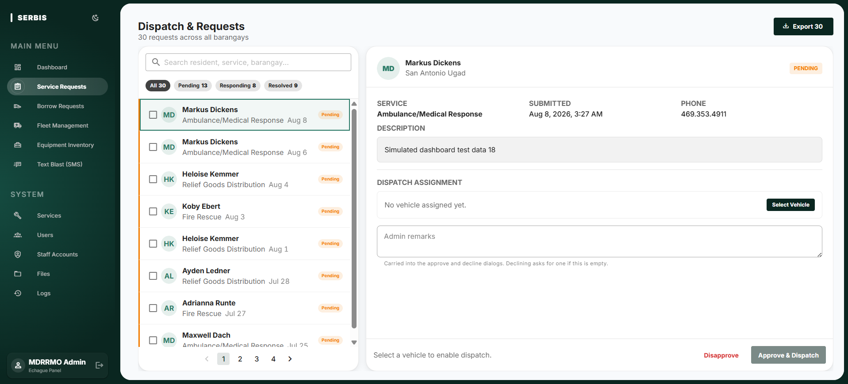
☑ Source Code Screenshot
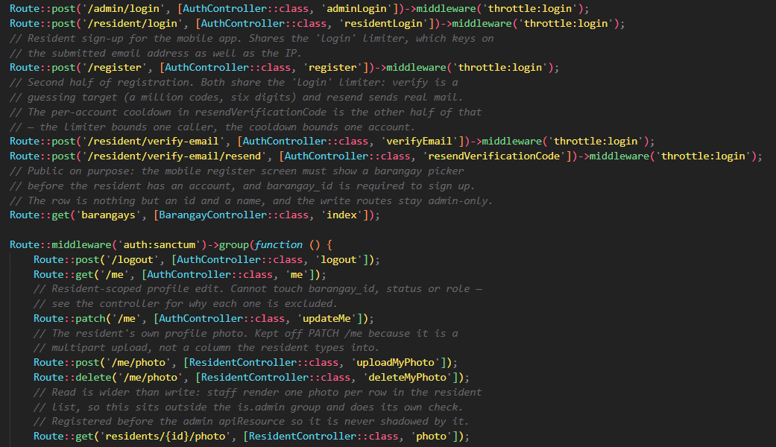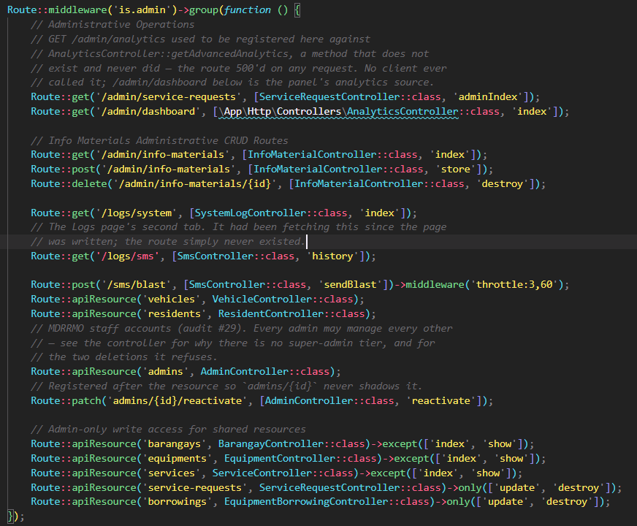
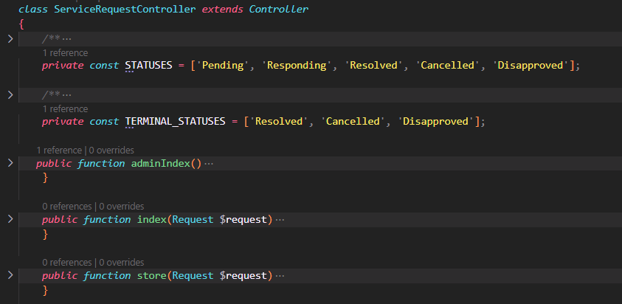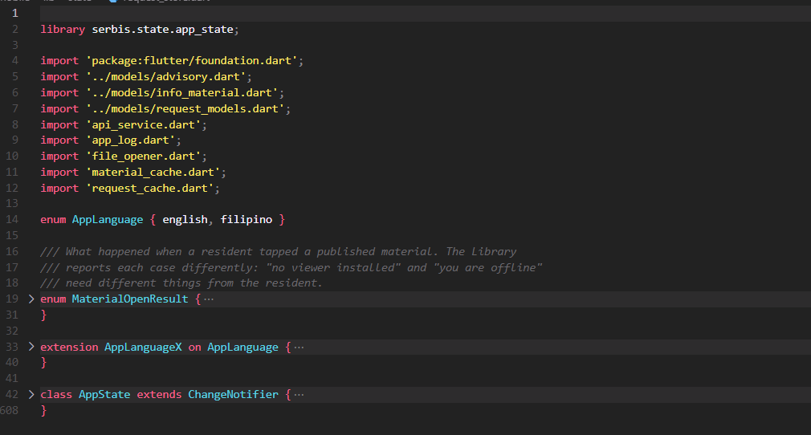
☑ Demonstration Screenshot
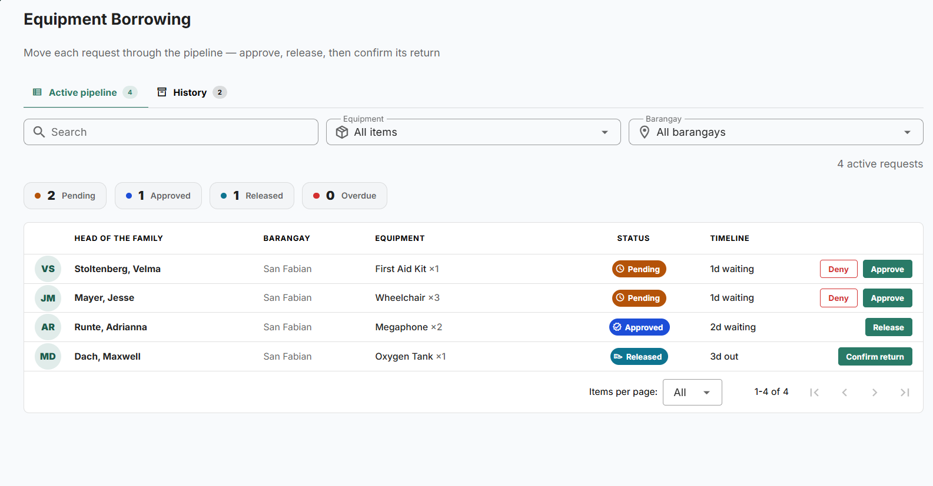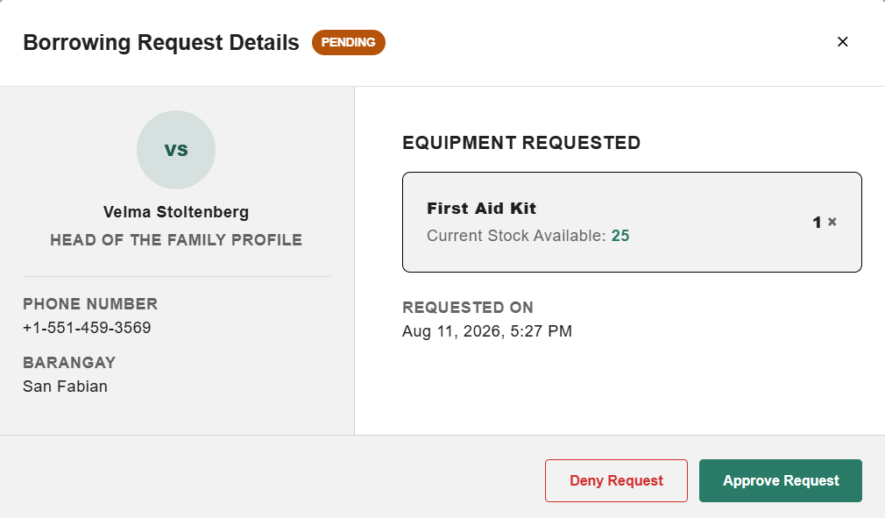
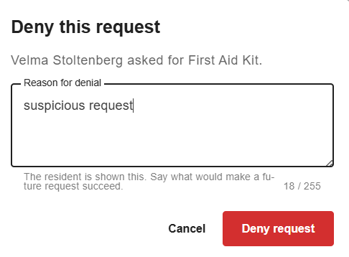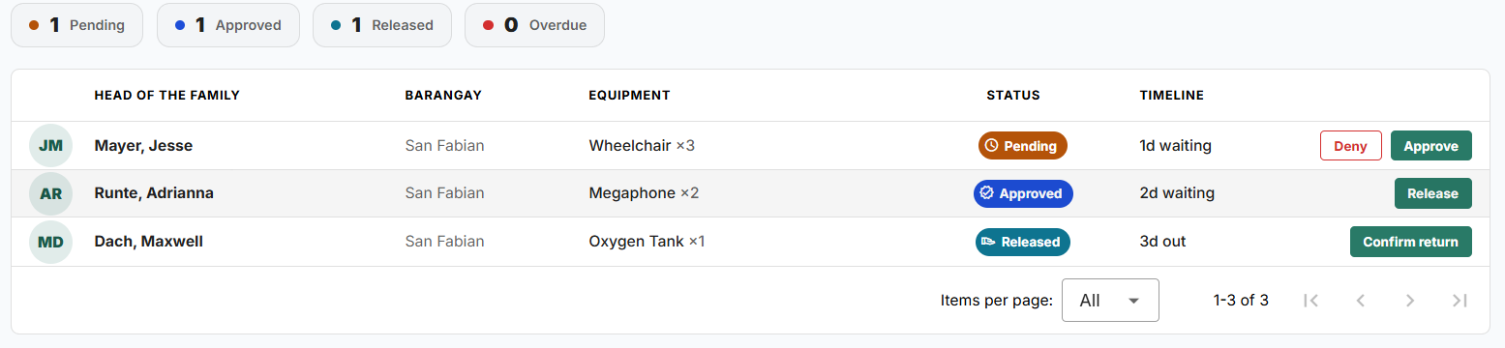

ACTIVITY 3 AUTHENTICATION AND SECURITY IMPLEMENTATION
Purpose
To implement user authentication, authorization, and basic security controls.
Procedure
1. Develop login and logout functionalities.
2. Implement user role management.
3. Configure access permissions.
4. Apply password protection mechanisms.
5. Test authentication processes.
6. Complete Form 3.
FORM 3 AUTHENTICATION AND SECURITY IMPLEMENTATION REPORT
Directions
Indicate the security features implemented in the system.
Security Feature | Implemented | Remarks
Login Authentication | ☑ | Token-based auth, separate flows for admin/operator vs. resident
Logout Function | ☑ | Token invalidation on logout
Password Validation | ☑ | Hashed storage; no longer leaked in API responses
Role-Based Access Control | ☑ | Confirmed via automated IDOR tests - admin cannot reach resident-only endpoints and vice versa
Session Management | ☑ | Split TTLs configured and applied per token - admin 8h, resident 30 days (config/sanctum.php, AuthController).
Input Validation | ☑ | Enforced via Laravel Form Requests
Email OTP Verification | ☑ | SandBox verification
Authentication Testing Results
Test Scenario | Result | Basis
Valid Login Credentials | Pass | Automated, in CI (AdminAccountTest, ResidentLoginStatusTest)
Invalid Login Credentials | Pas | Behavior confirmed by code read (401 responses, rate-limited login route);
Unauthorized Access Attempt | Pass | Automated IDOR tests confirm residents/admins cannot reach each other's resources
Session Timeout Test | Pass | TTLs configured and applied. an expired token is actually rejected

Required Evidence
☑ Login Screen Screenshot
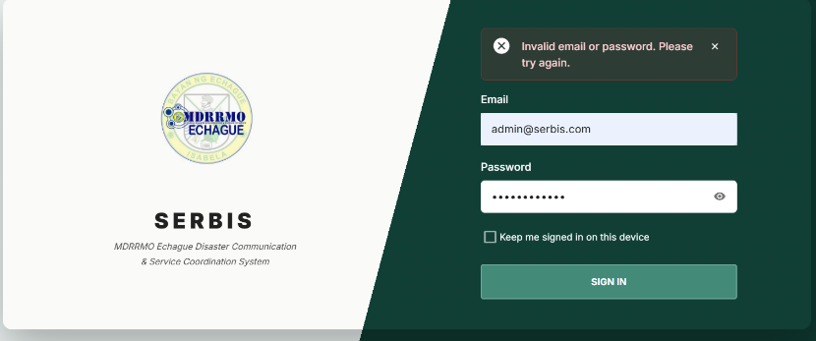
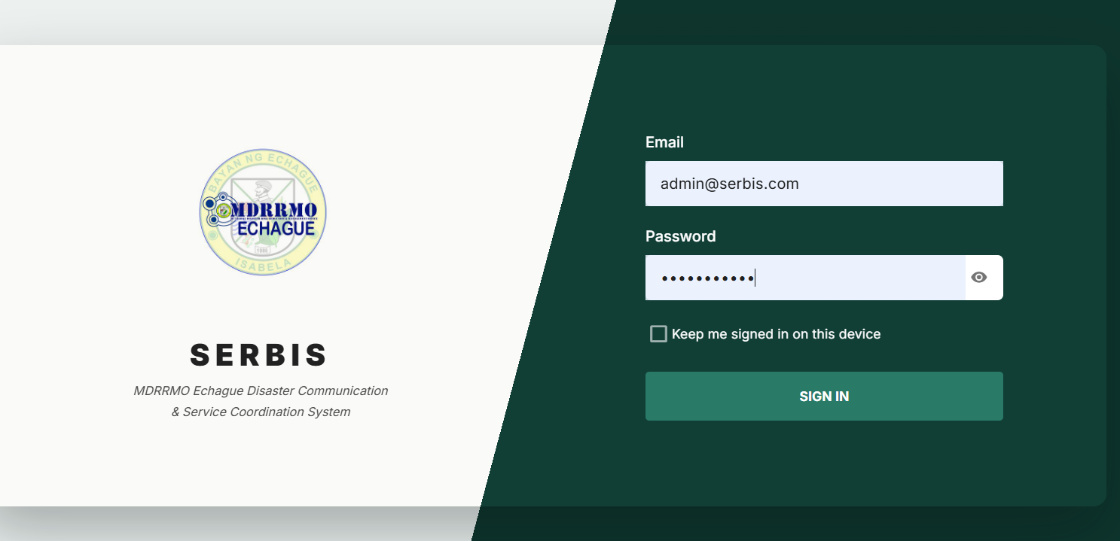
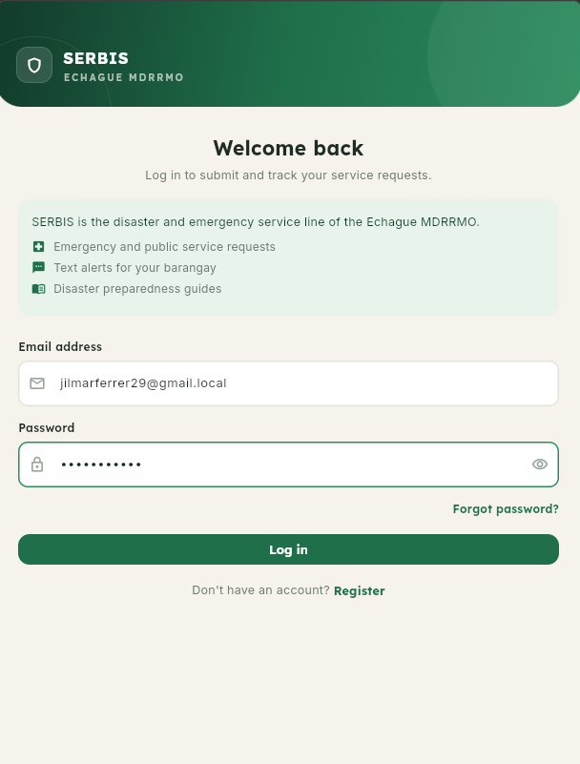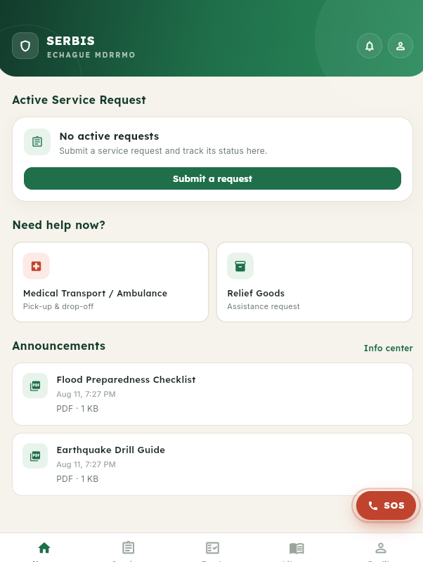
☑ User Role Management Screenshot
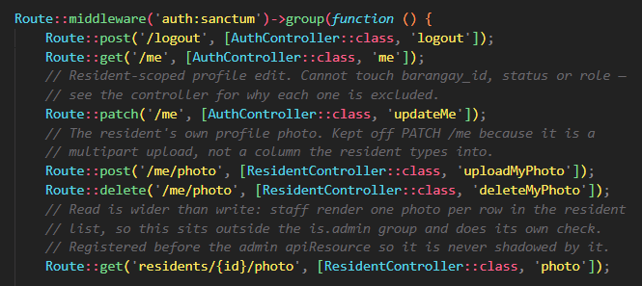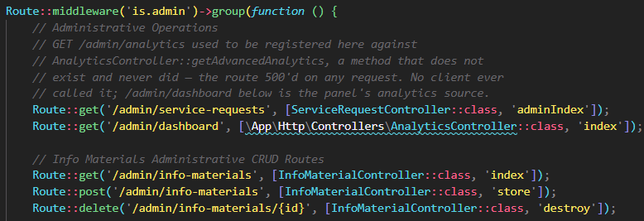
☑ Authentication Test Results
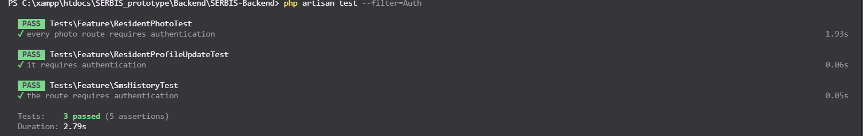

ACTIVITY 4 FRONT-END AND BACK-END INTEGRATION
Purpose
To establish communication between user interfaces, application logic, and database components.
Procedure
1. Connect front-end forms to back-end services.
2. Configure database transactions.
3. Verify data flow between components.
4. Test create, read, update, and delete (CRUD) operations.
5. Complete Form 4.
FORM 4 SYSTEM INTEGRATION REPORT
Directions
Document the integrated components of the system.
Component Integrated | Status | Remarks
User Interface ↔ Back-End | Integrated | Vue/Vuetify admin panel and Flutter mobile app both consume the Laravel REST API
Back-End ↔ Database | Integrated | MariaDB via Eloquent ORM
Authentication ↔ Database | Integrated | Token validation against user/resident tables; role separation verified
Reporting ↔ Database | Integrated | Dashboard analytics (Leaflet choropleth map, Chart.js) read live from the database
CRUD Functionality Verification
Function | Result | Basis
Create | Pass | AdminAccountTest, InventoryAuditLogTest (equipment/barangay creation)
Read | Pass | ListPaginationTest (18 tests across list endpoints); confirms no password serialization
Update | Pass | ResidentProfileUpdateTest, InventoryAuditLogTest (stock correction before/after)
Delete | Pass | AdminAccountTest, InventoryAuditLogTest (equipment/barangay removal)
Required Evidence
☑ Data Entry Demonstration
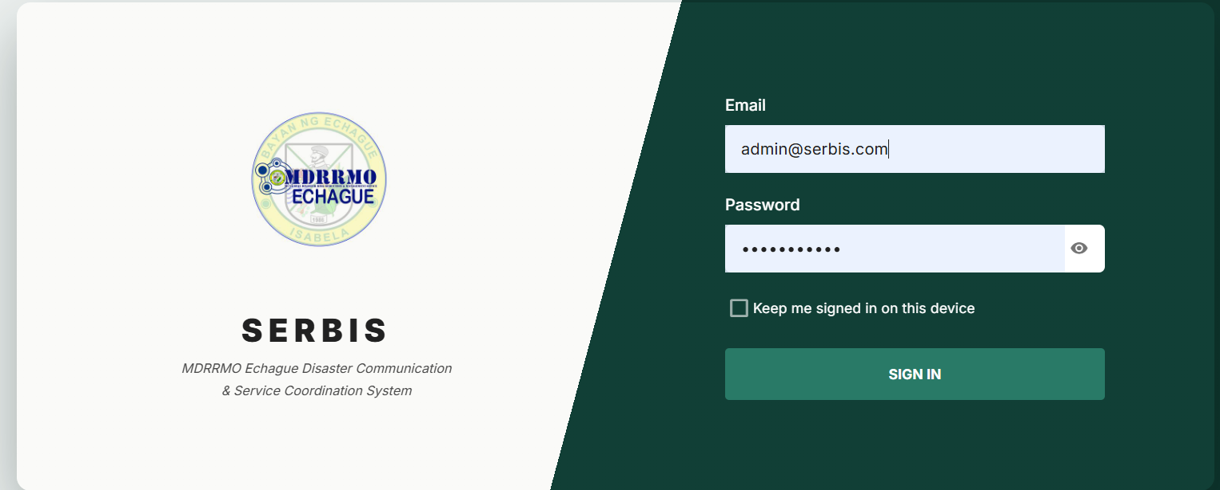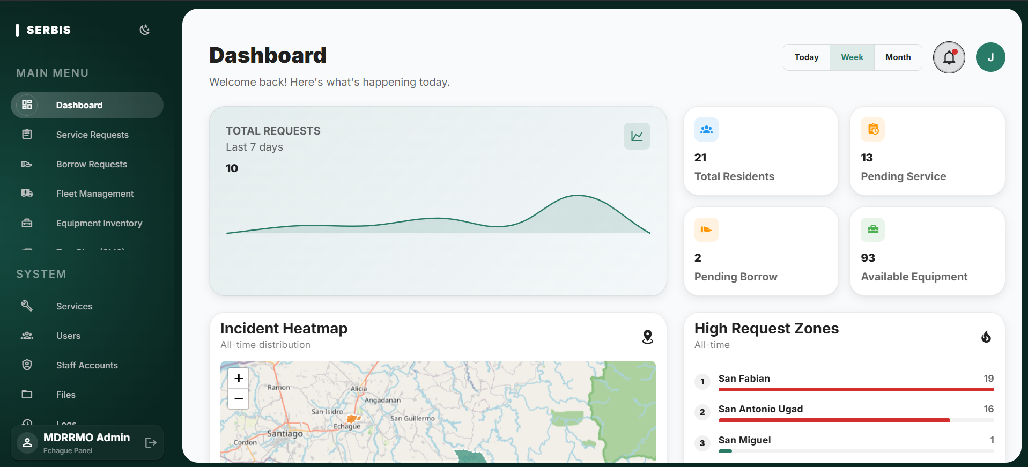
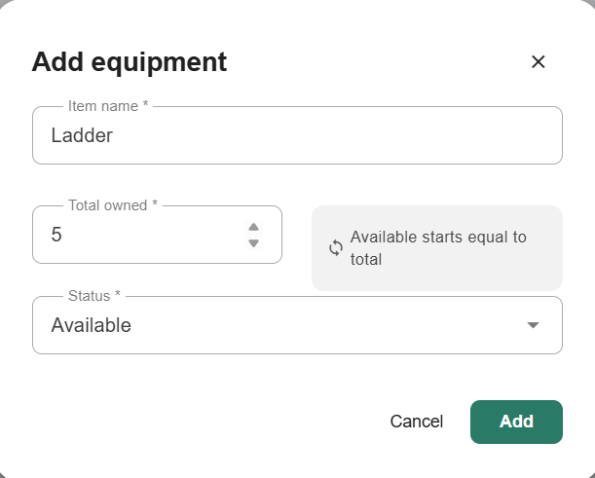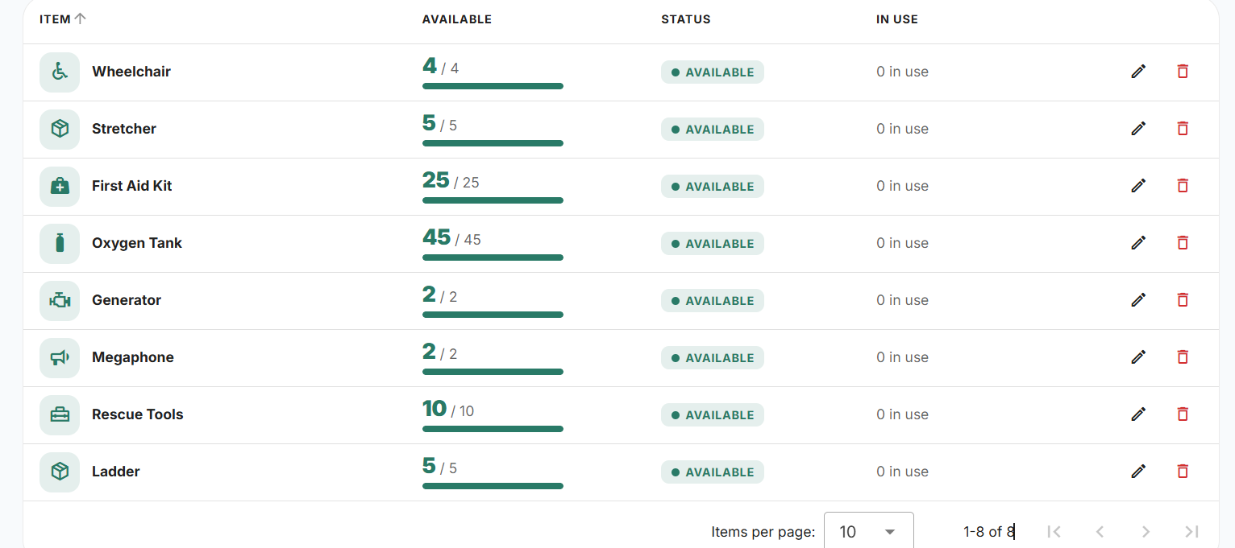
☑ Database Update Screenshot
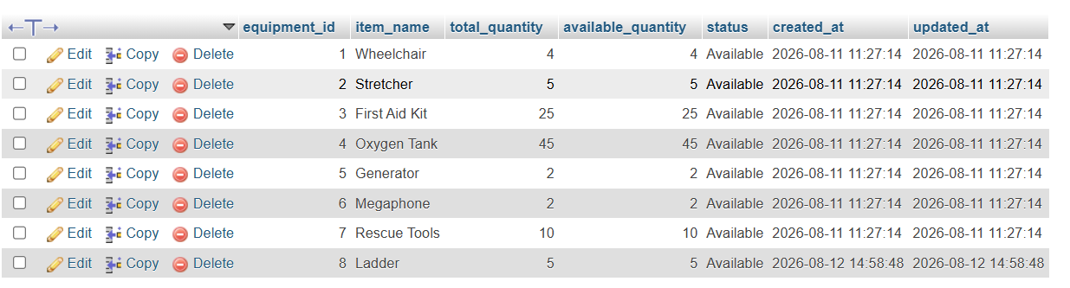
☑ Integration Demonstration Screenshot
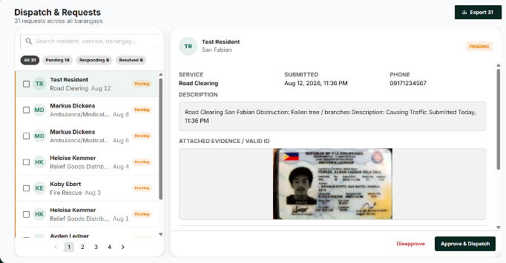
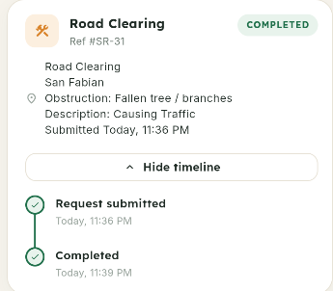
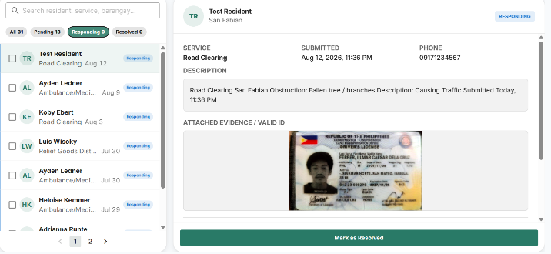
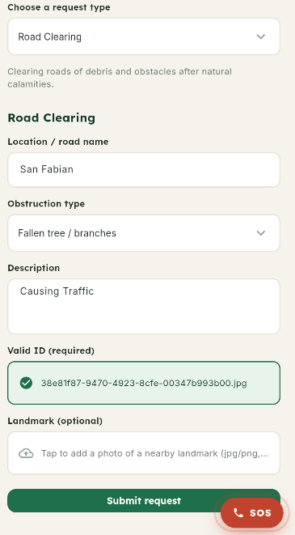
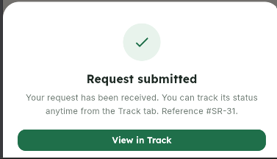
ACTIVITY 5 INTEGRATION TESTING
Purpose
To verify that integrated modules work together correctly.
Procedure
1. Execute end-to-end system transactions.
2. Observe system responses.
3. Record issues encountered.
4. Implement corrective actions.
5. Complete Form 5.
FORM 5 INTEGRATION TESTING CHECKLIST
Directions
Test integrated modules and record results.
Test Case | Expected Result | Actual Result | Status
Resident cannot read another resident's photo | 404 (resource not disclosed) | 404 returned | Pass
Admin/resident cross-role access attempt | Blocked | Blocked | Pass
List endpoints do not leak password field | Password absent from response | Confirmed absent | Pass
Stock correction records quantity before/after | Audit log entry created | Entry created | Pass
Issues Identified
Issue | Severity | Action Taken
Email OTP verification was documented as "in progress" but no implementation exists in code | High | Correcting documentation to "not started"; scope decision (implement vs. drop) needed with adviser before defense
ServiceRequestController::adminIndex() remains unpaginated with no supporting index | Medium | Scheduled for Week 5
No automated test asserts an expired token is rejected, despite TTLs being configured | Low | Add session-timeout test in Week 5
Tester Information
Conducted By: Jilmar Caesar D. Ferrer, Jamby Villarta, Eduard Joseph B. De Belen
Date: August 11, 2026

ACTIVITY 6 REPOSITORY UPDATE REPORT
Purpose
To document all development activities uploaded to the repository.
Procedure
1. Commit all completed code.
2. Update documentation.
3. Record development milestones.
4. Complete Form 6.
FORM 6 REPOSITORY UPDATE REPORT
Repository URL: https://github.com/BOXCUBE06/SERBIS_prototype (private, single monorepo Backend/, Web/, Mobile/ subfolders).
Commits Made This Week (Aug 8–11, 2026)
Commit | Date | Description
51c4d0a | Aug 11 | Applied audit trait to Equipment and Barangay — stock/record edits now write log rows (7 tests, mutation-checked; not yet pushed)
104684c | Aug 10 | Renamed optional request photo to "Landmark" (mobile + admin panel)
0f4746c | Aug 10 | Fixed dispatch panel reading a nonexistent column — was rendering "Vehicle Unknown"
35f1aa4 | Aug 10 | Added row numbering to Service Management table
344fb3d | Aug 10 | Rebuilt Equipment Inventory view as a scannable list
1919a30 | Aug 10 | Rebuilt Vehicles view as a scannable list
dab2d1f | Aug 10 | Required operators to give a reason when refusing a request
6da332f | Aug 10 | Applied head-of-household terminology across seven strings
416b860 | Aug 8 | Cleared 17 dependency security advisories
0e2c44f | Aug 8 | Documented rationale for resident login flow
84d70fc | Aug 8 | Added pagination to system-log and SMS-history endpoints (backend + panel)
6cbbdd3 | Aug 8 | Corrected declared PHP version floor to match lockfile
Repository Evidence
☑ Updated Source Code
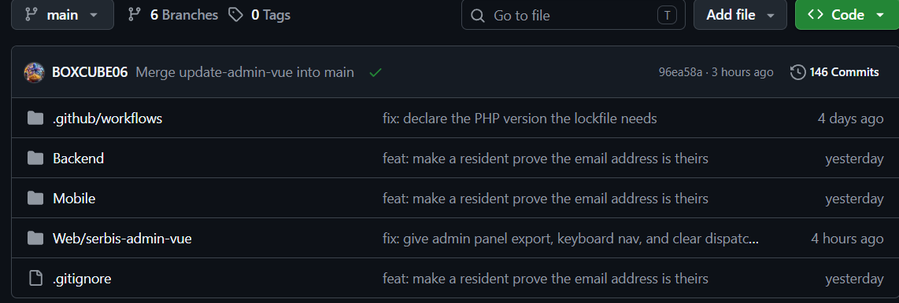
☑ Commit History Screenshot
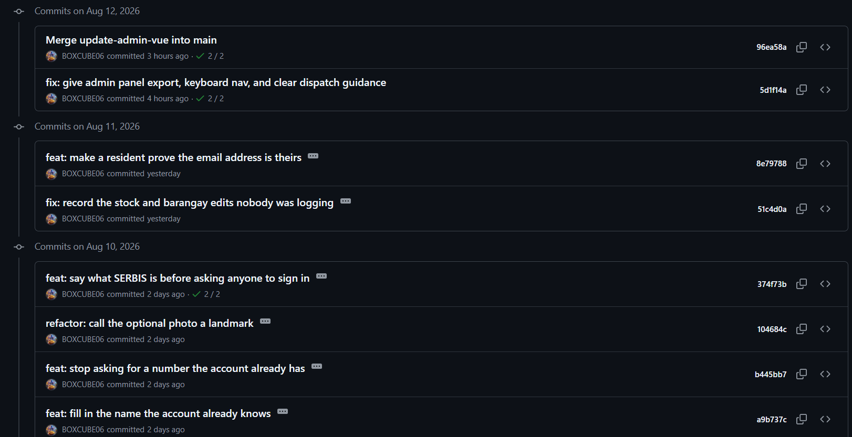
☑ Branch Update Screenshot
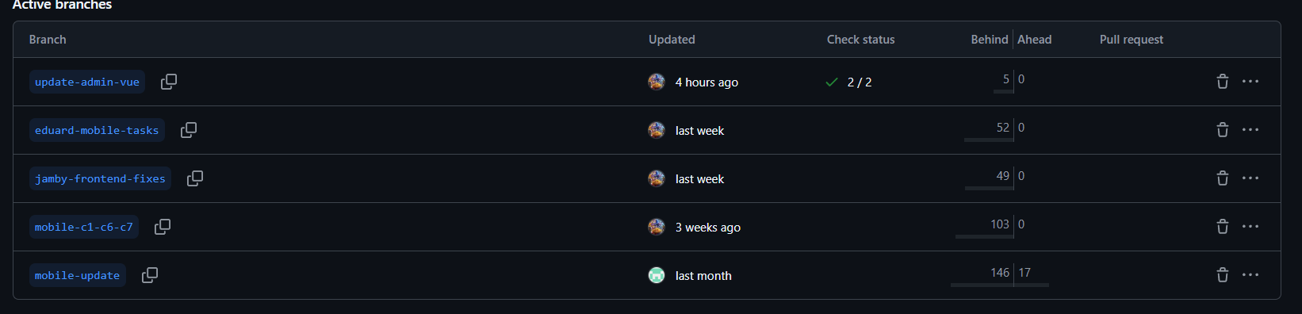
☑ Team Contribution Screenshot
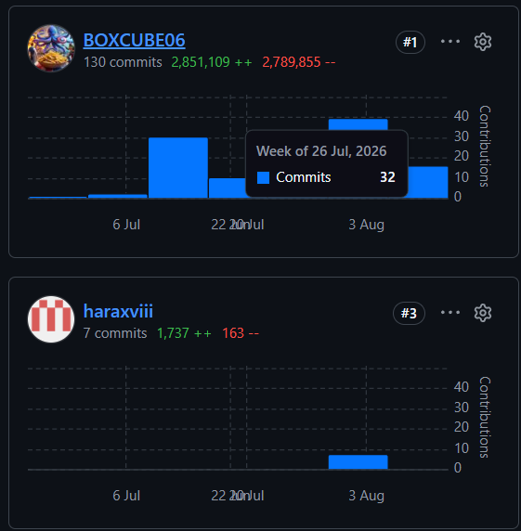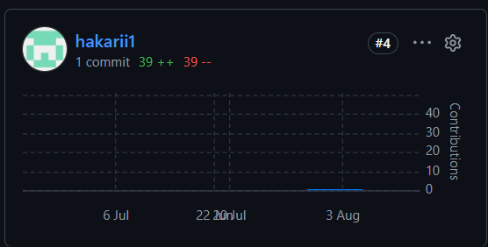
ACTIVITY 7 PROGRESS REPORT NO. 2
Purpose
To summarize development accomplishments and evaluate readiness for system integration and alpha version preparation.
Procedure
1. Review all completed activities.
2. Summarize development accomplishments.
3. Identify issues encountered.
4. Describe corrective actions taken.
5. Identify Week 5 targets.
6. Complete Form 7.
FORM 7 PROGRESS REPORT NO. 2
Project Information
Project Title: SERBIS (Service Request and Resource Management System)
Date Submitted: ___________
Accomplishments This Week
Activity | Status
Advanced Module Development | Completed
Authentication Implementation | Completed
Front-End and Back-End Integration | Completed
Integration Testing | Completed
Major Accomplishments
Applied audit logging to Equipment and Barangay stock edits, closing a known documentation gap. Cleared 17 dependency security advisories. Added pagination to system-log and SMS-history endpoints. Confirmed Sanctum token TTLs are correctly split and applied per role (admin 8h, resident 30 days). Rebuilt Vehicles and Equipment Inventory admin views as scannable list tables. Fixed a dispatch-panel bug that was silently rendering "Vehicle Unknown." Applied head-of-household terminology consistently across mobile and admin panel.
Challenges Encountered
Email OTP verification Implemented. Delivery configured against a sandbox SMTP provider for development and testing. Production delivery pending sending-domain authentication and provider selection. ServiceRequestController::adminIndex() remains unpaginated with no supporting index, a real performance risk as request volume grows. Session-timeout behavior is configured but not covered by any automated test.
Corrective Actions Taken
Consult with adviser and agency about the Email OTP verification. Applied the audit logging trait to Equipment and Barangay models. Logged the adminIndex() pagination gap and session-timeout test gap as scheduled Week 5 work.
Planned Activities for Week 5
Add pagination and a supporting index to ServiceRequestController::adminIndex, Finalize Email OTP, test SMS API to send bulk messages.
Prepared by: _______________________
Group Leader
Reviewed by: _______________________
Project Adviser

FORM 8 ADVISER CONSULTATION RECORD
Directions
Present all Week 4 outputs and obtain adviser feedback.
Topic Discussed | Recommendation
Module Development Progress
Authentication and Security Features (incl. corrected OTP status)
System Integration
Repository Updates
Readiness for Alpha Version
Adviser Remarks
_______________________________________________________________________
Required Actions Before Week 5
_______________________________________________________________________
Adviser Signature: _______________________
Date: _______________

V. REQUIRED WEEK 4 SUBMISSION
1. Form 1 – Development Task Assignment
2. Form 2 – Advanced Module Development Report
3. Form 3 – Authentication and Security Implementation Report
4. Form 4 – System Integration Report
5. Form 5 – Integration Testing Checklist
6. Form 6 – Repository Update Report
7. Form 7 – Progress Report No. 2
8. Form 8 – Adviser Consultation Record
9. Screenshots and Supporting Evidence
VI. WEEK 4 DELIVERABLES
✓ Progress Report No. 2
✓ Integrated Functional Modules
✓ Authentication and Security Features
✓ Front-End and Back-End Integration
✓ Integration Testing Results
✓ Updated Source Code Repository
VII. PERFORMANCE RUBRIC
Criteria | Weight
Completeness of Module Development | 25%
Authentication and Security Implementation | 20%
Front-End and Back-End Integration | 25%
Integration Testing Documentation | 10%
Progress Report Quality | 10%
Repository Updates and Documentation | 10%
Total | 100%

