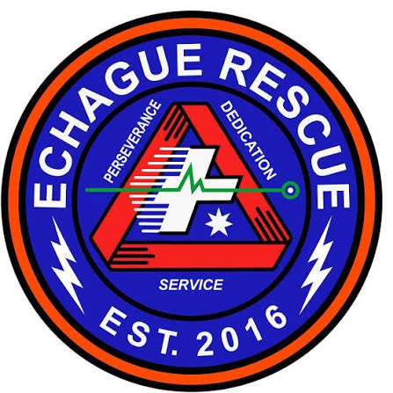
SERBIS Admin Panel User Manual
v1.0, October 2026
Municipal Disaster Risk Reduction and Management Office
Municipality of Echague, Isabela

Contents
Contents are filled in when the PDF is made.

About this manual
This manual is for MDRRMO Echague staff who use the SERBIS admin panel. It explains how to handle the requests residents send from the SERBIS mobile app, how to keep the vehicle, responder and equipment lists up to date, and how to reach residents by text.
SERBIS is for non-emergency services. Life-threatening emergencies still go through the hotlines.
Each task has numbered steps. Red numbered boxes on a picture match the numbers in the legend under it.
What you see depends on your access. A super admin sees every page. Other staff accounts see only the pages a super admin has given them. If a page in this manual is missing from your menu, you do not have access to it. Ask your super admin.

Getting started

Sign in
1. Open the SERBIS admin panel address in your web browser.
2. Type your username and password.
3. Click Sign in.
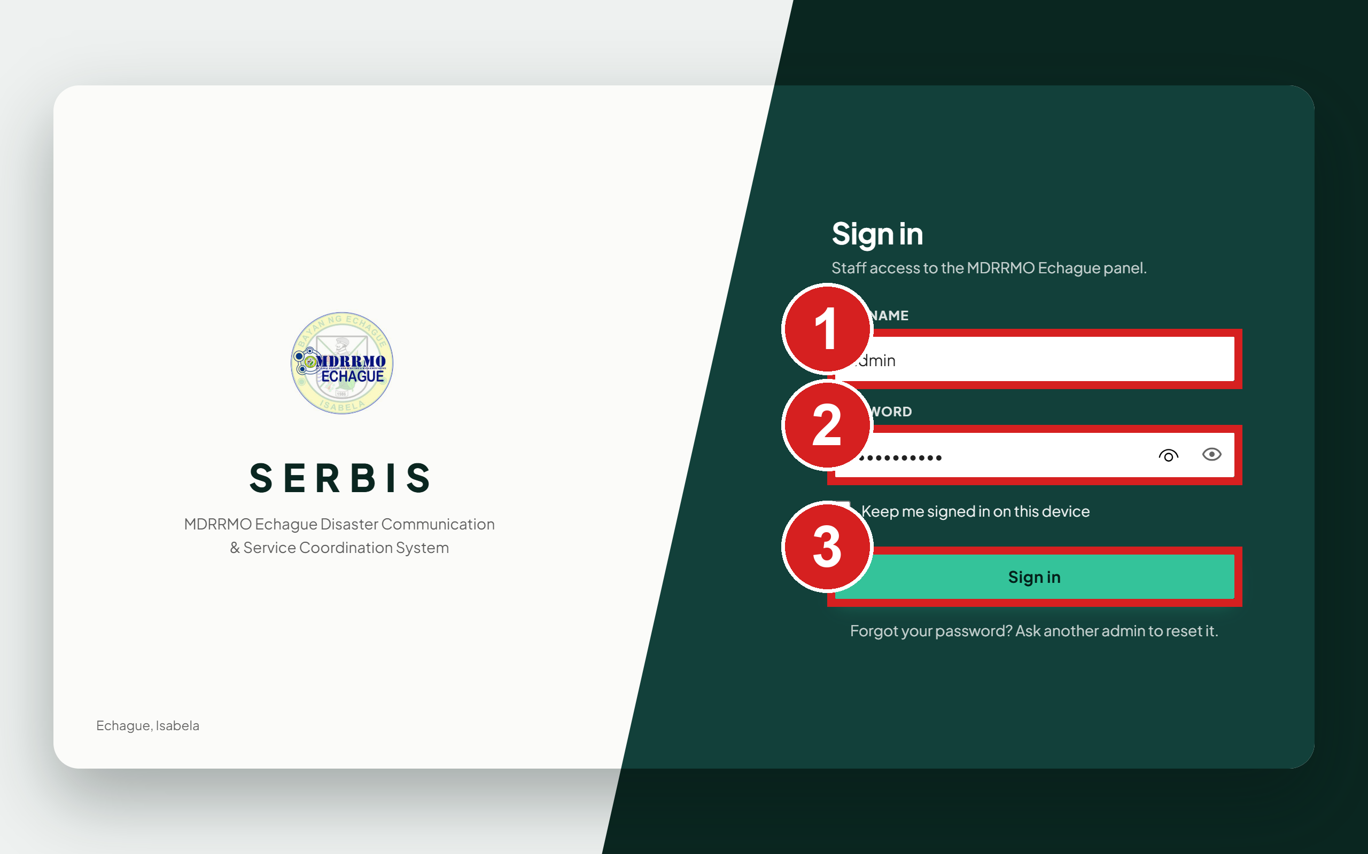
1 Your username
2 Your password
3 Sign in
SERBIS then texts a 6-digit code to the mobile number on your account.
4. Type the 6-digit code in the boxes.
5. Click Verify.
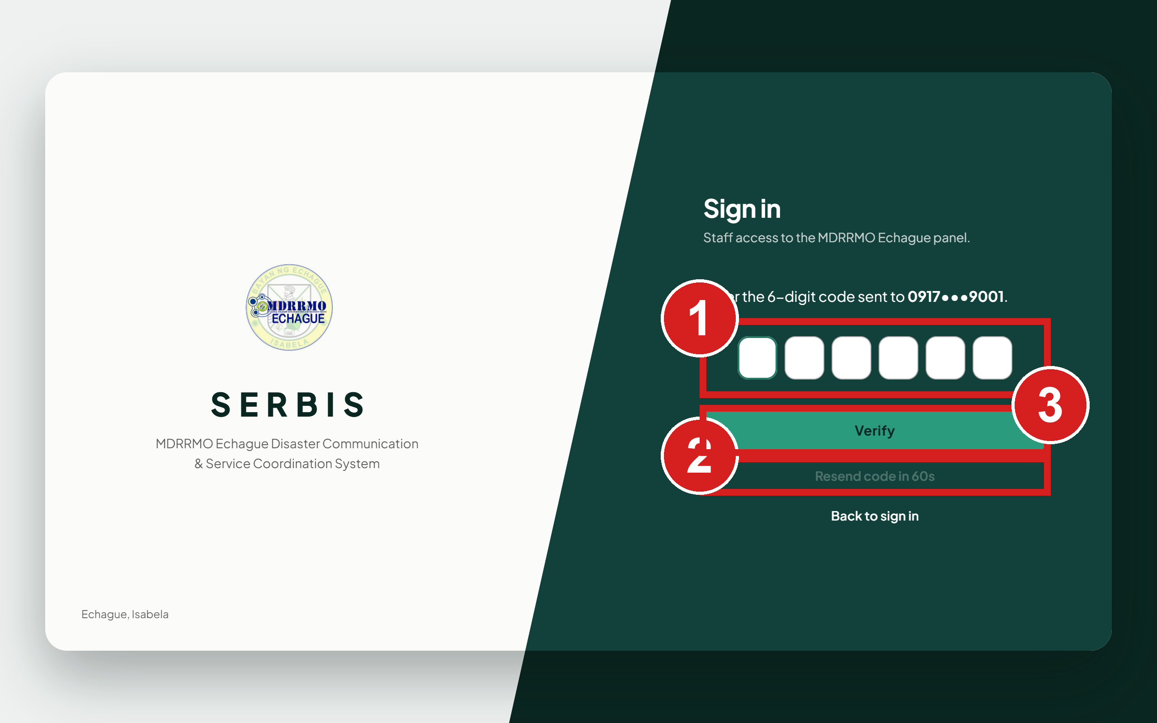
1 The 6-digit code from the text message
2 Ask for a new code
3 Finish signing in
If the text does not arrive within a minute, click Resend code. The button counts down 60 seconds before you can use it again.

Set your own password the first time
A new staff account, and one whose password a super admin reset, both start on a temporary password. After you sign in with it, the panel shows Set a new password and opens nothing else until you save your own. The new password needs at least 8 characters, with upper and lower case letters and a number.
1. Type the temporary password.
2. Type a new password.
3. Type the new password again.
4. Click Save and continue.
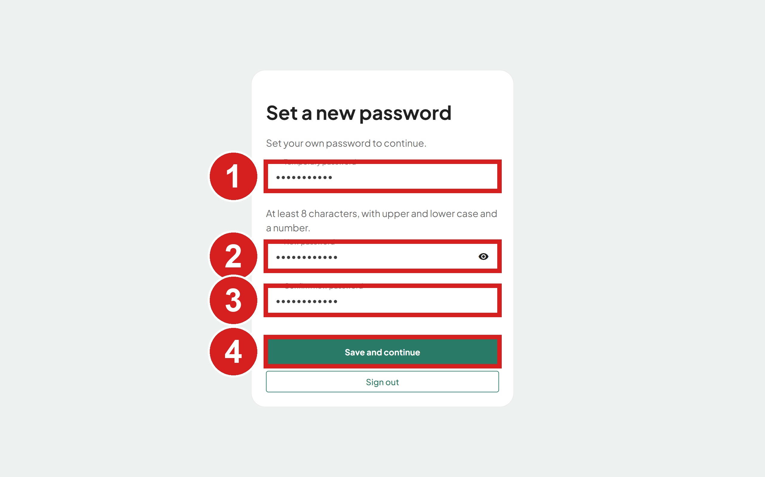
1 The password the super admin gave you
2 Your own new password
3 Type it again
4 Save it

Find your way around
The menu on the left lists the pages you can open, in groups. The page you are on is highlighted. A number beside Resident Requests, Ambulance Dispatch, Equipment Borrowing and Accounts counts what is waiting for you there (Pending requests; Pending ambulance requests and Booked requests with no unit yet; Pending borrowing requests; Pending accounts), and it updates by itself.
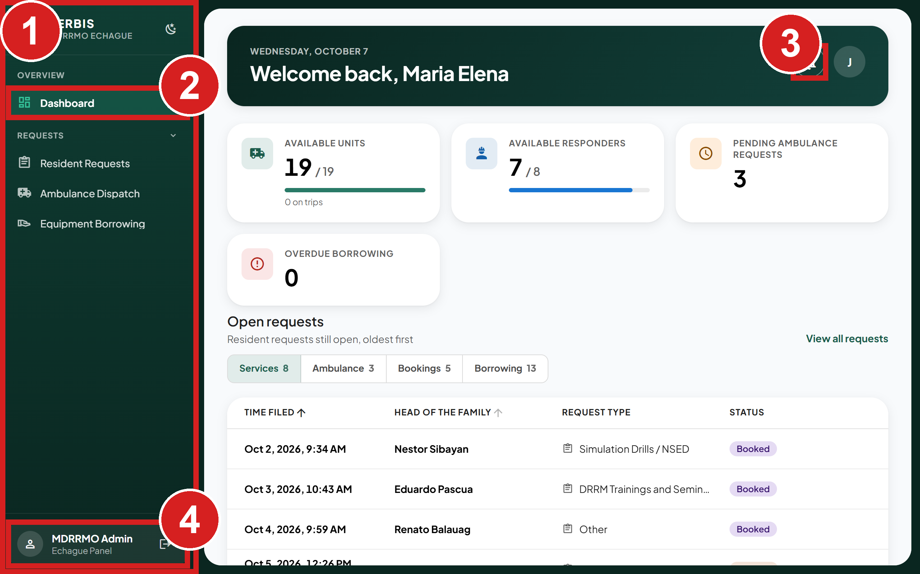
1 The pages you can open
2 Where you are now
3 System notices
4 Your account and Sign out

Sign out
1. Click Sign out, the arrow next to your name at the bottom of the menu.
2. Click Logout to confirm.
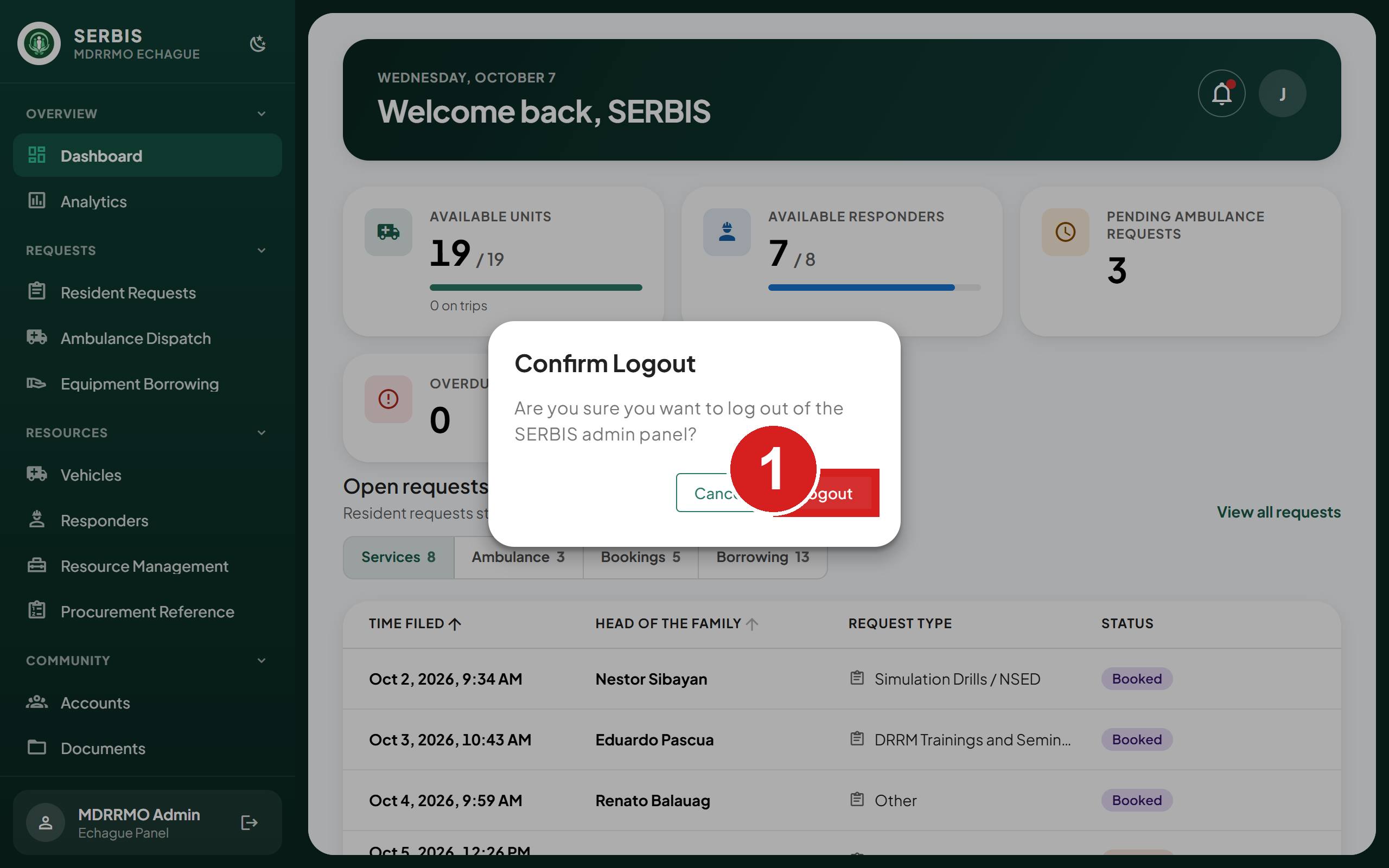
1 Confirm signing out

Check today's work

Read the dashboard
The dashboard shows what needs attention now: available units and responders, pending ambulance requests and overdue borrowing. Below the figures, the live board lists open requests. The dashboard updates by itself when a resident sends a request from the app, about every 30 seconds.
If you can open Accounts, two more things show:
• Pending accounts: accounts that registered and are waiting for you to activate them. Click the card to open Accounts showing only pending accounts.
• Awaiting activation in the bell: the same count, with how many are organizations. Click it to open the same list.
1. Click Dashboard in the menu.
2. Click a tab to switch boards.
3. Click a row to open that request on its own page.
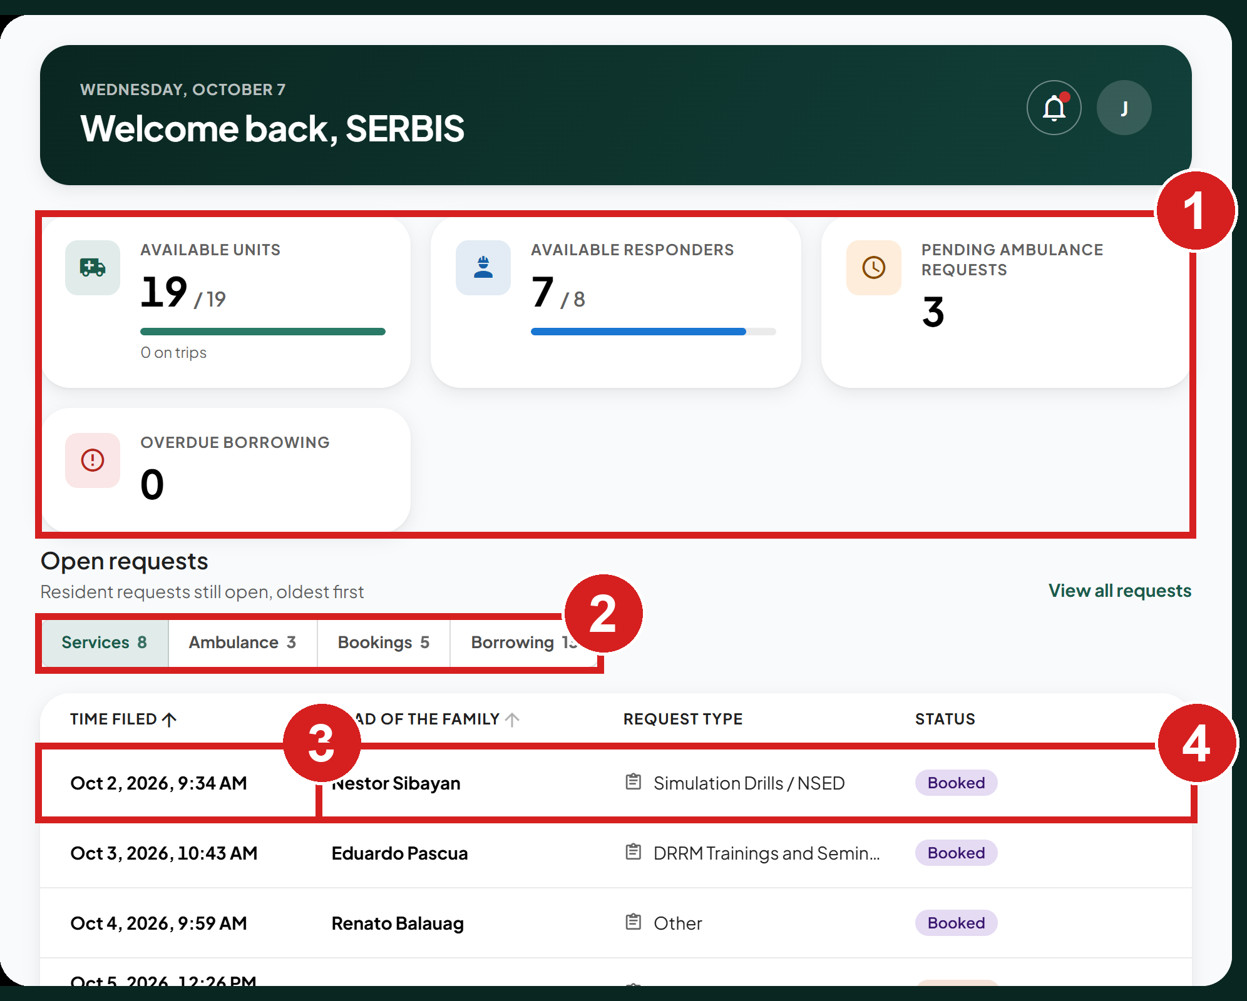
1 Today's figures
2 Switch between boards
3 How long it has waited
4 A request waiting for you

Look at trends in Analytics
1. Click Analytics.
2. Click a period: This month, This quarter, This year, All time or Custom.
3. Optional: limit the report to one or more barangays or services.
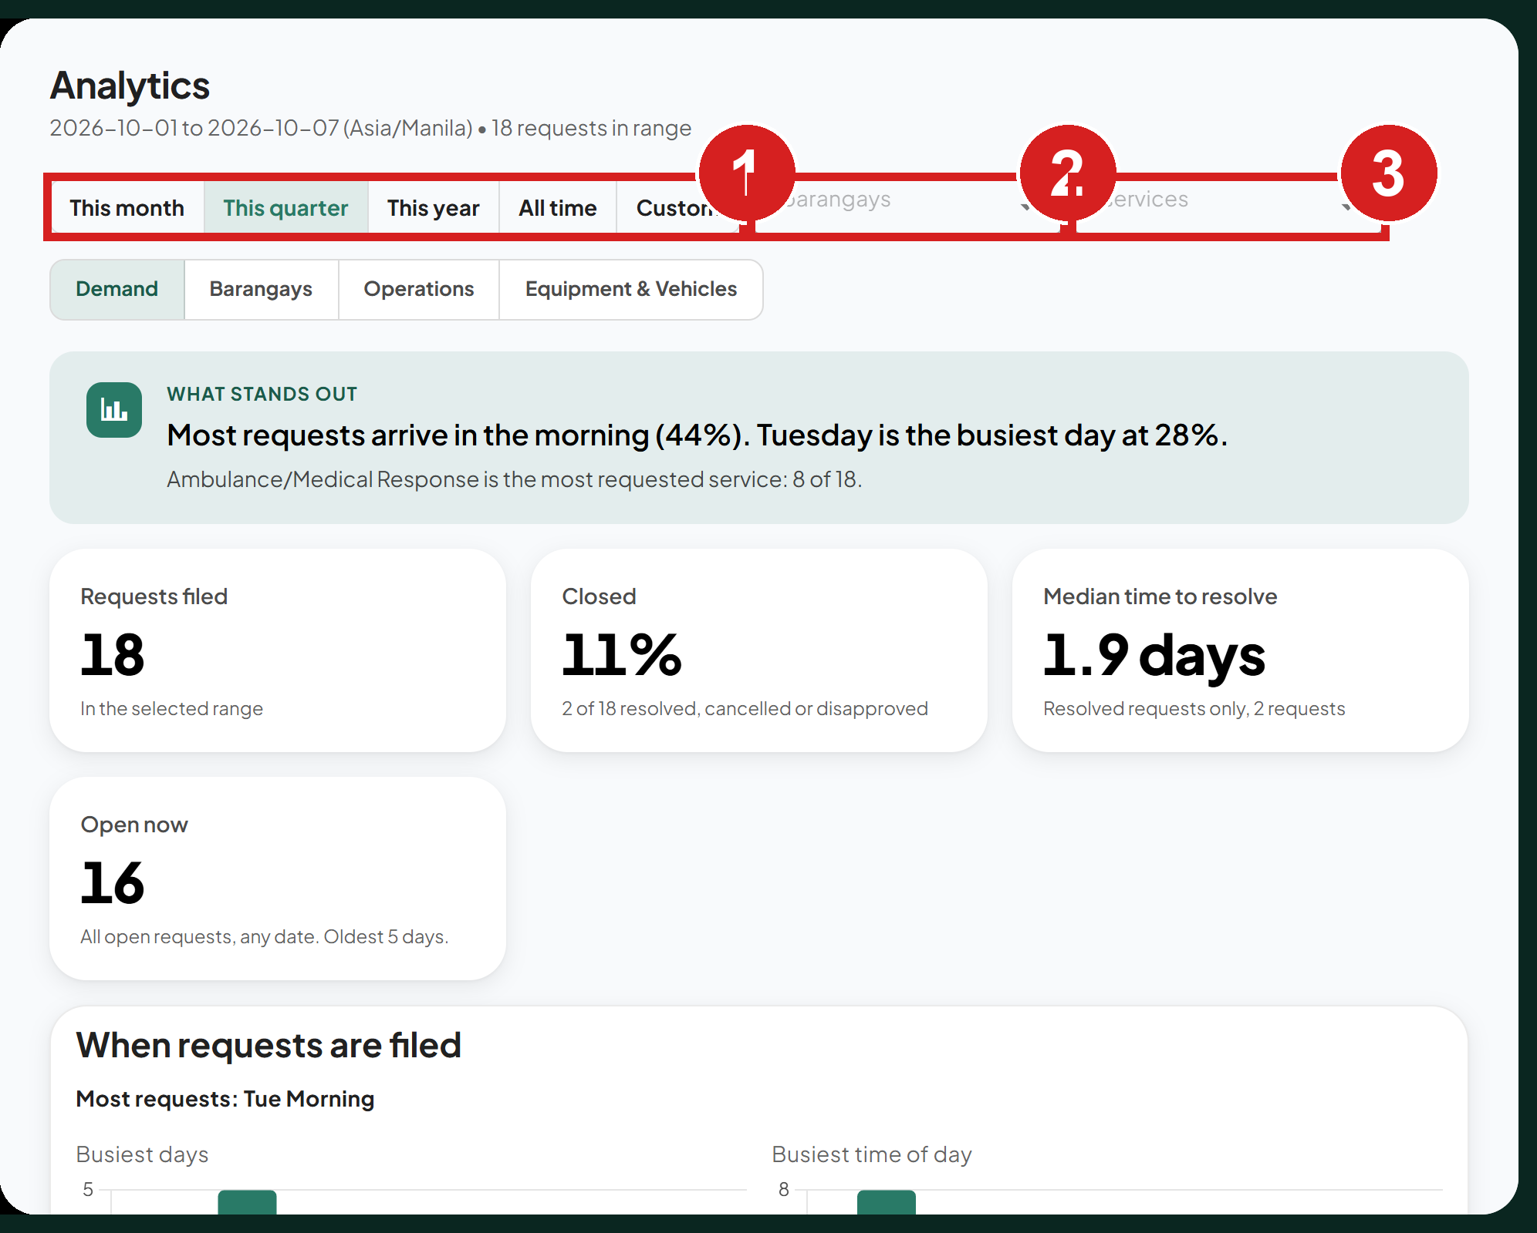
1 Period to report on
2 Limit to one barangay
3 Limit to one service
Each section can show a chart or the table of figures behind it.
4. Click Table to see the numbers, or Chart to go back.
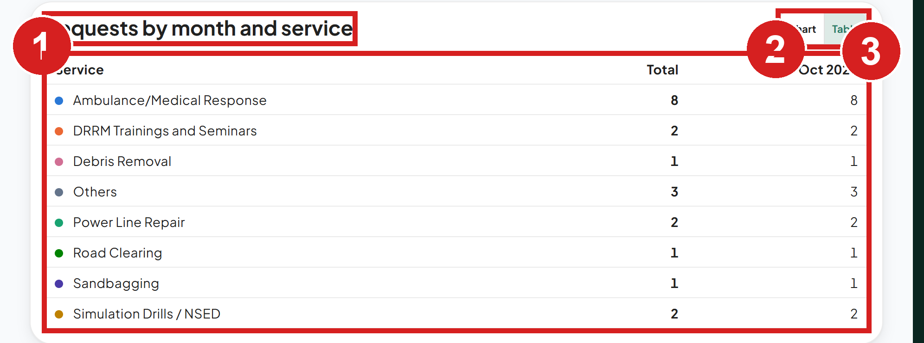
1 What this section measures
2 Switch chart and table
3 The figures behind the chart

Handle resident requests
A resident request moves through these statuses:
• Pending: sent, waiting for MDRRMO.
• Booked: approved for a set date and time.
• Responding: approved, and the team is working on it.
• Resolved: done.
• Disapproved: refused, with a reason the resident can read.
• Cancelled: withdrawn by the resident.

Find a request
1. Click Resident Requests.
2. Click a status tab, or use the search and filters.
3. Click the request to open it.
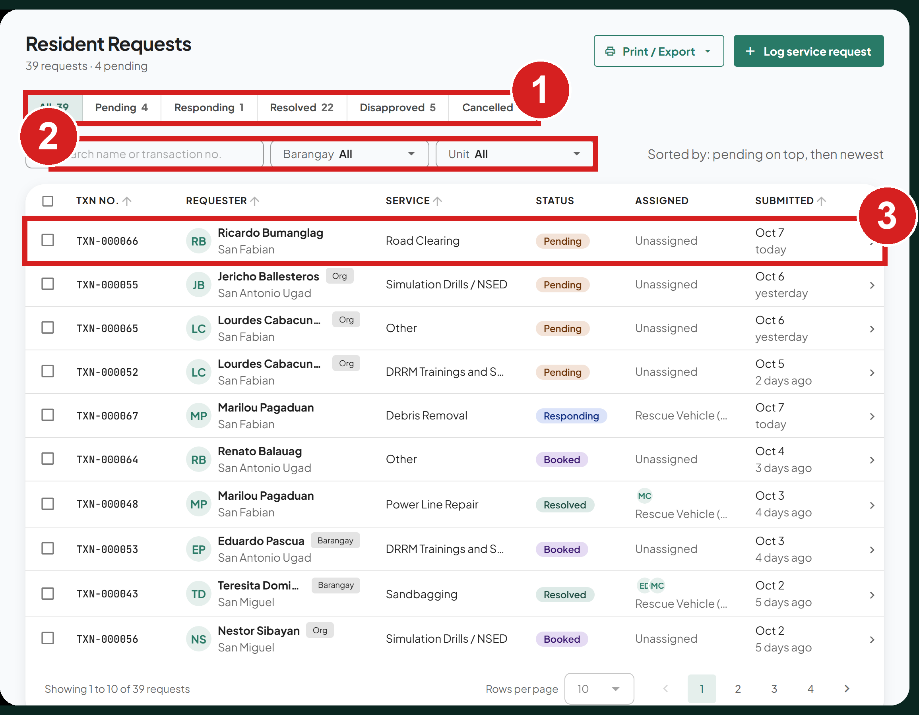
1 Requests by status
2 Narrow the list
3 Open a request
New requests while you work. The page checks for new requests about every 30 seconds. It does not move the list while you are working. A note shows above the list instead: 3 new requests · Show when residents have sent more, or This list has changed since it loaded · Refresh when another staff member changed one. Click Show or Refresh to load them.

Review a request
Click a request to open its panel on the right. It shows who sent the request, what they need, the photos, and the unit and responders to send.
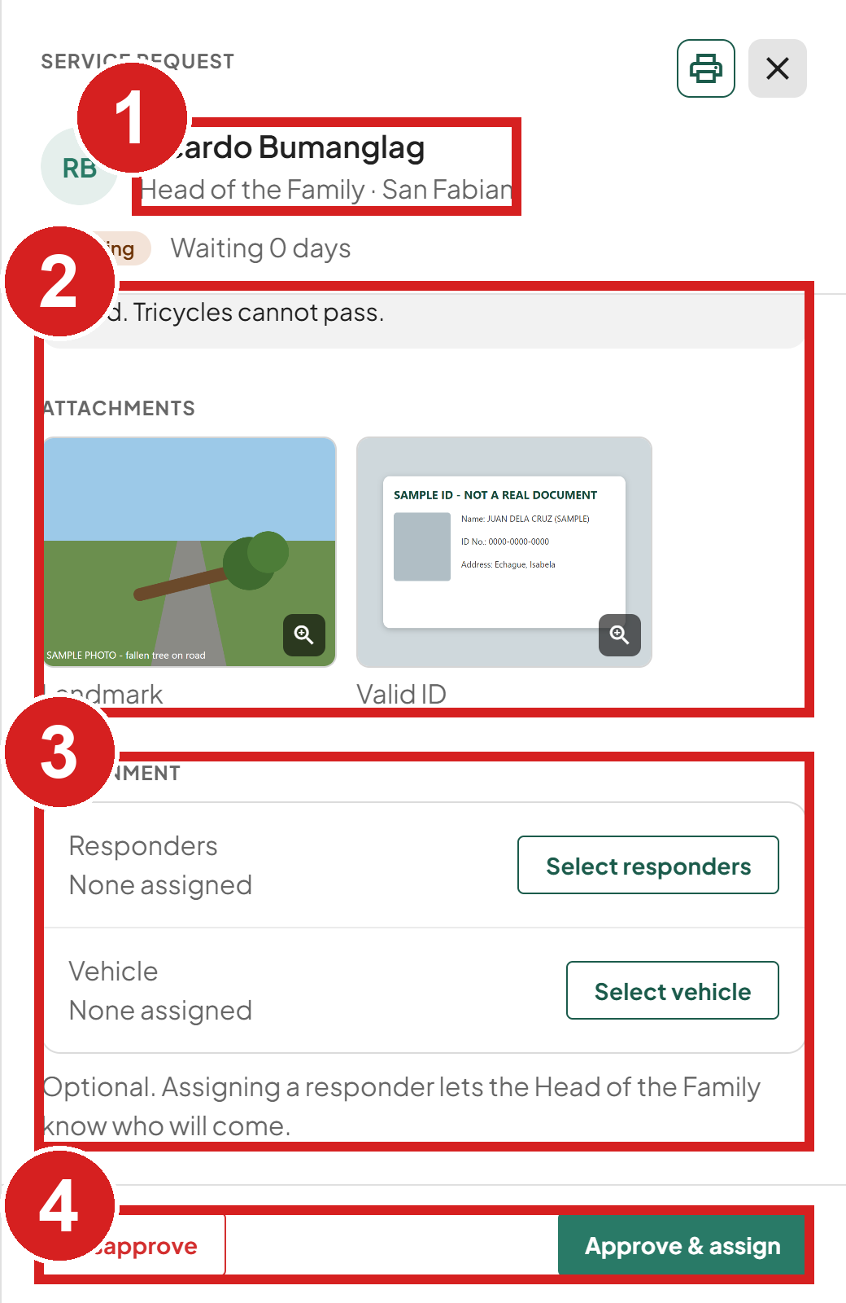 | 1 Who filed it  2 What they need  3 Unit and responders to send  4 Approve or disapprove

Approve and dispatch
Use this when a unit and responders go out for the request.
1. Open the Pending request.
2. Under Assignment, click Select vehicle. The panel changes to Assign to this request.
3. Tick a vehicle. The list shows only free units of the types set for this service on the Service Vehicles page.
4. Click the Responders tab and tick the responders. Only available responders can be ticked.
5. Click Done.
6. Click Approve & assign.
7. In Approve and dispatch, click Approve & dispatch. You can click Add a note for the Head of the Family first.
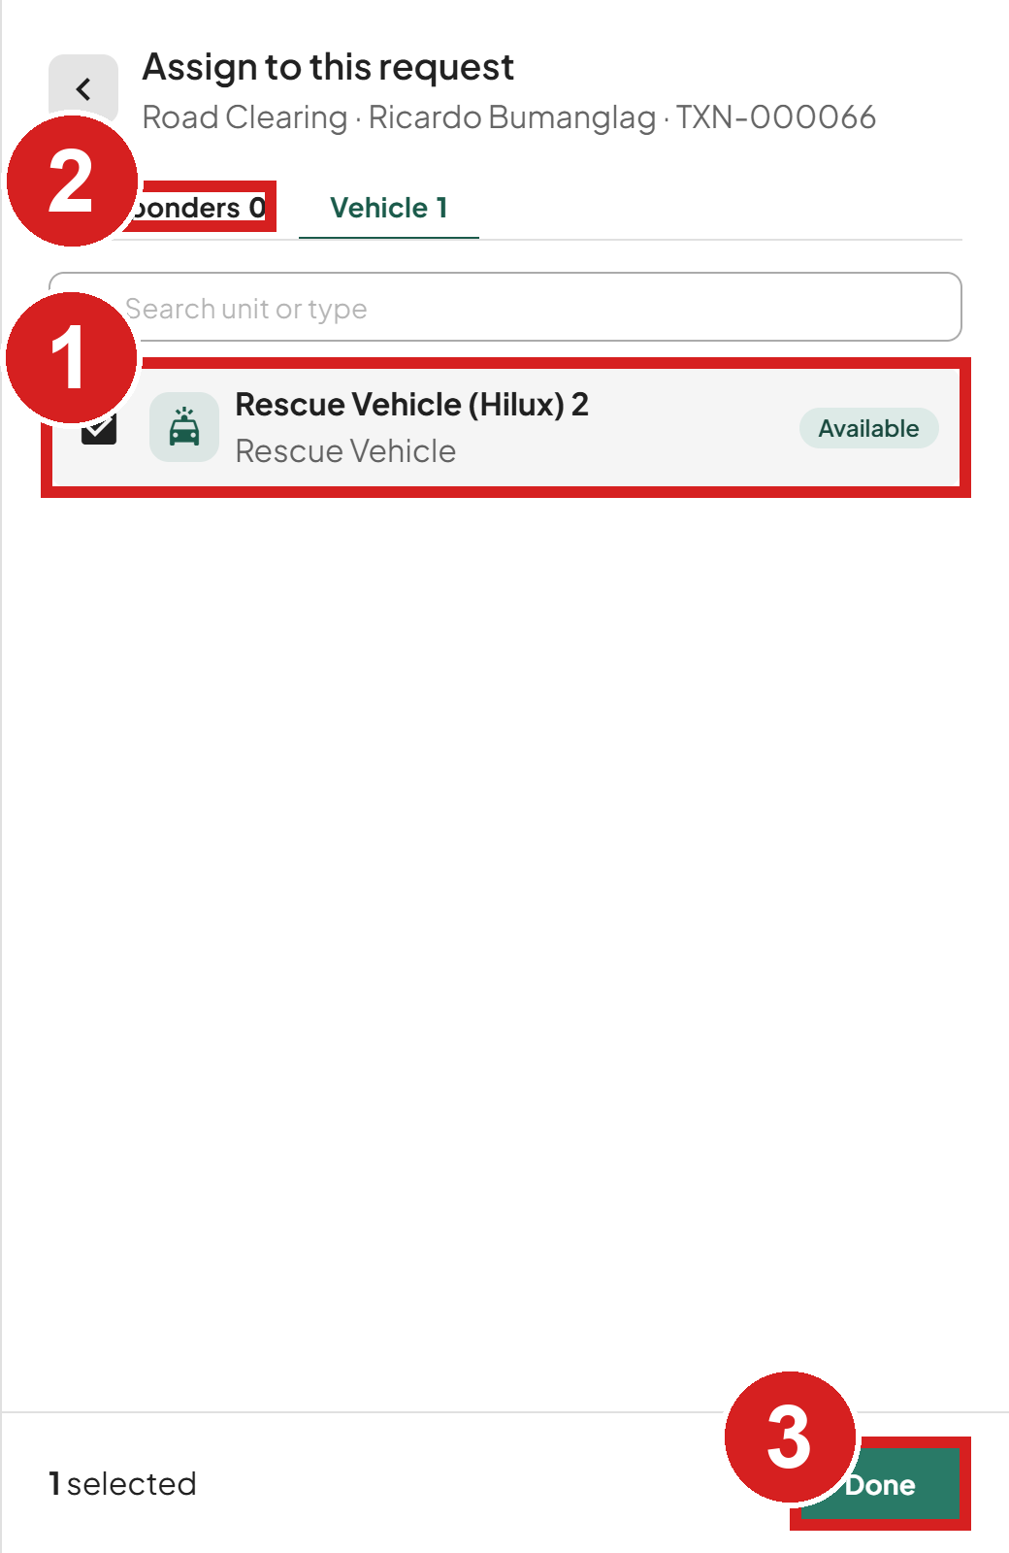 | 1 Pick a unit  2 Pick the responders  3 Back to the request

The request becomes Responding and the resident is notified.

Approve without a vehicle
When no unit needs to go out:
1. Open the Pending request.
2. Click Approve & assign without selecting a vehicle.
3. In Approve without a vehicle, click Approve. You can click Add a note first. The request becomes Responding. Trainings, drills and certifications have no vehicle: their dialog is Approve this request, and the resident sees Approved.
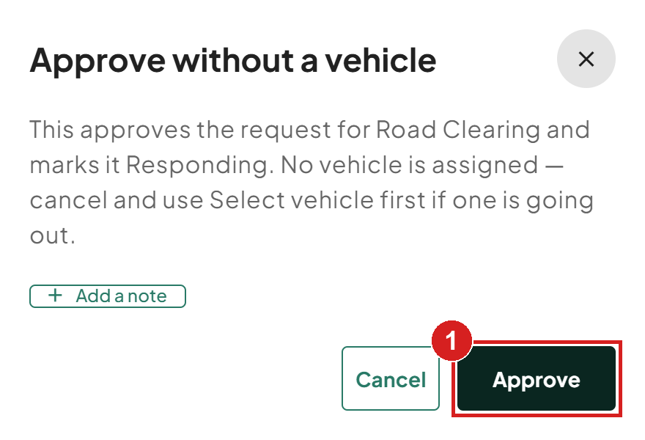
1 Approve when no unit is needed

Disapprove a request
1. Open the Pending request.
2. Click Disapprove.
3. Type the reason. The resident sees it in the app.
4. Click Disapprove request.
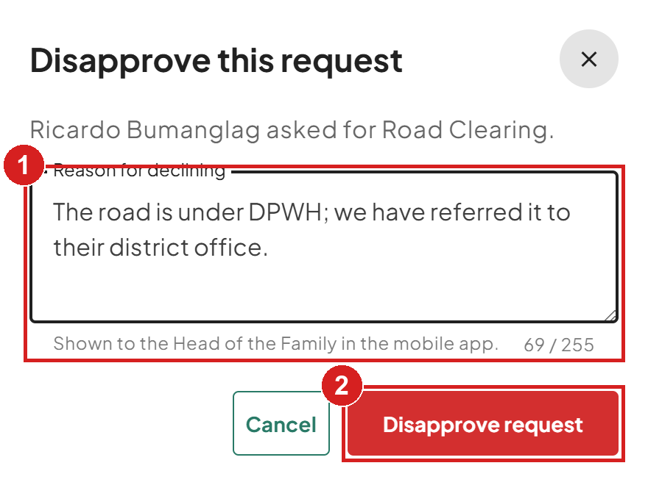
1 Why (the resident sees this)
2 Confirm

Mark a request resolved
1. Open the Responding request.
2. Click Mark as resolved when the work is done.
3. Click Resolve permanently. A resolved request cannot be changed back, and its unit and responders are freed.
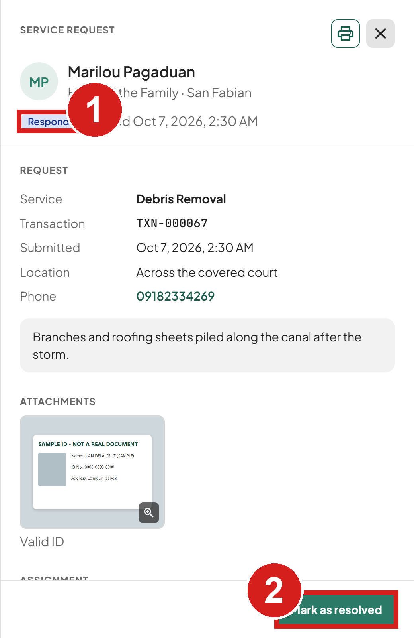 | 1 Work in progress  2 Mark the work done

Record a walk-in request
Use this for a request made at the office or by phone.
1. Click Log service request.
2. Choose Registered Head of the Family and pick the person, or No account and type their name and contact number.
3. Choose the service.
4. Type the description. It is required.
5. Click File request.
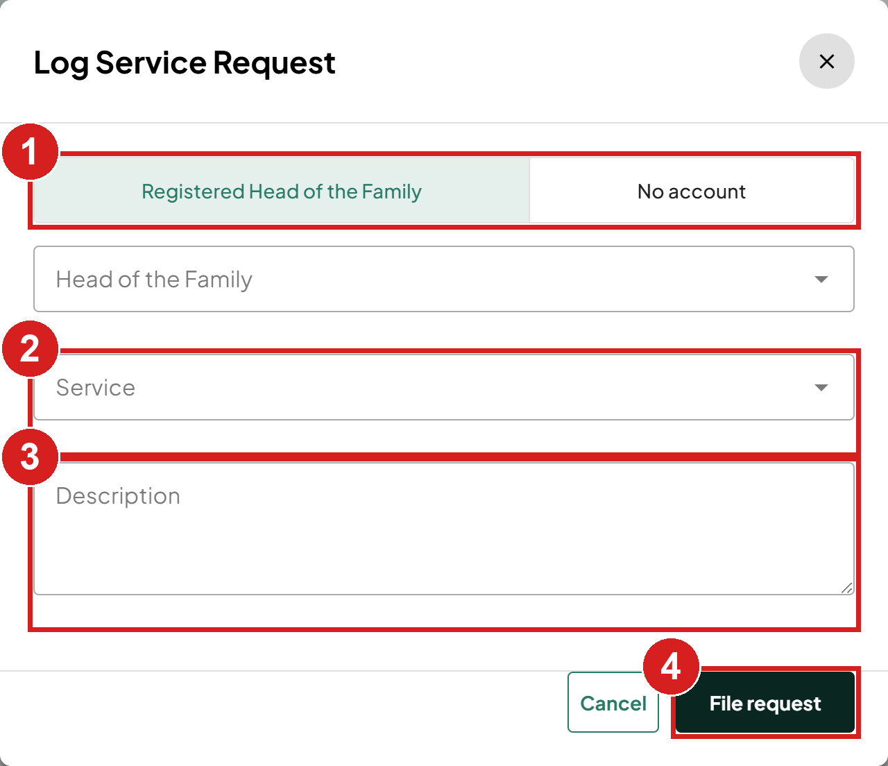
1 Is the person registered?
2 What they need
3 Details
4 Save the request

Print or export a list
1. Click Print / Export above the list, then Export all … matching (or Print all … matching). To export only some rows, tick them first and click Export selected.
2. Click Print / PDF, CSV or XLSX.
3. Choose the columns and the sort order. For Export all, you can also set a date range.
4. Click Export (or Print).
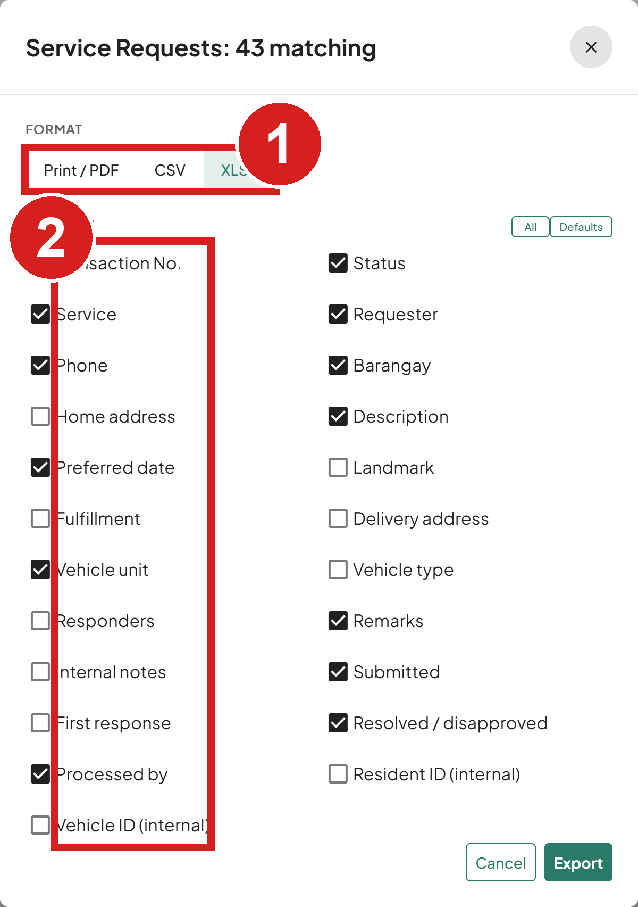 | 1 Choose the output  2 Columns to include

Dispatch the ambulance
Ambulance requests have their own page, Ambulance Dispatch. A request for "now" arrives as Pending and becomes Responding when you approve and dispatch it. A request for a later date and time arrives already Booked: the time is held, you assign a unit before the trip, and it becomes Responding when you dispatch it.
New requests and trip records do not appear in the list while you work. A note shows above the list instead, as on Resident Requests (see New requests while you work under Find a request).

Review an ambulance request
1. Click Ambulance Dispatch.
2. Click the request.
3. Check when it was sent, the route and the patient.
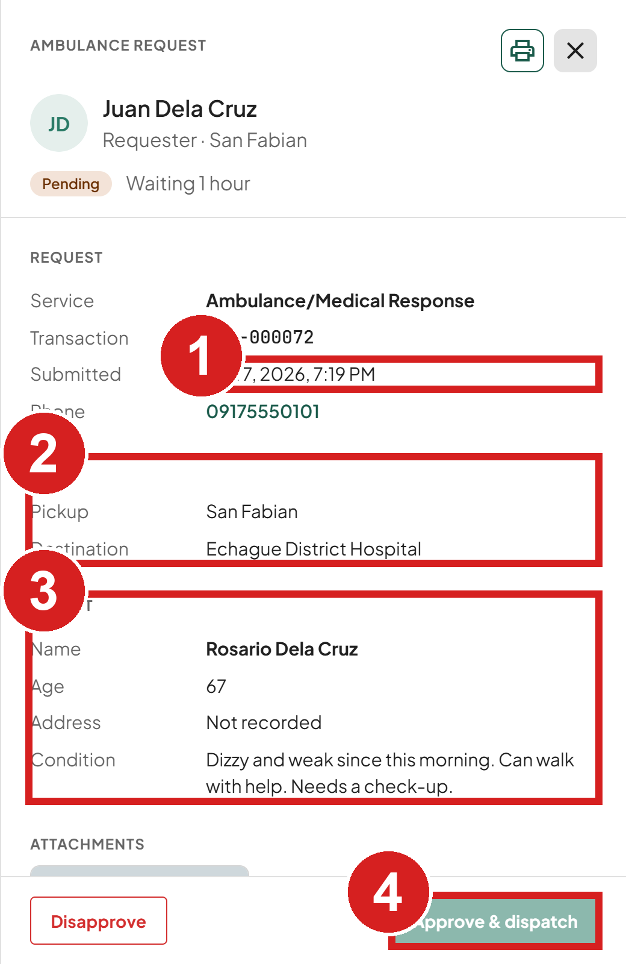 | 1 When it was sent  2 From and to  3 Who is being carried  4 Approve and send the unit

Approve and dispatch a request for now
1. Open the Pending request.
2. Under Assignment, click Select unit.
3. Choose an ambulance unit. Only free units are listed; busy units are hidden.
4. Click Done.
5. Click Approve & dispatch. It stays greyed out until a unit is chosen.
6. In Approve and dispatch, click Approve & dispatch. You can click Add a note for the Head of the Family first.
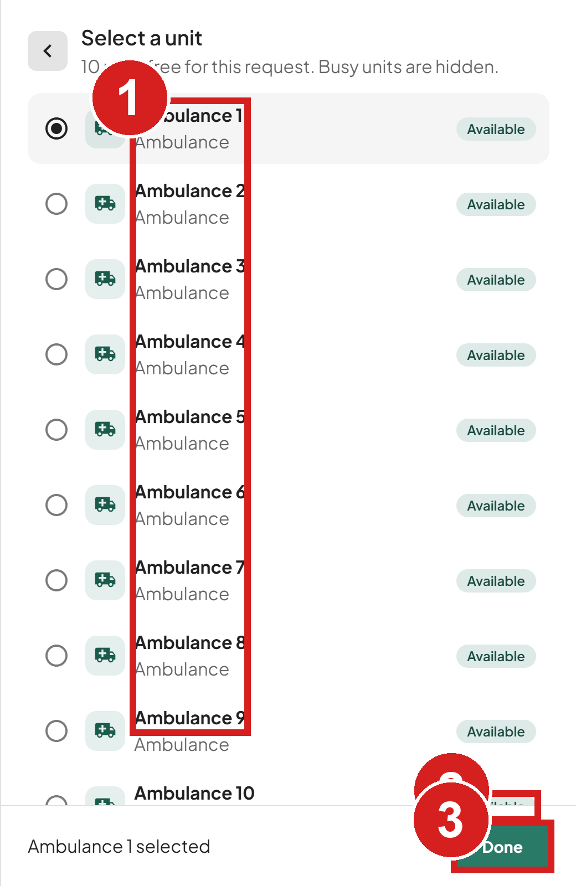 | 1 Ambulance units  2 Free for this request  3 Back to the request

The request becomes Responding and a trip record is started on the Trip logs tab.

Assign a unit to a booking
1. Open the Booked request.
2. Click Select unit beside Assignment.
3. Choose a unit. Only units free at the booked time are listed.
4. Click Done. The unit is saved at once and the request stays Booked. To change it later, click Reassign.
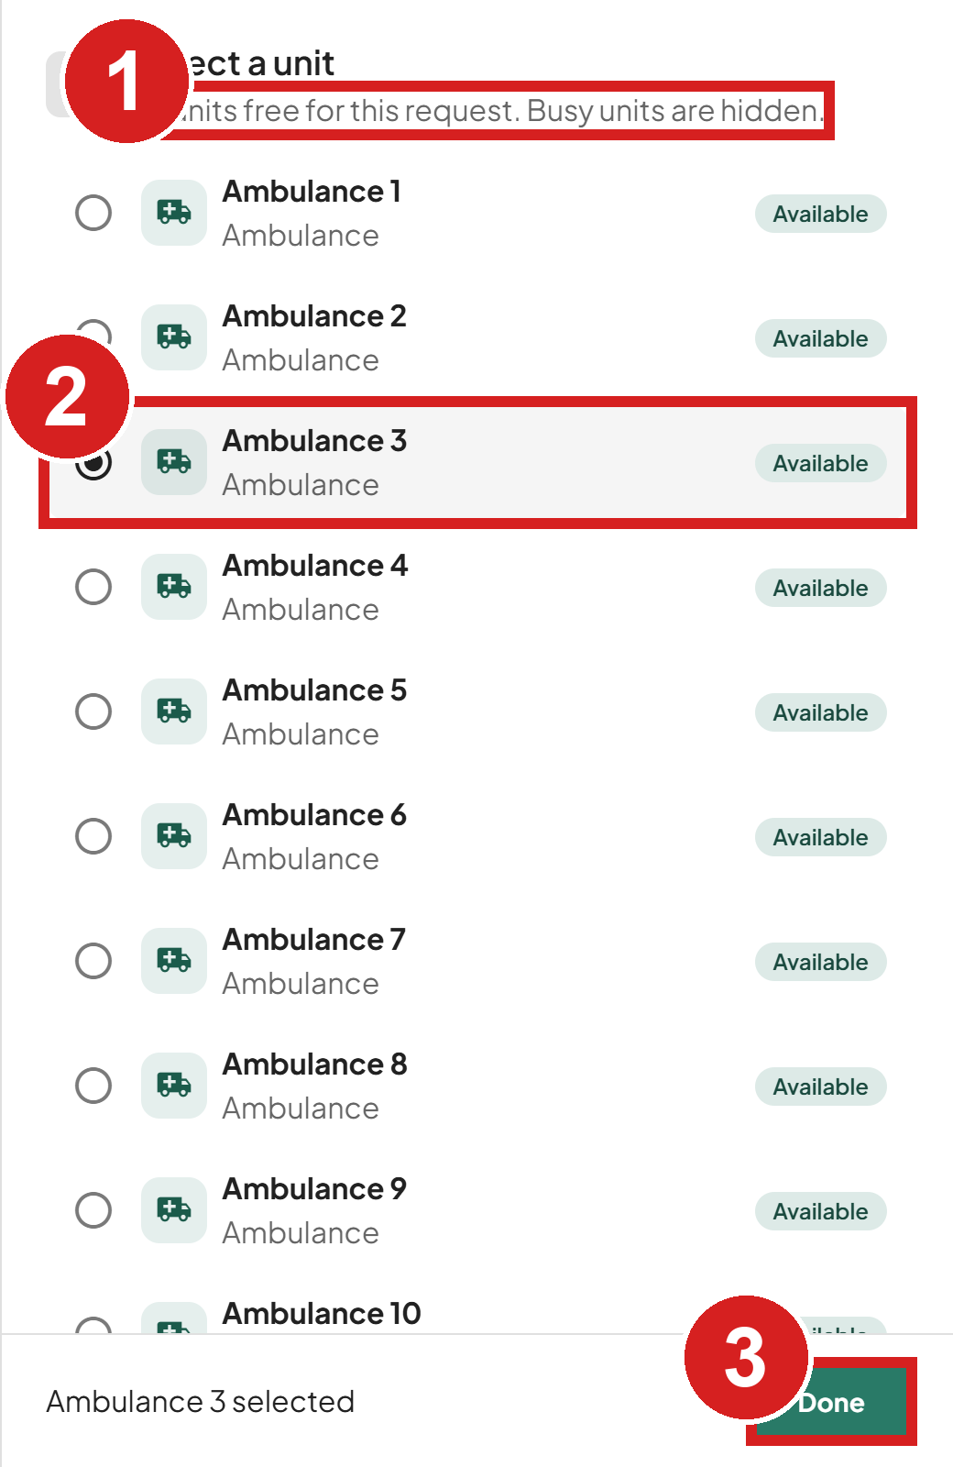 | 1 Only free units are listed  2 The unit you picked  3 Save it

Dispatch a booking
When the unit leaves for a Booked trip:
1. Open the Booked request.
2. Click Dispatch. It stays greyed out until a unit is assigned.
3. The Trip logs tab opens a new trip record filled in from the booking. Check it and click Save trip record.
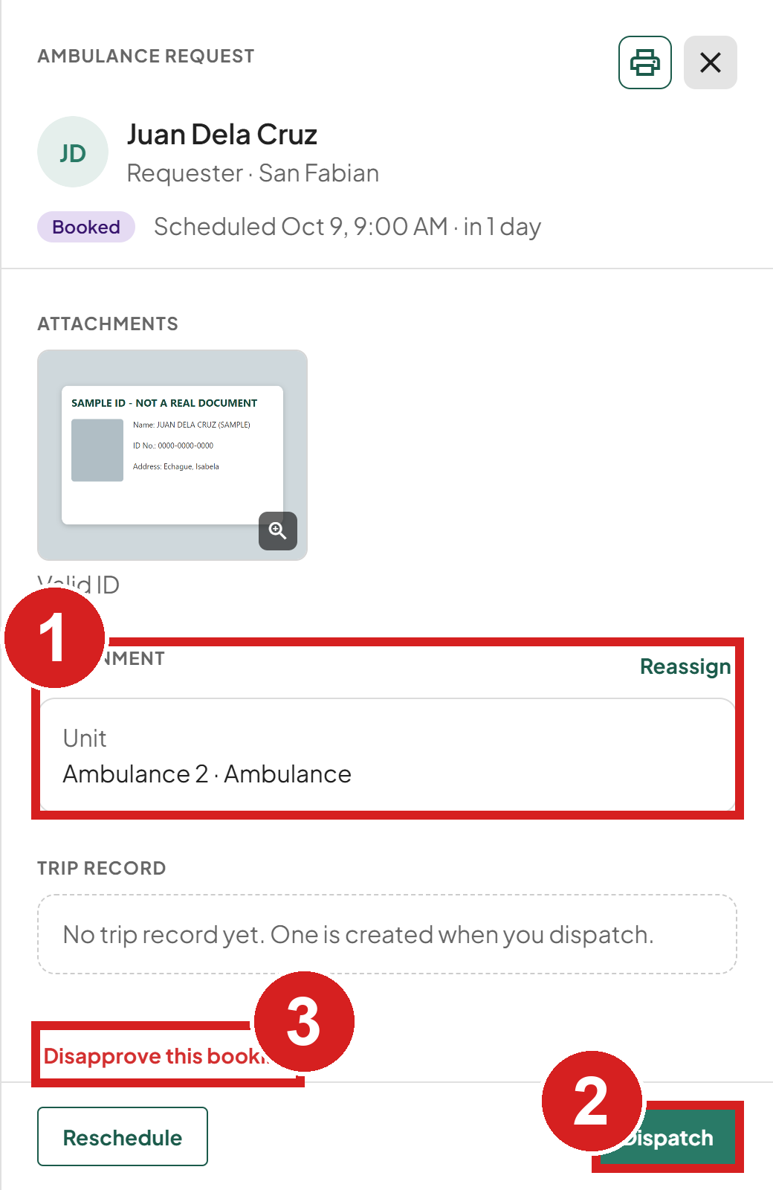 | 1 The unit assigned  2 Send it when the unit leaves  3 Refuse the booking

The request becomes Responding. To refuse a booking instead, click Disapprove this booking.

Change the time of a booking
1. Open the Booked request.
2. Click Reschedule.
3. Set the new start and end.
4. Type the reason for the change. The resident sees it.
5. Click Reschedule.
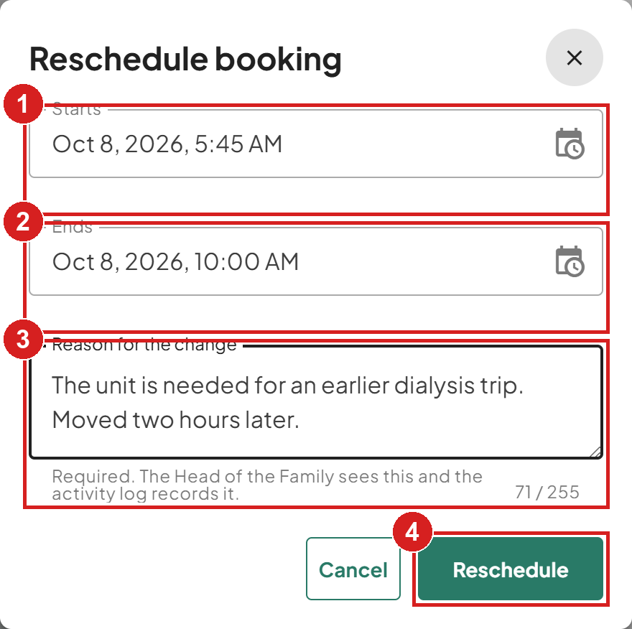
1 New start
2 New end
3 Why it moved (the resident sees this)
4 Save the new time

Check the ambulance schedule
1. Click Day view on the Ambulance Dispatch page.
2. Click Day or Month.
3. Click Today to come back to the current day.
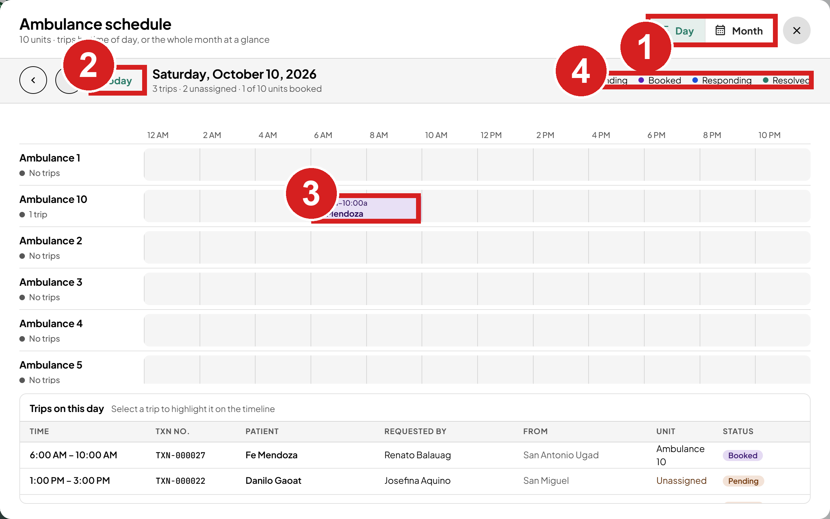
1 Change the view
2 Jump to today
3 One booked trip
4 What the colours mean

Fill in the trip log
Fill in the log as the trip happens. You can save part of it and come back later.
1. Open the Trip logs tab.
2. Click the trip, then click Complete trip log (or Update trip log once a departure time is saved).
3. Enter the departure and arrival times.
4. Enter the odometer readings.
5. If the patient was not carried, tick Did not reach destination and type the reason.
6. Under Crew, add the driver.
7. Click Save trip log.
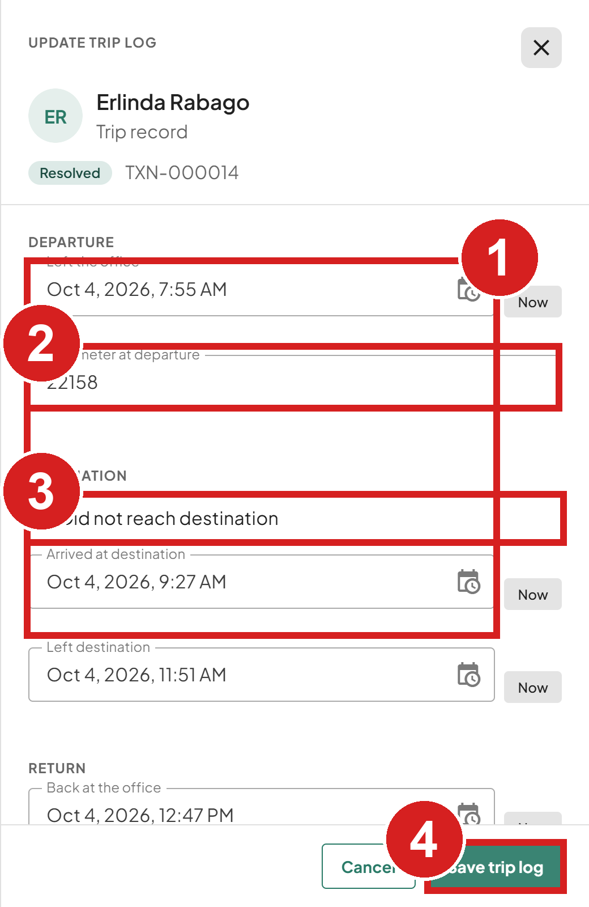 | 1 Times of each leg  2 Meter readings  3 Only if the patient was not carried  4 Save

An ambulance request can be marked resolved only when its trip log has a driver and an arrival time, or a reason it did not arrive.

Print the conduction request form
1. Open the Trip logs tab.
2. Click the trip. Its panel opens on the right.
3. Click Print in the panel.
4. Print from the window that opens.
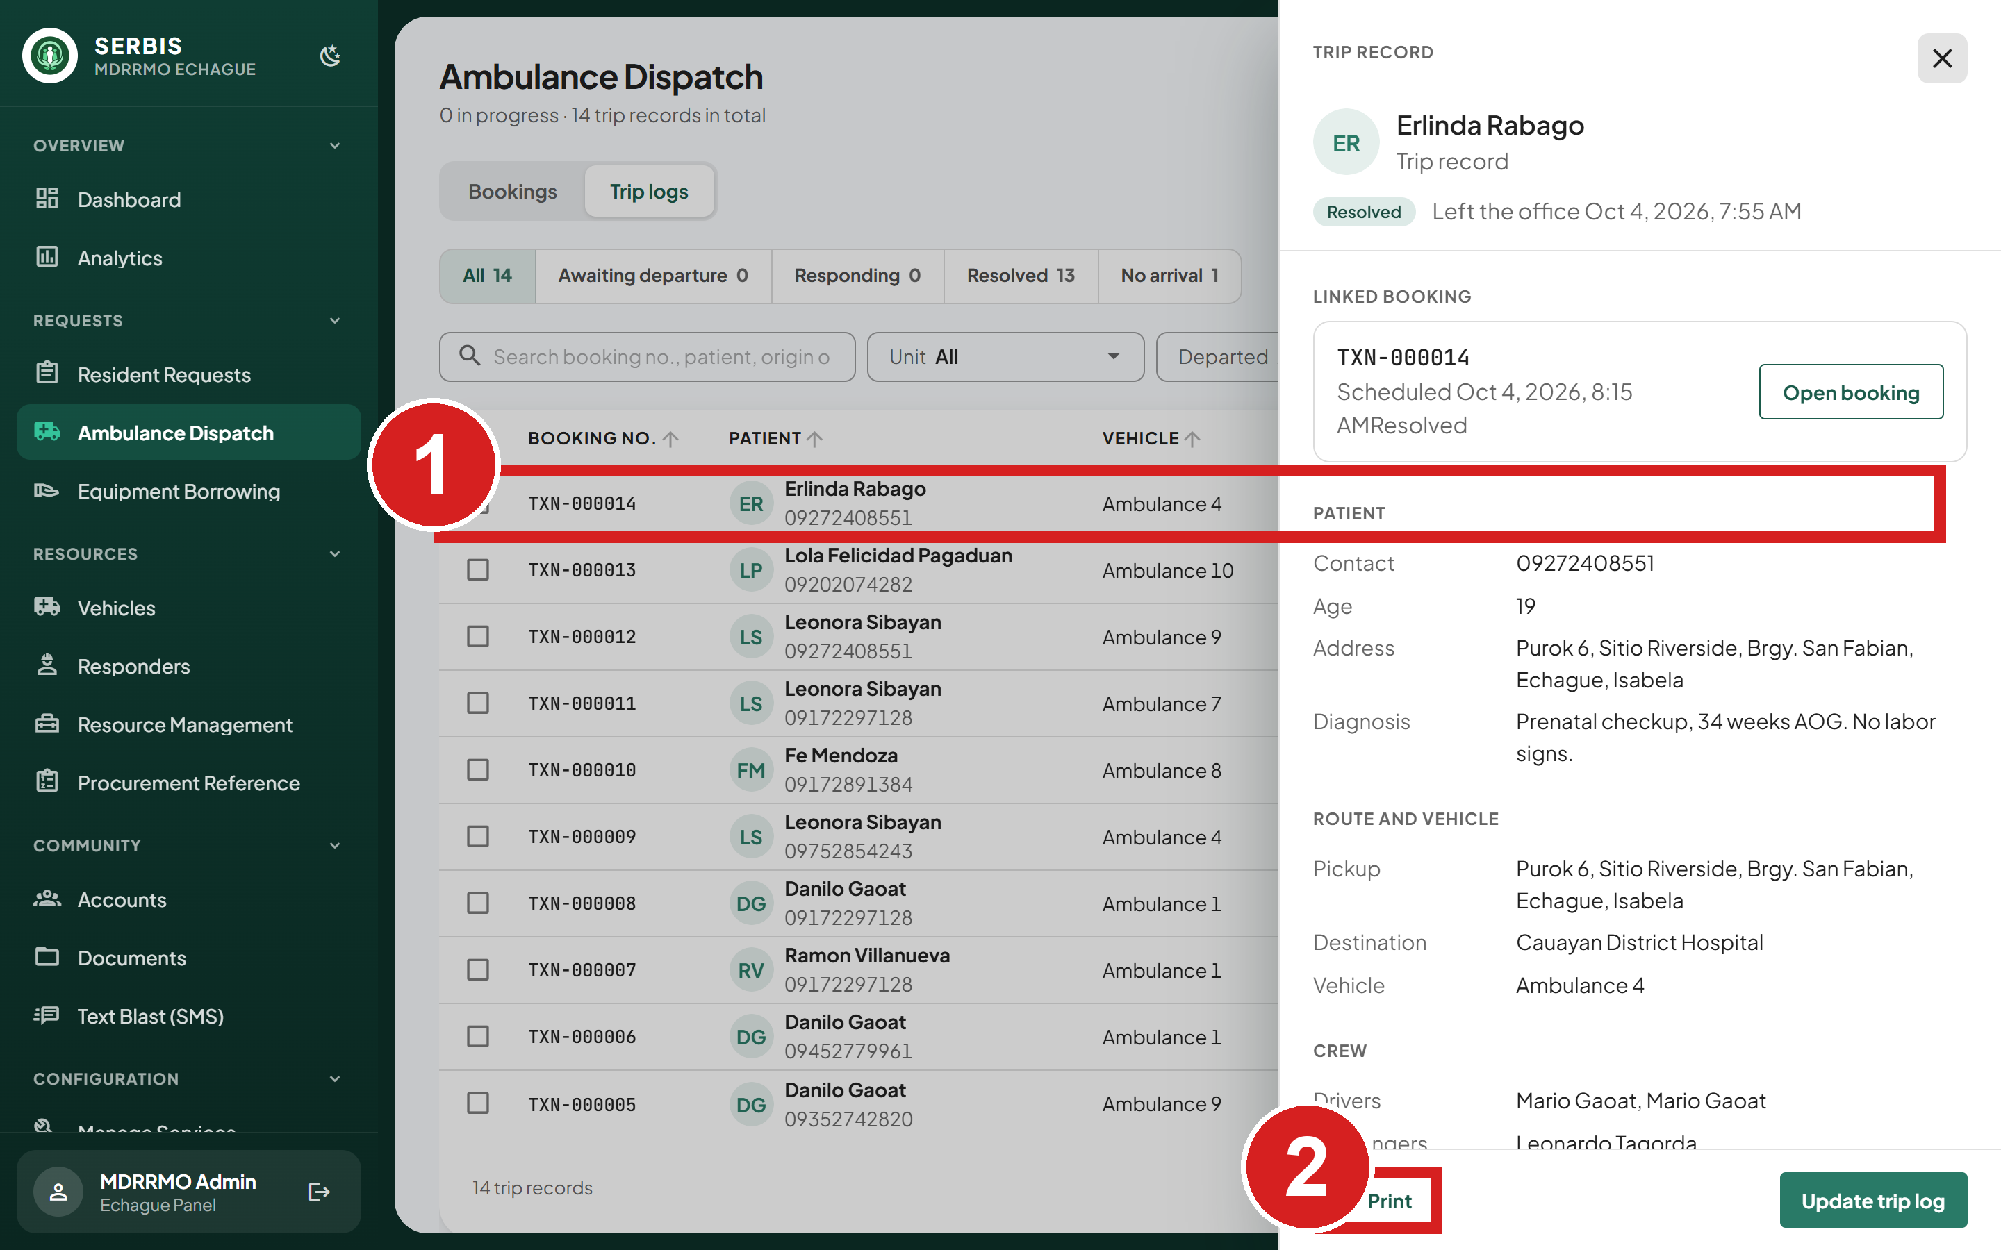
1 One trip
2 Print its conduction form
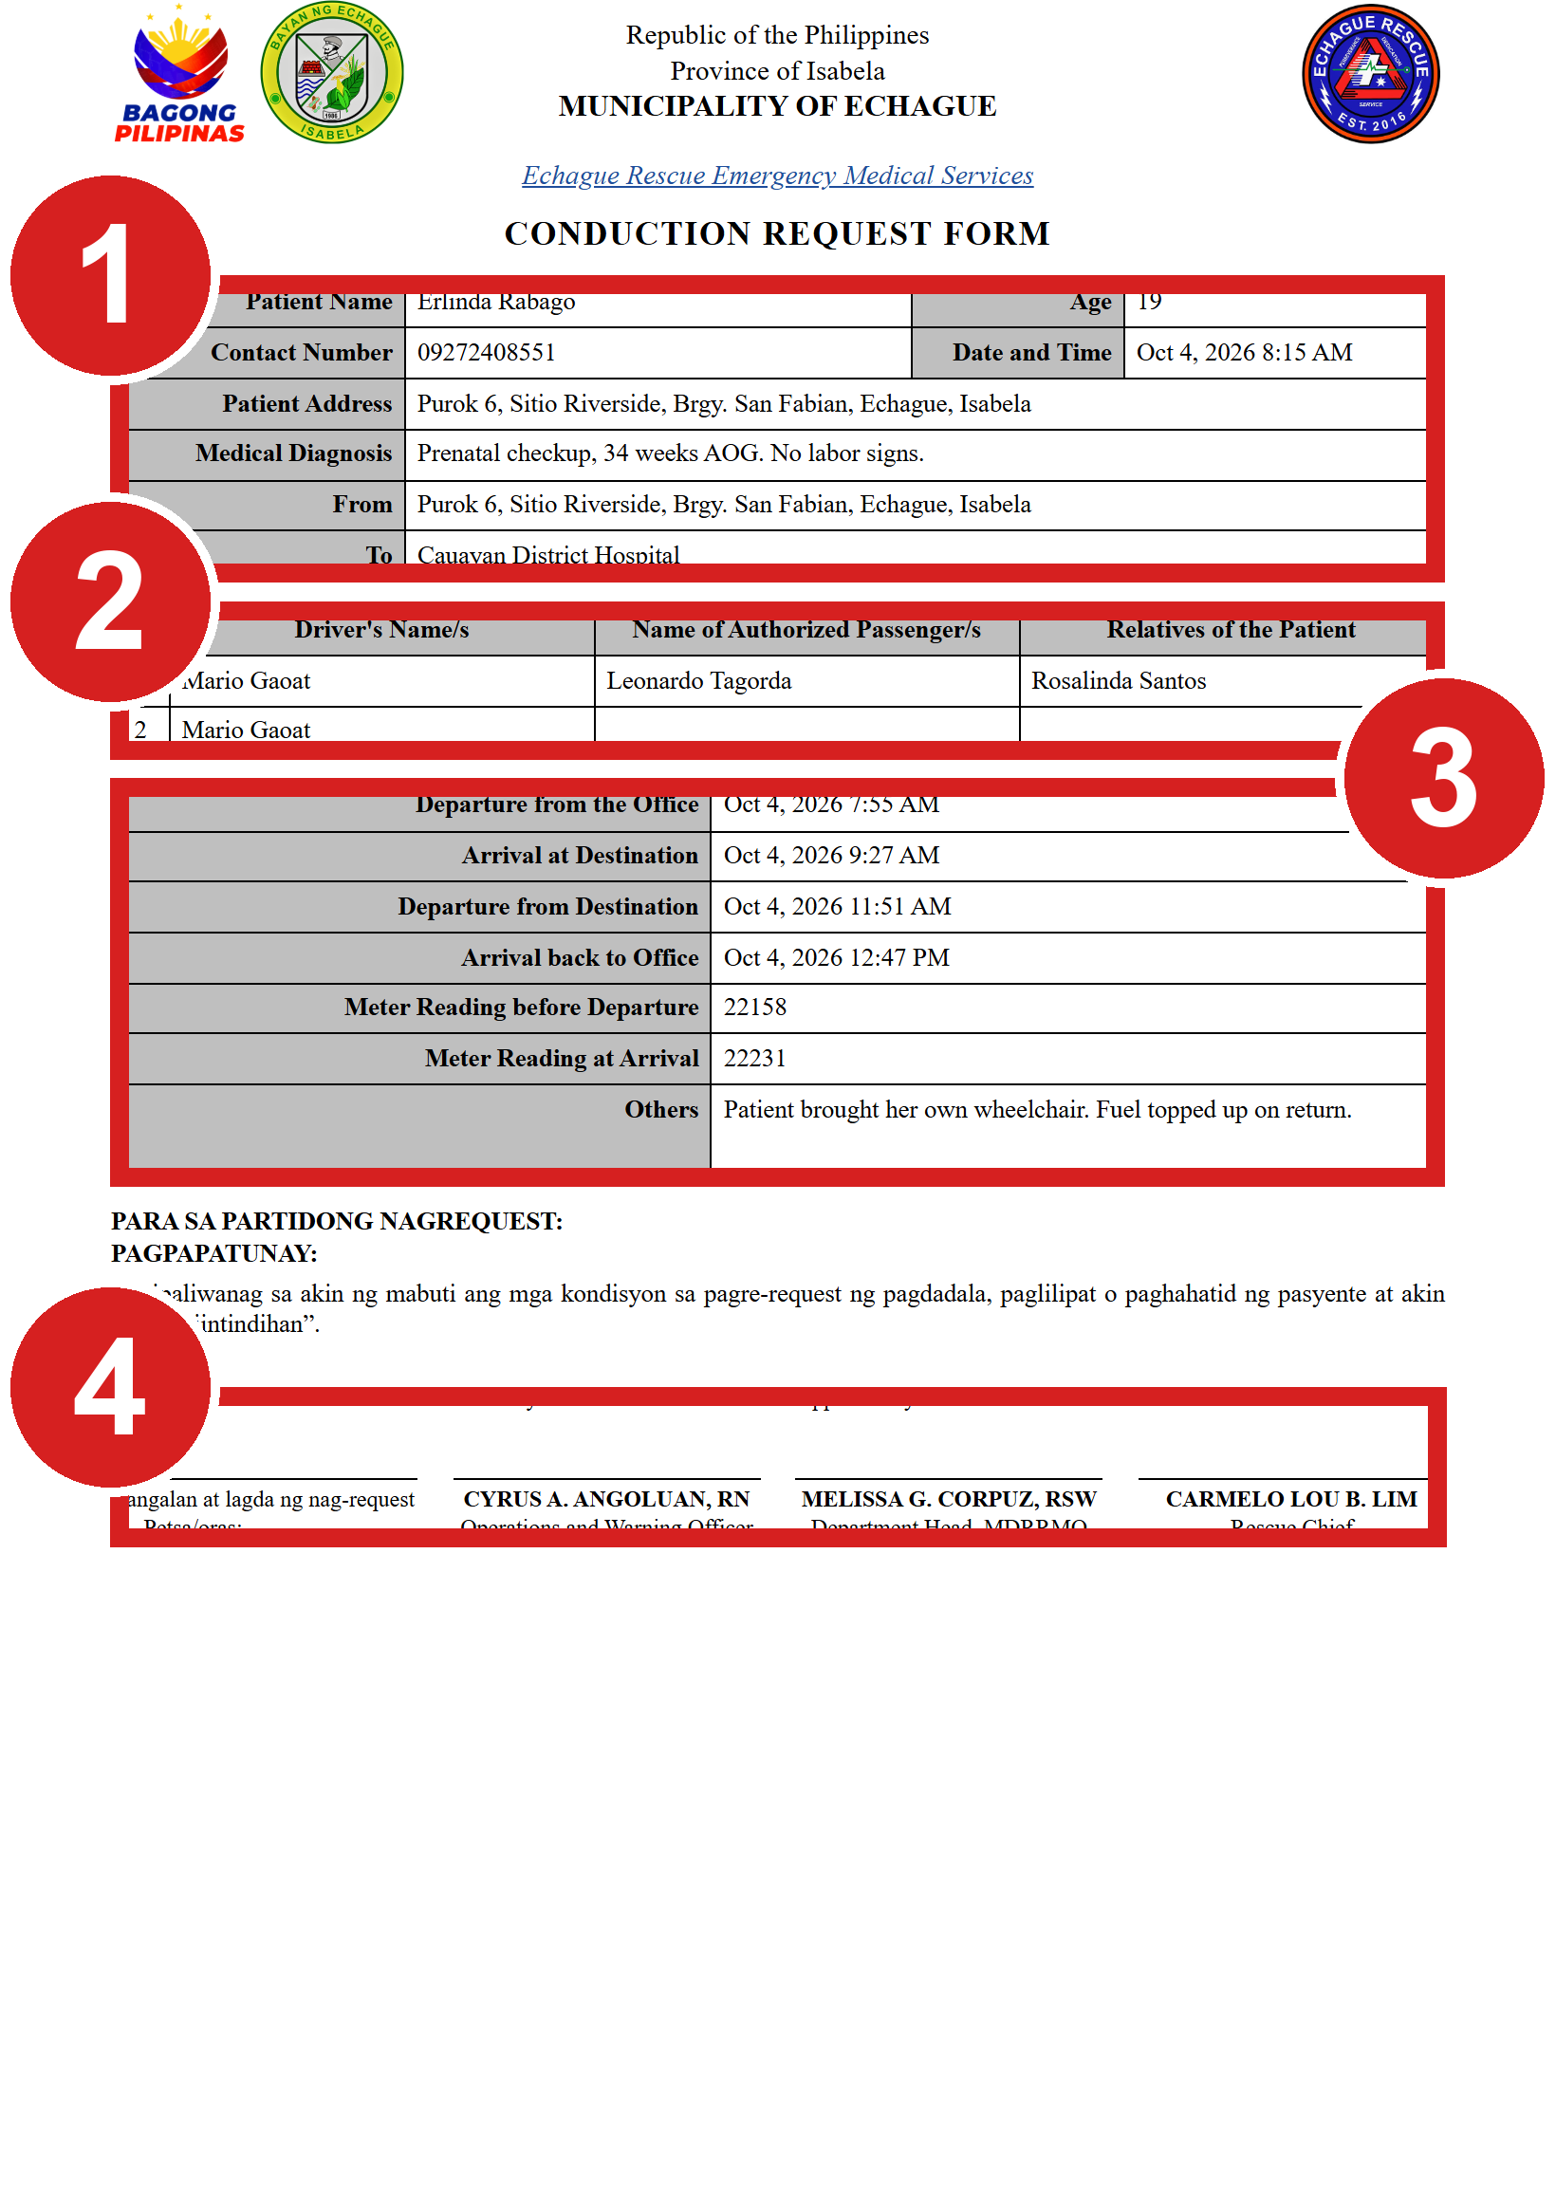 | 1 Patient and route  2 People on the trip  3 Times and meter readings  4 Signatures

Lend equipment
A borrowing request moves through Pending, Approved, Released and Returned. It can also end as Denied, or Cancelled by the resident. Stock goes down when an item is released and back up when it is returned.
New borrowing requests do not appear in the list while you work. A note shows above the list instead, as on Resident Requests (see New requests while you work under Find a request).

Review a borrowing request
1. Click Equipment Borrowing.
2. Use the equipment and barangay filters if the list is long.
3. Click the Pending request.
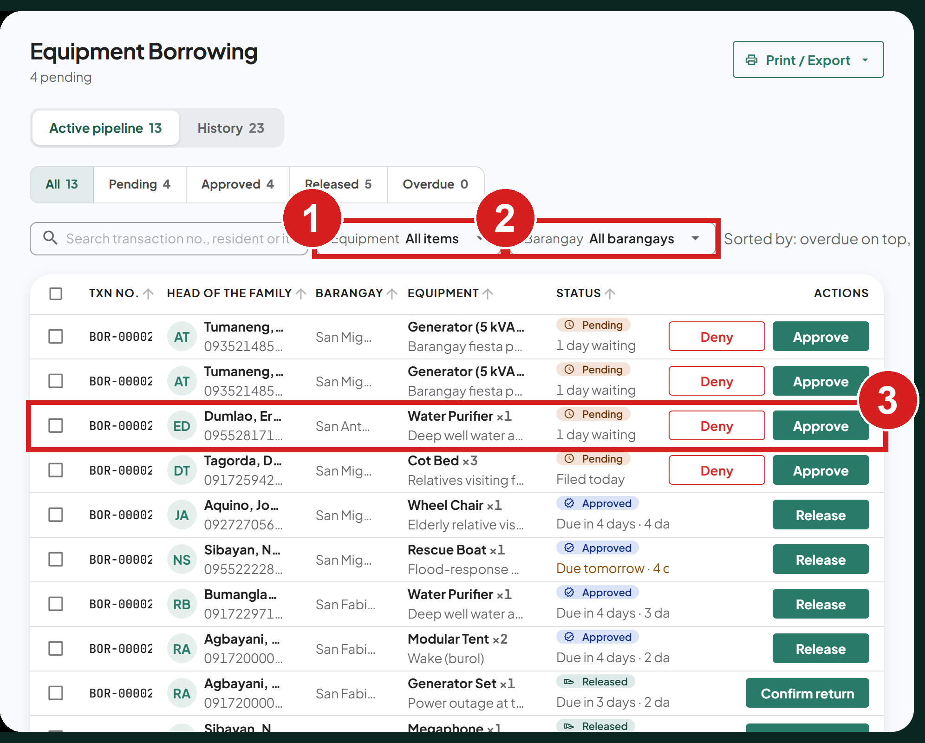
1 Limit to one item
2 Limit to one barangay
3 A request to review

Approve a borrowing request
1. Check the item, the quantity and whether it is picked up or delivered.
2. Click Approve request in the panel, or Approve on the row.
3. Set Due back on, the date the item must be returned. It starts 7 days ahead and can be from tomorrow up to 7 days.
4. Click Approve request.
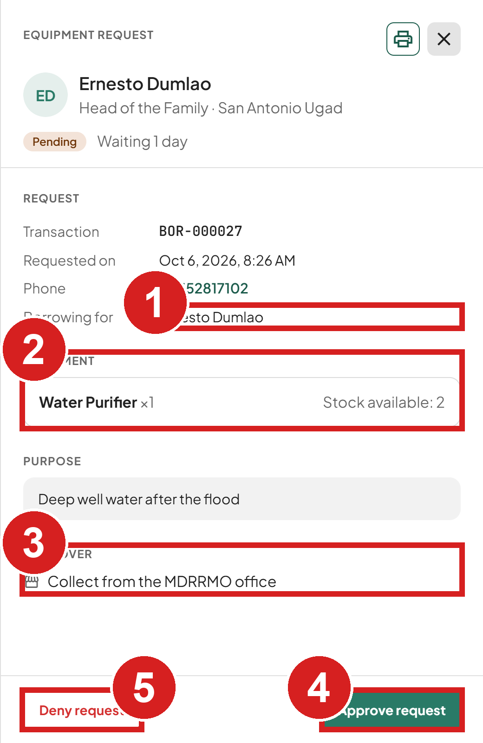 | 1 Who asked  2 What and how many  3 How it reaches them  4 Approve  5 Refuse

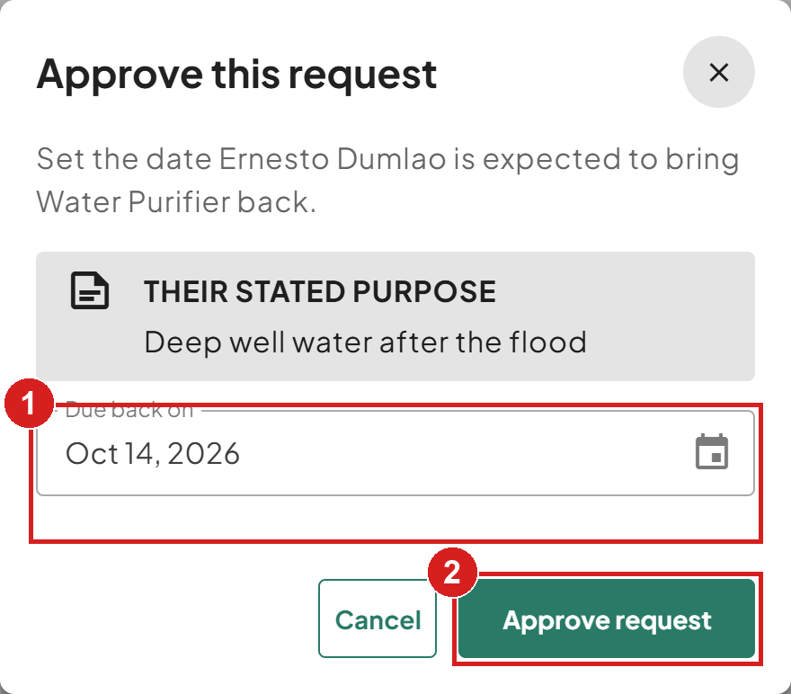
1 Return date
2 Approve
The resident's phone gets a reminder notification the day before the due date, or on the day if it was missed.

Deny a borrowing request
1. Click Deny request in the panel, or Deny on the row.
2. Choose Not available or Other reason, and type the reason. The resident sees it. With Not available, the resident is asked whether they still need it once the item is back in stock.
3. Click Deny request.
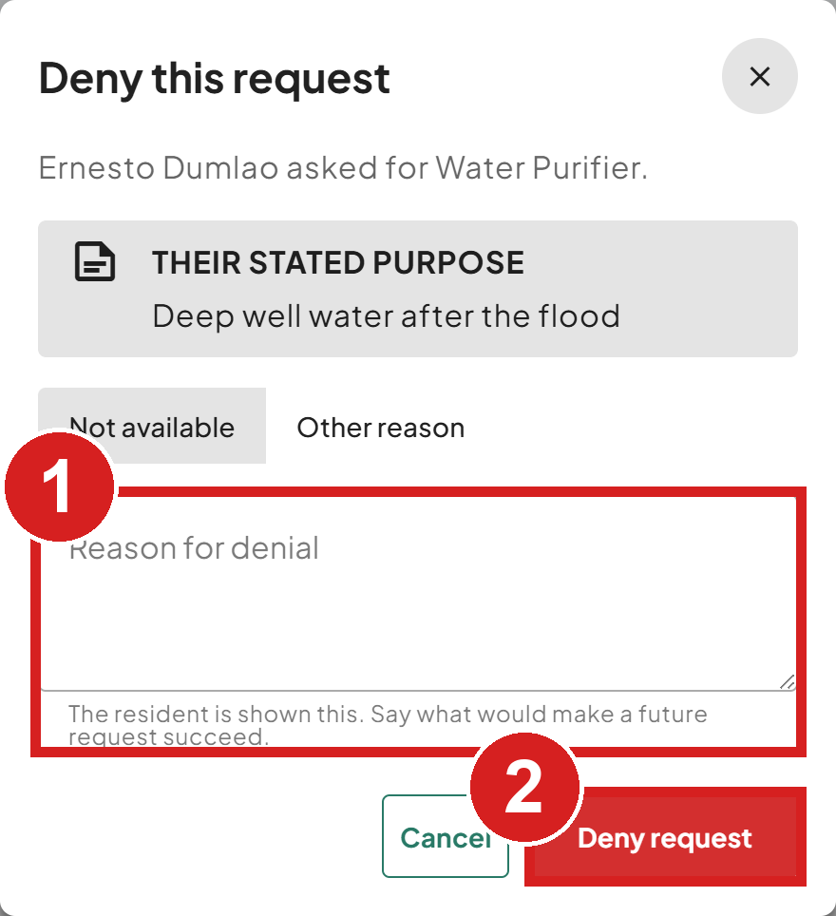 | 1 Why (the resident sees this)  2 Confirm

Release the item
When the resident collects the item, or it is delivered:
1. Click Release on the row, or Release to resident in the request. The item is released at once and stock goes down. There is no second step: the due date was set when the request was approved. A request for an item not in the inventory cannot be released.

Record the return
1. Open the Released request.
2. Check the item against the condition photos.
3. Click Confirm items returned in the panel, or Confirm return on the row.
4. Choose Good condition or Bad condition and type a note. The note is required.
5. Click Confirm return. Stock goes back up. This cannot be undone.
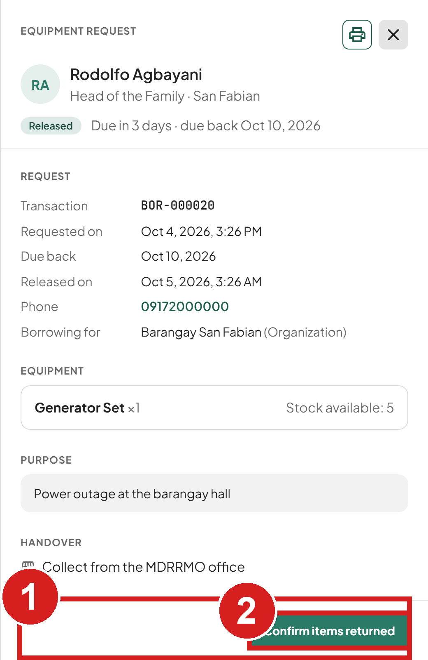 | 1 Photos taken at the counter  2 Record the return

Keep resources up to date

Add or change a vehicle
1. Click Vehicles.
2. Click Add unit, or Edit on an existing unit.
3. Type the unit name and choose its type.
4. Set the status. Choose Maintenance to take a unit out of service.
5. Click Add unit or Save.
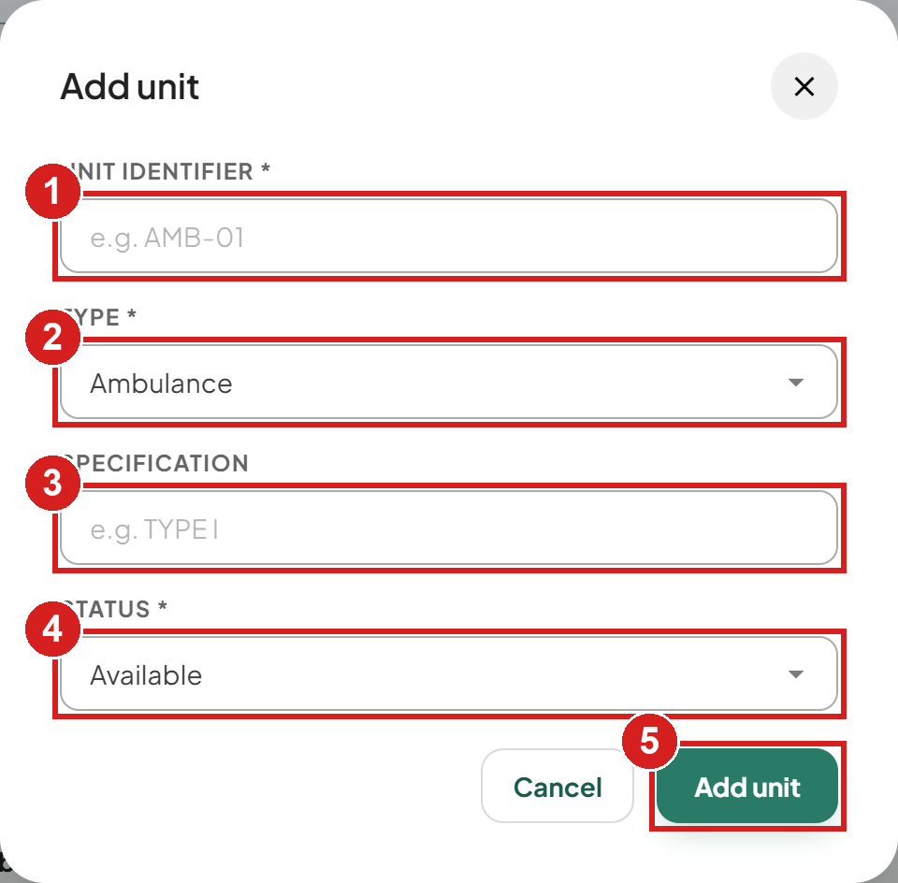
1 Name of the unit
2 Kind of vehicle
3 Model or notes
4 Available or Maintenance
5 Save
A unit cannot be deleted while it is dispatched, holds future bookings, or any request uses it. Set it to Maintenance instead.

Add a responder
Responders do not sign in to SERBIS. Staff assign them to requests.
1. Click Responders.
2. Click Add responder.
3. Type the name and contact number, and choose the position: Team Leader, Assistant Leader, Logistics or Driver.
4. Click Add responder.
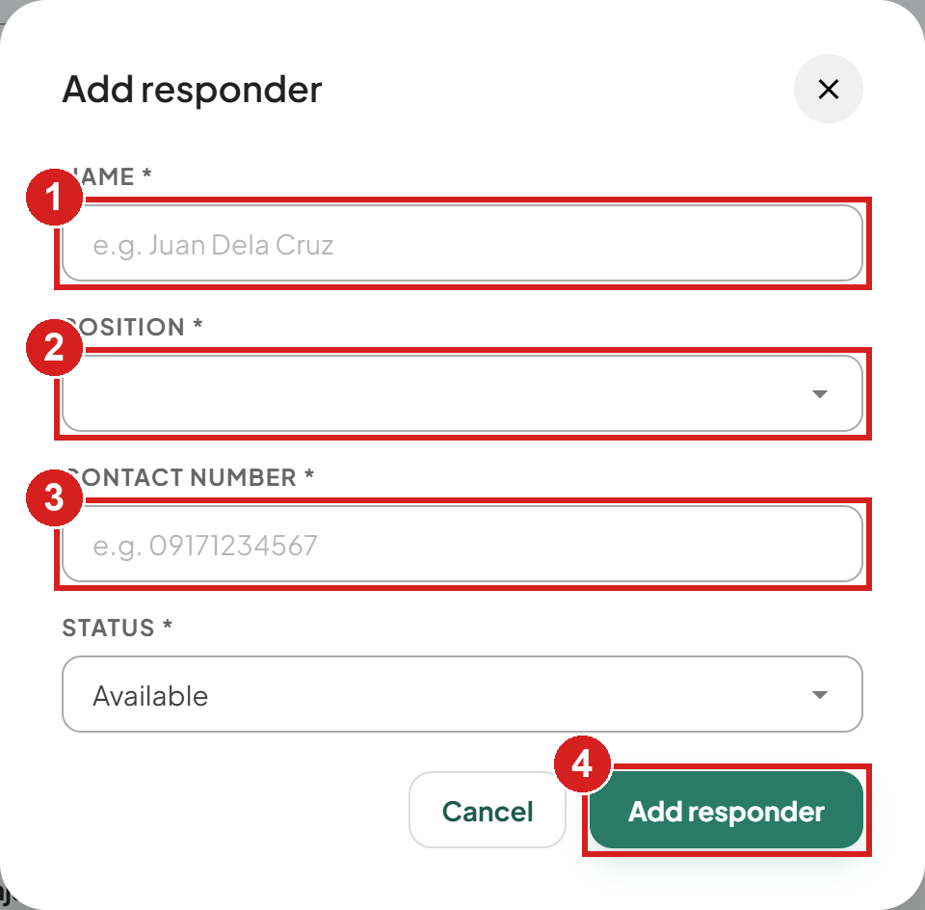
1 Full name
2 Role on the team
3 Mobile number
4 Save

Add or update equipment
1. Click Resource Management.
2. Click Add equipment, or Edit on an item.
3. Type the item name and the total the office owns.
4. Set the status. Unavailable hides the item from residents.
5. Click Add or Save.
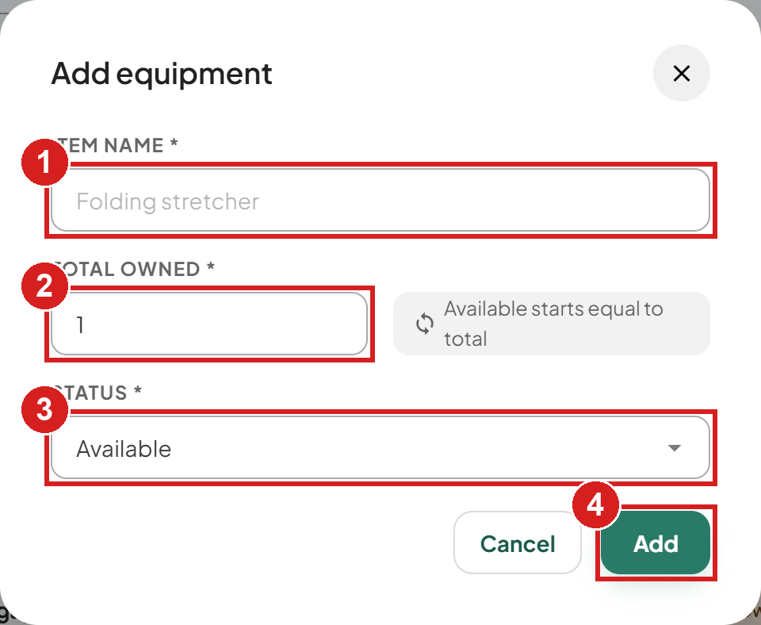
1 Name residents see
2 How many the office owns
3 Available or Unavailable
4 Save

Check what to procure
Procurement Reference lists items residents asked for that the office does not lend.
1. Click Procurement Reference.
2. Filter by status, or click Refresh.
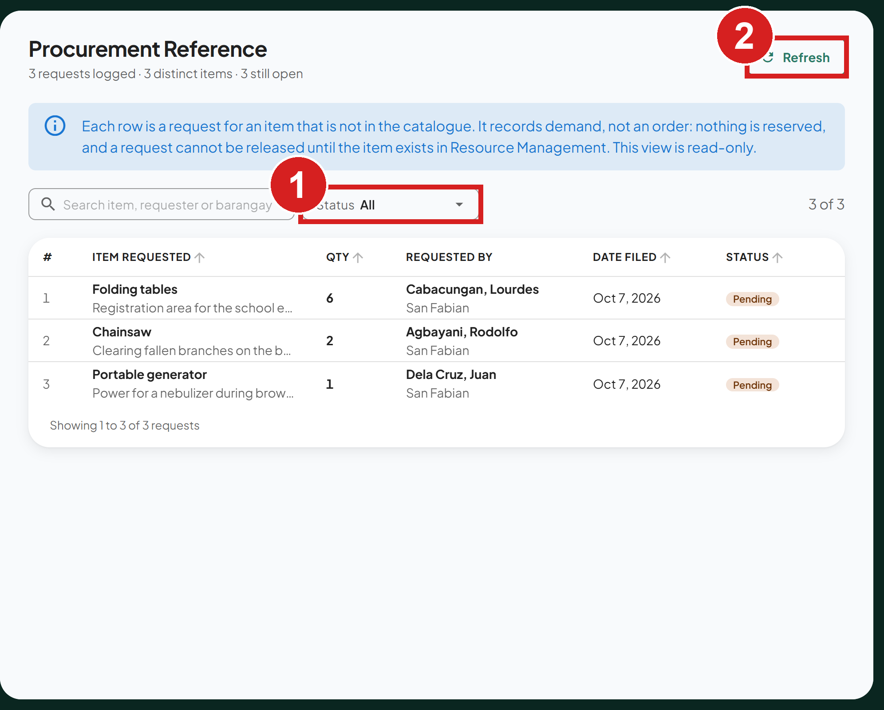
1 Limit the list
2 Reload it

Work with residents

Find an account
1. Click Accounts. A number beside it in the menu counts the accounts waiting for activation.
2. Search by name or mobile number, or filter by barangay and status. To see only the accounts waiting for you, set Status to Pending.
3. Click the account to open it.
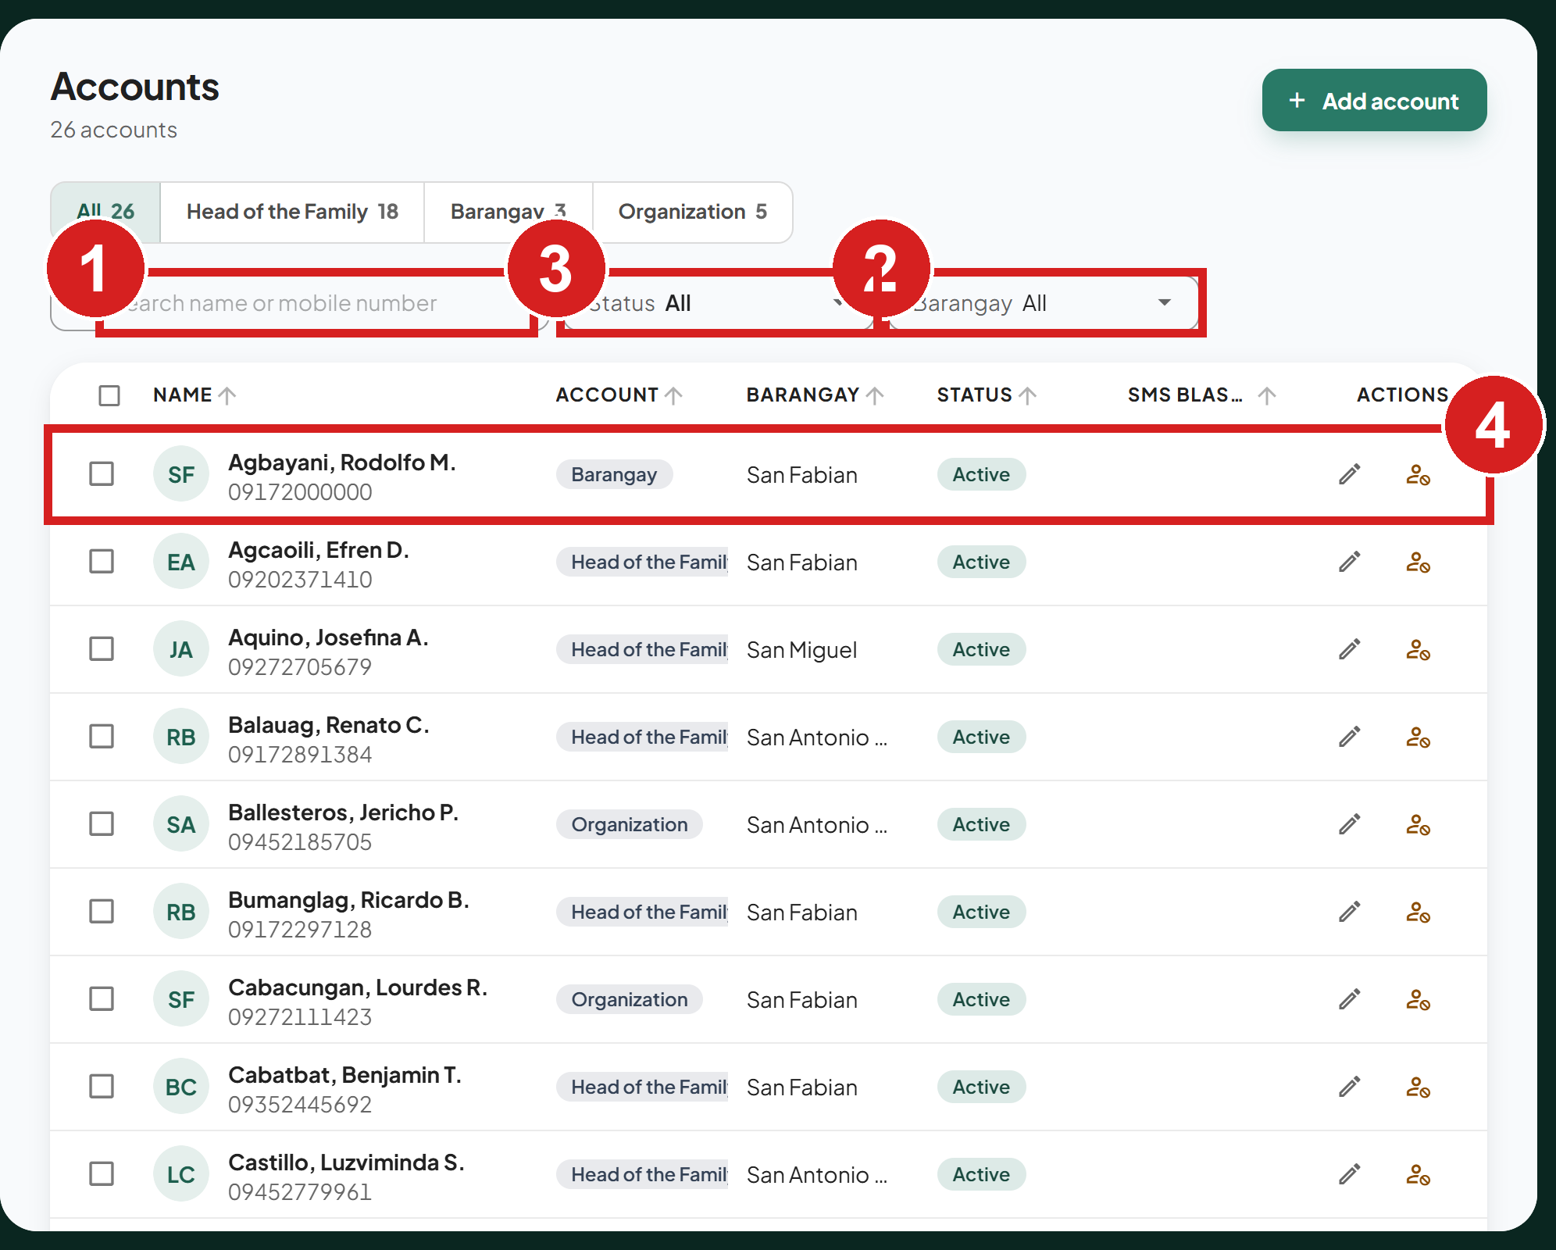
1 Find by name or number
2 Limit to one barangay
3 Active, pending or deactivated
4 Open the account

Activate an organization
An organization cannot request services until MDRRMO activates it. Its status shows Pending. To find it, set Status to Pending on Accounts, or click Pending accounts on the dashboard.
1. Click the organization's account to open it.
2. Check its details.
3. Click Approve organization. To refuse it, click Reject organization. The Activate account button on its row also approves it. Ticking it and clicking Activate in the selection bar does not: pending accounts are skipped there.
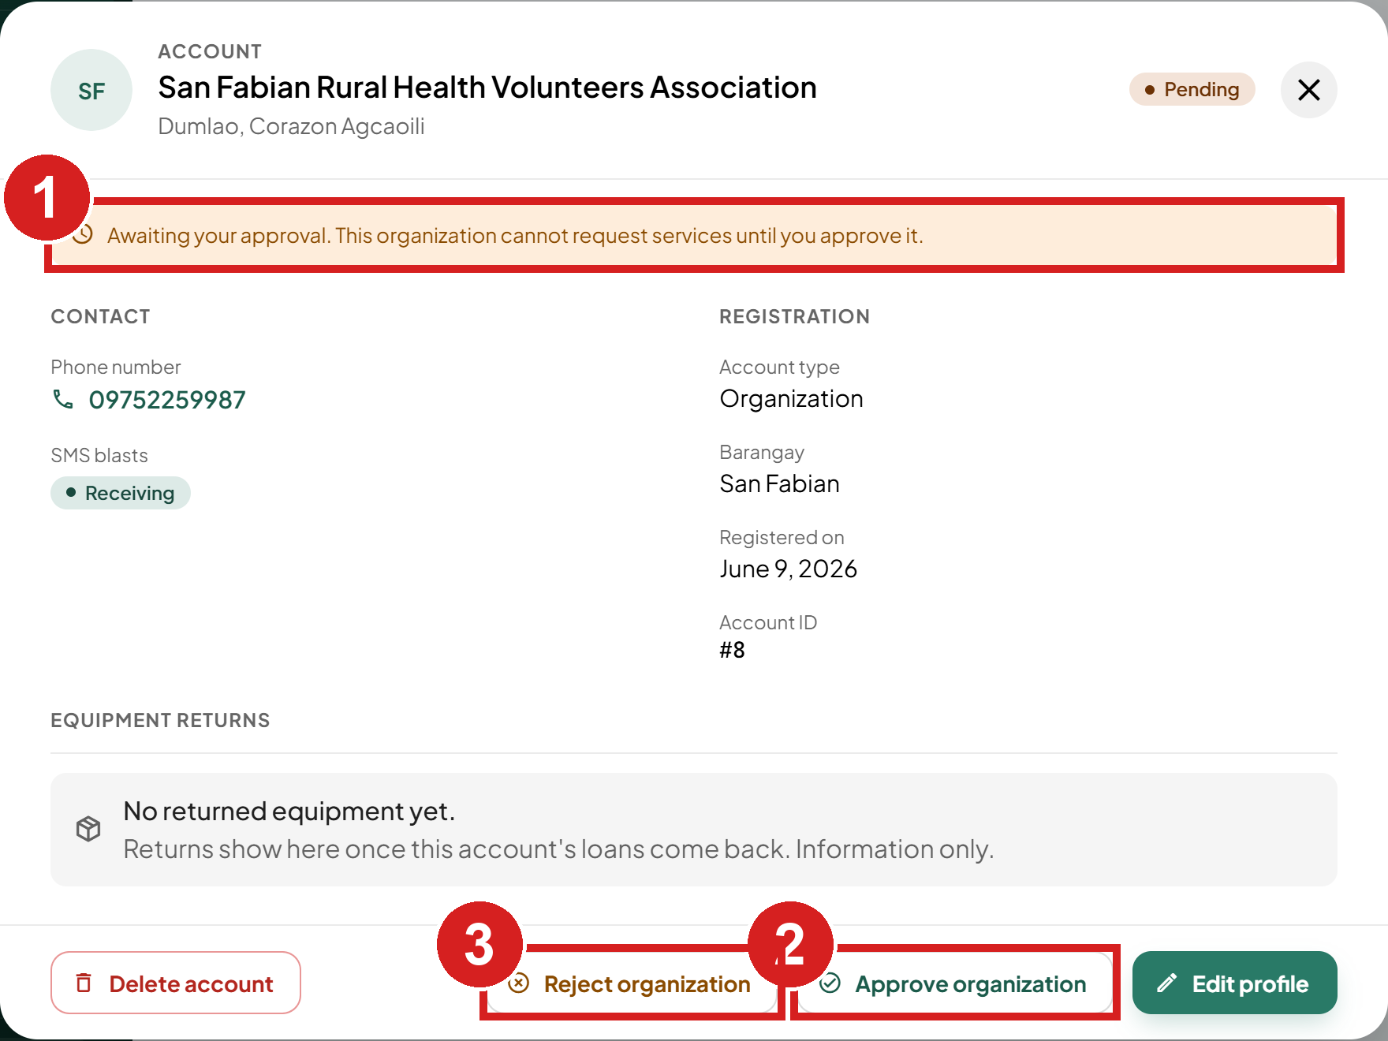
1 Waiting for approval
2 Let it request services
3 Refuse it

Publish a document
Documents appear in the app's Safety library under MDRRMO documents.
1. Click Documents.
2. Click the upload area (Upload a file) and choose the file, or drop the file on it.
3. In Title shown to residents, type the title residents will see.
4. Click Publish.
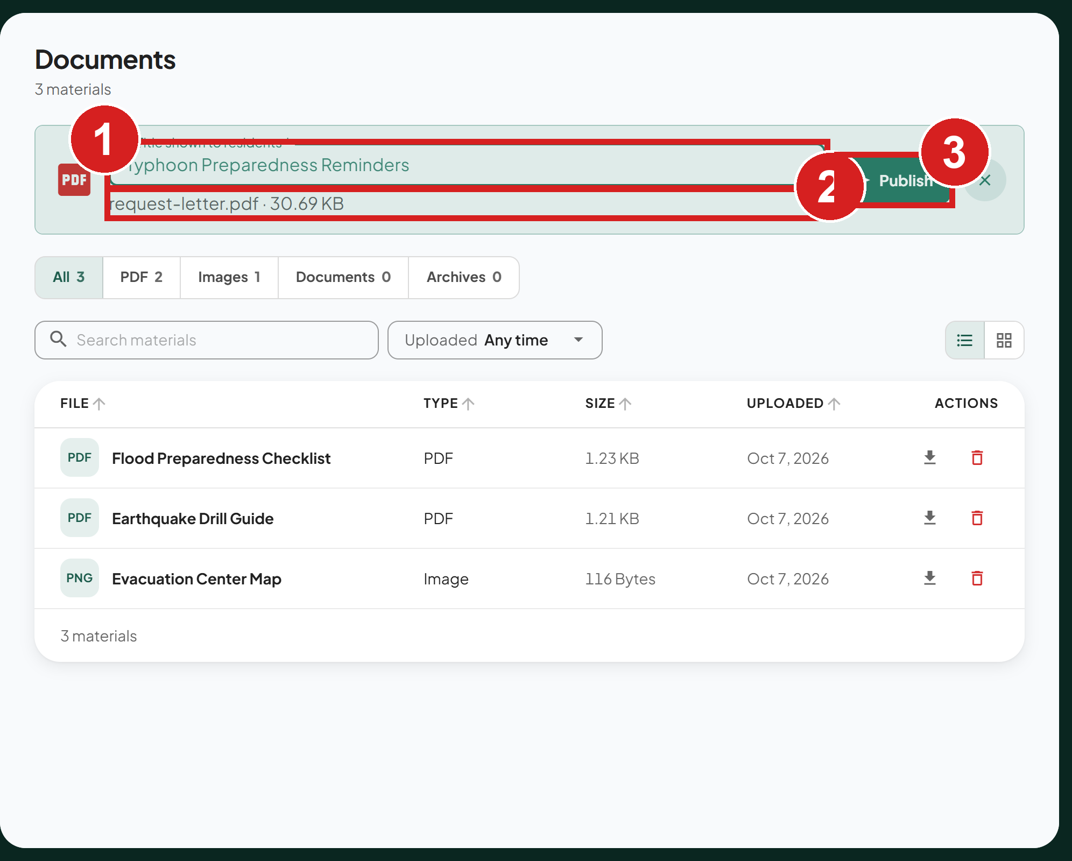
1 Name in the app's library
2 The chosen file
3 Publish it

Send a text blast
A text blast is an SMS to residents who have text alerts turned on. For news that does not need a text, post an announcement instead.
1. Click Text Blast (SMS). The New blast form is on the left.
2. Under Target audience, choose the barangays, or click Select all.
3. Optional: start from a template.
4. Type the message.
5. Check how many residents it reaches, shown under the message.
6. Click Send blast.
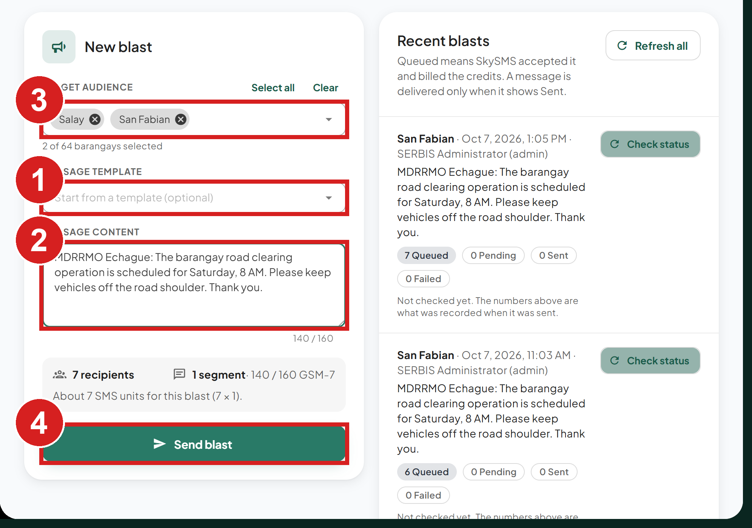
1 Start from a template
2 The text
3 Who receives it
4 Continue
7. Type the text blast code.
8. Click Send blast to send.
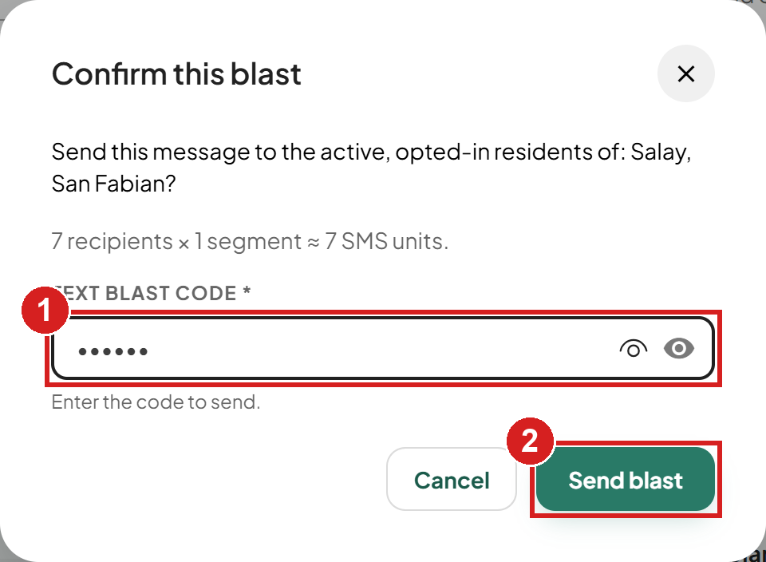
1 The code your office set
2 Send
Under Recent blasts, each blast counts its messages as Queued, Pending, Sent or Failed. A message has reached the phone only when it shows Sent. Each staff member can send up to 3 blasts an hour.

Set the text blast code
1. Click Text blast code on the Text Blast page.
2. Type the current code, then the new 6-digit code.
3. Click Set code.
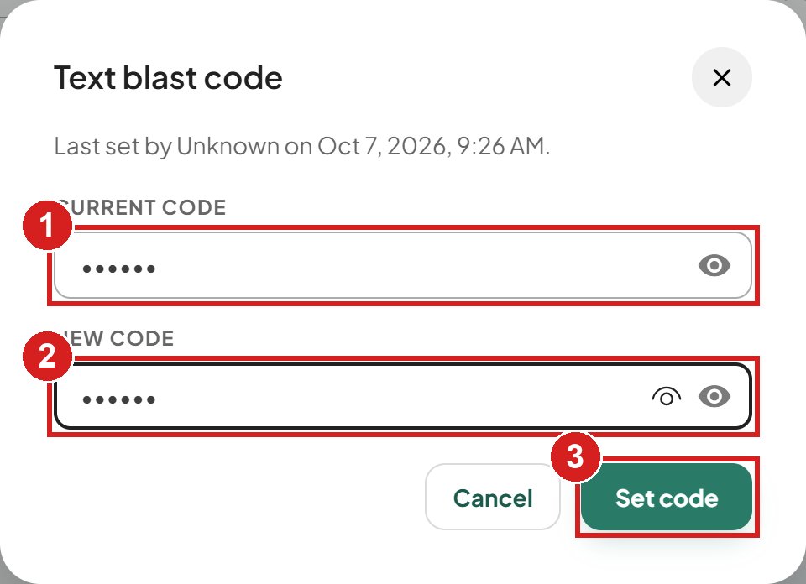
1 The code in use
2 The new code
3 Save it

Configure the system

Add, edit or disable a service
1. Click Manage Services.
2. Click Edit on a service.
3. Type the Filipino name and the description. A service's English name and category cannot be changed here.
4. Click Save changes.
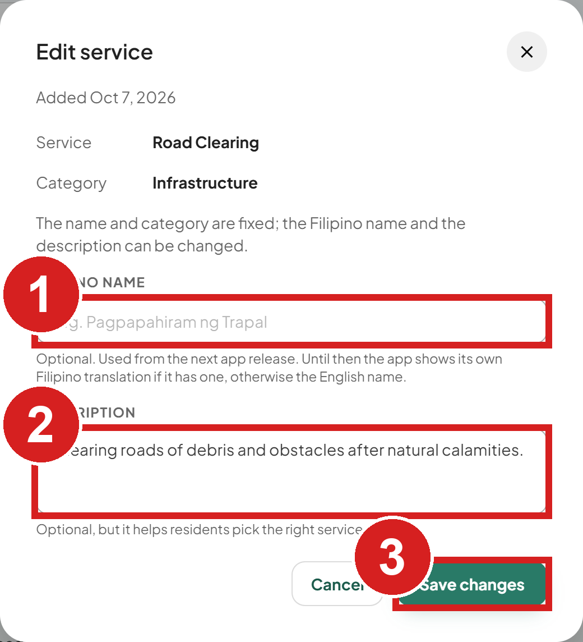 | 1 Filipino name  2 Helps residents pick the right service  3 Save

To add a service, click Add service. A new service is added switched off and uses the app's general form; residents see it after you set who can request it and click Enable. To hide a service from residents, click Disable on its row, then Disable service.

Choose who can request a service
1. Click Service Audience.
2. Tick or untick the account types for each service. Each tick is saved at once.
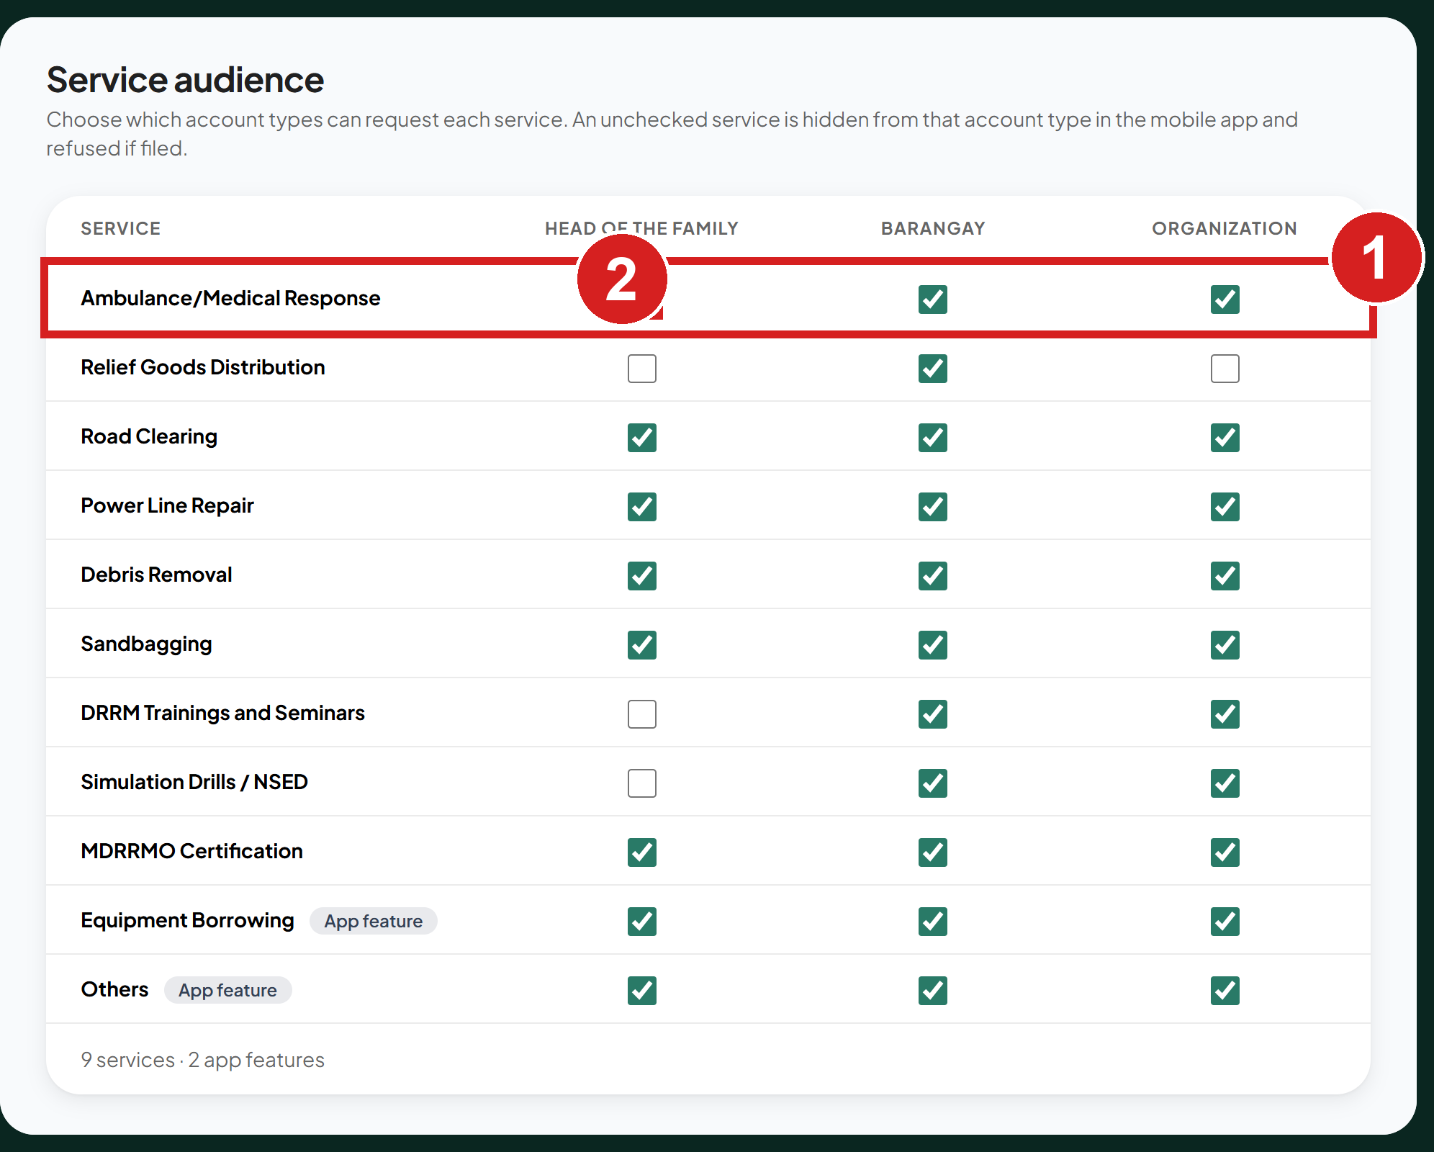
1 The service
2 Who may request it

Choose vehicles for a service
1. Click Service Vehicles.
2. Tick the vehicle types offered when approving each service. Each tick is saved at once.
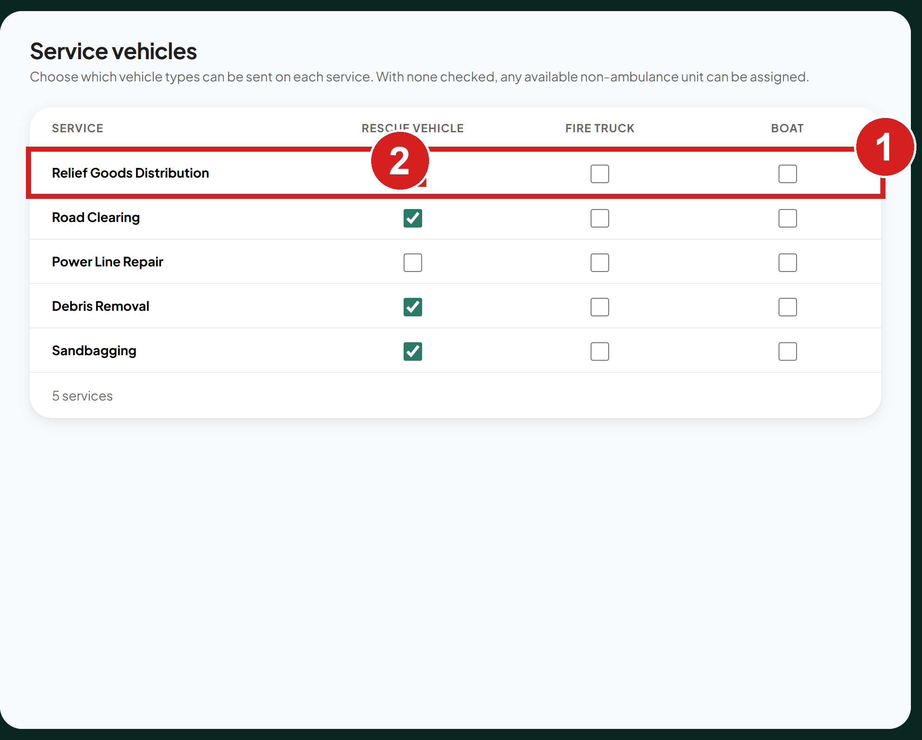
1 The service
2 Units offered when approving it

Edit emergency hotlines
The hotlines appear in the app's Safety library and emergency bar.
1. Click Emergency Hotlines.
2. Click Add hotline, or Edit on a hotline.
3. Type the name in English and Filipino, and the numbers.
4. Click Add hotline or Save changes.
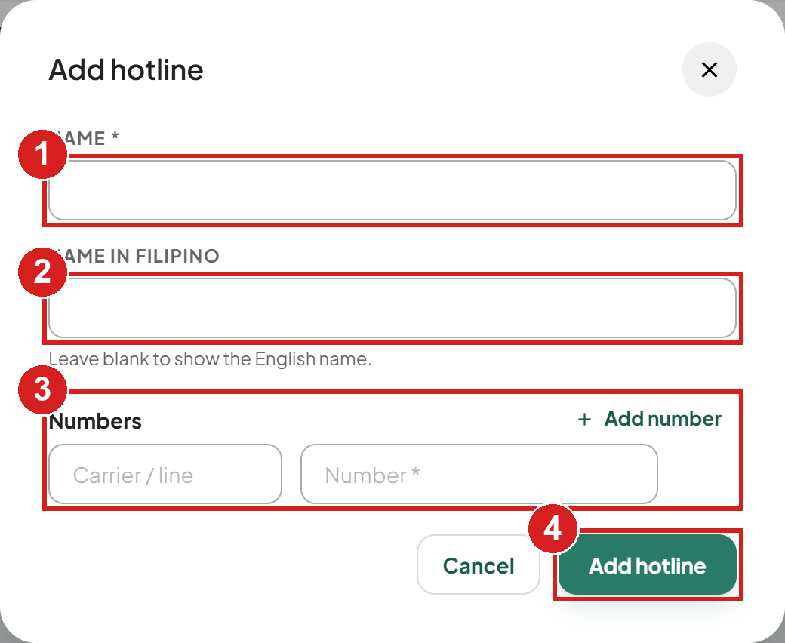
1 English name
2 Filipino name
3 One or more numbers
4 Save

Manage staff (super admin only)

Add a staff account
1. Click Staff Accounts.
2. Click Add staff account.
3. Type the name, username and mobile number.
4. Type a temporary password twice. It needs at least 8 characters, with upper and lower case letters and a number.
5. Click Create account.
6. Give the temporary password to the person directly. Like a reset password, it works only until they set their own at first sign-in.
7. A new account opens no pages. Give it access (see Set what a staff member can open).
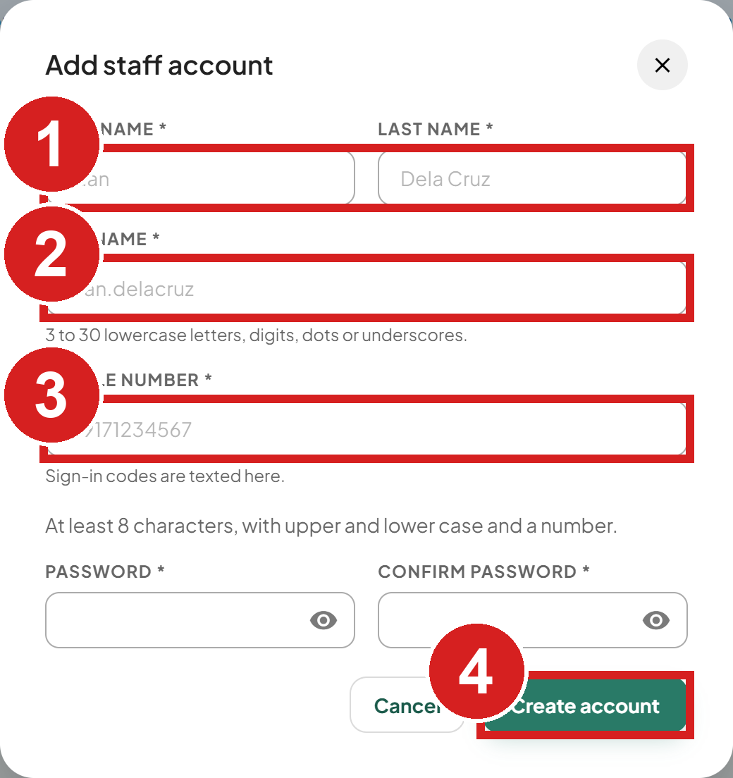 | 1 Their name  2 What they sign in with  3 For sign-in codes  4 Create the account

Set what a staff member can open
1. Click the account's More actions menu, then Manage access.
2. Tick the pages they may open.
3. Turn on Super admin only for full access, including Staff Accounts.
4. Click Save access.
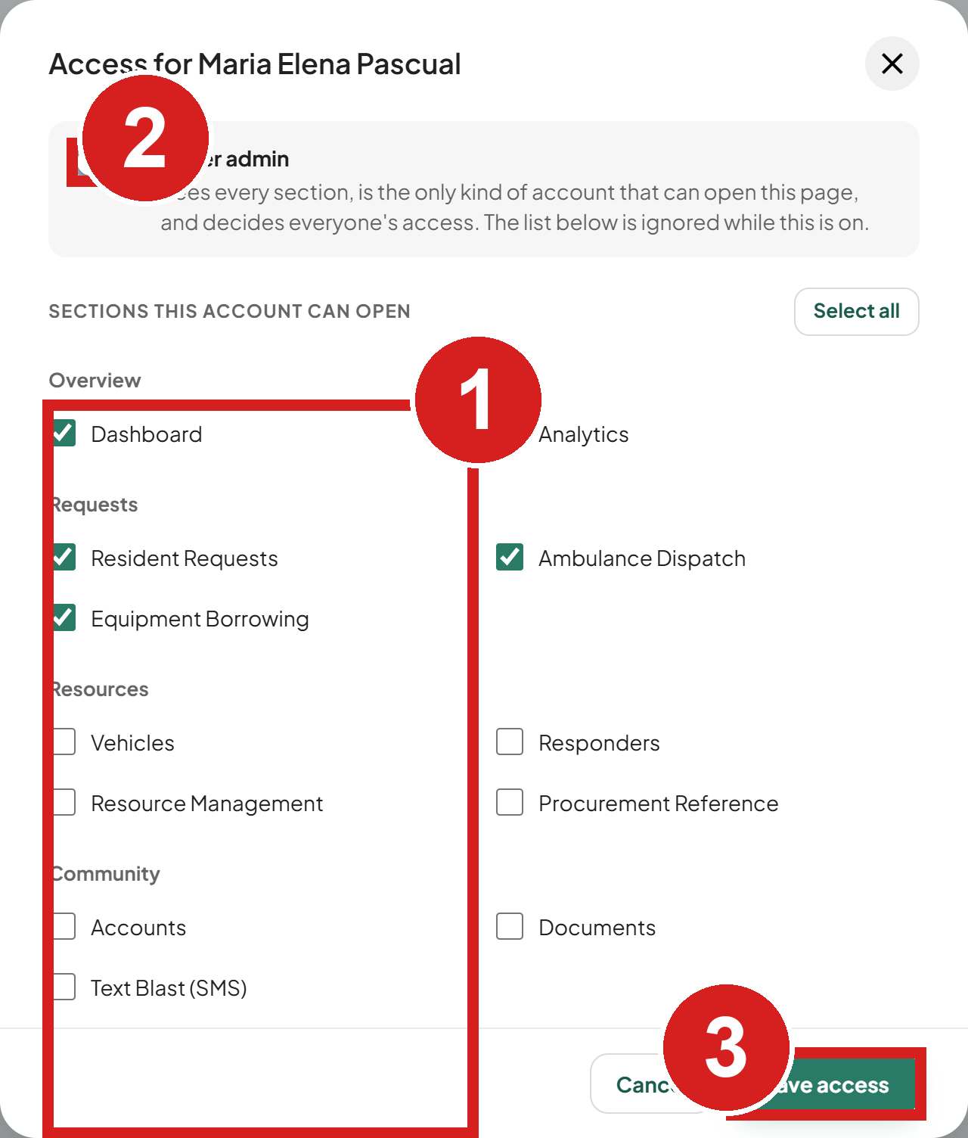 | 1 Pages they may open  2 Full access, including Staff  3 Save

Reset a password or close accounts
1. Open the account's More actions menu.
2. Click Reset password, then Reset password again to confirm. The person is signed out everywhere.
3. Copy the temporary password and pass it on in person. It is shown only once. You cannot reset your own password this way.
4. To close accounts, tick them and click Close accounts, or click Close account in the More actions menu. You cannot close your own account or the only active super admin. Closed accounts can be reactivated later.
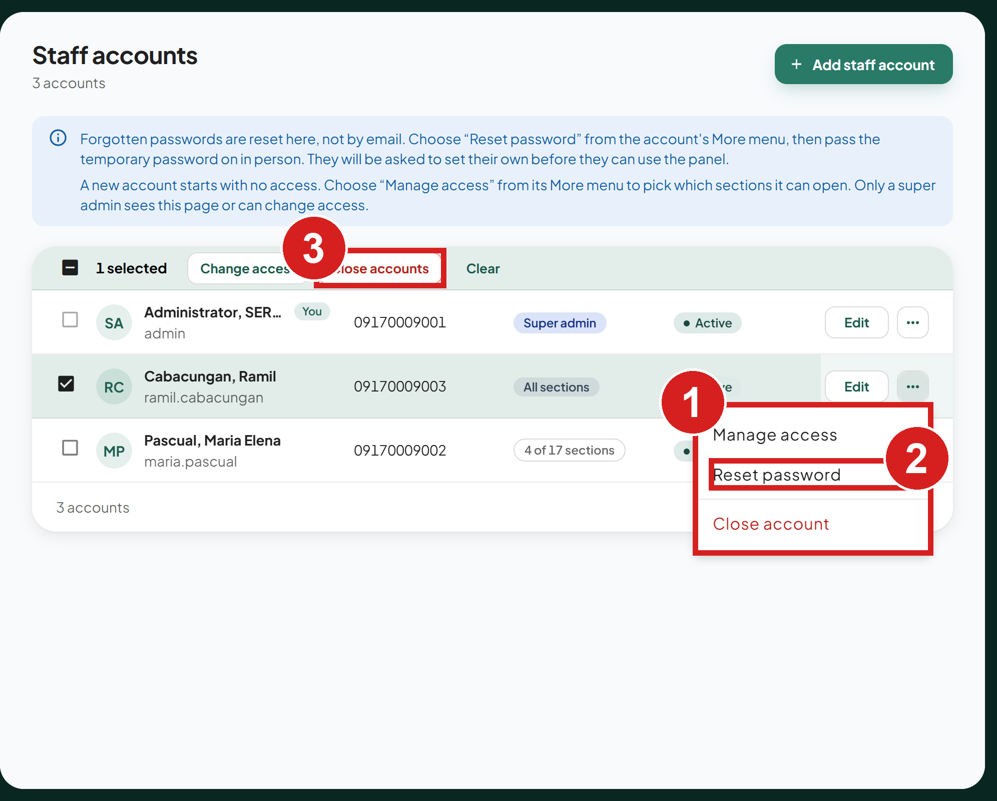
1 Actions for one account
2 New temporary password
3 Close the selected accounts

Read the activity logs
1. Click Activity Logs.
2. Search by user or action.
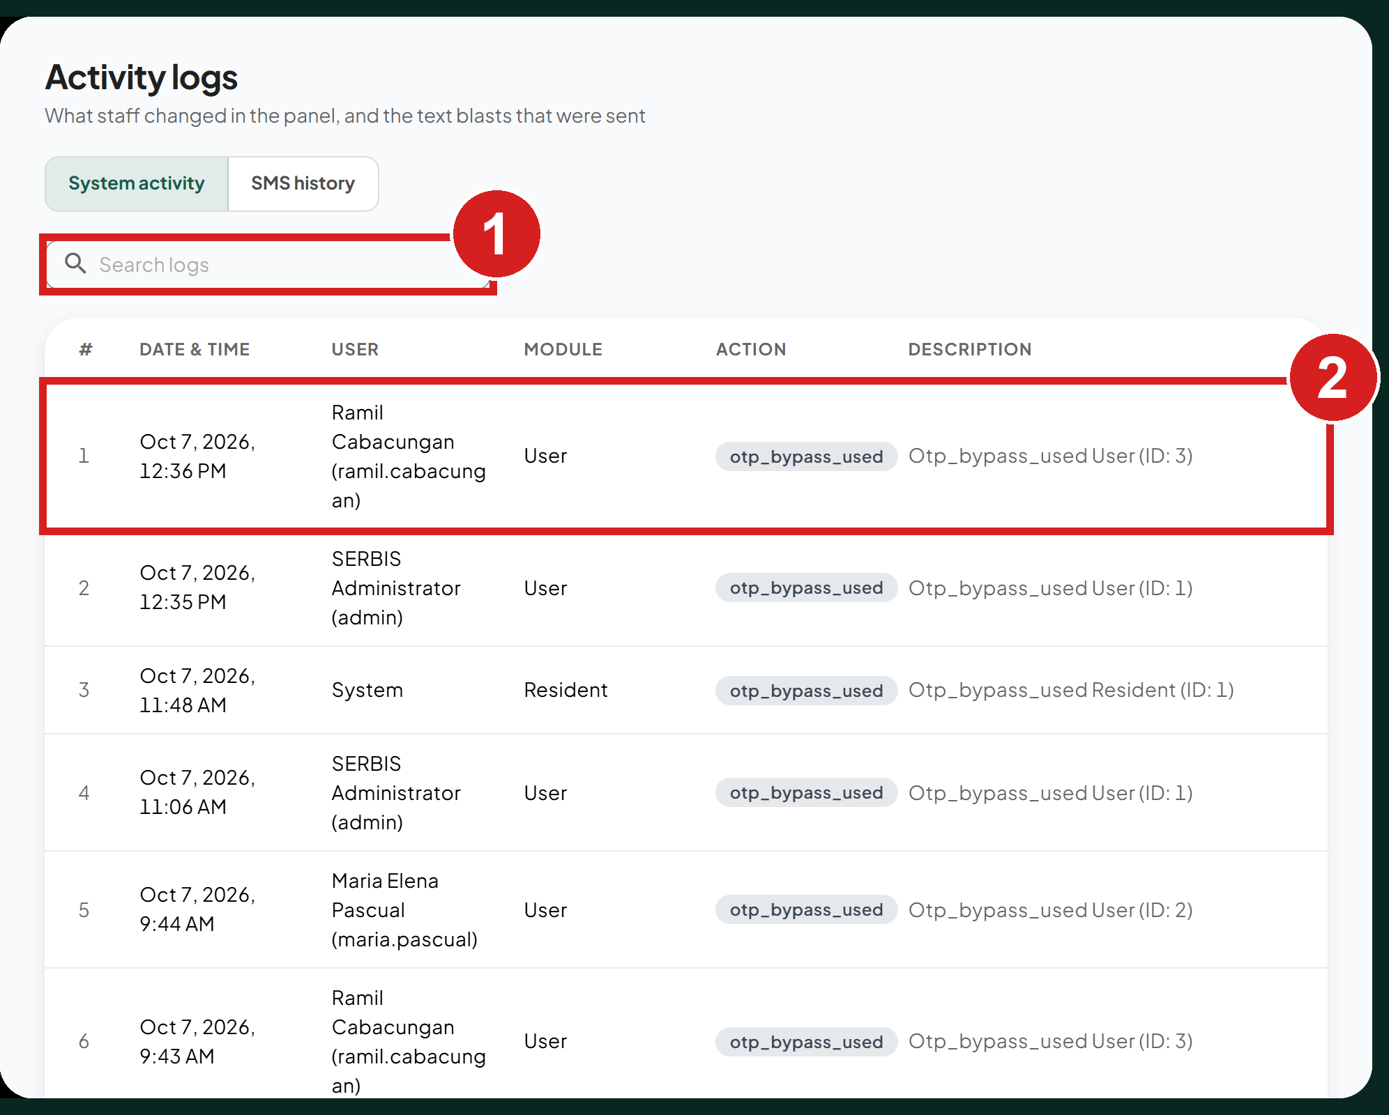
1 Find by user or action
2 Who did what, and when

Common problems
"LOCKED" on the Sign in button. Too many sign-in attempts in a minute. Wait for the countdown, then try again.
"This account has been deactivated. Contact another MDRRMO admin." A super admin closed your account. Ask them to reactivate it.
"Set a new password before continuing." You are on a temporary password. Set your own password (see Set your own password the first time).
"That code is not right, or it has expired. Ask for a new one." The code was typed wrong or is too old. Click Resend code and type the newest code.
"That login attempt has expired. Please log in again." The code step stays open for 5 minutes. Sign in again with your username and password.
"Too many wrong codes. Please log in again." After 5 wrong codes the attempt is closed. Sign in again to get a new code.
"Ask a super admin to add your mobile number." Your account has no mobile number, so no code can be sent. Ask a super admin to add it in Staff Accounts.
"We could not send the text message." The text did not go out. Wait a minute and sign in again. If it keeps happening, contact a super admin.
A page is missing from the menu. You do not have access to it. Ask a super admin.
A vehicle or responder cannot be deleted. A vehicle cannot be deleted while it is dispatched, holds future bookings, or any request uses it; set it to Maintenance instead. A responder cannot be deleted while deployed on a request.

SERBIS
Municipal Disaster Risk Reduction and Management Office
Municipality of Echague, Isabela
Operations Center, Municipal Ground, San Fabian, Echague, Isabela, 3309
Hotline: 09176262352 / 09431320604
Email: mdrrmo.echague@gmail.com
Facebook: Mdrrmo Echague | Page: Echague Rescue
v1.0, October 2026

