SERBIS Mobile App
  - User Manual for Residents
MDRRMO Echague
September 2026

Contents
About this manual 4
1 Installing the app 4
2 Creating an account 5
2.1 Account types 5
2.2 Registering 5
2.3 Confirming your mobile number 9
2.4 If you registered an Organization 10
2.5 Which services each account can use 12
3 Logging in and the Home screen 13
3.1 Logging in 13
3.2 Forgot your password 15
3.3 The Home screen 15
4 Asking for a service 17
4.1 The Services list 17
4.2 Filling in a request 20
4.3 After you submit 21
5 Booking an ambulance 22
5.1 Patient 23
5.2 Trip details 26
5.3 Condition and relatives 28
5.4 When 28
5.5 Sending the booking 32
6 Following your requests 32
6.1 What each status means 33
6.2 Cancelling a request 38
7 Borrowing equipment 39
7.1 Asking to borrow 39
7.2 Following your borrowing 42
8 Notifications, announcements and the Library 43
8.1 Notifications 43
8.2 Announcements 44
8.3 The Library 44
9 Using the app without internet 47
10 Changing the language 48
Appendix A. Status words 51
10.1 Service requests and ambulance bookings 51
10.2 Borrowing requests 52
Appendix B. Troubleshooting 52
10.3 I did not get the code by text message 52
10.4 My request was refused 52
10.5 A service is not shown for my account 52
10.6 My organization account is still waiting 53
10.7 The app says it cannot connect 53

About this manual
SERBIS is the app of MDRRMO Echague. With it you can:
- ask MDRRMO for a service, like road clearing or animal rescue;
- book the MDRRMO ambulance for patient transport;
- borrow equipment, like a wheelchair or a tent;
- follow your requests until they are done;
- read safety guides and call the emergency hotlines.
SERBIS is not for life-threatening emergencies. If someone’s life is in danger, call the hotlines in Section 8 or 911.
The pictures in this manual come from a test copy of the app with sample names. Your screens will show your own name and requests.
Words in bold are exactly what you see on the screen.

1 Installing the app
MDRRMO gives out the app as an APK file. It is not in the Google Play Store, so Android asks you to allow the install first.
- Download the SERBIS APK file from the link MDRRMO gives you.
- Open the downloaded file. You can find it in your Downloads folder or in your browser’s downloads.
- Android may say that your phone is not allowed to install unknown apps from this source. Tap Settings on that message.
- Turn on Allow from this source.
- Go back. Tap Install.
- When it is done, tap Open.
The words on your phone may be a little different. On some phones the setting is in Settings > Apps > Special app access > Install unknown apps. Choose the app you downloaded with (for example your browser or Files) and turn on Allow from this source.
If Google Play Protect shows a warning, tap More details, then Install anyway. Only do this for the file you got from MDRRMO.
Note: there are no pictures for this section. The install screens could not be captured from the test copy.

2 Creating an account

2.1 Account types
There are three kinds of accounts:
Account type | Who it is for | How it is made
Individual | The head of the family, for the household | You sign up in the app. You can use it right away.
Organization | A school, office or other group | You sign up in the app. MDRRMO must approve it first.
Barangay | A barangay hall | MDRRMO makes it. You cannot sign up for it in the app.
The app says “Individual”. In MDRRMO’s records this is the “Head of the Family” account. Make only one account per household.

2.2 Registering
- Open the app. Tap Register at the bottom of the log-in screen.
- Under Registering as, tap Individual or Organization.
- Fill in your name.
  - For Individual: First name and Last name.
  - For Organization: Organization name, then the Contact first name and Contact last name of the person in charge.
- Type your Mobile number, starting with 09 (for example 09171234567).
- Tap Barangay and start typing the name of your barangay. The list shows every barangay that contains what you typed. Tap yours.
- Type your street or purok in Street / Purok (optional). You can leave it blank and add it later in your profile.
- Type a Password. It must have at least 8 characters, with a capital letter, a small letter and a number (for example Pasada123).
- Type the same password again in Confirm password.
- Tick the box that starts with I agree that my information will be used by Echague MDRRMO.
- Tap Create account.
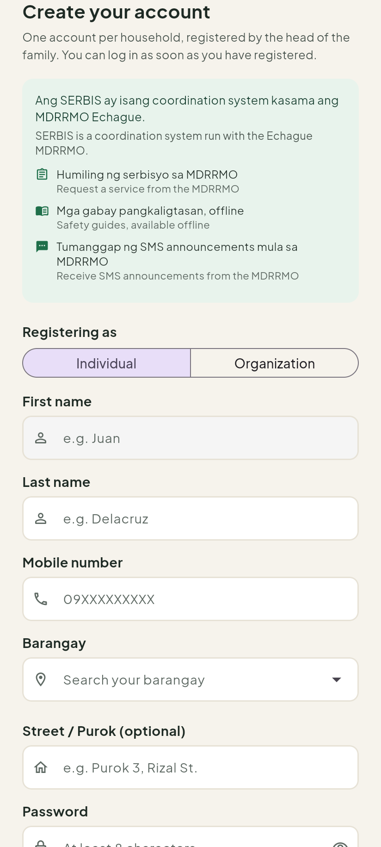
Figure 1. The register screen for an Individual account.
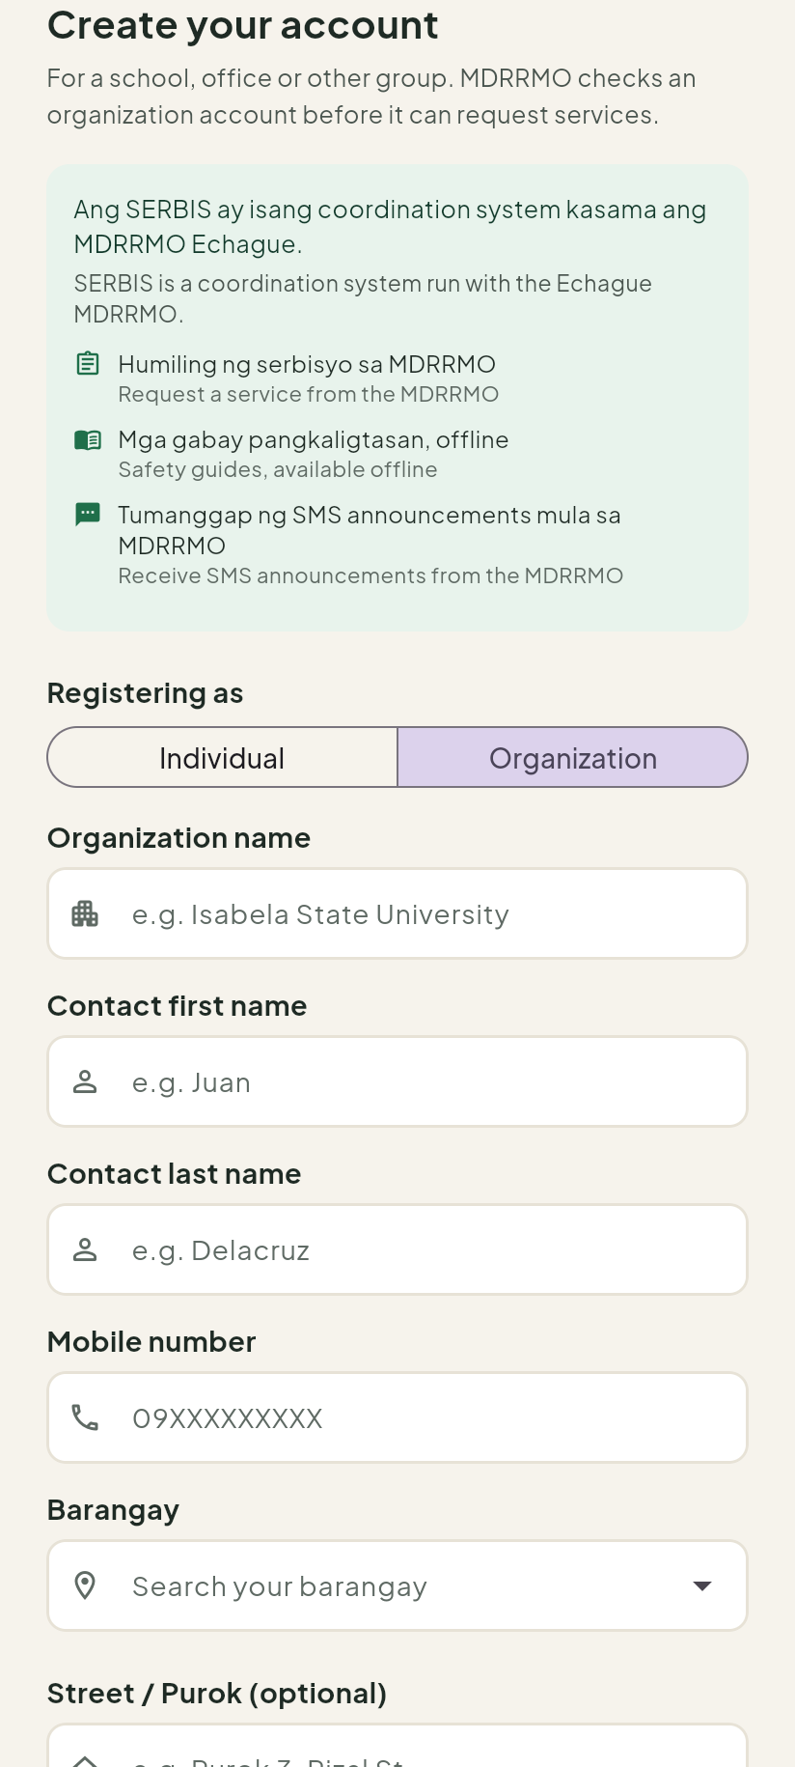
Figure 2. The register screen for an Organization account.
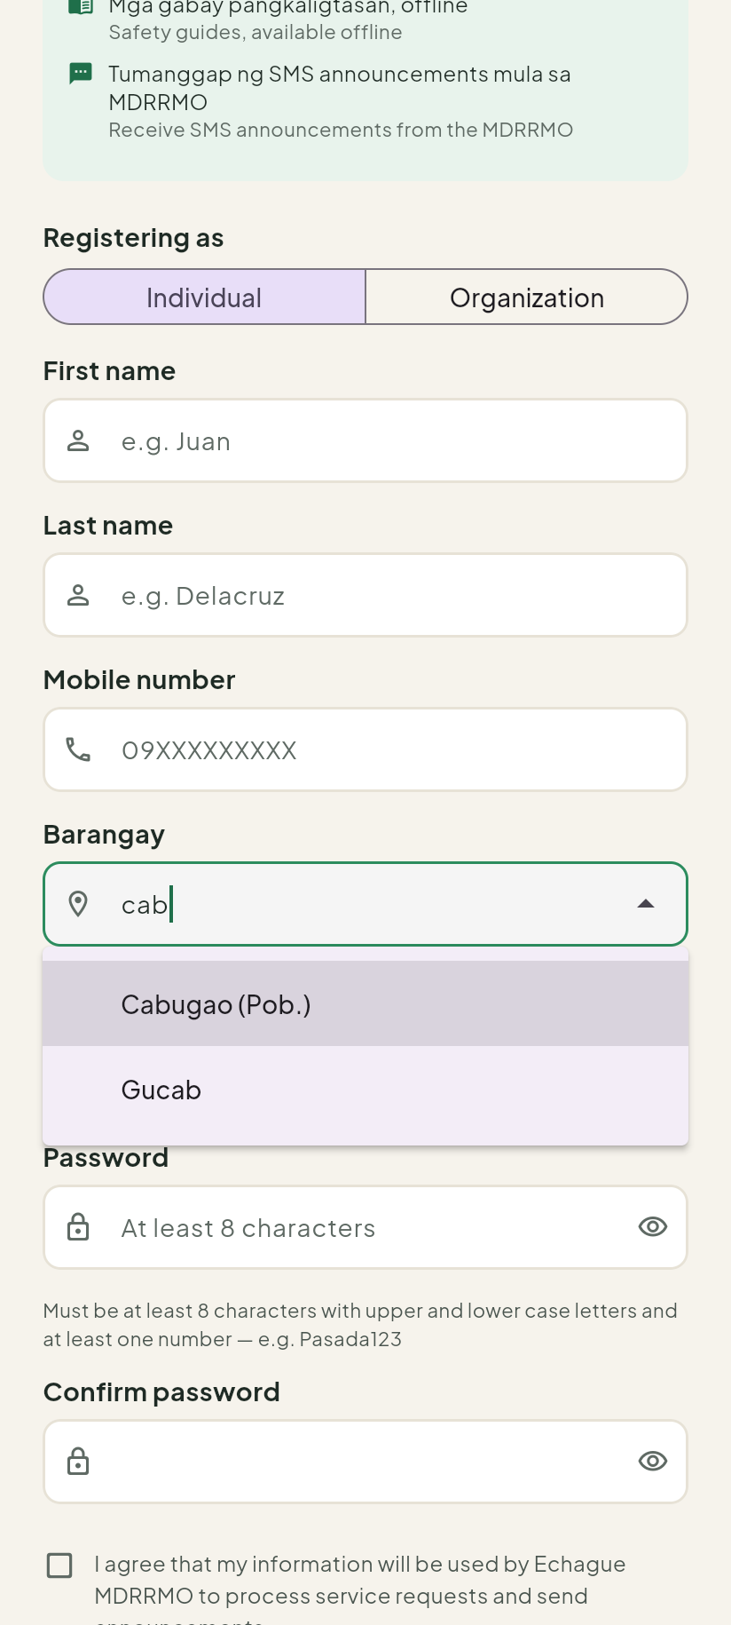
Figure 3. Typing “cab” in Barangay. The list shows Cabugao (Pob.) and Gucab.
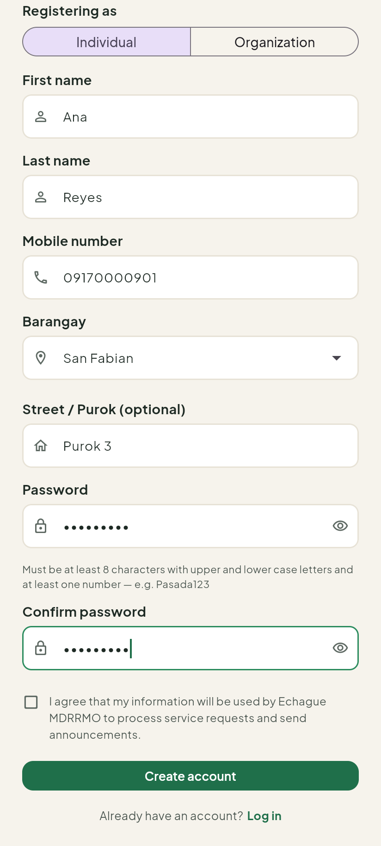
Figure 4. The form filled in, ready to tap Create account.

2.3 Confirming your mobile number
After you tap Create account, MDRRMO sends a 6-digit code by text message.
- Wait for the text message.
- Type the 6 digits in Verification code.
- Tap Verify.
If no text arrives, wait until the countdown Resend code in …s ends (about one minute). Then tap Send a new code. Your account is only created after you enter the code.
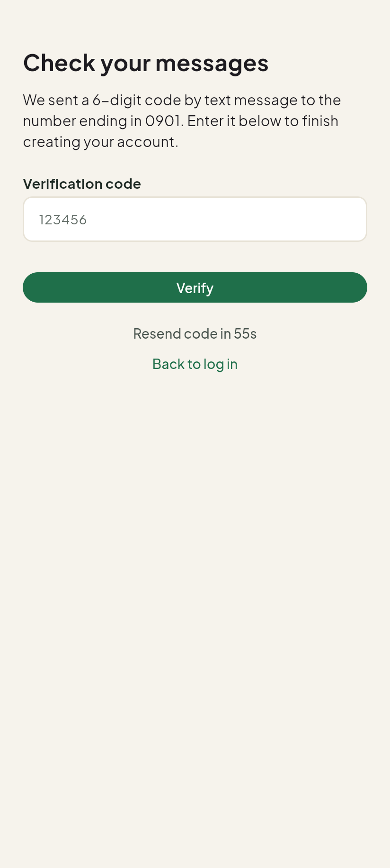
Figure 5. The screen where you type the code from the text message.

2.4 If you registered an Organization
An organization account must be approved by MDRRMO before it can ask for services.
- Your Home screen shows Awaiting MDRRMO approval.
- The service tabs show a card that says Awaiting MDRRMO approval.
- Tap Check again to see if MDRRMO has approved it.
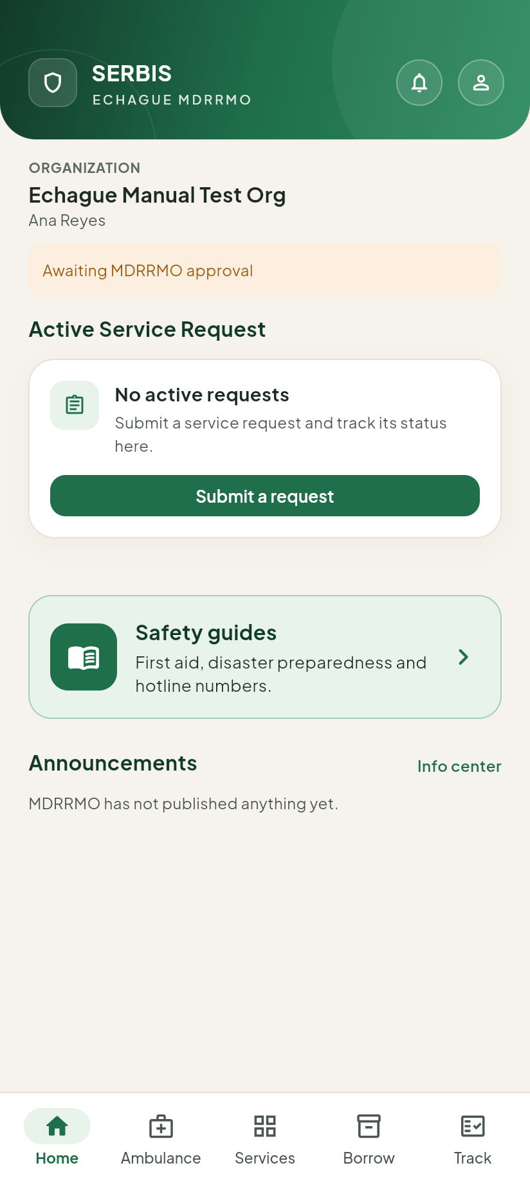
Figure 6. Home screen of an organization that is waiting for approval.
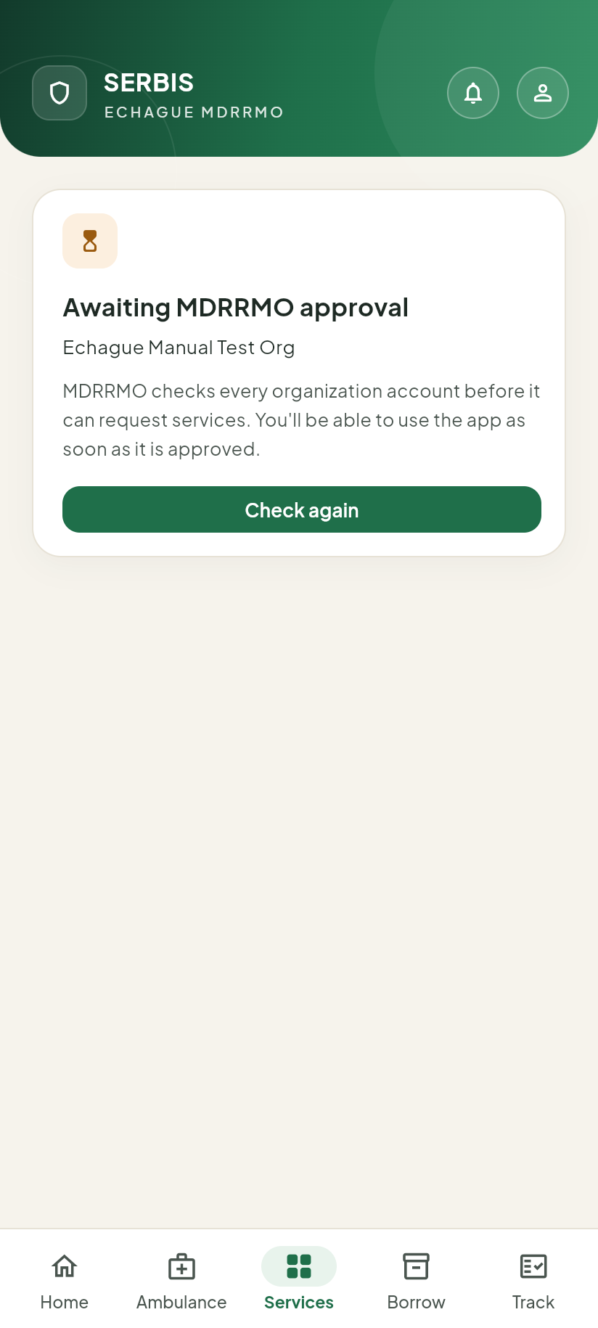
Figure 7. The Services tab while waiting for approval.

2.5 Which services each account can use
Not every account type sees every service. This table shows the current settings.
Service | Individual | Barangay | Organization
Ambulance/Medical Response | Yes | Yes | Yes
Road Clearing | Yes | Yes | Yes
Power Line Repair | Yes | Yes | Yes
Debris Removal | Yes | Yes | Yes
Animal Rescue | Yes | Yes | Yes
Sandbagging | Yes | Yes | Yes
Relief Goods Distribution | No | Yes | No
DRRM Trainings and Seminars | No | Yes | Yes
Simulation Drills / NSED | No | Yes | Yes
MDRRMO Certification | Yes | Yes | Yes
Others | Yes | Yes | Yes
Equipment borrowing | Yes | Yes | Yes
MDRRMO can change these settings at any time. If a service is missing from your app, it is not open to your account type right now.

3 Logging in and the Home screen

3.1 Logging in
- Type your Mobile number.
- Type your Password.
- Tap Log in.
- MDRRMO sends a 6-digit code by text message. Type it in Verification code and tap Verify.
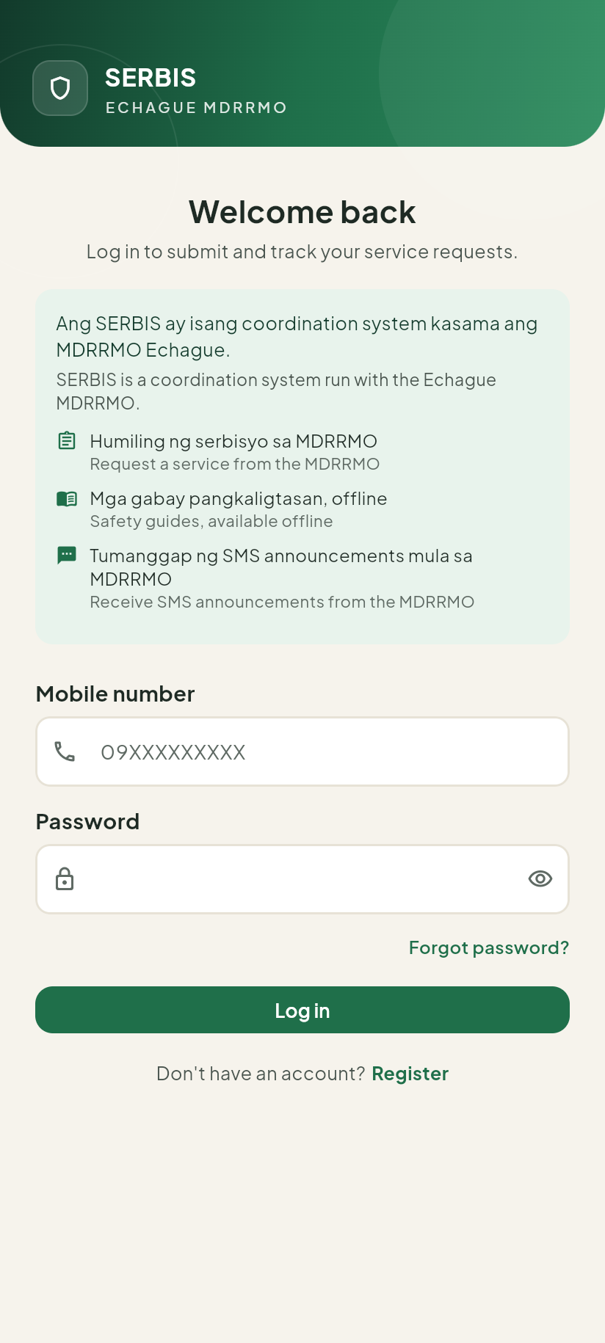
Figure 8. The log-in screen.
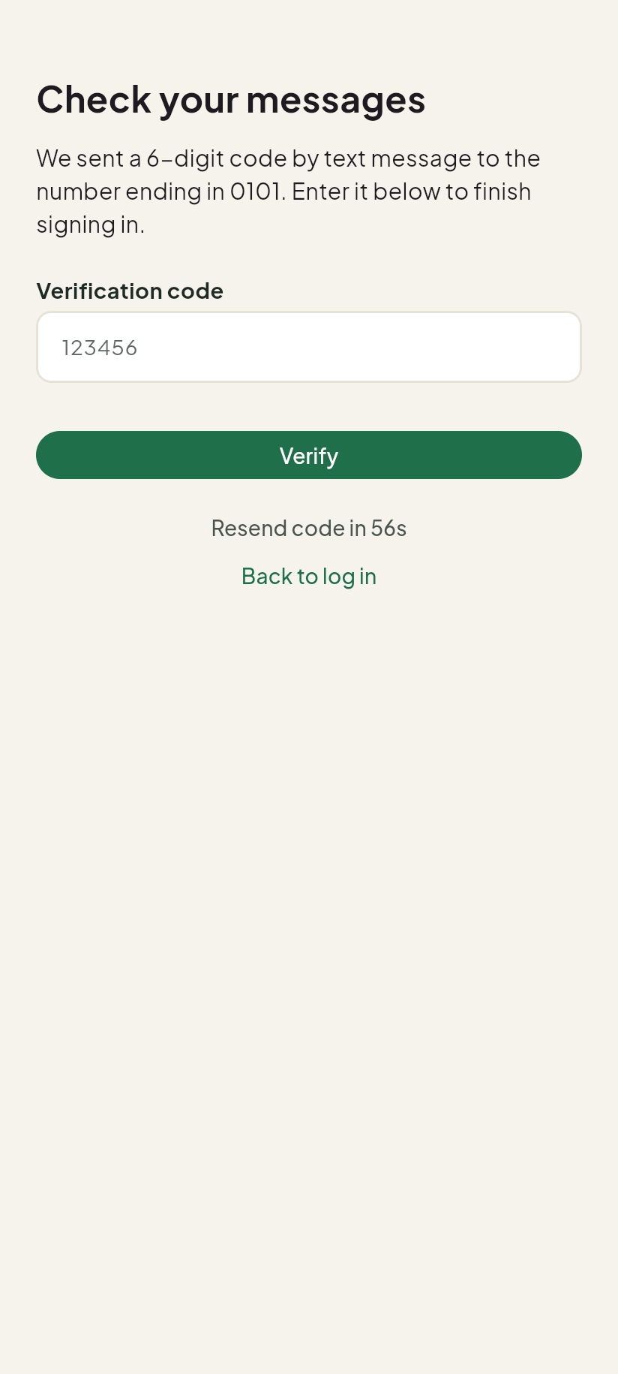
Figure 9. After you log in, type the code from the text message.

3.2 Forgot your password
- On the log-in screen, tap Forgot password?
- Type your Mobile number and tap Send code.
- Type the code from the text message and tap Verify.
- Type a New password, type it again in Confirm new password, and tap Change password.

3.3 The Home screen
At the top you see your account type and your name.
- Active Service Request shows your latest open request, with its status. Tap View details or View all to open it in Track. Tap Cancel to cancel it, if it can still be cancelled.
- Need help now? has shortcuts to Medical Transport / Ambulance and Borrow Equipment.
- Safety guides opens the Library.
- Announcements lists documents MDRRMO has published. Tap Info center to see them all.
- The bell at the top right opens Notifications. The round button next to it opens your profile.
At the bottom are five tabs: Home, Ambulance, Services, Borrow and Track.
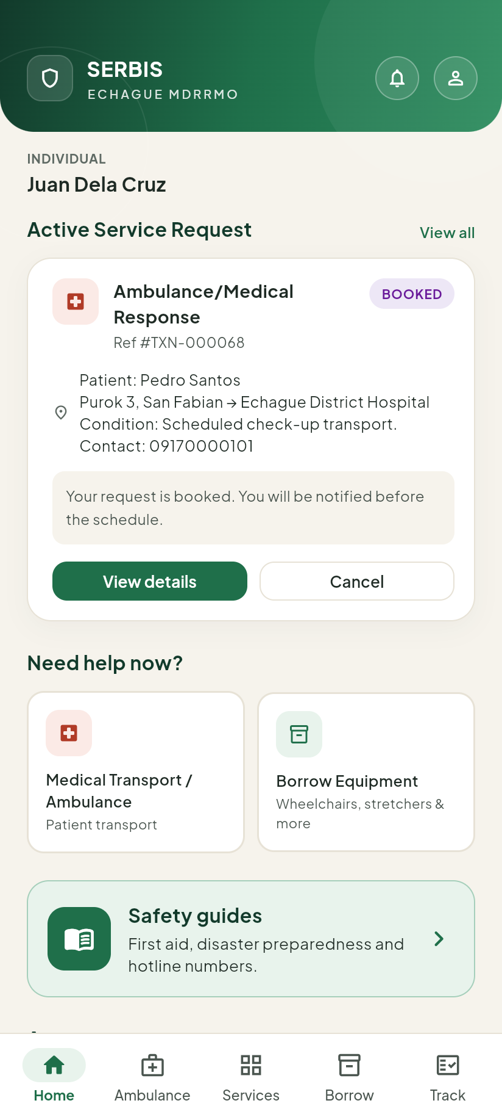
Figure 10. Home screen of an Individual account.
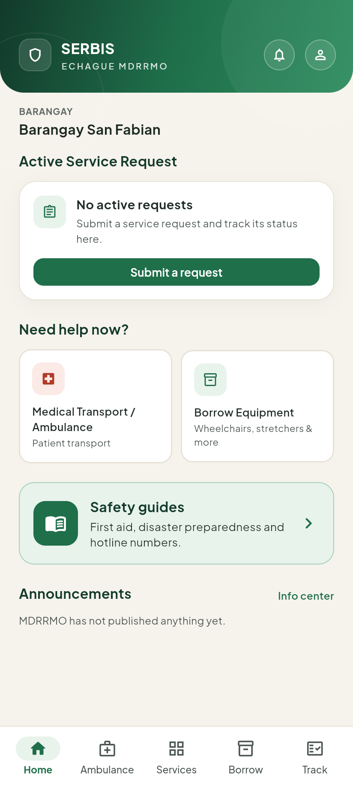
Figure 11. Home screen of a Barangay account.

4 Asking for a service

4.1 The Services list
Tap Services at the bottom. The services are grouped under headings: Infrastructure, Rescue, Relief, Programs and Other requests. Each row shows the service name and a short description.
The list depends on your account type (see the table in Section 2).
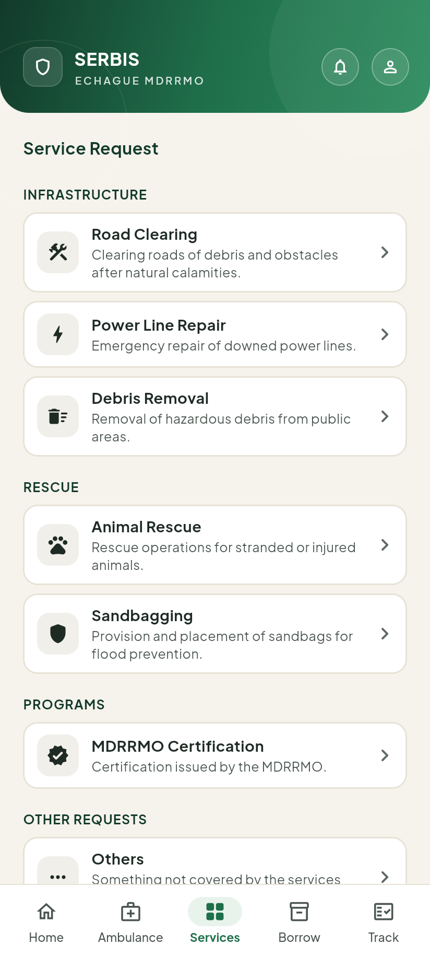
Figure 12. The Services list of an Individual account.
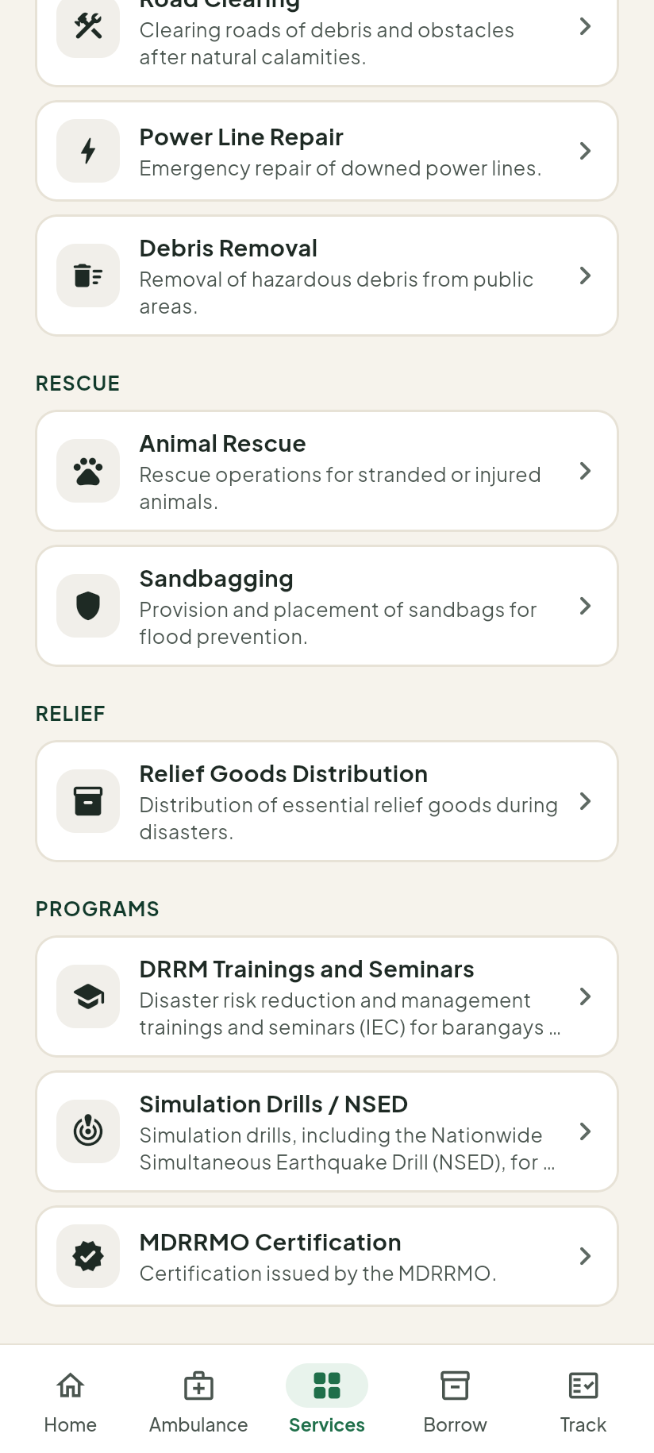
Figure 13. A Barangay account also sees Relief Goods Distribution and the training and drill programs.
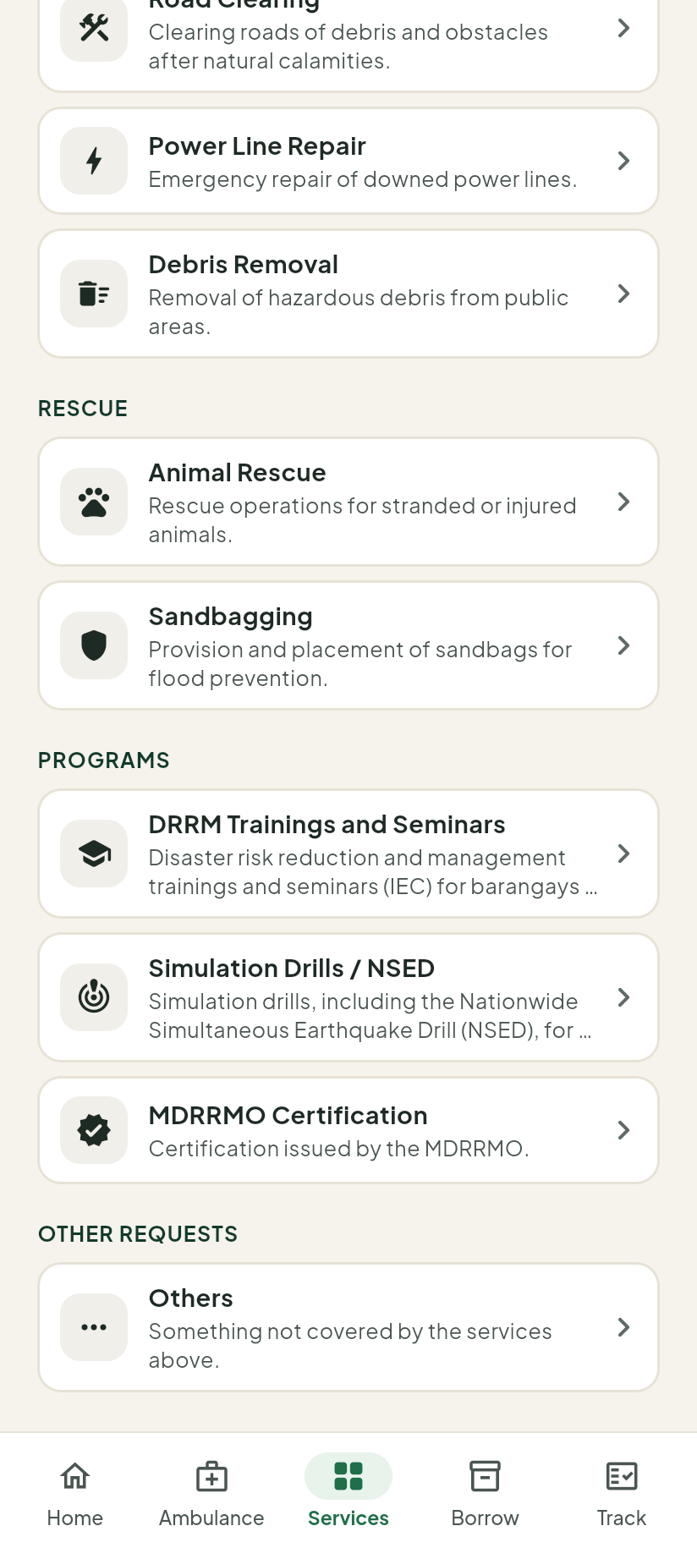
Figure 14. An Organization account sees the programs but not Relief Goods Distribution.

4.2 Filling in a request
This example uses Animal Rescue. Other services ask for different details, but the steps are the same.
- In Services, tap the service you need.
- Fill in the details. For Animal Rescue, type what you need and where in Details.
- Under Valid ID (required), tap the box and choose a photo of a valid ID (JPG or PNG, up to 2 MB). The box turns green and shows the file name.
- If you want, add a Site photo (optional) and a Landmark (optional).
- Tap Submit request.
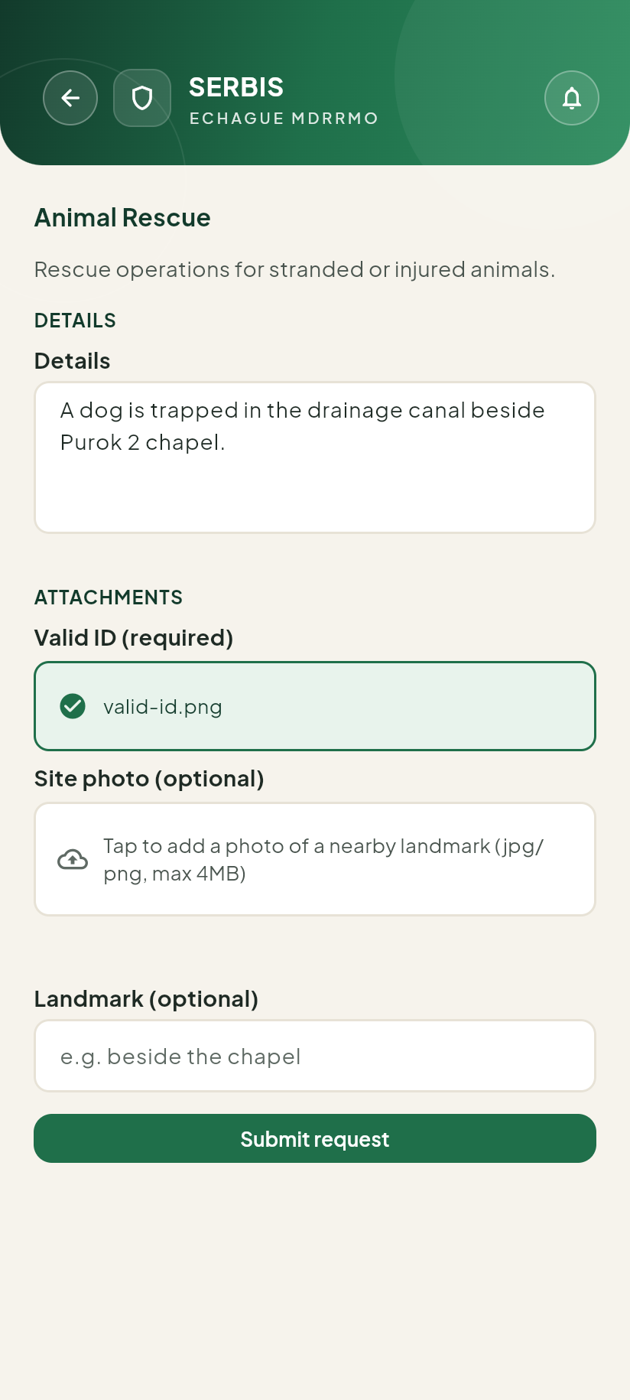
Figure 15. The Animal Rescue form, filled in, with the valid ID attached.

4.3 After you submit
The app shows Request submitted and your reference number, like TXN-000073. Keep this number. MDRRMO uses it to find your request.
Tap View in Track to follow your request.
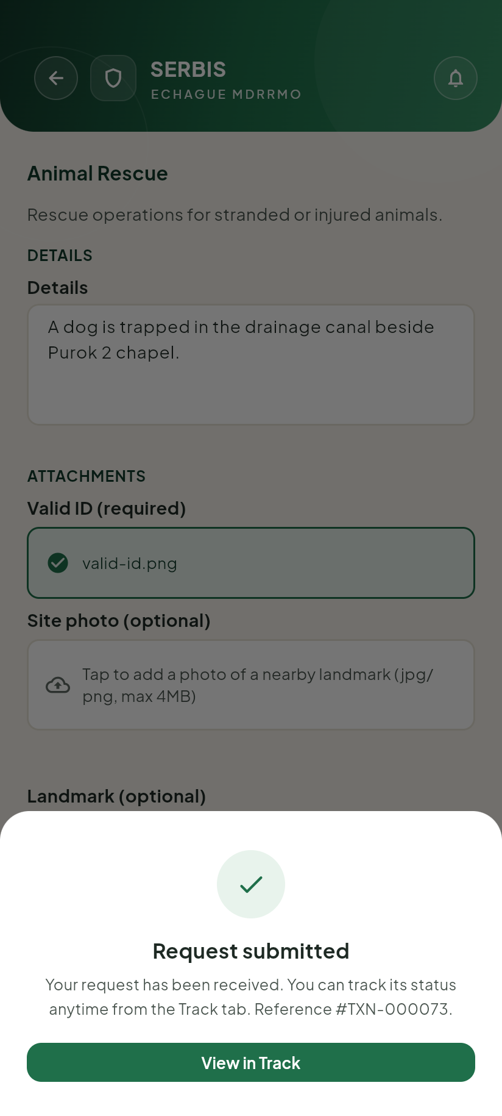
Figure 16. The confirmation, with the reference number.
If the app shows Your request wasn’t sent. Your details are still here — tap Retry to send them again., check your internet and tap Retry.

5 Booking an ambulance
Tap Ambulance at the bottom of the screen. The form has five parts: Patient, Trip details, Condition, Patient / Relatives and When.
At the top you see Non-life-threatening use only. If the patient’s life is in danger, do not use this form. Tap View emergency hotlines and call.
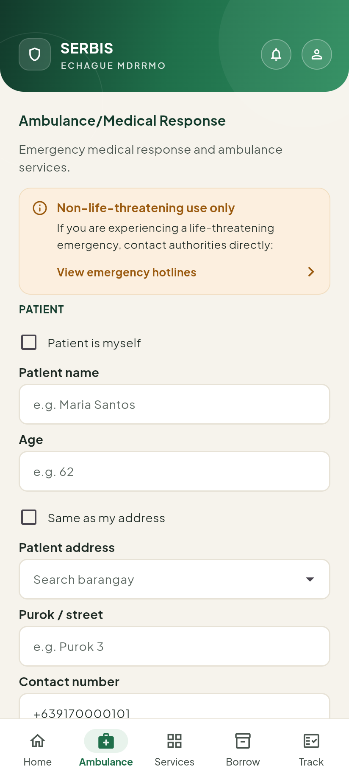
Figure 17. The top of the Ambulance form.

5.1 Patient
- If you are the patient, tick Patient is myself. Your name is filled in. You can still change it.
- Otherwise, type the Patient name.
- Type the patient’s Age.
- Set the Patient address:
  - If the patient lives at your address, tick Same as my address. Your barangay and street are filled in.
  - Or tap Patient address and start typing the barangay. Tap it in the list. Then type the purok or street in Purok / street.
  - If the patient lives outside Echague, choose Other in the list. The box below changes to Full address. Type the whole address there.
- Check the Contact number. It is your number at first. Change it if MDRRMO should call someone else about the patient.
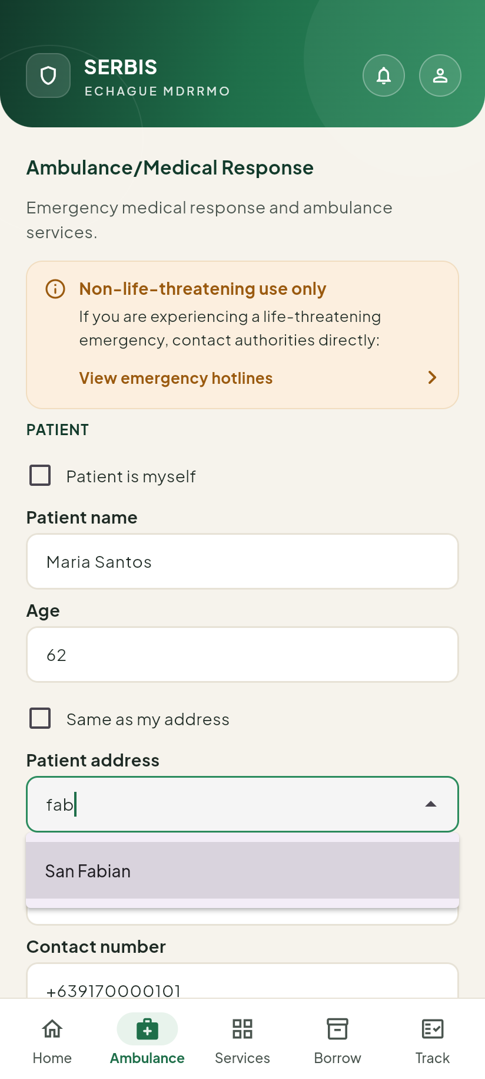
Figure 18. Typing “fab” in Patient address shows San Fabian.
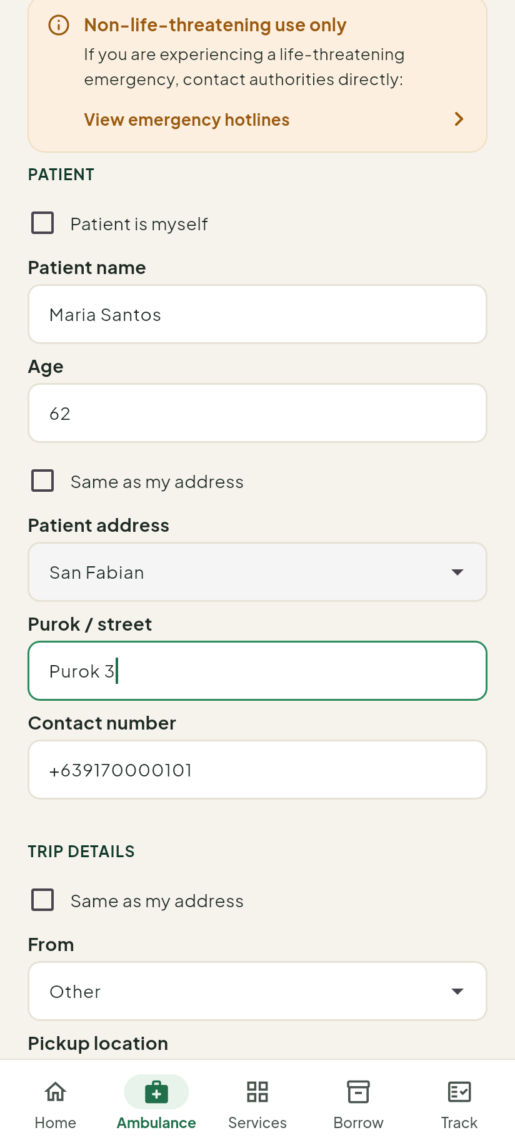
Figure 19. Patient details filled in.
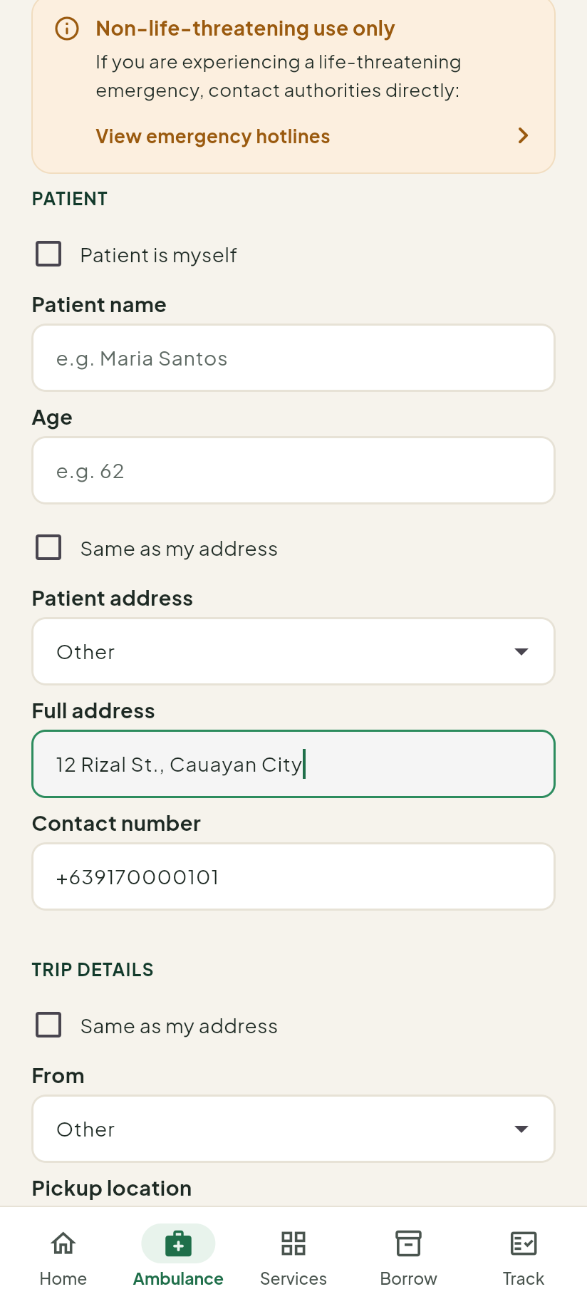
Figure 20. With Other, type the full address.

5.2 Trip details
- From is where the ambulance picks up the patient.
  - If the patient is at a hospital in the list, choose that hospital.
  - Otherwise leave Other and type the place in Pickup location.
  - Tick Same as my address to fill in your own address.
- Type a Landmark (optional) near the pickup place, so the crew can find it. For example “Beside the chapel”.
- To is where the patient is going. Choose a hospital in the list. If it is not in the list, choose Others and type the place in Destination.
You can type in From and To to find a hospital faster.
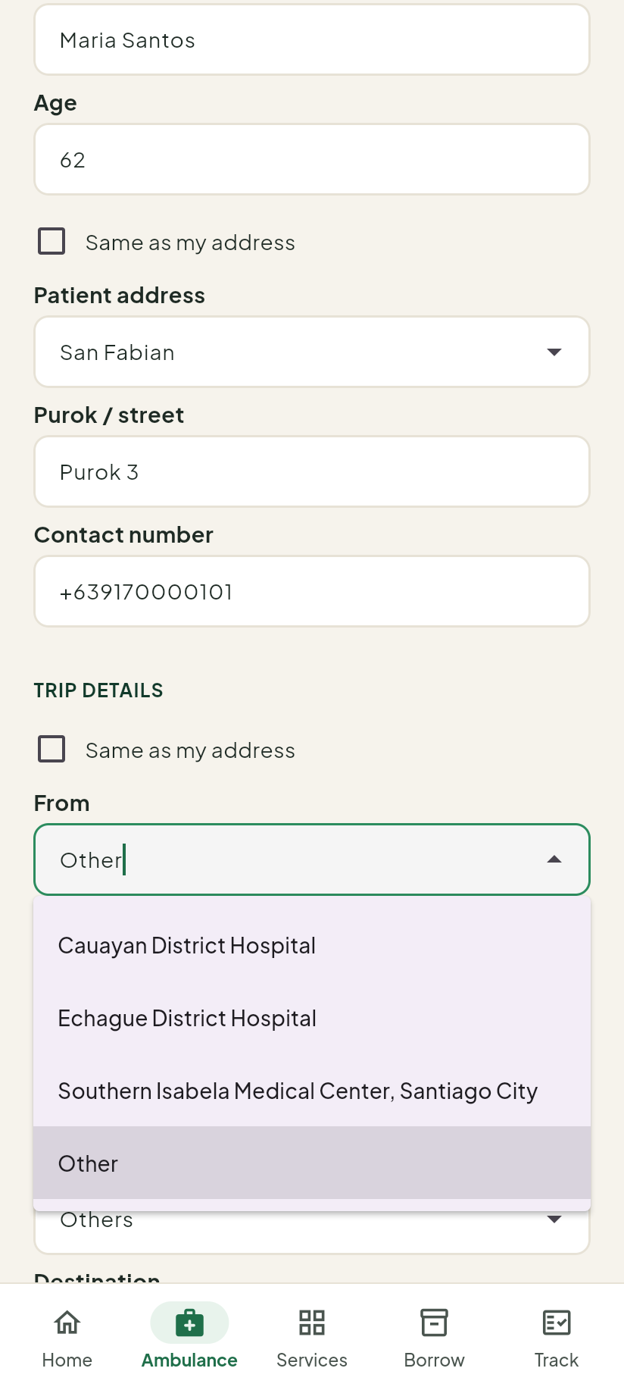
Figure 21. The hospital list in From, with Other at the end.
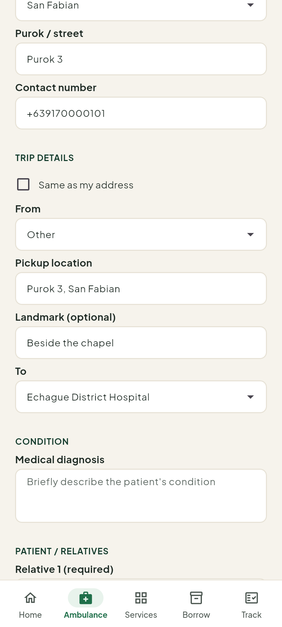
Figure 22. Trip details filled in.

5.3 Condition and relatives
- In Medical diagnosis, write the patient’s condition in a few words.
- In Relative 1 (required), type the name of a relative who will go with the patient.
- To add a second relative, tap Add relative.

5.4 When
- As soon as possible: MDRRMO sends the ambulance as soon as it can.
- Scheduled: you pick a date and time.
To schedule:
- Tap Scheduled.
- Choose the date and tap OK.
- Choose the time and tap OK.
The time must be at least 1 hour from now. You can book up to 60 days ahead. If you pick a time too soon, the app says Please pick a time at least 1 hour from now.
After you pick a time, the app checks if an ambulance is free. It shows At least one ambulance may be free at that time. or No ambulance may be free at that time yet. You can still submit — MDRRMO will confirm. This is only a guide. MDRRMO confirms the booking.
To pick another time, tap Change.
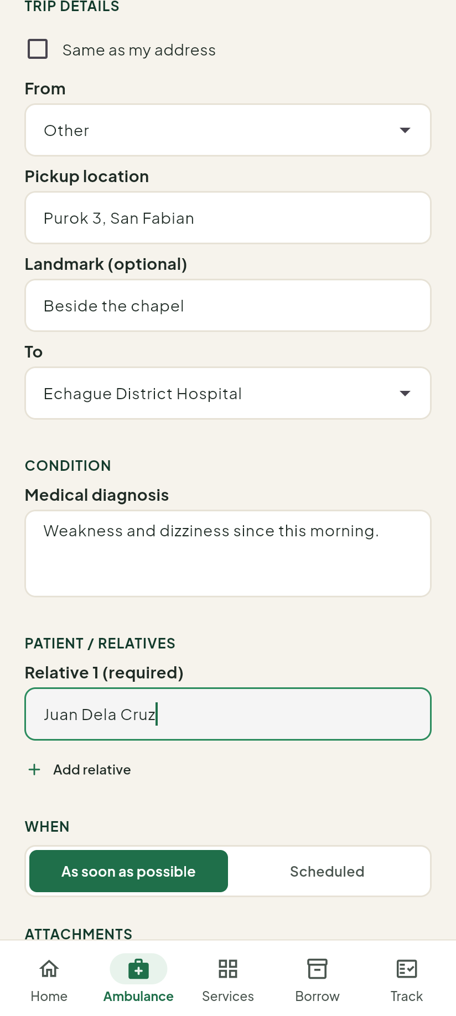
Figure 23. Relatives and the When choice.
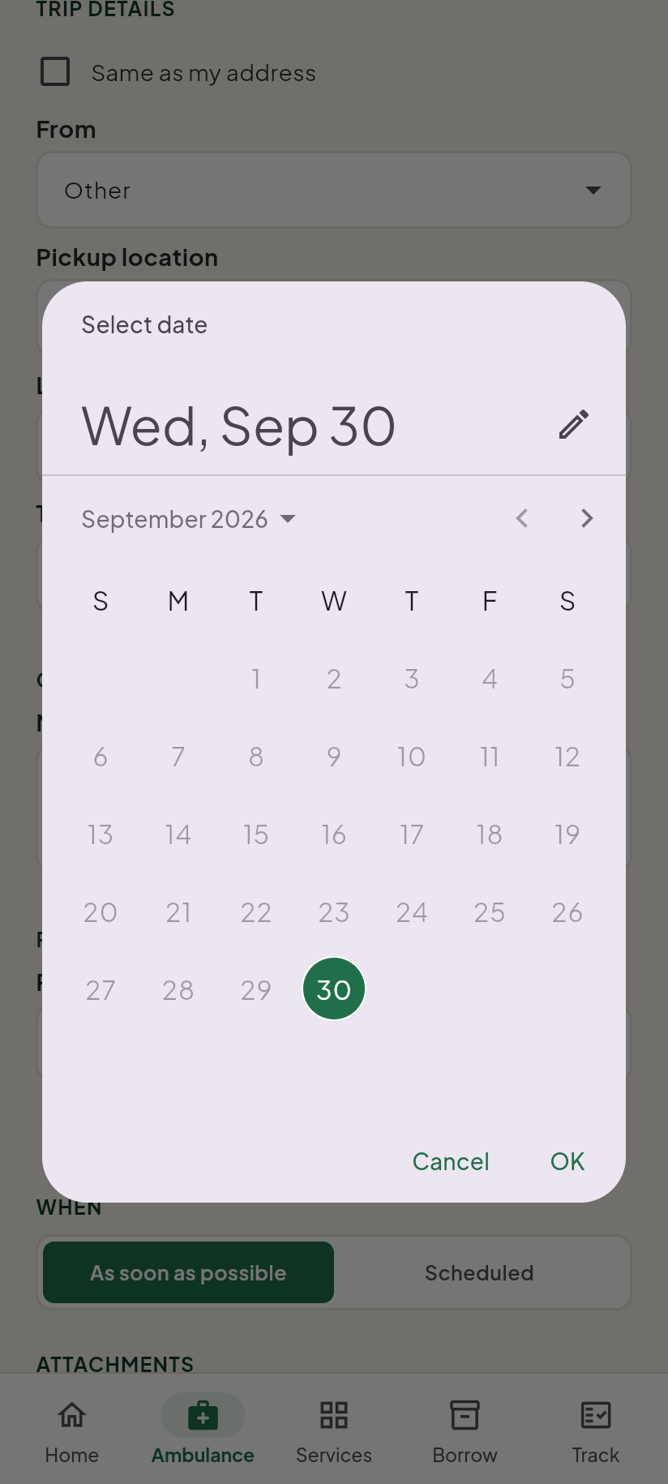
Figure 24. Choosing the date.
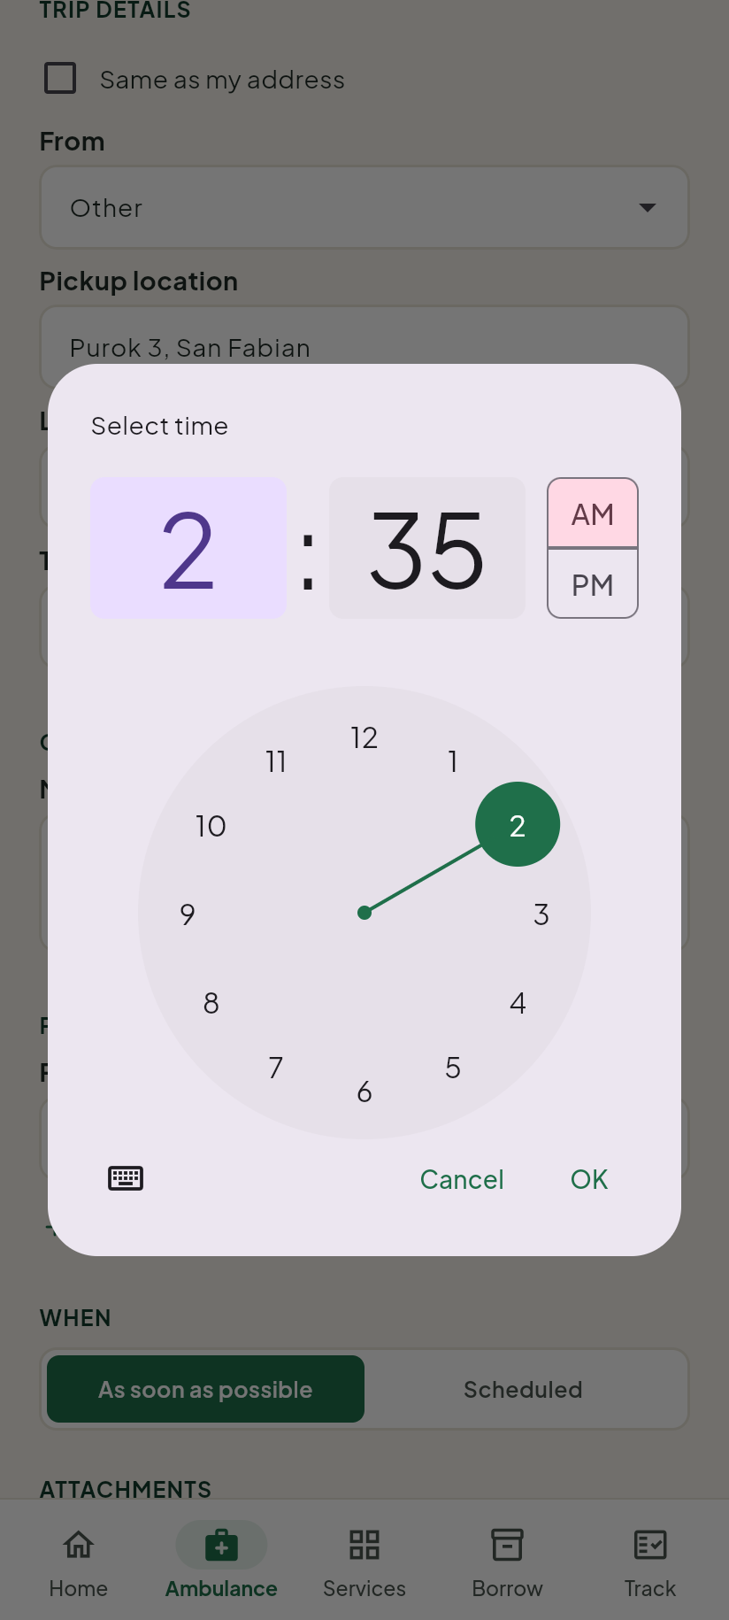
Figure 25. Choosing the time.
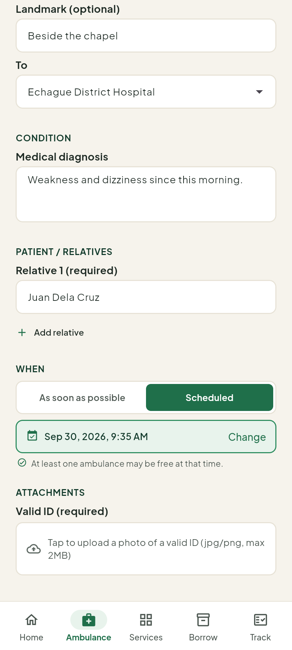
Figure 26. The chosen date and time, with the availability check.

5.5 Sending the booking
- Under Valid ID (required), attach a photo of a valid ID.
- Tap Submit request.
- Write down the reference number that appears.
The app will not send the booking without a patient name, a destination and at least one relative. It tells you which one is missing.

6 Following your requests
Tap Track at the bottom. Every request you made is here, newest first. Each card shows the service, the reference number (Ref #TXN-…), the details you sent and the status.
Tap a status at the top (All, Under review, Booked, Responding, Completed, Cancelled, Not approved) to show only those requests.
Tap View timeline to see each step and its time. Tap Hide timeline to close it.
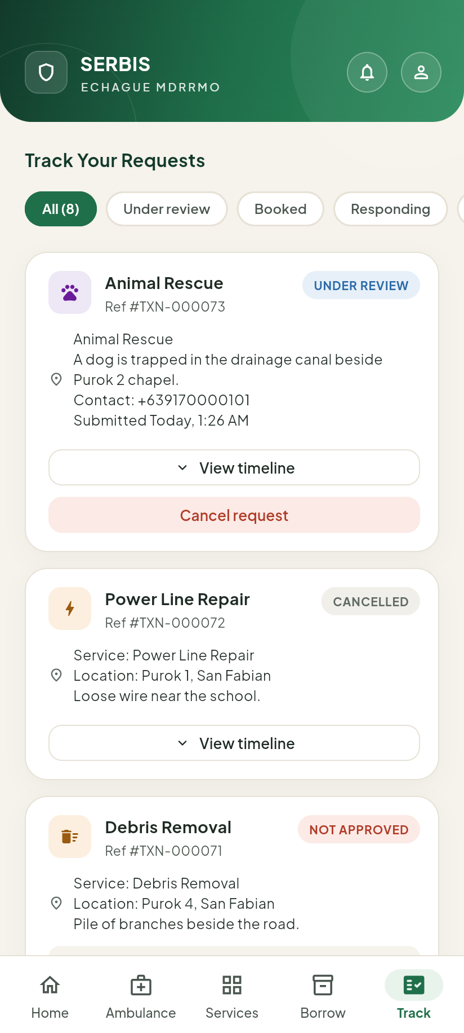
Figure 27. The Track list.

6.1 What each status means
The app uses its own words. MDRRMO’s word for the same status is in brackets.
What the app shows | What it means
Under review (Pending) | MDRRMO has your request and is checking it.
Booked (Booked) | Your scheduled ambulance is booked. The card shows the date and time. You will be reminded before the schedule.
Responding (Responding) | MDRRMO is working on your request. For an ambulance, the crew is on the way.
Approved (Responding) | Shown instead of Responding for trainings, drills and certification: MDRRMO has approved it.
Completed (Resolved) | The request is done.
Not transported (Resolved) | The ambulance trip ended, but the patient was not brought to the hospital. The card shows the reason.
Not approved (Disapproved) | MDRRMO did not approve the request. The card shows the reason.
Cancelled (Cancelled) | The request was cancelled.
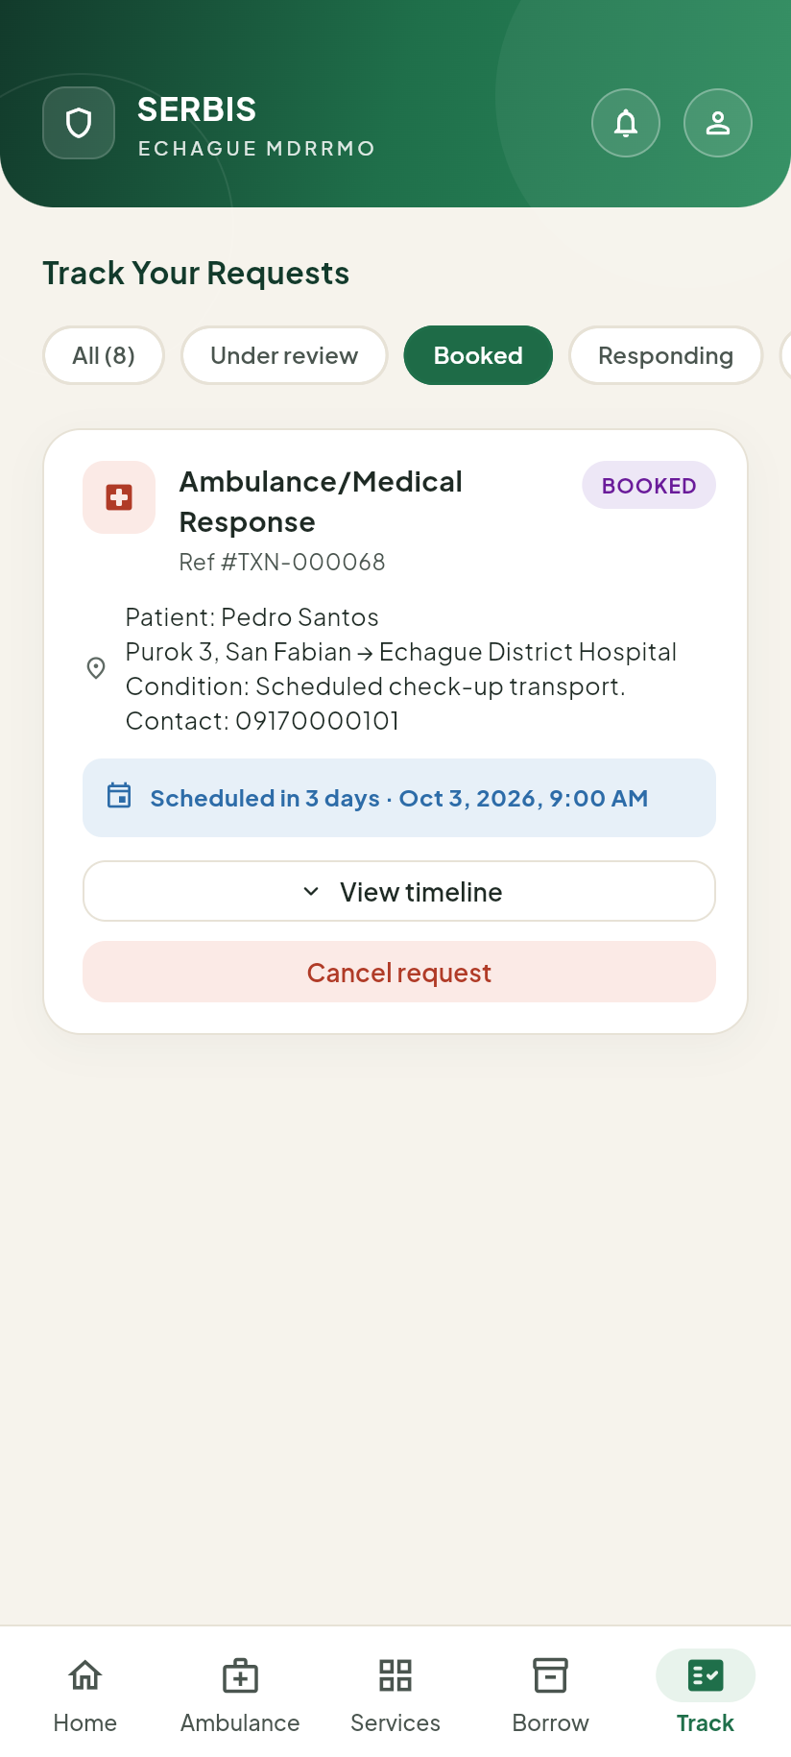
Figure 28. A booked ambulance, with its date and time.
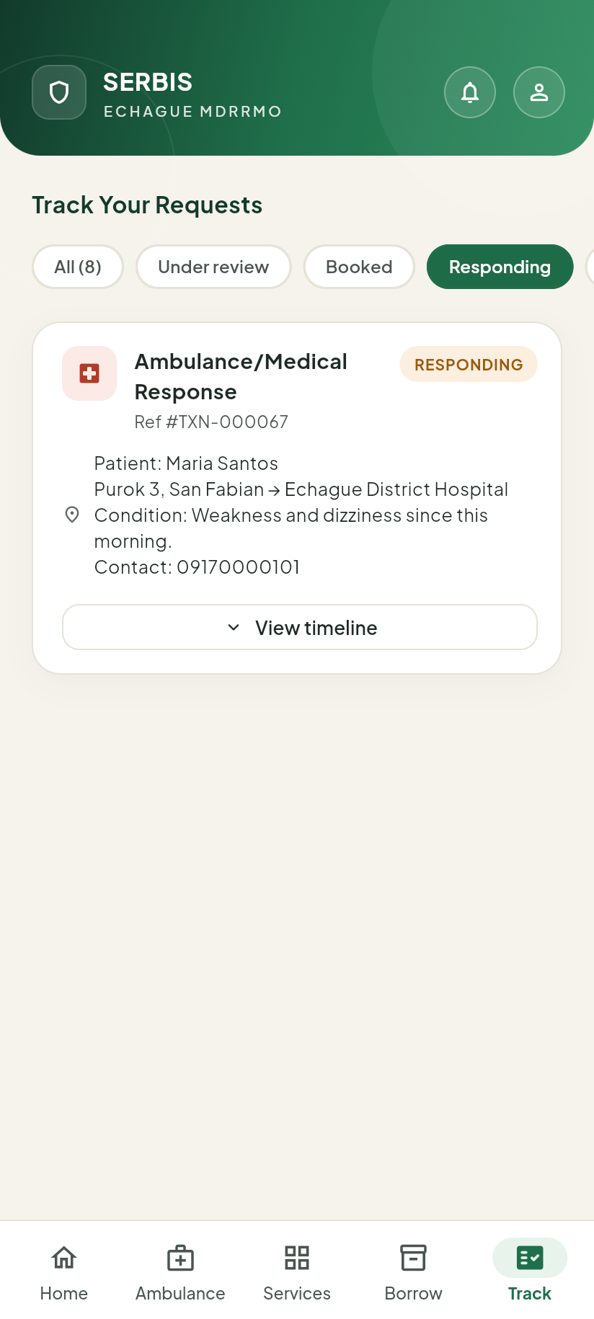
Figure 29. A request MDRRMO is responding to.
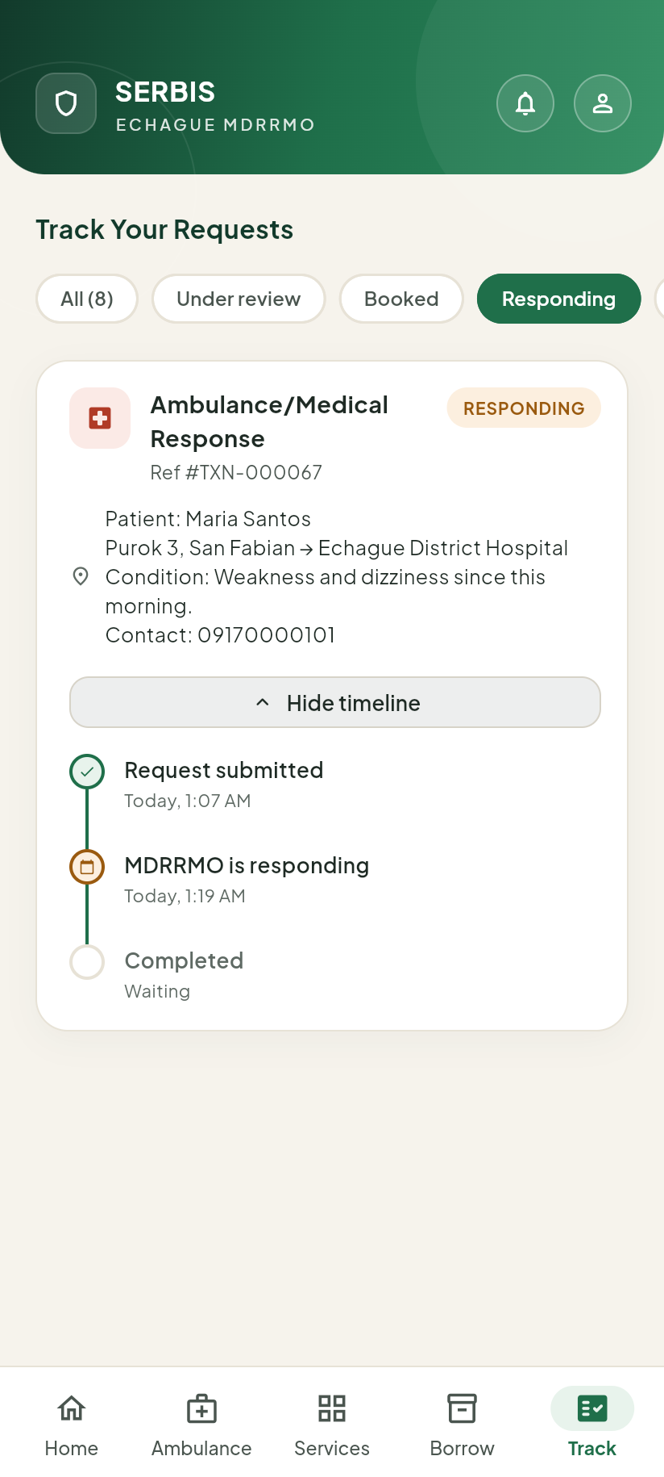
Figure 30. The timeline of a request.
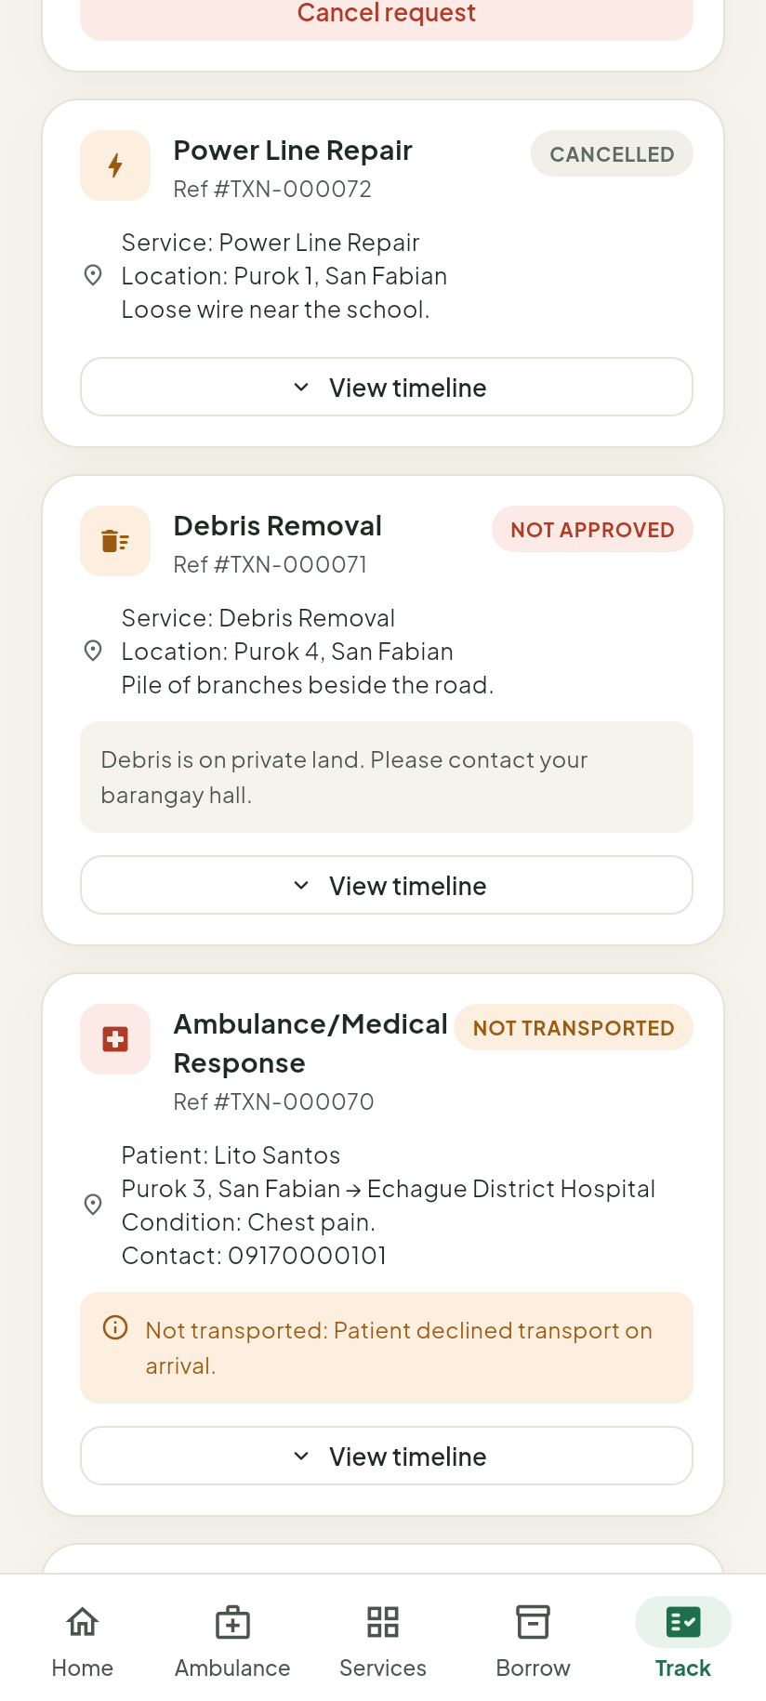
Figure 31. Cancelled and Not approved requests. A Not approved card shows MDRRMO’s reason.
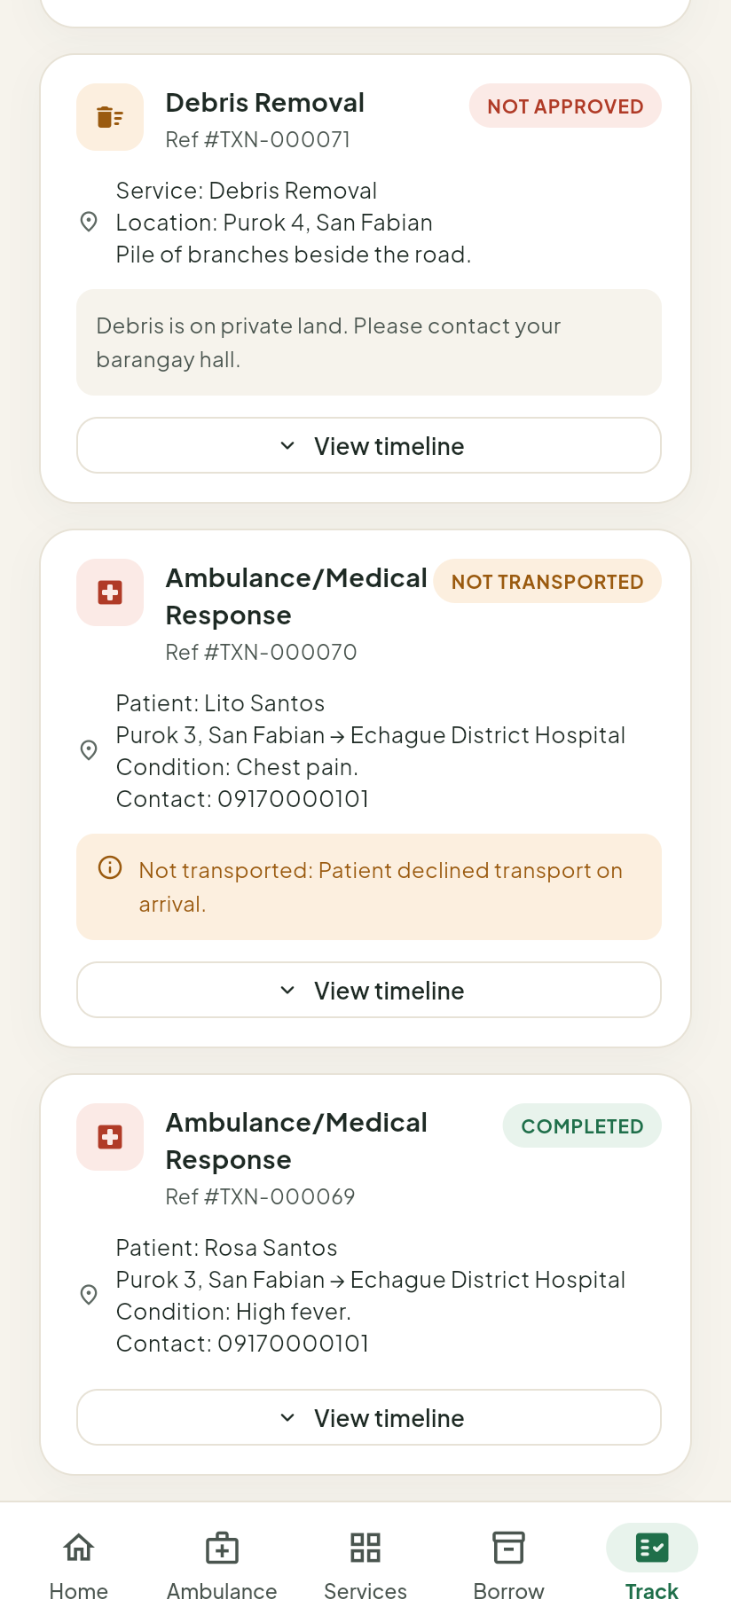
Figure 32. Not transported shows the reason. Completed is green.

6.2 Cancelling a request
You can cancel a request only while it is Under review or Booked. The Cancel request button appears only then.
You cannot cancel:
- once MDRRMO is Responding;
- a booked ambulance less than 2 hours before its scheduled time;
- once the ambulance crew has left the office.
In these cases, call MDRRMO instead.
To cancel:
- On the request card, tap Cancel request.
- The app asks Cancel request? Tap Cancel request again to confirm, or Keep request to go back.
A cancelled request cannot be undone.
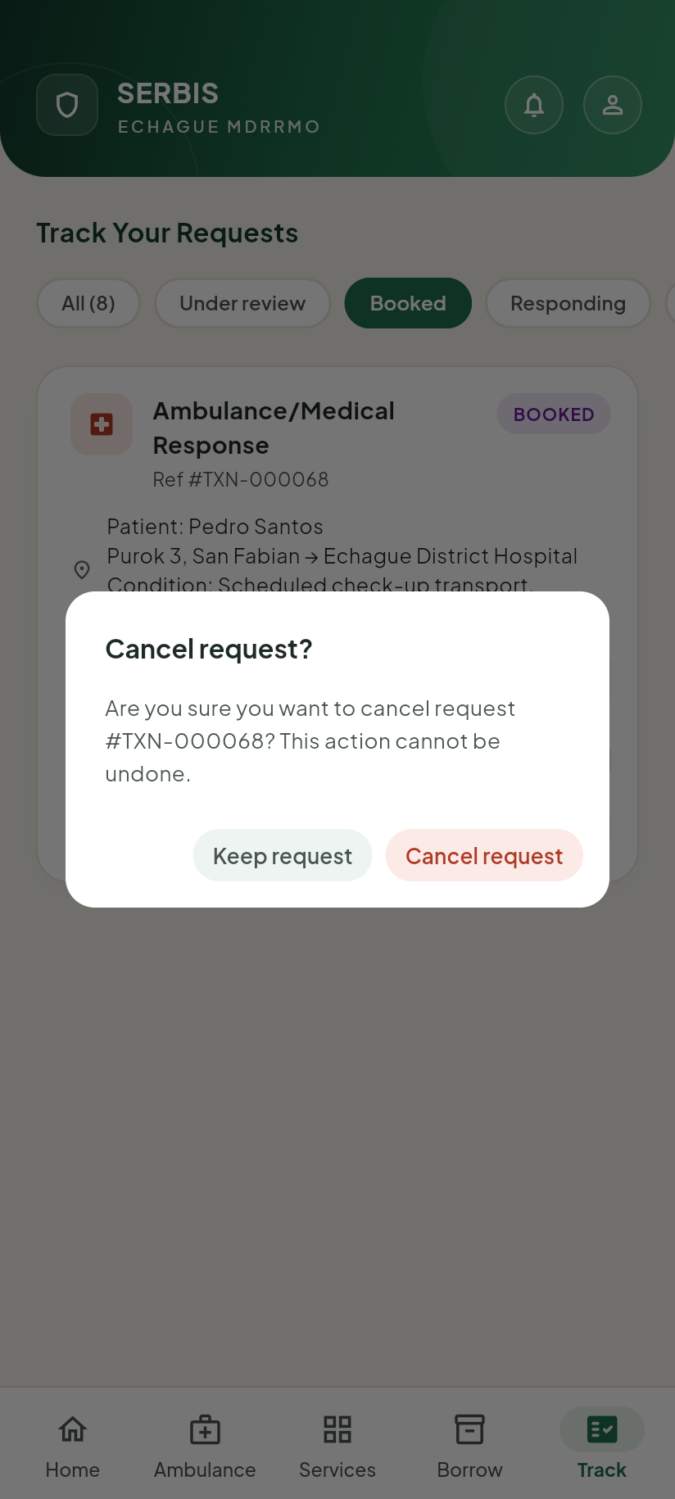
Figure 33. The question before a request is cancelled.

7 Borrowing equipment
Tap Borrow at the bottom. The tab has two parts: Available and My Requests.

7.1 Asking to borrow
- In Available, find the item. Each item shows how many are available.
- Tap Borrow.
- Use − and + to set how many you need.
- In What do you need it for?, write the reason. MDRRMO reads this before it approves.
- Under How will you get it?, choose Pickup or Delivery. For Delivery, type the Delivery address.
- Tap Request this item.
If the item you need is not in the list, scroll down to Need something else? and tap Request.
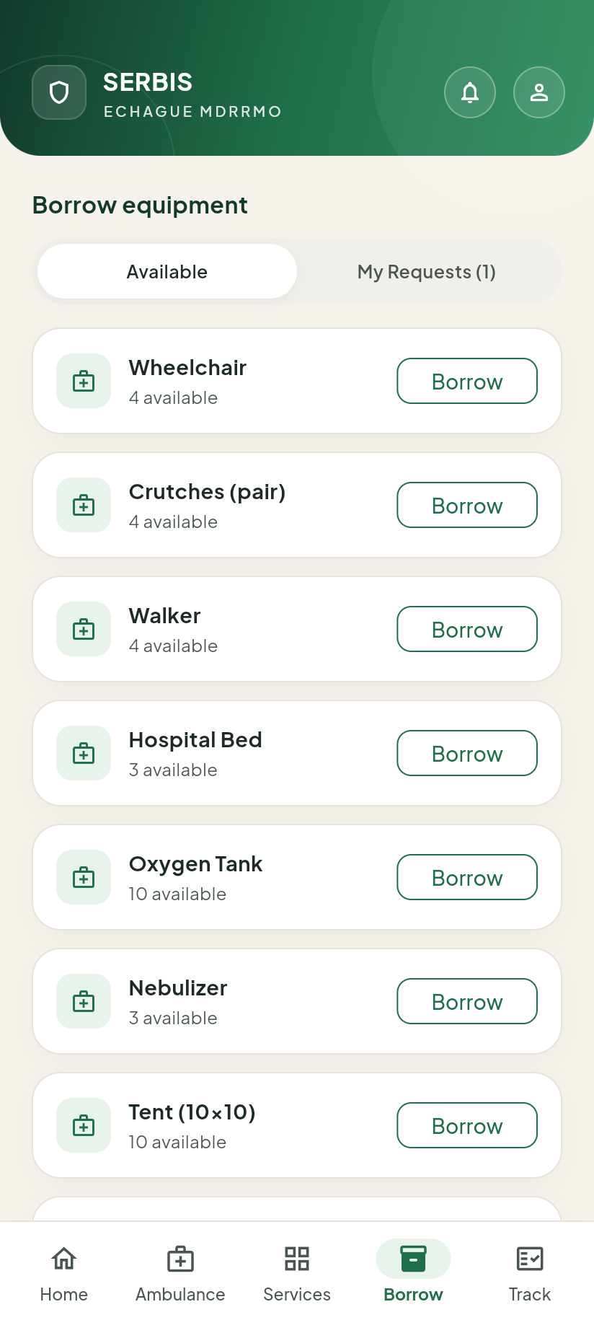
Figure 34. The list of equipment you can borrow.
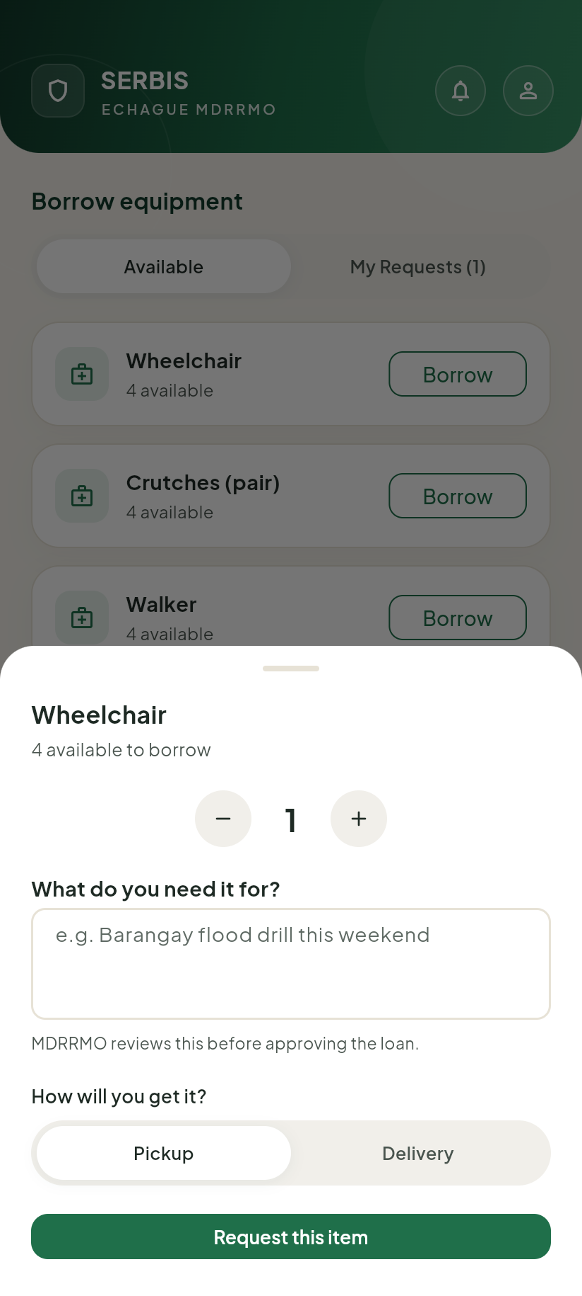
Figure 35. Asking to borrow a wheelchair.
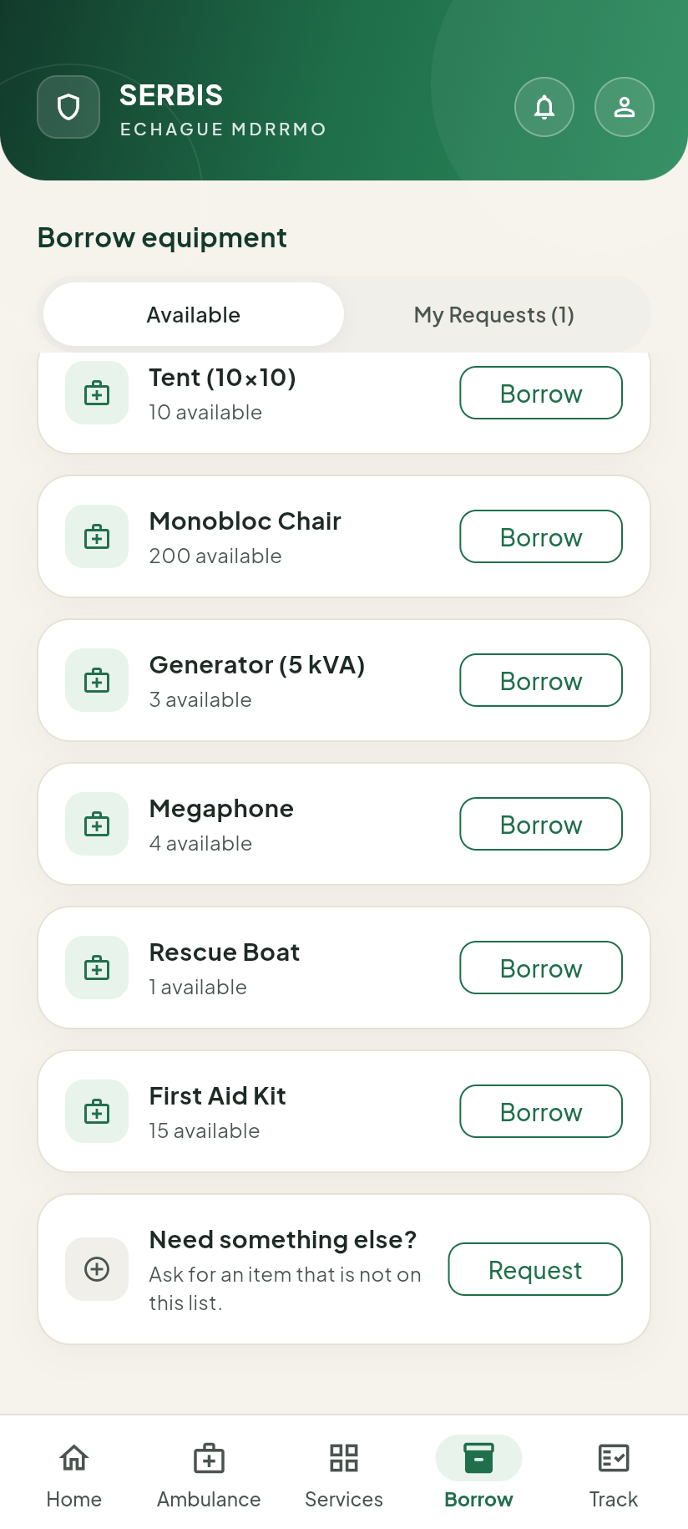
Figure 36. Asking for an item that is not in the list.

7.2 Following your borrowing
Tap My Requests to see your borrowing requests and their status:
What the app shows | What it means
Pending review | MDRRMO is checking your request.
Approved — awaiting pickup | Approved. Get the item, or wait for delivery.
Released to you | You have the item.
Returned | You gave the item back.
Not approved | MDRRMO did not approve it.
Cancelled by you | You cancelled it.
You can tap Cancel request while it is Pending review or Approved — awaiting pickup. After the item is released, call MDRRMO instead.
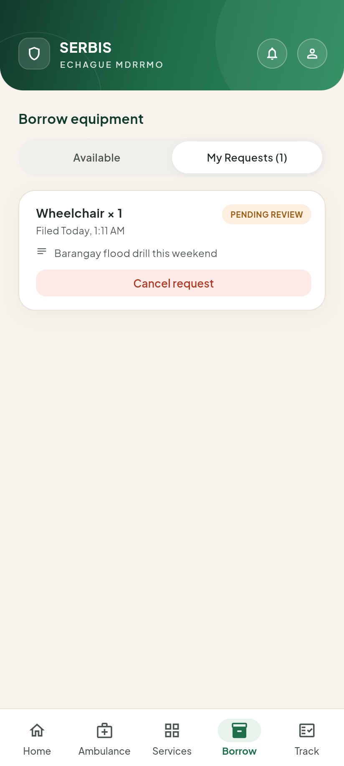
Figure 37. My Requests, with a request waiting for review.

8 Notifications, announcements and the Library

8.1 Notifications
Tap the bell at the top right. You see:
- MDRRMO advisories: text messages MDRRMO sent to your barangay, like weather warnings;
- Your requests: the latest news on your own requests.
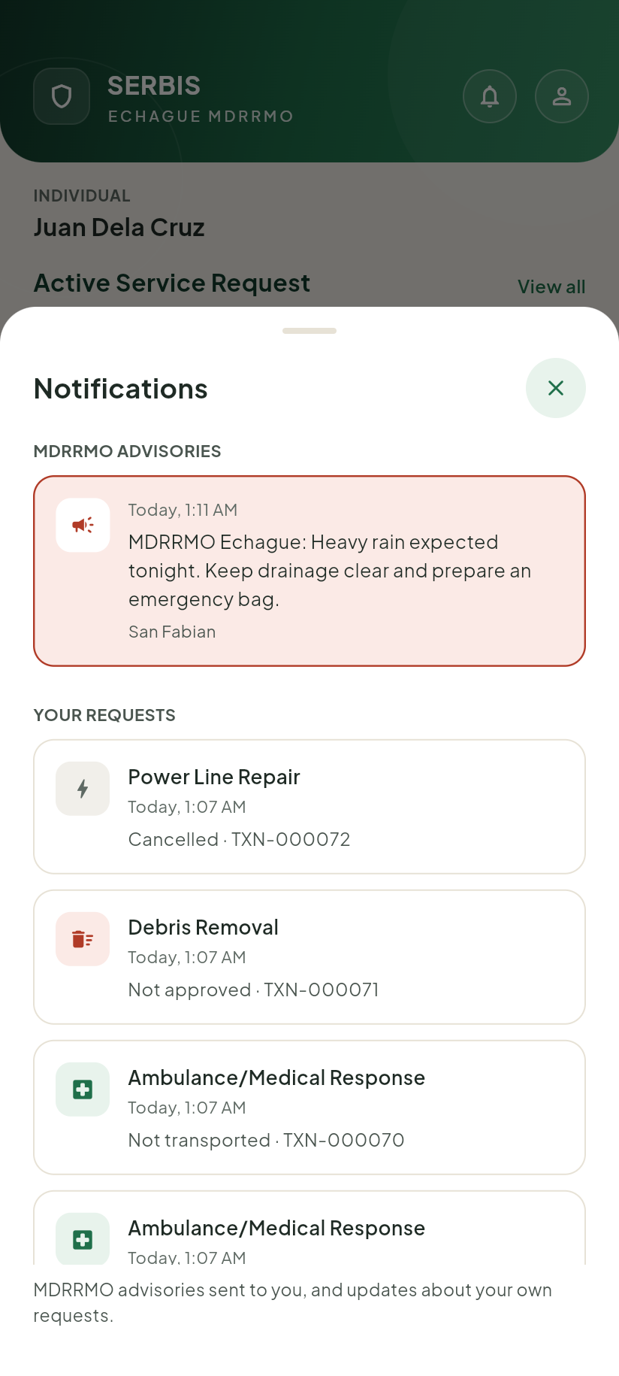
Figure 38. Notifications, with an MDRRMO advisory at the top.
To receive MDRRMO text messages on your phone, turn on MDRRMO text alerts in your profile. When it is off, you will not receive any MDRRMO text blast.

8.2 Announcements
The Announcements part of the Home screen lists the documents MDRRMO has published. If there are none yet, it says MDRRMO has not published anything yet. Tap Info center to open the Library.

8.3 The Library
Tap Safety guides on the Home screen. The Safety Library has:
- Emergency Hotlines: phone numbers of the Echague Rescue Hotline, PDRRMO, ISELCO I, BFP and 911. Tap a number to call it.
- Basic First Aid: CPR, burns and wound care.
- Disaster Preparedness: what to do before, during and after a disaster, the Echague DRRM Plan and evacuation centers.
- MDRRMO Documents: documents MDRRMO has published.
Tap a guide to read it. Items marked Saved can be read without internet. Tap EN or FIL at the top of a guide to change its language.
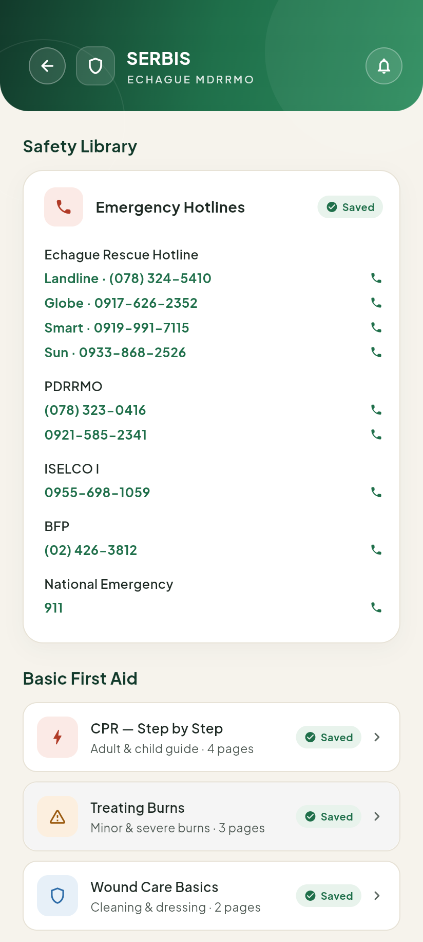
Figure 39. Emergency hotlines at the top of the Library. Tap a number to call.
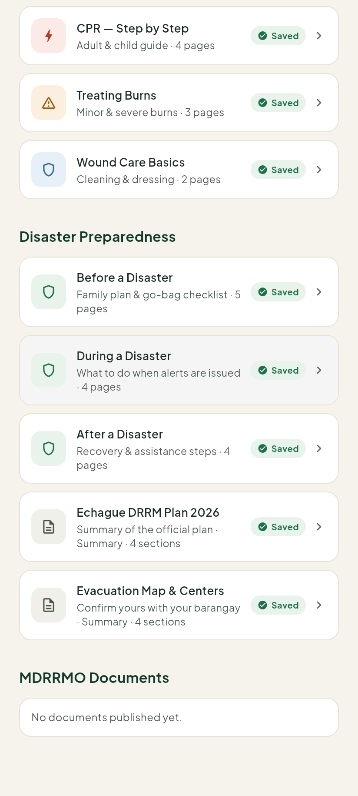
Figure 40. The first aid and disaster guides.
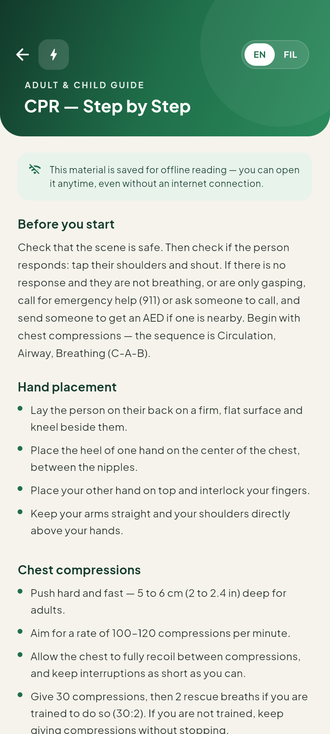
Figure 41. A guide, open for reading.

9 Using the app without internet
Without internet:
- You cannot send requests, ambulance bookings or borrowing requests. The app does not keep them to send later. Wait until you are online again.
- You can still see the requests that were already loaded on your phone.
- The Library guides marked Saved and the Emergency Hotlines still work.
When the app cannot reach MDRRMO, it shows No connection to MDRRMO. Requests can’t be sent., with the time the information was Last updated. Screens that could not load show a message like The list could not be loaded. Check your connection and try again. Tap Try again when you are back online.
You can choose which guides are saved on your phone under Offline materials in your profile.
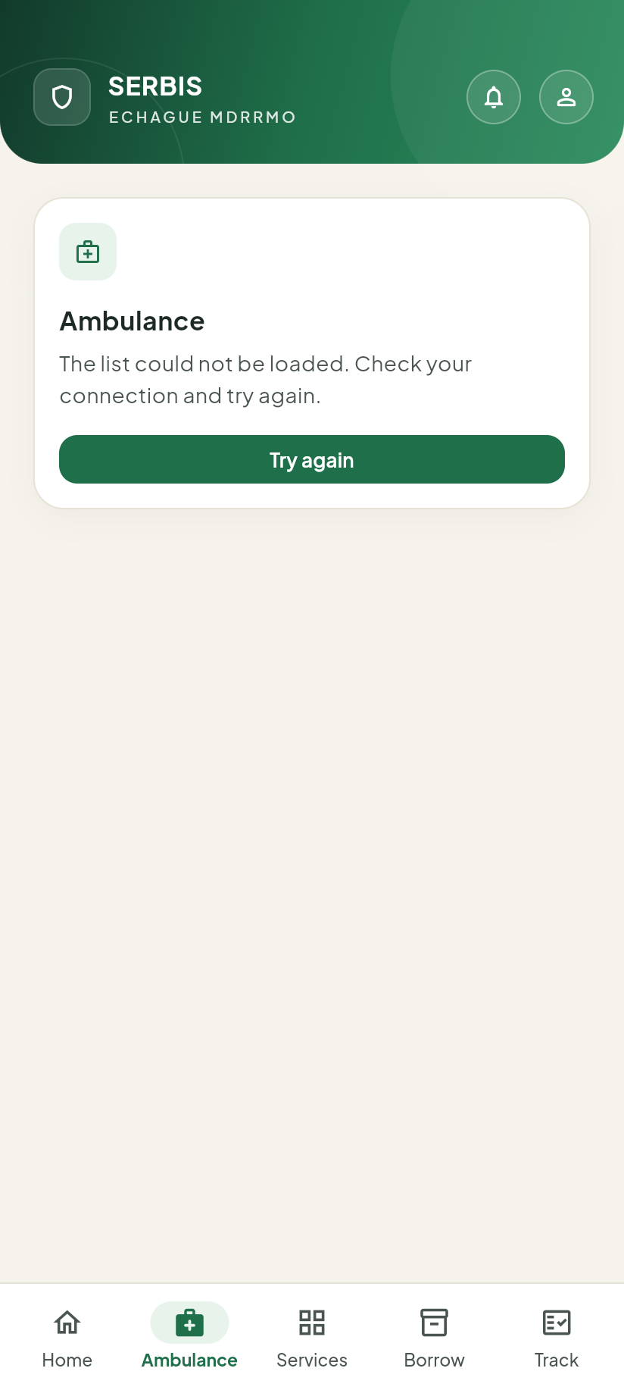
Figure 42. The Ambulance tab when the phone is offline.

10 Changing the language
- Tap the round profile button at the top right.
- Tap Language.
- Tap English or Filipino.
The app’s menus and buttons change language. The details you and MDRRMO typed stay as they were written.
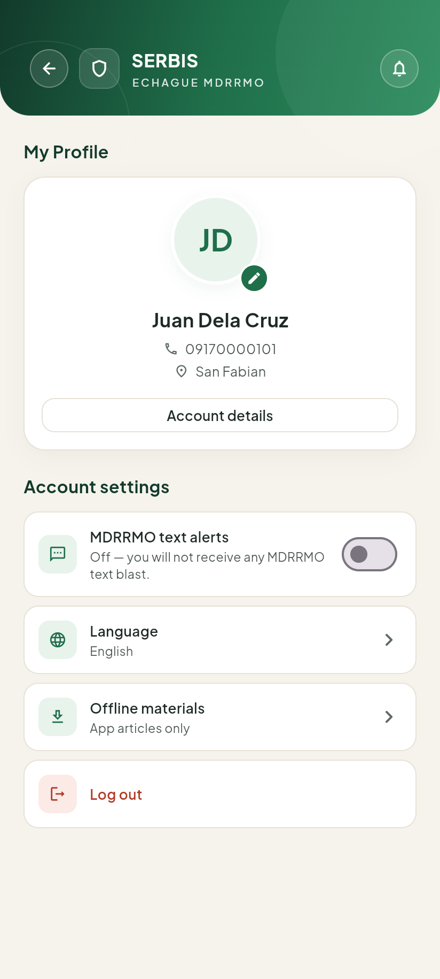
Figure 43. Your profile, with Language under Account settings.
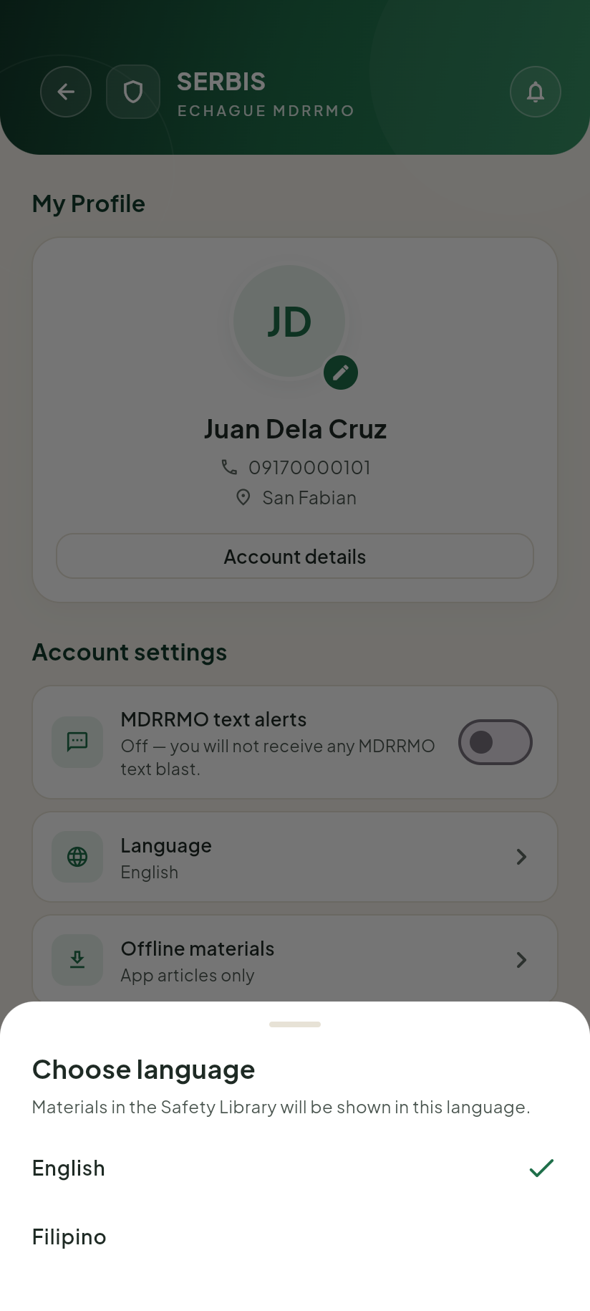
Figure 44. Choosing the language.
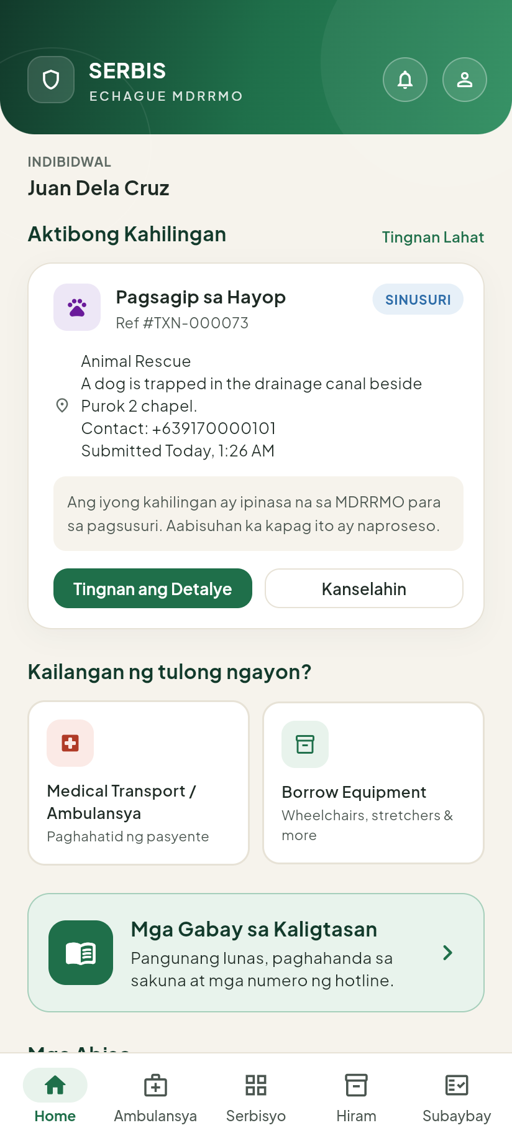
Figure 45. The Home screen in Filipino.

Appendix A. Status words

10.1 Service requests and ambulance bookings
English | Filipino | MDRRMO’s word
Under review | Sinusuri | Pending
Booked | Nakabook | Booked
Responding | Tumutugon | Responding
Approved | Aprubado | Responding (trainings, drills, certification)
Completed | Natapos | Resolved
Not transported | Hindi naihatid | Resolved
Not approved | Hindi inaprubahan | Disapproved
Cancelled | Kinansela | Cancelled

10.2 Borrowing requests
The borrowing statuses are shown in English only, in both languages.
What the app shows | MDRRMO’s word
Pending review | Pending
Approved — awaiting pickup | Approved
Released to you | Released
Returned | Returned
Not approved | Denied
Cancelled by you | Cancelled

Appendix B. Troubleshooting

10.3 I did not get the code by text message
- Check that the mobile number you typed is correct.
- Wait about one minute until Send a new code appears, then tap it.
- Check that your phone has signal.
- If it still does not arrive, tap Back to log in and try again later, or contact MDRRMO.

10.4 My request was refused
- The app says something is missing. Fill in the part it names. For every service, you must attach a valid ID photo. For an ambulance, you need a patient name, a destination and at least one relative.
- The time is too soon. A scheduled ambulance must be at least 1 hour from now.
- I cannot cancel. A request can be cancelled only while it is Under review or Booked, and a booking not within 2 hours of its time. Call MDRRMO.
- It says the service is not available. MDRRMO may have turned the service off. Choose another service or contact MDRRMO.
- It shows an error after Submit. The request was not sent. Check your internet and tap Retry.

10.5 A service is not shown for my account
Each service is open only to some account types (see Section 2). MDRRMO sets this and can change it. If you need a service that is not shown, contact MDRRMO or ask your barangay hall.

10.6 My organization account is still waiting
MDRRMO must approve every organization account. Tap Check again on the waiting card. If it takes long, contact MDRRMO.

10.7 The app says it cannot connect
Check your internet connection, then try again. Requests are never sent while you are offline.

